  Component One: Student Journal (learning log) | Student No: | 2238425
 | Module Title: | Hotel Administration  &Front Office Operation
 | Module Code: | BMIH4004
 | Lecturer: | Natalia Brailsford
Front office staff is one of the vital responsibilities that an employee has to handle for it needs someone who is not just trustworthy and is able to work with little direct supervision in enabling good customer service (Bardi, 2011). During my placement as a front office employee of the famous boutique hotel, DoubleTree by Hilton Southampton, I was charged with manifold responsibilities during which there were some challenging moments also which made me improve my job roles and handle situations smartly. These will be analysed by following the Gibbs Model of Reflection. I aimed to ensure that all our guests had a seamless experience starting from their arrival at the hotel premises to the time they check out by not just minimising their wait hours but assisting them throughout their check-in and checkouts. Check-in and check-out is the procedure by which guests are registered upon their arrival and departure and a smooth transition of this enables utmost satisfaction rate (Vallen and Vallen Jerome, 2014). Furthermore, I always dealt with resolving their concerns and requests so that they have a comfortable stay at our hotel. All of these roles have equally contributed in shaping the guest service experiences and it is by providing a friendly and comfortable atmosphere right at the arrival of the guests, I set a very optimistic tone so that they feel warm and a friendly feeling. Good communication along with professionalism are two of the crucial elements which ensures optimal guest satisfaction wherein courteous communication enables in building trust and rapport with clients whereas professionalism enables the fact that all clients feel valued and respected throughout their communication with the hotel employee (Corgel et al. 2011).
There were various challenges or surprises which I encountered within my placement and that made me analyse my performance even at a closer view. It is a known fact that adaptability and quick thinking are some vital skills which form the crux for managing quest check-ins, requests or inquiries and checkouts (Hammer, 2016). During the rush or peak hours when there were ample of guests arriving and needed their check-in quickly, I managed to remain calm under this pressurised situation and was dedicated to deliver exceptional service to all guests, irrespective of any grounds. One of the remarkable scenarios that I remember is a guest who approached me at my front desk and was angry enough to bring the notice that his room was not clean enough and he expressed dissatisfaction with it. In Spite of frequent inspections, there was an occasional oversight which caused this and that made him complain to me. During this time, I listened to all his words attentively, apologised deeply and organised for an immediate re-cleaning of his room. Thus, this demonstrated the vitality of attention to detail skill in proactively handling guest services and ensuring that they receive high standards of service throughout (Solomon, 2018). Even though this was challenging, I still found immense satisfaction in solving this issue with a proactive solution.
Reflecting on my skills and performance during my job role, I felt that my strength lay not just in communicating with the clients effectively but solving problems attentively with proactive solutions. Despite this unexpected request, I interacted effectively both with my team and guest and ensured that the guest can avail a room within a short timeframe. I left all other tasks and prioritised this one as it urgently needed a resolution. Thus, this speaks of my strong problem solving and adaptability skills to meet the guest needs promptly.
This placement journey of mine has genuinely deepened my understanding regarding the front office operations and has played a pivotal role in delivering positive customer experience. Interactions with clients underscores the vitality of building a welcoming and comfortable atmosphere for the guests to feel satisfied with the offerings (Tesone, 2010). It is by engaging with my clients I have come to the belief that personalised service holds an utmost significance in delivering positive guest satisfaction. I believe that it has been possible to satisfy my clients and their preferences by collaborating with my colleagues and all of these have significantly impacted the importance of teamwork. Teamwork is crucial for extending seamless client experiences by ensuring support, task execution and coordination among the colleagues, thus resulting in enhanced guest loyalty and satisfaction (Tewan, 2009).
Thus, my placement in this hotel has enhanced my knowledge and has encouraged me in improving my performance, thus enlightening my personal and professional growth. It is via this placement I have understood the reliance of communication, cultural sensitivity and problem-solving skill and that has made me build a welcoming environment for enhancing guest satisfaction. One of the action plans can be to seek mentorship from the senior colleagues as that can aid in enhancing my knowledge of the different facts of the front office team. To enhance my guest service, I can pursue courses on professional development so that I can deliver best class guest experience.

Component Two
Trip Advisor Review Response
Response to the positive feedback
Dear Guest,
Nice greetings to you for the day.
It is really good to hear such nice words of appreciation from you and that has encouraged us to work even better to enhance customer satisfaction. We take pride to have provided you with the best of amenities for your wonderful stay at DoubleTree by Hilton Southampton. It feels special to hear that you have found our hotel to have conveniently satisfied your taste and Celia, our staff to make sure all of your queries are solved promptly. We feel elated in knowing that we could take care of you during your stay with us and that you enjoyed delicious welcome cookies which made your day. We always aim to provide security to our guest's cars as our parking areas have CCTV cameras installed along with sincere guards who take care of the cars 24×7 and we feel happy that you felt secure in your car park. Your compliments regarding our collaborative housekeeping department and clean bedrooms really made our day and we would appreciate any of your feedback regarding areas you feel we need more improvement in. We pledge to continually strive hard towards enhancing our services and meeting your needs. Hope to have you again with us and serve you with our best to have yet another enjoyable time.
Warm regards.
Name: Peter Bartlett
Position: Manager
DoubleTree by Hilton Southampton.

Screen shot of referenced Trip Advisor review used:
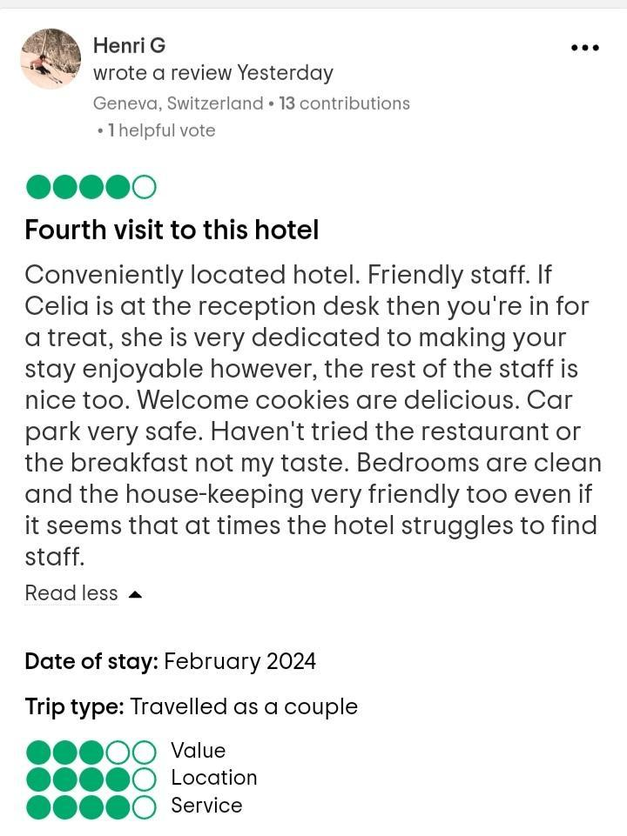
Figure 1: Trip Advisor review of DoubleTree by Hilton Southampton
(Source: TripAdvisor, 2024)
Letter of complaint response
Subject: Resolving issues during recent stay in DoubleTree by Hilton Southampton
Dear Mrs Blake,
Warm wishes for the day. I hope this letter finds you in good health. Prior to everything, I sincerely apologise for the dissatisfaction that you had to endure during your visit in DoubleTree by Hilton Southampton and stay in Room no. 330. Your feedback stands to be an integral part of our process and we appreciate you for taking time from your busy schedule and writing to us and giving us an opportunity to not just address your issues but put more focus on our customer satisfaction.
Right after we have received your email, we conducted an investigation to look into the matters at a closer level. Firstly, we feel so sorry that the room's cleanliness and hygiene did not meet your standards and just to let you know we have already fostered proactive steps for reinforcing our housekeeping team and operations so that such issue does not arise again. As guest satisfaction is our first and foremost priority, we have implemented staff training regarding housekeeping along with initiating more stringent quality control policies so that all the rooms tend to be immaculately maintained and clean.
We do realise the vitality of a stable broadband connection and the role it plays in the lives of our business travellers just like you are. We deeply regret the slow and unstable WIFI service and prioritising your feedback, we have organised a thorough review with our network operator and have implemented upgradation in our Internet infrastructure so that our guests can have access to a reliable and speedy Wi-Fi service throughout their stay at the hotel premises. We feel confident for these improvements and genuinely feel that you would not have to witness such issues during your future stays.
Noise levels were also unacceptable, and we cannot but sincerely apologise for the dissatisfaction you have experienced. This also has been addressed with our staff and it is after collective discussion that we have enforced not just quiet hours but ensured that all of our guests adhere strictly to the noise policies within the hotel premises. We pledge you to find our rooms soundproofing during your next stay here so that the guests can experience less disturbances and similar steps have been enforced respectively.
Delivering premium guest service forms our top motive and having not provided the same has really made us look deeper into such concerns and do all that we could, to provide exceptional service, thus meeting guest expectations. Retraining programs have been organised for reinforcing our attentiveness, professionalism and responsiveness of our customer service as every customer deserves swift response to their requests and inquiries.
Thus, we offer to extend this sincere apology and ask if you would like to enjoy a complimentary three-night stay at our boutique hotel, DoubleTree by Hilton Southampton along with breakfast till dinner. We wish this gesture makes you realise how sorry we feel for this inconvenience and request you to accept this offer and give us an opportunity to make amends for the mentioned shortcomings and provide you with an engaging and premium quality service. Please feel free to reach out to me with your free time and date so that we can arrange for a complimentary stay and answer your questions and concerns, if any.
Please restore your trust in our brand for we genuinely prioritise your feedback. We look forward to welcoming you and fulfilling your expectations.
Thank you.
Sincerely,
Gheorghita Elena Tudorache
DoubleTree by Hilton Southampton.

Component Three:
Contribution to Overall Module Assessment
Key Skill 1 – Customer Service Skills

One of the first and foremost skills that is essential for carrying out front office operations is customer service skills. Customer service skills are highly necessary for it helps in enhancing guest satisfaction along with customer loyalty by advocating the three P's namely patience, people-first attitude, and professionalism (Chowdhry et al. 2020). It has been revealed that 75% of the guests attest strong customer service skills to be the most important factor in shaping their choice of hotels or accommodation (Deloitte, 2024).
First and foremost, the crucial aspect of customer service in this industry has to be persuasive speaking skills. Front Office staff have to effectively communicate with diverse clients and understand their concerns and take steps accordingly. One must have patience and empathy in assisting customers throughout with an open persuasive communication skill to not just understand the customer's expectations but deliver swift and satisfactory solutions to their requests or inquiries. Handling complaints, feedback or conflicts in a respectful, calm and professional attitude is something that falls essential for a front office staff so that a friendly and conducive hotel atmosphere can be embraced. For example, the front office staff is one of the most priced assets of DoubleTree by Hilton Southampton which is renowned for their 24×7 expecting service and meeting all clients’ needs with their kind and professional nature just like a review seen on Tripadvisor by a guest who has been in this hotel and appreciated the great atmosphere created by the front office staff of this hotel who was really assisting and helpful throughout (Tripadvisor, 2024).
Empathy is yet another key skill of customer service where staff learns to empathise with diverse clients and their concerns and try to solve their issues providing personalised solutions (Gochwal, 2023). Premier Inn is one of the leading hotel chains who is widely known throughout the world for its smooth operations and brand awareness, and this has possibly been due to the empathetic attitude of their staff. As per a survey conducted by Statista (2023), 57% people said that they like the brand for its empathetic customer services which speaks volume of their fostering optimistic client relationships. Therefore, customer service skills encompassing interaction and empathy stands fundamental to the front office operations and must be enforced better in order to enhance guest loyalty and satisfaction.

Key Skill 2 – Communication Skills

Communication skills tends to be another vital skill that aids in conducting front office activities in a smooth manner. Research has found that transparent and clear lines of communication are helpful for not only building good rapport with guests but resolving issues in a comprehensive and efficient manner (Aripin et al. 2023). The front office department of a hotel company is someone who has to communicate clearly with the other departments and work collaboratively with them. To get the back and front office job done in an effective manner, it is the duty of the front office staff to communicate with their peers, colleagues, or subordinates. The front office staff at DoubleTree by Hilton Southampton undergo training periods so that they can master the manifold aspects of communication like verbal, non-verbal or written communication. The staff are trained to include facial expressions or body language in such a manner that they can embrace a welcoming and open body language which signifies attentiveness and approachability of the client's needs. This is an example of non-verbal communication which plays a profound role in attaining a pleasant arrival experience for guests. Besides interacting properly with guests, the front office staff have to communicate with the other departments in providing the best guest services resulting in registering guests, reserving their accommodations, managing client accounts, handling guest emails, assisting them during check-in or check-out and so on (Mossa-Basha et al. 2020). Written communication skills are equally necessary that helps them to maintain credible correspondence with the clients, thus resulting the staff at DoubleTree by Hilton Southampton to reflect on their motto to deliver excellent communication for responding to queries concisely and professionally along with delivering first-class customer experience.

Key Skill 3 – Organizational Skills

Organisational skills have emerged as yet another effective front office skill to aid in optimal client experience and a smooth workflow. 95% in hotel bookings have plummeted in April 2020 and this has been due to those customers who prefer convenience and efficiency in their hotel bookings (Statista, 2023). This highlights the profound role that organisational skill plays in fulfilling guest expectations. Under organisational skills comes the inclusion of time management, task prioritisation or attention to detail skills which collectively aim in enhancing customer experiences. The front desk staff at DoubleTree by Hilton Southampton delves deep in delivering smooth service and it has been possible due to the strong organisational skills that enables them to function smoothly. It must be the duty of the staff to ensure timely responses of their guests' issues or requests with the application of time management skills. The staff at this boutique hotel utilises effective systems for minimising wait times that helps foster good guest satisfaction. The brand which has made up the largest number of properties within the company's portfolio has been the DoubleTree by Hilton of around two and a half thousand units (Statista, 2023). This would not have been possible by customer loyalty and trust in the hotel's service that has worked hard in reaching this position. Besides this, task prioritisation which is useful for promptly resolving clients’ needs as per importance or urgency and attention to detail, ensuring consistency with service delivery like room allotments or reservations or reviewing each of the guest's review meticulously to personalise the requests as per their expectations helps in delivering best customer satisfaction.

Key Skill 4 – Problem Solving Skills

Problem solving skills are the main criteria for effectively managing guest issues and help foster a conductive guest experience. It has been recorded that 82% of individuals prefer quick resolution of their problems during their stay in hotels (Deepa et al. 2022). This highlights the idea that a front office staff must be proficient enough in handling client issues by applying their problem solving competencies. The front hotel team abides by inclusivity, diversity and equality policies in solving all client problems without differentiating on the basis of any societal grounds (Hilton, 2024). This sheds light on the extensive training that the staff at DoubleTree by Hilton Southampton goes through in not just developing their ability to identify but resolve innumerable kinds of guest challenges swiftly. All of the eminent hotel brands of the UK hospitality industry aim to take immediate solutions while addressing customer concerns, thus sometimes arranging for some complimentary amenities or by offering maintenance services to encourage guest satisfaction. The front desk members must actively listen to all guest feedback, empathise with their perspectives or issues, and then seek appropriate solutions to mitigate the issue (Min et al. 2021). This is one of the approaches that helps not just collaborate with the clients but with the other departments of the hotel to uphold the reputation of the hotel by finding innovative solutions to the same and ensuring that no such similar issues occur in the future. These are some ways by which problem solving skills can help solve a guest problem and enhance customer satisfaction holistically.

Reference List

Component 1:
Bardi, J. (2011). Hotel Front Office Management, Wiley, London.
Corgel, JB, Sturman, MC and Verma, R. (2011). The Cornell School of Hotel Administration on Hospitality: Cutting Edge Thinking and Practice, John Wiley & Sons, Incorporated, Hoboken.
Fallon, M. and Rutherford, D. (2011). Hotel Management and Operations, Wiley, London.
Hammer, J. (2016). Revenue superstar! The simple rules of hotel revenue management. Great Britain: Amazon.
Solomon, M. (2018). The Heart of Hospitality. New York: SelectBooks, Inc.
Tesone, D. (2010). Principles of management for the hospitality industry. London: Routledge.
Tewan, J. (2009). Hotel Front Office: Operations and Management, Oxford Higher Education Press.
Vallen, G.K. and Vallen Jerome J. (2014). Check-in check-out : managing hotel operations Ninth edition.; Pearson new international.
Component 2:
TripAdvisor, 2024. 146 reviews of DoubleTree Hilton Southampton. Available at: https://www.tripadvisor.co.uk/Hotel_Review-g186299-d192589-Reviews-DoubleTree_by_Hilton_Southampton-Southampton_Hampshire_England.html (Accessed on: 16 February, 2024).
Component 3:
Aripin, Z., Mulyani, S.R. and Haryaman, A., 2023. MARKETING STRATEGY IN PROJECT SUSTAINABILITY MANAGEMENT EFFORTS IN EXTRACTIVE INDUSTRIES: BUILDING A RECIPROCITY FRAMEWORK FOR COMMUNITY ENGAGEMENT. KRIEZ ACADEMY: Journal of development and community service, 1(1), pp.25-38.
Chowdhry, D.G., Verma, R. and Mathur, M. eds., 2020. The Evolution of Business in the Cyber Age: Digital Transformation, Threats, and Security. CRC Press.
Deepa, N., Parveen, A., Khurshid, A., Ramachandran, M., Sathiyaraj, C. and Vimala, C., 2022, May. A study on issues and preventive measures taken to control Covid-19. In AIP Conference Proceedings (Vol. 2393, No. 1). AIP Publishing.
Deloitte, 2024. 2024 commercial real estate outlook: Finding terra firms. Available at: https://www2.deloitte.com/us/en/insights/industry/financial-services/commercial-real-estate-outlook.html&ved=2ahUKEwj93_zh0LKEAxWVs1YBHbRcDMs4ChAWegQIBhAB&usg=AOvVaw18ViqI0-SL_-a5MjUf19Fa (Accessed on: 16 February, 2024).
Gochwal, A., 2023. Study Work-life Balance in the Finnish hospitality sector.
Hilton, 2024. DIVERSITY, EQUITY & INCLUSION. Available at: https://jobs.hilton.com/us/en/diversity-home2 (Accessed on: 16 February, 2024).
Min, K.S., Jung, J.M. and Ryu, K., 2021. Listen to their heart: Why does active listening enhance customer satisfaction after a service failure?. International Journal of Hospitality Management, 96, p.102956.
Mossa-Basha, M., Meltzer, C.C., Kim, D.C., Tuite, M.J., Kolli, K.P. and Tan, B.S., 2020. Radiology department preparedness for COVID-19: radiology scientific expert review panel. Radiology, 296(2), pp.E106-E112.
Statista, 2023. Hotel industry in the United Kingdom - statistics & facts. Available at: https://www.statista.com/topics/3146/hotel-industry-in-the-united-kingdom-uk/#topicOverview (Accessed on: 16 February, 2024).
Statista, 2023. Number of Hilton Worldwide Holdings hotels 2013-2022, by region. Available at: https://www.statista.com/statistics/297754/number-of-hilton-worldwide-hotels-by-geographical-region/ (Accessed on: 16 February, 2024).
Statista, 2023. Premier Inn brand awareness, usage, popularity, loyalty, and buzz among hotel customers in the UK in 2022. Available at: https://www.statista.com/forecasts/1335699/premier-inn-hotels-brand-profile-in-the-uk (Accessed on: 16 February, 2024).
Tripadvisor, 2024. Review of DoubleTree by Hilton Southampton. Available at: https://www.tripadvisor.com/ShowUserReviews-g186299-d192589-r938030390-DoubleTree_by_Hilton_Southampton-Southampton_Hampshire_England.html (Accessed on: 16 February, 2024).

