MSc Public Health and Social Care in Practice
Community Care and Management of Longer-term Conditions
LCHS7003
Component 1
Name: Sejal Odedra
Student id : 2607031

Lecturer : Dr. Aishat Bakre

Recommendations for Improving Person-Centred Asthma Care

Table of Contents
1. Introduction 2
2. Prevalence, Aetiology and Risk Factors 3
3. Physical, Psychological and Social Impacts 5
3.1 Physical impacts 5
3.2 Psychological impacts 5
3.3 Social impacts 6
4. Evidence-Based Treatment and Management 7
4.1 Optimising pharmacological treatment 7
4.2 Reviewing treatment and escalating care 8
4.3 Supporting adherence and specialist care 8
5. Models and National Policy 9
5.1 GINA and the Social Prescribing Model 9
5.2 National Health Service Long Term Plan and Person-Centred Care 11
5.3 Integrating the frameworks 12
6. Recommendations 13
7. Conclusion 14
Reference List 15

1. Introduction
Asthma is a chronic respiratory condition characterised by the implementation and narrowing of the Airways which cause wheezing, coughing, chest tightness and breathlessness. The symptoms can vary over the time and can worsen following exposure to the allergens, respiratory infections and environmental pollutants. However, asthma cannot currently be cured while appropriate treatment and self-management can support the symptom control and reduce the risk of severe exacerbations (National Institute For Health And Care Excellence, 2024).

Effective asthma management requires the consideration of how the respiratory symptoms affect daily functioning, independence and the ability to participate in education, employment and social activities. The condition also creates demands on the health services through routine monitoring, medication provision and emergency treatment. However, the outcomes cannot be understood solely through the clinical indicators as the patients experience different variations depending on their living and working environments, access to the health care and capacity to manage the treatment.

A person-centred care approach therefore required the practitioners to consider the individual circumstances alongside the clinical evidence. This includes recognising the environment and exposure, supporting the informed decision and ensuring that management strategies are realistic for each of the person. The research of Jayasooriya et al. (2025) highlights the importance of understanding asthma through its epidemiology where the modifiable risk factors and opportunities for prevention are emphasised rather than focusing exclusively on treating the symptoms after they develop. This broader perspective provides a foundation for evaluating asthma related inequalities and identifying opportunities to improve the long term outcomes.

Definition of Asthma and Asthma Management

Asthma is a chronic respiratory condition characterised by variable respiratory symptoms and changes in expiratory airflow, often associated with airway inflammation. Asthma management involves accurate diagnosis, appropriate medication, regular monitoring, inhaler-technique assessment and personalised self-management support to improve symptom control and reduce exacerbations (National Institute For Health And Care Excellence, 2026).

Aim
To critically evaluate asthma management and its physical, psychological and social impacts, examining evidence-based treatments, care models and UK policies to recommend equitable, effective and person-centred support.

2. Prevalence, Aetiology and Risk Factors

Asthma presents significant Global public Health challenges. The World health Organisation (2024) report indicates that more than 250 million people worldwide face the issues of asthma. The data also indicate that in 2019 it cost 455k deaths. In the UK almost 7.2 million people face the use of asthma which highlights the continuing demand of the effective long term respiratory care systems while 55.4 million people currently received the treatments of asthma (Asthma and Lung UK, 2023). The Statistics from Campbell (2025) also indicate that people 33% of the people of age group between 60-69 face the issues of Asthma that increase the burden. The exact cause of asthma remains incompletely understood while the genetic susceptibility and the history of allergies can contribute to its development. The environment and rest factors including the tobacco smoke and air pollution and Poland and dust mites and the occupational exposure to the chemicals can cause this issue. The cold dear and exercise and respiratory infections can also trigger the same terms for the individuals. Importantly the factors associated with the developing Asthma are not always the same as those that trigger and attack. Identification of the individual respect and reducing the advertisement exposure can support the prevention and the symptom control even if these measures cannot eliminate the exacerbations.
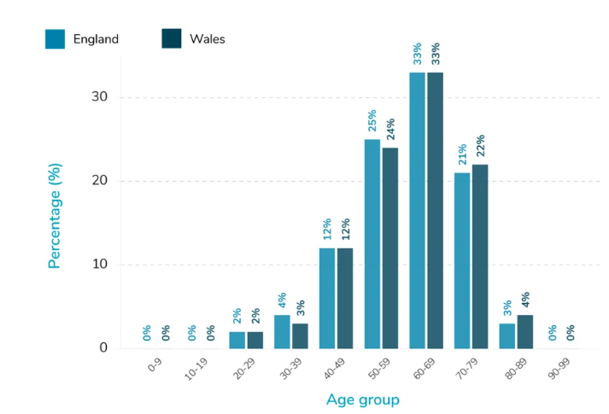
Figure 1: Asthma Prevalence as per Age group
(Source: Campbell, 2025)

Asthma continues to place a considerable burden on the healthcare systems internationally. In England, 3,944,639 people aged 6 and over were on the asthma register in 2024/25, representing 6.6% of the total population. During the same period, 39.3k emergency hospital admissions involved adults aged 19 and above which indicates that asthma control remains a significant healthcare challenge (Office for Health Improvement and Disparities, 2026). However the recorded prevalence reflects the diagnosed cases meeting the reporting criteria and should not be interpreted as the total number of people potentially living with asthma.

Asthma has a multi factorial aetiology which involves the genetic predisposition, immune responses and the environmental influences. The evidence from the study of Wang et al. (2023) Regarding the global warning of disease study identifies the high body mass index, smoking and occupational exposure to asthma related agents as important contributing factors to the disability and the health loss. The occupational exposure is particularly relevant where the worker encounters the chemicals, that's all the other respiratory irritancy. Moreover, the outdoor pollution may aggravate the existing disease while housing conditions and exposure to the indoor allergen can complicate the symptom control.

The study of Dai and Xiang (2026) also identified the nitrogen dioxide pollution among the risk factors associated with asthma burden, alongside smoking and occupational agents and the high body mass index. These finding Syndicate that prevention require more than individual behaviour related changes and the effective response which should also address the workplace safety and environmental quality and unequal exposure to risk.

3. Physical, Psychological and Social Impacts

3.1 Physical impacts

Asthma can significantly affect the physical health of an individual, psychological welfare and social participation. Physically the symptoms such as the breathlessness and wheezing and coughing can impact the sleep and limit the exercise and can reduce the ability to perform the everyday activities. The severe exacerbations of the issue can disrupt the normal routine and can require the emergency treatment for hospital admission particularly when the symptoms are poorly controlled (National Institute For Health And Care Excellence, 2024).

Beyond the immediate respiratory symptoms, asthma can create persistent difficulties for the older adults and the people with multiple long term conditions. The completing health problems and polypharmacy may complicate the treatment routines while under-reporting symptoms can impact the appropriate clinical interventions due to delay. The qualitative study of Jackson et al. (2022) found that older people with asthma experienced difficulties associated with multimorbidity, treatment management and feeling isolated. These findings mainly indicate that healthcare professionals should consider the functional limitations, treatment and the age related needs rather than evaluating asthma control in isolation.

3.2 Psychological impacts

At the psychological level the unpredictable attack may cause fear and anxiety and reduced confidence while the concerns regarding the future symptoms can impact independence. The research such as Stubbs et al. (2022) Identify the associations between anxiety and depression and poor health outcomes among people with severe Asthma issues.

For the young adults with the severe or uncontrolled asthma, uncertainty regarding the future attacks can affect confidence and identity and independence. The qualitative evidence of Mackiewicz et al. (2025) Found that recurring experience is about fear and embarrassment and shame created the restriction of the life choices. These psychological pressures can also influence the treatment adherence and lifestyle decisions while can create barriers in interaction between the emotional distress and the physical symptoms (Holmes et al., 2025). Therefore assessment of the psychological welfare is particularly important to find the patient report persistent difficulties despite receiving the treatments. However the emotional distress should not automatically be interpreted as the cause of core Asthma control where the clinical assessment should also investigate the psychological and the environmental factors.

3.3 Social impacts

At the social level as may contribute to the school and the workplace absence with restricted recreational activities and additional healthcare expenses. The family members may also experience the emotional stress and burden and the increased care giving responsibilities especially when supporting children and individuals with severe symptoms (Yi et al., 2025). These effects indicate the importance of holistic and people centric care systems that can address the physical symptom alongside the psychological need and the family circumstance.

The social consequences of asthma are particularly evident in employment, workplace relationships and financial security. Mackiewicz et al. (2025) found that people with severe Asthma experience difficulties in maintaining employment due to the fluctuating symptoms and workless triggers and the absence of policy limitations. Even if the workplace adjustments and flexible working may help, these options are not equally accessible to the different levels of the employees. Consequently, Asthma can contribute to the wider social economic disadvantages rather than simply causing the temporary disruption.

Social stigma can also undermine independence. The patients may feel uncomfortable using inhalers publicly or explaining their conditions to peers, potentially discharging the appropriate management. Holmes et al. (2025) identified shame, embarrassment and social isolation among the young adults with severe or uncontrolled asthma highlighting how the conditions can restrict the participation and identity.

The family circumstances can also affect the wider impact. The qualitative study of Yang et al. (2023) Regarding mother's caring for school age children with asthma identified the emotional strain, financial pressure and difficulties accessing the healthcare while social support helps the families to cope with the issue. These findings support the assessment of the patient's wider social environment and the practical support needed. The qualitative nature of the studies mean their findings offer detailed insights into the experience rather than estimate about how frequently these difficulties impact people with Asthma.

4. Evidence-Based Treatment and Management

4.1 Optimising pharmacological treatment

Effective Asthma management combines proper medication and regular monitoring and patient education. Inhaled corticosteroids are an important medicine as they reduce the inflammation in the airway and can help prevent the issues. Depending on the symptom and the clinical assessments and per the current guidelines the health care professionals may recommend combination of the inhalers containing the corticosteroids and the long-acting bronchodilators (National Institute For Health And Care Excellence, 2024, GINA, 2026). The regular Asthma reviews are essential for evaluating the symptoms control and medication adherence and maintaining the inhaler technique. The patients should receive the clear instruction on recognising the worsening symptoms and accessing the urgent medical assistance. The personalised return as my action plans can support the informed decisions and can improve the confidence in managing the conditions (National Health Service, 2026). The treatment should reflect individual preferences, age and clinical needs to respond to the medication rather than following an identical approach for every patient. The education regarding avoiding the relevant triggers and reducing the tobacco smoke exposure and environmental risks can also support symptom control. However, the self management can complement the professional Health Care systems rather than replacing the clinical assessment (Lim et al., 2026). The coordinator approach is important which involves the primary care and the respiratory specialist and the community services for improving the continuity of care and reducing avoidable Hospital admissions.

The current National Health Service asthma management follows the joint British Thoracic Society, National Institute For Health And Care Excellence and Scottish inter College yet guidelines network guideline which recommends the treatment according to the age, symptom control and exacerbation risks. For the newly diagnosed patients aged 12 and over the low dose inhaler of corticosteroid or Formoterol can be offered as the anti inflammatory reliever. Where the control remains inadequate, the maintenance and reliever therapy should be appropriate after the clinical assessment (British Thoracic Society (BTS) and National Institute for Health and Care Excellence, 2026). The systematic review of Rayner et al. (2025) Regarding the 27 randomised control trials involving 50.4k patients found that inhaled corticosteroid reduced the severe issues compared to the short acting bronchodilators treatment alone with support the move away from the reliever only treatment. That retreatment selection should consider the licence and correct inhaler usage and the patient preferences and individual response.

4.2 Reviewing treatment and escalating care

Prescribing the medication alone is not sufficient when asthma remains uncontrolled. National Institute For Health And Care Excellence recommends checking the adherence, inhaler technique, smoking exposure and comorbidities and psycho social and environmental factors before increasing the treatment. The clinical response should generally be reviewed after 8 to 10 weeks after starting or adjusting the medication (British Thoracic Society (BTS) and National Institute for Health and Care Excellence (NICE), 2025). A review of the digital inhaler Technology of Chan et al. (2022) Found that connected devices may help identify the pattern and support the clinical decisions even if their usefulness depends on the accessibility and patient engagement and integration into the routine services. The patients whose asthma remains uncontrolled despite optimised treatment may require the specialist assessments, including evaluation for severe asthma and eligibility for targeted biological therapies.

4.3 Supporting adherence and specialist care

The digital interventions may improve medication adherence yet their effectiveness varies across the studies where the technology should supplement rather than replace the consultation and the practical education (Chan et al., 2022). For the patients with severe asthma issues the specialist treatment may identify the eligibility for biology medicines that target specific inflammatory pathways (Gyawali et al., 2025). The systematic review of Kyriakopoulos et al. (2024) found that licence to biologics can reduce the exacerbation and can improve the asthma control in appropriately selected patients, even if the response have differences by the drug and patient phenotype.

5. Models and National Policy

5.1 GINA and the Social Prescribing Model

The Global initiative for asthma (2026) provides international evidence based strategy for Asthma diagnosis and treatment and the ongoing monitoring. Its approach focuses on the appropriate inhaled medication and the prevention of the exacerbations and the individual assessments.

The global Initiative for Asthma (GINA) provides the international evidence based Framework for asthma assessment and treatment adjustment and the ongoing review. Its 2026 strategy focuses on personalized treatment and sharing the decision making with assessment of exacerbation risks and the regular evaluation of the inhaler technique and adherence (Reddel et al., 2026). How is clinical guidance alone unable to address the social circumstances that influence the Asthma outcomes including isolation and housing difficulties and financial pressure and limited access to community support.
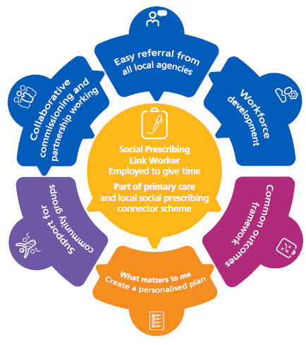
Figure 2: Social Prescribing model
(Based on Reddel et al., 2026)

The National Health Service social prescribing model complements the Global initiative for asthma by connecting the people with non-clinical services that address the practical, social and the emotional needs. The special prescribing links the workers and collaborates with the individuals to identify their priorities and develops the personalised support plan while potentially linking them with the community groups and welfare advice and the physical activity programs for the mental welfare services (National Health Service England, 2026). As an example, the person whose asthma related anxiety limits the participation of the everyday activities may benefit from the appropriate community support alongside the clinical treatments. However the social prescribing does not treat the airway inflammation which should not replace the prescribed medication for the specialist respiratory care.

5.2 National Health Service Long Term Plan and Person-Centred Care

The National Health Service Long term plan promotes the improved management of the long term conditions, prevention and more coordinated community based services (National Health Service England, 2019). Its objective aligns with the image's comprehensive model of personalized care which incorporates the shared decision making and the personalized care and support planning while supporting the self-management and social prescribing with community based supports. Applied to asthma, this approach requires the professionals to understand the goal of patients and treatment preferences and the health literacy and individual barriers before agreeing on the management plans (Gatheral et al., 2017).
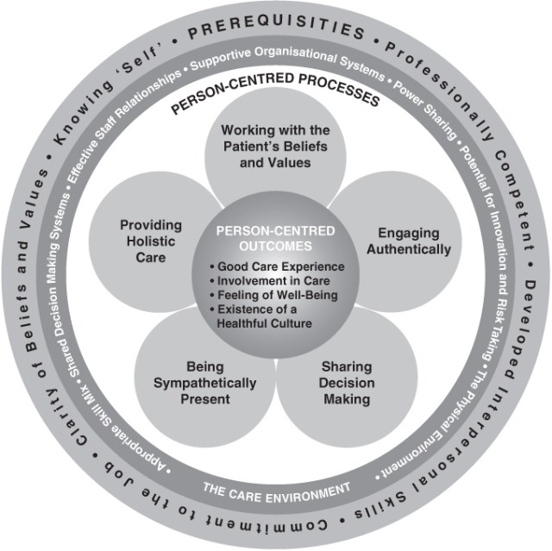
Figure 3: Person Centred Care model
(Source: Based on McCance and McCormack, 2025)

The evidence based policy implementation should involve collaboration between the general practitioners and respiratory nurses and pharmacists and social care professionals. These partnerships can improve the continuity and help patients access the appropriate support. However the policy aspirations do not automatically produce the consistent services (National Health Service England, 2026). The workforce pressure and fragmented referral system, digital exclusion and geographical differences in the community provision may also create the Limited implementation (Agache et al., 2025). Therefore the local service should evaluate if the personalized support improves the experience of the patients and self-management confidence and avoidable hospital attendance.

On the other hand in the UK the National Health Service England’s person centered care approach promotes shared decision making and patient education as well as supported self-management. These principles encourage the individuals to participate actively in the treatment decisions while receiving the appropriate professional support (National Health Service England, 2026; McCance and McCormack, 2025). The long term plan of the National Health Service also provides the relevant policy Framework through the emphasis on the prevention while the earlier interventions and the improved management are also essential for the long term conditions (National Health Service England, 2019). Application of these principles for asthma may help to enhance the community based care and reduce the avoidable emergency admissions to the hospital. Nevertheless, the policy intentions do not automatically guarantee the improved outcomes. Limited access to health care and the lack of consistent education of the patient and socioeconomic inequality can prevent some individuals from benefiting fully.

5.3 Integrating the frameworks

Integration of Global initiative for asthma with the social prescribing and personalized National Health Service care creates the complementary approach where Global initiative for asthma informs the clinical decisions while the social prescribing address is the relevant non-medical needs and personalised care support patient participation. The successful implementation required a clear referral pathway and trained staff, accessible community resources and the outcome monitoring process. This integration recognises that effective asthma management depends on both appropriate medical treatment and social conditions which enable the people to manage their health.

6. Recommendations

Asthma management should adopt the person centric care approach that considers the clinical needs of the patients, preferences and the psychological welfare. The health care professionals should provide the personalized asthma action plan and regular reviews as well as the inhaler technique assessments with accessible self-management education to improve confidence and the prevention of exacerbations (NICE, 2019).

Shared decision making and the family involvement with the patient consent can also enhance the treatment adherence and continuity of the care. The services should also address the inequalities in healthcare access and provide the appropriate psychological support. The patient with severe and complex illness and advance care planning as well as the end of life care should be considered when critically appropriate and respectful for the individual (National Health Service England, 2019).

Asthma services should introduce culturally appropriate education using the playing language and visual inhaler demonstration and the teach-back methods for conforming the understanding of the patients (Jäderlund Hagstedt et al., 2026). The digital self-management tools may supplement the consultation process when adopted to the health literacy needs of the patients even if the feasibility evidence does not guarantee the improved clinical outcomes (Salim et al., 2023). The health care professionals should agree the individual goals with the patients, review the treatment barriers and update the personalized action plan during the routine and the post-excerbation consultations.
The services should also enhance the share of decision making by discussing the medication concern, preferences and the practical difficulties without judgement. These measures can improve the engagement at implementation should be evaluated through the other and patient experience and exacerbation related outcomes (Han et al., 2024).

7. Conclusion

The improvement of the asthma outcomes required coordinated action across the healthcare services, community organisations and the wider public Health initiatives. Clinical effectiveness should be evaluated alongside the experience of the patients, confidence in managing their conditions and ability to participate in everyday life. The greater attention to the health inequalities and environmental exposure can help ensure that improvement benefits are provided to the different levels of people.

Reference List
Agache, I., Adcock, I.M., Baraldi, F., Chung, K.F., Eguiluz-Gracia, I., Johnston, S.L., Jutel, M., Nair, P., Papi, A., Porsbjerg, C., Usmani, O.S., Meyers, D.A., Zemelka-Wiacek, M. and Bleecker, E.R. (2025) “Personalized therapeutic approaches for asthma,” Journal of Allergy and Clinical Immunology, 156(3), pp. 503–522. Available at: https://doi.org/10.1016/j.jaci.2025.03.025.
Asthma and Lung UK (2023) Types of asthma | Asthma + Lung UK. Available at: https://www.asthmaandlung.org.uk/conditions/asthma/types-asthma.
British Thoracic Society (BTS) and National Institute for Health and Care Excellence (NICE) (2025) “BTS/NICE/SIGN joint guideline on asthma: diagnosis, monitoring and chronic asthma management (November 2024) - summary of recommendations,” Thorax, 80(7), pp. 416–424. Available at: https://doi.org/10.1136/thorax-2024-222910.
Campbell, C. (2025) Asthma Statistics Report, Guides. Available at: https://www.chemist-4-u.com/guides/research-insights/asthma-statistics/.
Chan, A., De Simoni, A., Wileman, V., Holliday, L., Newby, C.J., Chisari, C., Ali, S., Zhu, N., Padakanti, P., Pinprachanan, V., Ting, V. and Griffiths, C.J. (2022) “Digital interventions to improve adherence to maintenance medication in asthma,” Cochrane Database of Systematic Reviews. Edited by Cochrane Airways Group, 2022(6). Available at: https://doi.org/10.1002/14651858.cd013030.pub2.
Dai, Q. and Xiang, J. (2026) “Global Asthma Burden due to Attributable Risk Factors, 1990-2021, and Forecast to 2050: A Systematic Analysis of the Global Burden of Disease Study 2021,” npj Primary Care Respiratory Medicine, 36(1). Available at: https://doi.org/10.1038/s41533-026-00530-5.
Gatheral, T.L., Rushton, A., Evans, D.J., Mulvaney, C.A., Halcovitch, N.R., Whiteley, G., Eccles, F.J. and Spencer, S. (2017) “Personalised asthma action plans for adults with asthma,” The Cochrane database of systematic reviews, 4(4), p. CD011859. Available at: https://doi.org/10.1002/14651858.CD011859.pub2.
GINA (2026). 2026 GINA Strategy Report - Global Initiative for Asthma - Global Initiative for Asthma - GINA. Available at: https://ginasthma.org/2026-gina-strategy-report/.
Gyawali, B., Georas, S.N. and Khurana, S. (2025) “Biologics in severe asthma: a state-of-the-art review,” European Respiratory Review, 34(175), p. 240088. Available at: https://doi.org/10.1183/16000617.0088-2024.
Han, Y.-Y., Gutwein, A., Apter, A. and Celedón, J.C. (2024) “Health literacy and asthma: An update,” Journal of Allergy and Clinical Immunology, 153(5), pp. 1241–1251. Available at: https://doi.org/10.1016/j.jaci.2023.12.007.
Holmes, L.-J., Ludlow, S., Fowler, S., Marshall, M. and Lovell, K. (2025) “Psychosocial experience of living with severe and uncontrolled asthma as a young adult: a qualitative synthesis,” BMJ Open Respiratory Research, 12(1), p. e002541. Available at: https://doi.org/10.1136/bmjresp-2024-002541.
Jackson, T., Flinn, F., Rafferty, L., Ehrlich, E. and Fletcher, M. (2022) “Exploring the experiences of older adults living with asthma in the United Kingdom: A co-produced qualitative study,” Aging and Health Research, 2(2), p. 100079. Available at: https://doi.org/10.1016/j.ahr.2022.100079.
Jäderlund Hagstedt, L., Hvitfeldt, H., Riggare, S., Petersson, G., Davoody, N. and Hägglund, M. (2026) “Patients’ and Health Care Professionals’ Experiences of a Digital Self-Management System for Asthma: Qualitative Study,” JMIR Human Factors, 13, pp. e79866-e79866. Available at: https://doi.org/10.2196/79866.
Jayasooriya, S.M., Devereux, G., Soriano, J.B., Singh, N., Masekela, R., Mortimer, K. and Burney, P. (2025) “Asthma: epidemiology, risk factors, and opportunities for prevention and treatment,” The Lancet Respiratory Medicine, 13(8), pp. 725–738. Available at: https://doi.org/10.1016/s2213-2600(24)00383-7.
Kyriakopoulos, C., Gogali, A., Markozannes, G. and Kostikas, K. (2024) “Biologic agents licensed for severe asthma: a systematic review and meta-analysis of randomised controlled trials,” European Respiratory Review, 33(172), p. 230238. Available at: https://doi.org/10.1183/16000617.0238-2023.
‌Lim, Y.X., Choo, Y.N., Looi, Y.T., Chuan, Y.W., Chiam, K.X., Wong, R.S.-Y., Ng, N.C.-S. and Goh, B.H. (2026) “Emerging Therapeutic Strategies in Asthma: Advances in Treatment, Drug Delivery, Drug Adherence, and Disease Management,” Current allergy and asthma reports, 26(1), p. 17. Available at: https://doi.org/10.1007/s11882-026-01265-6.
Mackiewicz, P., Hussein, H., Mansur, A.H., Krishna, M.T. and Walters, G.I. (2025) “‘Stuck in catch-22’: a qualitative study of perceived work ability and decision-making about employment in severe asthma,” BMC Pulmonary Medicine, 25(1). Available at: https://doi.org/10.1186/s12890-025-03499-y.
McCance, T. and McCormack, B. (2025) “The Person-centred Nursing Framework: a mid-range theory for nursing practice,” Journal of research in nursing : JRN, 30(1), pp. 47–60. Available at: https://doi.org/10.1177/17449871241281428.
National Institute for Health and Care Excellence (NICE) (2024) Asthma: diagnosis, monitoring and chronic asthma management. NICE guideline NG245. Available at: https://www.nice.org.uk/guidance/ng245 (Accessed: 22 October 2026).
NHS England (2019) NHS England » Fit for the Future: 10 Year Health Plan for England, England.nhs.uk. Available at: https://www.england.nhs.uk/long-term-plan/.
NHS England (2026) NHS England » Supported self-management, England.nhs.uk. Available at: https://www.england.nhs.uk/personalisedcare/supported-self-management/.
NHS England (2026). NHS England » Comprehensive model of personalised care, England.nhs.uk. Available at: https://www.england.nhs.uk/personalisedcare/comprehensive-model-of-personalised-care/.
NHS England (2026). NHS England » Social prescribing, England.nhs.uk. Available at: https://www.england.nhs.uk/personalisedcare/social-prescribing/.
NICE (2019) Overview | End of life care for adults: service delivery | Guidance | Nice.org.uk. NICE. Available at: https://www.nice.org.uk/guidance/ng142.
Office for Health Improvement and Disparities (2026) Respiratory disease: data. Fingertips, Department of Health and Social Care. Available at: https://fingertips.phe.org.uk/profile/respiratory-disease/data
Rayner, D.G., Ferri, D.M., Guyatt, G.H., O’Byrne, P.M., Brignardello-Petersen, R., Foroutan, F., Chipps, B., Sumino, K., Perry, T.T., Nyenhuis, S., Oppenheimer, J., Israel, E., Hoyte, F., Rivera-Spoljaric, K., McCabe, E., Rangel, S., Shade, L.E., Press, V.G., Hall, L., Sue-Wah-Sing, D., Melendez, A., Orr, H., Winders, T., Gardner, D.D., Przywara, K., Rank, M.A., Bacharier, L.B., Mosnaim, G. and Chu, D.K. (2025) “Inhaled Reliever Therapies for Asthma,” JAMA, 333(2), p. 143. Available at: https://doi.org/10.1001/jama.2024.22700.
Reddel, H.K., Allan, K., Bacharier, L.B., Bonini, M., Bourdin, A., Brightling, C., Buhl, R., Chakaya, J., Cruz, A.A., Ducharme, F.M., Duijts, L., Fleming, L., Inoue, H., Kaplan, A., Ko, F.W.S., Krishnan, J.A., Levy, M.L., Masekela, R., Pitrez, P.M., Salvi, S., Yorgancioğlu, A., Zhang, M. and Brusselle, G. (2026) “2026 Global Initiative for Asthma (GINA) Strategy Report: Executive Summary and Key Changes,” American Journal of Respiratory and Critical Care Medicine [Preprint]. Available at: https://doi.org/10.1093/ajrccm/aamag542.
Salim, H., Cheong, A.T., Sharif-Ghazali, S., Lee, P.Y., Lim, P.Y., Khoo, E.M., Hussein, N., Harrun, N.H., Ho, B.K., Pinnock, H. and RESPIRE Collaboration (2023) “A self-management app to improve asthma control in adults with limited health literacy: a mixed-method feasibility study,” BMC Medical Informatics and Decision Making, 23(1). Available at: https://doi.org/10.1186/s12911-023-02300-6.
Stubbs, M.A., Clark, V.L., Gibson, P.G., Yorke, J. and McDonald, V.M. (2022) “Associations of symptoms of anxiety and depression with health-status, asthma control, dyspnoea, dysfunction breathing and obesity in people with severe asthma,” Respiratory Research, 23(1). Available at: https://doi.org/10.1186/s12931-022-02266-5.
Wang, Z., Li, Y., Gao, Y., Fu, Y., Lin, J., Lei, X., Zheng, J. and Jiang, M. (2023) “Global, regional, and national burden of asthma and its attributable risk factors from 1990 to 2019: a systematic analysis for the Global Burden of Disease Study 2019,” Respiratory Research, 24(1). Available at: https://doi.org/10.1186/s12931-023-02475-6.
WHO (2024) World Asthma Day: WHO calls for better education to empower people living with asthma, Who.int. World Health Organization: WHO. Available at: https://www.who.int/news/item/07-05-2024-world-asthma-day--who-calls-for-better-education-to-empower-people-living-with-asthma.
Yang, F., Chen, C., Deng, X., Hu, T., Bi, D. and Li, H. (2023) “Perspectives and experiences of mothers of school-age children with asthma: a qualitative study,” Journal of Asthma, 61(5), pp. 444–452. Available at: https://doi.org/10.1080/02770903.2023.2288322.
Yi, X., Sunzi, K., Liu, J., Yang, F., Wu, X., Bi, D., Huang, Q. and Dai, L. (2025) “Caregivers’ burden and its influencing factors among parents of children with asthma and comorbidities: a cross-sectional study,” Frontiers in public health, 13, p. 1698723. Available at: https://doi.org/10.3389/fpubh.2025.1698723.

‌

‌

