Welsh Competency Framework

Video Presentation Lesson Plan and Resources:

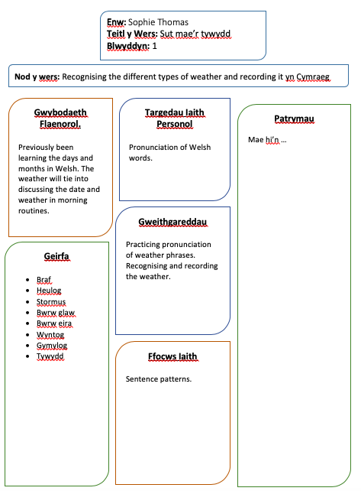
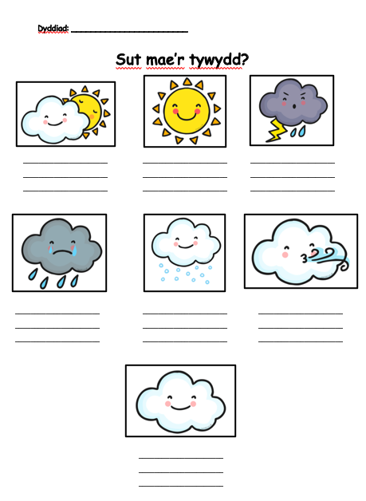
This the resource that was handed out to the learners after the core learning was completed.

Welsh Language Development Evidence:

Evidence 1 - Lanyard:
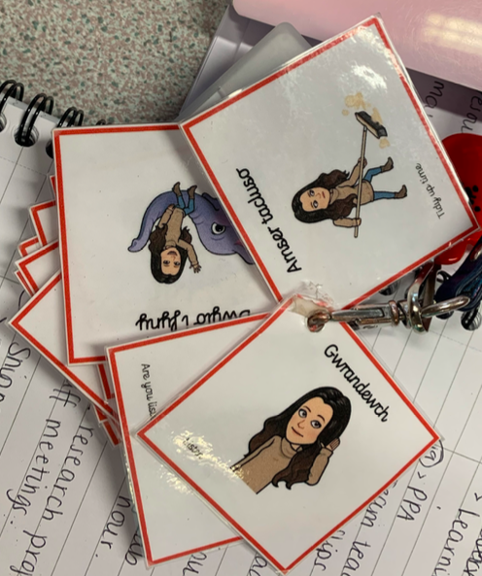
The phrase cards for my lanyard helped me and prompted me to use Welsh within the classroom. They contained key Welsh incidental phrases that are appropriate for the classroom.

Evidence 2 – Continuous Professional Development:
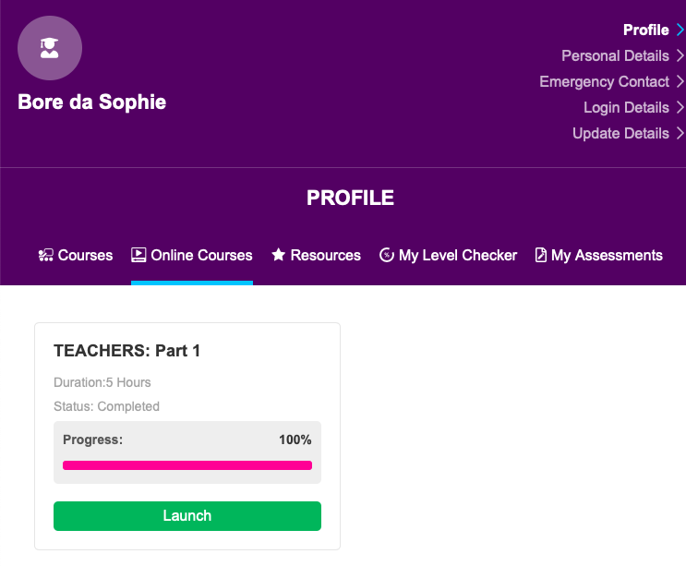
I have been working on my Welsh language and pronunciation skills using the Welsh Learn website. This has enabled me to develop my Welsh language skills further and learn new key phrases to use within the classroom and around the school.

Evidence 3 – Welsh Language
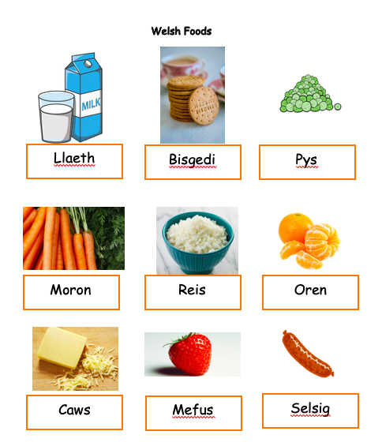
Leading up to the week in school where we focused on healthy eating, I made phrase cards for different Welsh bwyd for the children to learn. We focused on all the phrase cards daily and by the end of the week the children we able to recall the Welsh bwyd just by looking at the picture.
Reflection:
During the PGCE course, I have worked hard to improve and develop my Welsh language skills. Throughout developing my Welsh language skills, I have realised that I can recognise and understand a significant amount of Welsh being spoken. However, I need to further my conversation skills and pronunciation of the Welsh language.

In order to develop my conversation skills and pronunciation, I have been using Duolingo to help me develop my overall Welsh language skills. Furthermore, I have then used LearnWelsh.cymru to develop and gain new vocabulary for inside the classroom and around the school. The use of these two resources have been very beneficial for my Welsh language development and I feel more confident in my pronunciation. However, I am going to continue to develop my language further. As well as utilising these resources, I have also made key Welsh vocabulary phrase cards to put on my lanyard to prompt me to use the Welsh language more in the classroom. The lanyard has helped me to further develop my vocabulary and pronunciation. Reflecting on the use of the lanyard, I feel that I have positively improved my Welsh language as I now use incidental Welsh daily without the use of the lanyards.

Within the classroom, I have put my Welsh language skills into practice by using incidental Welsh during core learning, tidying up, the register etc. I have also used Welsh vocabulary when marking the learners work. The school during PTE1 had invested in Tric a Chlic which was done daily in the Foundation Phase. As I had a target to work on my Welsh language skills, my class mentor allowed and assisted me with carrying out Tric a Chlic sessions. Not only did this implement and teach the learners the Welsh language, it also helped me to further develop my skills and pronunciation.

Going forward, I am going to continue to develop my Welsh language skills. On the other hand, I am going to include more Welsh into my lesson plans and ensure that there is enough Welsh language around the classroom so learners can visually see the vocabulary.

Video Presentation
During the video presentation in university, I feel that I implemented a significant amount of Welsh language and I feel like I spoke more Welsh than English in the lesson. I felt that I tried hard and had good pronunciation of the Welsh phrases even though I could still work on the pronunciation of Welsh words. Going forward, I would like to improve my conversation skills in order to hold conversations with the children in my class.

