Welsh Architecture Today
A critical essay on the Swansea Guildhall, Swansea
Welsh Architecture: The genius of Percy Thomas, Our Guildhall Legacy
Introduction
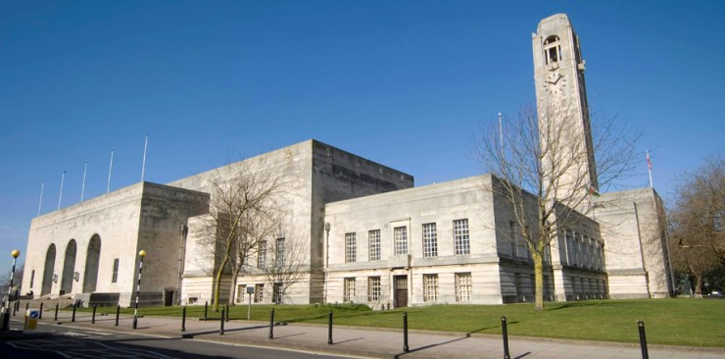(Swansea Council, 2021)
Introduction
The opening ceremony took place on Tuesday 23 October 1934.
The Swansea Guildhall is an art deco building in swansea and is a large public building with halls offices and other public facilities designed to be a public building to serve the people and the local council, is a grade 1 listed building and is one of swansea main landmarks.
The Mayor, Alderman Edward Harris, wrote at the time: ‘I express the hope that the new buildings will conduce towards making Swansea the town of our ideals […] the best and noblest traditions of Local Government will be continued and developed for the enduring benefit of the Town and the general wellbeing of the Community.’ (Swansea Council, 2022).
The tower of the Guildhall is 160 feet in height. It can be seen that each face slopes inwards to around 12 inches sloping towards the uppermost reaches of the tower. The grand clock was presented by local business J. T. Morgan. 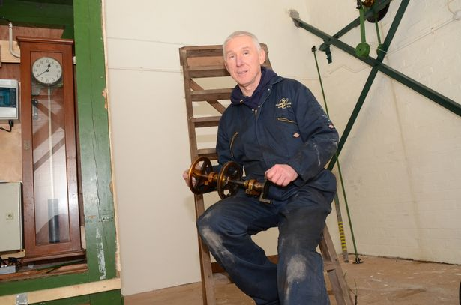
(Swansea Council 2019)
The Swansea Council website explains some of the exciting details of the Guildhall, which includes archival information that was possible to research, including data about the council chamber that seats 60 members, along with officials, members of the public and press. The columns are 22 feet high and are constructed of Australian walnut. The Brangwyn Hall itself is 160 feet in length and measures 62 feet wide, 44 feet in height and it can provide seating for more than 1300 people in its grand space (Swansea Council, 2022).

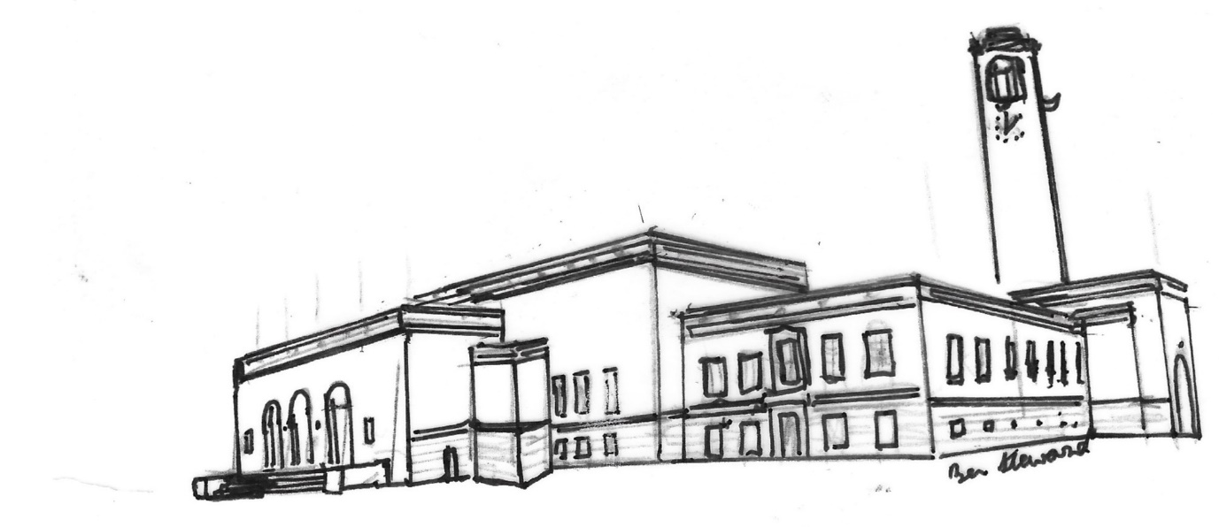
Guildhall (Steward 2022)

The most important social and economic focus of the Guildhall is its part in the regeneration of Wales. Thomas was the lead in this huge improvement task. Two clues to the importance of the Guildhall to Swansea are the location of both council chamber and courts central to the running of the then town and the more subtle clue is the fact that the floor of the Brangwyn Hall can be adjusted to make it, ‘sprung’ for dancing, for quality entertainment facilities.

The Guildhall was always meant to enhance the standards and wellbeing in the town and its amenities. To understand Thomas’s crucial importance to Wales is seen in the Doctor of Philosophy (2013) paper of Elaine Davey. She found that Wales was described as, ‘a grand national ruin’, (Morgan 1982 in Davey, 2013, p122). Industry on its knees, hunger marches led to the Special Areas (Development and Improvement) Act 1934. Though they set up plans for, ‘distressed areas they didn’t work as efficiently as expected. Once Thomas stepped in with buildings at Treforys and in Monmouth shire in the 1930s, jobs were created, and his use of a standard pattern as copied nationally.

Percy Thomas, his influences and the creation of the Guildhall
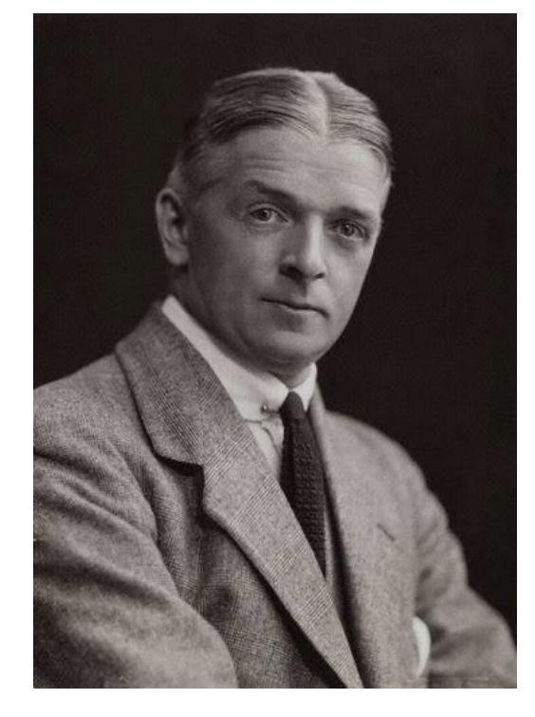Percy Thomas (1883-1969) (Owen 2020, p4)
Percy Thomas was the son of a sea captain who was from Narberth in Pembrokeshire. He grew up in England, Northumberland before his family moved to Cardiff. As a youngster Percy travelled the world and visited cities with fine architecture which could have contributed to his grand, classically inspired designs. Percy went to St. Petersburg before taking articles in Cardiff for architecture for five years with EH Burton of Cardiff in 1898. By 1903 he had won a national prize for architecture at the Llanelli National Eisteddfod (Owen, 2020, p4).
Thomas survived the Somme and WW1 returning in time to lead the creativity in the Art Deco movement. After 1919 he then went on to design a new campus for University College Aberystwyth, Swansea’s Guild Hall, and the iconic Temple of Peace in Cardiff (Owen 2020, p4).
From his journeys round the world, it could be clearly seen in his designs of the Guildhall that the ceilings look remarkably like the arch in the General Staff Building in St. Petersburg designed by architect K. I. Rossi. Rossi might have been one of the architects that influenced Thomas who went one to be a leading light in the in what can be considered the,’inter-war architectural style, (Owen 2020, p4). This international vision made Thomas the most innovative Art Deco influenced architect of his time.
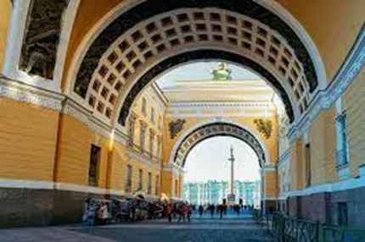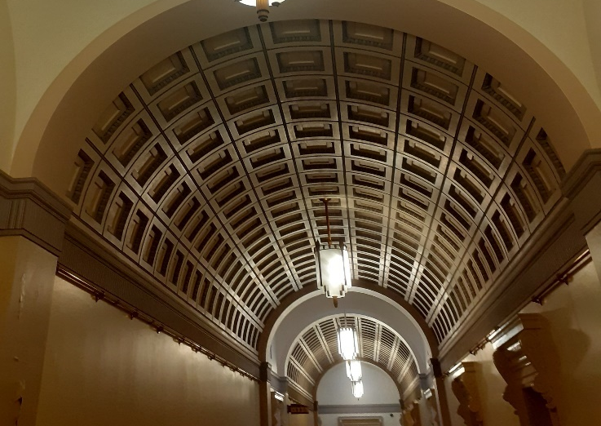
(Arch at the General Staff Buildings, St. Petersburg (left) (welsh, 2015) compared to the corridor looking towards the council chamber Swansea Guildhall. (Ben Steward, 2022).
‘Arts Decoratifs,’ Art Deco originated in France, becoming popular after
1925 Paris Exposition, heavily part of this revolution of style Thomas in 1930 is commissioned to build the Temple of Peace in Cardiff, then wins the competition with Ivor Jones to build the Guildhall (Owen 2020, p4).
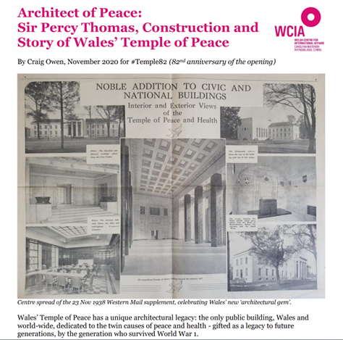
Styles, designs and details of the classic Guildhall Swansea
Building had started in 1932, on the site of Victoria Park in Swansea, the building was designed by the architect Percy Thomas the famous Welsh architect who built other large public buildings in England and Wales and president of the RIBA twice 1935 to 1937.
The building style is an art deco design with elements of classical roman and Greek architecture blended with other styles such as modernism, baroque, and Celtic. The art deco style in general used influences of many different styles of architecture from around the world as well as modernism and a less ornamental streamlined design.
It has a symmetrical appearance and has floors based around a quadrangle or cloister area found in monastic, gothic and Roman villas plans. Using a classical symmetrical layout, it could be said it is trying to imitate previous cultures such as Rome and emulate the culture of democracy, quality, creativity, and commerce. The building has ease of access with broad stairs and corridors.
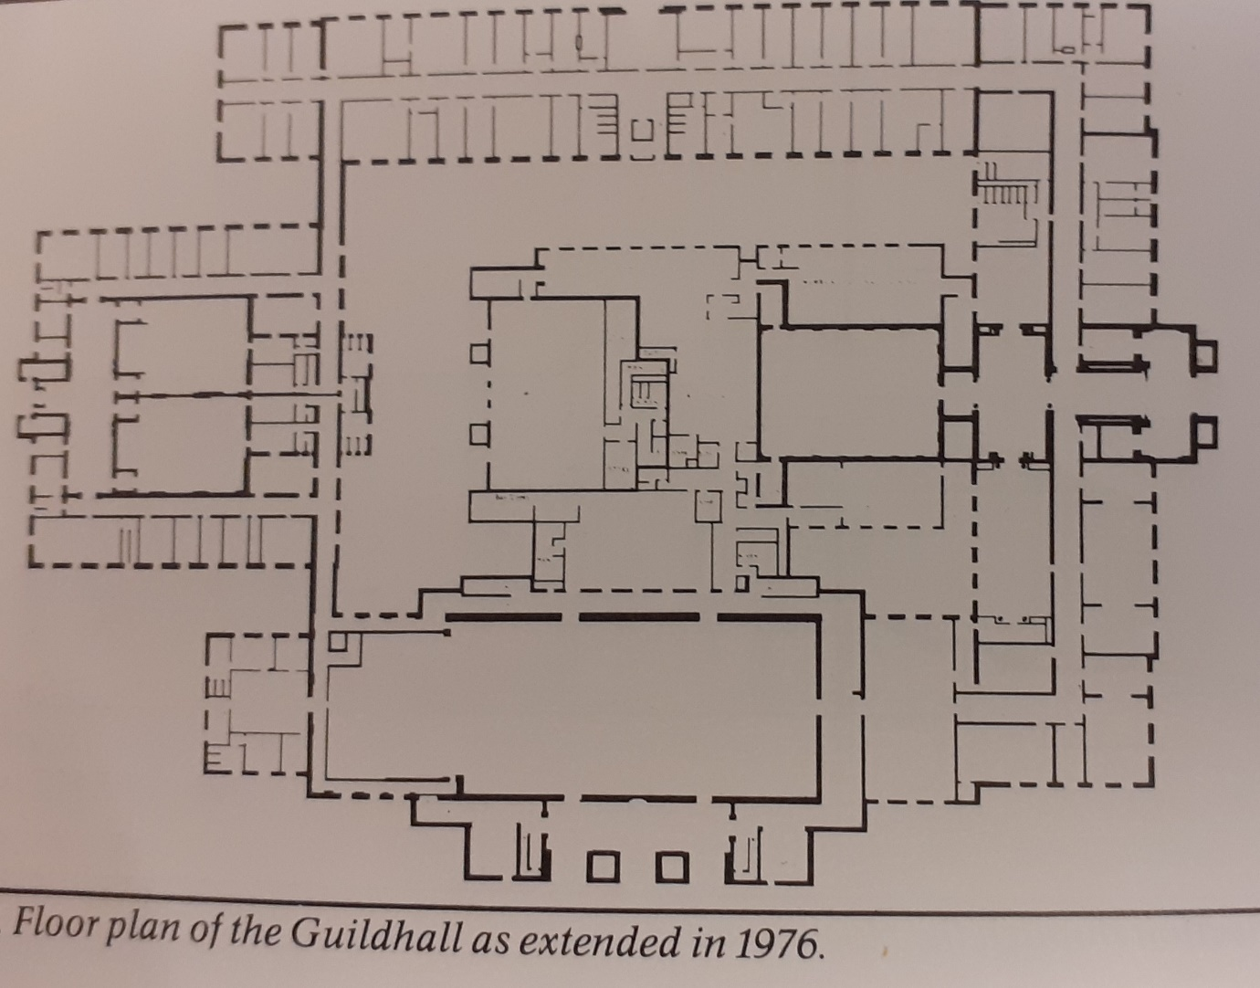
(Evans, 2019, p86)

The Guildhall has many interesting features such as, a built-in vacuum system and heating system. The clock tower has slim lines and a hint to the Viking past of Swansea with the ship designs. From the outside you can see the Guildhall’s exterior and the crisp Portland stone. Inside the stark and clean lines of stonework continue referencing the connections in Swansea’s past ‘Swansea’ as ‘Sweyn’s Eye’, the ancient Viking stronghold. Green suggests it could be a nod to styles of contemporary Scandinavian architecture and innovative design which British architects would have seen 1930s? (Green,2018,p1).
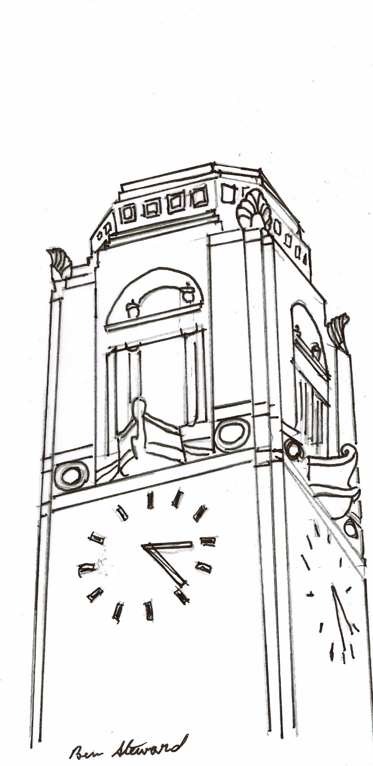
Art Deco clock tower (Steward, 2022)

The built-in vacuum system is one of the most interesting features of the building and still works today. The architect Percy Thomas wanted to incorporate modern technologies and advances in technology at the time, such as the vacuum cleaner which had been around for a few decades and hoover vacuums were used in Buckingham palace, and other large buildings.

It was a solution to problems still faced with traditional vacuum cleaners even today, finding a electrical supply, problems with tangled electrical cable, dust bags to be emptied. Thomas the architect designed a built-in vacuum where the vacuum pipe is connected into the wall collecting all the dust into the basement and supplying suction power through one pipe system for ease of cleaning. All complimented with a built-in central air heating system.
The Brangwyn panels are another interesting feature of building painted by Frank Brangwyn (1867-1956) a famous painter of the time.
The ‘British Empire Panels’ were commissioned by Lord Iveagh originally, in 1925 meant to depict the ‘Empire, in all its majesty and multitudinous resource,’ as Brangwyn phrased it. (Green 2018, p1).
Some panels hung at first in the House of Lords, then at the Daily Mail Ideal Home Exhibition held at Olympia in 1933 They cover 3,000 square feet covered in flora and fauna and the human form, seven years to complete, finding their forever home in Swansea in the mid-thirties.

At the House of Lords, it was felt they had little connection with notions of Empire and were found to be ‘inappropriate.’ Today with issues of racial inequality to the front of our society, the issue of how appropriate depictions of the conquest of empire should be have been hotly debated concerning public art. 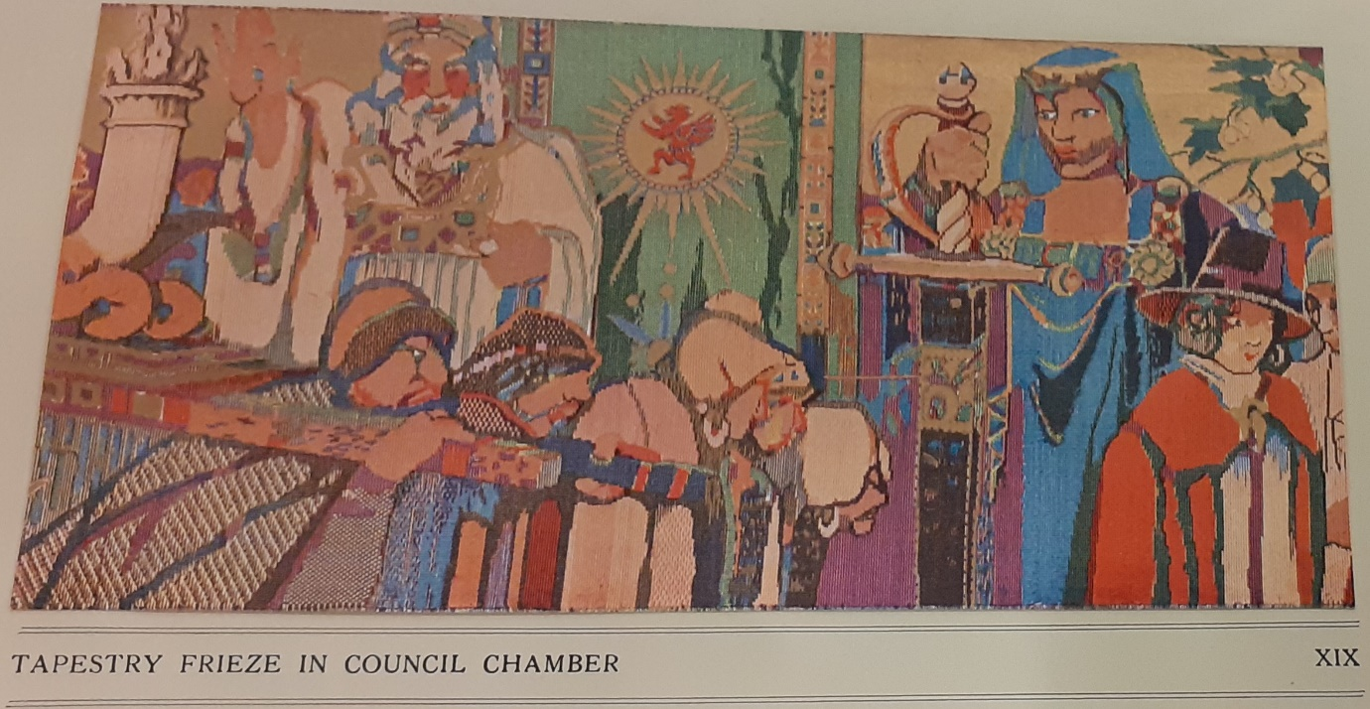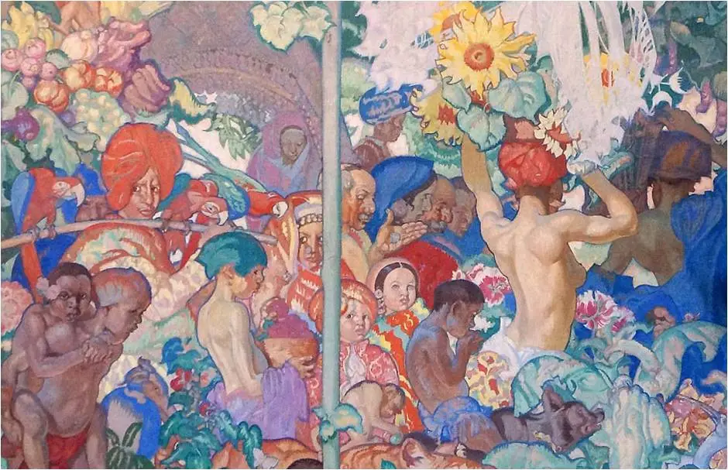
Compare the Welsh Tapestries (Hughes 2013) to the empire tapestries depicting daily life. (Photo credit Swansea Archives) )2022
Brangwyn doesn’t seem to have been critical of Britain’s empire, but what could be said in its favour is that the people are depicted with dignity and sympathy, and he focuses on the people, animals, and plants of conquered countries rather than activities of the conquering issues. How is this issue viewed by residents of multicultural Swansea today would be interesting to know through schools projects and community projects?

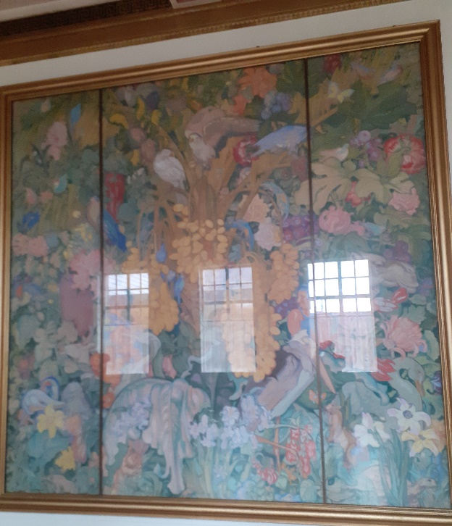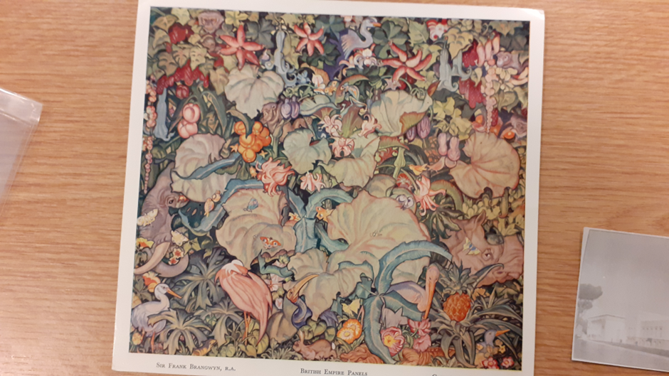
Brangwyn panels showing reflections of windows (Photo credit Ben Steward 2022)
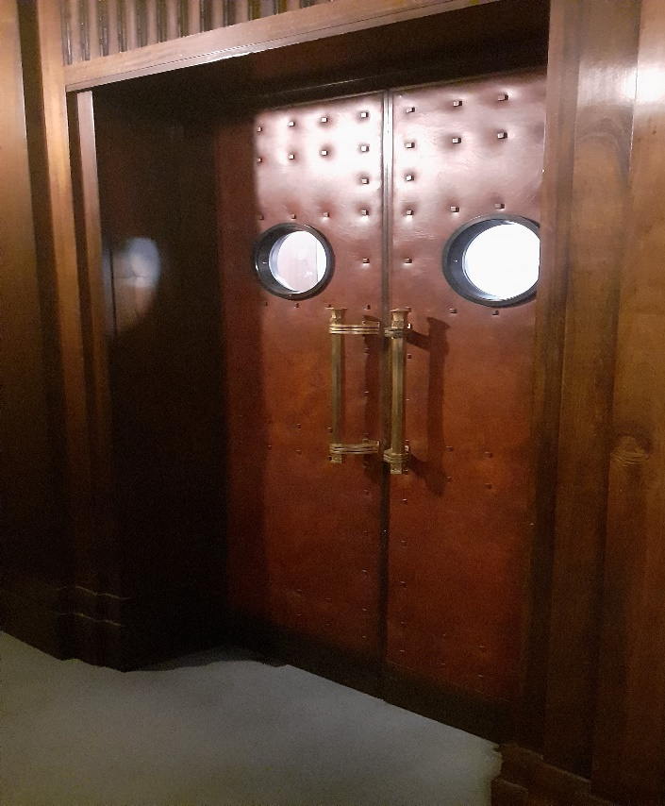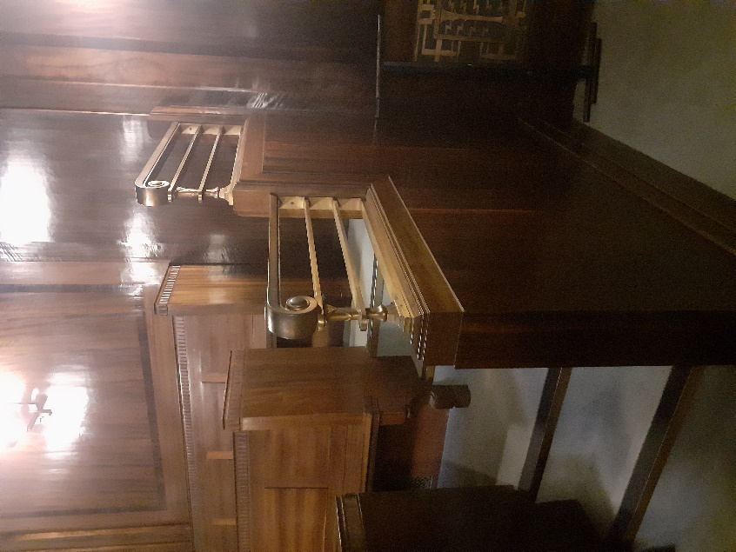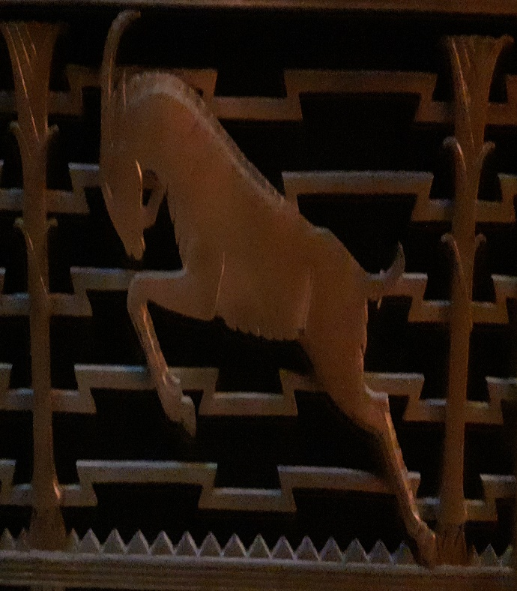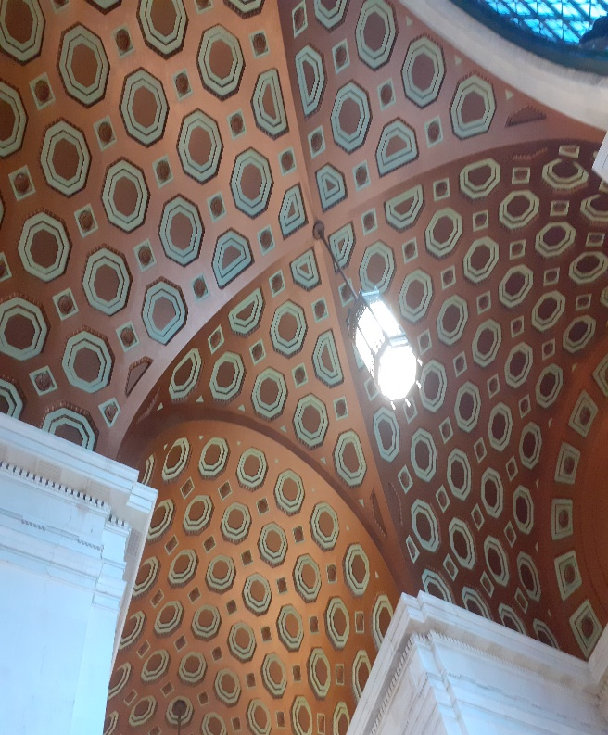
Art Deco features including doors in council chamber, details to rail in chamber and ceiling in main corridor to council chamber, decorated heating system cover ( Ben Steward 2022)

The context of the building today, amenities and the built environment.
The building is a prominent public building representing Swansea but is not situated in the town center or near the train station or any amenities apart from a bus stop and small car park. Compare it to the centrality of the Houses of Parliament?
Originally it replaced green space, part of Victoria Park. Where it compensates is as a centre of council, court and social activity including weddings and multifaith celebrations and concerts.
Recently, in 2-14, seven years of work began, JWC of Neath Road, Swansea have completed refurbishment the Guildhall with a total costing £18M. The work has included sympathetic and skilled refurbishment of the Grade 1 Listed Building.
There are upgraded meeting, commercial space, new kitchens and catering facilities, bar, and technology access. Sympathetic heating, cooling and electrics have been installed with 1930s fittings restored. (JWC, 2022). These included disabled toilets.
Restoration has celebrated again the ethos Of Thomas who wanted state of the art facilities to enhance the lives of the people of Swansea.

Word count 1650

References

Davey, D. ‘A National Architect? The Percy Thomas Practice and Welsh national identity,’ Cardiff School of Planning and Geography Thesis submitted for the Degree of Doctor of Philosophy (Cardiff University 2013).

Dreamstimes, 2022 ‘St Petersburg, Russia, Arch of General Staff Building at Palace Square in St Petersburg, Russia.’Arch of General Staff Building at Palace Square in St Petersburg, in Russia Editorial Image - Image of building, archway: 131547190 (dreamstime.com) (Accessed December 2022).

Evans, D.’2019 A new even better Abertawe: Rebuilding Swansea 1941-1901.’ West Glamorgan Archive Service.

Hughes, D.’2019. ‘Discovering your Guildhall 1934’. Swansea Archive Services.

Green, A. 2014 ‘Gwallter a blog and more from Swansea. ‘From empire to environment: inside the Brangwyn Hall’.https://gwallter.com/art/from-empire-to-environment-inside-the-brangwyn-hall.html (Accessed December 2022).

JWC, John Weaver Contractors 2022 ‘Swansea Guildhall’ John Weaver contractors (2021) https://johnweaver.co.uk/project/swansea-guildhall/ (Accessed December 2022).

Short, B, Gilbert, D and Mathern, D. (2003) ‘Historical Geographies of British Modernity’. In: Gilbert D, Mathern D and Short B. (eds.) Geographies of British Modernity: (Oxford. Blackwell, pp. 1-27).

Swansea Bay News, 2021 City clock to be back in action soon: Specialist engineers plan to work on Swansea’s historic Guildhall clock. https://swanseabaynews.com/2021/10/15/city-clock-to-be-back-in-action-soon/ (Accessed December 2022).

Swansea Council 2022 ‘The Guildhall opens its doors’
https://www.swansea.gov.uk/ArchivesGuildhallOpen (Accessed December 2022).

Morgan, K. (1982). Rebirth of a Nation. Wales 1880-1980. Oxford and Cardiff: Oxford University Press, University of Wales Press.

Owen, C,2022 ‘Architect of Peace: Sir Percy Thomas, Construction and
Story of Wales ‘Temple of Peace.’ (82nd anniversary of the opening)
https://www.wcia.org.uk/wp-content/uploads/2020/11/ARCHITECT-OF-PEACE-Percy-Thomas-Construction-of-Wales-Temple-of-Peace.pdf (Accessed December 2022).

Wales Online, 2022 ‘Why the historic Swansea Guildhall clock is stuck at 12 noon
It seems that Father Time has caught up with it.’
https://www.walesonline.co.uk/news/wales-news/swansea-guildhall-clock-council-brynmill-17441645 (Accessed December 2022).

.

