University of Wales Trinity Saint David

  - Wales Institute of Science and Art

Corsa B Efficiency with a Flywheel KERS System
(ACHA5010)
Alternative Propulsion Systems.

Jared Davage
2103529
4th January 2023

Contents
1.0 Introduction 3
2.0 Methodology 4
2.1 Test Vehicle 4
2.1.1 Ultra Low Emissions Zone (ULEZ) 4
2.2 Worldwide Light Harmonized Light Duty Vehicle Test Procedure (WLTP) 5
2.2.1 Kinetic Energy Recovery System (KERS) 6
3.0 Excel Calculations and Results 8
3.1 Tables 8
3.2 Graphs 9
4.0 Different KERS Systems 12
4.1 Fuel Consumption of Different KERS Systems 14
5.0 Conclusion 15
5.1 Summary of Results 15
5.2 Areas for Improvement 15
6.0 Reference List 16

1.0 Introduction
The purpose of this investigation is to analyse the effects of introducing an internal combustion engine (ICE), with a Kinetic Energy Recovery System (KERS) to reduce the chosen vehicles consumption of fuel. An appropriate vehicle has been chosen for this investigation, the data of this vehicle, that includes test mass, frontal area, Rolling Resistance and Coefficient of Aerodynamic Drag, have all been used to calculate and plot data within graphs, this is explained further into the investigation. Using spreadsheets, the cumulative tractive energy required at the wheel over the WLTP cycle and cumulative braking energy required at the wheel over the WLTP cycle are plotted.

2.0 Methodology
This investigation began by choosing a test vehicle, this being the Corsa B, as it was made to be an economical city car. The vehicles data includes, CDA, drag coefficient, curb weight (kg) and frontal area (m^2), by using this data the Rolling Resistance, Test Mass and Standard Force are all calculated.
With the previous calculations made the spreadsheet can begin to be built. This spreadsheet shows the results of a WLTP, through the low, mid, high, and very high range. The plotted data is then used to plot graphs which are later analysed in this investigation.

2.1 Test Vehicle
The Vehicle chosen for this test is the 1998 Vauxhall Corsa B, with the 1.6 16v engine. As stated on the spreadsheet, this vehicle weighs around a ton at 960kg. The Corsa B was made as a practical city car/super mini, with various trim levels to suit the buyer. For the most part it is an inexpensive economical vehicle that is ideal as an affordable car for the low – to middle class working person. (Motor Car History, n.d.)

2.1.1 Ultra Low Emissions Zone (ULEZ)
The Corsa B is no longer ULEZ compliant and requires a penalty charge of £12.50 a day. This car was originally made as an economical city car 24 years ago but no longer is, but by utilising the KERS design, by Ricardo LTD, the Corsa can become economical enough to be driven through ULEZ zones. (tfl.gov.uk, n.d.)

2.2 Worldwide Light Harmonized Light Duty Vehicle Test Procedure (WLTP)
The WLTP, introduced in 2017, is a test cycle for measuring fuel consumption and average daily driving behaviour. This test measures and compares fuel consumption and exhaust emissions produced by passenger cars across the world. The WLTP is also the best way to compare fuel economy between two vehicles, whether that be two petrol cars or a diesel car versus an electric car.
The WLTP also has four test stages, these being:
Test Stage | Low | Medium | High | Extra High
Type of Driving | City Driving | Town Driving | Rural Driving | Motorway Driving
Average Distance (Miles) | 2 | 3 | 4.5 | 5.1
Maximum Driving Speed (MPH) | 35 | 50 | 60 | 81

2.2.1 Kinetic Energy Recovery System (KERS)
A KERS system works by utilising a flywheel to store energy from the brakes under braking, so as the vehicle decelerates the inertia of the flywheel increases. It’s made up of a flywheel connected to CVT transmission to the drivetrain. (GreenCarGuide.co.uk, n.d.)
The mechanical KERS system used on the test vehicle in this investigation is the Kinergy Flywheel from Ricardo LTD. This is a mechanically driven flywheel with a Kinergy magnetic drive into a vacuum chamber. By having the flywheel within a vacuum chamber, it allows the flywheel to spin more freely for longer, up to 30 mins before regenerative braking will need to commence to recharge it. This flywheel can spin up to 60,000 RPM and utilises a roller bearing setup that is sealed and greased. The system weighs around 30kg or 15kg excluding the transmission and the power rating of this system is 60kw at peak power or 30kw at continuous power.
The containment system for this flywheel is made from an outer composite ring with filament wound carbon fibre wrapped around a steel hub that weighs around 5kg. Due to carbon having a high tensile strength it allows the flywheel to spin at very high RPMs without shattering. The image below depicts how the flywheel of a Mechanical KERS looks, as well as all components. (An Assessment of Flywheel High Power Energy Storage Technology for Hybrid Vehicles, 2011)
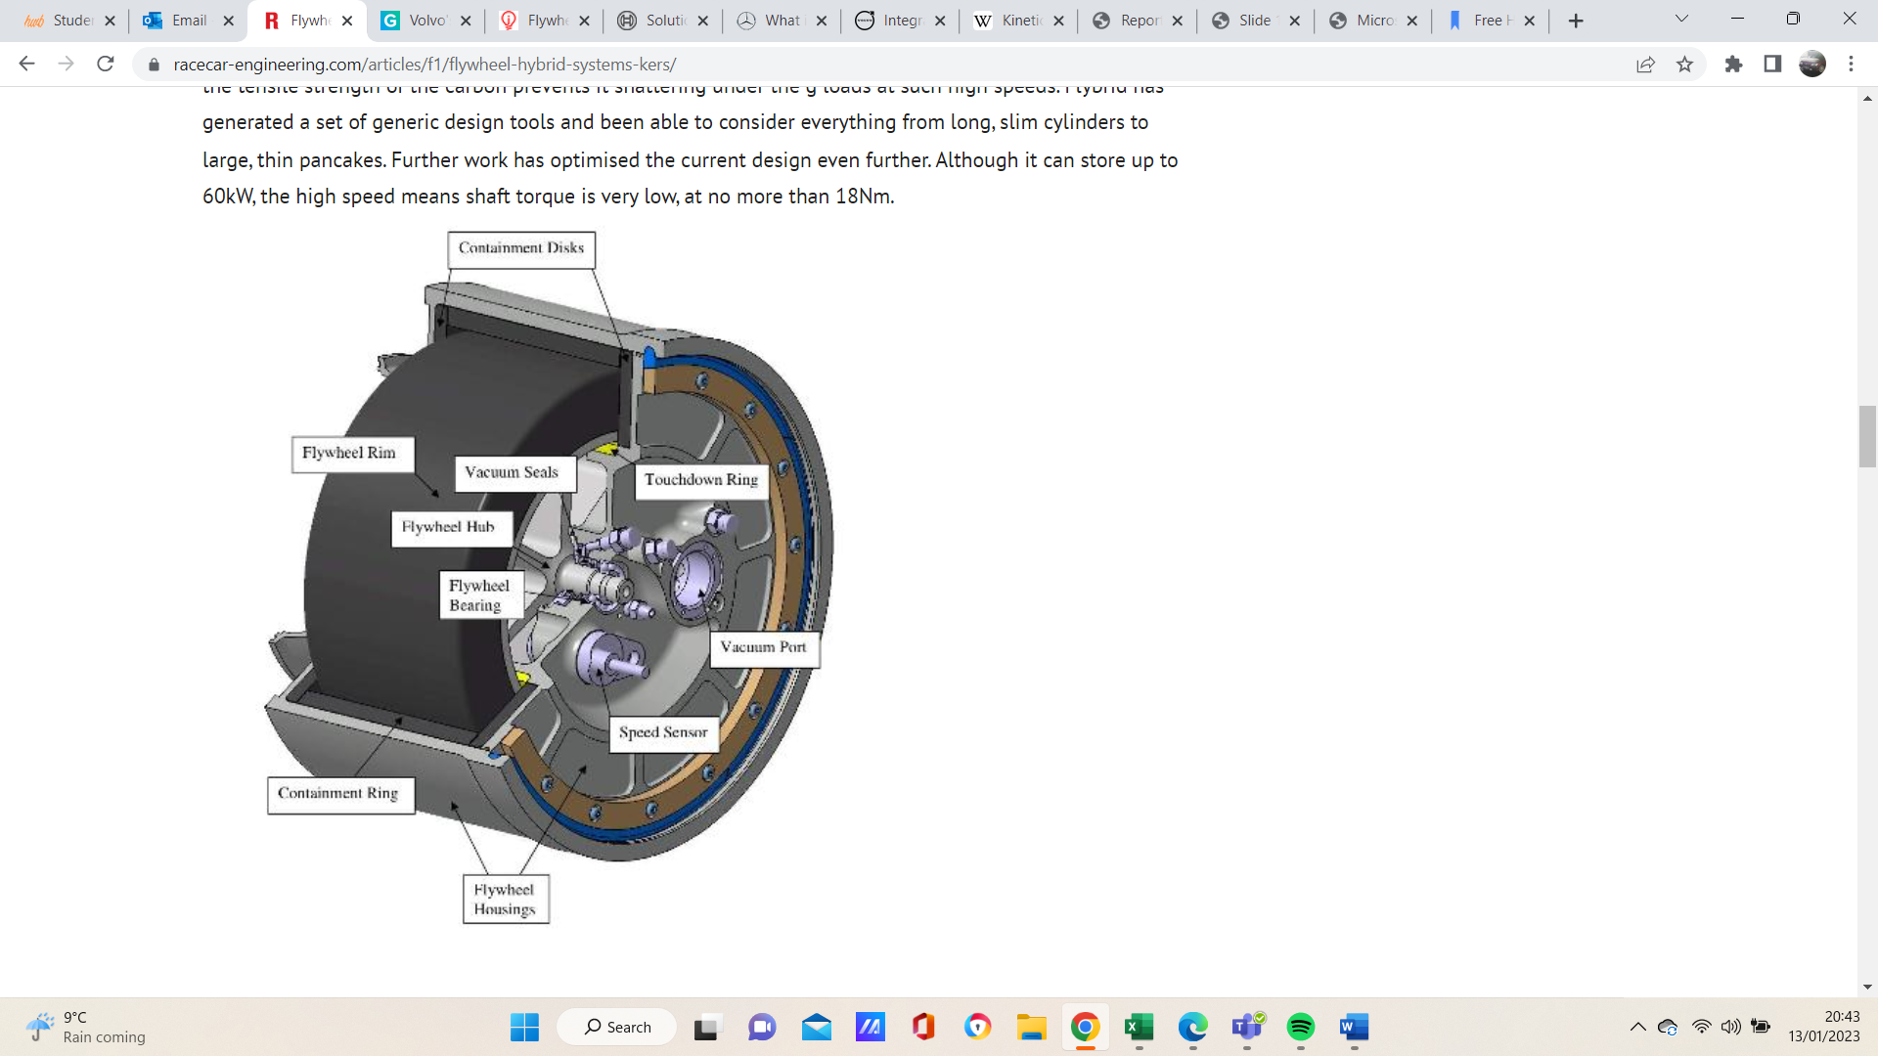

Sam (2011). Flywheel hybrid systems (KERS). Racecar Engineering. Available at: https://www.racecar-engineering.com/articles/f1/flywheel-hybrid-systems-kers/.

The benefit of this system being mechanical is that it doesn’t require any power electronics specially for the KERS system, as it is mechanically run off the interface of the transmission using the magnetic drive. (An Assessment of Flywheel High Power Energy Storage Technology for Hybrid Vehicles, 2011).
By using a flywheel wheel as the energy storage system, a maximum steady voltage and steady power level can be attained without effecting the temperature, quantity of load and the charge state.

3.0 Excel Calculations and Results
Spreadsheets have been produced using data calculated from the vehicle information and motor efficiency.


3.1 Tables
Figure 3.1.1 – Corsa B KERS Data
The above table displays the colums of data caluclated using the KERS system on the Corsa B. This Data is later used to plot graphs.


Figure 3.1.2 – Test Stage Energy Variations
The above table displays the 4 test stages and the variations on energy, this data was plotted from the spreadsheet. Evidently the low-test stage has the lowest figures, although on the very high-test stage there is considerably less negative energy in comparison to low. The medium test stage has recovered and reused the highest amount of energy through the KERS system.

3.2 Graphs

The following graphs have been created within excel using data from the spreadsheet. The different phases of the test can be compared and analysed with more ease using graphs.
Figure 3.2.1 – Energy Recovered Against Time
The table above displays the energy recovered over the entire test. Energy is recovered through the regenerative braking that stores energy within the flywheel. It is evident that as time increases a higher amount of energy is recovered, meaning at higher average speeds there is more regenerative braking. Although there are slight losses when comparing wheel to storage energy and storage of energy back to the wheel. This is because the flywheel will slowly lose momentum/RPM over time, but due to the vacuum chamber design the flywheel wheel is capable of spinning at very high speed for a large amount of time.

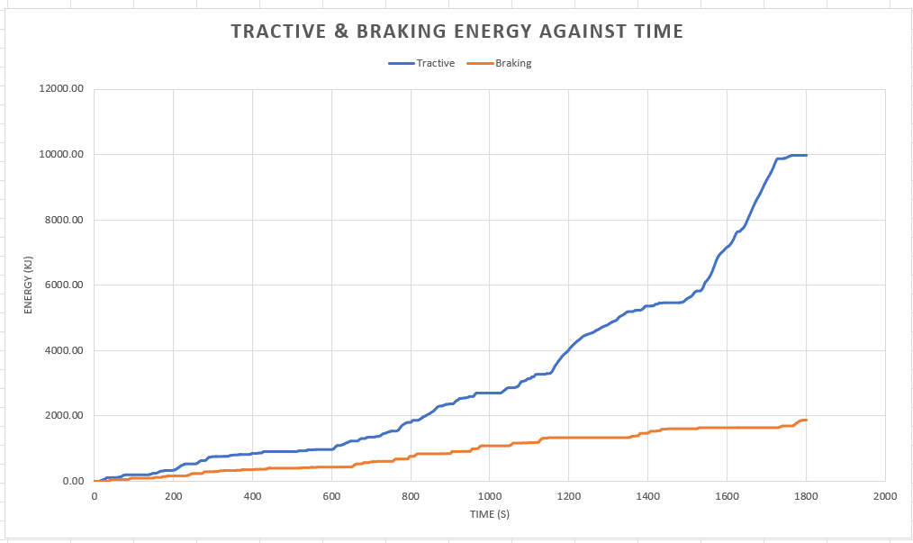
This graph shows tractive and braking energy over time. Clearly the tractive energy is considerably higher than the braking energy, with a linear increase over time. This is because energy from braking is stored within the flywheel, but that energy is used to propel the vehicle, hence why tractive energy is higher as the average speed increases.
Figure 3.2.2 – Tractive Energy & Braking Energy Against Time


This chart displays the cumalative test phases and cumulative energies. Evidently there is higher positve engery at the highest average speed.
Figure 1
Figure 3.2.3 – Cumulative Energy of Entire Test

4.0 Different KERS Systems
There are various KERS systems used, from light vehicles and passenger cars to heavy duty vehicles like buses. Below is a list of Energy Recovery systems. Majority of KERS systems store energy through Regenerative Braking. This works by storing kinetic energy in the form of energy electrical energy for example. This captured energy is stored and later used to propel the car back to speed, saving the need to use the engine as much which can result in lower improved fuel economy and reduced emissions. If this were to be applied using an electric vehicle. Regenerative braking does not disperse the electrical energy as heat, which in contrast to KERS makes it more energy efficient. (Ricardo, 2009).
- Mechanical KERS – This is the system that is being used on the test vehicle, the Corsa B. Most mechanical KERS systems use a form of rotating mass, which in most cases is a flywheel, to store the energy. This energy is then distributed through the driveline to and from the wheels through constant velocity transmission (CVT). Energy is taking from the vehicle, through braking, and stored as kinetic energy. (Boretti, 2013)
- Electric KERS – The electric KERS system works by using chemical batteries as its storage system for energy, whilst using an electric motor as a way of reusing the stored energy. This electrical energy is stored using capacitors that work as essential electric circuit system elements, these capacitors will charge and discharge the electricity. (Chan, C.C., Bouscayrol, A. and Chen, K., 2009.)
- Hydraulic KERS – Hydraulic KERS is not much of a common choice when it comes to KERS systems, mainly due to costs, despite the significant gains in efficiency when in use. This type of system is likely to be used in heavy goods vehicles like buses and trucks. This system works using a hydraulic motor and hydro pneumatic accumulator. (H. Shimoyama, S. Ikeo, E. Koyabu, K. Ichiryu, S. Lee, 2004)

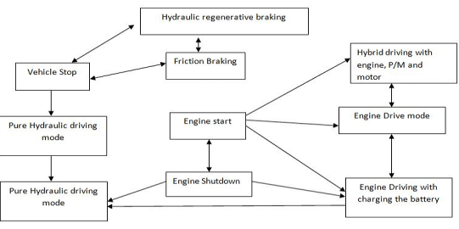
- Hydro-Electric KERS – This KERS system is well suited for frequent acceleration and deceleration within city driving environments. In comparison to the electric KERS system, It can more efficiently store energy under regenerative braking and can provide a greater amount of acceleration. The image below displays the operating modes of a Hydro Electric KERS system.
Figure 4.1 – Operating Modes of a Hydro Electric KERS System. Paswan, Ramashankar & Das, Jayanta & Kumar, N. & Kumar, Ajit & Mishra, Santosh & Sujit, Kumar. (2014).

4.1 Fuel Consumption of Different KERS Systems

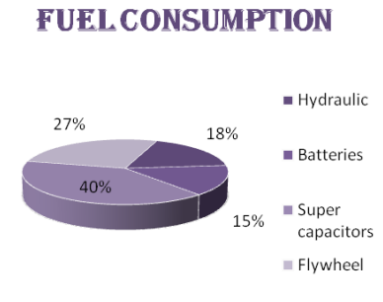
Figure 4.2 - Radhika Kapoor, C. Mallika Parveen, Member, IAENG, ‘’Comparative Study on Various KERS’’. (2013).

The image above has been taken from a study that compares various KERS systems. It displays the fuel consumption of different KERS systems. The fuel consumption is one of the main aspects when it comes to the KERS system, as it needs to make the test vehicle as economical as possible by reducing fuel consumption which will result in reduced emissions. Evidently the super capacitors used in the electric KERS system are the most fuel efficient, as 40% fuel is saved over the period of the full journey. Secondly is the flywheel, can save up 27% of fuel. This system isn’t as fuel efficient, but it can store energy for the lengthiest amount of time. In the case of fuel consumption batteries are evidently worse off, due to the short life and a reduced space for energy transfer. Batteries are also least efficient in comparison due to them discharging quicker than they can recharge, although the capacitors have a high efficiency, they are unable to obtain the kinetic energy under braking.

5.0 Conclusion
To conclude, this investigation displayed the efficiency of using a KERS system on a vehicle with an ICE engine and how it can be proven to be more economical when it comes to emissions and fuel consumption. KERS is a useful form of regenerative braking, storing and reusing energy lost whilst the vehicle is under braking. The mechanical KERS system utilizing a flywheel proves to be the most reliable and efficient in comparison to other KERS setups.
This was completed by taking plotting data on a spreadsheet to calculate energy recovered and energy reused using a KERS flywheel system. This data was then plotted into graphs and charts to show more clearly how efficient the KERS system really is.

5.1 Summary of Results
From the plotted graphs and charts as time and average speed increase over the length of the test, more energy was recovered and reused through regenerative braking. This increased over time due to more energy being recovered at higher speeds, even though it’s shows that the system can still be efficient at lower speeds.

5.2 Areas for Improvement
If this test were to be conducted again it would be an improvement if multiple vehicles had been tested, possibly with larger vehicles that will require more braking at higher speeds due to weight. The data from various vehicles can then be plotted to show how the weight of the vehicle can affect its efficiency and how much a KERS flywheel system can improve its efficiency and fuel consumption. Vehicles that have a higher or lower coefficient of drag could also be compared to show how that can affect efficiency.

6.0 Reference List
- An Assessment of Flywheel High Power Energy Storage Technology for Hybrid Vehicles. (2011). Available at: https://info.ornl.gov/sites/publications/files/Pub31707.pdf [Accessed 12 Jan. 2023].
- Boretti, A. (2013). Kinetic Energy Recovery Systems for Racing Cars. SAE International.
- Chan, C.C., Bouscayrol, A. and Chen, K., 2009. Electric, hybrid, and fuel-cell vehicles: Architectures and modeling. IEEE transactions on vehicular technology, 59(2), pp.589-598. [Accessed 13th Jan. 2023].
- GreenCarGuide.co.uk. (n.d.). Volvo’s flywheel KERS puts a new spin on hybrid cars. Available at: https://www.greencarguide.co.uk/features/volvos-flywheel-kers-puts-a-new-spin-on-hybrid-cars/#:~:text=Volvo%20has%20been%20working%20for [Accessed 13 Jan. 2023].
- H. Shimoyama, S. Ikeo, E. Koyabu, K. Ichiryu, S. Lee, “Study on hybrid vehicle using constant pressure hydraulic system with flywheel for energy storage,” SAE 2004-01-3064, 2004. [Accessed 13th Jan. 2023].
- Motor Car History. (n.d.). Vauxhall Corsa B (1993-2000). [online] Available at: https://motor-car.net/vauxhall/item/15409-vauxhall-corsa [Accessed 12 Jan. 2023].
- Paswan, Ramashankar & Das, Jayanta & Kumar, N. & Kumar, Ajit & Mishra, Santosh & Sujit, Kumar. (2014). Simulation Study on Different Energy Efficient Hydraulic System: An Overview. Applied Mechanics and Materials. 592-594. 2234-2238. [Accessed 13th Jan. 2023].
- Radhika Kapoor, C. Mallika Parveen, Member, IAENG, ‘’Comparative Study on Various KERS’’, 2013, London, U.K. Available at: https://www.iaeng.org/publication/WCE2013/WCE2013_pp1969-1973.pdf [Accessed 14th Jan 2023]
- Ricardo Chicurel, “A Compromise Solution for Energy Recovery in Vehicle Braking,” Energy, vol.24, pp. 1029-1034, 2009. [Accessed 12 Jan. 2023].
- Sam (2011). Flywheel hybrid systems (KERS). Racecar Engineering. Available at: https://www.racecar-engineering.com/articles/f1/flywheel-hybrid-systems-kers/.
- tfl.gov.uk. (n.d.). Check your Vehicle. Available at: https://tfl.gov.uk/modes/driving/check-your-vehicle/Results [Accessed 12 Jan. 2023].
- WLTPfacts.eu. (n.d.). What is WLTP: the Worldwide Harmonised Light Vehicle Test Procedure? Available at: https://www.wltpfacts.eu/what-is-wltp-how-will-it-work/. [Accessed 12 Jan. 2023].
- www.parkers.co.uk. (n.d.). Used Vauxhall Corsa Hatchback (1993 - 2000) Review | Parkers. Available at: https://www.parkers.co.uk/vauxhall/corsa/hatchback-1993/used-review/ [Accessed 12 Jan. 2023].
- www.vauxhall.co.uk. (n.d.). Fuel consumption based WLTP driving cycle | WLTP Data | Vauxhall. [online] Available at: https://www.vauxhall.co.uk/wltp.html#:~:text=European%20law%20means%20that%20WLTP [Accessed 15 Jan. 2023].

‌

