
Managing projects in organisations
Workshop Raising Awareness Children’s Rights and Services Available

July 1, 2022
University of Wales Trinity Saint David
ANGHEL ADRIAN BREZEANU 1918103

Table of Contents
Introduction 2
Main Findings 2
Initiation Stage 2
Planning Stage 3
Execution Stage 4
Closure Stage 6
Conclusion 7
Bibliography 8

Introduction

The definition of a project is that is the sum of all the actions needed to achieve a main objective, while utilising the organisation’s resources such as people, money and time (UMass Boston, 2022). A project management, however, means that the actions and the resources must be organised in an effective way to ensure that the main objective of the project is achieved (Munns, Bjeirmi, 1996). The main benefit of the project management is that it ensures that the resources are not wasted, and that all the actions needed for the project to be successful are completed (Munns, Bjeirmi, 1996). Still, the project management must be done accordingly in order to be affective, and this is the part where a Project Manager is needed to oversee all the process (Munns, Bjeirmi, 1996).
The report will assess the success of the Workshop for Raising Awareness of Children’s Rights and Services Available, which can be considered a project because it required multiple actions over a certain period of time, has a main objective, the one of raising awareness, and multiple resources have been used to ensure that the objective will be achieved. The project management of the workshop has been done by having four Project Managers, and by utilising project management tools such as Project Life Cycle, Quad Chart, Stakeholders Analysis, WBS and Gantt Chart, Risk Assessment and Project Evaluation.

Main Findings

The first concept that has been utilised during project management has been the Project Life Cycle. This represents a project management framework which gives managers the opportunity to overview all the stages of the project, in which they can implement different tools that will help them go to the next stage of the project, from initiation to completion (Puskaric, et al., 2018). The Project Life Cycle offers the benefit of viewing what needs to be done in each stage of the project, however it is considered to be a basic tool which only provides the opportunity to oversee the project, without any other scope or benefits (Puskaric, et al., 2018).

Initiation Stage

This stage represents the foundation of the project, as this is where the scope of the project is being established based on the identified need for such a project and its possible stakeholders, and the main resources are allocated for the project, such as human resources or financial resources, and an initial timeline is being established (Soderberg, 2020). A possible management tool used during this stage is the Belbin’s Team Roles Theory, which is helpful to establish the team that will undertake the project.
In the initiation stage of the workshop, the first action taken by the first Project Manager has been to ask each member of the team to complete the Belbin’s questionnaire in order to determine what roles are present in the team and if the team can be efficient in this format. The Belbin’s Team Roles is a helpful tool used especially within large organisations or even smaller teams to identify each member’s role within that team and to establish which are its strengths and weaknesses (Aritzeta, Swailes, Senior, 2007). The scope of this framework is to create teams with compatible members that can be highly performing together (Aritzeta, Swailes, Senior, 2007). There is certain criticism for this theory, especially due to the fact that it depends on the accuracy of the questionnaire to identify the correct role for each person, which can negatively impact the team as a whole and its productivity during the completion of the project (Aritzeta, Swailes, Senior, 2007). Given this, out of nine Belbin Roles, the members of the team had seven roles within the team, making them a potentially high performing team, as there are a Team worker member, a Resource Investigator member, a Shaper member, a Complete Finisher member, a Specialist member, an Implementer member and a Monitor Evaluator member. Still, during this stage the team noticed a challenge, which was the lack of a Coordinator, which could have had potential negative effects over the team’s organisation and the project management.

Planning Stage

This stage is where the actual planning and evaluation starts to happen, and the team is starting to work and to discover the details of the project which can help them to better understand the actions that must be taken in order to successfully complete the project (Serrador, 2012). Within this stage, project management tools such as Quad Chart and Stakeholders Analysis are very helpful to the team to better understand what is required from them.
The Quad Chart is a basic but effective project management tool as it offers the opportunity to have a full access and view over critical aspects of the project (Keenan, 2020), such as its objectives, which represent what the project is looking to achieve, stakeholders, which represents all the persons or organisations that are impacted, interested or involved with the project and which can be further analysed using the Stakeholders Analysis, the desired outcomes, which represent the most favourable outcome of the project, and the measures of success, which represent the realistic expectations of the project and determine its success.
The Quad Chart for the workshop has been established by the team in the first week of lecture, after the theme of the project has been chosen. The workshop has been a passionate subject for the team members that are all in contact with children, by being parents, or by living in a household with kids. The main desire that the team has was to know what the rights of the children are, and what are the services available as well. The challenge in creating the Quad Chart came from the fact that the team expected for the workshop to be very big, with more than 3000 participants, until the lecturer advised that this cannot be possible in such a short period of time. In this conditions, the team had to adapt its vision and the following Quad Chart has been developed:
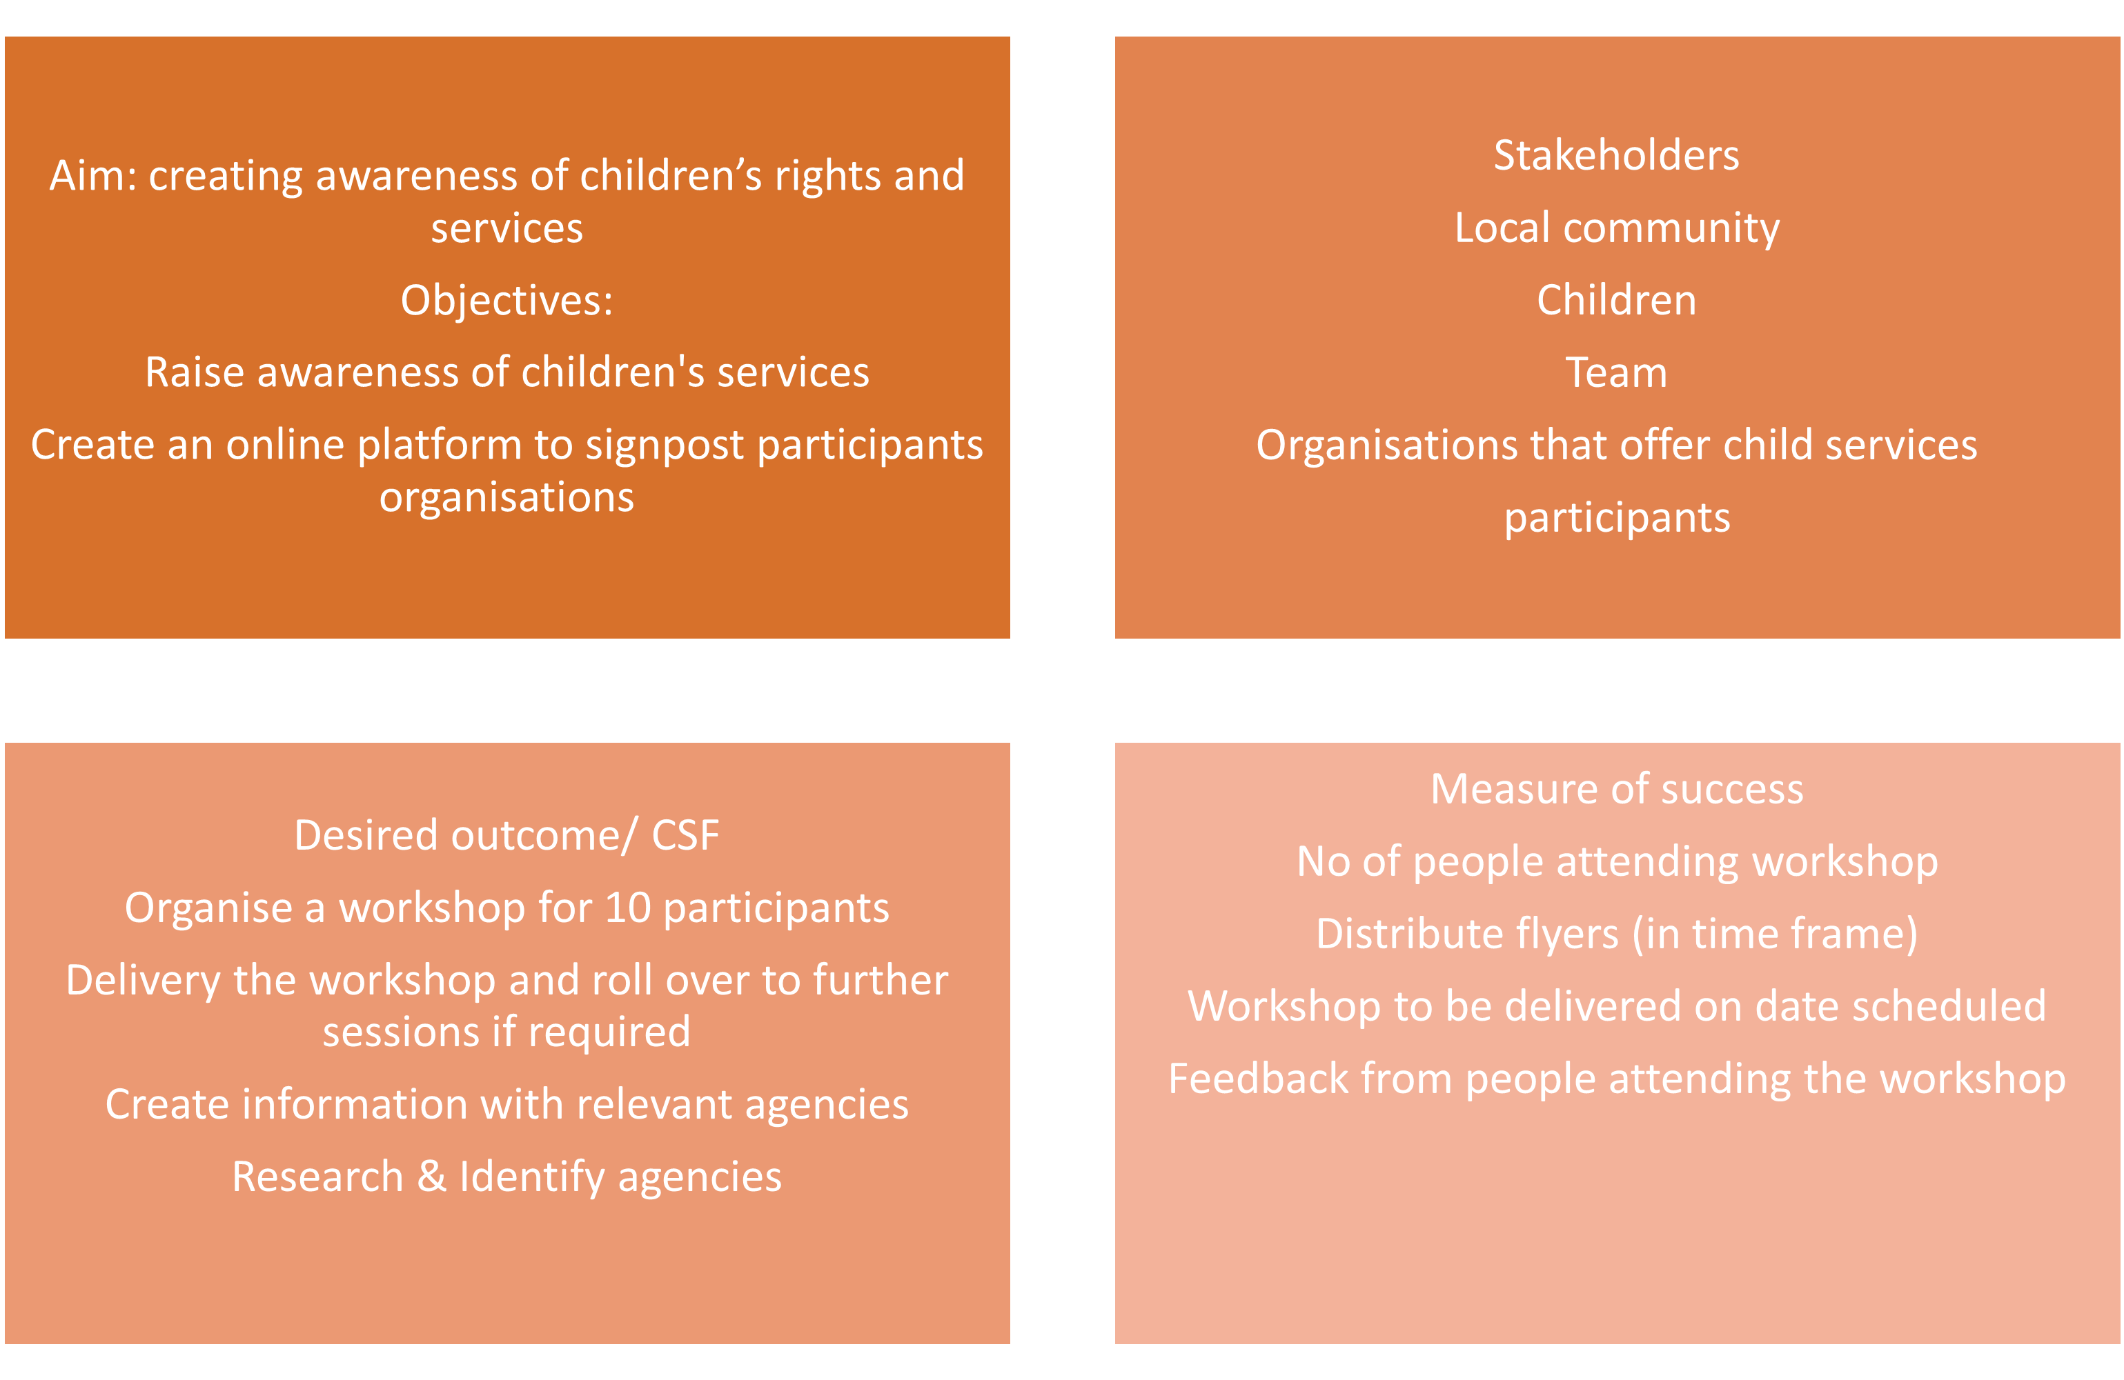

The following action during this stage has been to analyse the second box of the Quad Chart, the stakeholders, using the Stakeholders Analysis. The Stakeholders Analysis is a project management tool that is looking to identify the stakeholders of a project (Fionnbarra Brugha, 2000), which can be supporters, represented by those who help complete the project, drivers, represented by the target of the project which can have the power to decide if the project has been successful or not and observers, represented by the people or organisations that are interested in the project, without any type of involvement. The Stakeholders Analysis is a very helpful tool to understand the people involved in the project in any way, but it does not take into consideration any changes that might happen during the project, and it is difficult to include or to eliminate stakeholders from the analysis, as it might change the project as a whole (Fionnbarra Brugha, 2000).
The Stakeholders Analysis for the workshop revealed that there are multiple supporters. However, when the initial version of the analysis has been developed, there have been challenges in visualising stakeholders’ perspectives, as the perspectives looked very similar as it is an awareness raising workshop.
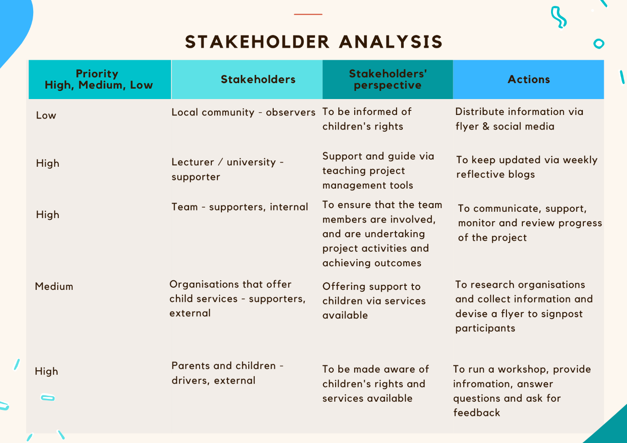

Execution Stage

The third stage of the Project Life Cycle consists of the actual performance of the project within the established timeline (Zwikael, 2019). Usually, this is the most complicated part of the project because during this stage all the plans made in the previous stage must be implemented and sometimes the actual actions can be different from the plans, due to unforeseen circumstances (Zwikael, 2019). However, the most important aspect here is the scheduling, and this can be done with the help of management tools such as WBS and Gantt Chart.
WBS, the abbreviation of Work Breakdown Structure, is one of the most helpful project management tools because it offers the opportunity of splitting the project in multiple tasks which can be delegated and monitor easily, providing in this way the possibility of keeping track of the advancement of the project (Alutbi, 2020). The only criticism of the WBS is that in order to have a high level of accuracy, it must be constantly updated with new tasks that might be required or it must remove the tasks that can be deemed unnecessary (Alutbi, 2020).
The WBS has been used in this stage for the workshop, and it has been a successful task for the entire team as everyone has been able to identify the correct and necessary tasks for the workshop.
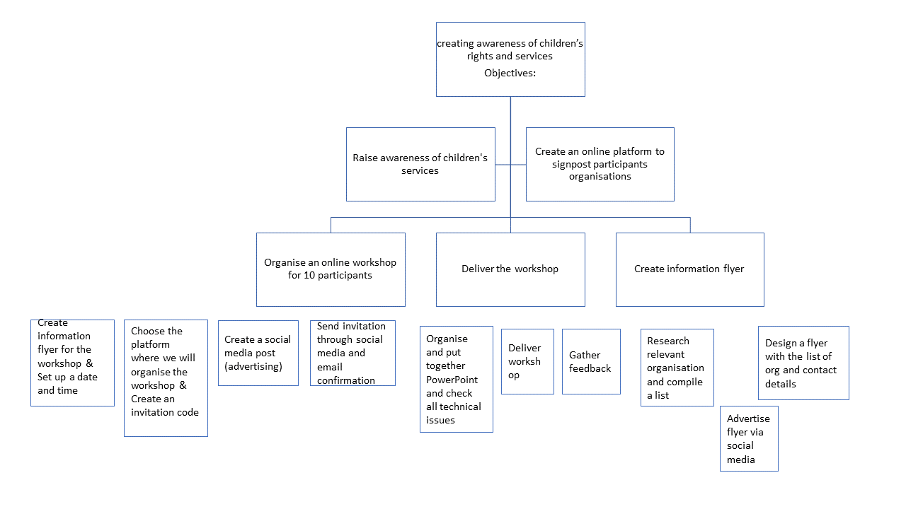
Another aspect of the WBS is that it helps scheduling, however this is not included in the framework, but there is another tool available that schedules the tasks from the WBS, and this is known as the Gantt Chart. As already mentioned, the Gantt Chart is a project management tool that enable a clear schedule to be put in place, and as well as the WBS, the Gantt Chart must be constantly updated to reflect the reality in order to be effective (Geraldi, 2012).
The Gantt Chart has been used for the workshop to schedule the tasks defined in WBS, and it has been successfully applied as well, as the team has been able to delegate the tasks accordingly to fit in the timeframe.
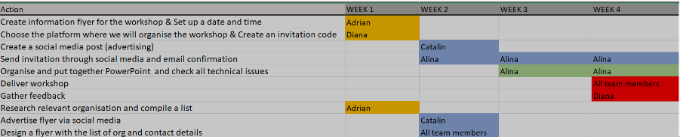

Closure Stage

The Closure Stage is the part where the project has been finalised from the point of view of the actions needed to be undertaken, but it is also the part where the project is being evaluated to determine if it had a favourable result or not (Kucuk, 2014). Within this stage the team conducted a Risk Assessment and a Project Evaluation.
The Risk Assessment is a project management tool used to identify potential threats to the project, their impact and how likely are they to happen, but most importantly it ensures that a series of mitigating actions are in place in order to avoid the threats or to make their impact to be as lowest as possible (Escobar-Wolf, Bouali, Oommen, 2018). The risks factors can be internal, usually coming from the supporters of the project, or external, usually coming from the drivers of the project.
The Risk Assessment for the workshop has identified two internal risks and two external risks, but the main identification has been the mitigating actions which managed to reduce the impact of the risks quite significantly and helped the team to be extra cautious and prepared to overcome any threats.
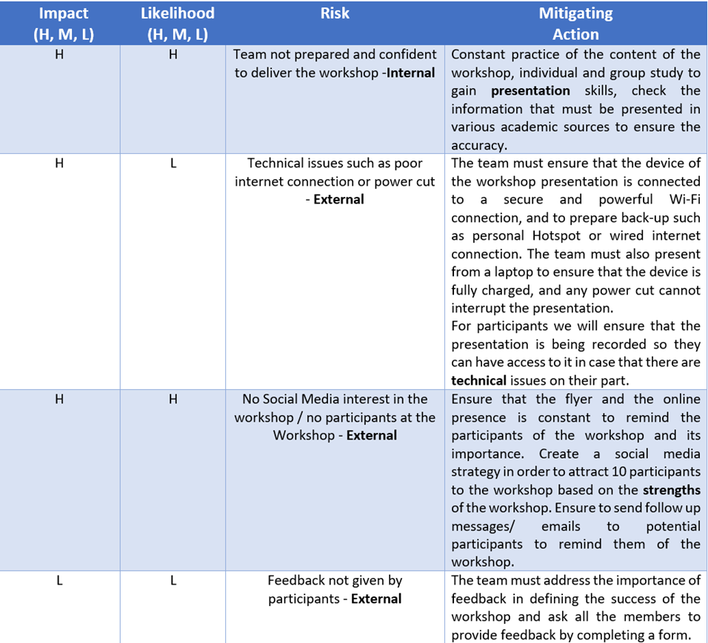
The Project Evaluation is a project management tool used to measure the success of the project by analysing the soft outcomes, which refer to results that cannot be counted or included in statistics, such as motivation or feedback, and the hard outcomes, which are the results that can be measured, such as, for example, the number of people that are participating within the project. The Project Evaluation tool is the most comprehensive tool used, as it looks not only at the physical results of the project which can be measured, but it also looks at softer, unmeasurable outcomes, and offer the most complete overview of the project’s results (Galas, et al., 2018).
The Project Evaluation of the workshop showed that the project has been a success, and the main argument for this is that the measures of success identified in the Quad Chart have all been achieved. The success of the workshop could have not been possible without the dedication and hard work of each member of the team, as all of them took responsibility for their week’s of being Project Managers and ensured that all the tasks have been successfully completed in the dedicated time frame.
Moreover, the team has been able to communicate effectively and to deliver as an effective team according to Belbin’s Team Roles theory, and the only struggle has been to correctly apply all the tools and to understand the stakeholders’ perspective.
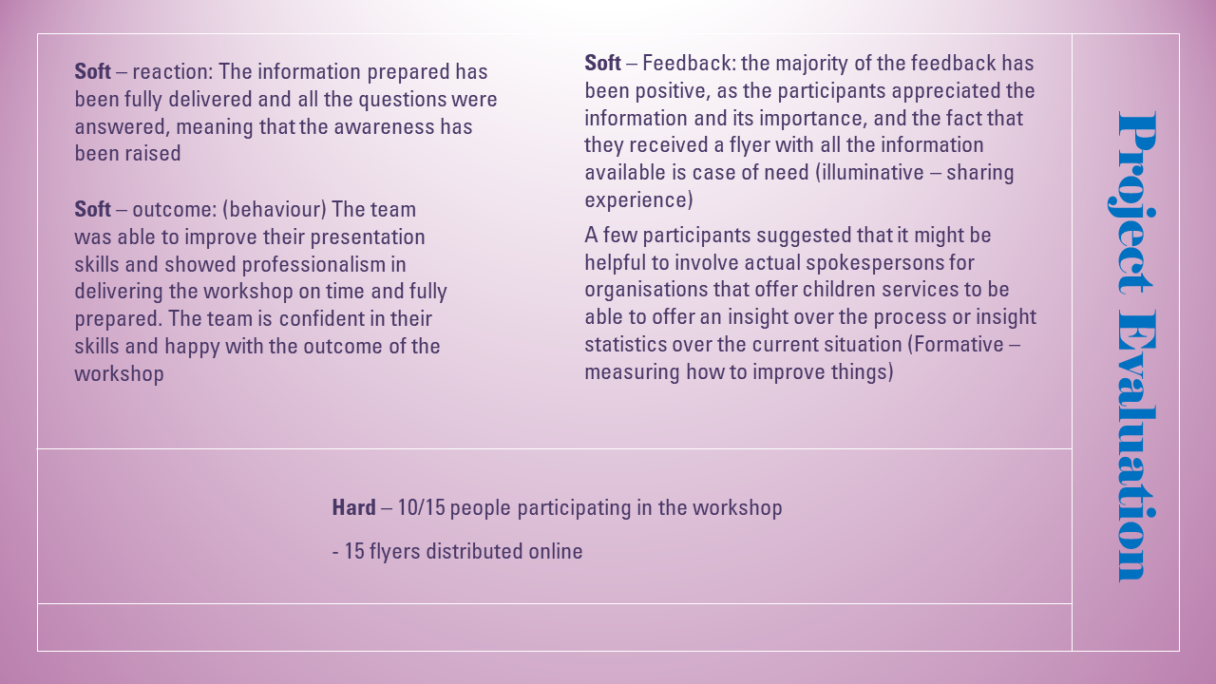

Conclusion

The purpose of the report has been to evaluate the understanding over the project management tools and how they were used in the context of the Workshop for Awareness Raising of Children’s Rights and Services Available.
The main findings of the report have been divided into four part, each corresponding to a stage in the Project Life Cycle. In the Initiation Stage, the tool used was the Belbin Team Roles Theory, which showed that the initial formed team had high changes to perform at a high standard. The Planning stage showed that the Quad Chart and the Stakeholders Analysis have been successfully applied to the workshop. The Execution Stage showed that the WBS and Gantt Chart have been applied effectively, and the last stage, the Closure Stage, showed that the Risk Assessment has been very effective in creating a list of mitigating actions to prevent the possible risks, and the Project Evaluation showed that the workshop has been successful and checked all the measures of success.
To conclude, the team has been performing effectively, with every task delivered on time. The communication, the teamwork effort and the consistency have made the project a success.

Bibliography

Alutbi, M. (2020) WORK BREAKDOWN STRUCTURE (WBS) [online] Available at: https://www.researchgate.net/publication/342163727_WORK_BREAKDOWN_STRUCTURE_WBS [Accessed: 30.06.2022].
Aritzeta, A., Swailes, S., Senior, B. (2007) Belbin’s Team Role Model: Development, Validity and Applications for Team Building*. Journal of Management Studies, Vol. 44, Issue 1, pp, 96-113.
Escobar-Wolf, R., Bouali, E.H., Oommen, T. (2018) Risk Assessment. [online] Available at: https://link.springer.com/referenceworkentry/10.1007/978-3-319-73568-9_239 [Accessed: 30.06.2022].
Fionnbarra Brugha, R. (2000) Stakeholder Analysis: A Review. [online] Available at: https://www.researchgate.net/publication/12312104_Stakeholder_Analysis_A_Review [Accessed: 30.06.2022].
Geraldi, J. (2012) Gantt charts revisited: A critical analysis of its roots and implications to the management of projects today. [online] Available at: https://www.researchgate.net/publication/263571905_Gantt_charts_revisited_A_critical_analysis_of_its_roots_and_implications_to_the_management_of_projects_today [Accessed: 30.06.2022].
Keenan, R. (2020) What is a Quad(rant) Chart? [online] Available at: https://positioninginsights.com.au/quad-charts/ [Accessed: 30.06.2022].
Kucuk, O. (2014) The Last Process Of Project Management: Closing And Needs To Be Done. [online] Available at: https://www.researchgate.net/publication/303694136_The_Last_Process_Of_Project_Management_Closing_And_Needs_To_Be_Done [Accessed: 30.06.2022].
Munns, A.K., Bjeirmi, B.F. (1996) The role of project management in achieving project success. International Journal of Project Management, Vol. 14, Issue 2, pp. 81-87.
Puskaric, H., Dordevic, M.Z., Nestic, S., Jovanovic, J., Tadic, D. (2018) Quality of Project Life Cycle. [online] Available at: http://cqm.rs/2018/cd1/pdf/papers/focus_1/28.pdf [Accessed: 30.06.2022].
Serrador, E. (2012) The importance of the planning phase to project success. [online] Available at: https://www.pmi.org/learning/library/importance-planning-phase-project-success-6021 [Accessed: 30.06.2022].
Soderberg, E. (2020) Project initiation as the beginning of the end: Mediating temporal tensions in school's health projects. International Journal of Project Management, Vol. 38, Issue 6, pp. 343-352.
UMass Boston (2022) Definition of a Project. [online] Available at: https://www.umb.edu/it/project_management_office/methodology/definition_of_a_project [Accessed: 29.06.2022].
Zwikael, O. (2019) Executing a Project. [online] Available at: https://www.researchgate.net/publication/331881298_Executing_a_Project [Accessed: 30.06.2022]

