Iram Shaheen (2520951)
LECTURER NAME: Daniel HARUNA
Module Name: Introduction to Health and Social Care
Module Code: LCHS4003
6/10/2026
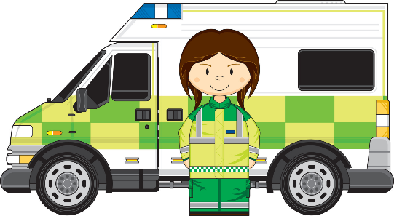
Ambulance Services

WHAT IS THE AMBULANCE SERVICE?

The ambulance service provides immediate, life-saving medical care and quick transportation for people who are severely injured or experiencing a sudden medical emergency.
It acts as both a mobile hospital room where treatment is given immediately on the scene, and a safe, monitored way to transport patients to the emergency department.
Within the UK, it is a vital part of the National Health Service (NHS), acting as the very first point of clinical contact for the public during a crisis.
HISTORY OF THE SERVICE
The 1800s (Early Horse-Drawn Care): The earliest concepts of organized ambulance transport began during major wars and large-scale conflicts. These initial services relied entirely on horse-drawn carriages, and their primary focus was simply removing wounded individuals from danger zones rather than treating them on site.
1800–1900 (The Transition to Motors): As industrial technology advanced, motorized vehicles slowly began to replace traditional horse-drawn units. This crucial shift allowed for significantly faster response times, and vehicles began carrying basic medical equipment and first aid supplies to help stabilize patients.
Mid-1900s (Advanced Mobile Care): By the middle of the 20th century, the service underwent a massive transformation from a basic transport vehicle to a space where advanced care could be provided. Equipment became highly specialized, and staff received formal medical training to deliver care en route.

CHALLENGES FACED BY THE SERVICE
Challenge 1: High Operational Demand and System Pressures
The Issue: The service faces a continuous surge in emergency calls, which becomes exceptionally severe during cold winter months, public holidays, or major public incidents.
The Impact: This massive volume of requests strains available resources. When combined with tight budget constraints, it becomes highly difficult to upgrade essential clinical equipment, leading to a heavy reliance on older systems that can slow down overall response times.
Challenge 2: Workforce Burnout and Severe Staff Shortages
The Issue: Frontline ambulance staff are frequently overworked and expected to perform highly stressful medical tasks in all types of severe weather conditions.
The Impact: Working under constant, high-pressure environments causes widespread emotional exhaustion and burnout. This leads to high levels of staff turnover, creating a difficult cycle where the remaining workforce must take on even more responsibility, ultimately impacting the overall speed and quality of care.

- Challenge 1: High Operational Demand and System Pressures
  - The Issue: The service faces a continuous surge in emergency calls, which becomes exceptionally severe during cold winter months, public holidays, or major public incidents.
  - The Impact: This massive volume of requests strains available resources. When combined with tight budget constraints, it becomes highly difficult to upgrade essential clinical equipment, leading to a heavy reliance on older systems that can slow down overall response times.
- Challenge 2: Workforce Burnout and Severe Staff Shortages
  - The Issue: Frontline ambulance staff are frequently overworked and expected to perform highly stressful medical tasks in all types of severe weather conditions.
  - The Impact: Working under constant, high-pressure environments causes widespread emotional exhaustion and burnout. This leads to high levels of staff turnover, creating a difficult cycle where the remaining workforce must take on even more responsibility, ultimately impacting the overall speed and quality of care.

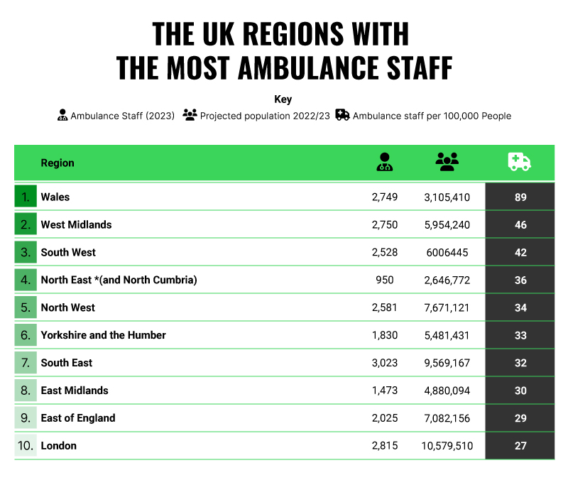
References:
https://www.londonambulance.nhs.uk/wp-content/uploads/2020
https://aace.org.uk/wp-content/uploads/2025/07/Nationall-Ambulance-Data-Full-Data-to-June-2025.pdf
www.bbc.co.uk/archive/nhs/5161.shtml
Emergency Number 999 or 112
Non-emergency health advice 111
Operates 24 hours a day
Funding NHS: Publicly funded
Conclusion:

UK ambulance service is improving with new technology, better training, more medical knowledge which helps paramedics treat patients faster and more effectively. They can often help service users where they are which saves time and takes pressure off hospitals.
Task 2 | Service Chosen: Community Mental Health Services

Introduction

A wide range of teams of professionals, psychiatric outpatient clinics, and social support networks make up community mental health services, which are intended to treat, rehabilitate, and assist people with mental health issues in their neighbourhoods as opposed to confined hospital settings. Community Mental Health Teams (CMHTs) are the foundation of community-based psychiatric care in today's social care environment. Their goals are to safeguard the civil liberties of vulnerable service users, encourage independence, and prevent acute relapse. This essay investigates the historical origins of community mental health, tracking its development from nineteenth-century institutional confinement to modern deinstitutionalization. After that, it provides a critical assessment of how these services now operate and looks at how important they are to improving the quality of life for those dealing with complicated mental illnesses.

Historical Origins and Context

A significant theoretical shift from the nineteenth-century "asylum movement" may be seen in the institutional development of community mental health care. Public policy during the 1800s placed a strong emphasis on containment and segregation, building a vast network of sizable county asylums to handle people who were considered "distressed or disorderly" (Sidi, 2021). For more than a century, these remote, state-run establishments were the main means of containment. But by the middle of the 20th century, deinstitutionalization—the widespread shift of mental health services from long-term institutions to localised, community settings—was sparked by a combination of clinical, social, and financial causes (Calabria & Cullen, 2024).

The Mental Treatment Act of 1930, which created the first official outpatient clinics and permitted voluntary hospital admissions without formal judicial authorisation, provided the first legislative basis for this change (Burns, 2020). After World War II, the development of innovative psychotropic drugs like chlorpromazine in the 1950s, which successfully treated severe psychotic symptoms outside of hospitals, greatly increased the drive for genuine community integration.

With Health Minister Enoch Powell's historic 1961 "Water Tower" speech, which clearly outlined a political intention to cut the country's psychiatric beds in half and move acute psychiatric specialities into district general hospitals, public policy officially turned against the asylum paradigm. The Mental Health Act of 1959, which encouraged informal admissions, eliminated the special administrative designation of isolated mental hospitals, and required local social services to work with health authorities to provide community-based housing and aftercare support, codified this philosophy (Burns, 2020).
The final phase of this restructuring culminated in the NHS and Community Care Act 1990. Influenced by the 1988 Griffiths Report, this statutory intervention dismantled the traditional long-stay asylum system entirely, formally transferring the operational and financial responsibility for long-term social care and community-based support out of the National Health Service (NHS) and into the hands of local municipal authorities (Sidi, 2021).

Contemporary Functioning and Critical Evaluation

Today, community mental health services operate through specialised, multi-disciplinary integration. Patients are referred by primary care general practitioners (GPs) to sectorized healthcare providers that include social workers, occupational therapists, psychiatrists, and community psychiatric nurses (CPNs). This statutory infrastructure works in tandem with independent third-sector charitable organisations, early intervention squads, and specialised crisis resolution home treatment (CRHT) teams. The Care Act of 2014's personalisation principles, which theoretically guarantee that care packages are tailored to match individual choice, self-determination, and personal safety, govern modern practice and are strictly regulated by the Care Quality Commission (CQC) (Calabria & Cullen, 2024).

However, a critical assessment of the current system indicates a significant gap between the tangible reality of underfunding and policy ambitions. Although the system was intended to offer comprehensive, ongoing psychosocial care, more than ten years of local government budget cuts have led to the methodical destruction of vital preventative community spaces like day centres and social clubs (Burns, 2020). As a result, high referral volumes often overwhelm CMHTs, requiring doctors to function mainly as emergency gatekeepers who put acute crisis containment ahead of long-term rehabilitation and social inclusion (Bouras et al., 2018).

Systemic barriers are also brought about by the division between local authority social care financing and NHS clinical mental health services. The line between obtaining local authority financing for domestic social care, housing, or job support and having clinical treatment for an illness is often difficult for service users to negotiate. An unintended paradox has resulted from this systemic rationing: mandatory admission and detention rates under civil mental health legislation have sharply increased as community preventative infrastructure deteriorates, revealing a critical lack of capacity within the community care model to support individuals before they reach a psychological crisis point (Burns, 2020).

Significance in Enhancing Quality of Life

The existence of community mental health care is still a crucial requirement for protecting the human dignity and quality of life of psychiatric service users in spite of these severe operational difficulties. Living in the community enables people to preserve ontological security, which is the fundamental psychological sense of continuity, safety, and individual autonomy that comes with residing in a familiar home setting as opposed to an institutional ward.

These services aim to prevent the severe loss of freedom, institutional dependency, and social humiliation that have historically resulted from long-term hospitalisation by providing psychiatric interventions, psychological therapies, and social aid right into the community. By maintaining essential localised support networks, effective community care helps service users keep up their ties with friends, family, and neighbours.

Additionally, the risk of societal isolation and clinical relapse is dramatically decreased by community care teams that offer ongoing, relationship-centered assistance. From a macroeconomic standpoint, community services serve a crucial dual purpose: they significantly reduce financial strain and logistical bottlenecks in acute NHS hospital wards while also protecting vulnerable people's fundamental human rights to a meaningful, self-directed lifestyle that is integrated into a democratic society.

Conclusion

From a period of traditional isolation to an integrated, human rights-focused approach of localised care, community mental health services have undergone a complete transformation. The service's contribution to human well-being is crucial, even though its effectiveness is seriously threatened by modern market-driven commissioning, institutional underfunding, and the loss of preventative day-care services. Moving past a model of reactive crisis management and reinvesting in well-funded, fully integrated health and social care partnerships capable of providing proactive, relationship-based support within the community is necessary to maximise the potential of community mental health care to transform lives going forward.

References

Bouras, N., Ikkos, G., & Craig, T. (2018). From community to meta-community mental health care. International Journal of Environmental Research and Public Health, 15(4), 806. https://doi.org/10.3390/ijerph15040806 Cited by: 30
Burns, T. (2020). Community-based mental health care in Britain. Consortium Psychiatricum, 1(2), 14–20. https://doi.org/10.17650/2712-7672-2020-1-2-14-20 Cited by: 8
Calabria, V., & Cullen, L. T. (2024). Deinstitutionalisation and the move to community care: comparing the changing dimensions of mental healthcare after 1922 in the Republic of Ireland and England. History of Psychiatry, 35(2), 141–157. https://doi.org/10.1177/0957154x241231057 Cited by: 8
Griffiths, R. (1988). Community care: agenda for action. HMSO.
Sidi, L. (2021). After the madhouses: the emotional politics of psychiatry and community care in the UK tabloid press 1980–1995. Medical Humanities, 48(4), 451–460. https://doi.org/10.1136/medhum-2020-012117 Cited by: 7

