Investigation and EvaLUATION OF SOCIAL MEDIA PROMOTION STRATEGIES FOR ORGANISATIONS

  - Research Proposal

  - Student Name: Lloyd Pennington

Subject Specialist:
James Williams

Contents
Introduction/Background to the propose research 2
Introduction 2
Background 2
Aims and Goals 4
Conclusion 5
Research and Development Methods 6
Introduction 6
Information Collection Method 7
Risks and Limitations 8
Analysing the project 8
Conclusion 9
Resources and Planning 10
Introduction 10
Conclusion 10
Bibliography 13

Figure 1: Positivism and Deduction [3] 6
Figure 2: Microsoft Project Plan Timeline 11
Figure 3: Microsoft Office Project Information 12

Introduction/Background to the propose research

Introduction
In the first section of the proposal, we are going to introduce and consider the type of project that will be undertook and the overall setting of the project. The considerations that will take place are the current literature and the current research, which is currently being done in the field. The aims and objectives will also be shown to show what will be the overall outcome of the completion of the project.
The working title for this project is Investigation and Evaluation of Social Media Promotion Strategies for Organisations

Background
Social media promotion strategies are being implemented in businesses to allow the customers/potential customers to see what services and/or items that the business currently offers. To give a better overview of what a promotion strategy is the question “What is a promotion strategy?” needs to be asked. A promotion strategy is, as defined by Timothy R. Graeff [1], “Promotional strategies should be designed to suggest, encourage, and facilitate personal interpretations of the self‐relevance and positive consequences of product use.” A business would use a promotion strategy to gauge how a product would be seen by a potential customer base. In current years, the main method of promotion strategy would be from the use of social media, rather than the use of a television and/or radio advert; this mainly being because there is an increase in people using these devices and, therefore, more potential clientele for the business. This, of course, does depend on the clientele that the promotion strategy is going to be aimed at; this will be explained further into the paper.
When approaching a promotion strategy there are a couple of prerequisites that would need to be taken into consideration. These prerequisites would be [2];
- To understand the target clientele
- Picking a marketing channel
- Observing oppositional promotional strategies
These items would need to be taken into consideration as each point has a valuable contribution when it comes to deciding on a promotion strategy.
Understanding the target clientele is highly important, if not the most important, aspect of a promotion strategy. The reasoning behind this is because the clientele will be the customer base, i.e. the type of people that the product is going to be aimed at. Understanding the clientele is also important it allows the promotion strategy to be targeted exclusively to a large group of customers; this could be, either, the age, location and/or the gender of the potential customer base; there are, of course, a lot more factors but these are the main ones to generally consider when it comes to a promotion strategy [3].
Understanding the clientele age would be important because the promotion strategy would have to alter [3]. An example of this would be that if the product were to be aimed at people aged from 16-20 years old then the best medium to promote would, most likely, be on a form of social media. This would be because people around this age would be spending most of their time on social media than other media platforms, i.e. television or radio [3].
Understanding the location of the customer would also alter the promotion strategy as, depending on the country, there would be some material that would be considered offensive when compared to other countries. An example of getting around this issue would be the use of the Hofstede’s Cultural Dimensions [4]. Hofstede’s cultural dimensions take into consideration the different aspects that make up a country, in terms of promotion. This will be explained further into the paper.
Understanding the potential clientele gender would be a massive part of the promotion strategy. This would be as simple as changing the colour of the product, even if this is a controversial subject matter [4]. There would be colours that are more aimed at boys, i.e. blue and/or green, while there are colours aimed more towards girls, i.e. pink and/or purple. This part of the promotion strategy would also work with the age part. This being because if the age range is 5-10 then the colour would matter more than if the age range was 20-30 years old; this is mainly to do with the age mentality of the clientele.
When it comes to a promotion strategy there needs to be the consideration of the marketing channel, this being because the marketing channel is the way that the promotion will be targeting the clientele [5]. There are a wide variety of marketing channels to choose from, examples would be; through the use of video, the use of applications for the phone, the use of pop up adverts on different websites and/or the use of social media marketing [5]. This has already been described in the previous two paragraphs; the basic premise being that depending on the age there would be different uses of technology, examples being teenagers and young adults with the use of social media and the elderly with the use of television and radio [5].
When it comes to a promotional strategy there needs to be the consideration for the oppositional promotional strategies, i.e. the competitors overall promotional strategy. This could be the way that the competitor is going about preaching their product and/or service towards the customer. This will need to be considered because if the competitor is gaining more customers than your own business then lessons could be learned from the competitor promotional strategy(ies). Learning a competitor’s promotional strategy can be useful because a business could take inspiration from the competitor and apply something new, and effective, to their promotional strategy [2].
This study will fit into the field of Promotional Strategies and Marketing because in this study there will be an overall analysis for the different types of social media and how different people from different age groups will experience different types of promotions on these mediums.
This research will be worth doing because it will give a significant insight into how potential clientele experience social media marketing, and the overall benefits of the customer experiencing the promotion that applies to them the most [5]. This would be worth doing because it will show the correlation between an age group and a particular social media, this would then allow the use of updating and/or reconsidering a current social media promotion that is in place and would allow the social media promotion to be more defined for the target audience. This research will be topical in the sense of that most people are currently using social media [3]. This meaning that in the current age of the internet and social media there will be an influx of people gaining insight to different products and services on social media [5], so businesses will need to know how to target a particular audience and/or a wide variety of audience to guarantee the ideal customer base.
There have been studies that will correspond with this one. An example of one of these studies would be a study done by the Journal of Interactive Marketing which gave an insight of the effects of social media marketing [6]. That particular study focussed on the use of social media, different brands and the different brand posts on the various social media. This study will focus on the power of social media marketing when it comes to a business. These studies will be similar in the sense of the main aspect of social media but will be different in the sense of showing different methods of achieving a goal with the use of social media.
The target company that will be analysed will be Domino’s Pizza, and there are many reasons to do so. The main reasoning would be because Domino’s Pizza utilise a wide variety of adverts that are directed towards a wide selection of customer. Domino’s Pizza mainly does this while utilising the use of many different social media, mainly Facebook and Twitter [7]. A different reason to focus on Domino’s Pizza would be because Domino’s Pizza targets many different customer age groups all at the same time; this is rather specific to the food industry and Domino’s Pizza does this pretty well – there is a lot of information to be gained from Domino’s Pizza, in the terms of social media promotional strategies, as Domino’s Pizza is always promoting their service online.
The next part of the study will show the overall main aim(s) and the overall main goal(s) of the study. These will be what the study will achieve at the end and will show the reader what the study will be leading up to and what the reader can expect.

Aims and Goals
The main aim of this study will be to find out how business can achieve more with the use of social media in the sense of a promotional strategy, i.e. how a business can make a product and/or service stand out on social media. In order to achieve this aim, there will be the need for the following objectives will need to be met;
- Investigate what a social media promotion is and how it will function within a business.
- To analyse Domino’s Pizza current social media promotion strategy(ies)
- To design a new social media promotion strategy for Domino’s Pizza
- To analyse and evaluate the new social media promotion strategy for Domino’s Pizza.
At the end of the project there will be a select few outcomes that would be achieved. These achieved outcomes will be;
- A report on the current social media strategy for Domino’s Pizza
- A design for a new social media promotion strategy for Domino’s Pizza
Each of these outcomes stem from the main aim and the main goals of the project; the goals will correspond with the project and will show the reader of the project what the entire project has been leading up to and what the reader can expect from this project.

Conclusion
Throughout this section, the main outlines are the research that is going to be undertaken and the overall setting of the project, there has been consideration for the past research in the field and how that corresponds with this study, the overall background of the study has been introduced; this allowing the reader to understand what the information of the project will mean and will give the reader an understanding, if they didn’t have an understanding before, of the overall information in the project. The overall aims and the overall goals have also been set out; these aims and goals will allow the reader to gain a firm understanding of what will be achieved by this study and what will be likely to achieve in the end of this study.
During the next section of the study, there will be the considerations and the overall view of the research and development methods that will be needed for this study.

Research and Development Methods

Introduction
In the previous section of the proposal, we set the scene for the research that will be undertaken in this study. In this section of the proposal, there will the considerations for the overall research methods that will be followed and the overall consideration for the research development that will be implemented. Secondly, there will be the considerations for the identification and the implementation of the data collection method that will be undertaken and the explanation of the information that will be gathered. Thirdly, there will be considerations for the developmental methods and the developmental techniques for the project and the overall systems development; this means type of information that will be gathered and how it will be attained. Fourthly, there will be the considerations for the legal and/or the ethical issues that could possibly affect this proposal and how these risks will be tackled, so they do not propose an issue for the information being used on this proposal. Lastly, there will be the method for the analysing and/or evaluating of the results that will be achieved by the study.
Before the research can be undertaken, there will have to be the considerations for the type of research and the type of research development strategy that will be used to attain the information needed. Figure 1, shows the differences between the two options of research development; Positivism and Phenomenology. This shows the difference by the use of the “Research Process Onion”, using this figure we can see how all the research philosophies are linked together and which research processes produce what information; we can also use this figure to see how to compliment the different research methods and how to be utilise the information given from the various research methods.
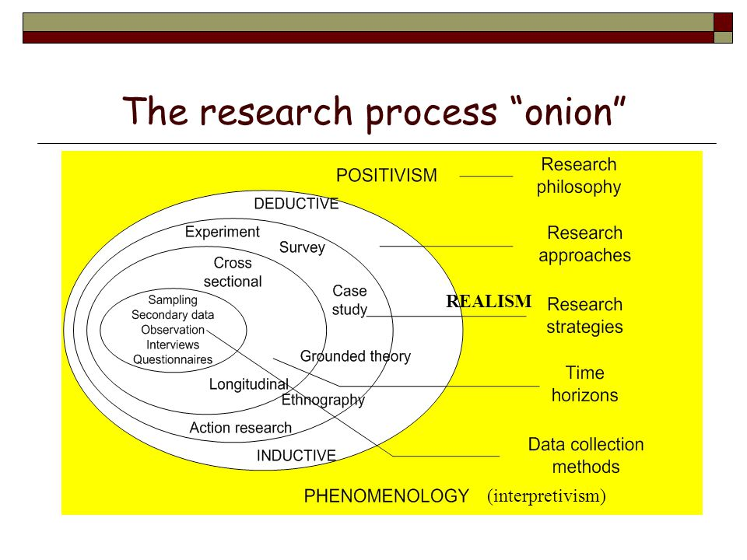
Figure 1: Positivism and Deduction [8]
This research would gain more from the philosophy positivism, as this project will be about utilising the current information retaining to social media marketing. The reasoning for choosing Positivism over Phenomenology is that Positivism is the approach that will entail the information gathered from scientific evidence, i.e. statistics, so show how an item operates. Using a positivism approach will also achieve the aims and the goals that were previously set in the proposal. The information gathered from this type of approach will be quantifiable and, also, will be credible as the information will be gathered from the source of the project background. In this case the information source will be Domino’s Pizza.
The other option for a development strategy is called Phenomology and is mainly used to research experiences. This approach could work for this type of project but would not be as suitable when considering the oval advantages that the positivism approach can give, when it comes to the type of information needed with this project. This type of strategy would focus on the human experiences, while the other option, will be using statistics. This type of strategy will not be very suitable for this project as there will be more of a need for the hard information, i.e. statistics.
The next step of the proposal will be to decide on the appropriate research approach that will complement the research philosophy. The research approach that will be suite this proposal will be the deductive approach. This means that the research approach will focus on building research through the use of theories and through the use of human insights. The overall nature of this type of research approach is that the nature will be change and adapt based on how the information is attained.
The research strategy that will be taking place will be the studying of current case studies and an experiment. The reasoning behind this will be that a case study(ies) will gain the relevant information needed for the project, while the experiment, i.e. surveys, will be used to attain a more human method of gaining the information. This means that the information gathered will be more from the customers of Domino’s Pizza and to show what they think of the social media advertisements that Domino’s Pizza implements on their social media page(s).

Information Collection Method
There will be information gathered for each objective and each main aim of the proposal. Going through the aim and the main goals will give a better understanding of what type of collection method will be utilised.
For the main aim and all the goals there will be one main method of collecting the data, this being the use of case studies. The use of case studies will be utilised in the sense of gaining information relating to the Domino’s Pizza promotional strategy. The other options were not really suited for this type of information, i.e. the use of a questionnaire would not really be useful for this project and therefore would not give the relevant information needed to get a keen understanding on the Domino’s Pizza promotional strategy.
In terms of the sample for the case study, Domino’s Pizza, annually, release a report that shows the different methods used and the overall earnings that they have received. This will be incredibly useful for this project, as that report should give all the necessary information needed. If the case study does not give the information needed then there are other ways around getting the necessary information; an example would be getting the information from the Domino’s Pizza store. This would be done by someone who works at Domino’s Pizza and would be valuable in the sense that the information comes straight from Domino’s Pizza and not made up by someone who does not understand Domino’s Pizza correctly.

Risks and Limitations
With any project there will be risks, there will be limitations and there will be issues relating to ethical and legal issues. This section will be about addressing these issues and how to overcome them, in a way that is beneficial and efficient for the overall project.
A risk is defined as “an uncertain event or condition that, if it occurs, has a positive or negative effect on a project's objectives” [9]. So tackling risks is of high importance to a project, as they can often hinder and/or stop a project in its entirety.
The risks for this project are that the information in the case study will not be adequate enough for the overall project. To overcome this risk there would need to be the use of questionnaires and the use of browsing the Domino’s Pizza Social Media pages to get a better understanding of the promotional strategies that are taking place. The use of questionnaires will be implemented mainly to get information from the customer base, but also could be used for the Domino’s Pizza staff. This is because the Domino’s Pizza staff, mainly the area managers, will know a lot about Domino’s Pizza and how Domino’s Pizza will operate online and offline; this is the best shot for attaining any information that will not be gathered from the case study(ies)
An ethical issue will be defined as “A problem or situation that requires a person or organization to choose between alternatives that must be evaluated as right (ethical) or wrong (unethical).” By BusinessDictionary [10]. One ethical issue which would stand over the rest would be that in the use of the questionnaire, the people might have to put down their age and/or their names. If the customer will not want to put down their name and/or age then it raises the ethical issue even further. To combat this issues there could be an “anonymous” section for the questionnaire, i.e. a place where the customer does not need to put down their name and/or age, so that they can remain detached if they so please.
A legal issue that sticks out will be the issue surrounding the use of the information from the case study and/or the use of information gathered from Domino’s Pizza. This would be a potential legal issue, as if the information gathered is only for one person then putting down that information will be a breach of privacy and will therefore become a legal matter if known to that person. To overcome this issue, there could be the use of applying the person’s name, crediting the person, or to credit where the information was found and how it was found. This would make it less of a legal issue as there would be viable credits for the information and how the information was found.

Analysing the project
The main method of analysing this project will be through the use of comparing the project to the main aim and the main goals. The reasoning behind this is to see if the aims and the goals have been attained. If the main aim and the main goals have been attained then the project should be a success and, of course, if the main aims and goals have not been met then the project will have potentially failed. This is not always the case because if the goals and aims are not met then, depending on the results, a new project idea could be made and/or the project could have proven a different theory. A failure is not always a failure, but it can be just that depending on the style of the project.

Conclusion
Throughout this section, the research and development methods have been decided, these being how the research is going to take place. It has been decided that the use of a positivism approach will be done with a deductive approach of gaining the information; this is done as they complement the type of information that is needed within the project and they also complement each other’s information gathering style.
Secondly, we went over the information collection method. In this section it was decided that the use of case studies and the use of questionnaires would be used to gather the information as they each offer different methods of gaining the information needed for the project; the case study(ies) will offer a more business-like information and the questionnaire will allow for a more informal customer-like method of gaining the information.
Thirdly, the risks were decided; this includes ethical, legal and general risks to the project. These risks were identified and also a method of working around them was also formed, as to make it so that the risks will not really affect he project in the long term.
Lastly, the method of analysing the project was decided on. This was done with the use of comparing the aims and the goals to the end project. This will allow the analysing of the project because it will show if the project has followed the aims and the goals, if the end project has followed and produced the results for the aims and the goals then the project has been an overall success, while if the project has not followed the overall aims and goals then the project could be deemed a failure.
In the next section, there will be talks on what resources are going to be used and a Gantt chart will be made to show how the resources are going to be decided on and how the resources are going to be used within the project.

Resources and Planning

Introduction
When it comes to a project there has to be resources that the user can use to find the information/make the project. These resources could range from a lecturer, to a library to the internet; this could also involve the use of money as a resource, as this could be used to buy certain information.
There are different types of resources, there are the information based resources; these would include items like a library/forums/websites. There are also the physical resources; these would include items like a computer or a person of interest, i.e. a lecturer.
For this project, the main resources would be;
- PC’s
- Internet
- Library
- Domino’s Pizza
- Lecturers
- Microsoft Office Word
- Microsoft Office Project
- Access to academic resources (Journals, Papers etc)
Microsoft Project has been utilised to show the planning stages of the project. This has been used as Microsoft Project is designed and built to allow the planning of a project in an efficient and simple way.

Conclusion
The overall resources needed in this project have been planned out. These are the main resources and will be used with every step of the project. There might be some resources that have not been considered and/or some resources that might not be needed, as there is no way of telling this is not a bad thing but will have to be considered as such until the project is completed.
In terms of the entirety of the project plan, it is still too early to see if the plan will work or if the plan with ultimately fail. The only way of knowing if the project will work is when the project is being worked on and being created and implemented; this will see if the plan is achievable.
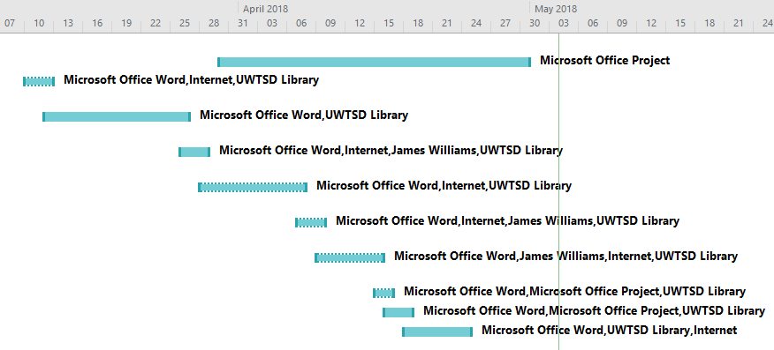
Figure 2: Microsoft Project Plan Timeline

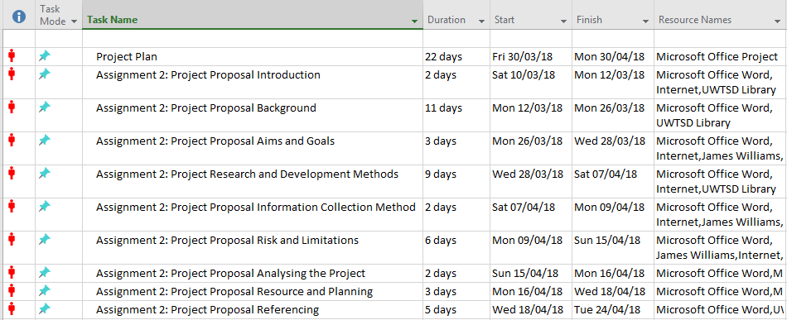
Figure 3: Microsoft Office Project Information

Bibliography

[1] | T. R. Graeff, “Product comprehension and promotional strategies,” Journal of Consumer Marketing, vol. XII, no. 2, pp. 28-39, 1995.
[2] | K. S. Leonidou, “Marketing strategy determinants of export performance: a meta-analysis,” Journal of Business Research, vol. LV, no. 1, pp. 51-67, 2002.
[3] | C. G. F. M. C. Y. Cana, “Clientele recognition of library terms and concepts used by librarians: a case of an academic”.
[4] | Hofstede, Culture's Consequences: International Differences in Work-Related Values, 1984.
[5] | S. P. Rylander, “Toward a Synthesized Framework of Relational Commitment: Implications for Marketing Channel Theory and Practice,” Journal of Marketing Theory and Practice, vol. V, no. 2, pp. 58-71, 2015.
[6] | S. G. P. S. L. Lisettede Vries, “Popularity of Brand Posts on Brand Fan Pages: An Investigation of the Effects of Social Media Marketing,” Journal of Interactive Marketing, vol. XXVI, no. 2, pp. 83-91, 2012.
[7] | J. V. Dijck, The Culture of Connectivity: A Critical History of Social Media.
[8] | revisesociology, “Positivism and Interpretivism in Social Research,” 18 May 2015. [Online]. Available: https://revisesociology.com/2015/05/18/positivism-interpretivism-sociology/. [Accessed 30 April 2018].
[9] | PMI, “Practice Standard Project Risk Management,” PMI, [Online]. Available: www.pmi.org. [Accessed 30 April 2018].
[10] | BusinessDictionary, “ethical issue,” BusinessDictionary, [Online]. Available: http://www.businessdictionary.com/definition/ethical-issue.html. [Accessed 03 April 2018].
[11] | T. A. Petit, “PUTTING STRATEGY INTO PROMOTION MIX DECISIONS,” Journal of Consumer Marketing, vol. II, no. 1, pp. 41-47, 1985.

