

CIPD Level 7 postgraduate diploma in
Human Resource Management

Employment Relations consideration in Change Management Strategies at the College of Arts and Humanities

Managing Employment Relations
BMHR7009
Rebecca Griffiths
1710889
Word Count: 4950
Executive Summary
The College of Arts and Humanities (COAH) have experienced resistance to change strategies in relation to technological change, which has impeded COAH’s performance. The pace of change in the current environment is unprecedented and future technological change is certain. The extent and speed however is unpredictable. COAH recognises a number of strategies in leading their employees through change however; the evidence suggests that these strategies have not been effective in their results.
This paper considers the strategies utilised by COAH in response to change. Consideration is given to employee response summarising areas of ineffectiveness. In order to make a thorough assessment, it is necessary to refer to the literature to understand key themes when analysing the employment relationship in this context.
A review of the literature has provided an alternative framework for analysing the employment relationship in terms of the psychological contract. Used in conjunction with other strategies there is potential for COAH to improve the employment relations whilst managing change.

Contents
Executive Summary

- Introduction 3
  - Business Context 3
  - Rationale 4
  - Methodology 6

- Discussion 7
  - Operating Environment 7
    - PESTLE Analysis 7
    - Technological Change 8
    - Change Management at COAH 10
  - Employee Relations 11
    - Definition 11
    - Perspectives & Approaches 12
    - The Employment Relationship & Psychological Contract 14
  - Managing Employment Relations 16
    - Employers and Managers 17
    - Employees, Representatives & Unions 18
    - The State 20

- Conclusion 23

- Recommendations 26

- References 28

List of Tables
Table 1. SU digital marking strategy rationale
Table 2. Work Intensity, Autonomy and Intrusion
Table 3. Literary comparisons to of technological change on ER at COAH
Table 4. Traditional and HRM approach to MER
Table 5. Actions from the State impacting ER

List of Figures
Figure 1. Change and L&D strategies implemented in the COAH adoption of
Grademark
Figure 2. The impact of technology on ER
Figure 3. Unitarist Perspective
Figure 4. Pluralist Perspective
Figure 5. Employee Relations Framework
Figure 6. Framework for applying the psychological contract to the employment
Relationship
Figure 7. The actors of the Psychological Contract
Figure 8. Workplaces with a union presence (%)
Figure 9. The State on ER Policy and Practice

Appendices
- PESTLE Analysis

1 Introduction

The College of Arts and Humanities (COAH), offers students a wide variety of study and work abroad options and is an integral function of Swansea University (SU) particularly due to the research outputs of the department and the revenue generated from teaching. SU utilises a number of strategies in order to achieve its goals and to respond to market demands such as its vision to become more accessible and increase diversity on its campus’ (Swansea University, 2018; Swansea University, 2019b). COAH has a significant role to play in achieving the organisations goals, for example, the surplus revenue generated by COAH undergraduate degrees is used to subsidise the cost of the Engineering. Furthermore, COAH’s robust network of stakeholders and collaborations across a variety of sectors enriches and facilitates a diverse portfolio of outputs, which has a societal and cultural impact at a local, national and international level (Swansea University, 2019a).

  - Business Context

Swansea University has undergone a period of substantial growth and development, which demands a concomitant response from the individual Colleges and departments. COAH has notoriously failed to transform in line with the internal demands of the University particularly where workforce attitudes to change are concerned. COAH has for a number of years demonstrated the highest number of student extenuating circumstances applications coupled with poor student attendance monitoring. It is suggested that this poor performance is due to the Colleges inability to implement change in response to market demands; i.e. introducing College level wellbeing strategies and ineffective use of new technologies implementation (McVeigh, 2019; Waddington, 2019). It is essential that COAH demonstrate the ability to respond effectively to changes in the external market, particularly in an environment, which is volatile, uncertain, complex and ambiguous (VUCA) (Bennett and Lemoine, 2014). The current Higher Education (HE) market is subject to a number of significant external factors such as BREXIT, demographic shifts and legislative changes therefore it is essential that COAH and SU are able to manage the pace of change remaining competitive in the process (Guest, 2004). There is a distinct need for COAH to demonstrate proactive abilities instead of reactive in order to remain competitive and demonstrate agility in their core functionality, workforce planning and their ability to implement and react to change (Beech, 2018a; Beech, 2018b; CIPD, 2018b; CIPD, 2018b; Inham, 2017).

- Rationale

A primary area of concern for COAH is employee resistance to change strategies brought about because of central University demands to market trends. As previously mentioned the College is underperforming due to the inability to implement change efficiently and there is a significant example of how this has effected the College.

In 2014 COAH were required to adopt a digital marking system called ‘Grademark’ via Turnitin, the argument for the change is depicted in table 1. During this transition, the change strategy met significant employee resistance, which led to trade union (TU) and occupational health (OH) participation in order to negotiate reasonable adjustment and resolution between all parties concerned.

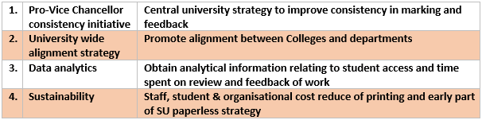
Table 1. SU digital marking strategy rationale (adaption of McVeigh, 2019)

The College utilised a number of recognised strategies in order to navigate change (figure 1). The initial step to ‘inform’ was organised in order to provide COAH staff with the information regarding the rationale for change, the implementation strategy and who would be affected and how. There was opportunity for staff to ask questions and highlight concerns.
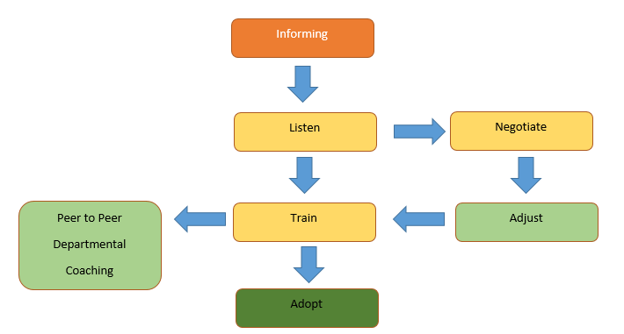
Figure 1. Change implemented I strategy for the adoption of Grademark at COAH (adaptation of Waddington, 2019)

The fundamental causes of employee resistance were as follows;
- digital literacy
- medical issues
- working patters
- resources
- anxiety regarding loss of individualisation
(Mcveigh, 2019)

During the negotiation process, University and College Union (UCU) represented the employees and there was consultation from OH. During the negotiation process a number of adjustments were made. Where medical grounds were claimed, OH were consulted and informed HR of any recommendations and adjustments required in order to assist the employee to undertake the work safely. There were two instances where medical conditions inhibited the employee’s from using the system. The adjustments made to the process were; employees are able to print and mark the work using a paper copy whereby the feedback and mark are uploaded to the digital system.

The process of implementing this change to a majority adoption took 2 years, with a subsequent additional 18 months when the Department of Adult Education (DACE) became managed by COAH (McVeigh, 2019; Waddington, 2019). In this instance, there was increased hostility in relation to tutor adoption of the process and it was reported that a number of employees retired in response (McVeigh, 2019; Waddington, 2019).

The purpose of this report is review the employment relationship (ER) issue of managing employee resistance in the context of delivering change strategies in an attempt to evaluate COAH practises in line with contemporary best practice. This report proposes to make recommendations informed by theoretical best practices, which will contribute to positive change management response and the College’s overall performance.

- Methodology

The discussion chapter of this paper analyses the environment in which the College operates in order to ascertain the potential change aggregators, which in turn may influence the ER. Secondly, a review of the literature will further evaluate the potential impact of technological change in the workplace in specific relation to ER. The way in which COAH have managed change and employee response to change will be reviewed.

The second part of the discussion chapter will define ER in an attempt to evaluate how attitudes to workplace conflict have transitioned. The ER and the actors who have the ability to influence the dynamics of the ER such as employers and managers, employees, reps and unions and the state are also considered.

2 Discussion

2.1 Operating Environment

COAH is operating in a VUCA environment where pace of change is unprecedented. The velocity of change can be attributed to key external changes and developments such as Political, Economic, Social, Technological and Environmental shifts (CIPD, 2018a; Sadler, 2001). Each external factor has the potential to ignite a need for change at College level, which requires effective organisational change implementation. Guest (2004) argues that the pervasiveness and pace of change owing to technological advances requires urgent and flexible response to remain competitive. In consideration of the rationale of this report; where employee response to technological change has been widely negative and in turn had a negative effect on College performance, it is then necessary to review how COAH manages ER in direct relation to change management. Guest (2004) further argues that there is a definitive need to develop a new framework that effectively analyses the overarching employment relationship, which is also subject to the challenges of the VUCA environment.

  - PESTLE Analysis

In order to asses COAH’s position in the context of ER, it is necessary to scan the external environment to highlight factors which have the potential to impact the way in which the College operates, and in particular, factors which could affect the ER. The PESTLE analysis framework was utilised and conducted for this purpose due to its flexibility and value in assisting organisations prepare for change (CIPD, 2018a). The PESTLE analysis framework is advantageous in the sense that it is a simple framework to use and encourages strategic thinking in order to avoid or minimise internal and external threats, however, it is also understood that conducting a PESTLE can in some instances be oversimplified therefore not providing a substantive reflection of threats to the organisation (CIPD, 2018a). To create a robust analysis of the internal and external aggregators to an organisation it is recommended that a PESTLE analysis should be conducted as a group task and in conjunction with other means of analysis such as SWOT in order to strengthen the output (CIPD, 2018a). The time constraints of this report could not afford a cumulative means of analysis however, this provides potential for further research.

The PESTLE analysis (appendix 001) has highlighted a number of external factors, which have been identified as significantly important to the way in which COAH performs. The time and word count constraints of this research do not allow for each of the factors to be directly considered however due to the nature of the report and consideration of the rationale, focus will be afforded to technological change in relation to potential threats to the ER.

    - Technological Change

There is an abundance of literature which argues the impact of technology on the modern workplace; discussions amongst academics and human resources (HR) practitioners in relation to the extent, speed and indeed the transformation of the world of work are prolific (Acas, 2017; CIPD, 2019b; Deloitte, 2019; Higginbottom, 2018; McKinsey Digital, 2016; PWC; 2019; Stubbings, 2017). Whilst it is difficult to predict the true impact of technological change in the workplace, it is possible to assess the impact of contemporary technological change on the ER (table 2).
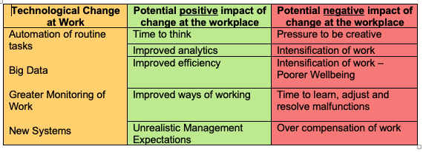
Table 2. Work Intensity, Autonomy and Intrusion (adapted from Brione, 2017)

An analysis of a report published on behalf of Acas (2017) explores the way in which technology can make work both easier and harder, the findings have been summarised in table 2. Whilst it is important to understand the way in which work can be effected, the purpose of this report is to analyse the impact of technological change on the ER and how organisations should approach change management in response.
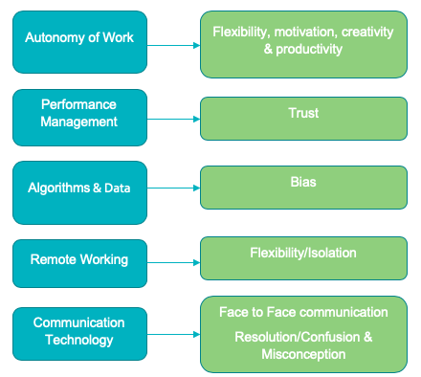
Figure 2. The impact of technology on ER (adapted from Brione, 2017)

The findings in figure 2 highlight a number of ways in which technological change can influence the ER. There is recognition that advances in automation technology can allow professionals to spend less time on the routine and repetitive tasks and dedicate more of their time to creativity, knowledge tasks and working autonomously (Gardner et al. 2003). In contradiction, the improper use of performance management technology has the potential to ignite a feeling of distrust among employees resulting in poorer engagement, breakdown of the ER and higher staff turnover (Crayon, 1994 as cited in Brione, 2016). It is possible to draw comparisons between the causes of resistance to change at COAH as highlighted in the rationale of this report and those recognised in the literature.

Table 2. Literary comparisons to of technological change on ER at COAH

The literature supports that technological change can influence the ER in a number of ways both positively and negatively (Brione, 2017; Bruce, 2018; CIPD, 2019b; Deloitte, 2019; Gardner, 2003). The pace of technological change can directly affect the way in which organisations are able to respond. To manage change effectively, organisations need to adopt a number of change strategies, which are compliant from an ER perspective in order to succeed (CIPD, 2019b, Deloitte, 2019).

Whilst drawing on the comparisons between the literature and the resistance to technological change at COAH there was another area that was highlighted as having a significant impact on response to change. It is necessary to highlight that generational differences in the workplace invite varying responses to technological change. This topic deserves sufficient attention, which suggests further research is required.

2.1.3 Change Management at COAH

SU advocates a university wide coaching style of management where each employee grade 7 and above undertakes the formal ‘Developing a Coaching Style of Leadership’ training provided by Worth Learning (2018). During this training COAH leaders are encouraged to develop their coaching skills in order to ‘help people move through change’ (Worth Consulting, 2018). The training utilises the Kubler Ross Change Curve in order to recognise the stages employees undergo during change. Worth Consulting (2018) explain that by raising awareness about the necessity for change and in turn the benefits of change it is possible to create an environment where change is perceived as a challenge to be undertaken rather than feared.

Adopting a coaching style and in particular using the change curve is useful in the sense that it allows the leader to recognise the varying stages each employee or group of employees are at and allows a tailored style of coaching in response (Worth Consulting, 2018, Kerley, 2018). There are however, limitations to consider when using the change curve model. The model is considered as broad in that there is no standard pattern of employee reaction due to variables in perception, time and resilience (Hayes, 2014). The change curve also suggests that these stages are linear however this is not always the case, the existence of a simultaneous change (such as a personal issue) has the potential to affect the way in which an employee transitions through a work based change or possibly regresses (Hayes, 2014).

This report has discussed the environment in which COAH operates and the factors that have the potential to ignite change in relation to the ER. The way in which COAH manages change together with employee response. The preceding section in this discussion chapter will propose a definition of ER, approaches and perspectives and an alternative framework for evaluating the ER.

  - Employment Relations

    - Definition

Employment Relations (ER) in its simplicity defines the relationship between employer and employee, the interdisciplinary nature of this relationship and the transformation the topic has undergone is far more complex than this initial definition. During the 1970’s the employer/employee relationship was categorised under the term IR which according to the literature explains the collective and often adversarial nature of the employment relationship (CIPD, 2018d; Gennard and Judge, 2005; Leat, 2007). The term IR inevitably became associated with the TU’s who represented the collective employee voice and negotiated with the actors (employers, the state and third parties) on their behalf (Gennard and Judge, 2005; Leat, 2007). Attitudes to the ER have evolved since the 1970’s in conjunction with the transformation from Personnel Management (PM) to contemporary Human Resources Management (HRM) (Farnham, 2015; Guest, 2004) driven by the radical changes in the labour market due to globalisation, technological, social, political and economic shifts (Farnham, 2015; Gennard and Judge, 2005). The following definition of ER offered by Lewis et al. (2003, pp. 6) will be utilised for the purpose of this report.

“The employment relationship is an economic, legal, social, psychological and political relationship in which the employee devotes their time and expertise to the interests of the employer in return for a range of personal and financial and non-financial rewards.”

The contemporary ER epitomises the contractual (legal and psychological), collective and individual dimensions of the relationship, includes union and non-union participation, all facets of actors and extends to consider the wider context of the relationship including the changing nature of work (Farnham, 2015; Lewis et al. 2003; Leat, 2007).

    - Perspectives and Approaches

In the context of ER, scholarly attention is widely afforded to understanding the perspective of the populous (Abbott, 2006; Ackers, 2017; Budd and Bhave, 2008; Lewis et al. 2003; Muller Jentsch, 2004; Provis, 1996). Perspective is determined through socialisation and experience and thus has a direct effect on how individuals view, participate and respond to relationships in the workplace. The view and understanding that each individual has determines how one may approach any given issue, concept or a particular event that they encounter. An organisation may broadly adopt a particular perspective as an ideology in order to manage change or ignite organisational culture.
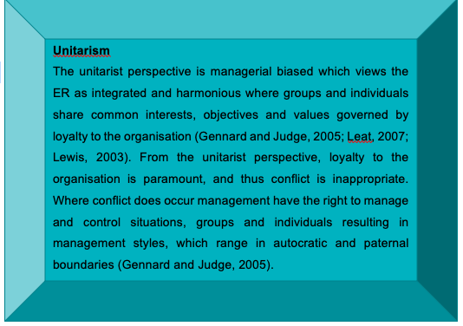
Figure 3. Unitary Perspective

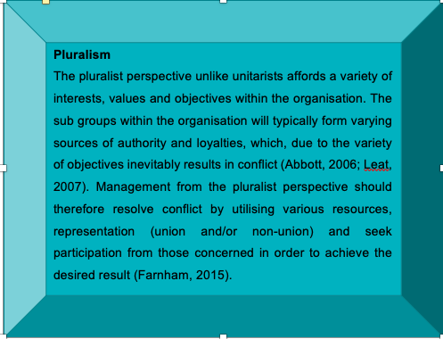
Figure 4. Pluralist Perspective

Perspectives are not limited to one exclusive nature; they can be interchangeable depending on the circumstance, environment and need of the actor as such, categorising organisations to one specific perspective has limitations (Bingham, 2016; Farnham, 2015; Storey, 2000). Provis (1996) argues that due to the increased emphasis on culture and values in the workplace the aforementioned perspectives require revision of interests and structure to avoid paradox and contradiction. It is suggested that analysing and reviewing ER by traditional perspectives is outdated, thus unsuitable for the contemporary workplace (Heery, 2016; Hollinshead, 2018; Kohler, 2018) however Farnham’s (2015) interpretation of the HRM approach (table 3) has been portrayed in the modern, unitarist and individualism understanding of the HRM function.
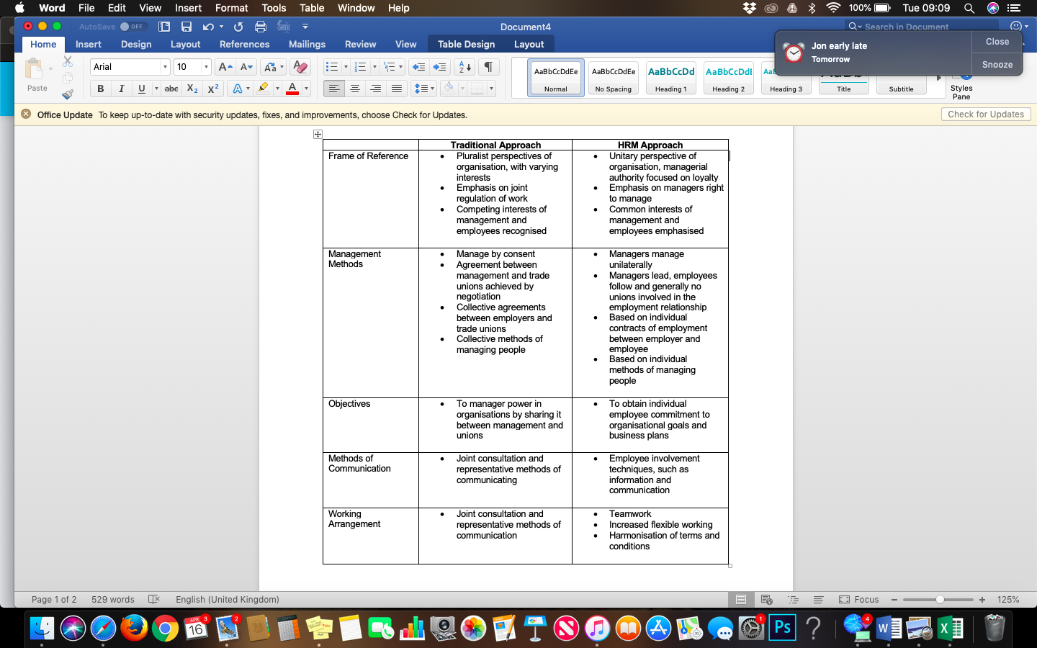
Table 3. Traditional and HRM approach to MER (adaption of Farnham, 2015 approaches to MER)

In relation to context of this paper, it is hypothesised that COAH demonstrated a pluralist perspective where employees and employer had contradicting interests, resulting in the need for a number of mediators including TU’s and OH. Evaluating the wider context of the rationale, COAH as a College demonstrated a unitary nature in that the College’s objectives are aligned with the wider University with a distinct need to align.

    - The Employment Relationship & Psychological Contract

The ER should not be considered in isolation from the wider context. Leat (2007) offers a framework for the study of ER (figure 5) which considers the wider agenda of ER aggregators. At the centre of the framework is the contractual ER which can be characterised as both legal and psychological (CIPD, 2018d; Gennard and Judge, 2005; Leat, 2007; Lewis et al. 2003). Whilst Leat’s (2007) framework is useful in the analysis of the wider context of ER it does not provide the individual contextual and background factors as highlighted by (Guest, 2004).

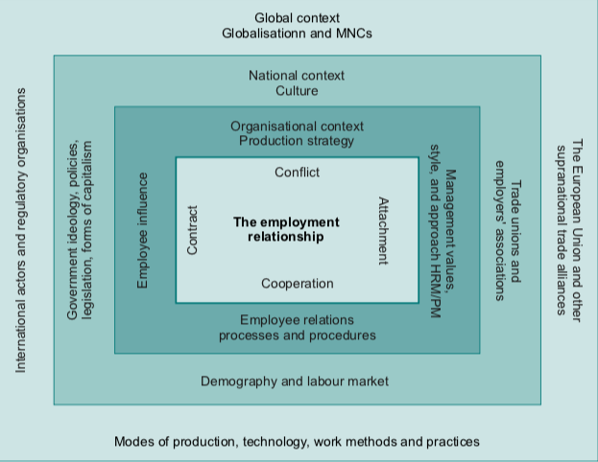
Figure 5. Employment Relations Framework (Leat, 2008)

Psychological Contract
The notion of the psychological contract (PC) suggests that in addition to the formal employment contract there exists subjective and reciprocal informal and unwritten assumptions and expectations about the nature of the ER (CIPD 2018d; Farnham, 2015; Gennard and Judge, 2005; Leat, 2007; Lewis et al. 2003). The CIPD (2019) affirm that the ER is more than the regulated transaction dictated by the legal contract and that the PC may be more influential when assessing the quality of the ER.

The increased validity of the PC in considering the ER can be attributed to the shift of the HRM function as a response to global, organisational and economic change (Farham, 2015; Guest, 2004) from a collective to individual level where a key goal is to obtain high employee commitment (Guest, 2004; Hayes, 2014). There is evidence to suggest that employees who demonstrate more commitment to an organisation will be more receptive to change (Hayes, 2014). Guest (2004) proposes a framework for applying the PS to the analysis of the ER, which considers context, content and consequence. In relation to the context of this report Guest’s (ibid) framework would offer substantive means of analysis as it considers a considerable amount of ER aggregators particularly when managing change.

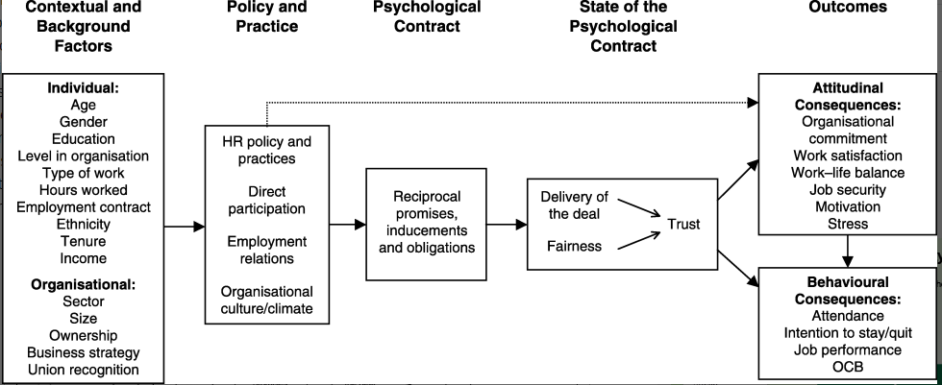
Figure 6. Framework for applying the psychological contract to the employment relationship (Guest, 2004)

The limitations of adopting a PC means of analysis in relation to response to change is that much of the study in the area has been undertaken from the employee perspective (CIPD, 2019; Guest, 2004). There is little empirical evidence to support the use of PC analysis of employer response when they believe that they employee has failed to meet their obligations (Guest, 2004).

  - Managing Employment Relations

The definition of ER has indicated the primary actors in the relationship, the employer and employee. Yet, there are additional actors who contribute to the way in which the ER is managed. Each party has a fundamental role and function in the management of the ER either individually or collectively and be it at organisational level or in a national context (Leat, 2008; Gennard et al. 2016; Guest, 2004). The nature and quality of the ER is defined and facilitated by the actors: employers and managers; employees, their representatives, and the State.

    - Employers & Managers

A number of varying factors inform the way in which employers and managers approach the ER. A predominant variant is the employing sector. In the UK over 80% of the workforce are employed by the private sector (ONS, 2019) where 99% of private organisations are small and medium sized enterprises (SME’s) (Gennard et al. 2016). The availability of specialist HR functions at SME’s is limited resulting in employers and managers accessing advice and support from legal professionals, consultants, employer associations and Acas (Gennard et al. 2016).

In larger private organisations who are owned by shareholders and managed by professionals, there is likelihood of a dedicated HR function. The objectives of the HR function and effect on ER will vary. Accordingly, in larger organisations there will be a number of managers ranging in seniority. These managers will have varying attitudes and values within the organisation depending on a number of variables such as stakeholders, experience and seniority (Gennard et al. 2016).

Each of these variables has to the potential to influence the PC; referring to Guest’s (2004) framework, the actors have the potential to have a direct impact on the PC through ‘Contextual and Background Factors’ (figure 7). In considering these factors in change management strategies in the context of ER, there is potential for favourable improvements.

Figure 7. The actors of Psychological Contract

    - Employee Representatives & Unions

The history upon which the ER has evolved has been highlighted in the preceding sections of this report. It is possible to apply the same context to the way in which employees have been represented in the workplace. Employees historically gained a collective voice through TU membership who primarily emerged to assist in rebalancing the power of the ER (Leat, 2008). Individual TU’s can be assessed in relation to their objectives and whether they are politically or business focused (Leat, 2008). TU’s can also perform independently from influence of organisations or in association with organisations.

During the 1970’s the UK recorded over 13 million TU members and exceeded 50% of the workforce (Leat, 2008). Over 5 million of those members were lost during the 1980’s. Circa 1995, the number of unionised workplaces has not significantly changed (figure 8).
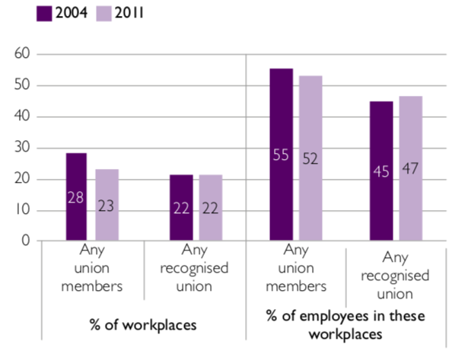
Figure 8. Workplaces with a union presence (%) (WERS, 2011)

Whilst TU membership and involvement in UK organisations has decreased dramatically over the last, 40 years they are still considered a primary actor of the ER and exist in order to protect and pursue the interests of their members (Gennard et al, 2016).

In response to the decline of union membership and power, it is argued that the Trade Union Congress (TUC) has changed its strategic focus in an attempt to reform unionism. There is debate that the reformed objectives of TUC is to form partnerships at organisational and national level (Heery, 2002; Johnstone, 2014, Simms et al. 2019).

From a PS perspective, Guest (2004) argues that due to the demise of TU representation in the workplace, and indeed a general decline in workforce numbers particularly in smaller organisations employer – employee relationships are more personal which limits the requirement for independent representation. This suggestion however is not supported empirically and the wider literature suggests alternative causes for the declining need for union representation.

    - The State

The State is the most significant actor in shaping organisational ER structure through its role as politician, economist and legislator (Dundon and Rollinson, 2011; Gennard et al, 2016). In this regard, it is worthy to note that the State is not a single actor and each facet will have its individual influence on ER (Dundon and Rollinson, 2011). This paper however considers the State in its broadest sense in order to assess significant developments in ER. Table 4 provides details significant developments in ER as a direct result of State influence.
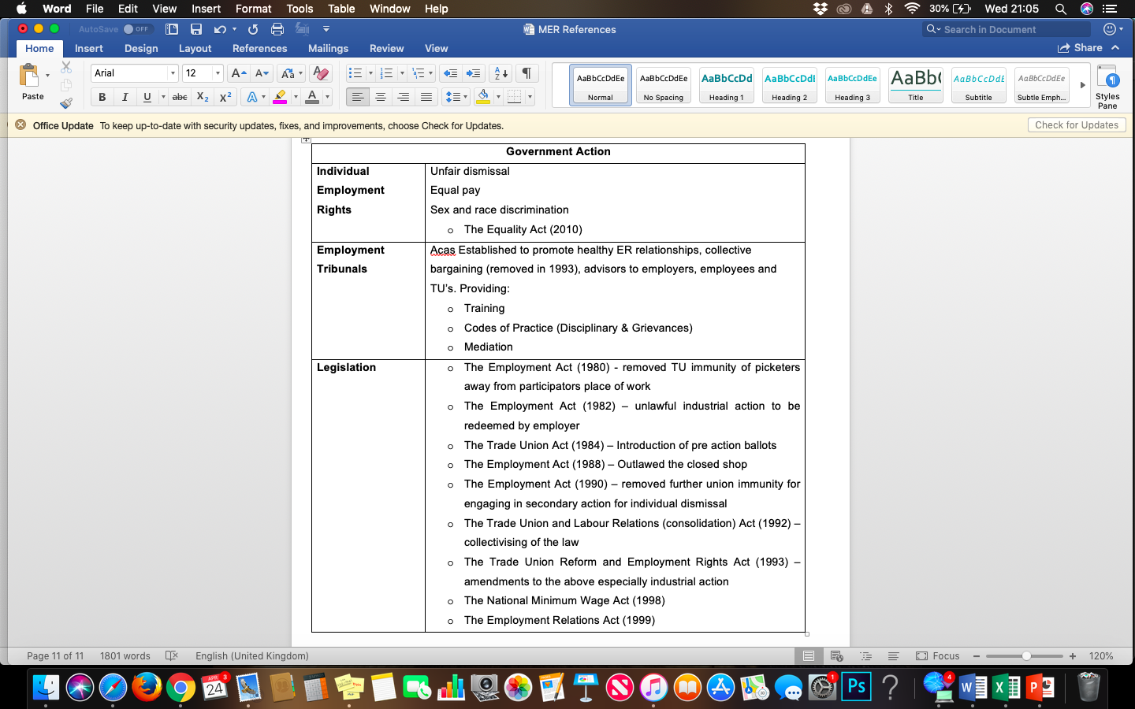
Table 4. Actions from the State impacting ER

The objectives of the State for concerning themselves matters of the ER are primarily to manage the social and economic environment of the nation. The way this is achieved is attributed to the ideology of the controlling political party (Dundon, 2011; Gennard et al. 2016) which inevitably affect the ‘Policy and Practice’ element of Guest’s PC framework (2004) (figure 9).

Figure 9. The State on ER Policy and Practice

The State is also a significant employer in the UK, employing 5.37% of the workforce (ONS, 2019). It is argued that the State has traditionally been cast as a model employer from a procedural viewpoint in the sense of advocating employee voice and equality (Bach, 2011) and often characterised by job stability and good working conditions (Gennard et al, 2016; Leat, 2008).

In recent years however, there has been a definitive shift in the privatisation of publicly owned and managed organisations in an effort reduce the UK deficit which in conjunction with the demise of the public pension creates challenges to the public sector ethos (Bach, 2011; Gennard et al, 2016). It is then almost paradoxical that the government champions the prolific research and implementation of employee centric improvements strategies such as the Macload and Clark report (2009) to make employee engagement a national discussion point or the Taylor Review (2017) focusing on good working practices.

Conclusion

The literature has been reviewed in the context of the rationale of this report and indicates that technological advances have the potential to affect the ER in both positive and negative ways (Brione, 2017). COAH have recently witnessed such impacts on ER at the College, which has negatively affected their performance. It is impossible to predict the extent to which ER will change as a result of technological advances however by reviewing contemporary cause and affect it is possible to surmise that in order to facilitate technological change effectively, organisations need to manage change by utilising strategies which are ER centric (CIPD, 2019b, Deloitte, 2019). Whilst COAH has adopted a recognised coaching means of managing change, it is evidenced that current strategies are essentially reactive in nature and broad in their approach. In order to remain competitive, COAH must develop proactive agile strategies to manage change in relation to ER (CIPD, 2018b; CIPD, 2018b; Inham, 2017).

The last 30-40 years has witnessed significant developments in approaches to ER due to extensive external and internal factors. There are a number of broad interchangeable perspectives and approaches whilst considering ER, which are affected and facilitated by a number of actors (Bingham, 2016; Farnham, 2015; Storey, 2000). It is therefore argued that traditional means of analysing the ER in this sense is outdated (Heery, 2016; Hollinshead, 2018; Kohler, 2018; Provis, 1996).

Guest (2004) proposes a PC framework for the analysis of ER. The framework evaluates the contextual and background factors and policy and practice factors, which result in the individual PC and subsequently the outcomes of the employee. By adopting the framework to assess the potential effects of change on the PC, it is possible to manipulate responses to change which are more favourable to the organisation. This is achieved by considering numerous aggregates of the PC and adopting them to ensure that the employees do not feel consider their PC at risk.

In relation to the context of this report, had COAH invested more resources in this regard then employee resistance to change could potentially have been less significant which may have resulted in a smoother more timely transition.

Recommendations
The conclusion chapter of this report has highlighted the findings of the literature and a distinct recommendation is that COAH should adopt strategies that are more ER centric when managing change. This report has suggested that in order to do so COAH should recognise the PC framework in assessing potential impact of change on the PC.

This section of the report is dedicated to highlighting recommendations on how COAH are able implement PS focused analysis.

- Defending Human Values

This recommendation is about learning and recognising individualisation. Loss of autonomy of work due to technological change was a central fear amongst employees in the literature and at COAH. Whilst organisational values are a key focus in contemporary organisations, it is important to recognise individual human values. By recognising and engaging in the defence of human values, there is opportunity to appease the individual PC.

Methods
- Generic, relaxed discussions regarding changes in technology and how jobs may look in the future
- Values board – creating a space for employees to voice anonymous concerns ensuring that responses are received via the board and via open discussion
- COAH departmental visits – liaising with other departments, Colleges and Universities who have implemented technology to see how it works for them
- Using technology for fun. Organising away days to VR studios or visiting a Digital Art Gallery such as the Atelier des Lumieres in Paris or a number of exhibitions at the V&A.

- Peer to Peer Scheme

In recognition of the individual factors, which affect the PC and in turn individual responses to change, the implementation of a peer to peer support scheme would encourage employees of like-mindedness and variety to communicate, understand and learn.

Methods
- Create a number of projects for which teams have entire responsibility
- Ensure that the teams are diverse for maximum affect
- The projects will need to be constructive to the department however will have an underlying greater message regarding the environment in which the College and University operate.

For Example:

TASK

How can COAH improve student resilience?

  - Task forces/Working Groups
1. Literature Research
2. Primary Research
3. Budgets
4. Logistics
  - Each taskforce has a purpose, will learn about the wider context of why COAH needs to develop. The literature will support SU and COAH strategy as will Student Feedback creating greater appreciation from the employee perspective. Where employees are able to understand the need for change and how change can help the individual and the greater good, buy in is increased.

By implementing these two introductory recommendations via numerous means, it is possible to alleviate the damage caused to the PC during change implementation strategies. It is vital that COAH recognise the contextual and background factors of the individual and the organisation, consideration also need to be afforded to the Policy and Practice guidelines in relation to the expectations of the employee.

5 References

Abbott, K. (2006) ‘A Review of Employment Relations Theories and Their Application’, Problems and Perspectives in Management, 4(1), pp. 187-199.

Ackers, P. (2017) ‘Reframing Employment Relations: the case for neo-pluralism’, Industrial Relations Journal, 33(1), pp. 2-19.

Bach, S. (2011) ‘A new era of public service employment relations? The challenges ahead’, Acas Future of Workplace Relations Discussion Paper Series.

Bennett, N. and Lemoine, J. (2014) ‘What VUCA Really Means for You’, Harvard Business Review. Available at: https://hbr.org/2014/01/what-vuca-really-means-for-you (Accessed: 9th January 2019).

Beech, D. (2018a) ‘Higher Education in Brexit Britain: A Changing Future for International Students in the UK’, Higher Education Policy Institute [Blog]. 21 Feb. Available at: https://www.hepi.ac.uk/2018/02/21/higher-education-brexit-britain-changing-future-international-students-uk/ (Accessed: 11th January 2019).

Beech, D. (2018b) ‘Change is Coming: How Universities Can Navigate Through Turbulent Political Times’, Higher Education Policy Institute. HEPI Policy Note 7. Available at: https://www.hepi.ac.uk/wp-content/uploads/2018/06/Policy-Note-7-Paper-June-2018-2.pdf (Accessed: 18th February 2019).

Bingham, C. (2016) Employment Relations: Fairness & Trust in the Workplace. London: Sage.

Bouckenooghe, D. (2010). Positioning Change Recipients’ Attitudes Toward Change in the Organizational Change Literature. The Journal of Applied Behavioural Science, 46(4), 500–531. Available at: https://doi.org/10.1177/0021886310367944 (Accessed: 15th April 2019).

Brione, P. (2017) ‘Mind Over Machines: New technology and employee relations’, IPA & ACAS. Available at: http://www.acas.org.uk/media/pdf/i/9/Minds-over-Machines-New-Technology-and-Employment-Relations.pdf (Accessed: 16th April 2019).

Bruce, J (2018) ‘Change Is The New Normal. How Will You Handle It?’, Forbes. Available at: https://www.forbes.com/sites/janbruce/2018/09/05/change-is-the-new-normal-how-will-you-handle-it/#28e310613959 (Accessed: 16th March 2019).

Budd, J. and Bhave, D. (2008) ‘Values, Ideologies and Frames of Reference in Industrial Relations’, in Blyton, P. et al. (ed.) The Sage Handbook of Industrial Relations. London: Sage Publications Ltd.

CIPD (2018a) PESTLE Analysis. Available at: https://www.cipd.co.uk/knowledge/strategy/organisational-development/pestle-analysis-factsheet (Accessed: 17th December 2018).

CIPD (2018b) 21st Century Workforces and Workplaces. Available at: https://www.cipd.co.uk/news-views/changing-work-views/future-work/thought-pieces/21st-century-workforce-workplaces (Accessed: 7th January 2019).

CIPD (2018c) Adopting Agility: Is it for everyone? [Podcast] (4 December 2018). Available at: https://www.cipd.co.uk/podcasts/adopting-agility (Accessed: 5th March 2019).

CIPD (2018d) Employee Relations: An Introduction. Available at: https://www.cipd.co.uk/knowledge/fundamentals/relations/employees/factsheet (Accessed: 29th March 2019).

CIPD (2019) Psychological Contract. Available at: https://www.cipd.co.uk/knowledge/fundamentals/relations/employees/psychological-factsheet (Accessed: 15th April 2019).

CIPD (2019b) Artificial Intelligence and Automation in the Workplace. Available at: https://www.cipd.co.uk/knowledge/work/technology/emerging-future-work-factsheet (Accessed: 16th April 2019).

Clark, I. and Ryan, A. (2010) ‘The Employment Relationship and Employee Right to Work’, in Beardwell, J. and Clayton, T. (ed.) Human Resource Management: A Contemporary Approach 6th Ed. Harlow: Pearson Education Ltd.

Clegg, R. (2019) ‘EMP02: Public and Private Sector Employment’, ONS. Available at: https://www.ons.gov.uk/employmentandlabourmarket/peopleinwork/employmentandemployeetypes/datasets/publicandprivatesectoremploymentemp02 (Accessed: 16th April 2019).

Conlon, G. et al. (2017) ‘The Determinants International Demand for UK Higher Education. HEPI. Available at: https://www.hepi.ac.uk/wp-content/uploads/2017/01/Hepi-Report-91-Screen.pdf (Accessed: 18th February 2019.)

Coyle‐Shapiro, J. and Kessler, I. (2003) ‘The Employment Relationship in the U.K. Public Sector: A Psychological Contract Perspective’, Journal of Public Administration Research and Theory, 13(2), pp. 213–230. Available at: https://doi.org/10.1093/jpart/mug018 (Accessed: 16th April 2019).

Currie, D. (2017) ‘The Management of Workplace Conflict: Contrasting Pathways in the HRM Literature’, International Journal of Management Reviews, 19, pp. 492–509. DOI: 10.1111/ijmr.12107 (Accessed: 28th March 2019).

Darlington, R. (2015) ‘The changing face of employment relations over the last 50 years’, Employee Relations, 37(6).

Deloitte (2019) Aligning Strategy, Workforce and Technology: Digital Disruption Index. Available at: https://www2.deloitte.com/content/dam/Deloitte/uk/Documents/consultancy/deloitte-uk-digital-disruption-index-2019.pdf (Accessed: 8th January 2019).

Donaghy, R. (2005) ‘The Changing Landscape of Employment Relations in Britain’, Warwick Papers in Industrial Relations, 78, pp. 1-20. Available at: https://warwick.ac.uk/fac/soc/wbs/research/irru/wpir/warwick_paper_2005_lowry.pdf (Accessed: 15th April 2019).

Dundon, T. and Rollinson, D. (2011) Understanding Employment Relations. London: McGraw-Hill Education (UK).

Edwards, P. (2003) Industrial Relations. Oxford: Blackwell Publishing Ltd.

Farnham, D. (2015) Human Resource Management in Context. London: CIPD.

Gall, G. and Hebdon, R. (2008) ‘Conflict at Work’, in Blyton, P. et al. (ed.) The Sage Handbook of Industrial Relations. London: Sage Publications Ltd.

Gardner, S. D. et al. (2003) ‘Virtual HR: the impact of information technology on the human resource professional’, Journal of Vocational Behavior, 63(2), pp. 159-179.

Gennard, J. and Judge, G. (2005) Employee Relations 4th ed. London: CIPD.

Gennard, J. et al. (2016) Managing Employment Relations 6th ed. London: CIPD.

Guest, D. (2004) ‘The Psychology of the Employment Relationship: An analysis Based on the Psychological Contract’, Applied Psychology, 53(4), pp. 541-555.

Hayes, J. (2014) The Theory and Practice of Change Management. Basingstoke: Palgrave Macmillan.
Heery, E. (2002) 'Partnership versus organising: alternative futures for British trade unionism’, Industrial Relations Journal, 33(1) pp.20-35.
Heery, E. (2016) Framing work: unitary, pluralist and critical perspectives in the twenty-first century. Oxford: Oxford University Press.
Harney, B. et al. (2018) ‘Employment Relations and Human Resource Management’, in Wilkinson, A. et al. (eds.) The Routledge Companion to Employment Relations. Abingdon: Routledge.

Higgnbottom, K. (2018) ‘The Impact of AI on the HR Profession’, Forbes. Available at: https://www.forbes.com/sites/karenhigginbottom/2018/06/14/the-impact-of-ai-on-the-hr-profession/#603b603591ca (Accessed: 16th April 2019).

Hollinshead, G. et al. (2018) Employee Relations 2nd ed. Harlow: Pearson Education Ltd.

Hollinshead, G. and Leat, M. (1995) Human Resource Management: An International and Comparative Perspective on the Employment Relationship.

Inham, H. (2017) ‘To Lead in a VUCA World, Practice Leadership Agility’, Forbes. Available at: https://www.forbes.com/sites/hennainam/2017/10/18/to-lead-in-a-vuca-world-practice-leadership-agility/#56a47252190e (Accessed: 21st December 2018).

IPA (1997) Towards Industrial Partnership. London: IPA.

Johnstone, S. (2014) ‘Workplace partnership’, In Wilkinson, A. et al. (eds.) Handbook of Research on Employee Voice. Cheltenham: Edward Elgar.

Kaufman, B. (2008) ‘Paradigms in Industrial Relations: Original, Modern and Versions In-between’, British Journal of Industrial Relations, 46(2), pp. 314-339.

Kelly, U. et al. (2015) ‘The Economic Impact of International Students in Wales’, Universities Wales. Available at: http://uniswales.ac.uk/media/The-Economic-Impact-of-International-Students-in-Wales.pdf (Accessed: 20th February 2019).

Kelly, U. et al. (2017) ‘The Economic Impact of International Students in Wales’, Universities Wales. Available at: http://uniswales.ac.uk/media/Unis-Wales-international-student-research.pdf (Accessed: 20th February 2019).

Kerley, T. (2018) ‘Creating Cultures of Trust: Three Steps’, HR Magazine. Available at: https://www.hrmagazine.co.uk/article-details/creating-cultures-of-trust-three-solutions (Accessed: 18th April 2019).

Kohler, H. (2018) ‘Industrial relations in twenty-first century Europe’, Employee Relations, 40(4), pp.566-568.

Leat, M. (2007) Exploring Employee Relations. Oxford: Butterworth-Heinmann.

Leat, M. (2008) Employee Relations. Edinburgh: Edinburgh Business School.

Levent, F. (2016) ‘The Economic Impacts of International Student Mobility in the Globalization Process’, Journal of Human Sciences, 13 (3), pp. 3853-3870.

Lewis, P. et al. (2003) Employee Relations: Understanding the Employment Relationship. Harlow: Pearson Education Ltd.

MacLeod, D. and Clarke, N. (2009) Engaging for Success: Enhancing Performance through Employee Engagement. London: BIS.

Maruyama, G. and Moreno, J. F. (2000) ‘University faculty views about the value of diversity on campus and in the classroom’, Does diversity make a difference? Three research studies on diversity in college classrooms, pp. 9-35.

McCabe, D. and Lewin, D. (1992) ‘Employee Voice: A Human Resource Management Perspective’, California Management Review, 34(3), pp. 112-123.
McKinsey Digital (2016) How Technology is Creating A New World of Work. Available at: https://www.mckinsey.com/business-functions/digital-mckinsey/our-insights/how-technology-is-creating-a-new-world-of-work (Accessed: 16th April 2019).
McVeigh, S (2019) Conversation with Rebecca Griffiths, 1st April.

Muller Jentsch, W. (2004) ‘Theoretical Approaches to Industrial Relations’, in Kaufman, B. (ed.) Theoretical Perspectives on Work and the Employment Relationship. Champaign: IRRA.

Nadin, S. and Williams, C. (2011) ‘Psychological contract violation beyond an employees' perspective: The perspective of employers’, Employee Relations, 34(2), pp. 110-125, https:// doi.org/10.1108/01425451211191841 (Accessed: 13th April 2019).

Nowak, P. and Hodder, D. (2019) ‘150 years of the Trade Union Congress – reflections on the past and challenges for the future’, Employee Relations: The International Journal, 44(2), pp. 270-278.

Oreg, S. et al. (2011). ‘Change Recipients’ Reactions to Organizational Change: A 60-Year Review of Quantitative Studies’, The Journal of Applied Behavioural Science, 47(4), 461–524. Available at: https://doi.org/10.1177/0021886310396550 (Accessed: 15th April 2019).

Peak, M. (2017) ‘UK is Top Host for International Students: But for How Long?’, The British Council. Available at: https://webarchive.nationalarchives.gov.uk/20170302154400/https://www.britishcouncil.org/voices-magazine/uk-top-host-international-students-how-long (Accessed: 18th February 2019).

Provis, C. (1996) ‘Unitarism, Pluralism, Interests and Values’, British Journal of Industrial Relations, 34(4), pp. 473-495.

PWC (2019) How will automation impact jobs. Available at: https://www.pwc.co.uk/services/economics-policy/insights/the-impact-of-automation-on-jobs.html (Accessed: 16th April 2019).

Roper, G. (2005) ‘Managing Employee Relations’, HR Magazine, 50(5), pp. 101-104.

Sadler, P. (2001) ‘Consultancy in a changing world’, in Sadler, P. (ed.) Management Consultancy: A Handbook for Best Practice. London: Kogan Page Limited.

Sadler, P. (2001) ‘Organizational Change’, in Sadler, P. (ed.) Management Consultancy: A Handbook for Best Practice. London: Kogan Page Limited.

Seifert, R. (2017) ‘Framing work: unitary, pluralist and critical perspectives in the twenty-first century’. Review of Framing work: unitary, pluralist and critical perspectives in the twenty-first century, by Edmund Heery, Industrial Relations Journal, 48(1), pp. 94095. DOI: 10.1111/irj.12170 (Accessed: 13th April 2019).
Simms, M. et al. (2019) ‘The Trades Union Congress 150 years on: a review of the organising challenges and responses to the changing nature of work’ Employee Relations. Available at: http://eprints.gla.ac.uk/174158/1/174158.pdf (Accessed: 17th April 2019).
Sjored Van, D.H. et al. (2016) ‘What ' s in it for me? A managerial perspective on the influence of the psychological contract on attitude towards change’, Journal of Organizational Change Management, 29(2), pp. 263-292.
Storey, J. (1992) Developments in the Management of Human Resources. Oxford: Blackwell.

Stubbings, C. (2017) ‘Is the future about robots or humans?’, PWC. Available at: https://pwc.blogs.com/the_people_agenda/2017/08/is-the-future-about-robots-or-humans.html (Accessed: 16th April 2019).

Swansea University (2018) Swansea University 2019/20 Fee and Access Plan. Available at: https://www.swansea.ac.uk/media/Swansea-University-Fee-and-Access-Plan-2019-20.pdf (Accessed: 2nd April 2019).

Swansea University (2019a) Research Impact: Overview of Potential and On-Going Research Impact Across the College. Available at: https://www.swansea.ac.uk/arts-and-humanities/research/research-impact/ (Accessed: 2nd April 2019).

Swansea University (2019b) Student Services: At the Heart of Your Student Experience. Available at: https://www.swansea.ac.uk/student-services/ (Accessed: 2nd April 2019).

Taylor, M. (2017) ‘Good Work: The Taylor Review of Modern Working Practices’, Department for Business, Energy & Industrial Strategy. Available at: https://assets.publishing.service.gov.uk/government/uploads/system/uploads/attachment_data/file/627671/good-work-taylor-review-modern-working-practices-rg.pdf (Accessed: 16th April 2019).

TUC (1999). Partners for Progress: Next Steps for the New Unionism, London: TUC.

University Business (2019) Tech for all in Higher Education. Available at: https://universitybusiness.co.uk/Article/tech-for-all-in-higher-education/ (Accessed: 9th April 2019).

Waddington, H. (2019) Conversation with Rebecca Griffiths, 9th April.

Wanrooy, B. et al. (2011) ‘The Workplace Employment Relations Study: First Findings’, BIS, ESRC, Acas, UKCES, NIESR. Available at: https://assets.publishing.service.gov.uk/government/uploads/system/uploads/attachment_data/file/336651/bis-14-1008-WERS-first-findings-report-fourth-edition-july-2014.pdf (Accessed: 16th April 2019).

Weatherburn, M. (2017) ‘Don’t believe the hype: work, robots, history’, Resolution Foundation. Available at: https://www.resolutionfoundation.org/publications/15046/ (Accessed: 16th April 2019).

Willis Towers Watson (2018) The Future of Work: Debunking myths and navigating new realities. Available at: https://www.willistowerswatson.com/en-GB/insights/2018/02/the-future-of-work-debunking-myths-and-navigating-new-realities (Accessed: 16th April 2019).

Worthing Consulting Ltd (2018) Using a coaching style to lead: Level 1 – Developing a Coaching Style of Leadership.

Appendix 001



