  Component One: Student Journal (learning log) 750 words +/- 10%  Contribution to Overall Module Assessment: 25% | Student No: | 2238425
 | Module Title: | Operating Hotel Facilities
 | Module Code: | 4006
 | Lecturer: | Natalie Brailsford

Component One: Learning Log
Introduction
This Learning Log discussion is based on my Reflective Journal and is focusing on my experience in Doubletree by Hilton Southampton’s in a Housekeeping Department. It includes the tasks I did, how I felt, what I learned about myself, things that came to me and what lies ahead for me. This reflective log is being done using Gibbs Model of Reflection, and will analyse about why team work and communication are essential in the hospitality industry. In addition to these, it is through practical knowledge that professionals grow and develop their careers aiming at continuous learning and doing better within the hotel industry.
Reflective Journal Entry: Housekeeping Placement Experience
Description: At DoubleTree by Hilton Southampton, I was a cleaner and I was performing cleaning duties such as cleaning guest rooms, making beds, changing linens, placing laundry items etc. These duties were essential as they help the hotel to be known as a clean and well reputed company. Being careful about the details to make sure that every room exceed perfection it set.
Feelings: Initially, I was filled with nervousness as well as excitement as I started working in the housekeeping. The pace was rather fast and I was having troubles with doing unfamiliar tasks. However, when I understood my authority, feeling complete after doing everything that I could made me feel proud. Working with my colleagues to meet deadlines showed me a huge contribution of teamwork and the way in which I can influence others to make a difference.
Evaluation: After analysis, these abilities became evident in my ability to pay more attention to details and in my capability to manage time better. My strength of being able to locate rooms that needed attention, and taking immediate corrective steps to make the rooms presentable again were all part of my ability. The development of my communication skills helped me to communicate with my guests and co-workers so that I can successfully address complaints and requests. Nevertheless, I realized that I must carefully design my task prioritization for efficient working during the busy takes.

Figure 1: Gibbs Reflective Cycle
(Source: Williams et al., 2020)
Analysis: Meditation is the one that has helped me learn the art of the minute details and time management. In my hotel work experience, I managed to apply myself well in maintaining the hotel cleanliness by identifying trouble spots and dealing with them quickly. The development of the communication skills allowed me to communicate with both guests and colleagues in various way to address their needs and solve difficult situations. However, I understood that I had to readjust the hierarchy of my work during the busiest times to save work time.
Conclusion: Confronting the DoubleTree by Hilton Southampton was an important experience in the sense of giving me an insight into the hospitality business. While not only on gaining practical skills but also building relationships with colleagues and lessons of a group work and detailing (Williams et al., 2020). This experience made me get to this point. This is what stimulates my interest to work in the hospitality industry and provides me with the opportunity to grow and develop.
Action Plan: As far as my plan of action is concerned, I expect to perfect my management skills and gain more information by taking additional training courses. However, scheduling is also a critical step for the successful production of the product during the busy period (Markkanen et al., 2020). Adopting an approach of continual improvement, I am dedicated to effecting tangible contributions to the hospitality sector while developing my professional career.
Conclusion
This is to conclude that the Housekeeping Department at DoubleTree by Hilton Southampton gave me many areas where I learned and grew. I focused on creating an effective and well-coordinated guest experience using careful attention to detail, good managerial skills concerning time and working in collaboration with co-colleagues. This period also helped me to replenish my passion for hospitality and served as a reminder that no one is perfect and that I must keep improving. In going forward, I pledge to work on my abilities and knowledge, make more effort to get further training, as well as welcome the upcoming challenges with great deal of enthusiasm. Indeed, the practical learning experience has absolutely determined my career path, giving me a deeper understanding about the industry, presenting a permanent evolution which is a personal and professional growth.

References
Adeani, I.S., Febriani, R.B. and Syafryadin, S., 2020. Using GIBBS’reflective cycle in making reflections of literary analysis. Indonesian EFL Journal, 6(2), pp.139-148.
Markkanen, P., Välimäki, M., Anttila, M. and Kuuskorpi, M., 2020. A reflective cycle: Understanding challenging situations in a school setting. Educational Research, 62(1), pp.46-62.
Williams, K., Woolliams, M. and Spiro, J., 2020. Reflective writing. Bloomsbury Publishing.

Component Two: Health and Safety Guide
Contribution to Overall Module Assessment: 25%

Component Two: Assessment of Practical Task Scenario
Identifying Potential Risks and Implementing Safety Measures in Housekeeping
Potential Risks
Slips, Trips, and Falls  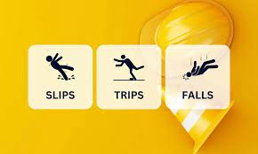 | Another high-risk group is a staff member for the housekeeping, which can get injured simply by slipping on wet floors, tripping over cords or clutter, or even falling from height while cleaning (Andrade et al., 2021).
Chemical Exposure  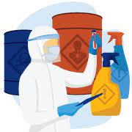 | Cleaning products exposure causes skin irritation, problems with the respiratory organs, or in the worst-case accidental incident, if handled incorrectly.

Lifting Injuries  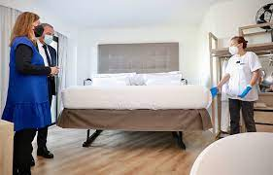 | Housekeepers can develop backaches or skeletal muscle injuries by lifting and handling heavy items, such as mattresses or furniture (Cunha and Oliveira, 2021).

Procedure and Precautions
Slips, Trips, and Falls  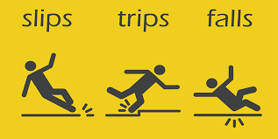 | Making sure that the walkways are kept free from obstacles and clutter. Enabling the guests and staffs to detect the hazard by using wet floor signs (Giousmpasoglou et al., 2021).
Chemical Exposure  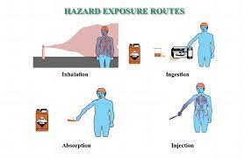 | Using manufacturer guidelines for dilution and application (Ulker-Demirel and Ciftci, 2020).
Ergonomic Hazards  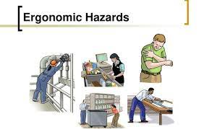 | Taking time off regularly just to rest and relax the body. Use of ergonomic equipment and cleaning tools that mitigate undue stress on the body.

Equipment
Micro fibering clothes | 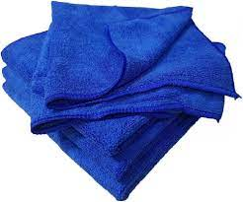
HEPA filter as a Vacuum cleaner | 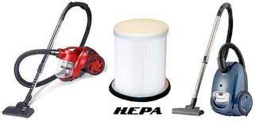
Bucket and Mop | 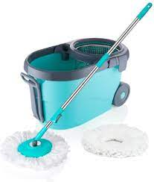
Pole of extension (Cunha and Oliveira, 2021). | 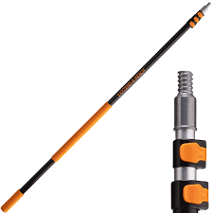
Spray bottle | 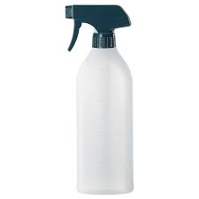
Safety sign | 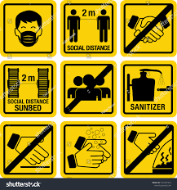

Hazard Mitigation
- Slippery Surfaces: Remove spills instantly and use wet floor signs to warn about the danger (Giousmpasoglou et al., 2021).
- Chemical Exposure: Provide training in safe chemical handling and use the required PPE (protective personal equipment).
- Lifting Injuries: One should lift the Sports equipment with the help of mechanical aids and apply proper lifting techniques (Andrade et al., 2021).
- Ergonomic Hazards: On the other hand, the staff should use ergonomic cleaning tools and take frequent breaks to prevent muscles from straining.
Ensuring the safety and health of the housekeeping staff is essential. Thus, having the behavioural precautions, procedures, and equipment recommendations will helps to build the most secure working environment for the employees and guests at the Doubletree by Hilton Southampton.

Bibliography
Andrade, M.S., Miller, D. and Westover, J.H., 2021. Job satisfaction factors for housekeepers in the hotel industry: a global comparative analysis. International Hospitality Review, 35(1), pp.90-108.
Cunha, A. and Oliveira, M., 2021, May. Human Resources in the Housekeeping Department: A Case Study. In ICTR 2021 4th International Conference on Tourism Research (Vol. 158). Academic Conferences International.
Giousmpasoglou, C., Marinakou, E. and Zopiatis, A., 2021. Hospitality managers in turbulent times: the COVID-19 crisis. International Journal of Contemporary Hospitality Management, 33(4), pp.1297-1318.
Ulker-Demirel, E. and Ciftci, G., 2020. A systematic literature review of the theory of planned behavior in tourism, leisure and hospitality management research. Journal of Hospitality and Tourism Management, 43, pp.209-219.
Verma, P., Singh, M. and Aggarwal, N., 2020, June. The Effect of Next–Level Housekeeping via Technology on the Perceptions of the Hospitality Aspirants. In 2020 8th International Conference on Reliability, Infocom Technologies and Optimization (Trends and Future Directions)(ICRITO) (pp. 1150-1156). IEEE.
Verma, P., Singh, M. and Aggarwal, N., 2021, January. Analysing the Opportunities for Technological Entrepreneurship: A Conceptual Framework for Hospitality-Housekeeping Industry. In 2021 2nd International Conference on Computation, Automation and Knowledge Management (ICCAKM) (pp. 254-259). IEEE.

Component Three: Presentation
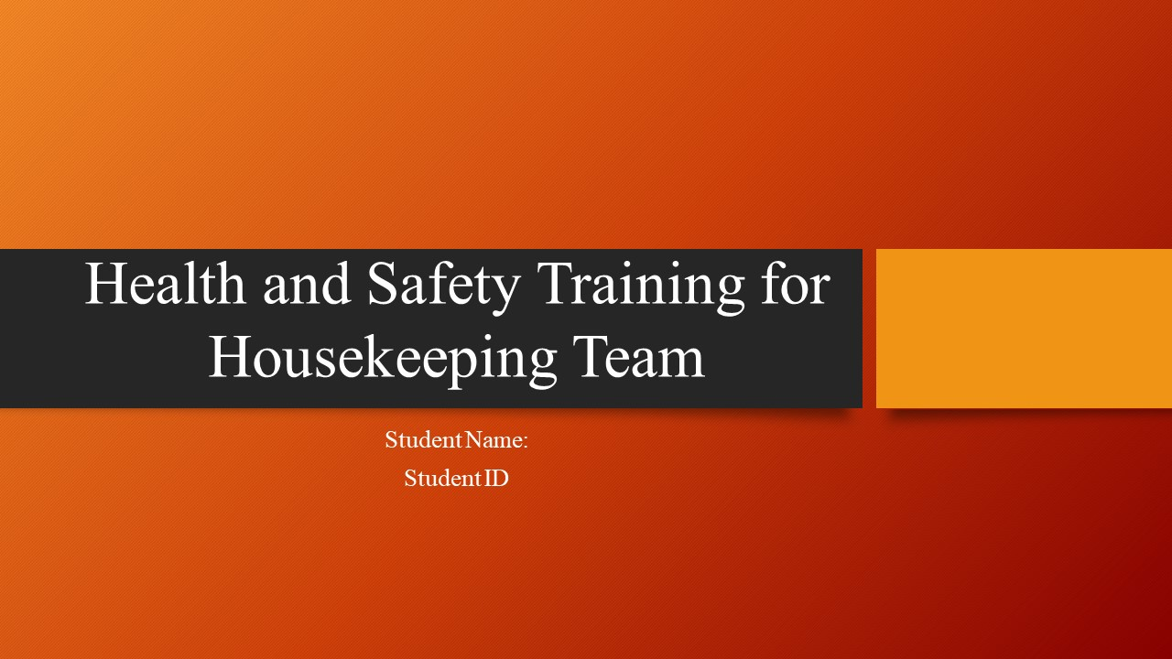
Title Page
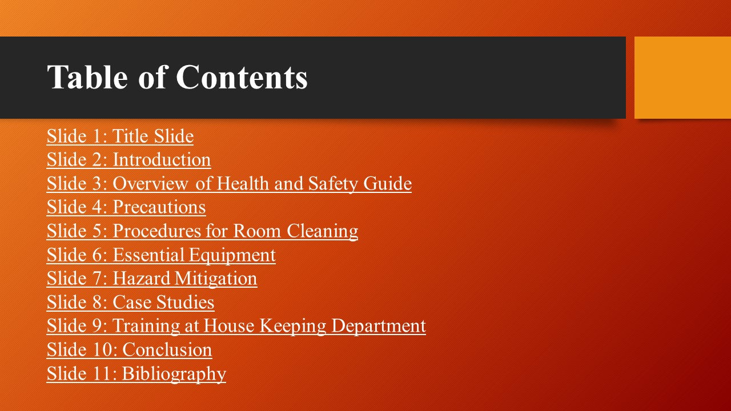
Table of Contents

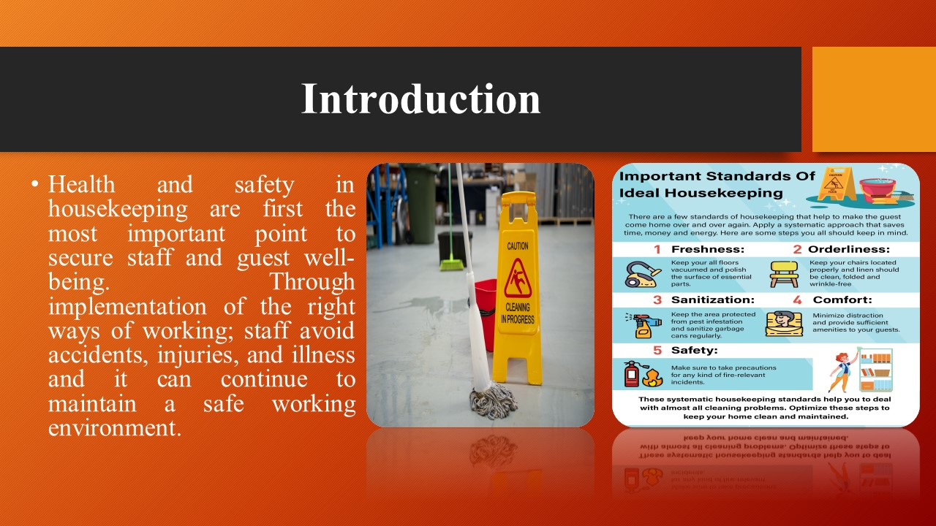
Speaker Notes: This barrier protects both the staffs and the hotels (Alcalde-Gonzalez et al., 2021). As a result, the reputation is upheld which leads to trust and loyalty among the guests. Through Health and safety, the completeness, and efficiency within the hospitality sector are shown. In the end it altogether assists in the achievement of the objectives, which in turn results into greater productivity, employee morale and customer satisfaction (Al-Hyari et al., 2023).

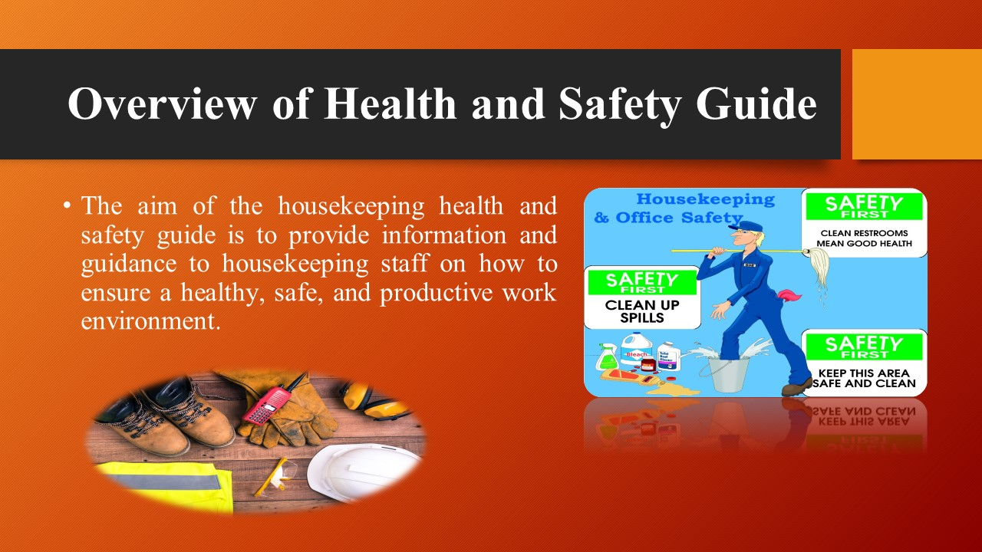
Speaker Notes: The Health and Safety Procedures for the housekeeping department of the Doubletree by Hilton Southampton is a complete document with the view of maintaining the safety and well-being of the workforce (Fadilah et al., 2024). The main function of this procedure is to provide a step-by-step guide on the acceptable protocols concerning room cleaning, with significance given to reduction of health risks and hazards. Structured in a user-friendly format, the guide covers four main areas:
Precautions: This is one of the most important parts which indicates specific safety measures and precautions that must be followed while working in the room (Gupta, 2024). It is a set of controls such as PPE use, safe chemical management, and identification of dangers.
Procedures: The section of procedures provides a detailed manner of cleaning the room by steps that are for effectively and safely performing the task. It consists of checklists for popping out and assessing rooms for hazards, ventilating the area, using cleaning products in the right way, and sanitizing of the high-risk areas (Le et al., 2023).
Equipment: This is where the guide will give a list of basic tools and equipment needed to carry out the function. It comprises microfiber cloths, cleaners with HEPA filters, HEPA mops, and signs indicating safety (Paulino, 2023). The right way of bugging the equipment and maintenance is also covered.
Hazard Mitigation: This section suggests obvious hazard specific to cleaning a room and provides practical methods to alleviate them. It includes the techniques for slips and falls prevention, chemical hazard control and injury reduction from the heavy lifting (Verma et al., nd). Overall, the guide is designed to be of easy of comprehension for every member of the team and offers the required information and tools that make it easier to carry out duties safely and effectively.

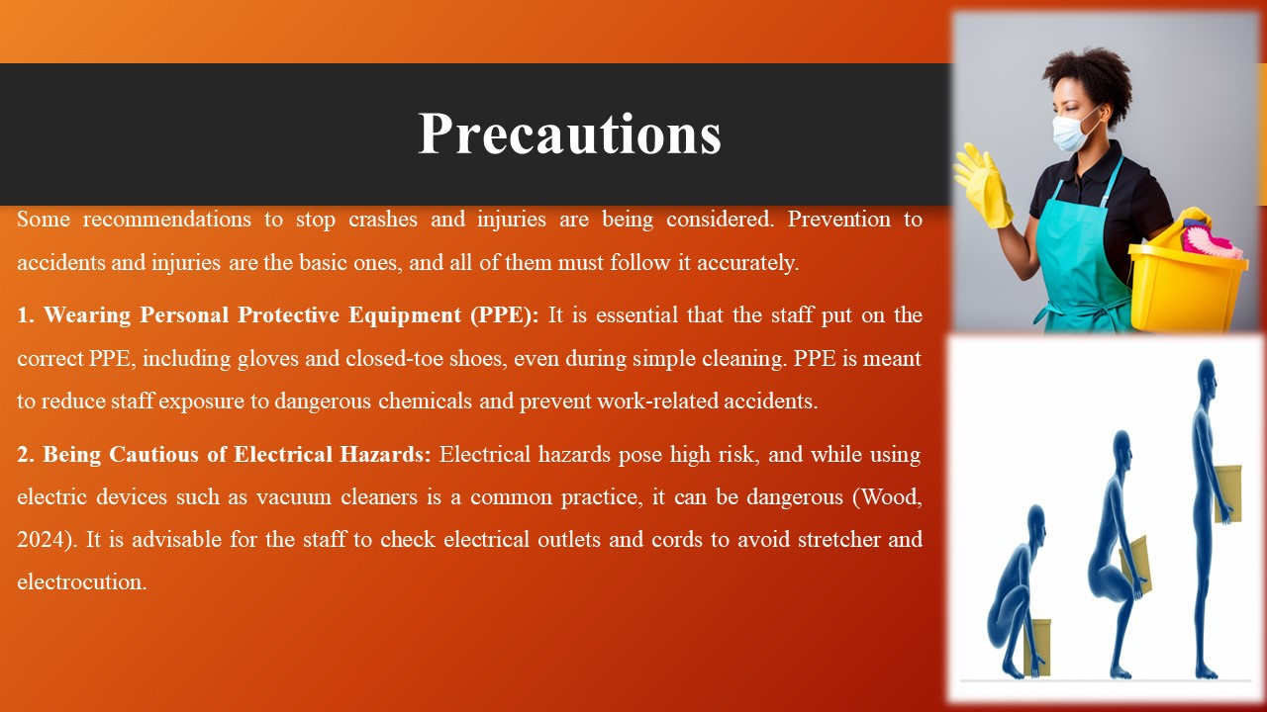
Speaker Notes: Using Proper Lifting Techniques: It is extremely important to use the correct lifting techniques whilst lifting heavy objects like mattresses or furniture to avoid muscle strains or injuries. Ensuring the staff by keeping the back straight and bend the knees actively (Al-Hyari et al., 2023).

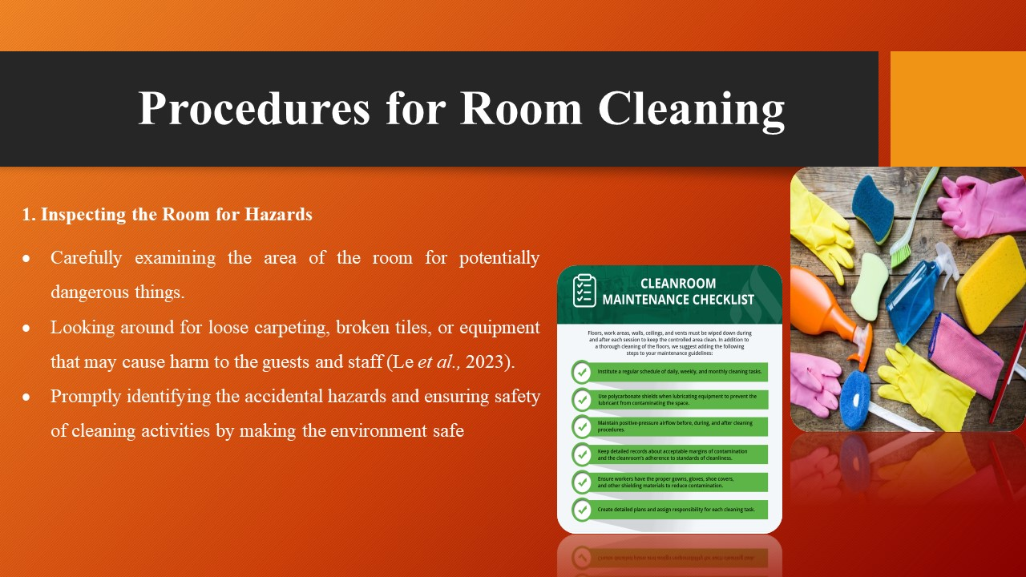
Speaker Notes: 1. Inspecting the Room for Hazards
- Carefully examining the area of the room for potentially dangerous things.
- Looking around for loose carpeting, broken tiles, or equipment that may cause harm to the guests and staff (Le et al., 2023).
- Promptly identifying the accidental hazards and ensuring safety of cleaning activities by making the environment safe
2. Ventilating the Area
- Ventilation is a crucial aspect to ensure staff; that are safe from cleaning chemicals and to keep the air quality.
- Airing out the room by leaving open windows and doors to let fresh air circulate throughout the room (Paulino, 2023).
- Providing local ventilation fans where available to maximize air circulation thus helping in the removal of any remaining odours or fumes.
3. Following a Systematic Approach to Cleaning
- Applying a methodical strategy which is detail-oriented and helps to get the best results.
- Cleaning the top surfaces (like light fixtures and ceiling fans) first, then start on the lower surfaces like furniture and countertops.
- Sweep or vacuum the floors last to catch and eliminate any dirt or dust that has settled during the cleaning session (Verma et al., nd).
4. Using Environmentally Friendly Cleaning Products
- Selecting the Green products to make sure their environmental impact is low and they are safe for both users and the environment.
- It is important to carefully read all product labels to comprehend usage instructions and hazards (Alcalde-Gonzalez et al., 2021).
- Disposing of the cleaning solutions and containers appropriately according to local regulations to avoid pollution and any negative impacts on environment.
Implementing these measures is indispensable to keep an acceptable level of cleanliness and safety during the housekeeping practices. Through the application of a system procedure, environmentally friendly products, the staff health is not only guaranteed. Moreover, the environment is not neglected but it is made healthy for our guests (Fadilah et al., 2024). It is important that everyone in the team observes and adheres to programme protocols successfully because it will help to uphold the commitment of DoubleTree by Hilton Southampton in cleanliness as well as safety.

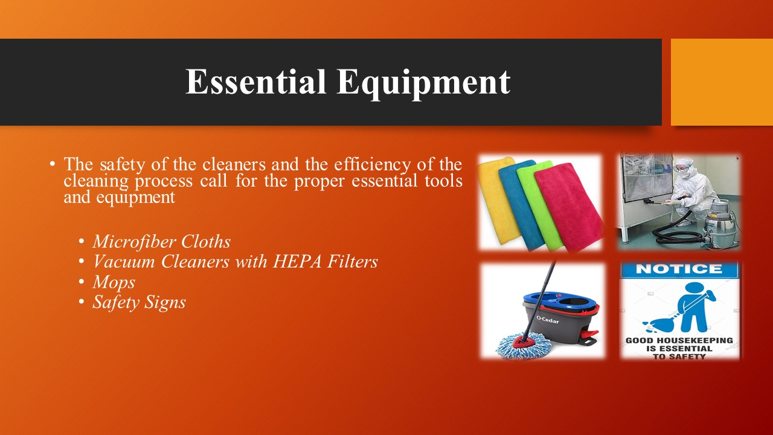
Speaker Notes: 1. Microfiber Cloths: These should include dusters and mops among others. Microfiber cloths are known to be highly efficient in entrapping dust and dirt particles, thus they leave surfaces cleaner and there is diminished spread of allergens (Paulino, 2023). It is essential to use a microfiber cloth which has been washed and cleaned, for each unique cleaning job to avoid cross-contamination.
2. Vacuum Cleaners with HEPA Filters: Vacuum cleaners with High-Efficiency Particulate Air (HEPA) filters must be used to remove allergens and airborne particles from the environment (Wood, 2024). These filters can capture such microscopic particles as dust mites, pollen, and pet dander, with the aim to enhance air quality indoors and cut the risk of breathing problems.
3. Mops: Mops are essential in cleaning surfaces such as floors to get rid of dirt, spills, and stains. Selecting mops with the microfiber or cotton mop heads that can absorb water and dirt efficiently and dry floors (Al-Hyari et al., 2023). Wring out the mops completely to eliminate any chance of leaving behind too much water on the floor that may result in slips and falls.
4. Safety Signs: The warning signs are necessary for warning both guests and staff members not to ignore dangers during cleaning. One of the most important things are caution wet floor signs, especially they will be placed where people can step on to prevent slips and falls on recently cleaned or wet surfaces. Using the suitable cleaning materials is not just a way of improving cleaning, but also minimizing risks and making the working environment safer. Awareness of the accurate use and care of each piece of equipment is critical to carry out cleaning tasks safely and properly (Al-Hyari et al., 2023). Through this procedure and by using the right protective tools, the hotel remains faithful to the cleanliness and safety which it advocates for in the DoubleTree by Hilton Southampton.

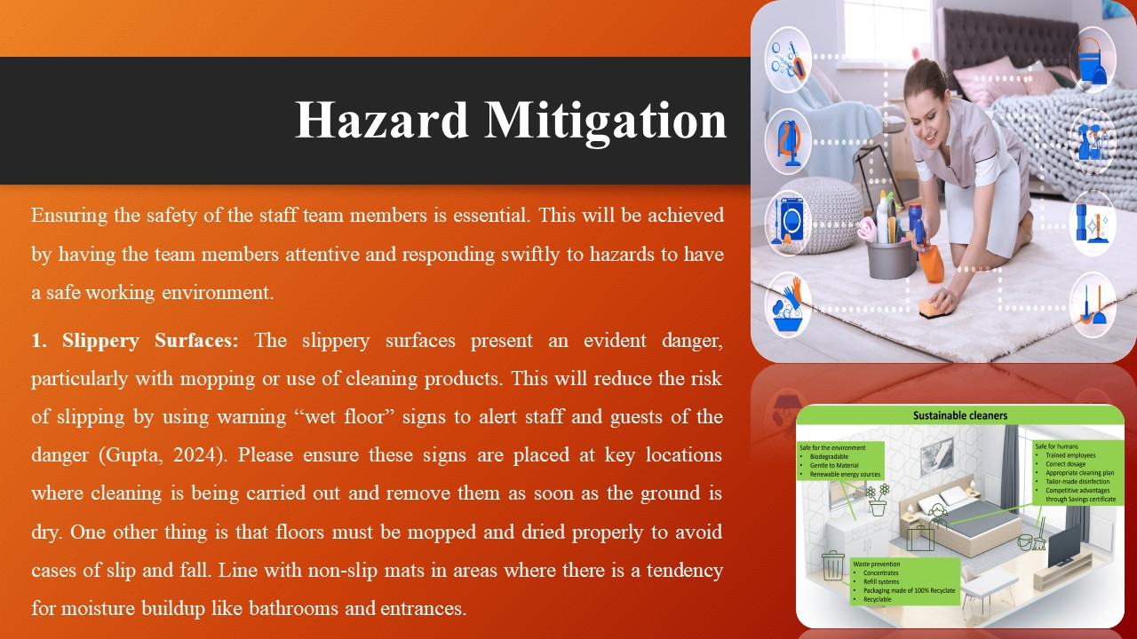
Speaker Notes: Ensuring the safety of the staff team members is essential. This will be achieved by having the team members attentive and responding swiftly to hazards to have a safe working environment.
1. Slippery Surfaces: The slippery surfaces present an evident danger, particularly with mopping or use of cleaning products. This will reduce the risk of slipping by using warning “wet floor” signs to alert staff and guests of the danger (Gupta, 2024). Please ensure these signs are placed at key locations where cleaning is being carried out and remove them as soon as the ground is dry. One other thing is that floors must be mopped and dried properly to avoid cases of slip and fall. Line with non-slip mats in areas where there is a tendency for moisture buildup like bathrooms and entrances.
2. Chemical Exposure: The other danger is chemical exposure. It can happen if cleaning products are mishandled or cleaning crew uses chemical substances without ventilation. To prevent this hazard, these cleaning products must be stored in specially-designated areas away from food and drinks (Paulino, 2023). Make sure tight seals are on containers and label them to avoid any possible spills or exposure. Always use environmentally friendly cleaning agents and follow them according to manufacturer's instructions, especially for dilution and application. Promote adequate ventilation through opening windows or using exhaust fans for control over exposure to fumes.

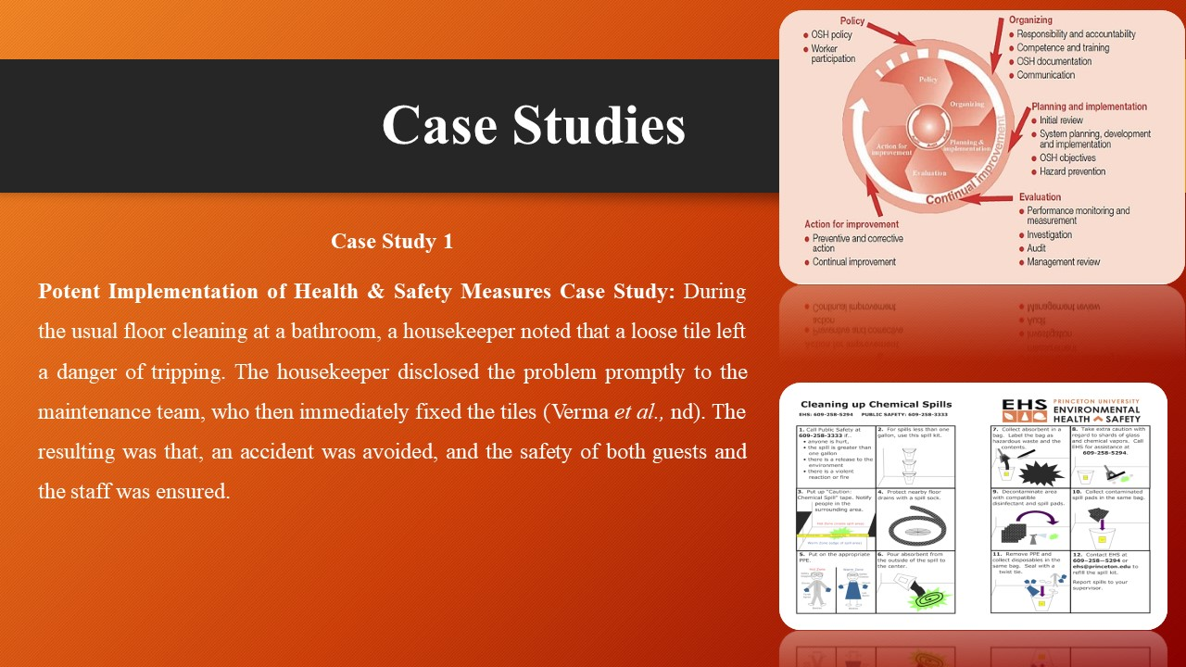
Speaker Notes: This section will research into some actual case studies, where health and safety measures were either properly implemented or totally neglected and the outcomes and key lessons shall be pointed out from each instance.
Case Study 1
Potent Implementation of Health & Safety Measures Case Study: During the usual floor cleaning at a bathroom, a housekeeper noted that a loose tile left a danger of tripping. The housekeeper disclosed the problem promptly to the maintenance team, who then immediately fixed the tiles (Verma et al., nd). The resulting was that, an accident was avoided, and the safety of both guests and the staff was ensured.
Key Lessons Learned: Reporting hazards is very important because it helps in preventing those accidents and injuries. The cooperation between the housekeeping and the maintenance departments is paramount for the efficient implementation of safety concerns (Wood, 2024).
Case Study 2
Monitoring Health and Safety Procedures Situation: While cleaning a room for a guest, the housekeeper spilt a chemical solution on the floor, but did not regulate the area, seek support, or report about the spill (Wood, 2024). The fault of the cleaner negligence resulted in the guest slipping on the wet floor and having an injury.
Key Lessons Learned
Key training on correct use and disposal of cleaning agent is needed, so that accidents can be avoided. Ensure staff scrub spills immediately and warn others about accident-prone areas by using wet floor signs. The stress should be on the communication and reporting process of incidents to avoid the recurrence of the same accident in the future.

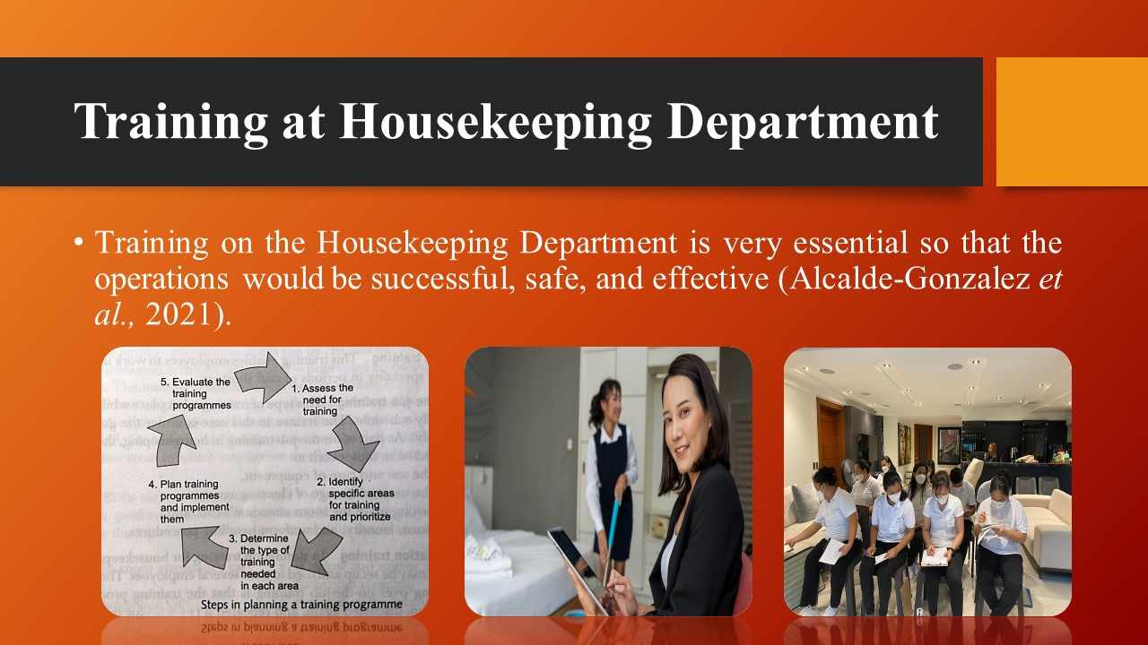
Speaker Notes: In the form of well throughout and comprehensive workshops, the employees are trained on how to run the business’s day-to-day operations, clean every area, meet the hygiene requirements, and ensure the highest quality of service. These training courses cover a full range of topics, which include health and safety procedures, usage of equipment and cleaning products, as well as a customer-oriented approach (Fadilah et al., 2024). Through training and development of the staff, they are equipped to conduct their tasks confidently and become a key component to the growth and realization of the organization’s mission.

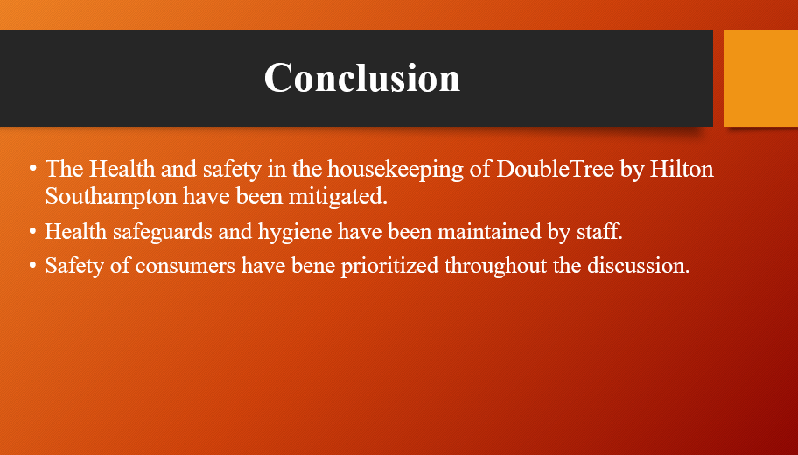
Speaker Notes: The above discussion has stressed the key roles played by health and safety in the housekeeping of DoubleTree by Hilton Southampton. The explanation has gone through basic principles including health safeguards and hygiene to keep the staff and guests safe. The admirable determination to fulfil the health and safety regulations is worth mentioning and greatly assists in the good performance of the organization. Keeping safety as the priority, helping each other, and making sure continuous adherence to the guidelines are the ways to follow what the above discussion has reflected.

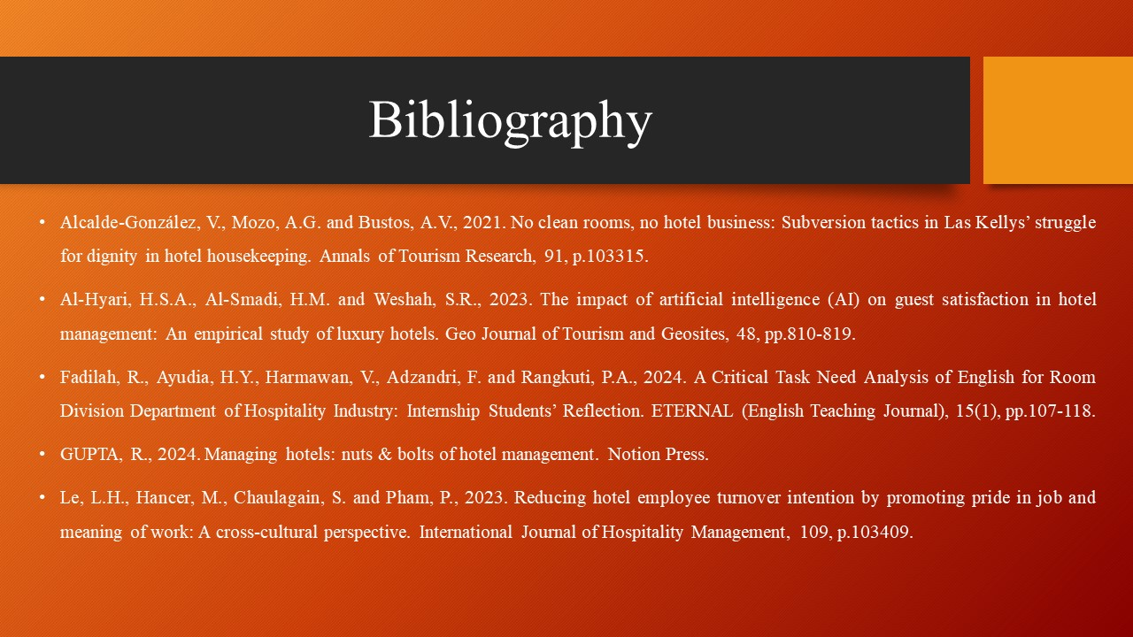
- Paulino, G.A.L., 2023. Management accounting in hospitality: Case study in a Lisbon 5-star hotel.
- Verma, P. and Singh, M., Sustainable Housekeeping Practices in Hotels: A Review of Trends in Sustainability Practices Performed By Housekeeping Staff. Hospitality and Tourism Emerging Practices in Human Resource Management, p.79.
- Wood, R.C., 2024. Working in hotels and catering. Taylor & Francis.



