ENTREPRENEURSHIP

Student name: MohammedakibMahammediqbal Shaikh
Student id: 2237233
Lecturer: Vasilios Tavlaridis
Internal verifier: David Jenkins
Module code: LCMB7004

Table of Contents
3. Overview of the business idea 3
4. Identify a gap in the market 4
5. Location of business and its legal entity 7
6. SWOT Analysis 9
7. Target market and adopted strategies 12
8. Financial plan and funding requirements also identify the potential external funding sources 15
References 17

3. Overview of the business idea
Solar energy in particular has emerged as a key source of clean and sustainable electricity as the renewable energy industry has seen exponential expansion in recent years. The company “Green ENERGY” focuses on providing installation and maintenance services for solar panels. This company seeks to decrease carbon footprints, respond to the growing demand for solar energy solutions, and promote a more sustainable, greener future. Hence, the company says, “There is always someone who cares for you”. The objective is to reduce carbon footprints, meet the growing demand for solar solutions, and promote sustainability.The vision of this business is to lead in the market of solar solutions provider, promoting eco-friendly energy and driving sustainable change. Professional solar panel installation on residential, commercial, and industrial buildings is the main service offered. Almost 59% business population has increased in the UK in 2022 (gov. uk, 2023). The comprises site evaluation, system design, and solar panel mounting to maximize energy production. Solar panels need to be maintained on a regular basis for maximum effectiveness. The innovative business concept will do regular inspections, clean-ups, and required repairs to maintain systems operating at top performances.
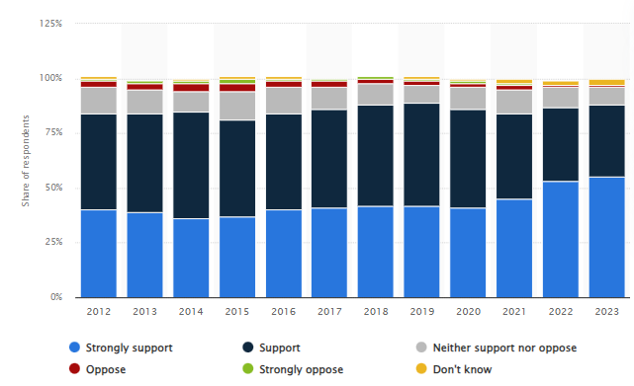
Figure 1: Solar power developments in the UK
(Source: statista.com, 2023)
In 2023, the UK has a level of support for solar energy development of about 88%. The consumer target market will be homeowners, businesses and industries looking to harness the benefits of solar energy.This renewable technology had the most support from the general people in the UK urban communities (statista.com, 2023). This proactive strategy helps clients save money and ensures their solar investments last longer. One of the most environmentally friendly energy sources currently accessible, solar energy lowers carbon emissions and reduces dependency on fossil fuels. Solar panels are a cost-effective option for both homes and businesses due to lower power expenditures. Solar energy adoption is supported by several government incentives, tax breaks, and rebates, which can increase the appeal of the investment. The expansion of the solar business helps to create jobs, which stimulates the local economy.
Services for installing and maintaining solar panels are in greater demand in the UK ensuring the business dynamic progression. The solar energy sector has a huge potential for continuous growth as environmental consciousness and the demand for energy cost savings both continue to rise (Raihan et al. 2023). The businesses look to capture the power of the sun, and the installation and maintenance of solar panels are expected to expand.In this regard, the financial needs require investment of $75000 in equipment, employee training, and marketing expenses.It raised market share and ensure long-term success in the flourishing solar energy industry. These innovative business ideas help customers lower their energy expenses and carbon footprint to clean and sustainable energy sources. The company tries to significant participant in this fast-paced and environmentally conscious business and plans to develop a significant strategy, qualified employees, and an ongoing commitment to quality.

4. Identify a gap in the market
The UK has made remarkable progress in shifting towards renewable energy sources to tackle climate change and lower carbon emissions. Solar energy is one of the main factors influencing this transformation. For complete solar panel installation and maintenance services, there remains a sizable gap in the market that presents substantial potential for company owners who want to launch a venture that leans into this expanding market also ensuring a more sustainable future.
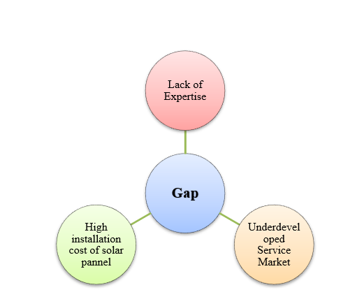
Figure 3: Identified Gap
(Source: Self-created)
Increased solar panel installations are influenced by the UK's commitment to decreasing its carbon footprint, which appears through programs such as the Clean Growth Strategy. More people are looking for methods for taking advantage of solar power's advantages, which include cheaper energy prices and a smaller environmental effect (Mubarratet al., 2023). Many small companies and households’ shortages the technical expertise necessary to properly maintain their solar panels. This business plan focuses on installing solar panels, there are very few that provide all-encompassing maintenance and repair services. The growing expenses of installment and maintenance are another gap in the market that influences this innovative business.
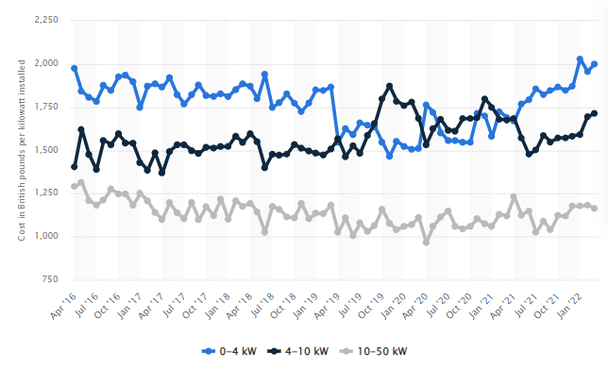
Figure 4: Solar panel installation cost in the UK
(Source: statista.com, 2023)
Based on the above figure, Prices for the 0-4 kW range peaked at 2,030 British pounds per installed kilowatt in 2022 (statista.com, 2023). Besides, this business plan will provide a selection of maintenance packages made to meet clients' demands that secure solar panels function at their highest efficiency for the duration of their lives. These packages will include routine inspections, cleaning, repairs, and performance optimization. The staff will be knowledgeable specialists with a strong background in solar panel installations to quickly spot problems and fix them, maximizing the return on clients' investments.
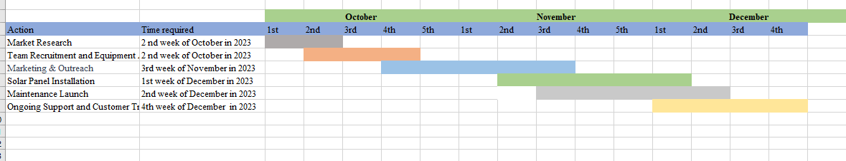
Figure 5: Start-up activities
(Source: Self-created)
The business will provide maintenance training and instructional materials for solar panels that limit the extra expenses for raising client happiness and encourage a sustainable culture.The major objective of the company plan is to supply complete solar panel installation and maintenance services. Professional solar panel installation and maintenance packages including regular cleaning, repairs, inspections, and optimization are provided by this business. Targeting urban areas with a strong demand for solar energy, the services will be provided throughout the UK. Expert professionals with extensive experience installing and maintaining solar panels make up the team. The program's corporate debut in 2023 will correspond with the rising need for solar energy solutions. By supplying a comprehensive service that many clients need help with, the concept immediately fills a market gap and meets the growing need for solar energy solutions in the UK.

5. Location of business and its legal entity
Birmingham is the perfect location for the company's solar panel installation and maintenance operations in the UK. Birmingham, the second-largest city in the nation, provides numerous crucial benefits for corporate operations (Berthodet al. 2023). Based on the facilities of geographic centrality, high energy demand, a thriving business ecosystem, a skilled labour population, and, most importantly, government support is beneficial for the new SME business plan. Being in the middle of the UK, Birmingham allows it to conveniently service a large area, including the Midlands and other areas. Thus, the company can reach a large consumer base and provide quick service due to its accessibility. The urban and industrial environment of Birmingham creates a sizable demand for power, making it a desirable market for solar energy products. The city's commitment to green programs and carbon reduction goals emphasizes the potential for solar energy adoption even more.
Several sectors and businesses looking for sustainable energy solutions may be found in Birmingham's dynamic business community. This ecosystem offers lots of chances for alliances and teamwork that can advance our company. A talented and diversified workforce, including experts in the renewable energy industry, is present in Birmingham. This business can depend on this local talent pool for hiring and training needs to maintain a high level of service quality. The Feed-in Tariff (FiT) and the Smart Export Guarantee (SEG) are two incentive programs that the UK government has actively used to boost renewable energy ventures. These initiatives promote the use of solar power, and Birmingham's location in a large metropolis puts us in a good position to take benefit from these initiatives.
Legal entity
The company has suggested developing its solar panel installation and maintenance business in the UK as a Limited Liability Company (LLC) for a number of compelling reasons. The LLC structure protects business owners from personal responsibility. The owners' personal assets are protected from unanticipated obligations or financial losses, providing their financial stability. LLCs are very adaptable and make changes to ownership and management structures in a simpler way (Kinds et al. 2022). This adaptability is helpful for the company to grow and for other partners or investors to join. LLCs are liable to corporate tax in the UK, which has advantages over personal income tax. The financial performance and profitability of the company may be enhanced with the aid of this tax structure.
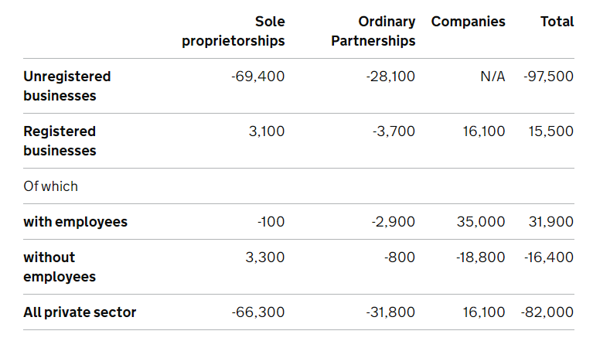
Figure 6: Changes in businesses by legal status in the UK
(Source: Gov. uk, 2023)
Comparing LLCs to other legal structures including public limited corporations, the regulatory and compliance requirements for LLCs in the UK are often less complicated. Based on the above figure the numbers with employee business legal structure are significant in company’s business rather than sole proprietorships, and ordinary partnerships with total values are 31,900 (gov. uk, 2023). This makes administrative tasks easier and frees us up to concentrate on main business activities. Creating an LLC gives the company respectability and inspires trust in potential customers, partners, and investors (Lewrick, 2022). It represents a dedication to longevity and expertise. This company's aim is to emphasize sustainability, development, and financial stability. The best option for the solar panel installation and maintenance firm is an LLC form because of its flexibility, limited liability, and tax effectiveness. In addition, Birmingham is an appropriate location for the solar services installation and maintenance company, a city renowned for its energy demand, business opportunities, and government support for renewable energy initiatives forging a significant presence in the UK's solar energy market. It aids in the transition of the nation to less polluted, more sustainable energy sources.

6. SWOT Analysis
SWOT analysis evaluates the internal and external factors that have an impact on a company with respect to a UK company that maintains solar panels.
Strength | Weakness
- Solar panel installations are in high demand as a result of the UK's renewable energy targets.  - Adherence to government incentives and sustainability programs.  - Access to a qualified labour force of renewable energy.  - Government funding is provided through initiatives such as the Smart Export Guarantee (SEG) and Feed-in Tariff (FiT) (Sovacoolet al. 2022). | - High initial capital expenditure for labor and equipment.  - solar energy generation is dependent on the weather, which causes revenue fluctuations (Alao and Cuffe, 2022).  - Obstacles to regulatory compliance brought on by changing standards.
Opportunities | Threats
- The UK solar energy sector is anticipated to develop as the nation works to decrease its carbon impact.  - Improvements in the efficiency of energy storage and solar panel technologies.  - Opportunities for alliances and cooperation with regional utilities, environmental groups, and governmental organizations. | - The rising demand for solar systems results in increased market competitiveness.  - Changes in the economy have an impact on customer solar panel investment intentions.  - Climate instability and climate change have an influence on the production of solar energy.  - Reforms to regulations that frequently have an impact on corporate operations and company viability.
Table 1: SWOT Analysis
(Source: Self-created)
Analysis
A firm entering the UK solar panel installation and maintenance market is positioned to have a significant influence on the renewable energy environment. The company's entry supports the UK's ambitious plans for renewable energy and makes a substantial contribution to the country's efforts to cut carbon emissions. Following governmental incentives and sustainability initiatives positions the business as a pioneer in eco-friendly energy solutions, attracting customers and organizations that care about the environment. Utilizing government subsidies via programs including the Smart Export Guarantee (SEG) and Feed-in Tariff (FiT) strengthens the company's financial situation by encouraging the uptake of solar energy (Sovacoolet al. 2022). Having access to a qualified workforce with expertise in renewable energy guarantees the business can offer top-notch services, building credibility and confidence in the market.
The firm has financial difficulties due to the significant initial capital cost needed for labor and equipment, demanding careful financial planning and investment. The weather dependence on solar energy output may cause revenue swings, necessitating the implementation of financial protections by the organization to handle fluctuating revenues. Continuous modifications to regulatory standards might complicate operations. The business must actively adapt in order to preserve regulatory compliance.
Profitability and market share may both increase for the company by taking advantage of the anticipated growth in the UK's solar energy sector. The company's competitiveness and operating efficiency are increased by embracing advancements in energy storage and solar panel technology (Hasan et al. 2023). Alliance-building with utilities, environmental organizations, and governmental organizations can lead to grants, subsidies, and cooperative company that support corporate expansion and environmental sustainability.
The firm must stand out from the competition as the industry grows more cutthroat in order to preserve its market position. Economic changes have an impact on consumer investment intentions due to shifting client needs and financial circumstances. Climate instability and climate change may have an impact on the predictability of solar energy output, necessitating good energy source diversification and management on the part of the business (Osman et al. 2023). Regular regulatory revisions may lead to corporate operations being disrupted which is significant to take proactive measures to stay compliant and reduce interruptions.
Based on national renewable energy objectives, the company's entry into the UK's solar panel installation and maintenance market has the potential to be a powerful force for environmental good. However, it traverses the financial obstacles, operational difficulties, and market competitiveness while grabbing opportunities and successfully handling threats in this fast-paced, always-changing sector.
PESTLE analysis
Factors | Description
Political | - Brexit has resulted in increased import-export activity and political pressure  - In 2022, the political stability of the UK standards is expected to be 0.54 (ons.gov.uk, 2023)
Economical | - In 2022, the per capita income of the UK exceeded 75.6% (ons.gov.uk, 2023)  - In 2023, the GDP rate in the UK developed by 0.2% (ons.gov.uk, 2023)
Social | - In the UK, 75% of people were employed in 2022. (gov.uk, 2023)  - Almost 80% people supports application of renewable energy in the UK (energylivenews.com, 2023).
Technological | - The UK government has made total investments in AI of about £3.8 billion (ons.gov.uk, 2023)  - More than £370 million has been given to technical development by the UK government (gov.uk,2023)
Legal | - Employment Act 2002 (legislation.gov.uk, 2023)  - The Equality Act 2010 (gov.uk, 2023)
Environmental | - Waste management strategy for environmental safety by the UK government  - The UK's CO2 emission rate in 2022 was 331.5 million tonnes decreasing 2.4% from previous years of 2021 (ons.gov.uk, 2023)
Table 2: PESTLE analysis
(Source: Self-created)
Analysis
PESTLE elements impact the decision to launch a solar energy business in the United Kingdom. Brexit has increased pressure and import-export activities on the political front. According to economic data, in 2023 there is going to be a 0.2% GDP increase and per capita income topping 75.6%(ons.gov.uk, 2023). Socially, 75% of people in 2022 were working, and about 80% of people favoured renewable energy(energylivenews.com, 2023). Significant technological expenditures have been made in AI and technology advancement. The Employment Act of 2002 and the Equality Act of 2010 have legal ramifications. In terms of the environment, the UK's waste management plan and the 2.4% decrease in CO2 emissions in 2022 are important factors. The UK solar energy industry landscape is shaped by these elements taken together.

7. Target market and adopted strategies
The UK target market for the solar panel installation and maintenance company includes a diverse group of clients, reflecting the rising desire for sustainable living and renewable energy.
Target Market
Residential customers | Owners and tenants that want to minimize their energy costs, lessen their environmental impact, and take advantage of government subsidies for solar panel installations.
Commercial and small business customers | Small and medium-sized enterprises, and bigger organizations, are eager to adopt solar solutions to cut operating expenses and demonstrate their commitment to sustainability.
Public sector and non-profit organizations | Governmental structures, educational institutions, medical facilities, and charitable organizations with an emphasis on green energy and sustainability efforts.
Table 3: Target market for solar panel installation and maintenance in the UK
(Source: Self-created)
A market capture strategy is necessary for a company to attract and keep consumers, build a competitive advantage, and experience growth in a fast-paced, cutthroat industry. adjusting marketing strategies and offerings to each consumer segment's particular requirements and objectives. It emphasizes cost savings and environmental benefits for residential consumers by emphasizing long-term financial gains, improved corporate responsibility, and access to government incentives for commercial and public sector clients (Cui et al., 2022). Creating educational content for blogs, webinars, and seminars that cover the advantages of solar energy, the installation procedure, financial savings, and government initiatives. Potential clients develop awareness and trust thanks to this instructional method. The competitors will be solar energy services provider in the UK such as Solarcentury, Octopus Energy, and others.

Figure 7: Market Capture Strategies
(Source: Self-created)
The development of an online presence with a user-friendly website that offers comprehensive information about our services, client testimonials, and case studies. The strategies for achieving specific goals including tailored marketing emphasizing cost savings and government incentives, educational content to build awareness and trust, a user-friendly online presence, partnerships with local utilities and government programs for funding opportunities, responsive customer service, and customizable maintenance agreements.Making effective use of online advertising and search engine optimization (SEO) establishing connections with local utilities, environmental charities, and government programs to gain access to funding, discounts, and future collaborative opportunities to reach a larger audience (Iqbal et al. 2022). These alliances allow to increase the number of customers and provide more extensive services. providing knowledgeable and helpful customer service to answer questions, deliver precise quotations, and walk clients through the installation and maintenance of solar panels. Customers have a good experience. Offering customizable and affordable maintenance and service agreements that include regular inspections, maintenance, and repairs. This includes educating them on the Feed-in Tariff (FiT) and Smart Export Guarantee (SEG) programs (Sorouret al. 2022). These agreements support optimum system performance and long-term client satisfaction. guiding clients through the maze of government grants and tax breaks to make solar systems more affordable.

8. Financial plan and funding requirements also identify the potential external funding sources
The success of the solar panel installation and maintenance business in the UK depends on having a thorough budgeting strategy. This plan includes a number of financial elements, such as projected revenues, operating expenditures, and starting costs.

Budget Categories | Amount (in GBP)
Start-up Costs | £750,000
Operational Expenses (Monthly) | £50,000
Year 1 Revenue Projections | £750,000
Annual Growth Rate | 20%
Table 4: Budget Plan
(Source: Self-created)
Year | Balance Sheet (GBP) | Income Statement/Profit & Loss (GBP)
Year 1 | -£750,000 | Revenue: £750,000
Year 2 | -£300,000 | Revenue: £900,000
Year 3 | £200,000 | Revenue: £1,080,000
Year 4 | £600,000 | Revenue: £1,296,000
Year 5 | £1,200,000 | Revenue: £1,555,200
Table 5: Balance sheet
(Source: Self-created)
Funding requirements
An initial investment requirement of £750,000 is necessary to meet start-up and operating costs while assuring business development. In the first year of operations, this amount will provide a financial cushion for dealing with any unanticipated difficulties and keep on growing. Traditional bank loans can be an effective source of outside investment due to their low interest rates and flexible terms (Evemyet al. 2023). It is a wise decision to pay for significant launch expenditures and continuing operating costs.

Figure 8:Potential external funding sources
(Source: Self-created)
Numerous government initiatives and programs in the UK encourage renewable energy installations. It is a great idea to use grants and subsidies to cover beginning expenses and encourage green energy. Venture capital or private equity investments might provide the money the company needs to build up quickly. Crowdfunding websites may be new approach to generating money by developing a network of followers that support the goals and values of the company. Multiple company awards and competitions in the renewable energy industry provide funding and mentoring, resulting in an alluring source of funding for start-ups.

References
Alao, O. and Cuffe, P., 2022. Hedging Volumetric Risks of Solar Power Producers Using Weather Derivative Smart Contracts on a Blockchain Marketplace. IEEE Transactions on Smart Grid, 13(6), pp.4730-4746.
Berthod, O., Blanchet, T., Busch, H., Kunze, C., Nolden, C. and Wenderlich, M., 2023. The rise and fall of energy democracy: 5 cases of collaborative governance in energy systems. Environmental Management, 71(3), pp.551-564.
Cui, Y., Cao, Y., Ji, Y., Chang, I.S. and Wu, J., 2022. Determinant factors and business strategy in a sustainable business model: An explorative analysis for the promotion of solid waste recycling technologies. Business Strategy and the Environment, 31(5), pp.2533-2545.
energylivenews.com, (2023). Almost-80-of-people-in-the-uk-support-the-use-of-renewable-energy. Available at:https://www.energylivenews.com/2020/11/12/almost-80-of-people-in-the-uk-support-the-use-of-renewable-energy/ [Accessed on: 24 October, 2023]
Evemy, J., Berry, C. and Yates, E., 2023. Low interest rates, low productivity, low growth? A multi-sector case study of UK-based firms’ funding and investment strategies in the context of loose monetary policy. New Political Economy, pp.1-20.
gov.uk, (2023), Equality Act, of 2010, Available at: https://www.gov.uk/guidance/equality-act-2010-guidance#:~:text=The%20Equality%20Act%202010%20legally,strengthening%20protection%20in%20some%20situations, [Accessed on : 24 October 2023]
Gov.UK, (2023). Business-population-estimates-2022. Available at:https://www.gov.uk/government/statistics/business-population-estimates-2022/business-population-estimates-for-the-uk-and-regions-2022-statistical-release-html#:~:text=Composition%20of%20the%202022%20business%20population,-The%20UK%20private&text=At%20the%20start%20of%202022%3A,4.1%20million%20had%20no%20employees[Accessed on: 14 October, 2023]
gov.uk,(2023), Government commits up to £3.5 billion to future of tech and science, Available at: https://www.gov.uk/government/news/government-commits-up-to-35-billion-to-future-of-tech-and-science, [Accessed on : 24 October 2023]
gov.uk,(2023), Understanding the numbers helps us understand the challenge, Available at: https://www.gov.uk/2022/09/21/recognising-the-power-of-literacy-when-designing-services/ [Accessed on : 24 October 2023]
Hasan, M.M., Hossain, S., Mofijur, M., Kabir, Z., Badruddin, I.A., Yunus Khan, T.M. and Jassim, E., 2023. Harnessing Solar Power: A Review of Photovoltaic Innovations, Solar Thermal Systems, and the Dawn of Energy Storage Solutions. Energies, 16(18), p.6456.
Iqbal, M., Khalid, M.N., Manzoor, A., Abid, M.M. and Shaikh, N.A., 2022. Search Engine Optimization (SEO): A Study of important key factors in achieving a better Search Engine Result Page (SERP) Position. Sukkur IBA Journal of Computing and Mathematical Sciences, 6(1), pp.1-15.
Kinds, A., Bugeja-Said, A., Speelman, S. and Guyader, O., 2022. Navigating Institutional Change in the French Atlantic Fishing Sector: How Do Artisanal Fishers Obtain and Secure Fishing Opportunities?. In Blue Justice: Small-Scale Fisheries in a Sustainable Ocean Economy (pp. 549-567). Cham: Springer International Publishing.
legislation.gov.uk, (2023, Employment Act, of 2002, Available at: https://www.legislation.gov.uk/ukpga/2002/22/contents [Accessed on :24 October 2023]
Lewrick, M., 2022. Design thinking for business growth: how to design and scale business models and business ecosystems. John Wiley & Sons.
Mubarrat, M., Mashfy, M.M., Farhan, T. and Ehsan, M.M., 2023. Research advancement and potential prospects of thermal energy storage in concentrated solar power application. International Journal of Thermofluids, p.100431.
Mubarrat, M., Mashfy, M.M., Farhan, T. and Ehsan, M.M., 2023. Research advancement and potential prospects of thermal energy storage in concentrated solar power application. International Journal of Thermofluids, p.100431.
ons.gov.uk, (2023), Foreign direct investment involving UK companies: 2021, Available at: https://www.ons.gov.uk/economy/nationalaccounts/balanceofpayments/bulletins/foreigndirectinvestmentinvolvingukcompanies/2021#:~:text=1.,billion%20to%20%C2%A31%2C769.3%20billion, [Accessed on : 24 October 2023]
ons.gov.uk, (2023), Greenhouse gas emissions and other environment measures, UK and European countries: 2020, Available at:https://www.ons.gov.uk/economy/environmentalaccounts/articles/climatechangeinsightsuk/may2023#:~:text=England%20had%20the%20highest%20number,of%20icing%20days%20in%202022.[Accessed on : 24 October 2023]
ons.gov.uk, (2023), Labour market overview, UK: January 2023, Available at: https://www.ons.gov.uk/employmentandlabourmarket/peopleinwork/employmentandemployeetypes/bulletins/uklabourmarket/january2023 [Accessed on : 24 October 2023]
Osman, A.I., Chen, L., Yang, M., Msigwa, G., Farghali, M., Fawzy, S., Rooney, D.W. and Yap, P.S., 2023. Cost, environmental impact, and resilience of renewable energy under a changing climate: a review. Environmental Chemistry Letters, 21(2), pp.741-764.
Pardede, G., (2022). A SWOT Analysis of the Hidroponics Entrepreneurship as Sustainable Income in Covid-19 Pandemic Adaptation. Teknotan: JurnalTeknologiPertanian, 16(2), pp.93-101
Raihan, A., Pavel, M.I., Muhtasim, D.A., Farhana, S., Faruk, O. and Paul, A., 2023. The role of renewable energy use, technological innovation, and forest cover toward green development: Evidence from Indonesia. Innovation and Green Development, 2(1), p.100035.
Sorour, A., Fazeli, M., Monfared, M., Fahmy, A.A., Searle, J.R. and Lewis, R.P., 2022. MILP optimized management of domestic PV-battery using two days-ahead forecasts. IEEE Access, 10, pp.29357-29366.
Sovacool, B.K., Barnacle, M.L., Smith, A. and Brisbois, M.C., 2022. Towards improved solar energy justice: Exploring the complex inequities of household adoption of photovoltaic panels. Energy Policy, 164, p.112868.
Statista.com, (2023). Average installation cost of small scale solar photovoltaic systems in the United Kingdom (UK) from April 2016 to March 2022, by size band. Available at: https://www.statista.com/statistics/499507/average-solar-pv-cost-per-kw-installed-uk/ [Accessed on: 26 September, 2023]
Statista.com, (2023). United-kingdom-uk-attitudes-towards-solar. Available at: https://www.statista.com/statistics/425048/united-kingdom-uk-attitudes-towards-solar/ [Accessed on: 14 October 2023]

