  Component One:  What are the key skills required when working in the housekeeping team? 750 words (+/- 10%)  Contribution to Overall Module Assessment: 25% | Student No: | Mr Parbes Ali  2127517
 | Module Title: | Operating hotel facilities
 | Module Code: | BMIH4006
 | Lecturer: | Kathryn Roberts
For a housekeeper to be successful in their position, housekeeping skills are necessary. These abilities can range from providing excellent customer service to having an eye for detail, and they may change depending on the specific tasks and employer of a housekeeper(Soltani, and Wilkinson, 2010). For instance, a housekeeper employed by a hospital might be required to follow stringent cleanliness regulations to guarantee that patients are in a hygienic setting. A personal housekeeper, on the other hand, might take care of simple cleaning tasks like vacuuming and dusting. No matter what a housekeeper does or where they work, they need to be good at a number of cleaning tasks. Housekeepers are primarily responsible for the upkeep of sanitary conditions in buildings of both public and private institutions (Singh and Jayakumar, 2019). An efficient and productive housekeeper possesses a number of crucial abilities, including attention to detail and organisational abilities. Here are a few examples:

- Time-management abilities
Cleanings must be completed a certain number of times each day, and housekeepers frequently work alone or in small groups. The ability to efficiently manage one's time and stick to a cleaning plan is an essential skill for housekeepers. Also, they have to show up on time for scheduled cleanings and finish the job in the time the customer gives them (Melad, et al; 2021).

- Attention to detail
To do a good job keeping the house, a housekeeper needs to pay close attention to detail. An excellent eye for detail is essential for the work of these cleaners, who must do everything from straightening up the living room to removing streaks from the windows and making sure the floors sparkle. Housekeepers who do a good job will be more productive (in fact, in 2020).

- Communication skills
To make sure that everyone is fully aware of the requirements for each cleaning, housekeepers must frequently interact with clients, co-workers, and supervisors. A housekeeper who is unable to communicate effectively may not receive important instructions or meet the needs of a customer.

- Interpersonal abilities
Housekeepers frequently interact directly with clients; thus, they need to be able to get along with others in order to succeed at their job. Housekeepers frequently need dependability, teamwork, and accountability to do their jobs properly.

- Flexibility
Depending on the demands of the customer, many housekeepers may be required to work irregular hours. A cleaner, for instance, may not be allowed to begin their shift until all of the workers have left the building since they must wait for the office to be empty. Some housekeepers frequently perform night-time or early morning shifts. There may be more openings and a better income for a housekeeper who is willing to adapt.
- Customer service
To succeed in their jobs, housekeepers need to have excellent customer service abilities. This is because a housekeeper's performance is based on the client's approval, so maintaining client satisfaction is critical to success in this line of work (in fact, 2020).

- Technical skills

Technical skills or education you've acquired through any life experience, including work or school, For instance, if you've worked in retail or food service, you might be familiar with point-of-sale systems. It's possible that you are familiar with Microsoft Excel if you have taken an accounting course. You might be able to speak a foreign language fluently if you've studied it. Every job calls for a specific set of industry-specific technical skills. You will need to know how to use drafting software if you want to work as an architect, for instance (Kennedy et al., 2015).

- Budgeting
The process of creating a budget involves planning your company's financial spending. You might have to develop and oversee budgets for several projects or divisions as a housekeeping manager. You may make sure that your department has the resources it needs to perform its tasks by having great budgeting abilities. You can examine your previous spending patterns and make changes to increase efficiency by using your budgeting abilities.

- Performance Management
The ability to provide their staff members with constructive criticism and establish goals is another skill that housekeeping managers must possess. They might perform better as a result, which might make the team more effective. Regular feedback can also help you spot areas where a worker might want further coaching or support to advance their career within the organization.

- Problem Solving

In order to solve difficulties, one must be able to identify them. You might need to address issues that come up in your department or with other departments as the manager of housekeeping. You might be able to discover solutions, such as rearranging schedules or hiring more staff members who are accessible at times, if there is a scheduling difficulty, for instance.

- Supervising

A crucial skill for an executive housekeeper is supervision. Using this ability, the executive housekeeper can supervise and control the work of the housekeeping team, making sure that duties are carried out accurately and on schedule. Without this ability, it would be challenging to keep the house neat and organised to a high standard.

- Organization

Any executive housekeeper must be well organized to succeed. Without it, jobs won't get accomplished on time, deadlines won't get met, and the operation won't run as efficiently as it could. An efficient executive housekeeper can set priorities, assign responsibilities, and maintain tabs on all the moving aspects of the business. This ability is necessary to uphold a high standard of quality control in the housekeeping division.

Word Count | words

Component Two:
Contribution to Overall Module Assessment: 25%
In this scenario – You have just been promoted to team leader for a floor within the hotel. A guest complains that on their arrival, their room had not been properly cleaned. Create an action plan and answer the following questions.

Problem | Why did it happen? | What are you going to do? | How will you prevent this from happening in the future? | What measures would you introduce to improve team effectiveness?
Change and Restock Bed Linen and Towels | The laundry machine was not maintained | Keep the restock linen and towel and place it | Maintain the laundry machine early | organizes and facilitates the room-making process.
The garbage was present at the shelves | Lack of communication | Clean the room | Monitor the room | Daily assignment of rooms and cleaning responsibilities to team members.
The bathroom was not cleaned properly | Not using the proper equipment | Clean the Bathroom Thoroughly | Monitor the bathroom properly | Maintain awareness of all room categories and amenities.
the floor looks dirty | was not maintain properly | Vacuuming Floors and Furniture | Maintaining a high level of quality requires a regular check of the guest rooms. | Provide training
the room smells musty | Room ventilation was not opened | Ventilate the Room | ventilate a hotel room before guests stay. | Training them

Component Three:
Contribution to Overall Module Assessment: 50%
Your task is to create and prepare a presentation following the detailed scenario provided below.

As the floor housekeeping manager and given the recent guest complaints you need to put together a basic training presentation for your colleagues within the housekeeping team to get the best out of them, ensure that brand standard is being achieved and that Health and Safety procedures are also being followed.

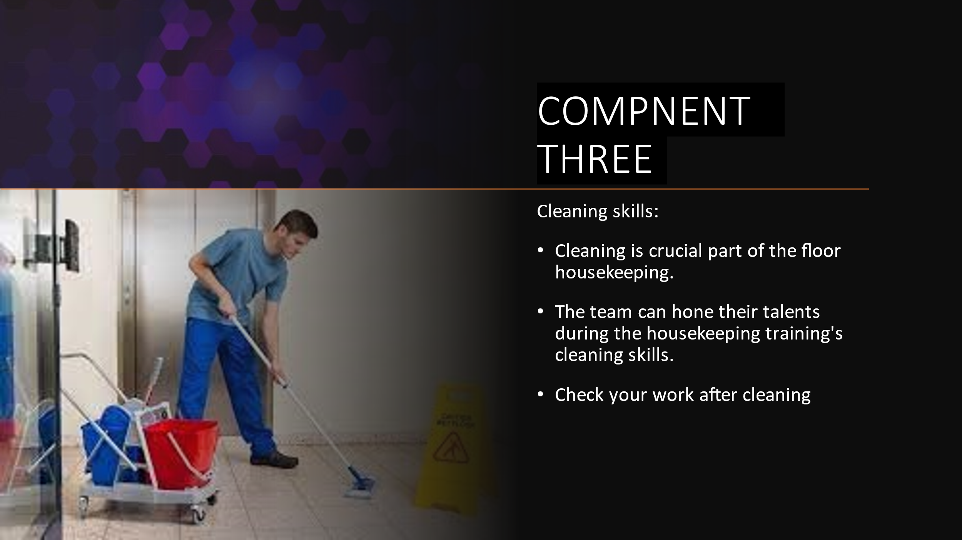

Training Notes:
During the cleaning training, we may create a shared understanding for the housekeeping staff regarding everything from the actual practices to the expected results. This doesn't mean every cleaner has to follow the same routine, but simply that if there's a faster way to get something done, we'll use that instead. Since there is always room for growth, the team will be able to hone their abilities during the training's section on cleaning. The procedure for cleaning skill are: Prepare your cleaning supplies, tools, and chemicals.

Communication:

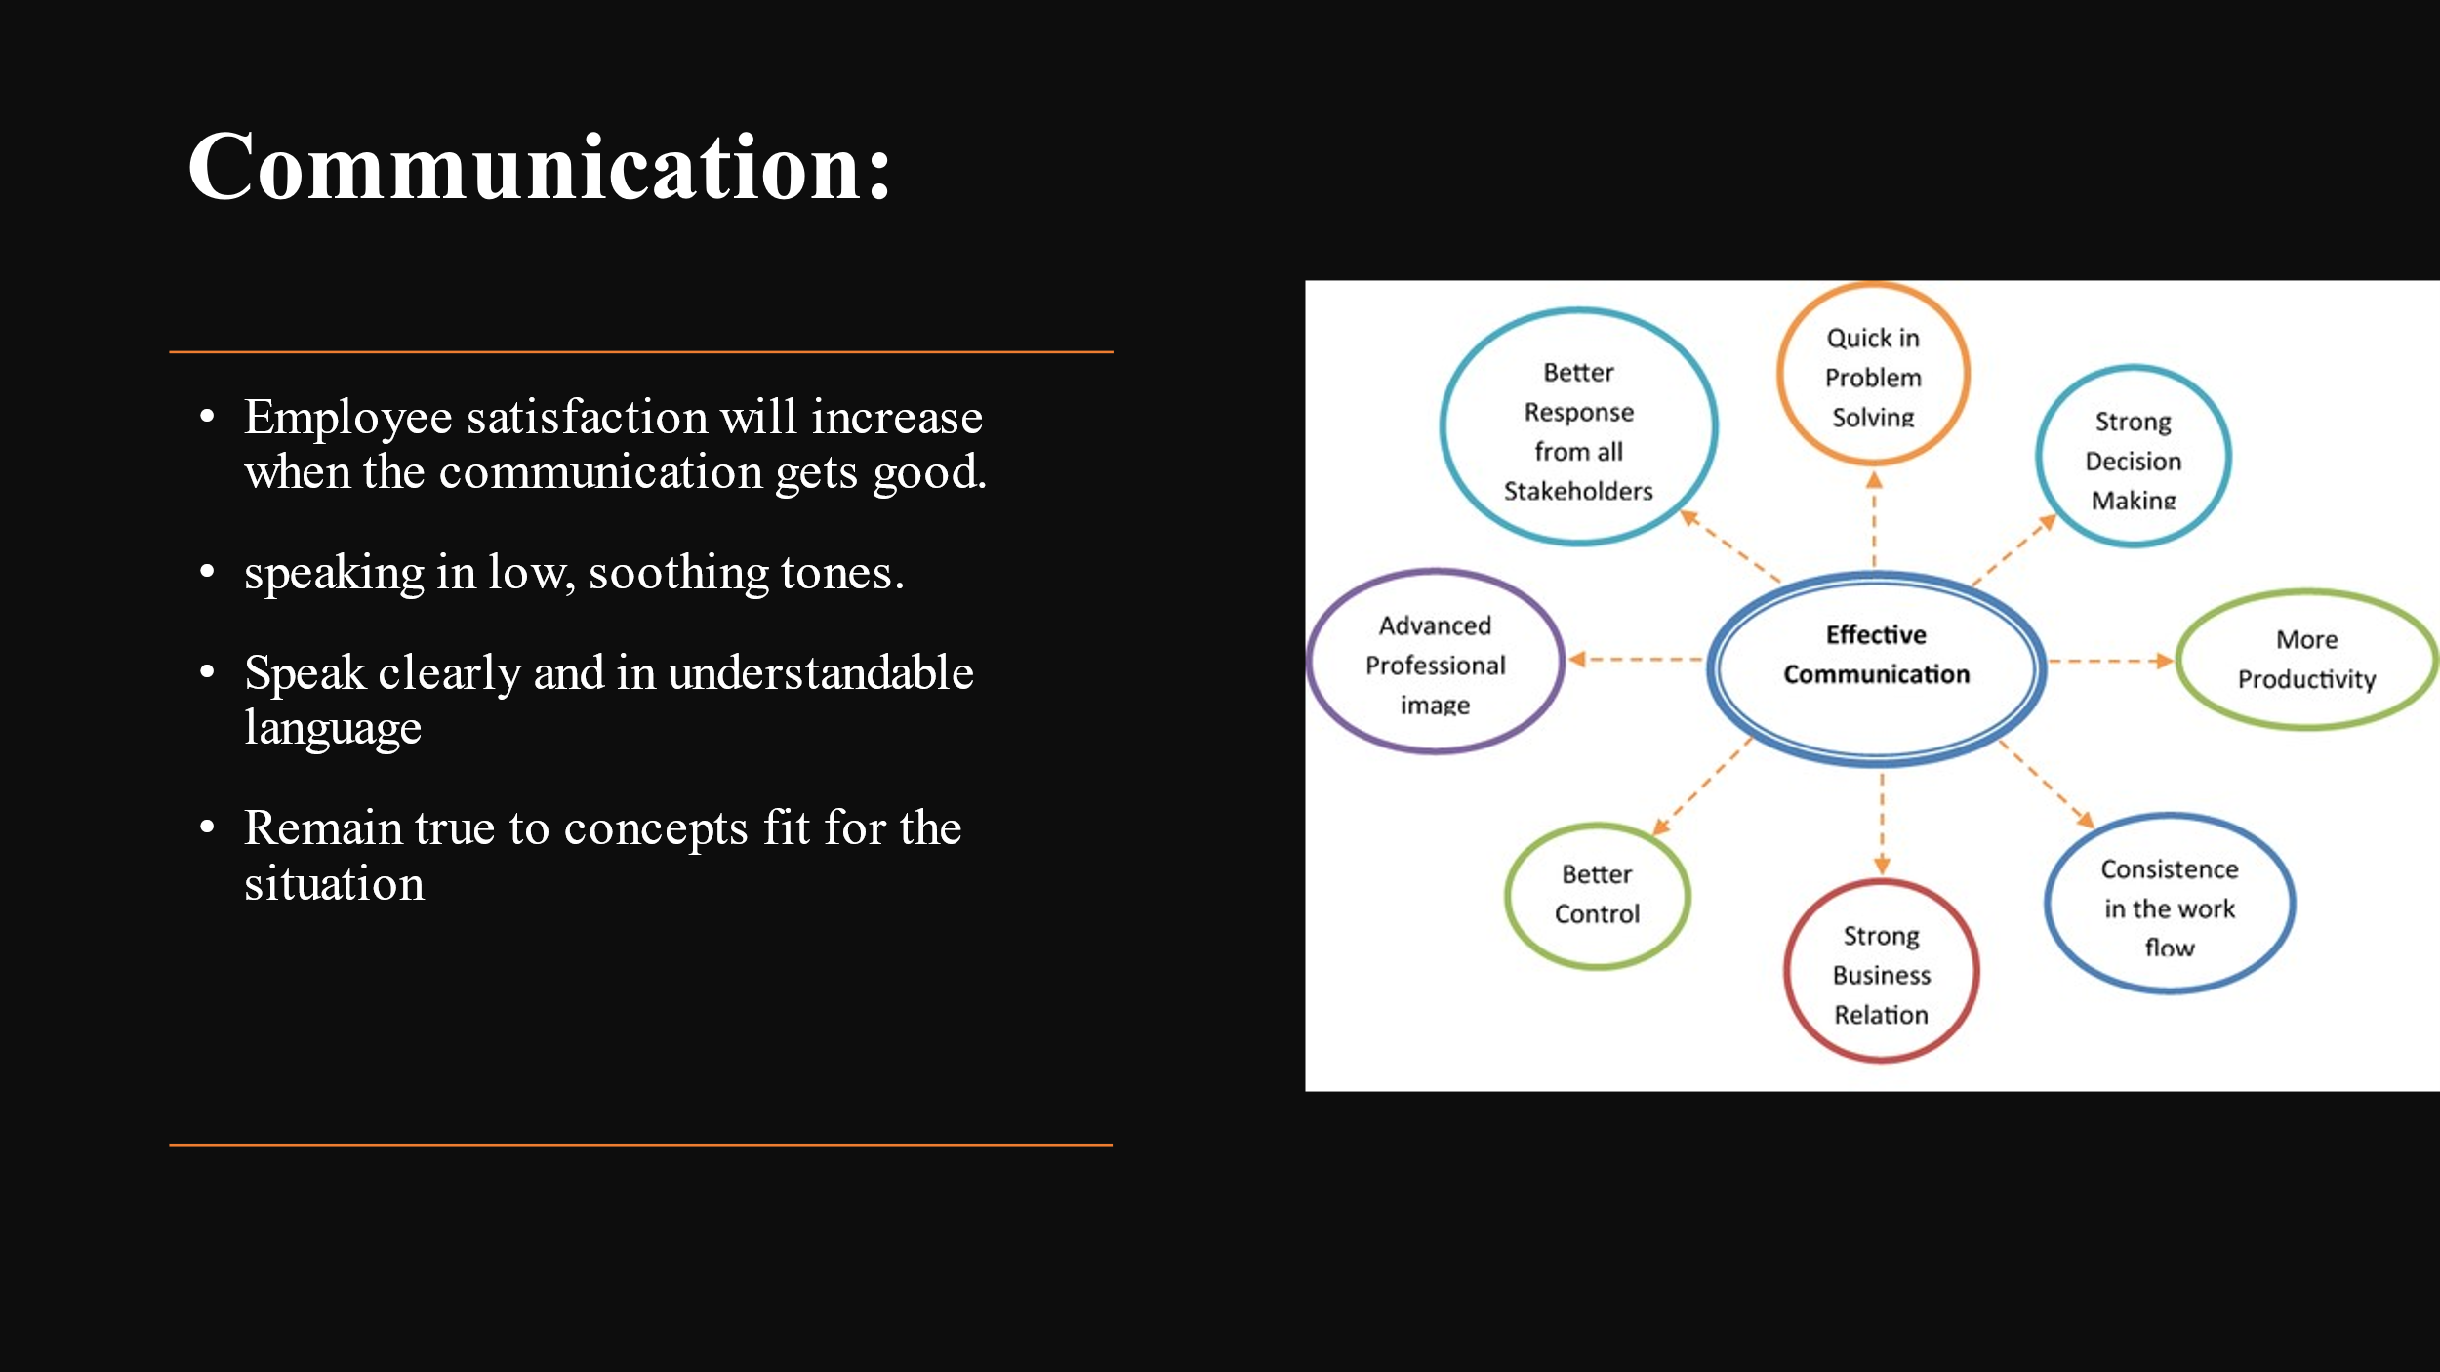
Training Notes:
No matter how big or small, all teams can improve their communication. It could be due to cultural differences, or it could just be that they communicate differently than the other individual or team members. Your housekeeping crew will become more productive at work and more effective at completing tasks if employee communication is developed and used. Additionally, employee satisfaction will increase, which will lower staff turnover. while having communication the following things should be consider:
Before speaking, prepare your speech by thinking it through.
Relax the audience by speaking in low, soothing tones.
Speak clearly and in understandable language.
Avoid rambling and focus on presenting one point at a time. Watch for clues that someone is understanding or confused.
Follow up with questions to make sure the recipient of the message understood it.
Encouraging inquiries from the listener to ensure understanding
Remain true to concepts fit for the situation.
Focus on the person you are talking to and refrain from any actions that might draw his attention away from you.
Employ persuasive language rather than combative language.
Always keep in mind that mockery, derision, and dispute halt communication.
Restate the exchange and state whether the decision has been made (Olimovich et al., 2020).

Making bed:
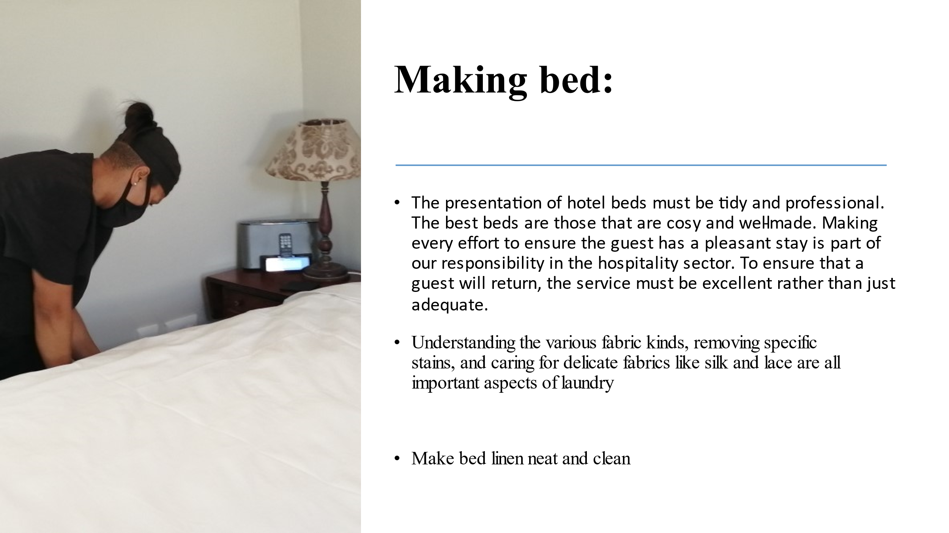

Training Notes:
Laundry

Laundry is a skill that is often overlooked. You'll quickly learn the importance of doing laundry properly if your principal's favourite shirt gets ruined in the wash. It's crucial to have a firm grasp on the ins and outs of laundry care, including the distinctions between different types of cloth, how to treat certain stains, and how to handle delicate items like silk and lace. Knowing what can be washed in the washing machine and how often, and what needs to be sent to the dry cleaners, is helpful. Knowing how to mend clothing, such as mending buttons and rips, and when to get expert help go hand in hand. The method of the laundry are
Make sure you have all of your clean covers, sheets, and pillowcases.
Verify that the mattress is free of dust and debris.
Your mattress should be topped with your mattress pad.
Fit the bottom sheet to your body.
Put your flat sheet down.
Set the bed cover in place.
Corners should all be folded in.
Put pillows in the appropriate pillowcases, puff them up, and then flatten them so they stand tall.

Etiquette & Interaction with Guests
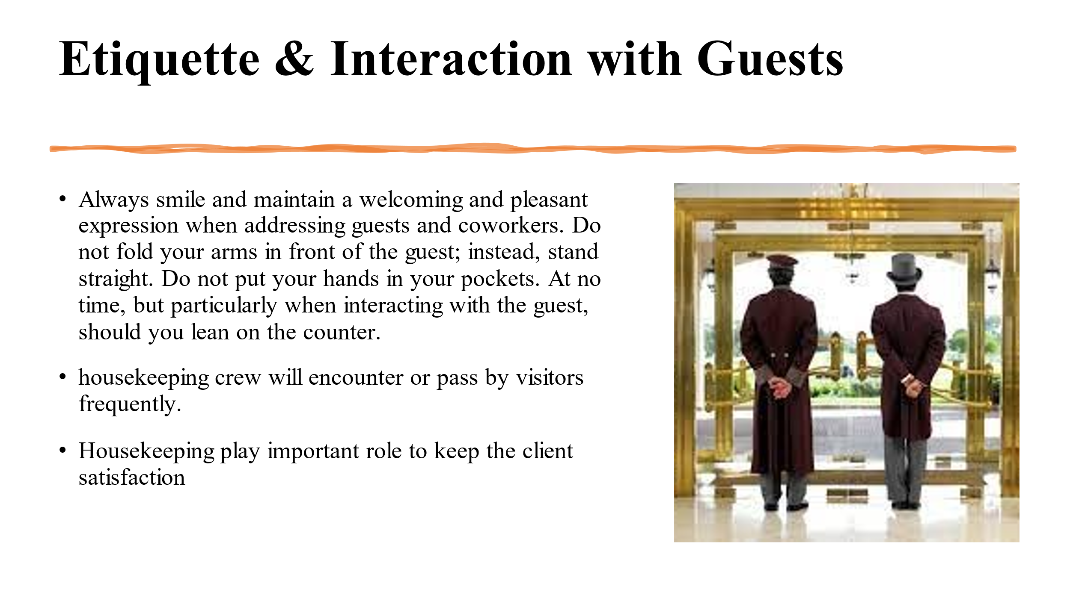

Training Notes:
Most likely, members of your housekeeping crew will encounter or pass by visitors frequently. They have a crucial role in how happy your visitors are and how likely they are to stay at your hotel again. Having problems with etiquette or having bad encounters will have a major impact on this. We can train your staff to understand cultural differences, make a favourable first impression, and cope with body language and etiquette. These minor adjustments will have a major impact on the cleaning staff's self-assurance, as well as their ability to interact with and impress guests in the area.
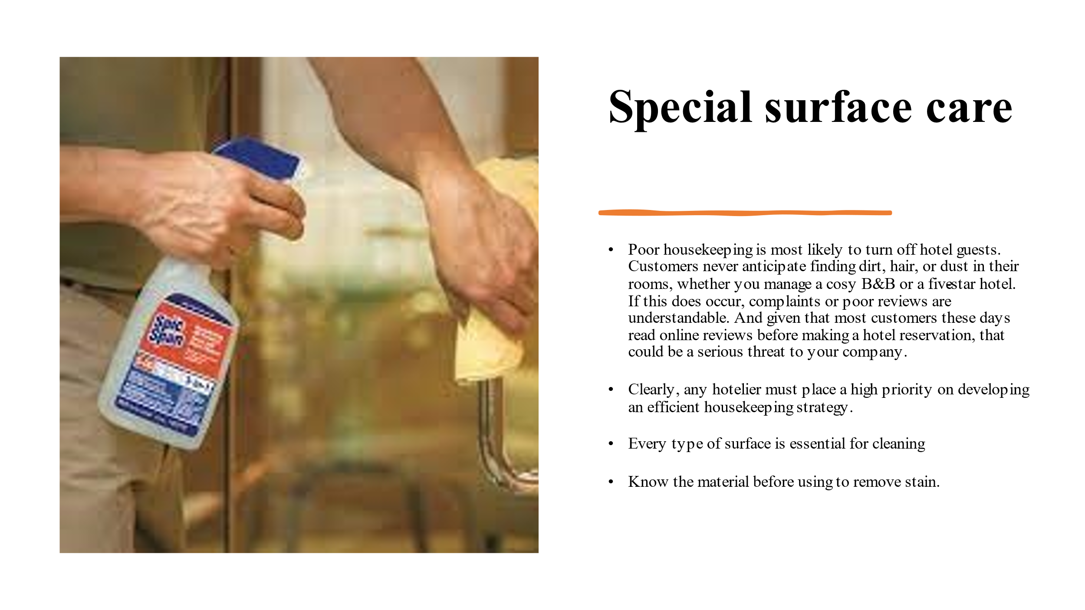
Training Notes:

Understanding every type of surface is essential for cleaning. Certain cleaning solutions can have a very negative effect on a marble floor (untreated wood). Knowing the material ensures that you can clean it properly and remove stains. If you use the wrong vacuum cleaner on particular flooring, they may easily scratch; if you use the wrong product or cloth to clean bathroom tiles, they may never be completely clean. Your time and frustration will be much reduced if you are aware of your diverse surfaces (Meelen, 2019).

Fire Safety and Health Protocol
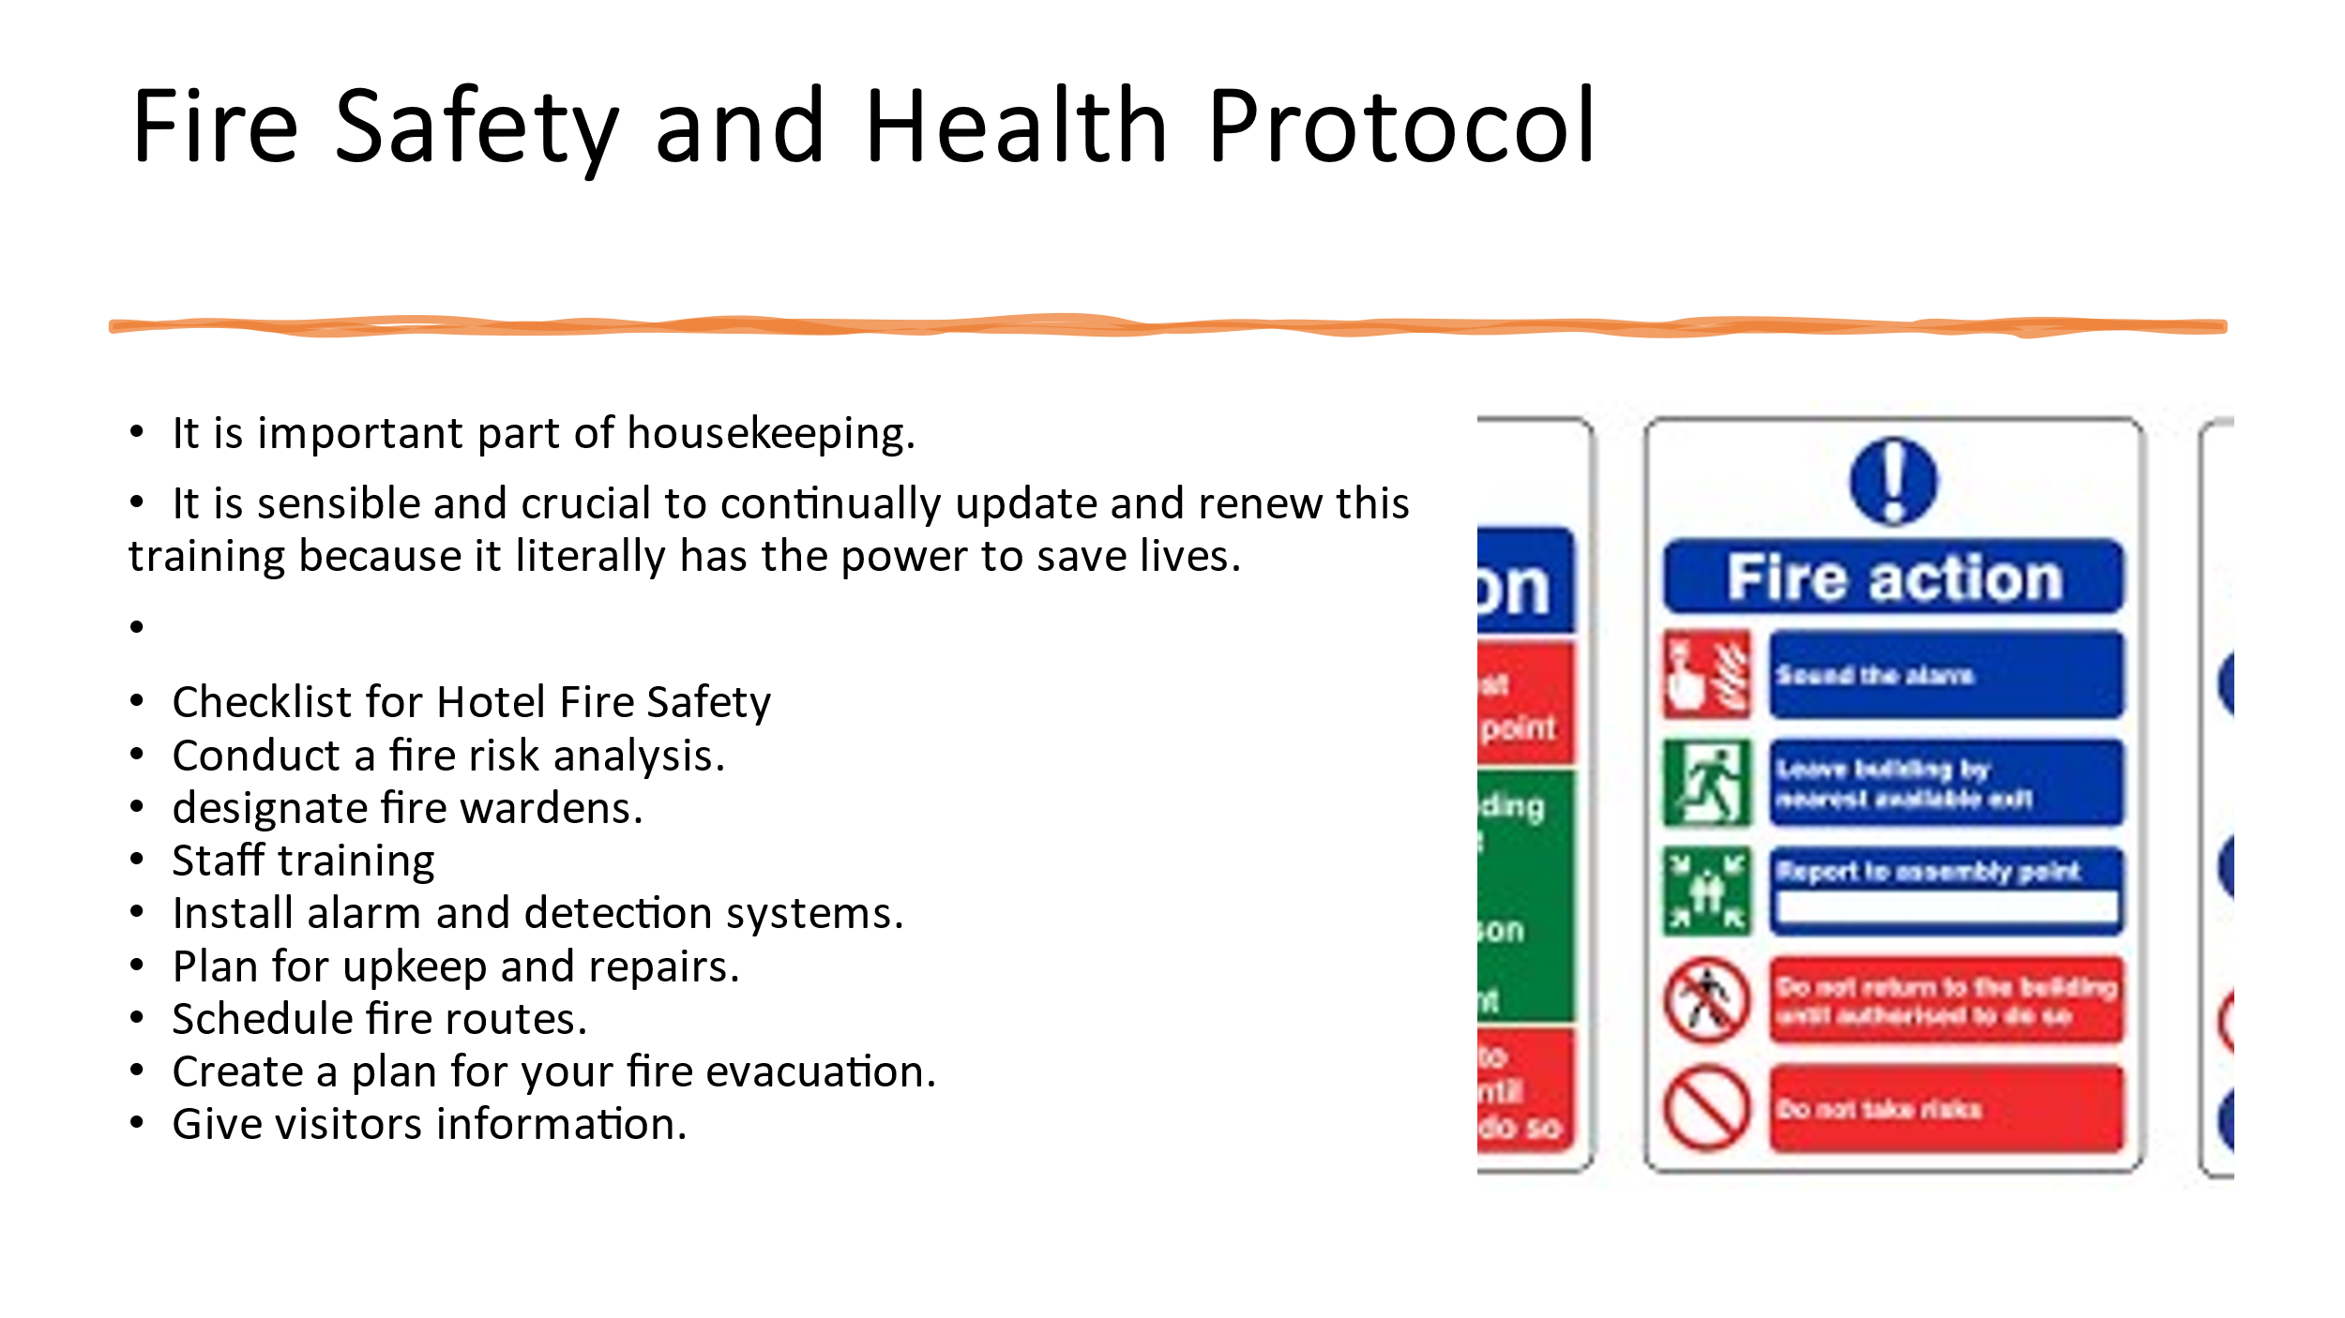
Training Notes:
Fire Safety and Health Protocol

Engaging your housekeeping personnel during the training portions of this is essential for them to retain the material, even though it might be a monotonous yet important subject. In order for students to retain the material and stay awake throughout training, it can be delivered in a fun and engaging manner. It is sensible and crucial to continually update and renew this training because it literally has the power to save lives.
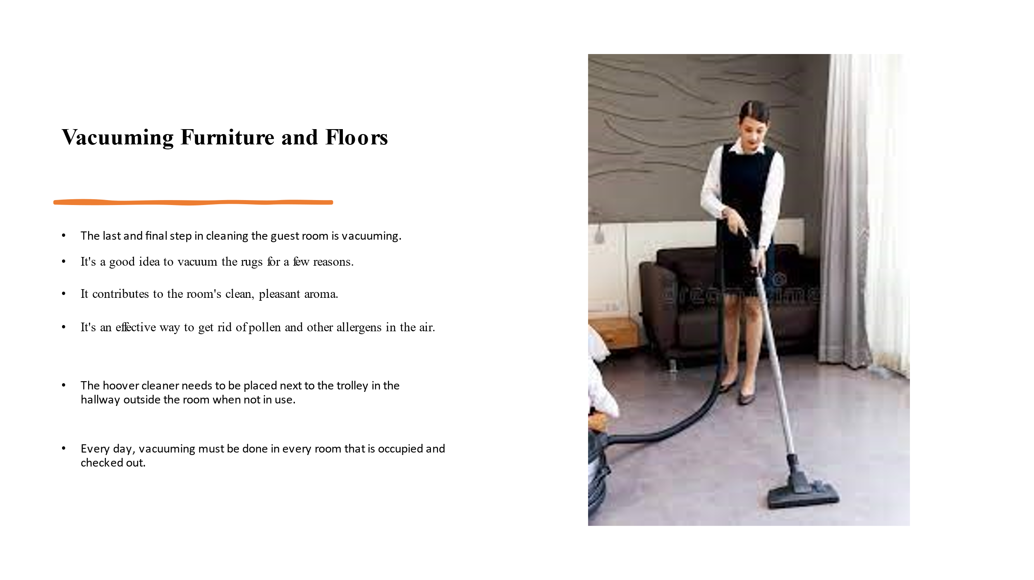

Training Notes:
There are a number of good reasons why you should vacuum your carpets in between hosting parties. The first step is to clean up any stray dust, hair, or dirt that may have been missed. Secondly, it contributes to the overall freshness and cleanliness of the air in the room. Thirdly, it aids in removing potential allergens from the environment. By regularly vacuuming the carpet, you can extend its life and ensure that your guests have a more pleasant stay. Regular vacuuming of upholstery and drapes is also recommended. The vacuum will come with localized attachments designed for certain areas.
Dusting
you must dust the every part of the room

This includes dusting the ceiling and any other object which are out-of-reach surfaces.
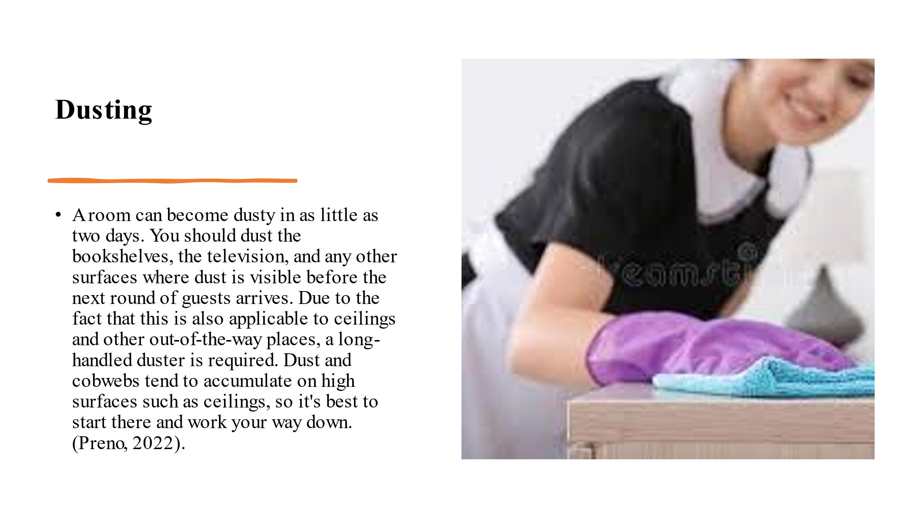

Training Notes:
Dusting

A room can become dusty in as little as two days. You should dust the bookshelves, the television, and any other surfaces where dust is visible before the next round of guests arrives. Due to the fact that this is also applicable to ceilings and other out-of-the-way places, a long-handled duster is required. Dust and cobwebs tend to accumulate on high surfaces such as ceilings, so it's best to start there and work your way down. (Preno, 2022).
Clean mirror and windows
Take the time to clean the spot
use specialized glass cleaner and microfiber towels to make it more clean 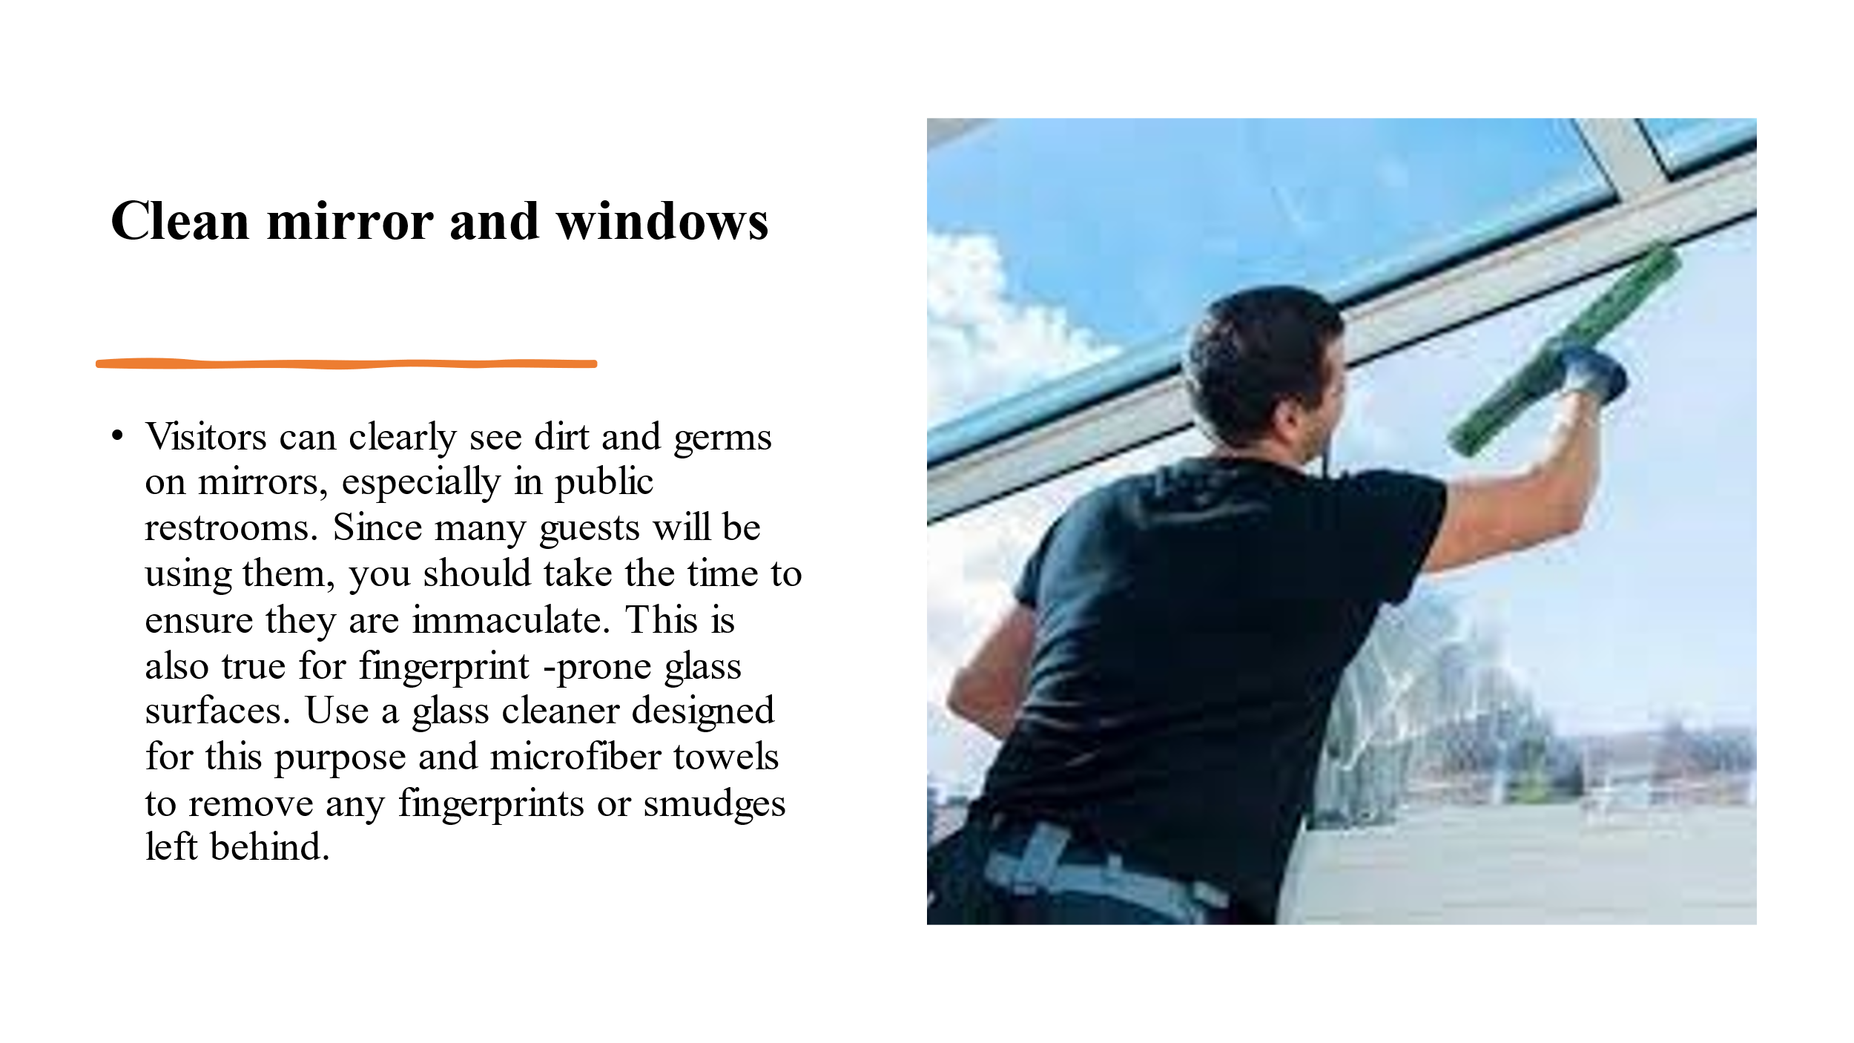

Training Notes:
Clean Mirrors and Windows

Visitors can clearly see dirt and germs on mirrors, especially in public restrooms. Since many guests will be using them, you should take the time to ensure they are immaculate. This is also true for fingerprint-prone glass surfaces. Use a glass cleaner designed for this purpose and microfiber towels to remove any fingerprints or smudges left behind.
Restock Consumables and Amenities

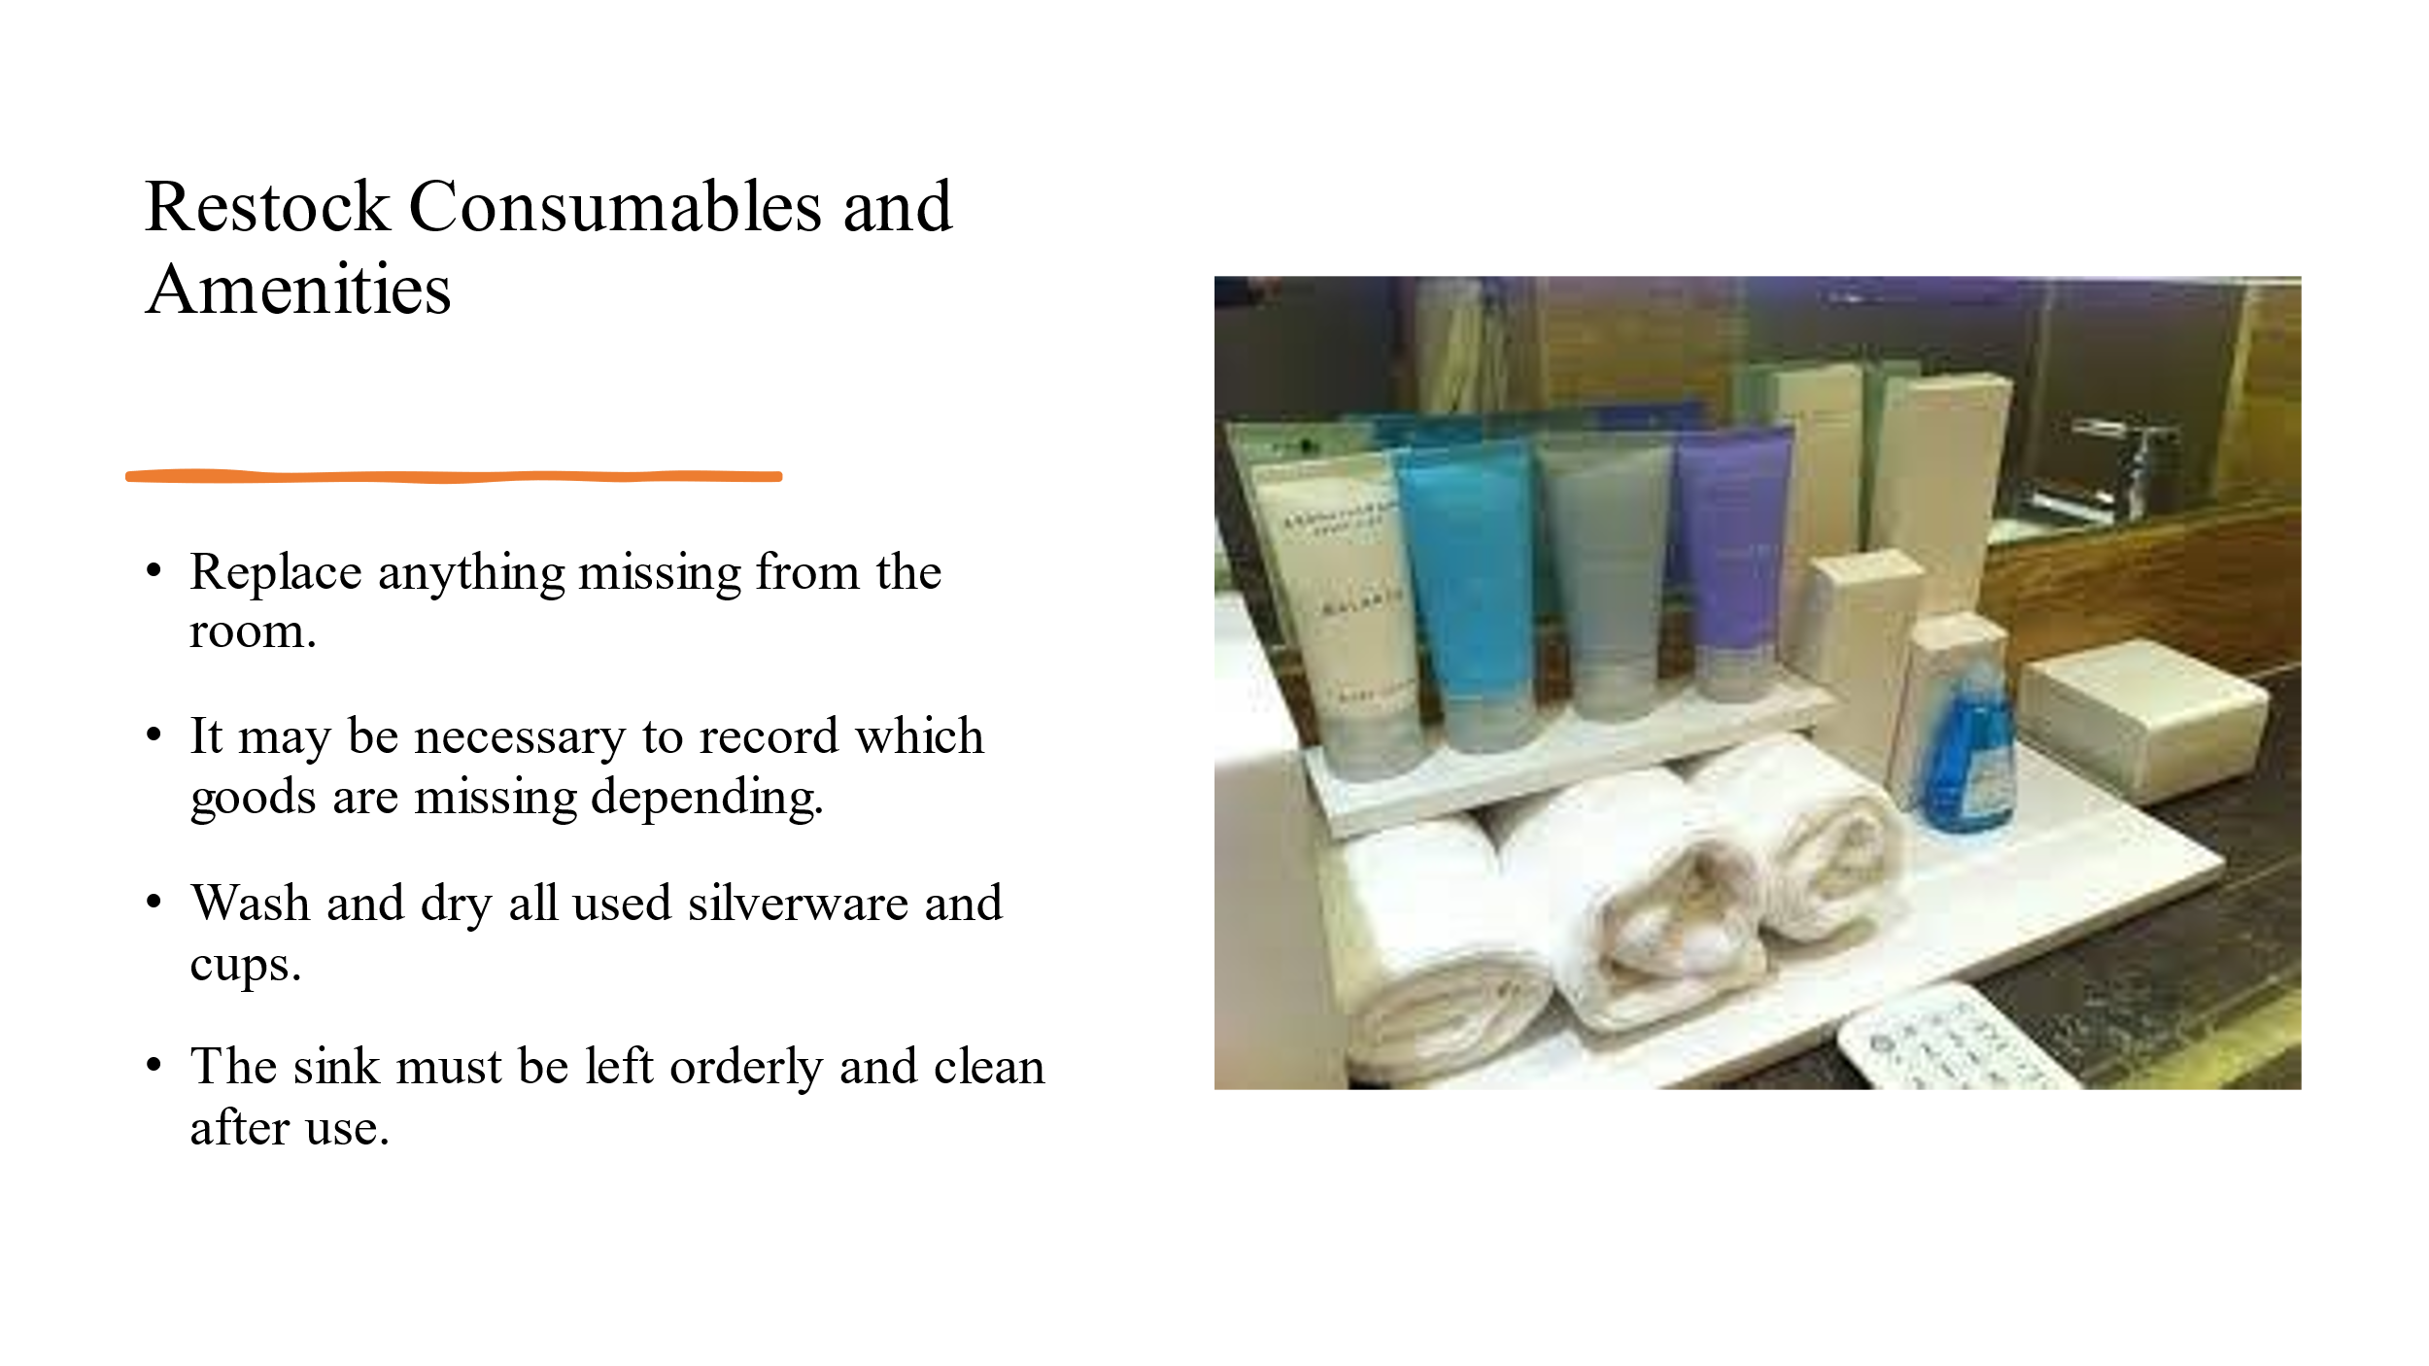

Training Notes:

make sure to restock the room with any amenities that may have been used up, like any toilet paper or soap. Rolls of toilet paper, bars of soap, and bottles of shampoo are among these. Guests won't have to leave without using the restroom, and new arrivals can get a head start on cleaning up. This includes replenishing the coffee and tea sachets, as well as any other consumables, found on the counter or in the mini-bar. Depending on your policies, it may be required to keep track of what items are missing in order to charge guests fairly. Use whatever is at hand to clean and dry the dishware and glasses that have been used. As an added requirement, the sink should be left neat and tidy after each usage.

References

Batinić, I., 2015. Organization of business in hotel housekeeping. Journal of Process Management and New Technologies, 3(1), pp.51-54.
indeed (2020) Guide to housekeeping skills (with tips and examples). Available at: https://www.indeed.com/career-advice/career-development/housekeeping-skills (Accessed: February 6, 2023).
Kennedy, J., Nansen, B., Arnold, M., Wilken, R. and Gibbs, M., 2015. Digital housekeepers and domestic expertise in the networked home. Convergence, 21(4), pp.408-422.
Meelen, A. (2019) Housekeeping skills training, Domestic Staff Recruitment & Training. Available at: https://poloandtweed.com/blog/basic-housekeeping-skills-training (Accessed: February 6, 2023).
Melad, E., Taleb, M.A., Abbas, J. and Abdelaal, E., 2021. The Effects of Time Management on Job Performance of Employees in Hotels. Journal of the Faculty of Tourism and Hotels-University of Sadat City, 5(1/1).
Olimovich, D.I., Bakhtiyorovich, T.M. and Salimovna, N.G., 2020. Improving of personnel training in hotel bussines. Academy, (2 (53)), pp.18-19.
Premier Inn (2023) Premier Inn Hotels: Book Direct, Premier Inn hotels | Book direct. Available at: https://www.premierinn.com/gb/en/home.html (Accessed: February 6, 2023).
Preno (2022) Hotel Housekeeping: Tips & Tricks for Cleaning Hotel Rooms, Preno HQ - Hotel Management Software. Available at: https://prenohq.com/blog/hotel-housekeeping-tips-tricks-for-cleaning-hotel-rooms/ (Accessed: February 6, 2023).
Singh, A. and Jaykumar, P., 2019. On the road to consensus: key soft skills required for youth employment in the service sector. Worldwide Hospitality and Tourism Themes.
Soltani, E. and Wilkinson, A., 2010. What is happening to flexible workers in the supply chain partnerships between hotel housekeeping departments and their partner employment agencies?. International Journal of Hospitality Management, 29(1), pp.108-119.

