01/05/2025

Case Study: Comparison of construction methods

Produced by Louis James (2415463)
Fundamentals of construction technology (ACBA4022)
Table of Contents
Offsite Construction 4
Panelised systems 5
Volumetric systems 5
Sub-assemblies and components 5
Hybrid systems 5
Building regulations 6
Ground floor cross section 6
Timber 6
SIPs 7
Brick and Block 7
External walls cross section 7
Timber twin frame 7
SIPs 8
Brick And Block 8
Roof structure cross sections 9
Timber 9
SIPS 9
Brick and Block 9
Recommended Construction method 10
References 10

Figure list
Figure 1: U-value in new & existing dwellings (online) Available at: Approved Document L Vol 1 Dwellings - Conservation of fuel and power [Accessed 24/04/2025]
Figure 2: Ground floor cross section – timber (PDF) TRADA timber frame construction designing for high performance 5th edition. [Accessed 26/04/2025]
Figure 3: Ground floor cross section – SIPs (PDF) TRADA innovative timber Construction new ways to achieve energy efficiency. [Accessed 26/04/2025]
Figure 4: Ground floor cross section – Brick and Block (PDF) Design to perform: an illustrated guide to delivering energy efficient homes [Accessed 26/04/2025]
Figure 5: External walls cross section – timber (PDF) TRADA timber frame construction designing for high performance 5th edition. [Accessed 26/04/2025]
Figure 6: External walls cross section – SIPs (PDF) TRADA innovative timber Construction new ways to achieve energy efficiency. [Accessed 26/04/2025]
Figure 7: External walls cross section – Brick and Block (PDF) Design to perform: an illustrated guide to delivering energy efficient homes [Accessed 26/04/2025]
Figure 8: Roof construction cross section – timber (PDF) TRADA timber frame construction designing for high performance 5th edition. [Accessed 26/04/2025]
Figure 9: Roof construction cross section – SIPs (PDF) TRADA innovative timber Construction new ways to achieve energy efficiency. [Accessed 26/04/2025]
Figure 10: Roof construction cross section – Brick and Block (PDF) Design to perform: an illustrated guide to delivering energy efficient homes [Accessed 26/04/2025]

Glossary of terms
DPC – Damp proof course
DPM – Damp proof membrane
OSB – Oriented strand board
SIPs – Structurally insulated panels
VCL – Vapour control layers

Offsite Construction
Offsite Construction is the pre-assembly of elements, components, and modules used in the construction of a building, typically this procedure occurs in a factory or warehouse before being transported to site (ikogroup, 2022).
In recent years offsite construction has become an alternative option compared to traditional on-site building methods, as interpreted from (Klocek, A, 2025) this is due to reduced costs and construction times as well as the improvement of workers health and safety.
There are four main categories of offsite construction such as, Panelised, Volumetric, Sub-assemblies and components and hybrid systems all of which can be constructed using primary materials such as concrete, steel and timber (Traylor, G, 2025a).

Panelised systems
Panelised systems are level units that can serve as structural or non-structural components. (WBDG, n.d.) explains panelised systems include prefabricated components for use of walls, floors, roofs, and foundations. There is a plethora of panelised systems such as:
Open panelised systems, tend to be structural components if viable sheeting on one side. This system usually is non-insulated requiring further construction (Traylor, G, 2025b).
As stated from (Traylor, G, 2025c) closed panelised systems include insulation and sheeting on both sides including a service zone, allowing additional insulation to be incorporated. Closed panels can also be produced containing opening for doors, windows, and services.
SIPs are a type of closed panelised system, (SIPA, n.d) stated SIP panels consist of an insulted foam core contained between and interior and exterior sheeting typically OSB.
Panelised systems can be incorporated into the house by using prefabricated wall, floor, and roof panels. The use of panelised systems reduces delays leading to a faster construction time compared to other methods (Western Building Systems, n,d).

Volumetric systems
Volumetric systems is another type of offsite construction, (FootAnstey, 2020a) gives an understanding of how the modules can be installed, typically the process involves connecting prefabricated modules including non- structural modules such as bathrooms to each other in order to create a finished building. Volumetric systems tend to be fully finished internally and can be finished externally reducing the overall construction time phrase.
Volumetric systems can be incorporated into the house by installing finished modules such as the bathroom and kitchen, as the modules are constructed offsite the use of this method reduces the overall construction phase and minimises on site labour leading to further benefits such as reduced waste, quality control and overall site safety (FootAnstey, 2020b).

Sub-assemblies and components
Sub-assemblies and components are pre-manufactured components, as interpreted from (H.L.N, n,d) this type of offsite construction can be designed and added to existing structures such as brick and mortar buildings or buildings constructed from other modern methods. The individual components can include prefabricated floor panels, roof panels and services.
Sub-assemblies and components can be incorporated into the house through the installation of prefabricated induvial elements, allowing for current or future adaptions to the property. For example, elements such as a chimney stack or floor panel can be replaced without causing damage to adjoining components allowing for reduced future costs for renovations.

Hybrid systems
As interpreted from (Birkbeck, n,d) hybrid systems is a common term that covers a plethora of construction techniques and combinations of materials such as timber, steel and concrete benefiting of the materials properties for improved structural performance and adaptability.
Hybrid systems can be incorporated into the house through components containing a variety of materials such as timber and steel, this can be done to comply with building regulations ensuring the materials used contain properties that contribute and enhance the overall quality of the build.

Building regulations
As interpreted from (LABC, n,d) building regulations are a variety of legislative documents that ensure new buildings, conversions, renovations, and extensions are high performing structures that are safe for use.
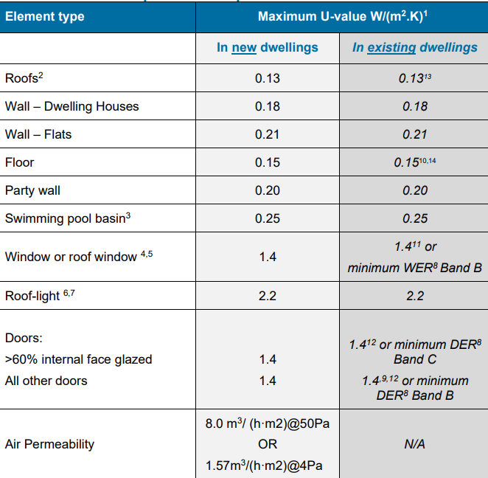
In accordance with Approved document L1A: conservation of fuel and power (‌Welsh Government, 2022a) state new-builds are required to meet the set U-values for individual elements shown in figure 1.
Additionally, as stated from (‌Welsh Government, 2022b) new dwellings require continuous installation minimising the likelihood of condensation and mould, furthermore additional insulation reduces thermal bridging within the property whilst ensuring airtightness reducing unwanted heat loss.

Figure 1:U-value in new & Existing dwellings

Ground floor cross section
From the ground investigation survey, the construction is recommended to be supported by a raft foundation, shown below are illustrations for timber twin frame, SIPs and brick and block cross sections.

Timber
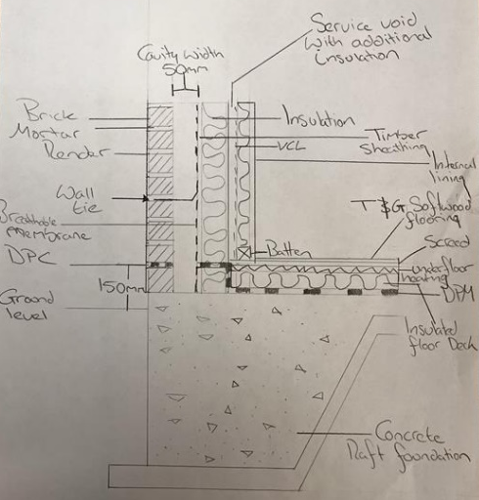
The timber twin frame structure Is supported by a concrete raft foundation, as shown in figure 2 the ground floor consists of DPM, Insulation, Underfloor heating, screed and a tongue and groove finish.

DPM is installed directly above the concrete foundation (Watertight Homes, 2023) explains DPM prevents damp from rising as well moisture penetrating insulation materials. In order to comply with building regulations, insulation is placed above the DPM and is extended vertically in line with the wall insulation reducing thermal bridging.

Figure 2: Ground floor cross section (timber)

SIPs
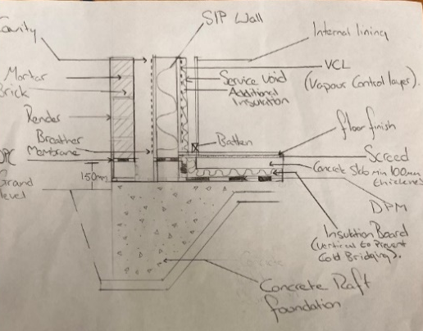
From the ground investigation a concrete raft foundation is recommended. To meet regulations under the approved document L1A DPM, insulation, Underfloor heating and screed makes up the floor, this is visualised in figure 3. SIPs are constructed off site before being transported to site, ensuring accuracy and thermal compliance, once transported onto site the SIP wall is connected to the foundation by a sill plate (Enercept SIPs - Structural Insulated Panel System, 2020).
Figure 3: Ground floor cross section (SIPs)

Brick and Block
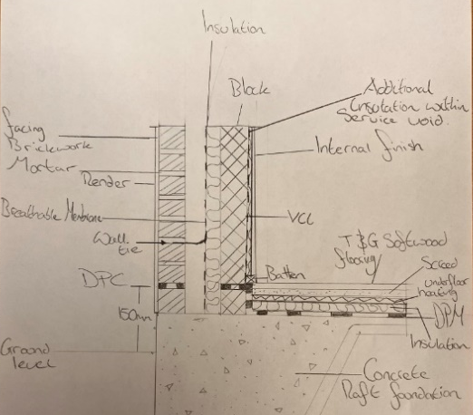
In comparison to both timber twin frame and SIP construction, the concrete raft foundation is best suited to support the structure, incorporated with DPM, insulation, underfloor heating, and a screed layer in order to achieve the requirements in approved document L1A.

A traditional brick and block cavity wall is constructed on site above the foundation unlike SIP construction which is prefabricated offsite. A DPM tray prevents water ingress into the property ensuring the insulation maintains its properties.
Figure 4: Ground floor cross section (Brick and Block)

External walls cross section

Timber twin frame
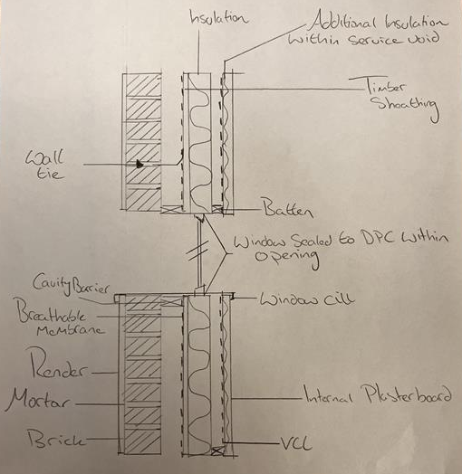
As shown in figure 5 the window opening in timber twin frame construction is formed between the studs and lintel, (TRADA, 2011) highlights the lintel transmits the loads onto the stud reducing stress on the timber wall. Insulation is placed between the stud walls, additionally between the internally battened service zone an insulation board is placed ensuring the wall meets the required U-value, shown in figure 1. The additional insulation minimises likelihood of thermal bridging whilst ensuring airtightness.

Cavity barriers have been placed below and above the window opening as stated from (Subframes UK Ltd, n,d) cavity closers help mitigate condensation and reduce thermal bridging, also improving the structural integrity of the building. In order to manage moisture ingress a layer of breather membrane and VCL is placed externally and internally.
Figure 5: External walls cross section (timber)

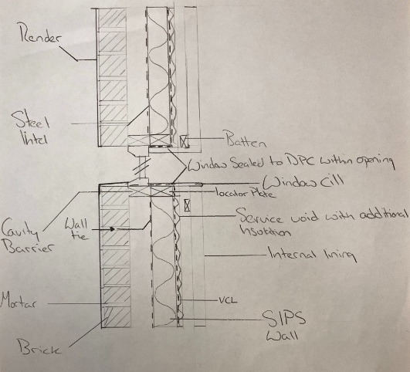
SIPs
Figure 6:External wall cross section (SIPs)
SIPs are prefabricated off site therefore allowing window openings to be cut out during production ensuring precision and efficiency, lintels are placed above the window opening to evenly distribute the loads onto the frame. Due to the amount of insulation filled within a SIP wall, U-values can be easily met however additional insulation has been placed between the internally battened service zone further minimising thermal bridging. A DPC tray is placed between the windows openings reducing occurrence of water ingress. As shown in figure 6 a wall tie is used to connect the inner and outer cavity wall enhancing the structural stability of the wall (BS Fixings, 2024).

Brick And Block
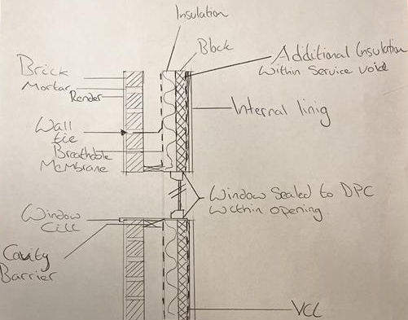
Window openings in brick and block construction require steel lintels supporting the forces acting upon the cavity wall, (Spacemaker, 2025) explains Unlike SIPs traditional construction occurs onsite increasing labour costs and time of job. As shown in figure 7 additional insulation is placed between the service zone in order to meet U-values unlike SIP and timber frame the insulation is continued directly below the opening. Cavity barriers are placed below the window cill and lintel to reduce thermal bridging.

A DPC tray is installed below and above the opening to prevent water ingress additionally the window cill reduces water ingress as it pushes the water off the opening. Illustrated in figure 7 wall ties are used to connect the inner and outer wall of the cavity ensuring the stability of the structure.
Figure 7: External wall cross section (Brick and Block)

Roof structure cross sections

Timber
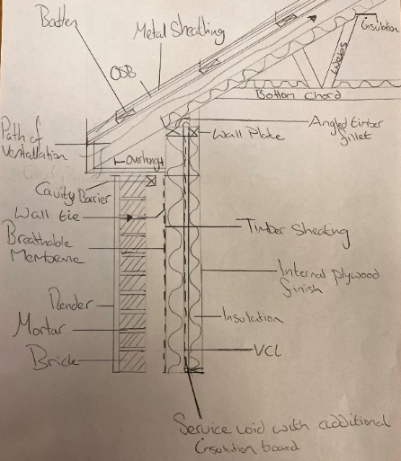
Figure 8 illustrates the raised tie truss fixed to the wall plate above the timber twin frame walls, additional insulation is placed between the rafters and truss to achieve the minimum U-value required, shown in figure 1.
Figure 8: Roof cross section (timber)

The soffit board provides a path of ventilation reducing moisture levels within the structure (Anglian, n,d).

A metal sheeting sits above the inner OSB board protecting the inner structure from water ingress, the metal sheeting allows water to runoff the roof into the gutters.

SIPS
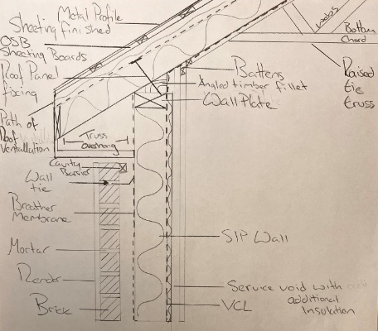
(Hill, S, 2023) highlights SIP roofs do not require traditional roof trusses due to the structural integrity that SIPs provide, however the client a raised tie truss as illustrated in figure 9. The use of SIP roof panels ensures the thermal performance of the building meets regulations. The outer metal sheeting sits above the additional sheeting, battens and breather membrane, figure 9 visualises the individual components. As construction of SIP components is offsite, the construction time phase is far more efficient compared to traditional methods.
Figure 9:Roof cross section (SIPs)

Brick and Block
Traditional brick and block construction roofs are connected to the inner cavity walls by a wall plate, additional insulation is placed between the rafters and ceilings in order for the structure to meet the minimum U-values, stated in figure 1.

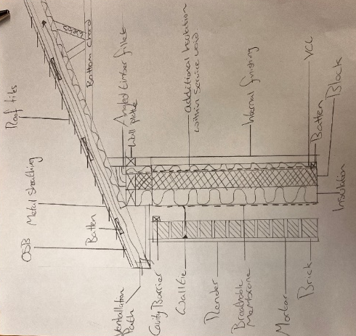
The soffits allow for correct ventilation in the roof structure, reducing moisture levels and prevent condensation therefore increasing the longevity of the structural components. A breathable membrane is installed between the battens and OSB sheeting providing further protection against water ingress (LABC, 2024).
Figure 10: Roof cross section (Brick and Block)

Recommended Construction method
The recommended construction method is SIP, according to (Checkatrade, n,d) SIPs are ‘made to measure’ ensuring accuracy and structural stability therefore once arrived at site they are ready for installation, reducing construction time and onsite labour leading to an overall lower cost. In order for the building to comply with approved document L1A: conservation of fuel and power individual components of the property must meet the thermal performance requirements shown in figure 1, insulation is a key factor in reducing U-values. As stated by (Outerspace Life, n,d) ‘SIPs are renowned for their exceptional thermal performance the continuous insulation and airtight construction minimise heat loss as well as likelihood of thermal bridging occurring, hence lowering energy costs and potential costs after construction.

References
Anglian (n,d). A Guide To Fascias and Soffits | Anglian. [online] Available at: https://www.anglianhome.co.uk/roofline/a-guide-to-fascias-and-soffits [Accessed 27/04/2025].
Birkbeck (n,d). What Is Hybrid Steel In Construction? | Structural | System. [online] Available at: https://www.birkbeck-structures.com/why-choose-a-hybrid-structural-system-in-construction/. [Accessed 24/04/2025].
BS Fixings (2024). What is the Purpose of a Wall Tie? [online] Available at: https://bsfixings.uk/blog/what-is-the-purpose-of-a-wall-tie/. [Accessed 26/04/2025].
Checkatrade (n,d). Why choose SIPs for your next building project? | Checkatrade. [online] Available at: https://www.checkatrade.com/blog/trade/why-choose-sips/. [Accessed 28/04/2025].
Enercept SIPs - Structural Insulated Panel System (2020). How SIP wall panels connect to the subfloor or the foundation wall. [online] Available at: https://www.youtube.com/watch?v=zzpkEdkQ57U [Accessed 25/04/2025].
FootAnstey (2020). What is volumetric construction? [online] Available at: https://www.footanstey.com/our-insights/articles-news/what-is-volumetric-construction/. [Accessed 24/04/2025].
H.L.N. (n,d). A Guide to Modern Methods of Construction (MMC). [online] Available at: https://www.hlnengineering.co.uk/modern-methods-construction-mmc/. [Accessed 24/04/2025].
Hill, S. (2023). Are SIPs Right for Your Self-Build Project? A Guide. [online] Available at: https://www.risedesignstudio.co.uk/blog/exploring-structural-insulated-panels-are-sips-right-for-your-self-build-project. [Accessed 28/04/2025].
‌ ikogroup (2022). Offsite construction methods and their benefits | IKO Group UK. [online] Available at: https://ikogroup.co.uk/news-advice/offsite-construction-methods-and-their-benefits/. [Accessed 23/04/2025].
Klocek, A. (2025). 8 reasons we need more off-site construction and why it’s the future. [online] Available at: https://underthehardhat.org/8-reasons-we-need-more-off-site-construction-and-why-its-the-future/ [Accessed 23/04/2025].
LABC (2024). LABC Warranty. [online] Available at: https://www.labcwarranty.co.uk/technical-blog/guide-to-breather-membranes [Accessed 28/04/2025].
LABC (n,d). What Are the Building Regulations? |Building Control | LABC. [online] Available at: https://www.labc.co.uk/about-labc/what-are-building-regulations. [Accessed 24/04/2025].
Outerspace Life (n,d). Unlocking the Power of SIPs: Why This Modern Method is Revolutionising UK Construction - Outerspace Life. [online] Available at: https://www.outerspacelife.co.uk/unlocking-the-power-of-sips-why-this-modern-method-is-revolutionising-uk-construction/ [Accessed 28/04/2025].
SIPA (n.d). What Are Sips. [online] Available at: https://www.sips.org/what-are-sips. [Accessed 24/04/2025].
Spacemaker (2025). Modular vs Traditional Construction - Spacemaker Modular. [online] Available at: https://spacemakermodularandportablebuildings.co.uk/modular-building-guides/modular-vs-traditional-construction/ [Accessed 26/04/2025].
Subframes UK Ltd. (n,d). Cavity Closers by Kingspan | Subframes UK Ltd | Cavity Closer Systems. [online] Available at: https://subframes.co.uk/cavity-closers/kingspan/ [Accessed 26/04/2025].
TRADA (2011) timber frame construction designing for high performance 5th edition. (PDF) [Accessed 26/04/2025].
Traylor, G (2025) Fundamentals con tech superstructure 10 offsite (Presentation), ACBA4022: Fundamentals of construction. [Accessed 25/04/2025].
Watertight Homes (2023). Damp Proof Membrane: What It Is and How It Works. [online] Available at: https://watertight-homes.co.uk/property/care/damp-proof/membrane. [Accessed 25/04/2025].
WBDG (n.d.). Structural Insulated Panels (SIPs) | WBDG - Whole Building Design Guide. [online] Available at: https://www.wbdg.org/resources/structural-insulated-panels-sips. [Accessed 23/04/2025].
‌Welsh Government (2022), Approved document L1A: Conservation of fuel and power (online) Available at: Approved Document L Vol 1 Dwellings - Conservation of fuel and power [Accessed 24/04/2025].
Western Building Systems. (n,d). Panelised Construction - Western Building Systems. [online] Available at: https://westernbuild.com/build/what-we-do/panelised-construction/. [Accessed 24/04/2025].

