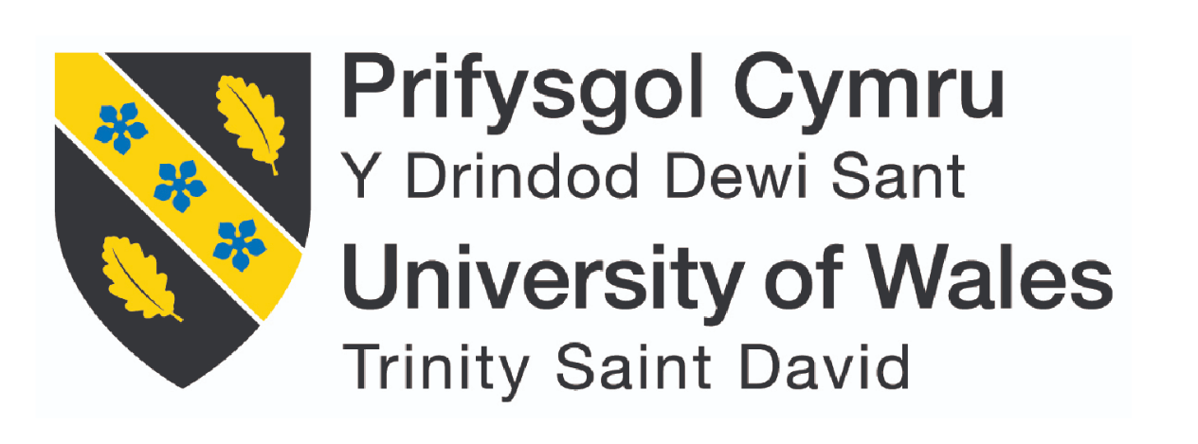

Usability Engineering (ACCB6017)

Full Interface & Testing

Carys Rees 2003859

Contents
Introduction 5
Full-Colour Design Storyboards 5
Overview of Storyboards 5
Major Screen Designs 6
Main Menu Screen 6
Gameplay Screen 6
Scoreboard Screen 7
7
Settings Screen 7
Feedback-Driven Changes 8
Home Page: 8
Single Player Page: 8
Scores Page: 8
Settings Page: 8
Feedback Collection Process 9
Methods of Feedback Collection 9
Diversity of Testers 10
Feedback Analysis 11
Positive Feedback 11
Negative Feedback 11
Emotional Response 11
Data Collection for a Working Version 12
Types of Data to Collect 12
Usability Data 12
Persona Responses: 12
Performance Data 12
Persona Responses 13
User Satisfaction Data 13
Persona Responses 13
Methods of Data Collections 14
In-App Analytics 14
Post-Testing Surveys 14
Individual Interviews 14
Next Steps Based on Persona Feedback 14
Refine Navigation Design 14
Improve Accessibility and Usability 14
Introduce Help and Onboarding Features 15
Usability Vs. User Experience Conflicts 15
Simplifying Navigation vs. Maintaining Immersive Aesthetics 15
Addressing this conflict: 15
Adding Accessibility Features vs. Avoiding Overwhelming Users 15
Addressing this conflict: 15
Conclusion 16
References 17
Appendix 18
19

Introduction
This report outlines the development of a UWTSD-themed mobile adaptation of Zombie Dice, a “press your luck” game by Steve Jackson Games. Retaining the original mechanics, the adaptation incorporates UWTSD branding and aims to deliver an engaging, user-friendly interface. Beginning with wireframe prototypes, the project progressed to full-colour storyboards informed by usability testing and user feedback.
This report details the evolution of the interface design, emphasising feedback integration, usability testing, and adherence to design theory. Additionally, it explores how user data would influence future iterations if the game were developed and released. Salen [1]. The collaborative nature of the design process, informed by both usability theory and user involvement, ensures that the final product meets the needs of its target audience while maintaining a balance between functionality and user experience. Beaufort [2].

Full-Colour Design Storyboards

Overview of Storyboards
The presented storyboards for the UWTSD-themed Zombie Dice mobile game showcase a comprehensive and engaging user interface design. Each screen is tailored to facilitate smooth navigation, usability, and a visually appealing experience for players. These storyboards highlight key interactions and features of the app while incorporating the thematic branding of UWTSD.

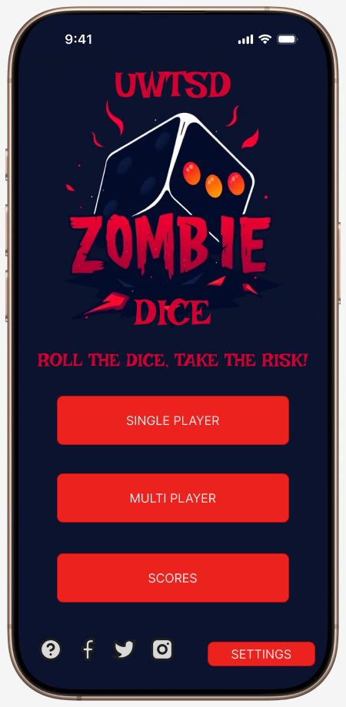
Major Screen Designs

Main Menu Screen
- Displays a bold, thematic logo at the centre, with the UWTSD branding seamlessly integrated into the design.
- Includes clearly labelled buttons for core actions like “Single player”, “Multi player” and “scores”.
- Acts as a central hub, directing users to all major features of the app.
- Players can quickly select their desired action without confusion. The consistent layout minimises the cognitive load and enables quick decision-making.

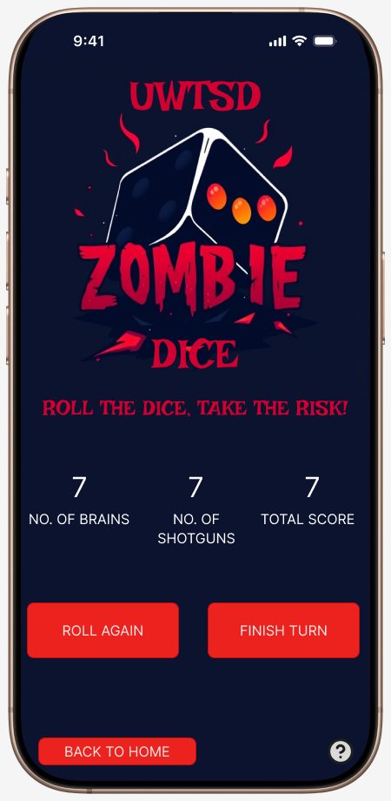

Gameplay Screen
- Includes clearly labelled buttons for core actions like “roll again” and “finish turn, promoting intuitive navigation. A “Back to Home” button ensures quick exits if needed.
- Real-time scores for the player are prominently displayed to ensure clarity during gameplay.
- Dynamic dice visuals and real-time score tracking keep players engaged. Buttons are positioned ergonomically for ease of use on mobile devices.

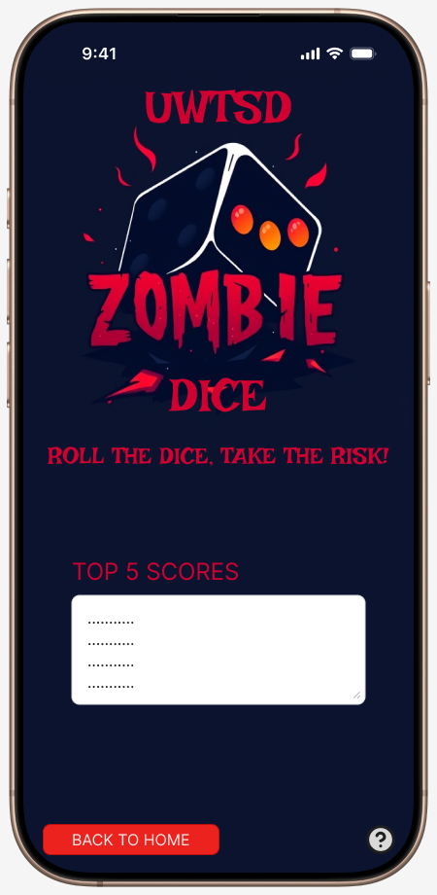
Scoreboard Screen
- Focused on presenting the top five scores in a clean and organised manner.
- Features minimalistic design elements to maintain user focus on the score data, while still adhering to the game’s thematic style.
- Minimalist design ensures the focus remains on the displayed scores. A "Back to Home" button provides a simple exit option, while the lack of clutter enhances usability.

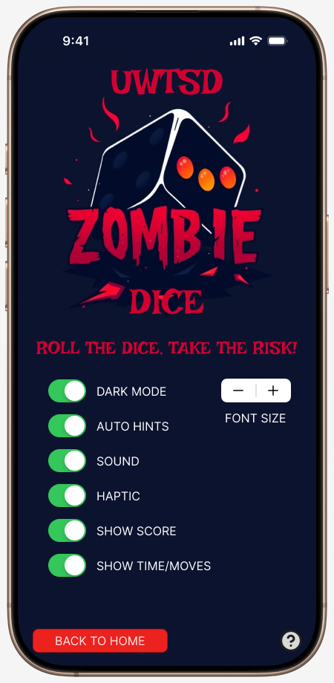

Settings Screen
- Provides easy access to customisation options such as toggling dark mode, enabling/disabling sound and haptic feedback, and adjusting font size.
- The design prioritises accessibility and user comfort, allowing players to tailor the app to their preferences.

Feedback-Driven Changes

Home Page:
Feedback Received: Some users found the menu options unclear and the layout slightly overwhelming. The "Back to Home" button placement was also not intuitive for all personas.
Changes Implemented:
- Redesigned the menu layout with larger, clearer buttons for easier navigation.
- Repositioned the "Back to Home" button to a consistent location across all screens for improved usability.

Single Player Page:
Feedback Received: Players wanted clearer labelling for gameplay actions (e.g., "Roll Again" vs. "Finish Turn") and requested better guidance for new players.
Changes Implemented:
- Enhanced button labels for clarity, ensuring players can easily differentiate between gameplay actions.
- Added a small question mark icon linking to a brief tutorial or explanation of the game mechanics.

Scores Page:
Feedback Received: Some users felt that the layout lacked visual interest and could benefit from thematic elements to maintain engagement.
Changes Implemented:
- Introduced subtle thematic decorations, such as dice icons or score animations, to enhance visual appeal while keeping the design clean.
- Adjusted font size and colour contrast to improve readability for all players.

Settings Page:
Feedback Received: Accessibility options like font size adjustment were not initially prominent, and some users struggled to locate key features.
Changes Implemented:
- Moved font size adjustment controls to the top of the page for better visibility.
- Reorganised toggle switches into logical groups (e.g., visual settings, gameplay settings) to make options easier to locate.
- Added a brief description next to each toggle to explain its functionality.
These changes were informed by usability testing and persona feedback, ensuring the app delivers a cohesive, user-centred experience. The navigation and design refinements make the app more accessible, engaging and functional for players across diverse backgrounds.

Feedback Collection Process
To ensure that the design of the UWTSD-themed mobile game meets the needs and expectations of the target users, feedback was collected through a combination of usability testing and user feedback surveys. The goal was to assess the usability of the interface as well as gauge the emotional response to the game mechanics and visual elements.

Methods of Feedback Collection
The feedback collection process involved two key research methods: questionnaires and individual interviews. These methods were employed in both wireframe and full-colour storyboard testing stages.
- User Recruitment: A set of personas was defined to represent a range of target users for the mobile game. These personas included casual mobile gamers, competitive players and UTWSD students. Four persona feedback was gathered, ensuring a diverse range of perspectives.
- Questionnaire: After presenting participants with the wireframe and full-colour storyboards, they were asked to fill out a questionnaire designed to access key aspects of the game’s usability and emotional impact. The questionnaire included both closed-ended questions (such as ratings on ease of use, visual appeal and game engagement) and open-ended questions (such as “What did you enjoy most about the game?”, “What areas would you improve?”). This helped gather both quantitative data and qualitative feedback on user experience.
- Individual Interviews: In addition to the questionnaire, one-on-one interviews were conducted with each participant. These interviews allowed for a deeper exploration of user thoughts and feelings, particularly around specific elements of the game design. For example, participants were asked to describe their experience with the dice-rolling mechanic and their emotional response to the game’s theme and visual design. The interviews were semi-structured, allowing for flexibility in discussing specific points that emerged during testing.

- Testing Phases:
  - Phase 1: Wireframe Testing – Initially, participants reviewed the wireframe storyboards to test basic functionality such as navigating through the app and understanding how to roll the dice and make in-game decisions. The goal was to identify any major usability issues.
  - Phase 2: Full-Colour Storyboard Testing – After revisions were made based on the initial feedback, participants tested the full-colour storyboards. This phase focused on aesthetics, interactions, and overall game flow. Participants were encouraged to explore more complex features, such as score tracking and decision-making, while providing feedback on the visual appeal and usability.

Diversity of Testers
To ensure diverse feedback was gathered, several key user personas were targeted:
- Seren Greig (Age 16): A year 11 student who enjoys casual mobile games, particularly those that are quick and engaging. Seren prefers games that can be played during short commutes or between classes and enjoys multiplayer options when playing with friends.
- Charlie Smith (Age 21): A third-year computer science student at UWTSD who enjoys casual games with both solo and multiplayer modes. He values quick, rewarding gameplay and a university-themed aesthetic, making the UTWSD theme a key appeal for him.
- Steffan Garland (Age 29): A full-time plumber who enjoys unwinding with mobile games after a physically demanding day. Steffan prefers games that are easy to pick up, quick to play, and playable offline.
- Manon Rees (Age 48): An office worker in the civil service who enjoys simple, relaxing games to unwind. Manon prefers games that are visually clean and easy to navigate, with features like adjustable text size or night mode to accommodate for eye strain.
By using these varied personas, the feedback collection was comprehensive and represented both novice and experienced players with diverse needs.

Feedback Analysis

Positive Feedback
- Ease of Use: Many participants found the app’s interface intuitive, with clear navigation and simple controls. The dice-rolling mechanic was easy to understand and engaging, particularly for players unfamiliar with Zombie Dice, such as Manon.
- Visual Appeal: The UWTSD-themed design was well-received. Participants appreciated the navy colour palette, which created an energetic and fun atmosphere that aligned well with the game’s theme.
- Engagement: The “press your luck” mechanic was particularly popular, with users enjoying the challenge of rolling dice and deciding when to stop.

Negative Feedback
- Button Size and Placement: Some participants noted that the buttons on the main screen appeared small, making them difficult to interact with quickly during gameplay. They suggested increasing button size and improving their placement for easier access.
- Instructions for New Players: A few participants found the instructions somewhat unclear, particularly regarding how the dice results were interpreted. A clearer tutorial or guidance for first-time players was recommended.
- Game Pace: Some users felt the game could feel slow, especially when deciding whether to roll again. Suggestions for speeding up transitions and providing options to skip animations were made.

Emotional Response
Participants expressed a range of emotions during testing. Many reported feeling excitement and suspense when rolling the dice and waiting for the results. However, there were moment of frustration when the game did not respond quickly enough or when users struggled to find certain buttons. The overall theme, though, was widely appreciated for its creativity and connection to UWTSD.
In conclusion, the feedback collection through questionnaires and individual interviews provided a comprehensive view of the app’s usability and emotional appeal. The insights gained will help refine the games interface to ensure it meets user expectations and provides an enjoyable experience.

Data Collection for a Working Version
This section outlines the feedback gathered from the four personas after they played the UWTSD-themed mobile game. These finding will guide future refinements to better meet user expectations. Mazhar [3].

Types of Data to Collect

Usability Data
This type of data will assess how efficiently users can interact with the game, ensuring the final interface is intuitive and easy to navigate. Specific data points will include:
- Completion Rates: All personas successfully navigated the game and completed tasks such as rolling dice, tracking scores, and accessing settings. However, varying levels of ease were reported.
- Error Tracking: Issues were highlighted with button placement and the clarity of instructions for new players.

Persona Responses:
- Seren Greig: Found the app easy to navigate but felt the multiplayer setup was confusing. She suggested adding a simple invite system for friends.
- Charlie Smith: Navigated the interface without issue but noted that accessing advanced settings like customising dice or viewing game history could be streamlined.
- Steffan Garland: Appreciated the straightforward design but mentioned that restarting a game after paying could be more intuitive.
- Manon Rees: Struggled slightly with small button sizes, especially in the settings menu, and requested larger, more accessible buttons.

Performance Data
This data will focus on the technical aspects of the game, ensuring it performs smoothly under real-world conditions. Key performance indicators will include:
- Load Time: Feedback indicated that the game generally loaded quickly, but some minor delays occurred during transitions between screens.
- App Stability: Most participants reported smooth transitions between screens, though some mentioned that certain animation slowed the process.

Persona Responses
- Seren Greig: Appreciated the quick load times but felt that transition animations could be shorter to maintain a fast-paced experience.
- Charlie Smith: Suggested optimising the app’s performance for older devices, as minor delays were observed when switching between settings and gameplay screens.
- Steffan Garland: Confirmed that transitions were fluid but requested offline functionality for navigation in low-connectivity environments.
- Manon Rees: Found the transitions smooth but recommended an option to disable animations for quicker access.

User Satisfaction Data
Collecting data on player satisfaction will ensure that users enjoy the experience and feel motivated to continue playing. This data will be captured through post-play surveys, focusing on:
- Visual Appeal: Feedback on the visual layout of screens was generally positive. The personas appreciated the clear structure and logical placement of buttons, though some improvements were recommended.
- Consistency: The consistent colour palette and theme across screens were praised for creating a cohesive experience.

Persona Responses
- Seren Greig: Liked the clean design but suggested grouping multiplayer-related features into a dedicated section for easier access.
- Charlie Smith: Enjoyed the UWTSD-themed aesthetic and proposed adding visual cues, such as highlighted buttons, to indicate active screens.
- Steffan Garland: Valued straightforward layout but suggested larger, more prominent navigation buttons for quick access.
- Manon Rees: Praised the clean interface but emphasised the need for adjustable text sizes to improve readability on the settings screen.

Methods of Data Collections

In-App Analytics
Used to track navigation patterns, such as frequency of screen transitions and time spent on each screen. For instance, data showed that Seren frequently accessed the gameplay screen, while Manon spent more time exploring the settings menu.

Post-Testing Surveys
Personas completed surveys rating the ease of navigating between screens, visual clarity, and overall satisfaction with the design. For Seren, she rated the ease of navigation highly but suggested clearer labels for buttons on the main menu. And Manon rated the visual layout positively but requested larger text for screen labels.

Individual Interviews
Each persona provided detailed feedback during one-on-one interviews focused on design and navigation usability. For Charlie, he recommended adding breadcrumbs or labels to show the current screen location. Steffan emphasised the importance of offline navigation functionality. And Manon suggested reorganising the settings menu for quicker access to key features.

Next Steps Based on Persona Feedback
Building on the detailed feedback from the four personas, the following steps will address their specific suggestions and improve the overall design and usability of navigating between screens in the UWTSD-themed mobile game.

Refine Navigation Design
- Highlight Active Screens: Based on Charlies feedback, visual cues such as highlighted buttons or breadcrumbs will be added to indicate the current screen location. This will improve user orientation and reduce confusion when transitioning between screens.
- Simplify Main Menu Layout: Seren suggested clearer labels and a dedicated multiplayer section. To address this, the main menu will be reorganised into distinct categories with easy-to-understand labels.

Improve Accessibility and Usability
- Adjustable Text Sizes: Manon emphasised the need for text size adjustments. A slider option will be introduced in the settings menu to allow users to customise text size for better readability, benefiting users with varying visual needs.
- Night Mode Option: To address Manon’s need for better visibility in low-light environments, a night mode with darker backgrounds and higher-contrast text will be introduced.

Introduce Help and Onboarding Features
- Interactive Navigation Tutorial: To assist users like Manon, who occasionally struggled with button placement, an optional onboarding tutorial will be added. This tutorial will highlight navigation elements and explain how to access key features.
- Contextual Help Buttons: A small “Help” icon will be available on each screen, providing brief guidance on what the screen offers and how to navigate from it.
This feedback-driven process ensures that the design not only meets the personas’ diverse needs but also upholds industry best practices for mobile app usability. Bui [4].

Usability Vs. User Experience Conflicts

Simplifying Navigation vs. Maintaining Immersive Aesthetics
One key conflict arose when simplifying navigation to improve usability while retaining the immersive UWTSD-themed aesthetic. During testing, Steffan found the intricate designs visually overwhelming and felt they distracted from quick navigation.

Addressing this conflict:
Simplified Navigation: Button labels and screen transitions were streamlined to prioritise clarity and reduce visual clutter. For example, the Main Menu was redesigned with larger, clearly labelled buttons for core actions like “Single Player” and “Settings.”
Retaining Immersion: The thematic elements were preserved in key areas, such as the logo, colour palette (navy and red), and subtle design accents, without detracting from usability.

Adding Accessibility Features vs. Avoiding Overwhelming Users
Another conflict arose when adding accessibility features, such as adjustable text sizes and a night mode, while avoiding interface complexity that could overwhelm users. Manon highlighted the importance of these features for accessibility.

Addressing this conflict:
Grouping Features Logically: Accessibility options, such as font size adjustment, dark mode, and toggle switches, were grouped under the “Settings” screen. This kept the main gameplay screens clean and uncluttered.
Simplified Controls: Instead of offering a wide range of detailed settings, the design limited customisation options to essential features.

Conclusion
The development of the UWTSD-themed mobile game interface has been a comprehensive process that emphasised user-centred design principles, informed by iterative feedback from diverse personas.
Ultimately, the project demonstrates the importance of incorporating user feedback into the design process, not only to address usability challenges but also to enhance the overall user experience. By prioritising the needs of its users, the UWTSD-themed game sets a strong foundation for potential development and future iterations.

References
- “Rules of Play,” Google Books, 2025. https://books.google.co.uk/books?hl=en&lr=&id=YrT4DwAAQBAJ&oi=fnd&pg=PR13&dq=importance+of+design+in+game+design&ots=fqSH9b3rm-&sig=eKTNlu5l9AMMFPMweLjL0aQedHE&redir_esc=y#v=onepage&q=importance%20of%20design%20in%20game%20design&f=false (accessed Jan. 07, 2025).
- F. L. Beaufort, A Digest of the Criminal Law of the Presidency of Fort William. 1860. Accessed: Jan. 07, 2025. [Online]. Available: https://www.learntechlib.org/p/24229/
- S. A. Mazhar, R. Anjum, A. I. Anwar, and A. A. Khan, “Methods of Data Collection: A Fundamental Tool of Research,” Journal of Integrated Community Health (ISSN 2319-9113), vol. 10, no. 1, pp. 6–10, 2021, Accessed: Jan. 08, 2025. [Online]. Available: http://medicaljournalshouse.com/index.php/ADR-CommunityHealth/article/view/631
- P. Bui, G. Rodríguez-Aflecht, Boglárka Brezovszky, M. M. Hannula-Sormunen, Samuli Laato, and E. Lehtinen, “Understanding students’ game experiences throughout the developmental process of the number navigation game,” Educational Technology Research and Development, vol. 68, no. 5, pp. 2395–2421, Mar. 2020, doi: https://doi.org/10.1007/s11423-020-09755-8.
‌

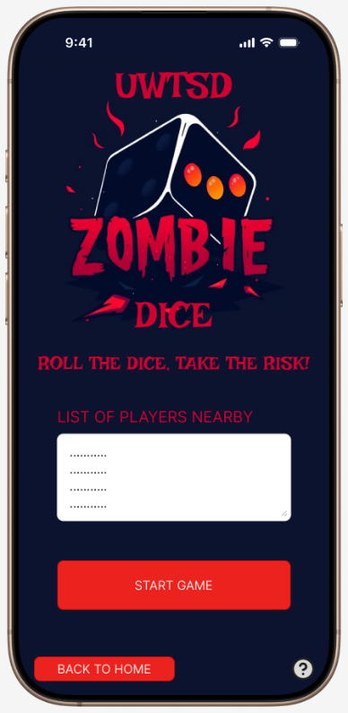
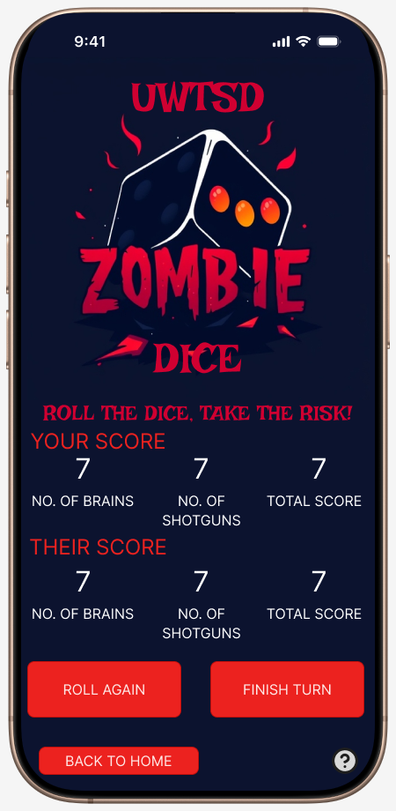
Appendix



