MUMPS IN THE UK
(Report)

STUDENT: DIANA CASTANO GIRALDO (2207095)

INTRODUCTION TO PUBLIC HEALTH (LCHS4004)
LECTURER: BIANCA SANFILIPO

UNIVERSITY OF WALES TRINITY SAINT DAVID
(London Campus)

JANUARY 2023

CONTENT:
Page

1. Introduction…………………………………………………………………………...…… 3
2. Strategies used in the UK to measure the incidence of mumps………………… 4
3. Strategies used in the UK to monitor the incidence of the mumps…………….. 6
4. Strategies used in the UK to control the incidence of the mumps……………... 8
5. Conclusion………………………………………………………………………………… 9
6. References……………………………………………………………………………….. 10

1. INTRODUCTION:
This report talks about the strategies to measure, monitor, and control mumps outbreaks in the UK, since being easily contagious it is considered a notifiable disease and therefore, each possible outbreak must be under the constant monitoring of The UK Health Security Agency, as has happened in previous years when considerable numbers of cases have been reported.
Before starting with our topic, I must mention that the Medical Dictionary, (2022) defines mumps as "A relatively mild short-term viral infection of the salivary glands that usually occurs during childhood." And whose most noticeable symptom is painful swelling of both areas of the cheeks under the ears (although it could be only one side), but which can also be accompanied by fever, headache, and malaise.

2. STRATEGIES USED IN THE UK TO MEASURE THE INCIDENCE OF MUMPS.
In the years leading up to the introduction of the MMR vaccine in the UK in 1988, approximately 8 out of every 10 people contracted mumps, many of these cases ending in complications such as viral meningitis and acquired deafness, especially in children (Oxford Vaccine Group 2020).
With the incursion of the vaccine cases decreased markedly, however, there have been subsequent outbreaks. According to Public Health England, (2014) by 2004 the cases of people infected with mumps increased in the country reaching the highest number in 2005, the year in which more than 43,000 infections were reported.
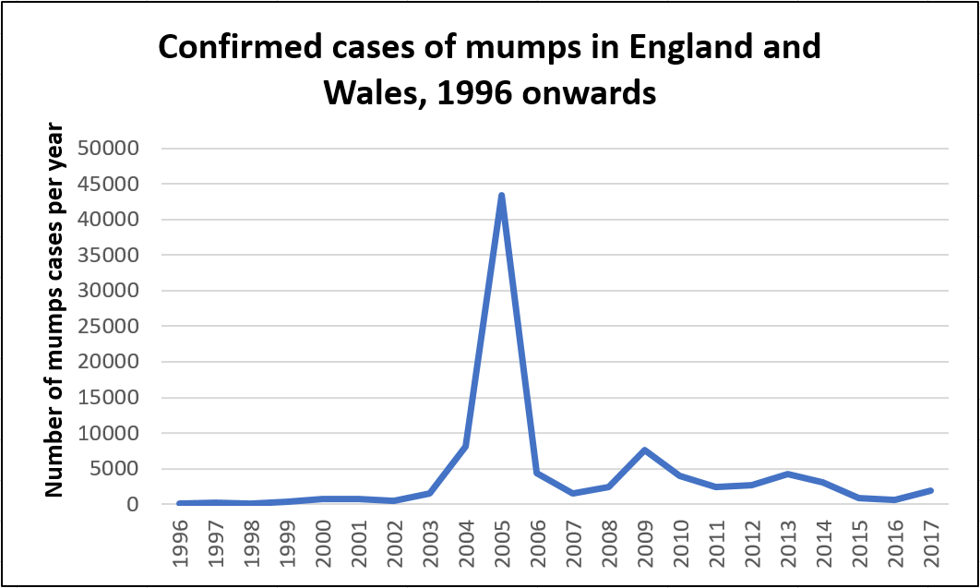 (Oxford Vaccine Group, 2020)
In recent years there have been new outbreaks, although of lesser intensity presenting the highest numbers in 2019 and 2020 apparently because many children born in the late 90s and early 2000s did not receive their doses of the MMR vaccine, so the outbreaks happened in some colleges and universities mainly (GOV.UK, 2020).
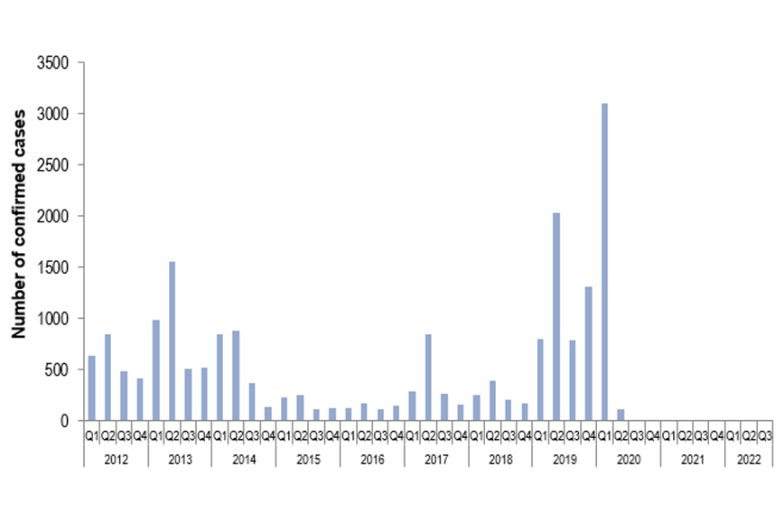 (GOV.UK, 2022)
The main strategy used in the United Kingdom to measure the incidence of mumps is based on the collection of data in terms of morbidity (people infected) and mortality (deaths caused by the disease). These figures are obtained by hospitals and health centers where the diagnosis is obtained through antibody and oral fluid tests that are performed on those who present symptoms of the disease. Upon obtaining the results, positive cases must be reported on a mandatory basis to the UK Health Security Agency as contemplated in the Control of Disease Act 1984 and the Health Protection Regulations 2010. And in that way, the statistics are obtained and administered by Public Health England.

Cases of mumps deaths have been low in recent years. According to the following report presented by the Office for National Statistics, (2022) 12 people have died between 2013 and 2021 due to the disease or some complication related to it.

(Nomis, 2022)

3. STRATEGIES USED IN THE UK TO MONITOR THE INCIDENCE OF THE MUMPS.
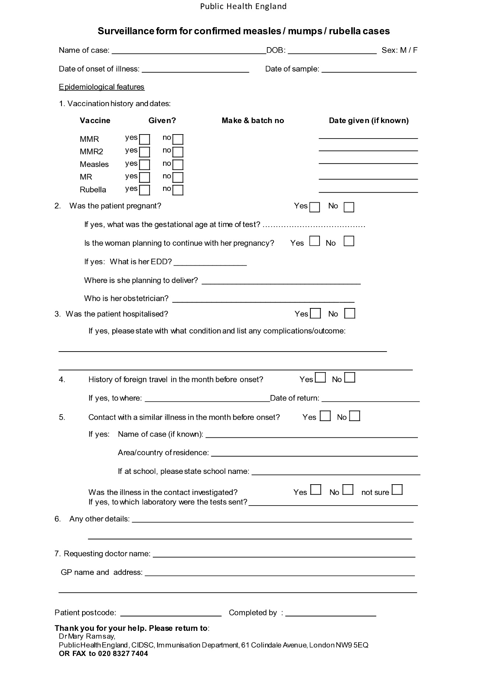
(GOV.UK, 2022)
The above is the surveillance format for confirmed cases of measles, mumps, and rubella through which monitoring of these viral diseases begins.
Although mumps does not usually present as a serious disease, there may be complications and since it is easily spread through saliva droplets, it is necessary for health entities to do the corresponding monitoring to prevent important outbreaks of the disease from being generated. For this reason, when a person with mumps-like symptoms goes to the GP or hospital, the case must be reported by health practitioners to the Local Health Protection Unit so that a saliva sample can be scheduled to be taken to confirm the diagnosis and make the relevant monitoring (NHS 2021).
However, it is not necessary to wait for the confirmation of the diagnosis to generate the report that, as mentioned in the previous point, is mandatory. “Accuracy of diagnosis is secondary, and since 1968 clinical suspicion of a notifiable infection is all that’s required.” (GOV.UK, 2022)
The body in charge of monitoring is the United Kingdom Health Security Agency (UKHSA, formerly Public Health England) whose main function is to identify potential outbreaks of infectious diseases and that may become epidemic (GOV.UK 2022).
All this process is essential to prevent the disease from spreading and through the statistics generated in the measurement of incidence, identify the common aspects that infected people may present, such as region where they live, age, gender etc. And based on that data, appropriate actions can be taken to control outbreaks.

4. STRATEGIES USED IN THE UK TO CONTROL THE INCIDENCE OF THE MUMPS.
The control of infectious diseases is directly related to the monitoring of these; since it is the second, the starting point to establish the necessary control measures and the steps to follow.
In the case of mumps, the main control measure is immunization through the MMR vaccine, which was created in the United States in 1967 and later introduced to the United Kingdom. The vaccination schedule consists of 2 doses that must be applied as follows:
Child's age Vaccine
1 year MMR (1st dose)
3 years and 4 months MMR (2nd dose) (NHS, 2022)
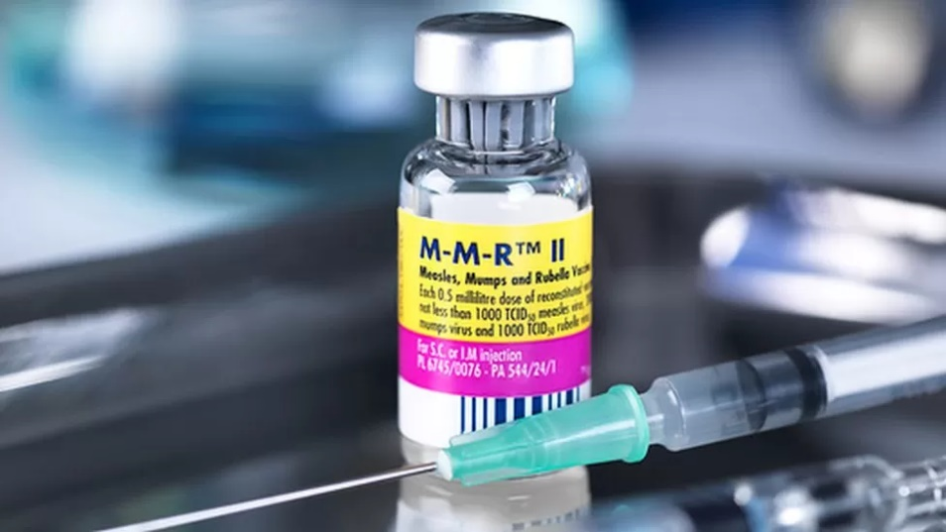
(BBC News, 2018)
This vaccine is highly effective since, according to the NHS, (2022) "around 88% of people will be protected after obtaining it". However, vaccinated people could still get the disease, but without very serious symptoms. On the other hand, if adult people have missed one or both doses of their vaccine, they can go to a GP at any time to acquire them. All doctors and health practitioners must be immunized too (NHS, 20222). For this purpose, campaigns have been generated by the NHS to inform people about vaccines and their availability.
Other control and prevention tools are daily cleaning habits such as proper and constant hand washing, the carrying and use of facial tissues when coughing or sneezing to prevent the spread of the virus. As well as avoiding contact of infected people with those who are not, do not go to crowded places and in the case of children, should not be sent to school.

5. CONCLUSION:
After reviewing all the information obtained for this assignment, it can be said that the strategies used by the government and the national health system of the United Kingdom to measure, monitor and control the incidence of mumps seem right to me because despite being an easily contagious disease it has been possible to avoid more serious outbreaks. In addition, although morbidity has reached high peaks at some times, mortality has been low and that is because the monitoring system is effective especially because it is a mandatory reporting disease.
On the other hand, thanks to the vaccination scheme offered by the NHS and awareness among parents, most children are being immunized at the required age. However, some isolated cases in which people have not obtained their doses, which could be caused by "anti-vaccine" thoughts of the parents or by negligence.

6. REFERENCES:

1. The Free Dicitionary (2022) Medical Dictionary. Available at: https://medical-dictionary.thefreedictionary.com/mumps. Accessed: (December 17, 2022)
2. Oxford Vaccine Group (2020) Vaccine Knowledge Project. Available at: https://vk.ovg.ox.ac.uk/vk/mumps. Accessed: (December 17, 2022).
3. GOV.UK (2022) Laboratory confirmed cases of measles, rubella and mumps in England: July to September 2022. Available at: https://www.gov.uk/government/publications/measles-mumps-and-rubella-lab-confirmed-cases-in-england-2022/laboratory-confirmed-cases-of-measles-rubella-and-mumps-in-england-july-to-september-2022#mumps. Accessed: (December 18, 2022)
4. Office for national statistics (2022). Official Census and Labour Market Statistics. Available at: https://www.nomisweb.co.uk/query/construct/submit.asp?forward=yes&menuopt=201&subcomp=. Accessed: (December 19, 2022).
5. GOV.UK (2022) Notifiable diseases and causative organisms: How to report. Available at: https://www.gov.uk/guidance/notifiable-diseases-and-causative-organisms-how-to-report. Accessed: (December 19, 2022).
7. BBC News (2018) Don't be taken in by anti-vaccine myths on social media. Available at: https://www.bbc.co.uk/news/health-45990874. Accessed: (December 20, 2022)
8. NHS, (2021) Mumps. Available at: https://www.nhs.uk/conditions/mumps/. Accessed: (December 20, 2022)

