The Theory and Application of Fuel-Air Explosions
Knight Charlotte EJ
15-12-2022

Contents
Table of Figures 1
Abstract 2
Introduction 2
Mechanism 2
Effects 3
Initial Blast Wave Effects 3
Reflected Waves 4
Case Study 5
Optimising Performance Through Design 6
1- The case 6
2- The proximity fuse 6
3- The secondary initiation device 6
4- Fuel 7
5- The Central Bursting Charge and the Fuel Cloud 7
Multiplying the effects 8
Thermobarics 8
Application 8
Enclosed Spaces 8
Urban Attack 9
Minefields 9
Indirect Effects 10
Limitations 10
Summary 10
References 11

Table of Figures
Figure 1-A diagram of the overpressures of Fuel air explosives when compared to conventional explosives 3
Figure 2- A diagram of a Mach stem from a FAE [12]. 4
Figure 3- A graph of overpressures against distance for three FAE cloud diameters [13]. 5
Figure 4- A diagram of the Russians Father of All Bombs (FOAB) [25] 6
Figure 5- The Use of modified aircraft bombs during the siege of Sarajevo [11] 9

Abstract
Since their creation in the Second World War, Fuel Air Explosives (FAEs) have been used extensively in combat scenarios from Vietnam to Iraq [1]. This paper details how they work, their main components, and how they compare against conventional munitions such as TNT and RDX. It then details its performance upon a range of military scenarios. It was concluded that the optimal military targets for these weapons were caves and foxholes due to the added levels of destruction reflected blast waves could cause.

Introduction
Put simply, fuel air explosions involve the dispersion of a gas, liquid or powder which is then detonated at the correct stoichiometric ratio with atmospheric oxygen. The earliest examples of FAE can be traced back to flourmill explosions. One example of this is the Matthew Muir & Sons Flour Mill explosion of 1872. A fine mist of flour was dispersed across the environment, whilst the mill was in operation. A spark from a pair of millstones caused a flame to accelerate through the cloud at supersonic speeds, creating a lethal shockwave killing 16 people and destroying the mill [2].
This phenomenon was then militarised, firstly by the US, then Russia to create munitions such as the CLU-55. The design, workings and operational usage of such munitions will be explained below.

Mechanism
FAEs are typically deployed via a rocket or dropped as a bomb from an aircraft.
When the warhead reaches the optimum distance above the target, its central burster detonates, breaking the fuel casing. The fuel is evenly dispersed into the air to provide it with sufficient oxygen to complete initiation. If the munition contains liquid fuel, the role of this burster is vital, as the particle size and distribution of the fuel within the aerosol influences it ability to detonate. This fuel cloud can permeate any holes or openings in nearby structures.
When the fuel cloud reaches the correct diameter for the optimum stoichiometric ratio between fuel and oxygen, it detonates via a second detonator that has been projected into the fuel cloud. The delay time between dispersion and initiation is in the order of 150ms which means meteorological conditions such as wind has little effect on the cloud formation.
After initiation, aerodynamic forces acting upon the droplets affect the cloud expansion [3]. These droplets are progressively broken up until expansion ceases, and a “pancake” shaped cloud is formed. This trademark pancake shape is produced due to the hot air from explosion rising rapidly until it reaches a cooler layer of air where it flattens out [4].

Effects
Firstly, a powerful blast wave is produced, equivalent to 5-10 times the power of TNT [5]. This wave has a high impulse due to the fuels high heat of combustion and detonation volume, resulting in more damaging effects to the local environment. A fireball is formed from the explosion, sucking up all of the available oxygen. This then creates a vacuum, sucking in loose objects from the nearby area. This can cause secondary injuries to any personnel or structures on the ground. The negative pressure wave that follows can also cause barotrauma of the lungs [6].
If the warhead does not function correctly, it will still be hazardous to enemy personnel. If the secondary explosive caused deflagration instead of detonation, victims will be severely burnt, and may inhale the burning fuel. If the warhead fails to function at all, the fuel cloud will still be incredibly toxic if inhaled [7].

Initial Blast Wave Effects

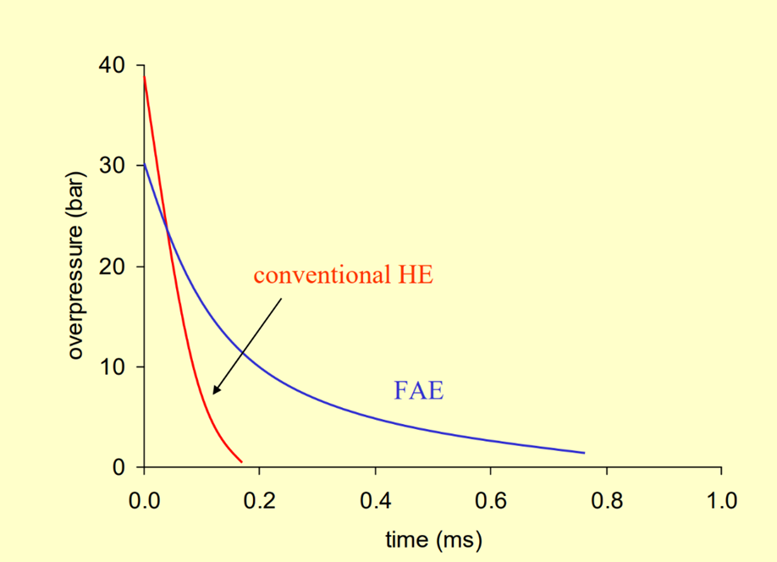
Figure 1-A diagram of the overpressures of FAEs when compared to conventional explosives

FAE’s are designed to impart as much energy as possible into the target to cause damage. As shown in figure 1, FAEs produce a long pulse of energy with a low blast pressure. This gives a higher impulse, meaning the force acts over a longer time period, allowing it to cause more damage to the local environment. Unfortunately, its low initial detonation pressures and velocities gives it a lower brisance effect, making it less effective against structures [8].

This differs from other high explosives such as TNT, RDX, PETN and HMX, which generate shock waves of short duration but high intensity. This makes them more effective for fragment propulsion, destruction by shattering mechanism or penetration of armoured structures. These effects only occur in their vicinity, making them useless against larger targets such as minefields [9].
Fuel air explosions experience a larger negative phase than most conventional munitions. This negative phase sucks any loose debris back into the explosive centre causing secondary injuries due to fragmentation.
Conventional explosives experience a faster decay of overpressure as they are a condensed point source. The source of a FAE explosion is a large cloud, which cannot be viewed as a point source. Consequently, it experiences a less rapid decay in pressure with distance from the edge of the cloud.
Despite their destructive effects, fuel air explosions have an efficiency of less than 40%. This is because the air contains mostly nitrogen, with only 21% consisting of the oxygen required for detonation. This nitrogen dilutes the system and absorbs heat, reducing the amount of energy available to the blast wave. Consequently, the nine-fold advantage of propane over TNT is therefore reduced to four-fold operationally [3].

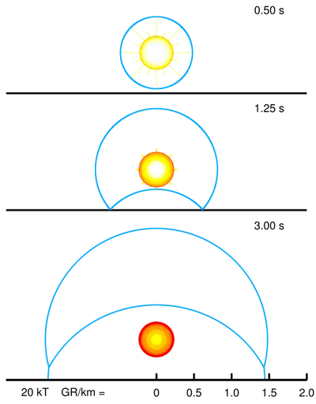
Reflected Waves
Figure 2- A diagram of a Mach stem from a FAE [12].
The shockwave intensity of an FAE explosion attenuates slower than a dynamite explosion. Therefore, unprotected structures and personnel are more likely to receive damage from further away than a conventional explosive. [10]. This can be enhanced in confined spaces as the shockwave reflects off walls, creating a much larger pressure. As the shockwave travels, it moves along air particles which collide with the surface upon arrival. If these particles are able to bounce back freely, the reflected pressure would equal the incident pressure and thus the surface would receive double the effect. In stronger blast waves, this reflection is obstructed by subsequent air particles that are transferred there, leading to even higher incident pressures.
As FAEs are designed to function mid-air, they experience Mach waves. As per figure 2, during detonation, overpressure waves travel in all directions including the ground. As previously mentioned, these waves reflect from the ground, travelling into the hot thin air they have just travelled from. Within this region, they travel at high enough velocities to meet with incident waves from the initial explosion. These waves then merge to create a Mach stem. This significantly increases the force produced from the explosion, sometimes by a factor of 2. Not only does this expand the damage radius, but it also produces a large downwards force capable of collapsing tunnels and exploding mines [11] [12].

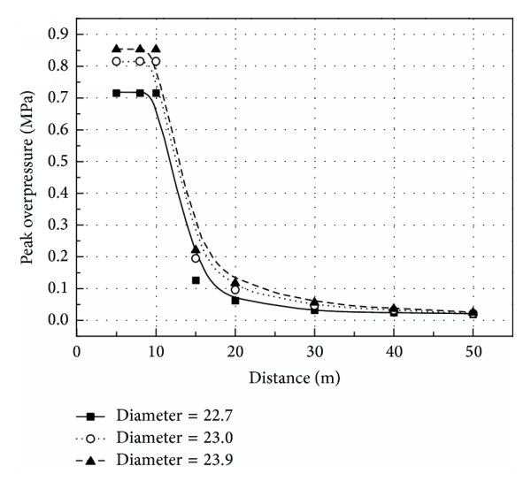
Case Study
In an experiment done by Bai et al, the peak overpressure of a fuel air cloud was recorded in respect to distance. The FAE munition had 1.08kg TNT within its central charge and an 8kg initiator. It held 125kg of fuel. Figure 3 displays the overpressures of 3 different diameters of cloud detonations with respect to distance. At 50m from the detonation point, 0.02 MPa was experienced [13].
Overpressure value/MPa | Effect
0.003-0.007 | Windows break
0.007-0.017 | Breakage of corrugated steel
0.007-0.014 | Breakage of wooden panels
0.013-0.021 | Breakage of concrete walls
<0.02 | Personnel uninjured
0.02–0.03 | Minor contusion to personnel
0.03 | Breakage of metal sheeting
0.03–0.05 | Hearing and tracheal injury
0.048-0.055 | Breakage of brick walls
0.07-0.09 | Breakage of reinforced structures
0.05–0.1 | Serious injury to internal organs
>0.1 | Causing most people death
Table 1 provides the damage levels to structures and unprotected personnel after experiencing a range of overpressure values. From this experiment, it can be concluded that the FAE used will cause death from approximately 20m away, and is likely to cause some degree of injury up to the 50m mark. The destruction of reinforced structures can occur up to 30m away, but after that the FAE is only capable of defeating light targets. This reiterates the fact that conventional explosives are the preferred option for causing structural damage.
Figure 3- A graph of overpressures against distance for three FAE cloud diameters [13].
Table 1- A table of overpressures and their effects [8]

For reference, the first FAE created, the CBU-55 had an Net Explosive Quantity (NEQ) of 340kg- over 2.5 times the NEQ of this experiment [14].Therefore, the effects of any in-service munitions are to be far greater than this case study. Additionally, this study only takes into consideration the incident overpressure- not the reflected overpressures, high temperatures, impulses, and barotrauma mentioned which are the distinctive features within the FAE.

Optimising Performance Through Design
A rough diagram of a typical FAE can be seen in figure 4.
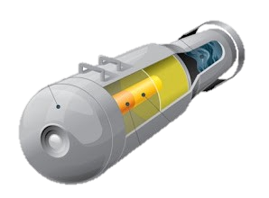
1

3
4

5

2

Figure 4- A diagram of the Russians Father of All Bombs (FOAB) [25]

1- The case
The case is made from a strong, thin material so less energy is wasted on rupturing it. Cases often have thick indentations on their surface to allow for the rapid formation of homogenous clouds [13].

2- The proximity fuse
This is designed to detonate at a set height above the ground. In the BLU-73/B, this detonated the central bursting charge 9m above the ground for mine clearing operations [14].

3- The secondary initiation device
This is designed to explode when the aerosol fuel cloud has reached its maximum effective volume. It detonates the fuel cloud in at least 3 points to ensure full detonation [11]. In the BLU-73/B, when its extendable nose probe hits the ground, the secondary charge ignites the fuel cloud [14].

4- Fuel
The fuel is a hydrocarbon-based gas, liquid or finely powdered explosive. For detonation to occur, the percentage of fuel in the atmosphere must lie between the upper and lower explosive limits. When the fuel cloud detonates, some of the fuel droplets evaporate causing variations in this percentage. Therefore, fuels with a wide range of upper and lower limits are used to account for such variation [3].
Any chosen fuel must have a high sensitivity to detonation, and sufficient damage potential. When stored within the warhead, it cannot initiate as it requires oxygen to burn, however it must still demonstrate storage stability to ensure it will function as intended.
Table 2 shows the energy outputs from both FAE fuels and conventional explosives. The common fuels for FAE are Propylene or Ethylene Oxide. As shown, they release over 400% more energy than TNT [3].
Fuel | Energy/ Unit Mass (kcal/g) | Energy/ Unit Volume (kcal/cm³)
Propylene Oxide | 7.9 | 6.6
Aluminium Powder | 7.4 | 11
Ethylene Oxide | 6.9 | 6.0
TNT | 1.1 | 1.6
Propane | 9.08
Table 2-The energy outputs of conventional explosives, as well as fuels and additives commonly used in FAEs
Aluminium powder has also been added to table 1, as it is often added to FAE mixtures due to its high heat of combustion, which thereby increases the heat of explosion. It has also been found to increase the shockwave overpressure for FAEs [15]. Small particles are preferred due to their faster burn as a result of their higher surface area to volume ratio. The optimum aluminium content was found to be 30%, as this prolongs both the duration of the fireball and the duration of the blast wave the most [6].

5- The Central Bursting Charge and the Fuel Cloud
The role of the burster is to break up the casing and evenly disperse the fuel mixture. Having a larger NEQ will create a larger fuel cloud, as the fuel gets evenly dispersed. However, it is important the charge does not provide too much energy into the fuel, otherwise this could result in premature detonation. Consequently, the NEQ typically makes up 1 to 2% of the fuel weight [3].
The ratio of diameter to height is also key within this cloud. The larger the diameter of the cloud, the larger the shock wave overpressure. The height, however, was found to have little effect. Therefore, pancake shaped clouds are the most effective in obtaining wider overpressures [13].
Initially, explosives with high brisance were used for bursters, however these produced doughnut shaped clouds. This could not be effectively detonated due to the central void, so multiple cloud detonators were required. These then had to be dispersed into the fuel cloud in the hopes of one achieving detonation. As such dispersion could not be completed at the bombs terminal velocity, parachutes had to be employed prior to impact. This made them susceptible to enemy sightings, wind drift and dispersal prior to bomb detonation. Explosives with lower brisance, provided a hemispherical cloud with a uniform fuel air density. This only requires a single/ duel detonator, so was far less complex to use [16].
The burster configuration within the FAE affects the cloud orientation. Having a central burster can also create a flat, doughnut shaped cloud, which can cause the issues demonstrated above. When this burster is not positioned over the ground perpendicularly, this could mean upon detonation, the resulting cloud could be at an angle to the ground. When clearing a minefield, for example, this means an uneven amount of pressure is distributed to the ground, which may not cause all of the desired mines to activate. Consequently, alternative solutions were being designed such as a gravity responsive burster which sinks to the bottom of the fuel container and forces the fuel upwards radially from the ground [17].

Multiplying the effects
When multiple FAEs explode near the target, the shock waves produce a cumulative superposition effect, which increases the damage done to the target. Consequently, most in service FAEs utilise multiple cluster bombs to create this effect. The CBU-55B, for example, featured 3 BLU-73A/B FAE sub-munitions inside a SUU-49/B Tactical Munitions Dispenser. Unfortunately, once each propane cylinder was deployed and released their parachutes, they were highly susceptible to wind drift [18] [19].

Thermobarics
Thermobarics were initially developed in the US in the 1970s and are often mentioned interchangeably with FAEs despite offering slightly different effects . They were originally designed to blast helicopter landing sites through the Vietnamese jungle. Additionally, they have also been used against troop concentrations, supply depots, and for mine clearance [20].
Typically, a thermobaric consists of a powerful high explosive (HE) centre sheath and a fuel mixture of gas, liquid or powder is axially spaced from the sheath. Upon detonation of the burster charge. A fuel mixture is dispersed into the environment. This fuel then aerobically combusts when combined with the surrounding oxygen. These particles burn for a longer duration, maintaining the pressure wave by keeping the gases at high temperatures [9].
Unlike FAEs, Thermobarics require no separate secondary means of initiation, reducing the complexity required upon design, manufacture and firing.

Application

Enclosed Spaces
The formation of the highly toxic fuel cloud makes these explosives ideal for use in caves and fox holes, as demonstrated in figure 5. The toxic fuel cloud can easily enter the small gaps within the structure before detonation. During explosion, the blast wave will reflect off all surfaces, positively interfering with itself to cause a massive increase in pressure at certain points. This positive interference occurs more frequently in the corners of rooms due to waves reflecting off the perpendicular surfaces into each other. As there is a difference in pressure between the corners and the flat walls of a structure, a structure is more likely to break down. This could cause the cave system to collapse.
Loose rocks can contribute to fragmentation effects. Additionally, the fireball will create scorching temperatures which spread throughout the cave system due to limited ventilation. This technique was used extensively in Afghanistan against Islamic forces by both America, Russia and the UK [11].
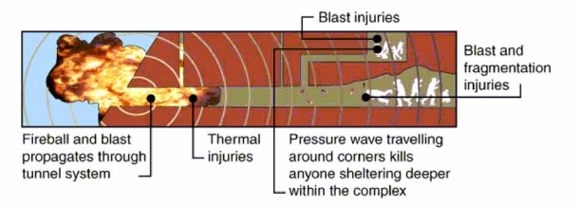
Figure 5- A diagram of the FAE effect within a cave [11]

Urban Attack
Utilising FAEs in built up areas, such as cities, are an optimal way to harm insurgents due to the higher concentrations of personnel. Additionally, urban environments have a high concentration of structures which the blast wave can reflect off. As previously mentioned, this can create even higher overpressures, adding to the damage caused.
FAEs can cover a wide surface area, due to the large diameter of explosion and fireball produced. Consequently, they can be utilised against agricultural targets such as farmlands and forestry to impact food and resource supplies [21].

Minefields
FAEs were originally designed for clearing mines, boobytraps, foliage, and enemy personnel from helicopter landing zones within Vietnam. Upon detonation, they impart high pressures over a wide area, especially downwards due to the Mach stem effect mentioned previously. This allows them to defeat pressure sensitive and trip wired mines without wasting energy carving out craters.
The ideal fuel cloud shape for this is a pancake, as fuel dispersed in the vertical direction has minimal effect. To limit this, a design was proposed to place a steel slug in front of the burster charge. This helps deflect the pressure to a direction parallel to the minefield surface [22].
Multiple cluster FAE bombs, such as the CBU72 are ideal for path clearing, as the bombs create a wider berth than unitary versions. When dropped from helicopters, the CBU-55 was able to create a 30m breach, with a probability of kill of 0.5 [23].

Indirect Effects
It is widely agreed that it is more effective in a military scenario to injure the enemy than kill them, due to the intense clinical and logistical strain on medical resources [24]. The high impulse, scorching temperatures and lack of atmospheric oxygen available after the fireball result in FAEs being highly efficient in causing both injury and death large distances from the target.

Limitations
As FAEs require atmospheric oxygen to burn, they are therefore unsuitable against aircraft travelling at higher altitudes, as there is insufficient oxygen for a complete detonation. In this scenario, a continuous long rod is typically used, as it requires a lower NEQ of explosive to function effectively at this height.
Due to the lack of oxygen underwater, FAEs are useless against boats and submarines. In these situations, powerful conventional munitions such as RDX are required with built in oxidisers. Alternatively, thermobarics can also be used, as they contain oxygen in their explosive slurry.
As mentioned previously, FAEs have a low brisance, meaning they aren’t effective against heavily fortified structures. Instead, they are better used against light structures and soft skinned vehicles [24].

Summary
To conclude, fuel air explosives are deadly weapons which deliver a high impulse to the target. Their slow attenuation enables them to reflect and create Mach stems increasing their effect. They are best utilised in foxholes and caves due to the fuels ability to permeate through small holes within the cave structure. After detonation, the reflection of these blast waves, as well as the high temperatures and fragmentation create a hostile environment for any insurgents.

References

[1] | D. Andr, “MUNITIONS – Thermobaric Munitions and their Medical Effects!,” in Australian Military Medical Association Annual Conference, Australia, 2001.
[2] | L. Dalgetty, “Remembering the Glasgow Flour Mill explosion that killed 18 people,” Glascow Live, 10 July 2022.
[3] | Technical Notes for Mine Action, “Fuel Air Explosive (FAE) Systems,” 2013.
[4] | D. Hambling, “Deadly Blast from the past,” The Guardian, 18 1 2001.
[5] | X. Zhang, Q. Huang, X. Bai, Y. Liu and L. Gao, “Establishment and analysis of damage calculation model under fuel air explosion effect,” IOP Conf. Series: Earth and Environmental Science, vol. 446, no. 2, 2019.
[6] | L. Türker, “Thermobaric and enhanced blast explosives (TBX and EBX),” Defence Technology, vol. 12, no. 6, pp. 423-445, 2016.
[7] | Defense Intelligence Agency, Fuel-Air and Enhanced-Blast Explosive Technology, Defense Intelligence Agency, April 1993.
[8] | Action Against Armed Violence , “What is a thermobaric bomb?,” Action Against Armed Violence , 2022.
[9] | M. M. T.-V. Ț. G. E. Ovidiu-George IORGA, “Experimental and Theoretical Aspects Regarding Design and Testing of Thermobaric Munitions for Recoilless Armament Systems,” in International conference KNOWLEDGE-BASED ORGANIZATION, Bucharest, 2018.
[10] | X.-y. Z. J. Y. B.-f. S. Chun-hua Bai, “Numerical investigation of the shockwave overpressure fields of multi-sources FAE explosions,” Defence Technology, vol. 17, no. 4, pp. 1168-1177, 2021.
[11] | B. Zecevic, “The Use of Modified Aircraft Bombs during the Siege of Sarajevo 1994-1995,” The university of Sarajevo, 2007.
[12] | R. Letzter, “Here's why the 'mother of all bombs' exploded 6 feet above its target in Afghanistan,” INSIDER, 13 April 2017.
[13] | Y. W. J. L. M. C. Chunhua Bai, “Influences of the Cloud Shape of Fuel-Air Mixtures on the Overpressure Field,” Shock and Vibration, vol. 2016, 2016.
[14] | A. Parsch, “BAK to BSU/BSG - Equipment Listing,” 4 April 2020. [Online]. Available: https://www.designation-systems.net/usmilav/asetds/u-b.html#_BLU73. [Accessed 12 12 2022].
[15] | Y. L. Q.-m. X. B. L. L.-f. X. Yong-xu Wang, “Effect of metal powders on explosion of fuel-air explosives with delayed secondary igniters,” Defence Technology, vol. 17, no. 3, pp. 785-791, 2021.
[16] | P. B. H. L. L. G. E. L. Husler, “Fuel Air type Bomb”. US Patent US4132170A, 12 02 1971.
[17] | D. S. Hutcheson, “Fuel air explosive device”. USA Patent US4493262A, 3 11 1982.
[18] | “Wikipedia,” 15 10 2022. [Online]. Available: https://en.wikipedia.org/wiki/CBU-55#:~:text=The%20CBU%2D55%20was%20a,was%20fueled%20primarily%20by%20propane. [Accessed 15 12 2022].
[19] | X. Z. e. a. 2020, “Establishment and analysis of damage calculation model under fuel air explosion effect,” in IOP Conference Series: Earth and Environmental Science, 2020.
[20] | M. Montazzoli, “ARE THERMOBARIC WEAPONS LAWFUL?,” Articles of War, 23 3 2022.
[21] | Humans Rights Watch, “Chechnya Conflict: Use of Vacuum Bombs by Russian Forces,” Humans Rights Watch, 2000.
[22] | J. A. B. C. A. G. Michael H. Aley, “Surface-launched fuel-air explosive minefield clearance round”. US Patent US4273048A, 26 3 1979.
[23] | J. T. L. L. C. M. JOHN D. SULLIVAN, “FAE BOMBING FOR MINEFIELD BREACHING,” BALLISTIC RESEARCH LABORATORY, Maryland, 1992.
[24] | T. W. B. a. J. B. Holcomb, “Bombs, Mines, Blast, Fragmentation,and Thermobaric Mechanisms of Injury,” Ballistic Trauma, pp. 45-66, 2005.
[25] | R. A. D. S. Kulshrestha, “Russia Deploys the “Father of all Bombs”?,” IndraStra Global, vol. 3, no. 9, 2017.
[26] | A. A. Rao, “Fuel Air Explosives,” Defence Scientific , vol. 37, no. 1, pp. 23-28, 1986.
[27] | T. W. B. a. J. B. Holcomb, “Bombs, Mines, Blast, Fragmentation, and Thermobaric Mechanisms of Injury,” in Ballistic Trauma, London, Springer, 2005, pp. 45-66.

