ACCA6026

Data Warehousing

Data Mining & Data Warehousing
May 2026

2218899
Siân Eleri Kiely










Table of Contents
Task 1 4
Introduction (30/50 words) 4
1.1 Online Transaction processing (225/200 words) 4
1.2 Data Warehouse 6
1.3 Data Marts (267/375 words) 8
1.4 Dimensional Modelling (145/250 words) 10
Task 2 12
2.1 Source Systems (90/125 words) 12
2.2 Star Schema (283/500 words) 13
16
2.3 Data Marts (158/250 words) 17
2.4 ETL Plan (/125 words) 18
2.5 Data Governance (82/75 words) 20
References 21
Appendix 22

Table of Figures
Figure 1 Operational BI System supports day-today operations but performance concerns with large reports 5
Figure 2 Operational & Source Systems: Internal and External sources 6
Figure 3 BI with a Data Warehouse: Source systems data is extracted, transformed (cleaned, standardised) Loaded into data warehouse at a scheduled time usually daily allowing business users to query and analyse the data for reporting 7
Figure 4 Data Warehouse with business marts: Operation, Finance, Sales & Marketing Mart each to serve specific needs without impacting day to day operations 8
Figure 5 Rags'n'Riches Data Warehouse High Level Example Star Schema, Central Fact with surrounding dimensions examples of key attributes only. Note additional descriptive fields such as Item Type, Quarter, Fuel_Card, Damage would be implemented in a full version. 10
Figure 6 Large star-join data warehouse schema with 5 fact tables and 7-dimension tables 11
Figure 7 Large star-join data warehouse schema alternative view with 5 fact tables and 7-dimension tables 11
Figure 8 Rags’n’Riches Data Warehouse Multiple Star Schema including Master Data, Metadata, Aggregate Data, and Facts and Dimensions 14
Figure 9 Close up of schema with multiple stars 15
Figure 10 Close up of Star Schema Title, Notes, Metadata, Aggregate Data, Key and Master Data 16

Table of Table Figures
Table 1 Data mart schema with fact table and dimension table extraction highlighted 17
Table 2 ETL Plan: operational systems > Extractions > Staging Area > Transform & Clean > Data Warehouse > BI Analytics Tools 18
Table 3ETL Plan - Rags'n'Riches Data Warehouse 19
Table 4 Database to data warehouse attribute mapping 19

Task 1

Introduction

The following report outlines a data warehousing proposal for the consideration of ‘Rags’n’Riches Ltd.’ The report will refer to: Online transaction processing (OLTP), Extract-Transform-Load (ETL) and Dimensional Modelling (DM).

1.1 Online Transaction processing
Unlike an OLTP database which holds current data, used for day-to-day running of a business, a Data Warehouse stores large amounts of historical data. Data from different sources which can be analysed for business needs once gathered data into a central repository.

De-normalised data and redundant data are often present in a data warehouse by centralising, unlike OLTP with normalised data and no redundancy. Geek for geeks explain a Data warehouse [1] is subject orientated and uses query processing, is typically larger (100GB-2TB) than OLTP (10MB-100GB) which is application orientated and uses transaction processing. OLTP is designed for business transaction processes, whilst decision making process is the intended use of a data warehouse.

Krishnan [2, p. 35] discusses OLTP and data warehouses as “share everything architectures” with transactional data having finite data volume and structure to “satisfy the user needs for performance, throughput, and storage whilst keeping a reasonable cost.” They compare with a data warehouse which is “architected to be the enterprise version of the truth and the data repository for the enterprise”
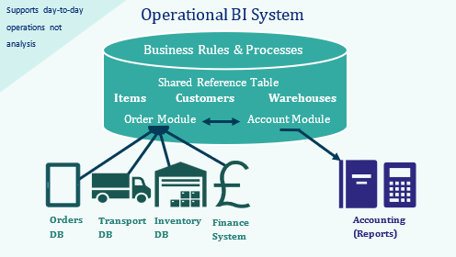
Figure 1 Operational BI System supports day-today operations but performance concerns with large reports
The advantage of a data warehouse is that it allows for a scalable business intelligence solution, by separating queries and analysis from the day-to-day applications needed to keep the business operating uninterrupted. Bhatt [3, p. 1] summarises running a large report shouldn’t strain the systems and services which generate the revenue. Usually, a company looks to move towards a data warehouse once the reporting is significant enough to slow down operational systems.

1.2 Data Warehouse
Once the sources have been identified, the data warehouse typically has two types of tables, fact tables and dimension table, Kimball [4, pp. 240-241] . Let’s say prop rentals are captured in an orders fact table, this will include foreign key links to look up tables, such as products and customers. There will also be measures in the fact table such as prices and sale numbers. The dimension tables are referred to by the fact tables, the warehouse locations and customer locations would be internal for example, however an external map or post code look up may be used to plan routes or calculate distance. Data in a data warehouse is stored for long term analysis rather than short term transactions.
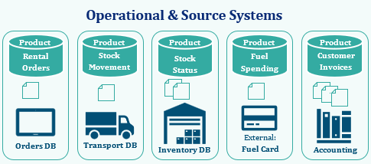
Figure 2 Operational & Source Systems: Internal and External sources
Usually outside of working hours, the ETL process is scheduled to run a time which minimises day-to-day operational impact. Kimball [4, pp. 370-375] explains 10 areas on ETL requirements, Business Needs, Compliance, Data Quality, Security, Data Integration, Data Latency, Archiving and Lineage, User Deliver Interfaces, Available Skills and Legacy License. The business can make decisions but “requirements dictate the core elements that your ETL system must deliver”.
Extract  Retrieve operational systems data | Transform  Clean, standardise and restructure | Load  Insert into the data warehouse (DW)
To interact with the data without putting a strain on operation business, the data can be extracted from the various internal and external sources at a convenient scheduled time to the datawarehouse. This is the Extract step of ETL. However the data has come from various sources, it needs to be Transformed into something standardised, even something like a numerical date can appear in different formats (0001-01-01 / 01-01-0001). Note that standardised does not mean the datawarehouse databases are normalised. Rather than manually cleaning the data each month, the data warehouse plan will consider what regular data transformations need to be accounted for so the data can be useful once ready to Load.
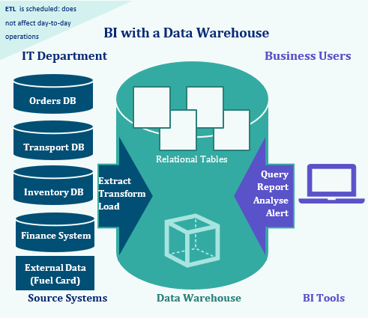
Figure 3 BI with a Data Warehouse: Source systems data is extracted, transformed (cleaned, standardised) Loaded into data warehouse at a scheduled time usually daily allowing business users to query and analyse the data for reporting

1.3 Data Marts
Data marts take data warehousing a step further in terms of getting the most use out of your data. If sales and marketing for example want to know what’s profitable or worth selling, they’ll likely benefit from access to historic data, aggregated fact tables can be used e.g. all sales in the previous quarter. A data mart used by finance may want close monitoring of fuel costs, possibly even high usage alerts. A data mart provides focused department-specific access. By separating finance, operations, and sales into their own marts, Rags’n’Riches can ensure each department works with consistent and valid metrics whilst avoiding conflicting definitions. Or duplicated spreadsheets.
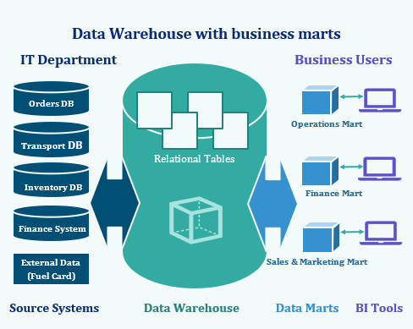
Figure 4 Data Warehouse with business marts: Operation, Finance, Sales & Marketing Mart each to serve specific needs without impacting day to day operations
BI Reporting is most likely to be performed on a subset of data, rather than the whole of the data, the subset would depend on departmental relevance, i.e. data mart. Drawing data from a data warehouse, operational systems, or an existing database, a data mart can draw data from many sources. Companies considering converting to a data warehouse from an OLTP may explore pilot projects through the creation of individual data marts.

Traditionally OLAP technologies were used to analyse, today the same concepts can be seen in technologies such as Tableau extracts, PowerBI semantic models, even Excel is still widely familiar in many organisations and makes use of pivot tables. Empowering end business users independently explore data, to create their own reports and dashboards, this minimises strain places on the IT departments and removes the need for time sat in meetings and various stages of development. Conversely this level of freedom can see conflicting metrics or definitions, questionable or incorrect joins, duplication, spreadsheets spiralling out of control. To balance the strengths and weakness of self-service BI, data governance is essential, decisions come with ethical responsibility and BI tools will ultimately influence those decisions.

1.4 Dimensional Modelling
Normalised data is structured to minimise redundancy by only storing each fact once, organising tables into logical dependency- based relationships. Dimensional Modelling (DM) allows for high-performance access using a logical design technique and presenting data in a standard framework. Restrictions are applied to a standard relational model. One or more fact tables contain measures and a multi-part key within a dimensional model. Alongside the fact table(s) are multiple dimension tables, primary keys in single part, corresponding to fact table multipart key. The fact table ‘measures’ are where the user will find numerical data record defined by a related combination of keys. Dimension tables on the other hand contain descriptive text. SQL queries often constrained in their source collection of said descriptive text.
Kimball Group [5]
“DM is the only viable technique for databases that are designed to support end-user queries in a data warehouse. ER is very useful for the transaction capture and the data administration phases of constructing a data warehouse, but it should be avoided for end-user delivery.” When comparing dimensional modelling and entity-relation modelling (ER).
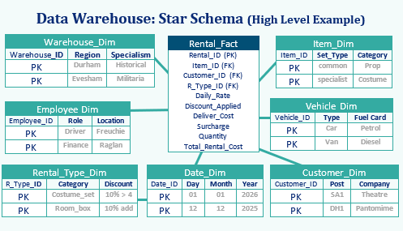
Figure 5 Rags'n'Riches Data Warehouse High Level Example Star Schema, Central Fact with surrounding dimensions examples of key attributes only. Note additional descriptive fields such as Item Type, Quarter, Fuel_Card, Damage would be implemented in a full version.
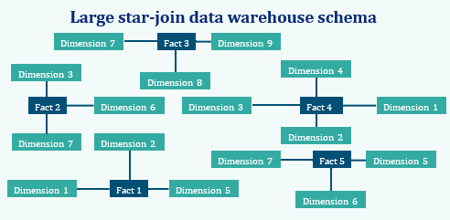
Figure 6 Large star-join data warehouse schema with 5 fact tables and 7-dimension tables
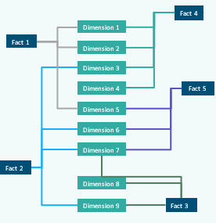  Figure 7 Large star-join data warehouse schema alternative view with 5 fact tables and 7-dimension tables | Fact 1: Damage_Fact  Fact 2: Internal_Movement_Fact  Fact 3: Fuel_Usage_Fact  Fact 4: Rental_Fact  Fact 5: Salary_Fact  Dimension 1: Item_Dim  Dimension 2: Warehouse_Dim  Dimension 3: Date_Dim  Dimension 4: Customer_Dim  Dimension 5: Category_Dim  Dimension 6: Location_Dim  Dimension 7: Employee_Dim  Dimension 8: Vehicle_Dim  Dimension 9: Fuel_Dim

Task 2
The following report details source system identification, a solution using a star schema diagram, condensed ETL plan, concluding with data quality and governance considerations for the use of ‘Rags’n’Riches Ltd.’
with the intention to support the development of a data warehouse.

2.1 Source Systems

Before a data warehouse can be implemented, source systems must be identified. These can be divided into internal (company generated) and external (fuel prices) sources. ‘Rags’n’Riches Ltd.’. External sources such as fuel card providers and postcode-to-distance lookups are essential for calculating delivery costs and monitoring vehicle efficiency, both of which directly influence profitability.

As Hammergren explains [6, pp. 203-212] “Source data plays a key role in a data warehousing project because all the subsequent extraction and transformation processes depend on what data the data sources really contain.
 | Internal  - Orders DB  - Transport DB  - Inventory DB  - Finance System  - Damage Reporting  - Mileage logs | External  - Fuel card provider  - Distance lookup (postcode, map, miles)

2.2 Star Schema

Source data won’t be the only data in the schema. Metadata is data about data. Providing an auditable trail metadata may include the business context of an item, the source system, tables, and fields the data was calculated or directly extracted from, when it was extracted, and when it was loaded into the warehouse.

Master Data Management (MDM) might look like ensuring the same produce ID is used throughout the system. It’s a way of capturing and integrating and subsequently complete, consistent, punctual and importantly accurate master data. Housing descriptions and code for the items, customers and more. To facilitate, translation tables can be used which map operational product ID to the supplier product ID when a prop is written off and replaced for example. MDM is essentially the methods and tools, procedures, business applications, infrastructure to support said data capture.
A huge advantage of a star-join schema includes the ease in which new facts and dimensions can be added without a complete database redesign being required. Additionally aggregates, summary records which can be calculated from table data, can also be used with ease resulting in improved performance. Consequently, the joined fact and dimension tables are required to apply the same meaning between them. The transformation of the data for example selecting the most up to date customer address if stored in various systems.

Conformed dimensions; as seen in fig.7 multiple fact tables can use the same single dimension table. Data content and user interfaces should be consistent when the dimension is used, and attributes interpretated in a consistent manner. As is often with data preparation, the conformed dimension design for a data warehouse is estimated to take 80% of architectural design time.

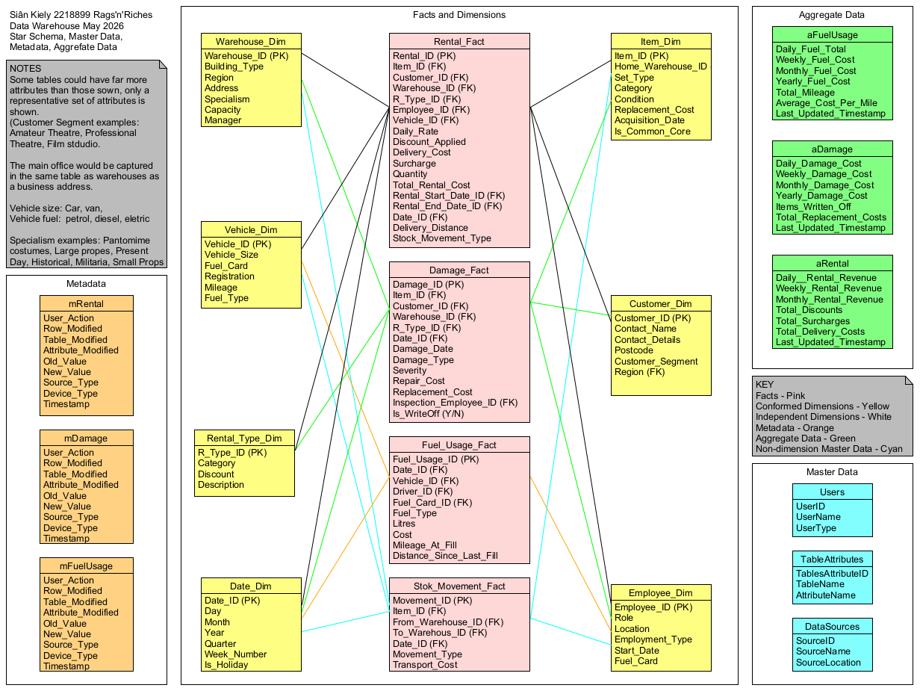
Figure 8 Rags’n’Riches Data Warehouse Multiple Star Schema including Master Data, Metadata, Aggregate Data, and Facts and Dimensions

The Rags’n’Riches schema consists of several star schemas, sometimes known as [7] constellation schema, consisting of multiple fact tables which share the same conformed dimensions. This approach is recommended by Kimball, as it allows separate business processes, rentals, damage inspections, and fuel usage to be analyses independently. This method still allows cross-processes reporting. The above image shows how each dimension has scenario specific attributes, such as warehouse specialism, customer segment, vehicle size and item condition, in order to reflect operational detail described in the case study. In this way we it ensures analytical queries can answer real business questions such as identifying popular items, monitoring utilisation of calculating true cost of expediated delivery time orders.

Figure 9 Close up of schema with multiple stars

Figure 10 Close up of Star Schema Title, Notes, Metadata, Aggregate Data, Key and Master Data

2.3 Data Marts
Once the source data has been extracted, transformed, and loaded into the data warehouse away from operational day-to-day processes, analysis querying and reporting can take place. Although not exclusive to data warehousing, for higher long term cost data marts can technically be applied directly to an operational BI system, they add the benefit of tailoring extracts. For example, ‘Rags’n’Riches’ data marts divided into a finance mart, a sales & marketing mart, and operations mart, each with their own needs and therefore separate data access and analysis needs. Data marts can even feed data back into the data warehouse, if rates need to be updated for example, and the data warehouse can be used to update source systems.
Kimball [5] also recommends marts are fed from the warehouse rather than operational systems.
Finance Mart:  - Revenue  - Discounts  - Surcharges  - Delivery cost  - Fuel cost  - Profitability | Sales & Marketing Mart:  - Popular items  - Seasonal demand  - Customer patterns  - Rental frequency  - Regional patterns  - Promotional insight | Operations Mart:  - Delivery distance  - Vehicle usage  - Damage charges  - Warehouse utilisation  - Written off stock  - New Stock
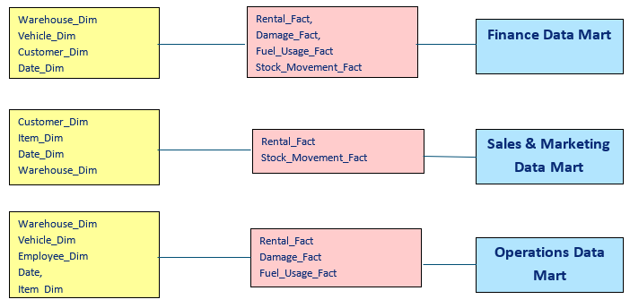
Table 1 Data mart schema with fact table and dimension table extraction highlighted

2.4 ETL Plan
ETL bridges the gap between Operational systems; optimised for transaction management, speed., operational processes and Data warehousing, designed for analysis, historical comparisons, reporting. ETL processes typically load into a staging area, before applying cleaning validation and transformation rules. For Rags’n’Riches this includes standardising dates, mapping product IDs, warehouse code validations, calculating delivery distances and fuel costs using external sources. Once transformation is complete the data I loaded into fact and dimension tables in a controlled sequence to maintain referential integrity.
Extract  Retrieve operational systems data | Transform  Clean, standardise and restructure | Load  Insert into the data warehouse (DW)
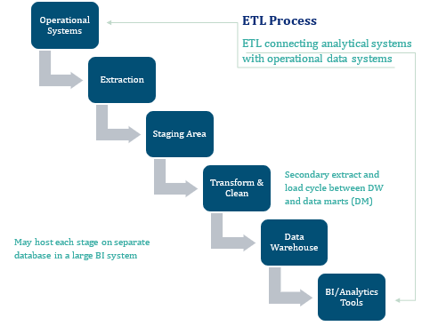
Table 2 ETL Plan: operational systems > Extractions > Staging Area > Transform & Clean > Data Warehouse > BI Analytics Tools
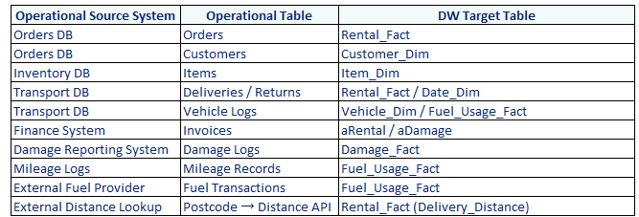
Table 3ETL Plan - Rags'n'Riches Data Warehouse

Table 4 Database to data warehouse attribute mapping
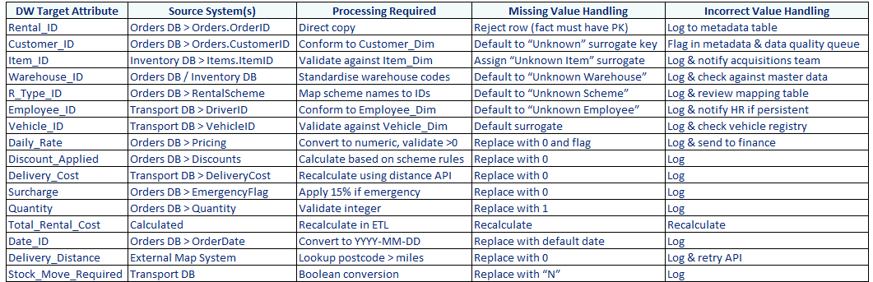

2.5 Data Governance
In conclusion Data, which is poorly defined, duplicated or inconsistent without control in place can result in misleading dashboards and negatively impact business decisions as a result. The goal is good data, good dashboard, good decision. By setting rules, assigning accountability, ETL logic, database checks and being strategic in approach, Governance is about control structures and decision writes, unlike the day-to-day operation of management. Not to be confused with privacy protected and lawful data protection, governance is about trust, meaning and control.

References

[1] | geeksforgeeks, “Difference between Data Warehousing and Online transaction processing (OLTP),” 15 July 2025. [Online]. Available: https://www.geeksforgeeks.org/dbms/difference-between-data-warehousing-and-online-transaction-processing-oltp/. [Accessed 11 May 2026].
[2] | K. Krishnan, Data warehousing in the age of big data, Amsterdam: Morgan Kaufmann, 2013.
[3] | R. M. Bhatt, “Differentiate between OLTP and Data Warehouse,” [Online]. Available: https://www.scribd.com/doc/229758807/Artificial-Intelligence. [Accessed 11 May 2026].
[4] | R. Kimball, The data warehouse lifecycle toolkit, 2nd ed., Indianapolis: Ind: Wiley, 2008.
[5] | R. Kimball, “A Dimensional Modeling Manifesto,” 2 August 1997. [Online]. Available: https://www.kimballgroup.com/1997/08/a-dimensional-modeling-manifesto/. [Accessed 14 May 2026].
[6] | T. C. Hammergreen, Data warehousing for dummies, 2nd ed., Hoboken: Wiley Publishing Inc. , 2009.
[7] | A. A. a. A. AbdulRahman, “An online analytical processing multi-dimensional data warehouse for malaria data,” 2017. [Online]. Available: https://www.researchgate.net/publication/320387629_An_online_analytical_processing_multi-dimensional_data_warehouse_for_malaria_data. [Accessed 14 May 2026].
[8] J. Fothergill and British Broadcasting Corporation, The Age of Big Data, J. Fothergill, Director. BBC Worldwide, 2013. [Video]. Available: https://video.alexanderstreet.com/watch/the-age-of-big-data

