Student Name: Yawar Abrar Hossain

Student Id: 1916654

Module: Academic and Employability Skills

Module Code: BMSW4001

Lecturer: Peter Allen

Submission Date: 04/05/2020

Contents Page

Introduction ......................................................….……………………………………… 1

Academic Skills Explained ....................………………………………………………………. 1

Employability Skills Explained ........…….……………………………………………………… 1

Key Competency and STAR Approach ..……………………………………………………… 2

Five Key Skills Explained ....................................………………………………………… 3

Case Study ....................……………………………………………………………………………. 3

Eisenhower .................................................................................................... 4

Time Management ........................................................................................ 5

SWOT............................................................................................................... 7

Personal Development Plan .......................................................................... 8

Conclusion ...................................................................................................... 9

References ..................................................................................................... 10

Appendices .................................................................................................... 11

Academic skills are developed while studying in an institution, earliest these skills are learnt at school age and until further or higher education. These skills are needed at different stages of life, either to write formal letter or email, report, note taking, time management, critical thinking etc and required by different aspects of jobs. Academic skills are necessary to achieve outstanding performance at higher level of academic studies. It is essential to be well organised and to get the most output from this skill. According to (Cleeve 2018), academic skills gives a boost in their confidence and becomes more efficient at learning it also encourage them to engage in any subject taught in English and teaches a great lesson to the individual who performs better after graduation.

Employability skills could be best described as transferrable skills, an individual required to get employed. In short, the employability skills are certain job skills that an employee needed to fully function a job role. The most employers set minimum skills required for the job advertised. These skills are often sought by the employers at graduate entry, to ensure the employers hiring the right candidate and the candidates fit for the job. There are fourteen skills, some of them are soft and some are hard; to name a few: communication, teamwork, problem solving, decision making, planning and prioritising, organising, leadership and management, etc. These are transferrable skills and some of them overlaps. These are transferable skills and effective for every job, it is as an advantage as the employer or recruiter sees them as an expert in that field, having all that knowledge allows them to stick out from other candidate on the job market.

The recruiters use certain competencies to recruit quality candidates and it makes the hiring process easier; for the graduate entry the individuals do not have any work experience, but they may have gained some competencies while studying at the university. These competencies allow the individual to be hired based on the answers they provided, recruiter looks for example based on situation, to understand if that person fits the team or company. The individual should follow STAR, to answer those questions.

S stands for Situation
T stands for Task
A stands for Action
R stands for Results

‘The STAR method is a great tool to answer competency-based questions, and it will guarantee a well-structured answer’.

All the recruiter puts a lot of emphasise on the competency based, as it showed on various career websites. Recruiter uses competency-based questions and use a template to score each candidate depend on how they have answered the question based on previous experience or examples. It means everyone is interviewed fairly, so there’s no discrimination and individuals get fairer chance; the recruiter then shortlists the best candidate whose experience closely match with the job advertised.
There are 14 competencies, however, will discuss the five most important competencies. Please see below:

- Communication
- Decision Making
- Teamwork
- Leadership and Management
- Prioritising and Planning

Communication – Communication could be briefly described as transferring of information, idea, from an individual to another or between the group of people. According to the indeed.com, one of the major competencies a recruiter looking for in a candidate. ‘There are five ingredients to communication, consists of sender, receiver, message, medium and feedback.’
Effective communication allows to communication between individuals or the work groups, etc more efficiently, to understand the key subject to ensure there are no barriers to understanding of the subject matter and it removes any misunderstanding and errors.

Decision Making – Decision Making is an intellectual process of choosing different ideas or beliefs or action that has different or possible outcomes. According to the author (Litherland, N, 2013), there are seven steps to decision making process, they are as follows: ‘defining the problem, identifying and limiting the factors, development of potential solutions, analysis of the alternatives, selecting the alternative, implementing the decision, establishing a control and evaluation system.’

Teamwork - Teamwork is a group of people working together for the same cause or goal or aim to achieve the same result most effective and efficient way. Teamwork skill is an ability to work with others peacefully, productively to reach a common goal.

Leadership and Management – Leadership is one of the key skills an individual required to work as a manager. Leaders are the individuals who has the practical skill and theoretical knowledge and works with the team to share the company’s vision to achieve a common result or objectives

Prioritising and Planning – Prioritising and planning is a key skill needed to be successful in both places academically and employment. It is required to achieve goals, function smoothly, and avoid last minute stress. There are different ways an individual can plan and organise; Pareto’s 80-20 rule could be applied to ensure more productivity.

CASE STUDY

To achieve both skills, as a student it requires of lot of research and reading. Studying at University of Wales Trinity Saint David, allowed me to gain the knowledge on key aspects of both skills. Key strategy to ensure we are staying one step ahead on the job market, by gaining extra skills and experience.
These skills helped me to improve my knowledge on academic skills, which are academic writing skills, in class exercise, paraphrasing and summarising, basic essay structure, effective assignment or report writing, etc.
Skills such as, time management, planning and prioritising, communication all plays a vital part in academic skills while learning above module. Tutor provides lesson, but there are certain learning method needs to be followed, note taking, problem solving, planning and organising our self, and managing time between work, family life, leisure activity, sleep and studying. Writing technique taught us how to write a well-formed essay or report to the academic standard, another important bit is how to do paraphrasing and summarising notes from the reading and how to put them on our own writing, the importance of correct referencing. In class activity also helped us to understand better, and solving problems taught us where we need to put more focus on our learnings.

Working as a General Manager, I can not emphasise enough how important is employability skills. These skills play vital role every single day; to function as a manager. There are few techniques, which I have used to ensure higher efficiency and maximum result, follows:

- Eisenhower method
- Time management
- SWOT (strength, weaknesses, opportunities and threats) analysis
- Personal Development Plan (PDP)

Eisenhower method:

Urgent Not Urgent

Do | Delegate
Delegate | Delete

Important

Not
Important

Figure 1: Eisenhower method

Eisenhower method explains how to manage time efficiently by getting the work done. Important and Urgent task should be done without failure, Not important but urgent or not urgent but important jobs could be delegated to someone else if its not possible to do yourself, and lastly not urgent and not important task should be eliminated, as spending time on this task would be waste of time.

Time Management:
DAYS | Monday | Tuesday | Wednesday | Thursday | Friday | Saturday | Sunday
0800 | Work - Starts | Drop Kids at school | Work - Starts |  |  |  | Wake up
0900 | Financial and Due Diligence Checks | Weekly Grocery Shopping | Financial and Due Diligence Checks |  |  |  | Family - Breakfast
1000 | Scheduling | Weekly Grocery Shopping | Drink Checks | Ordering/  Drink Check | Stock Check  And Ordering |  | Family Activity
1100 | Weekly Manager Meeting | Study Time | Drinks AM Meeting | Staff Briefing | Drink Checks/ Staff Briefing | Peak Time/ Staff Briefing | Family Activity
1200 | Business Peak Time | Study Time | Business Peak Time |  |  |  | Cook Lunch
1300 | Business Peak Time | Study Time |  |  |  |  | Lunch
1400 | Break | Cook Lunch | Break |  |  | Business Peak Time | Study Time
1500 | GM – Weekly meeting | Pick Kids from School | HR Update | Team Training | Own learning | Business Peak Time | Study Time
1600 | Weekly Due  Diligence | Homework with kids | Admin/other responsibilities | Manager(s) on Training | Work on own PDP | Peak Time/ Handover | Study Time
1700 | Work - Ends | Homework with kids | Work - Ends |  |  |  | Family Activity
1800 | Commute | Prepare Dinner | Commute |  |  |  | Family Activity
1900 | Dinner
2000 | Family Time |  |  |  |  |  | Weekly Planning
2100 | Study Time | Movie Night | Study Time |  |  |  | Movie Night
2200
2300 | Sleeping Hours
0000
0100
0200
0300
0400
0500 | Wake up
0600 | Get Ready |  |  |  |  | Exercise | Get Ready
0700 | Prepare Breakfast | Leave for Work and drop kids to school |  |  |  | Exercise | Leave for Work and drop kids to school
Figure 2: Time Management

Follow the time management, strictly allowed me to take more responsibility. Some days off would vary, or shifts would change, due to lesson hours and other commitments. With current Covid19 situation, would still work from home. Time management is a great tool, again planning and prioritising task helps to achieve more, also using Pareto’s 80-20 rule helps to achieve more by putting 20% of effort trying to achieve 80%. It increases the efficiency and productivity of an individual. Strict weekly schedule, allocated working hours, study hours and family time, gives a choice of work-life or study-life balance.

SWOT Analysis:
Strengths | Weaknesses
- Good Communication Skills  - Good Work Ethics  - Teamwork and Delegation  - Planning and Prioritising  - Time Management  - Strong Leadership Skills  - Work Related Experience  - Worked in Different Sectors, Retail, Hospitality, Customer Service, Management  - Commercial Skills/ Awareness  - Financial Knowledge – Worked with P&Ls  - Managed High Volume Businesses  - Problem Solving and Decision Making  - Motivate Others  - Personal Development Plan for others  - HR Knowledge  - Ability to Work Under Pressure | - Academic Qualification  - Time Management  - Not much Progression Without Academic Qualification
Opportunities | Threats
- Time Management  - Delegation  - Theoretical Knowledge  - Not Much Progression Without Academic Qualification | - Academic Qualification  - More People Holds Academic Qualification  - Progression  - Competition  - Tough Job Market  - Covid 19 Impact on the Global Economy
Figure3: SWOT Analysis

Personal Development Plan:
Name: Yawar Hossain |  |  |  |  | Date: 03/05/2020
SMART GOAL - PDP
GOAL | SPECIFIC | MEASURABLE | ACHIEVEABLE | REALISTIC |  | TIME-BOUND
Sales Plan | Yawar will make sales plan, with using relevant tool available and support if required from line manager | Once finalised, submit for approval to line manager | Goals needs to be reviewed weekly and agreed with line manager, any changes to be communicated | It is results driven, and should be made according with SMART approach |  | Weekly  review
Course for Further Development on Business | Five modules to be completed by mid of June 2021, to finish the course | It will be assessed by the Apprenticeship Team | Four Assignment to be submitted and the line manager should be updated with progress, certificate and further progression | SMART goals to be used to ensure all goals are achieved |  | Weekly review with Apprenticeship team
Level 4 – Certificate in Higher Education | Six modules to be completed by February 2021 | Assignment, In class activity, Lessons  Support from Tutor and other study tools and materials | Six Assignments, learning, certificate at the end of the course and progress to next year to finish degree | SMART goals, Time Management tool to be used to maximise productivity |  | Weekly review from Tutor  Personal Study Time
Developing Writing Skill | Use relevant writing material from the internet and books | Online lesson or use of other online to learn, reading books on writing skill, watch online workshops | Improvement in learning skill from basic to intermediate to advanced by next six months | SMART approach to achieve the goal |  | Bi-weekly review according to the guideline
Figure 4: PDP

Academic and Employability skills are both needed to succeed in real life. Academic skill enhances the subject learnt at educational institution and whereas the employability skill needed to ensure the job could be done at full satisfaction, it also allows an individual to move forward in their career. Both skills overlap and both are required for employment.

(Word count: 1868)

References

Moore, E (2018), 14 Must -Have Skills for Entry-Level Workers, Career Advice, Glassdoor [blog] 23 November 2018. Available at:
https://www.glassdoor.com/blog/must-have-entry-level-worker-skills/
(Accessed: 01 May 2020)

Cleeve, R (2018), 5 academic skills to prepare your students for higher education, Pearson English [blog] 22 October 2018. Available at:
https://www.english.com/blog/academic-skills-for-higher-education/
(Accessed: 01 May 2020)

Indeed, (2019), Employability Skills: Definition and 10 Examples, Finding A Job, Career Guide, 12 December 2019, Available at:
https://www.indeed.com/career-advice/finding-a-job/employability-skills
(Accessed: 02 May 2020)

Reed, (n.d), Five competency questions you should be asking every candidate, Interview Questions, Recruiter Advice, n.d. Available at:
https://www.reed.co.uk/recruiter-advice/five-competency-questions-you-should-be-asking-every-candidate/
(Accessed: 02 May 2020)

Seager, C (2020), How to handle competency-based interview questions, Total jobs, 3 February 2020. Available at:
https://www.totaljobs.com/advice/how-to-handle-competency-based-interview-questions
(Accessed: 02 May 2020)

Smith, J (2019), 7 skills for a successful management career, Prospects, October 2019. Available at:
https://www.prospects.ac.uk/jobs-and-work-experience/job-sectors/business-consulting-and-management/7-skills-for-a-successful-management-career
(Accessed: 02 May 2020)

Luxafor, n. d, The Eisenhowar matrix: Time and Task Management Made Simple, Available at:
https://luxafor.com/the-eisenhower-matrix/
(Accessed: 02 May 2020)

https://www.indeed.com

https://www.totaljobs.com

https://www.caterer.com

Appendices:

Homework on SWOT Analysis

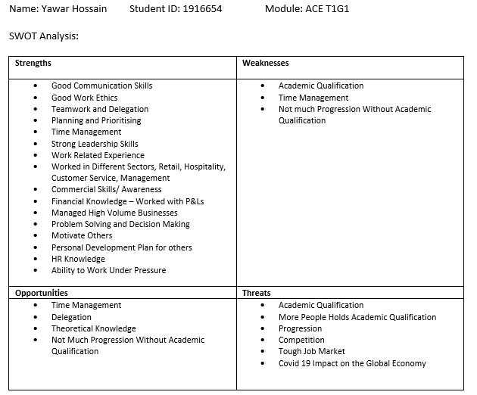

Homework on Eisenhower method:

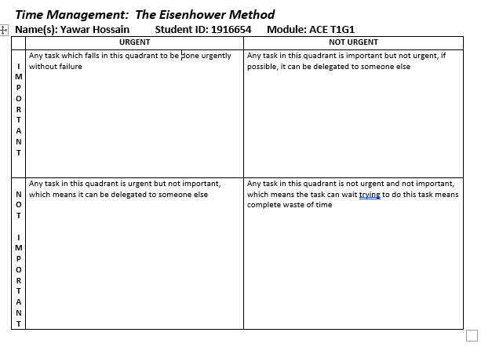

Homework on Time Management:

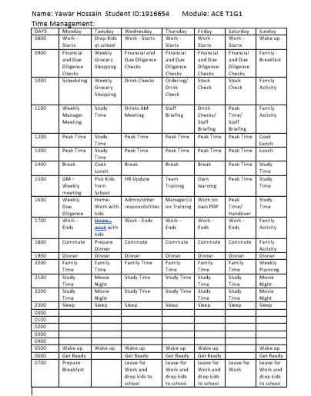

Homework on PDP:

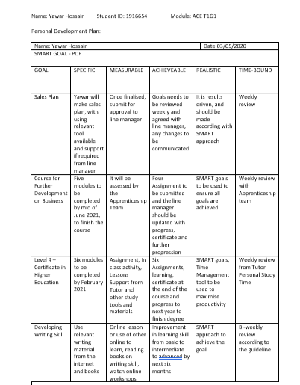

Cleeve, R (2018), 5 academic skills to prepare your students for higher education, Pearson English [blog] 22 October 2018. Available at: https://www.english.com/blog/academic-skills-for-higher-education/ (Accessed: 01 May 2020)
Moore, E (2018), 14 Must -Have Skills for Entry-Level Workers, Career Advice, Glassdoor [blog] 23 November 2018. Available at: https://www.glassdoor.com/blog/must-have-entry-level-worker-skills/ (Accessed: 01 May 2020)
Indeed, (2019), Employability Skills: Definition and 10 Examples, Finding A Job, Career Guide, 12 December 2019, Available at: https://www.indeed.com/career-advice/finding-a-job/employability-skills (Accessed: 02 May 2020)
Seager, C (2020), How to handle competency-based interview questions, Total jobs, 3 February 2020. Available at: https://www.totaljobs.com/advice/how-to-handle-competency-based-interview-questions (Accessed: 02 May 2020)
Indeed, (2019), Employability Skills: Definition and 10 Examples, Finding A Job, Career Guide, 12 December 2019, Available at: https://www.indeed.com/career-advice/finding-a-job/employability-skills (Accessed: 02 May 2020)
Luxafor, n. d, The Eisenhowar matrix: Time and Task Management Made Simple, Available at: https://luxafor.com/the-eisenhower-matrix/ (Accessed: 02 May 2020)
Figure 2 represents diagram made by Yawar Hossain
Figure represents diagram made by Yawar Hossain
Figure represents diagram made by Yawar Hossain

