

EXAMINATIONS 2013/2014 Semester 2
ARHOLIADAU 2013/2014

FACULTY OF: APPLIED DESIGN AND ENGINEERING
SCHOOL OF APPLIED COMPUTING

NAME OF COURSE/PROGRAMME: | HND/BSc Computer Networks  BEng Computer Network Technology
YEAR OR LEVEL: | Year 2
NAME OF MODULE/UNIT/EXAM PAPER: | Local Area Networks
MODULE NO: | M2X8625/ M2X8521/M5X8930
DATE OF EXAMINATION:

EXAMINATION TIMES:

START TIME:

FINISH TIME:

TIME ALLOWED: | 2 hours

INSTRUCTIONS TO CANDIDATES:

Answer 3 out of 4 questions.

Candidates are not permitted to bring calculators, dictionaries; text books/case studies or any other reference materials into the exam room.

SECTION A
Answer all questions

- How many broadcast domains are created when you segment a network with a 12-port switch?
  - Two
  - One
  - Twelve
  - None

- What is a stub network?
  - A network with more than one exit point
  - A network with more than one exit and entry point
  - A network with only one entry and no exit point
  - A network that has only one entry and exit

- If your Router is facilitating a CSU/DSU, which of the following command do you need to use to provide the router with a 64000kbps serial link?
  - RouterA(config)# bandwidth 64
  - RouterA(config)# clockrate 64000
  - RouterA(config)# clock rate 64000
  - RouterA(config)# clockrate 64
  - RouterA(config)# bandwidth 64000

- Which VTP mode is capable of creating only local VLANs and does not synchronise with other switches in the VTP domain?
  - A client
  - Dynamic
  - Server
  - Static
  - Transparent

- Which set of commands is recommended to prevent the use of a hub in the access layer?
  - Switch(config-if)#switchport mode trunk
Switch(config-if)#switchport port-security maximum 1
  - Switch(config-if)#switchport mode trunk
Switch(config-if)#switchport port-security mac-address 1
  - Switch(config-if)#switchport mode access
Switch(config-if)#switchport port-security maximum 1
  - Switch(config-if)#switchport mode access
Switch(config-if)#switchport port-security mac-address 1

- Refer to the exhibit, switch port FastEthernet 0/24 on ALSwitch1 will be used to create an IEEE 802.1Q compliant trunk to another switch. Based on the output shown, what is the reason the trunk does not form, even though proper cabling has been attached?

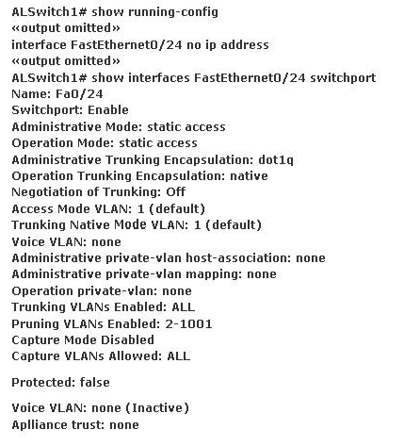

  - VLANs have not been created yet
  - An IP address must be configured for the port
  - The port is currently configured for access mode
  - The correct encapsulation type has not been configured
  - The no shutdown command has not been entered for the port

- Which statement about VLAN operation on Cisco catalyst switches is true?
  - When a packet is received from an 802.1Q trunk, the VLAN id can be determined from the source MAC address table.
  - Unknown unicast frames are retransmitted only to the ports that belong to the same VLAN
  - Ports between switches should be configured in access mode so that VLANs can span across the ports
  - Broadcast and multicast frames are retransmitted to ports that are configured on different VLAN

- Refer to the exhibit; the 3 catalyst 2950 switches have been configured for VTP. Trunking is properly configured and operational on all three switches. The show vlan command issued on SwitchC displays only the default VLANs. Based on the output from the show vtp status commands shown in the exhibit, why is this true?
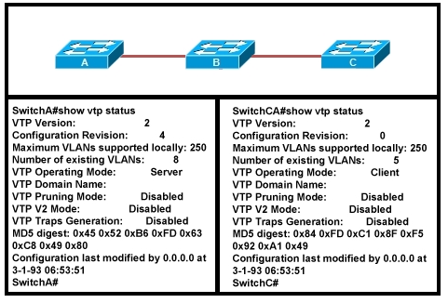

  - Only the default VLANs are configured on SwitchA
  - SwitchA does not have a VTP domain name configured
  - VTP pruning needs to be enabled on SwitchA
  - SwitchC needs to have the VTP domain name configured
  - SwitchB is in transparent mode

- What is a valid reason for a switch to deny port access to new devices when port security is enabled?
  - The denied MAC addresses have already been learned or configured on another secure interface in the same VLAN
  - The denied MAC addresses are statically configured on the port
  - The minimum MAC threshold has been reached
  - The absolute aging times for the denied MAC addresses have expired

- Which two of these statements regarding RSTP are correct? (choose two)
  - RSTP cannot operate with PVST+
  - RSTP defines new port roles
  - RSTP defines no new port states
  - RSTP is a proprietary implantation of IEEE 802.1D STP
  - RSTP is compatible with the original IEEE 802.1D STP

- On the basis of the IEEE 802.1w standard, which two switch ports can forward traffic?
  - Alternate
  - Backup
  - Designated
  - Disabled
  - Root

- Refer to the exhibit, given the output shown from this Cisco Catalyst 2950, what is the most likely reason that interface FastEthernet 0/10 is no the root port for VLAN 2?

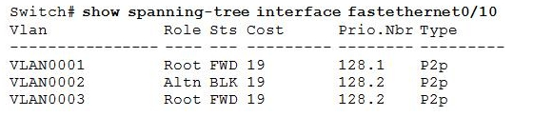
  - This switch has more than one interface connected to the root network segment in VLAN 2
  - This switch is running RSTP while the elected designated switch is running 802.1D STP
  - This switch interface has a higher path cost to the root bridge that another in the topology
  - This switch has a lower bridge IP for VLAN 2 than the elected designated switch.

- Which Cisco Catalyst feature automatically disables the port in an operational PortFast upon receipt of a BPDU?
  - BackboneFast
  - Uplink Fast
  - Root Guard
  - BPDU Guard
  - BPDU Filter

- Which port state is introduced by Rapid-PVST?
  - Learning
  - Listening
  - Discarding
  - Forwarding

- Cisco Catalyst switches CAT1 and CAT2 have a connection between them using ports FA0/13. An 802.1q trunk is configured between the two switches. On CAT1, VLAN 10 is chosen as native, but on CAT2 the native VLAN is not specified. What will happen in this scenario?
  - 8021q giants frame could saturate the link
  - VLAN 10 on CAT1 and VLAN 1on CAT2 will send untagged frames
  - A native VLAN mismatch error message will appear
  - VLAN 10 on CAT1 and VLAN1 on CAT2 will send tagged frames

- A network administrator must configure 200 switch ports to accept traffic from only the currently attached host devices. What would be the most efficient way to configure MAC-level security on all these ports?
  - Visually verify the MAC addresses and then telnet to the switches to enter the switchport –port security mac-address command
  - Have end users email their MAC addresses, telnet to the switches to enter the switchport –port security mac-address command
  - Use the switchport port-security MAC address sticky command on all switch ports that have end devices connected to them
  - Use show mac-address-table to determine the address that are associated with each port and then enter the command on each swithc for MAC address port-security.

- Refer to the exhibit; which switch provides the spanning-tree designated port role for the network segment that services the printer?
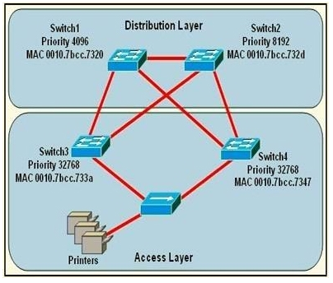
  - Switch1
  - Switch2
  - Switch3
  - Switch4

- What is the purpose of the Cisco VLAN trunking protocol?
  - To allow traffic to be carried from multiple VLANs over a single link between switches
  - To allow native VLAN information to be carried over a trunk link
  - To allow for managing the additions, deletions, and changes of VLANs between switches
  - To provide a mechanism to manually assign VLAN membership to switch ports
  - To provide a mechanism to dynamically assign VLAN membership to switch ports

- While troubleshooting a connectivity problem, a network administrator notices that a port status LED on a Cisco Catalyst series switch is alternating green and amber. Which condition could this indicate?
  - The port is experiencing errors
  - The port is administratively disabled
  - The port is blocked by spanning tree
  - The port has an active link with normal traffic activity

- Refer to the exhibit; Computer 1 is consoles into switch A. Telnet connections and pings run from the command prompt on Switch A fails. Which of the following could cause this problem?

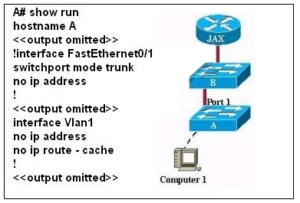

  - Switch A does not have a cdp entry for switch B or router JAX
  - Switch A does not have an IP address
  - Port 1 on switch A should be an access port rather than a trunk port
  - Switch A is not directly connected to router JAX
  - Switch A does not have a default gateway assigned

- How are VTP advertisements delivered to switches across the network?
  - Unicast frames
  - Multicast frames
  - Broadcast frames
  - Anycast frames

- In which circumstance are multiple copies of the same unicast frame likely to be transmitted in a switched LAN?
  - After broken links are re-established
  - In an improperly implemented redundant topology
  - When upper-layer protocols require high reliability
  - During high traffic periods
  - When a dual ring topology is in use

- Which value is primarily used to determine which port becomes the root port on each nonroot switch in a spanning-tree topology?
  - Port priority number and MAC address
  - Lowest port MAC address
  - Path cost
  - VTP revision number
  - Highest port priority number

- Why will a switch never learn a broadcast address?
  - Broadcast frames are never sent to switches
  - Broadcast addresses use an incorrect format for the switching table
  - A broadcast address will never be the source address of a frame
  - Broadcast only use network layer addressing
  - A broadcast frame is never forwarded by a switch

- Which command enhances the 802.1D convergence time on ports that are connected to hosts?
  - Spanning-tree backbonefast
  - Spanning-tree uplinkfast
  - Spanning-tree portfast
  - Spanning-tree cost512

SECTION B
Answer any two questions

QUESTION ONE

- Refer to the exhibit, If the default gateway cannot be reached, the local device is unable to send packets off the local network. Even if a redundant router exists that could serve as a default gateway for that segment, there is no dynamic method by which these devices can determine the address of a new default gateway. Explain the ability of a network to dynamically recover from the failure of a device acting as a default gateway. [13 marks]

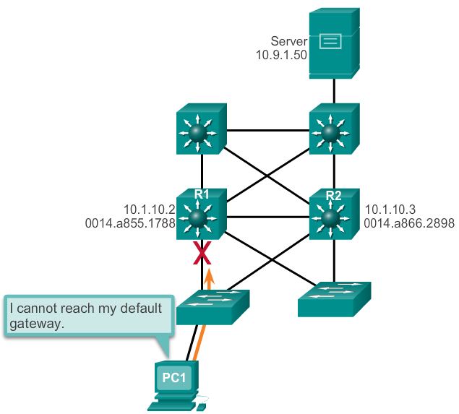

Figure 1
.
- In reference to VTP components, explain the following;
  - VTP Server
  - VTP Client
  - VTP Transparent
  - VTP Pruning [10 marks]

- What are the configuration guidelines to from EtherChannel? [2 Marks]

QUESTION TWO

- Layer 2 redundancies improve the availability of a network by implementing alternate network paths, by adding equipment and cabling. But they result in some drawbacks, list those drawbacks and with an example explain the solution in detail. [17 Marks]

- Explain Cut-through and store-and-forward switch packet forwarding methods. [8 Marks]

QUESTION THREE

- Illustrate hierarchical network topology and list switch features on each layer. [12 Marks]

- Using the table below compare Layer 3 switching with Router. [3 marks]

Table 1
Feature | Layer 3 Switch | Router
L3 Routing
Traffic Management
WIC Support
Wirespeed routing
Advanced Routing Protocols

- With appropriate network diagrams compare various methods of Inter-VLAN routing. [15 marks]

