business plan
mODULE CODE: LCBB5001
module name: enterpreneurship
Lecturer: Riaz Bhatti, nishi ramsurrun, rita ukachi-lois
Student Number: 2028273
Student name: Stanislava boneva

BUSINESS PLAN

BUSINESS DESCRIPTION / MARKET OPPORTUNITY

Source: K12, 2022

Educational centre Smarty Academy is a private learning company which offers advanced services in the field of education that enables users to interconnect, grow cognitively, professionally, and personally and expand knowledge through personalized approaches. The facility features a simulation centre and rooms with interactive boards and tables where people from various ages can gain expertise and refine their capabilities through participation in interactive games and activities.

Mission statement:
Our mission is to encourage the individuals to strive toward professional growth, self-actualization, success, and mutual well-being through provision of conductive and motivating learning environment in various fields of study. The business-entity main goal corresponds with the idea of becoming a leading educational centre in UK in terms of innovation and competitiveness (The Learning Academy, 2020).

Description of product:
Smart Academy is going to offer a unique product – interactive training and learning through a variety of educational services in different fields the UK. Interactive learning is a practical modern approach to education which actively engages students to grapple with a material and be stimulated to become able to resolve problems in practice easily through holistic approaches (Silver, 1996).
Services which will be provided include: (The Learning Academy, 2020)
- Planning a personalized and innovative curriculum for each student.
- Creating and developing activities to meet the unique interests and demands of students and to determine a path to learning adventure.
- Conducting educational processes for general education and specialized knowledge.
- Providing an all-day educational service and practice.
- Organizing competitions and events to raise educational awareness and motivation for study.
Education is and always will be a fundamental right for everyone that is required to deal with tricky situations in the workplace or even in everyday practices. In a post-Covid 19 setting, the need for employing educated and highly capable in terms of technology and professional skills people is urgent. The innovative programmes of Smart Academy are an alternative to resolve the issue of the demotivation of adolescents to study and develop their potential in the field of education. This learning centre is going to support inclusion, initiative and development of individuals who have experienced the repercussions of online education during the pandemic and who need an additional assistance in their endeavours (The Learning Academy, 2020). The importance of knowledge, practice, and constant development in times of digitalization and advances is great and post-pandemic consequences require students to be adaptive, flexible, and equipped for today’s rates of development of life, education, and economy.

Ownership structure:
Smart Academy is going to operate as a sole proprietorship run by one owner but is also going to establish partnerships with many educational institutions to raise the awareness initiative and pay forward the message.

INDUSTRY ANALYSIS
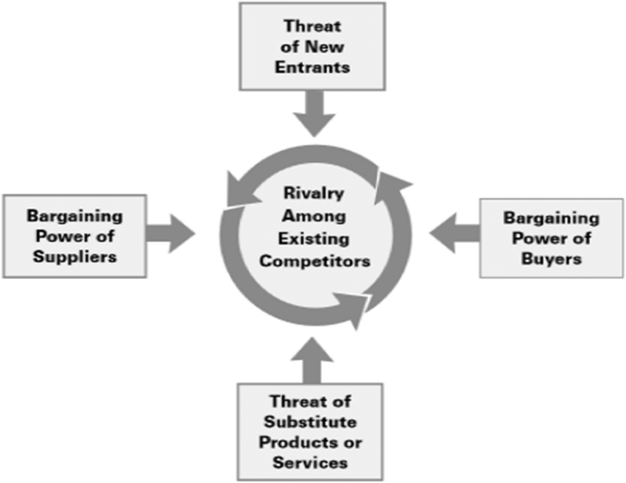
Source: Ahmed et al, 2022

Threat of new entry

The barriers to entry into the education market are extremely high so the threats of new entry are somehow minimized. The new entrants on the market are in difficult position to establish and position their business well and to build their trustworthy reputation due to the existing barriers – government policies, funding, brand reputations and reactions from potential customers (Porter, 2008). However, new entrants are observed as a huge threat as they might reduce the market power by gaining market share and might alter the industry development. Therefore, governments pose regulations such as licensing and capital requiring the entities to prevent the market from overcrowding with non-quality service (McGahan, 2004).

Threat of substitutes

Substitute products are products or services from another industry which provide the same benefits when purchased to the end users and therefore the threat of substitutes is responsible for outlining the competitiveness in terms of structure of the entire industry (Dan, 2013). The substitutes place a ceiling of the prices in the services within the educational field and can challenge the market by declining the profitability potential of the firms (Riley, 2012). Within the following industry, there is a big threat of providing private lessons or online educational activities within the scope of various fields. Therefore, the threat of capturing and attracting potential clients with substitute products is high and Smart Academy should orient toward presenting the most attractive product proposal.

Bargaining power of customers

The bargaining power of potential customers poses the basis of pressuring the businesses to give to customers higher quality and better serviced products at competitive prices which reflects negatively upon profitability of the business entity (Alkhafaji, 2003). In this field, customers have high bargaining power as they are sensitive to price changes and are captivated by the competitiveness of price and the offers provided by other educational institutions (Dan, 2013). Therefore, a crucial step for Smart Academy is to follow a strategic pricing strategy to satisfy the changing perceptions and needs of the consumers and to help streamline their power.

Bargaining power of suppliers

Another crucial element which places a pressure on the industry through reduction of quality or availability of products and services or raise in prices is the supplier bargaining power (Mathooko & Ogutu, 2015). If suppliers are powerful and take advantage to establish monopoly by charging products expensively and failing to supply in the most effective way, then the businesses might run into huge operational costs (Porter, 2008). The bargaining power of supplier within the educational industry is measured by their concentration in the place of functioning of the business and the expenses which they require for the purchases (Grant, 2005). Therefore, Smart Academy can differentiate the base of suppliers to ensure that it has an easy and fast access to alternative supplying forces for getting lower prices at the same or better quality when needed to get learning materials or technological products for the activities.

Competitive Rivalry – main competitors
Name of competitor | Differentiation
Competitor 1 – British Study Centres    Source: BSC, 2022 | They offer a variety of educational services comprising of teacher and corporate trainings, university pathways programmes, student development activities, young learners’ initiatives (BSC, 2022). Therefore, to differentiate from them, Smart Academy can diversify the service base by providing transformational educational experience with more practical orientation – the same range of courses but transforming each of them through the prism of practicality.
Competitor 2 – First Class Learning    Source: FCL, 2022 | The second competitor’s operational activity is focused on holistic student focus with a detail towards Maths and English education (FCL, 2022). To compete with this rival, Smart Academy is going to deliver a vast range of specialized products - subject and courses variety in student and professional orientation fields- and core competency of teacher. Another differentiation technique which can be adopted is to stablish a free skills assessment testing to attract more potential consumers as the one in FCL Academy is paid and often fully booked.
Competitor 3 – The Learning Academy  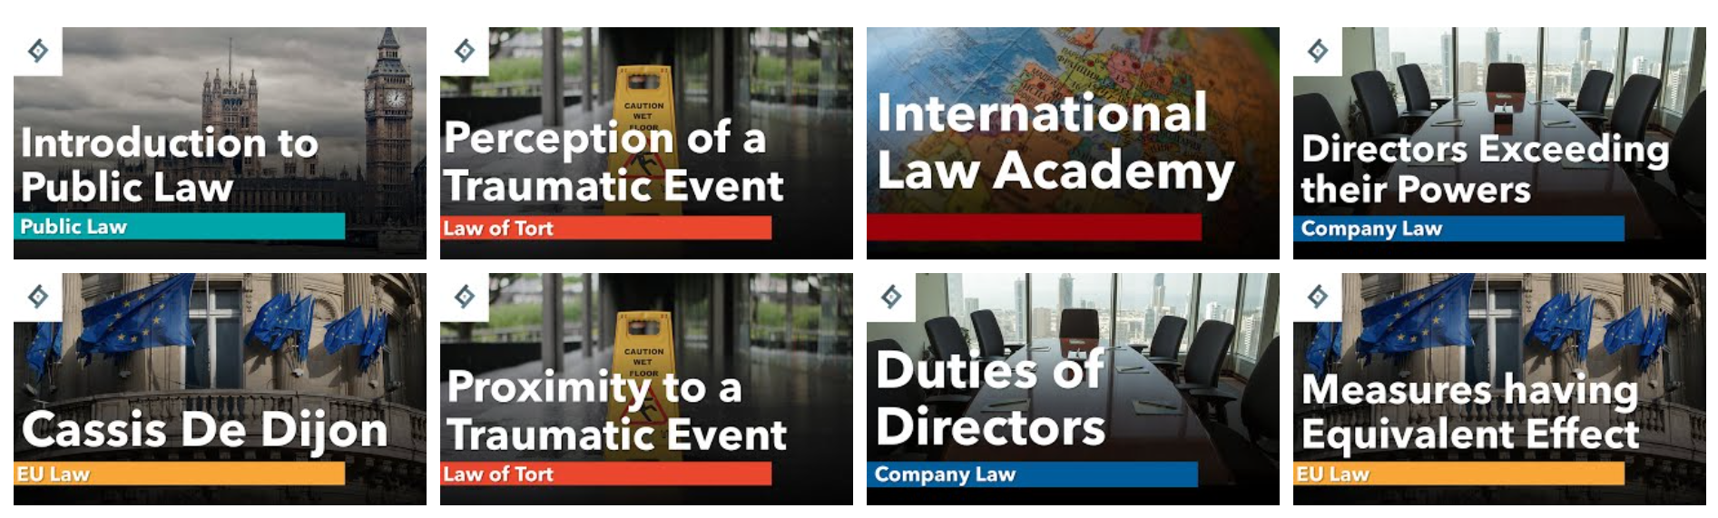  Source: TLA, 2022 | They are primarily concentrated toward offering high quality educational services for young individuals studying according to GCSE and A Level Programmes in different subjects as Law, Philosophy, History, English, Politics, Economics (Learning Academy 2020, 2022). To differentiate from them, Smart Academy expands the age category by taking children from the smallest ages and following them through their cognitive development path until late ages. The intention is to focus on broader target auditory and to be capable in establishing learning pathways for every demand –from smallest to the oldest.

OPERATIONS AND MANAGEMENT TEAM
OPERATIONS
The business process begins with equipping the academy with machines, technological products, and supplements. The suppliers are big competitive companies which distribute educational materials at competitive prices. Purchasing school supplies and services online is a strategy to minimize the initial costs of operations. Apart from school materials, technological equipment in terms of interactive boards and displays, projectors, VR glasses, computer-based systems, providers and learning platforms will be bought also online from Optoma, Baloo Learning and Edtech UK and will be delivered through their delivery systems to the production site. Competitive and highly qualified employees will then be hired to provide the services needed. In the academy itself, those materials will be integrated within the practice of the teachers and professors who will apply them in their modern and innovative teaching practices. Professionals from other countries will be assigned to assist the processes online by providing expertise knowledge in specialized fields of education.

How would you generate revenue for your business? How would you prevent loss of revenue?

To generate the wanted levels of revenue, Smart Academy integrates sales strategy for generation of income and profits from the operation of the centre by selling the products both on-site and online and engaging in direct marketing and advertising approach to spread awareness and encourage more people to make a purchasing decision. To prevent losses of revenues, the company will constantly innovate to supply the newest educational trends on the market.

MANAGEMENT TEAM (Martins, 2019)
Name | Skills | What do they bring to the firm
Head of the Centre | Competence; leadership; responsibility; coordination; time and organizational management; risk taking | Accountable for coordinating the overall activities of the entity; providing directions to the operations; evaluating and assessing the success
Administrator | HR management; teamwork; guiding competence; training; supervision; working with documentation | Liable for designing job descriptions, managing deliveries and orders, interviewing potential employees, arranging appointments
Specialist | Planning capabilities, customer service; organization skills; time management | Planning school curricula and developing activities; establishing rules and regulations for functioning; handling complaints and demands; operating the programmes.
Marketing Specialist | Presentation abilities; research and risk analysis competences; strategic planning and thinking | In charge for prioritizing, developing, implementing, and monitoring communication and advertising practices; oriented toward increasing sales and growth of the company

MARKETING
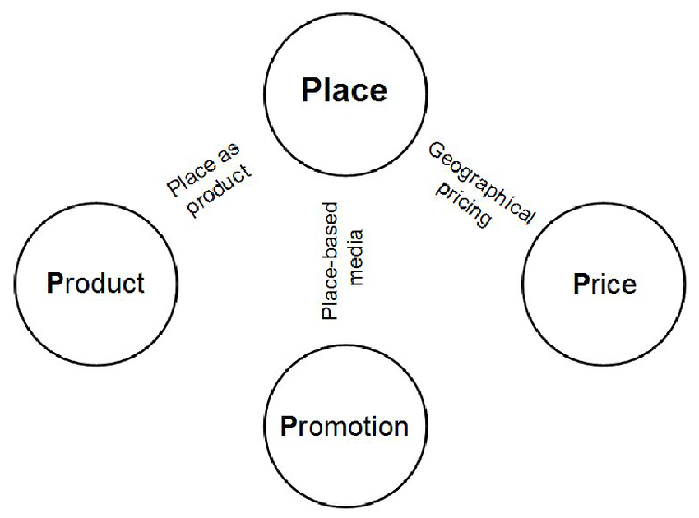
Source: Shepherd, 2009
Product:
The product of the company includes variety of educational services in different fields which are consistent with consumer demands and have effective launching on the market through positioning, advertising, and pricing strategies (Kotler, 2001). Here are included professional development and training courses, learning programmes in major General Educational Fields, Science, Languages, Technological Education, Practice courses, Exam preparation.

Price:

The pricing strategy is a combination of fixed prices for lessons as well as promotional and discount offers which are focused on attracting potential customers and rising the number of sales (Pereira, 2020). The price is competitively chosen regarding the market trends and is highly individualized based on the desire for individual or group lessons and the duration of the course.

Promotional Mix:

The promotion plan of the company is a synthesis of various activities such as social media marketing, influencer marketing, advertising campaigns, creating events, word of mouth marketing (Armstrong et al, 2015). Through such a diversified presence in both traditional and online media, the company ensures to spread the message about the services and their effectiveness, to raise customer awareness and to motivate them to make an action.

Place (Distribution strategy):

The distribution channels within the supply chain are especially important for the effective positioning of the products on the market, which is why Smart Academy will integrate direct channels by selling the service directly to the customers (Kotler Armstrong, 2014).

FINANCIALS

Sources of funds – generating funds from the following sources:
- Personal savings
- Start-up capital from a Bank loan
- Grants from a funding programme – Education Funding Agency (Gov UK, 2022)

Use of funds (as a guideline for projecting the financial figures the competitor’s Annual Financial Report is used – TLA, 2021)
Values are measured in pounds.

 | Month 1 | Month 2 | Month 3
Revenue | 128 333 | 135 400 | 148 200
Fixed Costs  - Rent  - Utility payments  - Salaries  - Interest on loan  - Internet/learning platform services  - Accounting services  - Insurance premiums | 49 532 | 49 532 | 49 532
Variable Costs  - Electricity/heating and water  - Overheads  - Marketing/advertising costs  - Events/activities/further materials  - Software licences  - Supplies  - Office decor | 29 873 | 27 500 | 28 350
Profit = Revenues – FC – VC | 48 928 | 58 368 | 71 318

REFERENCES

Ahmed, Zia & Hussain, Belayeth & Alam, Rafiul & Kumar, Ashok. (2022). Perils and prospects of Manipuri handloom industries in Bangladesh: An ethnic community development perspective. GeoJournal. 10.1007/s10708-020-10365-3.

Alkhafaji, A. (2003). Strategic management. Formulation, implementation, and control in a dynamic environment. New York: The Haworth Press, Inc.

Bakytgul Abykanova. (2016). [online] Available at: https://files.eric.ed.gov/fulltext/EJ1124626.pdf.

BSC (EN). (2019). British Study Centres - International Education Group - Home. [online] Available at: https://www.british-study.com/en/.

Dan (2013). Threat of Substitutes (one of Porter’s Five Forces) - The Strategic CFOTM. [online] https://strategiccfo.com/. Available at: https://strategiccfo.com/articles/financial-leadership/threat-of-substitutes-one-of-porters-five-forces/.

GOV.UK. (2022). Education Funding Agency. [online] Available at: https://www.gov.uk/government/organisations/education-funding-agency.

Grant, R. (2005): Contemporary Strategy Analysis: – Blackwell Publishing Ltd., Oxford Porter, M. (1985): Competitive Advantage: -Techniques for Analysing Industries and Competitors. The Free Press, New York.

Firstclasslearning.co.uk. (2020). [online] Available at: https://www.firstclasslearning.co.uk/.

Kotler, Philipp. (2001). Marketing Management, Millennium Edition. University of
Peshawar. [online] University of Peshawar. Available at:
http://www.uop.edu.pk/ocontents/KotlerMarketing%20Management%20Millenium%2
0Edition.pdf. Accessed 08 April 2022.

Kotler, P. and Armstrong, G. (2014) Principles of Marketing: global edition. 15th ed.
Pearson Education Limited.

K12. (2022). K12. [online] Available at: https://www.k12.com/.

Marc. (2014). Marketing Mix – Place in Four P’s [Internet], Marketing, Entrepreneurial
Insights. Accessed 11 April 2022.

Martins, A.T. (2019). Learning Centre Business Plan [Sample Template for 2022]. [online] Zen Business Plans. Available at: https://www.zenbusinessplans.com/learning-center-business-plan/#generating_fundsstartup_capital_for_little_rock_community_learning_center_inc [Accessed 20 Nov. 2022].

Masinde Indiatsy, C., Mwangi, M., Mandere, E., Miroga Bichanga, J., Gongera, E. and George (2014). The Application of Porter’s Five Forces Model on Organization Performance: A Case of Cooperative Bank of Kenya Ltd. Online), [online] 6(16). Available at: https://core.ac.uk/download/pdf/234625548.pdf.

Mathooko, F.M. and Ogutu, M. (2015), "Porter’s five competitive forces framework and other factors that influence the choice of response strategies adopted by public universities in Kenya", International Journal of Educational Management, Vol. 29 No. 3, pp. 334-354. https://doi.org/10.1108/IJEM-12-2013-0187

McGahan, A. (2004): How Industries Evolve: – Principles for Achieving and Sustaining Superior Performance. Harvard Business School Press.

Miller et al. (2016). Strategic Marketing STRATEGIC MARKETING REPORT. (2016).
[online] Available at:
https://zachariahmillerblog.files.wordpress.com/2016/06/ubereats-strategic-
marketing-report.pdf.

Pereira-Kotze C, Doherty T, Swart EC. Use of social media platforms by manufacturers to market breast-milk substitutes in South Africa. BMJ Global Health 2020;5: e003574. doi:10.1136/ bmjgh-2020-00357

Porter, Michael E. (2008). The Five Competitive Forces that Shape Strategy. Harvard Business Review.

Riley, J. (2012). Porter’s Five Forces Model: analysing industry structure. Retrieved June 14, 2013, from http://www.tutor2u.net/business/strategy/porter_five_forces.htm.

SCHOOL IN A BOX Guide Series MANUAL 8 HOW TO WRITE A BUSINESS PLAN FOR A SELF-SUFFICIENT SCHOOL. (n.d.). [online] Available at: https://www.teachamantofish.org.uk/assets/images/assets/uploads/Manual8-HowtoWriteABusinessPlanforaSelf-SufficientSchool.pdf.

Shepherd, Ifan. (2009). From Geography Department to Business School: Strategies for Transplanting GIS Courses between Disciplines. Journal of Geography in Higher Education - J GEOGR HIGHER EDUC. 33. 10.1080/03098260903034038.

Silver, H.F. (1996) Teaching Styles &amp; Strategies. Silver Strong &amp; Associates; 3rd edition, Print.
StudyCorgi.com. (n.d.). Zicklin School of Business’s Porter’s Five Forces Analysis | Free Essay Example. [online] Available at: https://studycorgi.com/zicklin-school-of-businesss-porters-five-forces-analysis/.

The Learning Academy. (2020). Learning Academy. [online] Available at: https://www.learningacademy2020.co.uk/learning-academy [Accessed 29 Nov. 2022].

tlacad.org. (2021). Annual Audit Reports. [online] Available at: http://tlacad.org/organizations/annual-audit-reports/ [Accessed 28 Nov. 2022].

