System Improvement Programme
MSc Digital Skills for the Health and Care Professions
Module Name: Digital Technology in Health and Social Care
Module Code: BMDS7006

Submission Date: 16/12/2022
Word Count: 3,940

Simon Wellington
Student ID: 2215317

Introduction

Describe the nature of the organisation and the operational context.

The NHS 111 service provides a free, single point-of-access phone number that enables patients to be directed to the appropriate care in the appropriate location by a multidisciplinary team. The 111 service integrates 'GP out of ours' services with NHS Direct Welsh Government, 2018. The NHS 111 Wales service is operated by Welsh Ambulance Service NHS Trust (WAST) and the seven NHS Wales health boards. The service is split into two operational teams a public-facing access point offering a call handling and nurse triage service managed by WAST and an urgent primary care service conducting consultations remotely, face-to-face in primary care centres and home visiting by the seven health boards. The urgent primary care service receives its caseload via electronic transfer from the WAST 111 Clinical Assessment Software (CAS) with clinical prioritisation into their system Adastra. Health professional referrals are received via a bypass telephony number and then manually entered and not clinically prioritised by clerical teams working for the health board. The current flow of Health Professional Calls can be seen in figure 1.
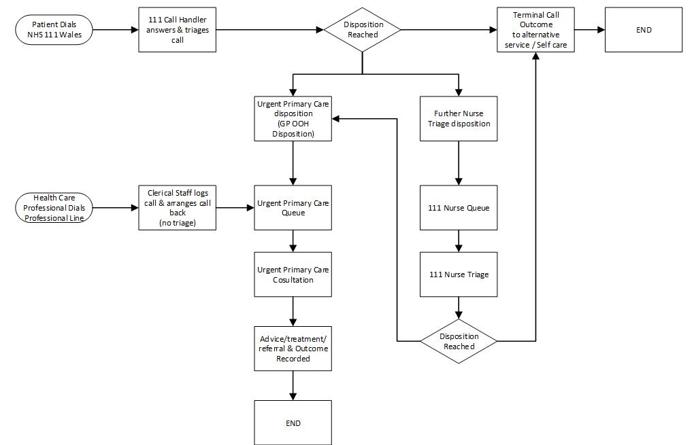

Fig. 1 – Current NHS 111 Wales Health Professional Call Flow for Urgent Primary Care

Identify the business problem

The current model for urgent primary care to receive a referral for a patient into the service from a health professional is based on point of access rather than clinical need. This means a generic priority is assigned to all calls received via this bypass access line and varies amongst the seven health boards. This means local arrangements for “Paramedic” type calls receive a higher priority than that of “District Nurse” based on operational pressures the ambulance service has rather than the patient's clinical need. This reliance on a telephony model means clerical staff must operate the telephony system 24/7 while also conducting their usual role within the urgent primary care centre. There is no clinical prioritisation undertaken by the clerical staff when placing these calls on a call-back queue from the out-of-hours teams and reliance on notes captured by the clerical team at the time of the call. Currently as noted in the figure below on average xx number of health professional calls are generated manually by clerical team. The data from Adastra also indicates there is a need for clinical decision support for health professionals accessing primary care noting the number of “Paramedic Requests Advise Only”. Currently the Health Care Professional access model for urgent primary care does not include transfer from General Practice (“in hours”) to Out of Hours (“Urgent Primary Care”) with an expectation that they manage their own workload during in hours.
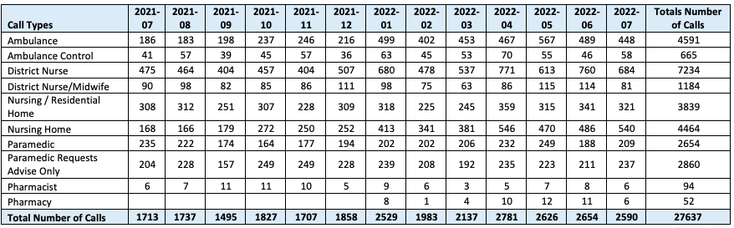
Figure 2 – NHS 111 Wales Service (2022), Health Professional Calls July 2021-July 2022.
NHS 111 Wales Service (Unpublished).

Explain how it can be improved using an Information system.

The implementation of an Information System would bring several benefits to the service. Firstly, the NHS would benefit from a single point of access via a web page/portal instead of numerous telephone numbers managed by the health boards which can be difficult for health professionals operating nationally or regionally often working across health board boundaries such as the Welsh Ambulance Service. Secondly, clinical decision support algorithms could help prevent inappropriate referrals to the urgent primary care service and could signpost health professionals to alternative services available based on the criteria captured in the information system. By using clinical decision support algorithms/criteria, all referrals could be prioritised into the urgent primary care service based on entered criteria by the health care professional and offer a realistic call-back time to health care professionals for their patients which may help them to evaluate the appropriateness for the referral. Integrating the information system with national patient demographic services would ensure that urgent primary care services have confirmed patient demographics cutting out manual searches for patients by clerical teams. Implementing a national information system would set a standard for all NHS health boards receiving health care professionals into the urgent primary care service making them reportable. The introduction of an information system would enable for staff currently undertaking this manual process to be redeployed into other operational areas of urgent primary care and enable cost savings by the organisation.

Justification

Explain the change you will be introducing

Implementing an electronic referral system for health care professionals to enable patient referrals to the urgent primary care service rather than a manual telephone process facilitated by clerical staff operating within the Health Board. Integrating clinical decision support within the electronic referral system to aid clinical prioritisation and alternative pathways to avoid inappropriate referrals. Utilising an NHS standard patient demographic look-up to ensure accurate patient information is transferred into the Urgent Primary Care service system. Assigning national priority standards against all referrals received into the service based on referral/clinical decision support criteria. Implementing accurate reporting standards against the health care professional referring to the service (for example capturing Nursing Midwifery Council pin) and any associated clinical documentation for the patient.

Justify why you think these changes are important

Implementation of a national electronic referral system into the urgent primary care service would help facilitate the Welsh Government's aim of 6 Goals for Urgent and Emergency Care - Specifically helping to meet Goal 2 “Signposting to the right place, first time” and Goal 3 “Access to clinically safe alternatives to hospital admission” (Welsh Government, 2022). Integrating Clinical Decision Support within the electronic referral system could help avoid “Paramedic Requests Advise Only” calls that are currently generated in the urgent primary care service by promoting clear guidance and alternative pathways based on referral criteria. Improving access to urgent primary care by integrating the electronic referral system into existing digital platforms used by organisations such as the Electronic Patient Clinical Record (ePCR) used by the Welsh Ambulance Service (Welsh Ambulance Service, 2022). There is currently no nationally adopted pathway and reporting for Health Professionals accessing Urgent Primary Care and implementing a national referral system would aid in adopting a national standard that can then be used by the NHS to accurately report on these types of interactions with Urgent Primary Care.

Aim

To implement an electronic referrals support system with clinical decision support integration for health care professionals to refer patients to the Urgent Primary Care Service (GP Out of Hours)/NHS 111 Wales.

Objectives

- To develop an electronic referral system for Healthcare Professionals to access Urgent Primary Care.
- Engage with Stakeholders in Urgent Primary Care and Wider NHS to establish a pathway and nationally recognised referral criteria for Urgent Primary Care
- Integrate with national and local NHS systems to establish and enable national reporting and maintain NHS standards of data for referrals made by the system.
- Establish local IT compatibility and procure additional IT hardware if required.
- To complete solution design, user acceptance testing and end-user training of the new information solution within 1 year.

Literature Review

The following search strategy will be used when conducting a literature review based on the business problem. The literature chosen will be published within the last 20 years – this is to enable a wider choice of literature available to evidence how implementation and adoption of how IS solved business problems and investigate the different project methodologies as technology has evolved. The literature chosen will be based on all types of referrals within the health and social care setting – this is because there is limited literature for referrals into primary care as most commonly referrals are made from primary care into other health settings (such as secondary care and specialist services e.g. oncology or dental services). The use of keywords such as “Electronic Referral System”,”eRES”, “NHS Referral Systems” “Health Referral Systems” “Implementation of Referral Systems” will be key in ensuring literature pertinent to the topic is found.

Present your results and discuss the emerging themes. (evidence of how implementation and adoption of IS solved business problems and evidence of the use of different project management methodologies for IS implementation projects).

Methods

Identify a suitable Project management methodology with justification

The project management methodology that the implementation of this IS system will be that of PRINCE2. PRINCE2 provides a guide on best practices based on the seven principles which are based on lessons learnt from previous projects (AXELOS Limited, 2017). One of the principles that make PRINCE2 attractive as a project methodology is continued business justification, whilst justification for the project can evolve PRINCE2 is clear in its guidance that should the justification no longer remain the project should be stopped whilst appearing as a failure this in PRINCE2 is seen as a positive as potential funds and resources are saved by the organisation (AXELOS Limited, 2017). PRINCE2 has the benefit of user engagement throughout the development meaning that stakeholders will have direct input into the functional, environmental, service and management of the electronic referral system (Bentley, 2010). PRINCE2 is also a flexible project methodology and is suited to any type of project allowing for efficient control of development resources (AXELOS Limited, 2017). As the project will be involving multiple stakeholders with different skills PRINCE2 recognises that projects need to be cross-functional allowing for the different skill sets to define what is required and others to develop (Bentley, 2010). By using PRINCE2 the implementation delivery can be conducted using an agile approach where requirement gathering coding and testing all take place throughout the project through sprints (AXELOS Limited, 2017). PRINCE2 methodology is focused on the delivery of the product and its quality requirements meaning that planning, controls and quality that the project requires are all based on the product (Bentley, 2010).

PRINCE2 has three parts to its methodology – Principles, Themes and Processes (Bentley, 2010). PRINCE2 principles provide a framework for projects to help adhere to best practices and were developed based on lessons learnt from successful and unsuccessful projects (Tuttle, 2018). The principles of PRINCE2 are universal in that they apply to every project, self-validating in that they have been proven in practice over many years and empowering because they give practitioners of the method added confidence and ability to influence and shape how the project will be managed (AXELOS Limited, 2017). The themes of PRINCE2 define the different aspects of project management that the project should address from the start and closure of the project these themes are integrated with each other (AXELOS Limited, 2017). There are seven PRINCE2 processes that the lifecycle of a project will go through to enable a set of activities required to direct, manage and deliver a project successfully (AXELOS Limited, 2017). Successful PRINCE2 processes will be tailored to the needs of the project being undertaken (Bentley, 2010).

PRINCE2 believes that a project should be primarily driven by its business case and the existence of a viable business case should be proved before the project is allowed to begin, be documented and continued learning of the project should be checked at all major checkpoints throughout the project (Bentley, 2010). PRINCE2 also considers lessons learnt from experience be that from previous projects undertaken by individuals with previous experience or by previous projects undertaken by organisations and should be reviewed at the beginning of a project and allow for further learning as the project progresses to closure (Bentley, 2010). PRINCE2 principles also deal with roles and responsibilities, within an organization's structure, PRINCE2 has defined and established roles and responsibilities that consider the interests of the business, users, and stakeholder groups (AXELOS Limited, 2017). PRINCE2 is managed by stages in which a project should have an overall project plan where there is an overview of the whole project with the project manager only detailing the next stage, the project board then asserts its control of the plan by approving the next stage at the end of a stage (Bentley, 2010). For a project to adhere to this PRINCE2 principle, it must have at least an initiation stage and one further management stage, the number of stages can vary depending on organisational size, the number of key decisions required and organisational standards (AXELOS Limited, 2017). PRINCE2 is managed by exception in that it recognises four levels of authority in a project that is deleted from one level of management to the next allowing for tolerances within which can avoid the need to refer to the higher level of management (Bentley, 2010). The six tolerances limits are time, cost, quality, scope, risk and benefit and applying control and assurance mechanisms so that firstly every management level can be assured every level is working within their boundaries and that if tolerances are exceeded inadvertently that the next level of management is notified immediately for a decision on how to proceed(AXELOS Limited, 2017). PRINCE2 is product-focused ensures the project only contributes to the delivery of the product, helps to manage any potential scope changes and reduces the risk of the product being unusable by the end-user on delivery by defining each product (AXELOS Limited, 2017). As PRINCE2 focuses on the definition, delivery and quality of each product this ensures that planning, controls and quality needs of the project are based on the products themselves (Bentley, 2010). PRINCE2 is flexible in that it can be adapted to suit the project and all the characteristics of that project such as size, team skillset, complexities, culture and geography(AXELOS Limited, 2017). Tailoring PRINCE2 should be undertaken by the project manager before the project beings where it may be agreed that roles may be split or combined between individuals in the project (Bentley, 2010). The PID (Project Initiation Document) should outline how PRINCE2 has been tailored for the project so that if any adjustments have been made all individuals are aware of their roles and responsibilities (AXELOS Limited, 2017).

Discuss how you will implement the project management methodology

Using the PRINCE2 processes will help guide the project through the various stages of the electronic referral system for urgent primary care project and highlight important documentation and deliverables that need to be achieved. PRINCE2 highlights seven processes which need to be addressed in some form during the project to enable successful delivery - starting up a project, directing a project, initiating a project, the controlling stage, managing product delivery, managing a stage boundary and closing a project (AXELOS Limited, 2017).

The directing a project process will need to be established first and remains during the project from start to finish and helps set the ground rules for the project board (Bentley, 2010). The key activities for this process are to allow for the preparation of a project plan, business case approval, approval of the project to proceed, check the justification at key points during the project, monitoring project progress and ensuring the project comes to an agreed close (Bentley, 2010). This stage will be key to establishing whether the electronic referral system for urgent primary project should proceed or whether the project should not be initiated.

The starting up a project process is intended to be a short process in which a number key of activities will need to take place (Bentley, 2010). The project will need to ensure that the business justification has been established in the business case (AXELOS Limited, 2017). The appointment of a project management team will take place to help establish the project initiation document or further roles during the project life cycle (Bentley, 2010). The project will need to put together the project brief which should define the project, identify its present state, clarify its goals and intended results, and confirm its scope and exclusions. Additionally, it will need to list any restrictions, assumptions, and project tolerances (AXELOS Limited, 2017). Along with incorporating the business case, the project brief will also need to identify the known interested parties and interfaces that the project must maintain (AXELOS Limited, 2017). Lastly, the project brief will need to also include the project approach decided upon, the product design description and management team roles/structures (AXELOS Limited, 2017). It is within the starting up of a project process that the lessons learn log is created to be maintained throughout the project (AXELOS Limited, 2017).

Creating and collating the documentation for the PID (Project Initiation Documents) takes place during the project initiation phase, this should contain all relevant guidance and supplementary information for all involved in the project and be presented for agreement with stakeholders (AXELOS Limited, 2017). The PID should contain information from the project brief such as project definition and project approach, whilst the PID is created during this stage of the project and used for agreement by the directing process to determine whether it should proceed it will be referred to later in the project to assess the performance and progress of the project against the predicated effort of the project team/products (AXELOS Limited, 2017). In the case of the electronic referral system for urgent primary care, a phased approach of the system implementation amongst health boards could be a work package creating different stages.

The controlling stage is monitoring and controlling the activities of the project by the project manager to ensure delivery is not hindered by any unexpected issues/risks (Bentley, 2010). This will involve creating work packages, logging progress information about work packages, reporting potential changes in work packages, and risks to ensure that any associated corrective action to ensure the project maintains the predicted timeline (Bentley, 2010). It is during the managing product delivery phase that the project team works on the work packages assigned to them by the project manager, they should check the work packages and create a plan for how they will deliver the package along with ensuring that the work package delivers the expected quality, development and criteria detailed within the work package (AXELOS Limited, 2017).

Where there are multiple stages within the project these need to be managed through PRINCE2’s process of managing a stage boundary. The managing stage boundaries are used to ensure that all deliverables in the current stage are complete, plan for the next project stage, update the project plan, business case, risk assessments and most importantly communicate the outcome of the current stage and obtain authorisation from the project board via the directing project stage to move into the next stage (Bentley, 2010). This stage would be particularly helpful in the implementation of the electronic referral system for urgent primary care as it would help plan the next delivery phase if adopting a phased approach by the health board noting the risks and performance noted in the previous stages.

The final process that the project will need to go through is the closing project process which is where the project team plan for the closure, transfer the products over to the intended host, evaluate the project and recommend the project closure to the project board via the directing project process (AXELOS Limited., 2017). It is during this stage that the project should highlight any uncompleted work, issues and risks that may need to be handed over to the host organisation(AXELOS Limited., 2017).

Discuss how you will evaluate the impact of your project.

Using PRINCE2 and other tools will help to evaluate the impact of the project. The project's original objections, project plan, project initiation document and the business case would be documented throughout the stages therefore, PRINCE2 recommends reviewing several key actions to help evaluate the project (AXELOS Limited, 2017).

Review the lessons log to identify potential lessons that could be used when conducting new potential projects not only for the project team but for the organisations to consider when initiating new projects (AXELOS Limited, 2017). According to PRINCE2, the final project report should include the lessons learned logged, which should also include recommendations for improving the project methodology, delivery strategy, approach, and controls (AXELOS Limited, 2017). Measuring the impact of the project will depend on ensuring that any unresolved issues have been resolved, since this may need delegating to the future organisation tasks once the project team transfers the product over to the organisation for further development after the product goes into production (Bentley, 2010). A review of the original project's objection agreed upon within the Project Initiation document would detail whether all objections were met (AXELOS Limited, 2017). If the project's products were based on the end user and stakeholders' objectives this should result in a successful project. PRINCE2 recommends evaluating the project's outcomes in relation to the benefits that were initially anticipated and described in the business case (AXELOS Limited, 2017).

An alternative method of evaluating the impact of a project could be conducted using the FITT framework (Fit between Individuals, Task and Technology) which is based on the theory that IT adoption in a clinical setting is dependent on the fit between the characteristics of the users, the features of the technology and the attributes of the clinical tasks and processes (Ammenwerth, Iller and Mahler, 2006). Within the FITT framework, an individual is defined as a user or a group of users, technology refers to the coordination of numerous tools used to complete a task (Ammenwerth, Iller and Mahler, 2006). Technology includes all tools used by people to carry out activities which includes paper and computer-based tools (Ammenwerth, Iller and Mahler, 2006). Task encompasses the entirety of tasks and working processes that must be completed by the individual that is enabled by the specified technology (Ammenwerth, Iller and Mahler, 2006). Ammenwerth, IIIer and Mahler (2006), note that “the larger the difference between the actual fit and the planned fit, the higher the problems during an IT introduction. For example, low fit between users and technology may lead to user frustration and finally to user boycott if no interventions (e.g. IT training sessions) are organized”.

Discussion

Reflect on how you envisage your change will influence wider system improvements

Clinical prioritisation would be in line with the public method of accessing urgent primary care via 111 by implementing a national system for electronic referrals. This would mean that overall call-back queues would be based on similar standards, with operational clinicians working in the service being able to target the sickest (or highest priority) patients first. As a result, urgent primary care would have a system that is generally safer.
By the project integrating clinical decision support within the referral criteria in the system, it can better promote alternative services if they are not appropriate for urgent primary care. This data could then be extracted to find what alternative services are being under or overused by health professionals to aid the development/expansion of them within the NHS. The primary care service within the NHS (General Practices in hours) might use the electronic referral system for urgent primary care as a model to create comparable referral criteria and systems that allow referrals from health professionals electronically for their own service.
If a patient appears and a service like a community pharmacy is unable to deal with it and determines that the patient needs the urgent primary care service, they can refer them directly to that service rather than depending on the patient to obtain it through the public mechanism – providing a safety net to the patient and community pharmacy.

Relate this to other relevant domain knowledge from the literature.

Discuss possible extension or downstream benefits of your intervention.

Because of the project, the electronic referral system to urgent primary care could be made available to general practises in primary care when they are facing significant demand/capacity issues. This would help maintain patient safety levels and help alleviate staff fatigue.

References
Ammenwerth, E., Iller, C. and Mahler, C. (2006) ‘IT-adoption and the interaction of task, technology and individuals: a fit framework and a case study’, BMC medical informatics and decision making, 6(1), pp. 3–3. Available at: https://doi.org/10.1186/1472-6947-6-3.

Axelos Limited, Managing Successful Projects with PRINCE2 2017 Edition. 6th edition, 2017 edition, 3rd impression 2021 (2017). Norwich: The Stationery Office Ltd.

Bentley, C. (2010) PRINCE2 a practical handbook. 3rd ed. Amsterdam: Elsevier/Butterworth-Heinemann.

Tuttle, S. (2018) Prince2® in action : project management in real terms : project management in real terms. 1st edition. Cambridgeshire: IT Governance Publishing.

NHS 111 Wales Service (2022), Health Professional Calls July 2021-July 2022.
NHS 111 Wales Service (Unpublished).

Welsh Ambulance Service (2022) Welsh Ambulance Service's patient records go digital. Available at: https://ambulance.nhs.wales/news/nhs/2022/welsh-ambulance-services-patient-records-go-digital/ URL (Accessed: 2 December 2022).

Welsh Government (2018) 'Evaluation of the 111 Pathfinder Service in Wales', 5 April [Written Statement]. Available at: https://www.gov.wales/written-statement-evaluation-111-pathfinder-service-wales (Accessed: 20 October 2022).

Welsh Government (2021) 'Six goals for urgent and emergency care and expectations for the system', 22 July [Written Statement]. Available at: https://www.gov.wales/written-statement-six-goals-urgent-and-emergency-care-and-expectations-system (Accessed: 21 November 2022).

