MARKETING MANAGEMENT

Student id:2015087

Course name: MBA General Management

Subject name: LCMB 7001 Marketing management
Table of Contents
Introduction 3
A brief overview of the chosen company 3
PESTEL analysis 3
Outline international marketing strategy 5
Justification of the opportunity/ gap in the market for the chosen SME within the allocated country 7
Develop a set of actionable, realistic, measurable international marketing objectives 8
Product modifications 9
Marketing mix 9
Conclusion 11
References 12

Introduction
International marketing is the process of selling goods and services in markets outside of the country. This report shows how the brand is growing its business in other countries. Before deciding to expand a business into a foreign market, it is important to understand both the outside and inside of the business.

A brief overview of the chosen company
Digital Kitchen is an Irish brand that is known for making high-end kitchen changes. Digital Kitchen specializes in bringing in and selling high-end electronics. In Israel, where the digital kitchen team serves both private and project markets, the brand is seen as an official importer. International marketing means selling goods and services to people who do not buy the domestic brand (Paul and Mas, 2020, p.681). By moving into new countries, a business can raise brand awareness and build a global audience. This helps the business grow. The main and long-term goal of the company is to provide services that go above and beyond what each customer expects. To keep up its brand image, the company makes high-quality electrical products. At a port in Tel Aviv, the company has a showroom where they sell different kinds of products like refrigerators, stoves, ovens, and more.
With 1.3 billion people, India is one of the biggest democracies in the world and a good market for international brands (Lee and Falahat, 2019, p.11). India is seen as one of the most important forces in the world economy, and it ranks sixth in terms of helping the world economy grow. India's economy has a big effect on the world market, and over the years, India has become more open to new ideas to attract people from other countries. India has been named one of the world's most powerful economies that is on the rise.

PESTEL analysis
Political factors
Running a business and making money depending on how stable the government is. Political metrics include rules and laws made by the government that has had a direct effect on the industry. It usually includes things like trade policy, service tax, income tax, labour law, sales tax, corruption, and many others (Tien et al., 2019, p.6). The country's capital market is often affected by politics, and in the past few years, India has seen political turmoil. Different ideas, the interests of politicians, and other things can cause political crises. But things have gotten better in the last few years, even though politics is one of the most important things to worry about. India has stable politics, which is good for business, and as the world's largest democracy, it can handle problems like corruption. The country has tried more than once to cut down on political or government interference in new businesses, business operations, and business start-ups (Li et al., 2021, p.51).
Economic factors
The economic factors affect how well a business does and help it set both short-term and long-term goals. The financial performance of a company is based on inflation, employment, economic growth, and the unemployment rate. Businesses use a specific supply-and-demand model to figure out which factors are important. As the country's GDP has gone up, businesses have had more chances to grow (Amelia et al., 2019, p.31). The Indian government's tax policies make it easier for businesses to grow. But the large domestic market gives business owners several new ways to make money. After FIBP was made, Indian industrial policies about foreign investment in the country were made sure of.
Social factors
The way people think and act is shaped by social factors, which affected the factor. Socio-cultural norms include things like place, traditions, beliefs, values, health concerns, ways of life, population growth, and many others (Hult et al., 2018, p.21). So, it tends to help the industry meet the needs and wants of its target audience. India is known for having a lot of different types of land, so it's important for businesses that want to grow in India to know about the country's culture. Along with that, it is important to know how many people are available to work in the country and how much demand there is for the product. Businesses have helped the people of the country because of how many people live there. This is why the rate of employment is high. So, it's easier for businesses to find workers at prices they can afford. One reason why most multinational companies want to grow their brands in India is that the country has a huge domestic market. It tends to raise the standard of living and change the way people live (Acosta et al., 2018, p.1128).
Technological factors
Technology development is an important part of the country's economic growth. Automation, new ideas, and an awareness of technology have changed how businesses work. It also tends to affect, spread, make, and build communication with consumers. India's tech industry is growing quickly and is now one of the strongest in the world. In the IT sector of the country, the software is always being updated and improved (Steenkamp et al., 2019, p.2). Most foreign technology companies want to invest in the Indian market, which is growing thanks to technology. It has been estimated that investing in technology can help the economy grow and move forward. Also, since the global pandemic, most people prefer to buy products through online platforms. So, companies have to move into the digital world if they want to sell their goods and services to customers. Also, it is easier for brands that want to grow to work with international brands.
Environmental factors
Technology development is a big part of how the economy grows in a country. The way businesses work has changed because of technology, new ideas, and automation. It also tends to change, spread, make, and build communication with consumers. India's tech industry is one of the strongest in the world and is growing quickly (Wilkins and Huisman, 2021, p.704). Software is always being updated and made better in the IT sector of the country. Most technology companies from outside India want to invest in the growing Indian market, which is made possible by technology. Investing in technology is thought to help the economy grow and move forward. Also, since the global pandemic, most people would rather buy things online. So, if businesses want to sell their goods and services to customers, they have to move into the digital world. Working with international brands makes it easier for brands that want to grow.
Legal factors
Legal factors in India are like political factors in that they give everyone the same chances. For example, discrimination laws, advertising laws, consumer rights laws, copyright laws, and other laws do this. Businesses that want to grow in the Indian market need to follow the rules and laws that the government has put in place. Foreign trade can help businesses grow if the rules are flexible.

Outline international marketing strategy
If a brand wants to grow its business in international markets, it needs to stick to some strategies that will help it stay in the market. Here are some of the traditional ways to get into international markets, such as exporting, partnering, licensing, strategic alliances, and starting from scratch.
Exporting is one of the easiest ways to get into the international market, and most brands use expansion as their entry model. Exporting means selling goods and services in countries other than your own. When a brand exports, it doesn't have to pay to set up operations in a new country, which saves the brand money. When brands are exported, they need to follow rules about labelling, pricing, and packaging so that they can be sold on the market. In terms of advertising and marketing, brands usually get people interested in buying their products on the international market through local sales, trade shows, and advertising. But one of the problems with exporting is that it might be expensive and bad for the environment to ship goods out of the country (Kumar et al., 2020, p.384). Most countries have tariffs, which have a big effect on how much money firms make. Also, companies that market and distribute products without a contract have less control over how their distribution partners run and how much they charge. By using other entry models, the brand could lower the cost of exporting and make it more likely to sell its products on the global market. Currency exchange rates caused a lot of problems for companies that exported, but they also helped them solve any problems.
One of the two special ways for a business to get into the market quickly and with little cost and risk is through licensing or franchising.
Getting help from local partners is also a good way to get into a new market through partnerships and strategic alliances. A strategic alliance is a contract between two or more organizations that says they will work together in a certain way and at a certain time to reach a common goal. If the alliance approach is right for the company, then the company needs to know what partners find valuable. Also, it could include ventures for both things that can be seen and things that can't be seen. Working with locals will help companies learn about the local culture, market, and what customers want from the brand. Partners are one of the most important things for a brand to have a good reputation, be known by customers, and keep the relationships it already has with them. Strategic alliances are good for small businesses because they help them make the investments; they need to enter a new market. Local partners help foreign companies deal with all the problems and keep a strong brand image in the current market (Sari et al., 2022, p. 25).

Justification of the opportunity/ gap in the market for the chosen SME within the allocated country
India is thought to have the third-largest economy in the world based on purchasing power parity, which means that it has a lot of opportunities and can be very profitable for western companies. Over $110 billion worth of American goods and services have been sold and bought in India. India's nearly $2.1 trillion economy has made it more important for businesses, consumers, and the government to buy European and American goods (Sharma et al., 2020, p.188). It can be hard to grow a business in the international market, and India has a very different culture, so there are also big differences in language and culture. To expand the business into the international market, information about the international target market needs to be gathered. Learning more about the culture and language will help the brand run its business in the international market and keep it going. The way people live, what language they speak, what they do every day, and what they buy have a big effect. So, knowing a lot about the market will have a lot of benefits. One of the most important parts of marketing campaigns that come from going global is market research. When entering a foreign market, there are several things to think about.
Cultural differences
One of the most important things to know about traditions, customs, and religious beliefs is how they differ from culture to culture. By taking these things into account, businesses will be able to figure out if they will fit in the market or what they need to do to fit in the market (Falahat et al., 2020, p. 1108).
Economics is the study of how growth and investment are affected by a recession or a boom in growth. One of the most important things for getting international projects to market is when the economy is doing well.
Different governments use different laws and rules to run the market, so each country has its laws and rules. For example, some good preservatives may be against the law in some countries but not in others (Goh, 2021, p.1056).
One of the best ways to market internationally is through social advertising, and creating global SEO is seen as a long-term strategy. More often than not, websites for international markets have different language versions that help with SEO and make it easy for customers to connect. By using the same social accounts on multiple language sites, marketers can connect with customers in their language. One of the most successful brands, for example, is Spotify. The app lets people listen to music in different languages and makes suggestions based on what they do. By doing this, new artists can reach their target audience and connect with them through crossed borders (Bocconcelli et al., 2018, p.227).
Before entering the market, it is suggested to conduct an in-depth market understanding, phased entry, and segmentation which is considered a key to a successful economy and diversity. For entering the market it is required to analyze the best distribution channels and needs to be marketable in the Indian market. Thus, the brand will be able to maintain a competitive advantage (Labanauskaitė et al., 2020, p.1652).
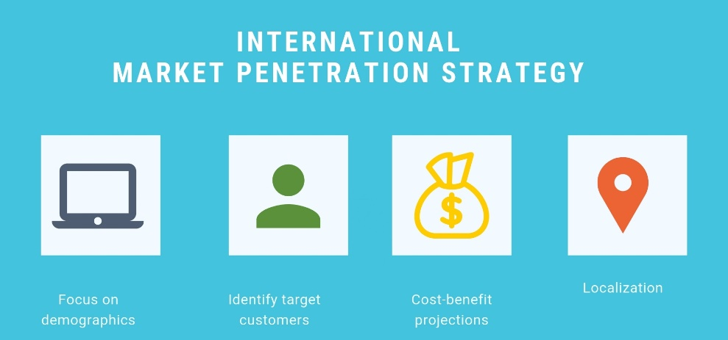
Figure 1: International marketing strategy
(Source: Labanauskaitė et al., 2020, p.1652)

Develop a set of actionable, realistic, measurable international marketing objectives

Objectives | Specific | Measurable | Actionable | Realistic | Timebound
Objective 1: Building relationships with customers and increasing customer loyalty. | The brand's primary purpose is to optimize customer perspective about the products. Company products need to build relationships with costumes. | Increasing 1000 plus monthly customers able to attract customers with the help of social media platforms. | It can be achievable with the help of different digital media platforms such as Twitter, Facebook, and Instagram as well as company websites. | Increasing number of followers on digital platforms and customer purchasing rate near about 500 plus products. | 1 year
Objective 2:  Creating a market leadership approach. | For brand expansion in the Indian market leaders can use a democratic leadership style where leaders need to make a decision based on the situation. | The leadership approach is beneficial for the brand which can be measurable by engaging 20000 plus customers in the first month (Choe et al., 2021, p.16). | Aligning company goals and mission altogether for maintaining a strong brand hold. | Tracking and evaluating entire progress. | 2nd year
Objective 3: Providing different/unique products compare to other competitors. | Providing differentiation products would help the brand target potential customers. | It can be measurable by increasing customer engagement toward the brand. | Providing quality products by maintaining the price of the product. | Competing with others and sustaining brand image in the market. | 3rd years

Product modifications

Marketing mix
Marketing mix refers to the tactics and strategies used by a company for promoting products and brands in the current market.
Product
Digital Kitchen is one of the best ways to give customers a good cooking experience and one of the high-quality products they can buy. The main goal of the company is to make people's lives easier and make cooking easier (Nambisan et al., 2019, p.1464). Digital Kitchen is a popular Irish brand that makes high-quality appliances like refrigerators, dishwashers, steam ovens, induction cookers, and many more. The main goal of the company is to provide customers with high-quality products that meet their needs. In the Indian market, people prefer to buy products that are both cheap and of good quality. Even though the prices of Digital Kitchen's products are a bit high, the products are of high quality. In the Indian market, it can be hard for the brand to stay ahead of the competition.
Price
Digital kitchen has a very large business portfolio that varies by industry. In the Indian market, the company has gone up against several rivals. For example, brands like Whirlpool, LG, Godrej, and many others already exist (Głodowska et al., 2019, p. 55). So, the brand needs to set prices that will make Indian customers want to buy their products. It's important to know what Indian customers want from a brand if you want to attract them. People are more worried about their finances and prefer to spend money on things they need. India has a lot of people, so it's good for the brand to do more business there. Also, the brand needs to have a simple pricing policy that doesn't change the quality of the product, even if it costs more than competitors. Customers in the Indian market are more likely to spend money on high-quality, premium products, even if they are hard to use.
Place
In the Irish market, which is different from the Indian market, Digital Kitchen has been able to keep a strong brand image. Indian customers talk about equipment that is easy to get to and that helps keep customers' perspectives. The brand can sell products in big cities, which raises brand awareness (Olson et al., 2018, p. 62). Before going into a foreign market, it's important to look at everything to learn about the culture and what will work for the business. The company sells products directly to customers through its websites. Wholesalers then sell the products to retailers all over the world. Lastly, get in touch with the end user to offer free installation and service. The company has a strong marketing plan that includes selling products to retailers and making sure that customers can easily get those products. Digital Kitchen also thinks about online sales and has a lot of employees working on its website. The brand works with multiple delivery service providers to make sure that products get to customers on time and that online business runs smoothly and efficiently.
Promotion
Digital kitchen promotes products and raises brand awareness through several different channels. The current social media platform is one of the best ways to get customers interested in your business. Along with more traditional ways to promote, such as through radio, print, TV, and sponsorships (Zahra, 2021, p.1143). A popular way to get the brand's name out there is to sponsor celebrities or digital influencers. In the Indian market, there is a lot of demand for discount cards and coupons, which is seen as part of a business strategy. So, giving discounts and coupons for the next purchase would be a good way for the brand to make it easy for customers to choose it.
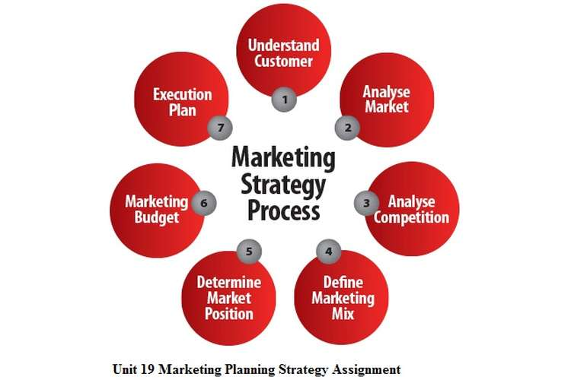
Figure 2: Marketing strategy
(Source: Zahra, 2021, p.1143)

Conclusion
Based on the research that has been done so far, it has been found that international marketing strategy is one of the complex factors that are hard to deal with. Brands need to follow some business strategies as they grow their business in the international market. So, this study has shown that different brands need to use different methods to run their businesses.

References
Acosta, A.S., Crespo, Á.H. and Agudo, J.C., 2018. Effect of market orientation, network capability and entrepreneurial orientation on international performance of small and medium enterprises (SMEs). International Business Review, 27(6), pp.1128-1140.
Amelia, S., Salamah, H. and Sofyan, M., 2019. Effect of Marketing Strategy and Service Quality Against the Decisions of Parents. Ilomata International Journal of Management, 1(1), pp.31-37.
Bocconcelli, R., Cioppi, M., Fortezza, F., Francioni, B., Pagano, A., Savelli, E. and Splendiani, S., 2018. SMEs and marketing: a systematic literature review. International Journal of Management Reviews, 20(2), pp.227-254.
Choe, J.Y., Kim, J.J. and Hwang, J., 2021. Innovative marketing strategies for the successful construction of drone food delivery services: Merging TAM with TPB. Journal of Travel & Tourism Marketing, 38(1), pp.16-30.
Falahat, M., Ramayah, T., Soto-Acosta, P. and Lee, Y.Y., 2020. SMEs internationalization: The role of product innovation, market intelligence, pricing and marketing communication capabilities as drivers of SMEs’ international performance. Technological Forecasting and Social Change, 152, p.1108.
Głodowska, A., Pera, B. and Wach, K., 2019. International strategy as the facilitator of the speed, scope, and scale of firms’ internationalization. Central European Management Journal, 27(3), pp.55-84.
Goh, H.C., 2021. Strategies for post-Covid-19 prospects of Sabah’s tourist market–Reactions to shocks caused by pandemic or reflection for sustainable tourism?. Research in Globalization, 3, p.1056.
Hult, G.T.M., Hair Jr, J.F., Proksch, D., Sarstedt, M., Pinkwart, A. and Ringle, C.M., 2018. Addressing endogeneity in international marketing applications of partial least squares structural equation modeling. Journal of International Marketing, 26(3), pp.1-21.
Kumar, A., Paul, J. and Unnithan, A.B., 2020. ‘Masstige’marketing: A review, synthesis and research agenda. Journal of Business Research, 113, pp.384-398.
Labanauskaitė, D., Fiore, M. and Stašys, R., 2020. Use of E-marketing tools as communication management in the tourism industry. Tourism Management Perspectives, 34, p.1652.
Lee, Y.Y. and Falahat, M., 2019. The impact of digitalization and resources on gaining competitive advantage in international markets: Mediating role of marketing, innovation and learning capabilities. Technology Innovation Management Review, 9(11).
Li, F., Larimo, J. and Leonidou, L.C., 2021. Social media marketing strategy: definition, conceptualization, taxonomy, validation, and future agenda. Journal of the Academy of Marketing Science, 49(1), pp.51-70.
Nambisan, S., Zahra, S.A. and Luo, Y., 2019. Global platforms and ecosystems: Implications for international business theories. Journal of International Business Studies, 50(9), pp.1464-1486.
Olson, E.M., Slater, S.F., Hult, G.T.M. and Olson, K.M., 2018. The application of human resource management policies within the marketing organization: The impact on business and marketing strategy implementation. Industrial Marketing Management, 69, pp.62-73.
Paul, J. and Mas, E., 2020. Toward a 7-P framework for international marketing. Journal of Strategic Marketing, 28(8), pp.681-701.
Sari, D.C., Apino, E., Setiawan, A., Hamid, A. and Rulyansah, A., 2022, January. The Economic In International Islamic Education Strategy Collaboration: A Rapid Review. In International Conference On Social, Economics, Business, And Education (Icsebe 2021) (pp. 25-28). Atlantis Press.
Sharma, P., Leung, T.Y., Kingshott, R.P., Davcik, N.S. and Cardinali, S., 2020. Managing uncertainty during a global pandemic: An international business perspective. Journal of business research, 116, pp.188-192.
Steenkamp, J.B.E., 2019. Global versus local consumer culture: Theory, measurement, and future research directions. Journal of International Marketing, 27(1), pp.1-19.
Tien, N.H., 2019. Comparative analysis of multidomestic strategy of P&G and Unilever Corporation. International journal of foreign trade and international business, 1(1), pp.5-8.
Wilkins, S. and Huisman, J., 2021. Institution strategy in transnational higher education: late entrants in mature markets–the case of international branch campuses in the United Arab Emirates. Studies in Higher Education, 46(4), pp.704-720.
Zahra, S.A., 2021. International entrepreneurship in the post Covid world. Journal of World Business, 56(1), p.1043.

