JIAYING HE
2208747
——An Analysis of International Business Communication for a UK Clothing Retailer Entering Asian Markets
Intercultural Communication and Culture

Executive Summary
Globalization has led companies to expand internationally, with Asia becoming a key market due to economic growth and increased international trade activity, attracting interest from sectors such as clothing retailing. Under this background, a UK clothing retailer plans to expand into Asia, but intercultural business communication can be challenging due to cultural differences. Thus, this report explores the theories and skills necessary to address these challenges, providing strategic recommendations for retailers to enter the Asian market.
Main findings highlight the importance of cultural understanding in business communication. To be specific, Asia's high-context culture prioritizes harmony and non-verbal cues, in contrast to the UK's low-context, task-focused approach. Key theories, such as Hall's contextual culture, Lewis's Model of Communication, and Trompenaars’ cultural dimensions, emphasize differences in communication styles and value orientations and further support the analysis of our situation. In terms of case support, success stories such as Starbucks' partnership with India's Tata Group strongly illustrate the importance of being in tune with local customs. However, from a critical perspective, theoretical frameworks like Trompenaars' model must be applied flexibly to avoid oversimplification and stereotyping. In addition to direct analysis and argument, failure occasions are also listed and explored, represented by Burberry's failure in China, which underscores the need to be sensitive to local power dynamics. These situations help our UK retailer to prevent possible international business communication failures in advance.
To ensure effective communication, the UK retailer must adapt its strategy to focus on building relationships, show patience when making decisions, and respect cultural differences. It is crucial to recognize challenges such as language barriers, cultural misunderstandings, and ethnocentrism. By adopting inclusive communication practices and developing cultural insights, retailers can build strong relationships with Asian partners and audiences, ultimately achieving their global expansion goals. This report provides actionable insights to support this effort, bridging the cultural gaps and promoting long-term success.

Table of Contents
Executive Summary 1
1. Introduction 4
2. Main Findings 5
2.1 International Business Communication 5
2.2 Methods of Communication 6
2.2.1 Hall’s High- and low-context cultures 7
2.3 Effective Communication 8
2.3.1 The Lewis Model of Cross-Cultural Communication (2018) 8
2.4 International Culture 10
2.4.1 Trompenaars’ 7 dimensions to culture 10
2.4.2 Critical Analysis 12
2.5 Failed Relationships 13
3. Conclusions 14
4. Recommendations 15
4.1 Develop cultural sensitivity 15
4.2 Apply Flexible business practices 15
4.3 Strengthen relationship-building 16
References 17
Appendices 24

- Introduction
As globalization continues to accelerate, more and more companies are choosing to expand their operations to other countries in order to broaden the audience for their products and tap into a wider product chain. Among all the regions, Asia grasps the attention of many enterprises for its influence across the global economy and its growing international trade affairs. According to Aggarwal and Bharadwaj (2024), many countries in Asia are expected to see significant GDP growth and rising commodity trading volumes. Specifically, China, despite its slower growth of 3%, still has around $5 trillion more GDP than in 2022; and the trade of the Association of Southeast Asian Nations (ASEAN) is also predicted to grow by $1.2 trillion in the coming decade. Undoubtedly, Asia has become a core competitive market areas for all international organizations. Among them, the global expansion of the clothing retail industry is a positive trend, represented by the success of the British clothing retailer NEXT, with overseas online sales growing by 21.9% (Darvey, J. 2024).
Under this background, a local clothing retailer in the UK plans to expand its business to Asia. During this process, potential challenges in terms of intercultural business communication will emerge as the existing cultural and social differences of these two regions (Hajar et al., 2023). Communication, as the core of most international business operations, plays a major role in the exchange of information, the establishment of relationships, and the negotiation of transactions (Szkudlarek et al., 2020). Thus, this report will present the theories and skills required in successful international business communication, highlighting both the effective strategies and potential failure during the Asian market entry. The goal is to help the clothing retailer build benign and solid relationships with Asian partners and audiences, finally achieving global expansion. Key theories and skills will be presented, assisted with targeting cases, and recommendations will also be given at the end of this report, in order to draw a clear picture of the useful takeaways.
- Main Findings
  - International Business Communication
With the continuous increase of international business contacts, the discussion of international business communication has gradually become a hot topic. The communication between different cultures profoundly affects the effectiveness and efficiency of business interaction (Aririguzoh, 2022). However, each culture has its own unique communication styles, which are not just differences in vocabulary or language structure, but also expressions, manners, and underlying values (Harris and Bargiela-Chiappini, 2020).
In our case, the two cultures involved are British culture and Asian culture respectively. In general, Asian culture is more indirect and hierarchical, focusing on harmony and relationship-building, while in Western culture, especially for our British clothing company, it is often believed that egalitarianism and innovation stimulation are emphasized more (Pampanini et al., 2024). The result-oriented working mode will make them more direct, requiring the strategy-shift when collaborating with Asian enterprises. In addition, the UK also differs from Asia in terms of how the apparel industry operates and the different aspects of product focus. This requires the UK retailer to manage diversity in cross-border business communications and also take into account the inherent cultural differences in the actual operation of the apparel and fashion sectors (Dsouza and Aubry, 2020). Understanding this difference is a positive point to attract the customer and cooperate with local companies more appropriately during the global expansion.
  - Methods of Communication
In the process of working with Asian companies, different dimensions and types of business communication will be involved. This could be divided into internal and external business communication (Simon and Simon, 2022). When connecting with Asian markets, B2B marketing is an effective way to introduce the business and products to potential partners, which falls into external business communication, like advertising, as the first step. After building initial collaboration intentions, more communication will be involved including written forms like email, reports, contracts; verbal ways like meeting, casual chats, presentations; and non-verbal forms like body language and social interactions (Järvi, 2023). In all of these communications, both parties go through a process of information encoding and decoding (Figure 1), so how senders and receivers process the information decides the effectiveness of business communication. Among this, the biggest factor is the cultural context and information processing mode of the two sides. The famous anthropologist Edward T. Hall (1976) exactly explained this by his theory of context cultures.
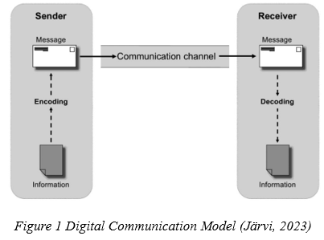
    - Hall’s High- and low-context cultures
Edward T. Hall (1976) introduces the theory of high- and low-context communication in his book “Beyond Culture”. He explains that in a high-context culture, most of the information is derived from the surrounding context or is internally understood, with less reliance on explicit wording. In contrast, low-context cultures place most meaning within the explicit, direct message itself (Cosman, 2021). Back to our target cultural communities, in Asian business environment, politeness and respect are highly emphasized. Thus, non-verbal cues like eye-contact, gestures and silence are extremely important, because they contain extra meaning outside the direct words (Alafnan, 2022).
Moreover, Asian businesses assume others know much about their cultural rituals, historical background, social conventions (Jackson, 2020). On the contrary, low-context cultures like our UK retailer, people tend to focus on the target task while some interpersonal details are ignored during this business process, so they may illustrate information directly in their verbal message (Ursu and Ciortescu, 2021). Because the emotive aspects are restrained, the intensity of politeness and passion seems lower and may be perceived as uncomfortable in Asians’ eyes. Therefore, in intercultural business communication, fostering a "sense of affiliation" among partners is vital to ensure understanding and goodwill. This shared sense of purpose helps individuals interpret unexpected behaviours like directness, loudness, or unusual eye contact as unintentional rather than offensive, which will help reduce potential threats to interpersonal harmony (Cosman, 2021).
  - Effective Communication
Effective international business communication is often the creative and inclusive transmission of information for different cultural groups under the premise of respecting differences (Braslauskas, 2020). Enterprises first need to align their value orientation with the target cultural market, and pass on their cooperation intention and efforts to Asian enterprises and consumers.
    - The Lewis Model of Cross-Cultural Communication (2018)
Starbucks' partnership with India's Tata Group is a good example of how Western companies expand into Asian markets (Mishra, 2020). As a large Western enterprise, Starbucks attaches great importance to goals and efficiency in global expansion, which is defined as Linear Active in the Lewis Model of Cross-Cultural Communication (Jaakkola, 2023), represented by task-orientation. India, on the other hand, places great emphasis on market cooperation, valuing relationship-building, harmony and consensus in decision-making. This is consistent with both Multi-Active Cultures and Reactive Cultures in the Lewis Model.
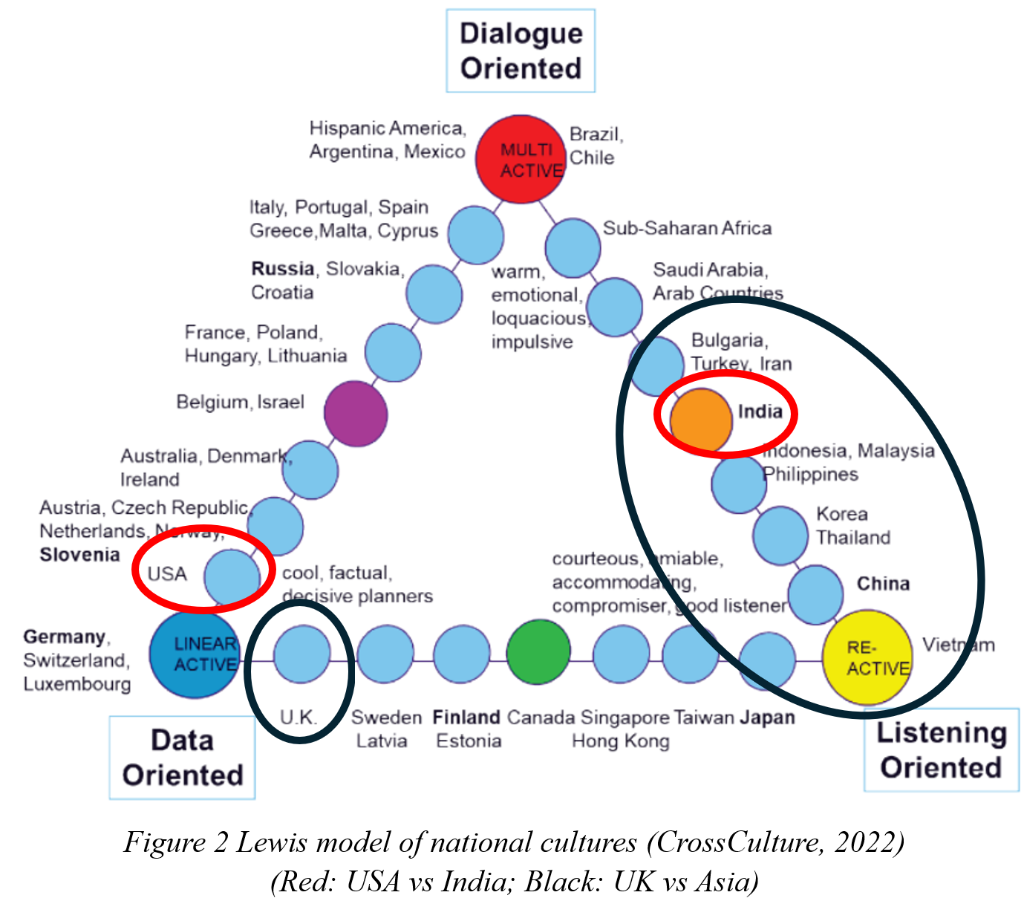
Recognizing the flexible and relationship-driven business culture in India, Starbucks collaborated closely with Tata to make context-sensitive decisions. This included selecting product offerings that catered to Indian tastes and adjusting operational strategies to fit India’s multi-active style, showing respect for local culture and preferences (Siddhartha, 2024). Starbucks CEO Howard Schultz has expressed deep admiration for industrialist Ratan Tata, particularly for his grace and wisdom, and was particularly moved by Tata’s remarks during the opening of Starbucks’ first store in India in 2012. He even authored an essay titled "Reimagining INDIA: Unlocking The Potential of Asia’s Next Superpower", promoting India’s emerging potential (HT News Desk, 2024). All of these reflect Starbucks' emphasis on relationship building, as well as its deep understanding and practice of re- and multi-active Asian culture. The success of the Asian market entry is also the best proof of the effectiveness of this strategy and a reference to our situation.
  - International Culture
    - Trompenaars’ 7 dimensions to culture
In order to have a deeper understanding of the importance of international culture in business communication, more theoretical analysis should be introduced into the possible interactions to come. Based on this, the most powerful framework comes from Trompenaars’ Cultural Dimensions, which details 7 aspects of international cultural differences (Woolliams and Trompenaars, 2024). By analysing these differences and distinguishing the features of British culture and Asian culture under this theory, we can more clearly know how to respect and accommodate each other's perspectives in business communication.
Combined with the work of Qi and Ling (2020) on connecting 7 dimensions with different elements in business, clearer guidance on cross-cultural business communication will be produced (Figure 3).
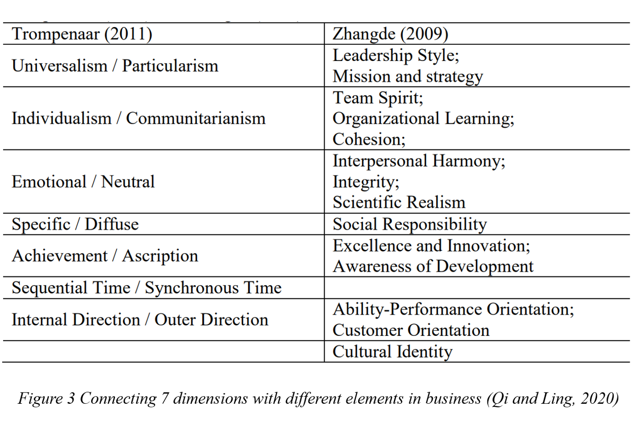
The first dimension is Universalism vs Particularism. As the represents of Universalism, the UK culture tends to emphasize rules and general standards, often viewing them as universally applicable. While in Asia, flexibility and situational contexts are often emphasized over strict rules (Horn et al., 2021). According to Qi and Ling (2020), this has a deep link with the leadership style and strategy during business process, which can affect the organization’s directions. Therefore, although agreements and contracts are upheld consistently in UK market, more flexibility and alternatives should be considered when connecting with Asia companies, especially in setting terms.
Another dimension is Individualism and Communitarianism. While the UK emphasizes personal achievement and autonomy, Asian cultures prioritize group goals and community (Fahmi, 2024). Thus, the degree of team spirit and cohesion is higher in Asian organizations. To effectively navigate Asian markets, our UK retailer should focus more on relationship-building and set a common goal specifying the collective interest, in order to encourage motivation and maintain harmony. Specifically, decision-making may take longer in Communitarian contexts due to the emphasis on group consensus. The UK clothing retailer should be prepared for extended discussions and show patience during this process, valuing collective input over individual assertions (Lill, 2019).
Additionally, we should spend more time to consolidate relations through private events with important people of target Asian organizations, because Asian culture is Diffuse with public and private space (Magnier-Watanabe, 2020). Breaking through the Specific mode and stepping into their private life will help build trust and deep relationships, which seems unusual in UK markets. Other dimensions are equally important like aspects related to time concepts requiring Sequential UK companies adapting to Asian Synchronous approach for multi-tasking; the awareness of status linked with Achievement and Ascription; and the opposite direction of controlling outcomes (Sattorovich, 2020). Due to the word limits, not all of them will be specifically presented, but key skills should be learnt during the real communications assisted with these theories.
    - Critical Analysis
Trompenaar’s Cultural Dimensions framework offers a nuanced approach to understanding cultural diversity in global business contexts. However, some limitations may exist, so we should view this from a critical perspective (Dearin, 2024). First, this theory presents culture in binary terms, which can oversimplify cultural nuances, potentially leading to stereotyping, because culture is often more fluid and less easily categorized than these dimensions imply (Acemoglu and Robinson, 2021). Additionally, it focuses more on national culture over organizational culture. The different organizations within a country or region can vary a lot, and can be influenced by specific industry characteristics. For example, in our clothing industries, more concepts related to fashion will be introduced, which could lead to a bolder and opener mode of business communication within Asia companies (Amalanathan and Reddy-Best, 2024). This could be the variables of rigid application of Trompenaars’ theory. Therefore, in real cross-cultural communications, more flexible strategies should be considered to adapt to different specific situations.
  - Failed Relationships
Even with theoretical and research support, possible failures may also occur in actual business communication scenarios. This could of course be caused by language barriers, where differences in proficiency and interpretation can create misunderstandings (Magnani and Gioia, 2023). Miscommunication over terms, product specifications, or marketing strategies can often be influenced by this factor, which needs more checks and proofreading.
Cultural misunderstanding is another key obstacle. Inherent cultural differences as well as diverse business etiquette and practices may hinder smooth communication despite comprehensive understanding. A typical case is Burberry's missteps in the Chinese market, especially its ineffective partnership with local companies (Zhu, 2023). In China, high-status local celebrities are key to expand brand awareness, but Burberry did not agree on famous ambassadors when working with Chinese companies, which underestimated the importance of such influencers and failed to build the kind of "face" (reputation and respect) that is crucial in Chinese culture (Luo, 2023). This is caused by insensitivity to hierarchy and power in Asia and needs us to avoid.
Failed Relationships can also be caused by ethnocentrism. When businesspeople assume that their own cultural norms are superior or standard, it can lead to problems in adapting to the local culture, which can hinder relationship-building and negotiation success (Braslauskas, 2020). In the universal sense, each of us is ethnocentric to some degree (Aithor, 2024). What we have to do is pay attention to and try our best to avoid this potential tendency, so as to maintain smooth international cooperation.
- Conclusions
In conclusion, the process of expanding a UK clothing retailer into the Asian market presents both opportunities and challenges, which require a deep understanding of cross-cultural business communication. The report's findings highlight the importance of recognising cultural differences, such as the contrast between the direct and results-oriented communication style of the British and the more indirect and structured communication style of the Asians. To cope with these differences, businesses must adapt their communication styles and align their strategies with local values and cultural norms. This includes understanding the role of context in communication, as demonstrated by Edward Hall's theory of high-context and low-context culture, and applying Trompenaars’ 7-dimensional framework to guide interactions.
However, despite theoretical understanding, real-world challenges such as language barriers, cultural misunderstandings, and ethnocentrism can still lead to failure if not handled carefully. The success of Starbucks in India and the failure of Burberry in China illustrate the importance of cultural awareness. Therefore, businesses must keep an open mind, adjust their communication strategies and constantly learn from their experiences to ensure long-term success in the international market.
In conclusion, the ability to communicate effectively across cultures is key to building strong business relationships, facilitating global expansion and ensuring sustainable growth in the Asian market.
- Recommendations
Based on the above analysis, this report also puts forward corresponding suggestions for UK clothing retailers to enter the Asian market to provide inspiration.
  - Develop cultural sensitivity
- Cultural Training Program: The UK company should conduct cultural sensitivity training for employees in different Asian markets, such as "Guanxi culture" in China and "harmony culture" in Japan (Kahandawa, 2021). Training can include analysis of business mode, cultural taboos and regional fashion trends to promote awareness and respect for local culture.
- Build a Local Team: They can hire culturally familiar consultants or work directly with local teams to participate in strategy development and consumer research. The multi-team structure ensures that the decision-making process reflects the real needs of local consumers (Lastro and Schuster, 2024), like partnering with local e-commerce platforms such as Shopee in Southeast Asia and adapting your strategy with their insights (Tsang, 2024).
  - Apply Flexible business practices
  - Relationship-Driven Negotiation Strategies: For Asia business partnerships who emphasize relationships, tough contract terms should be avoided but highlight the long-term value of the partnership (Holt, 2023), such as offering flexible payback policies and plans to jointly develop products to build trust.
  - Respect the Collective Decision-Making: In many Asian markets, decisions are often made collectively rather than quickly by individuals (Guo et al., 2022). Companies should give their partners more time and avoid pushing too hard, supporting a long-term planning of win-win cooperation.
  - Strengthen relationship-building
- Private Interactions and Activities: Host high-level networking dinners or local festivals, invite key partners, and use private occasions to build deeper connections (Allen et al., 2022). For instance, "Mid-Autumn Festival special gift box" can be presented to important partners to express the importance of the relationship.
- Corporate Social Responsibility (CSR) Projects: Because of Asia's collectivist values, supporting sustainable fashion, environmental projects or community development can win the buy-in of consumers and partners. For example, donating part of the income to support local education or conservation projects will be beneficial to leave a positive reputation in Asian market (Wang et al., 2021).
Through these strategies, cultural resilience and brand influence will be established in Asian markets, promoting the long-term development of the business.

References
Acemoglu, D., and Robinson, J. A. (2021). Culture, institutions and social equilibria: A framework (No. w28832). National Bureau of Economic Research.
Aggarwal, N. and Bharadwaj, A. (2024) Connecting the dots behind current and future Asian growth, World Economic Forum. Available at: https://www.weforum.org/stories/2024/06/why-asia-s-time-is-now-whats-fueling-asian-growth-and-what-does-it-mean-for-the-rest-of-the-world/ (Accessed: 07 November 2024).
Aithor (2024) Effects of ethnocentrism essay, aithor.com. Available at: https://aithor.com/essay-examples/effects-of-ethnocentrism-essay (Accessed: 15 November 2024).
Alafnan, M. A. (2022). Politeness as a nonverbal communication Behavior: An investigation into driving habits in Asia. Studies in Media and Communication, 10(1), pp.112-123.
Allen, J., Harris, R., and Jago, L. (2022). Festival and special event management. John Wiley and Sons.
Amalanathan, S., and Reddy-Best, K. L. (2024). Modesty in business, bold in fashion: entrepreneurial experiences of US Muslim women in niche fashion markets. Journal of Innovation and Entrepreneurship, 13(1), p. 57.
Aririguzoh, S. (2022). Communication competencies, culture and SDGs: effective processes to cross-cultural communication. Humanities and Social Sciences Communications, 9(1), pp. 1-11.
Braslauskas, J. (2020). Effective creative intercultural communication in the context of business interaction: theoretical and practical aspects. Creativity studies, 13(1), pp. 199-215.
Cosman, O. (2021). CULTURAL DIFFERENCES IN BUSINESS COMMUNICATION. USV Annals of Economics and Public Administration, 21(33), pp. 78–87.
CrossCulture (2022). Know Culture for Better Business. Richard Lewis Communications. Available at: https://www.crossculture.com/ (Accessed: 14 November 2024).
Darvey, J. (2024) Overseas expansion paying off for UK clothing retailer next | reuters, Overseas expansion paying off for UK clothing retailer Next. Available at: https://www.reuters.com/business/retail-consumer/next-raises-profit-outlook-after-quarterly-sales-beat-expectations-2024-08-01/ (Accessed: 10 November 2024).
Dayan, M., and Ndubisi, N. (2020). B2B service innovation and global industrial service management. Industrial Marketing Management, 89, pp. 140-142.
Dearin, C. (2024) Five top tips on creating trust in International Business, Dearin and Associates. Available at: https://dearinassociates.com/five-top-tips-on-creating-trust-in-international-business/ (Accessed: 12 November 2024).
Dsouza, R and Aubry, M (2020) Cross-Cultural Global Fashion Business, International Journal of Science and Research (IJSR), 10(5), pp. 813-819. DOI: 10.21275/SR21519100836.
Fahmi, R., Ramdhani, H., Latuconsina, H., and Lesmana, S. J. (2024). Corporate Social Responsibility: Environmental Concern Through the Application of Communitarian Citizenship Thinking. In Forum Ilmu Sosial (Vol. 51, No. 1).
Gao, Y. (2024). Differences Between Chinese and Western Educational Models Based on the High-Low Context Culture Theory. Journal of Education, Humanities and Social Sciences, 32, pp. 119-123.
Guo, W., Chen, X. R., and Liu, H. C. (2022). Decision-Making under Uncertainty: How Easterners and Westerners Think Differently. Behavioral sciences (Basel, Switzerland), 12(4), p. 92. https://doi.org/10.3390/bs12040092
Hajar, E. H., Omar, T., Bilal, E. A., and Khaoula, S. (2023). An Assessment of Ethics in a Cross-Cultural Organizational Context: A Systematic Literature Review. International Journal of Organizational Leadership, 12(4).
Hall, E. T. (1976). Beyond culture. Garden City.
Harris, S. and Bargiela-Chiappini, F. (2020) ‘The languages of business: Introduction and overview’, in F. Bargiela-Chiappini and S. Harris (eds.) The Languages of Business: An International Perspective. Edinburgh University Press, pp. 1–18.
Holt, M. (2023) Successful partner search in Asia, Asian Insiders. Available at: https://asianinsiders.com/2023/07/19/a-successful-partner-search-in-asia-is-crucial-to-enter-the-market-effectively/ (Accessed: 15 November 2024).
Horn, S., Sekiguchi, T., and Weiss, M. (2021). Thrown off track? Adjustments of Asian business to shock events. Asian Business and Management, 20(4), pp. 435-455.
HT News Desk (2024) How ratan tata once moved Starbucks founder Howard Schultz to tears: ‘so much wisdom and insight’, Hindustan Times. Available at: https://www.hindustantimes.com/business/how-ratan-tata-once-moved-starbucks-founder-howard-schultz-to-tears-so-much-wisdom-and-insight-101728543166486.html (Accessed: 14 November 2024).
Jaakkola, H. (2023). How to manage cultural differences?, Tampere University Research Portal, Information and Communication Technology.
Jackson, J. (2020), Introducing Language and Intercultural Communication, London: Routledge.
Järvi, A. (2023). Internal and External Communication and Communication Issues in Multilingual Organizations. p. 13.
Kahandawa, P. (2021). International Business Management in Asian Countries: Different Strategies and Relationship Marketing. Available at SSRN 3987885.
Lastro, T., and Schuster, S. (2024). Cross-team Decision-making: Challenges and Improvements in Large-scale Agile Organizations.
Lewis, R. (2018). When cultures collide: Leading across cultures. Hachette UK.
Lill, D. (2019) A guide to business etiquette in Asia: Talk business, Talk Business | Entrepreneur and Business Advice. Available at: https://www.talk-business.co.uk/2019/08/23/a-guide-to-business-etiquette-in-asia/ (Accessed: 14 November 2024).
Luo, Y. (2023) The culture of ‘face’ in China, identity recognition, and luxury consumption, LinkedIn. Available at: https://www.linkedin.com/pulse/culture-face-china-identity-recognition-luxury-consumption-yuyu-luo/ (Accessed: 15 November 2024).
Magnani, G., and Gioia, D. (2023). Using the Gioia Methodology in international business and entrepreneurship research. International Business Review, 32(2), 102097.
Magnier-Watanabe, R., Uchida, T., Orsini, P., and Benton, C. F. (2020). Organizational virtuousness, subjective well-being, and job performance: Comparing employees in France and Japan. Asia-Pacific journal of business administration, 12(2), pp. 115-138.
Mishra, S. (2020) How Starbucks made an alliance with Tata for the indian market?, Medium. Available at: https://sanketmishra24.medium.com/how-starbucks-made-an-alliance-with-tata-for-the-indian-market-6d84ec0c1aae (Accessed: 10 November 2024).
Pampanini, S. et al. (2024) Bridging cultural differences: Asian-western collaboration in the Workplace, DiverseJobsMatter. Available at: https://diversejobsmatter.co.uk/blog/bridging-cultural-differences-asian-western-collaboration-in-the-workplace/ (Accessed: 08 November 2024).
Qi, J. C., and Ling, L. K. (2020). A Review on Western and Chinese Organization Culture: Similarities and Differences. Inti Journal, 2019.
Sattorovich, J. U. (2020). Intercultural difference parameters: Hofstede and Trompenaars theories. European Journal of Research and Reflection in Educational Sciences, 8(11), pp. 115-124.
Shaw, J. (2024) From west to east: Unravelling the secrets of market entry into Asia., Kadence. Available at: https://kadence.com/from-west-to-east-unraveling-the-secrets-of-market-entry-into-asia/ (Accessed: 05 November 2024).
Siddhartha, S. (2024). Starbucks Market Entry Plan to India. International Journal of Innovative Science and Research Technology (IJISRT).
SIMON and SIMON (2022) The Complete Guide to International Business Communication, SIMON and SIMON. Available at: https://www.simonandsimon.co.uk/blog/the-complete-guide-to-international-business-communication (Accessed: 08 November 2024).
Szkudlarek, B. et al. (2020) ‘Communication and culture in international business – moving the field forward’, Journal of World Business, 55(6), p. 101126. doi:10.1016/j.jwb.2020.101126.
Tsang, B. (2024) How to start selling to Southeast Asia shoppers on e-commerce platforms, RSS. Available at: https://choco-up.com/blog/selling-southeast-asian-platforms (Accessed: 15 November 2024).
Ursu, O. and Ciortescu, E. (2021) ‘Exploring Cultural Patterns in Business Communication. Insights from Europe and Asia’, CES working papers, XIII(2), pp. 149–158.
Wang, H., Jia, M., and Zhang, Z. (2021). Good deeds done in silence: Stakeholder management and quiet giving by Chinese firms. Organization Science, 32(3), pp. 649-674.
Woolliams, P., and Trompenaars, F. (2024). Cultural Differences. In New Approaches to Flexible Working. Emerald Publishing Limited, pp. 59-67.
Zhu, Y. (2023). Exploring Burberry’s Consumer Boycott: A Cross Cultural Comparison of the UK and China. Academic Journal of Business and Management, 5(4), pp. 30-36.

Appendices
Figure 1 Digital Communication Model (Järvi, 2023) 7
Figure 2 Lewis Model of National Cultures (CrossCulture, 2022) 9
Figure 3 Connecting 7 Dimensions with Different Elements in Business (Qi and Ling, 2020) 10

