A comparison of Unreal Engine 4 and Unity in regards to shader system accessibility and fidelity for an experienced Unreal Engine 4 user.



Joel David Gray-P143919-
Game Design and Critical Analysis [M6X02045]
Paper submitted to the University of Trinity Saint David as a requirement of the BA Creative Computer Games Design degree.

Declaration:
I, Joel David Gray hereby declare that the work within this academic document has been wholly created by myself for the degree of: BA Creative Computer Games Design. This academically purposed document has not been submitted whole or in part to any other university, degree, course, association or recognised background. External information and sources have been acknowledged in both the ‘References’ and ‘Bibliography’ section of this document with their authors/creators accurately credited, their work not created by myself, complementary to this document.

Name: Joel David Gray
Signed:
Date: 07/12/2017

Abstract:
Documented academic knowledge comparing the shader systems of Unreal Engine 4 and Unity is inaccessible or does not exist. The test was planned to outline which engines shader system was more accessible and test the respective engines shader fidelity, as an experienced Unreal Engine 4 user attempted to use Unity shader system. The test subject was given the default engine(s) editor screen with all required asset loaded in but without shaders applied, they were timed in their creation of one simple shader to test accessibility and one complex shader to test fidelity. A survey would be circulated to correlate opinions on Unreal Engine 4 and Unity shader systems to draw correlations with the test data.
The results show that though the interfaces are named differently in both game Engines, both share similar layouts allowing the user to transition. The greatest impact on the time was Unity having a default set up shader that in terms of accessibility it makes Unity better and is accessible to users used to Unreal Engine 4. The subject also struggled most with Unity’s Cg shader scripting language failing to finish that section of the test, as Unreal Engine 4 uses a node based scripting system the subject struggled with syntax and the specifics of the Cg language, showing a difficultly in transitioning when editing the shader script.
Due to the structure of the test, the complex shaders did not test fidelity as the results only reflected the user’s current knowledge of each game engine, not how well they can each be used. The survey was not circulated as opinions collected would simply be opinions of existing developers on a credible analysis of the two engines. This leaves room for further work by testing more people to draw more accurate comparatives, and testing fidelity with a different testing method.
Contents:

Cover Page Page: 1

Declaration Page: 2

Abstract Page: 3

Contents Page: 4

Introduction Page: 5

Literature Review Page: 6

Methodology Page: 7,8

Results Page: 9,10,11,12

Analysis Page: 13,14,15,16

Conclusion Page: 17

Further Work Page: 18

References Page: 19

Bibliography Page: 20

Appendices Page: 21,22,23,24,25
Introduction:

The current documented knowledge comparatives of the game engines is largely sparse and un-academic, Unity does have some achieved data on its usability and features, however these articles have information relevant to the version of Unity that was new at the time of the articles creation. Information about the Unreal Engine 4 is sparse still because it is a newer engine that’s community has not archived much information on the shader systems accessibility and fidelity, only on how to use it. Data on comparisons between the two engines are mostly heavily opinionated blogs on what the developer writing the article prefers to use. This is a huge gap in research that this study wished to address so that better more academically founded comparative analysis between the game engines can be made.
Within this document, the literature review will discuss key terminology and background knowledge required to understand the topics discussed in this paper. The way the test would have been approached is underlined in the methodology, followed by the results of the test in the results section. The results will be analysed in the analysis section covering topics such as the user interface and accessibility, the following conclusion will summarise the project and further work discussed afterwards. References will contain information on work directly referenced in this report, the bibliography will contain external works used to influence this report yet not directly mentioned. The Appendix will contain extra information briefly covered in the report, as well the documentation of the test such as the test diary.

Literature Review:

Game Engine:
A game engine is a tool that in its simplest definition allows the development of computer games, and runs the games when they are completed. Many core elements are provided by a game engine to a developer, each element a complex system such as (but not limited to); Lighting, Collision Detection, Rendering and shaders, the focus of this topic.
The two engines that are having their shader systems compared are Unreal Engine 4, an Engine that’s base version was released in 2014 and updated regularly, and the Unity engine that was originally released in 2005 and updated with many versions since. The versions used in this paper are Unreal Engine 4.17.2 and Unity 2017.2.
Shader:
A shader manipulates how the game world is perceived, producing the desired colour, reflections, lighting and other visual effects seen by the player on the screen. Assets inherited from a shader that use their scripting are instances, these instances can have their parameters changed without recompiling the scripting.
It should be noted that the different shader systems have different terminologies for the same features such as Unity’s “Materials” functioning the same as Unreal Engine’s “Material Instances”, and Unity’s “Shaders” being equal to Unreal Engine’s “Materials”.
Model/Textures:
Models in a game engine are three dimensional shapes made from polygons that are effected by simulated lighting and can be morphed.
A texture is an image file that is wrapped around a three dimensional in game rendered model often conveying, colour, roughness, shadow, metallic and emissive values.
User Interface:
The ‘user interface’ of the engines refers to the computer inputs and options displayed on the screen related to the programme, that the user uses to complete tasks in the programme.
Accessibility:
The accessibility of using the shader system in each engine refers how easy the system is to use for those new to it.
Fidelity:
The fidelity of the shader systems means how well the systems can be used to accomplish more complex tasks such as those shown in the test.
Methodology:
Academic Comparative.
The test subject must firstly state their current understanding of both Unity and Unreal Engine 4 shaders in a multiple choice questionnaire [Appendix 1], this will be for data categorisation and to take into account potential bias in the subject’s subjectivity on the subject.
The test will see how quickly the subject can create and apply two different shaders to two models in both Unreal Engine 4 and Unity to see what shader system is more time efficient to use. The first shader is a simple Metallic/Roughness/Diffuse with Normal map, while the second is a more complex shader that needs two Normal Textures overlaid and panning in different speeds with a Diffuse colour Non-Texture. If a shader is not completed within forty minutes, the test for that shader is ended.
The official engine help pages are provided for the subject to research on how to complete a task if needed. It will be noted if the subject used the documentation and what it was used to search for.
The test subject will be presented with a Unity/Unreal Engine 4 application opened to its default editor screen with a series of texture/mesh assets in the asset toolbars. In the level scene are two pre made static mesh assets with default shaders that need to have new shaders applied. Video recording starts when the subjects start their work to accomplish the two specific tasks in the Game Engines so that their work is documented timings can be taken for each of the tasks to be completed. The subject is allowed to give up on a task when they want. When the tasks have been completed (the test subjects shader, matches the look previously shown) or the individual gives up on the last task, the test subject will be given an ending questionnaire asking what game engine they prefer (Unreal/Unity) and an open question asking about the difficulties and benefits of each engine [Appendix 2]. The subject will provide an in depth analysis of both engines found in the analysis section of this report.

Criteria of task completion:
Asset Simple= SteelBeamMesh (Team Red Sofa, 2015)
The shader must use the provided textures for the asset:
-SteelBeamBaseTex as a Diffuse. (Giving the asset its colour)
-SteelBeamMRTex as a Metallic/Roughness [Unreal Only]. (Giving the asset reflectiveness and a metallic look)
-SteelBeamMSTex as a Metallic/Smoothness [Unity Only]. (Giving the asset reflectiveness and a metallic look)
-SteelBeamNormalTex as a NormalMap. (Giving the asset shadows on the mesh)
[When the three textures are applied to the mesh in the correct manner the task is completed.]
Asset Complex= WaterfallMesh (Joel Gray, 2017)
The shader must use the provided textures for the asset:
-WaterfallNormalTex as a NormalMap. (Giving the asset shadows on the mesh)
The Shader must also:
-Have a ‘blue’ diffuse colour without using a texture file.
-Have one two moving NormalMap layers moving vertically down the waterfall, each at a different speed.
[When the shader is applied to the mesh, has the correct colour and the normals are moving down the mesh at different speeds, the task is completed.]

Surveying Developers Correlation:
A potential online questionnaire should be circulated to various online developer groups, the questionnaire will have questions querying the individual’s experiences with the shades system in both Unity and Unreal Engine 4 to see if the data correlates with what the individual(s) have experienced in the Academic Comparative. Firstly a question will be asked on the individual’s skill level in each of the game engines categorising the results into categories of the users perceived skill in the specific engine and what shader system an individual prefers to use and why. This data can be used correlate data sets potentially showing that, for example, individuals that have experience with both engines at a basic level prefer ‘engine x’. Questions such as ‘What is your preferred Game Engine’ would be multiple choice to easily categorise the data. Other questions may be open ended, such as what aspect of the individual engines the user preferred.
Results:
[Unreal Engine 4] User Interface presented to the test subject.
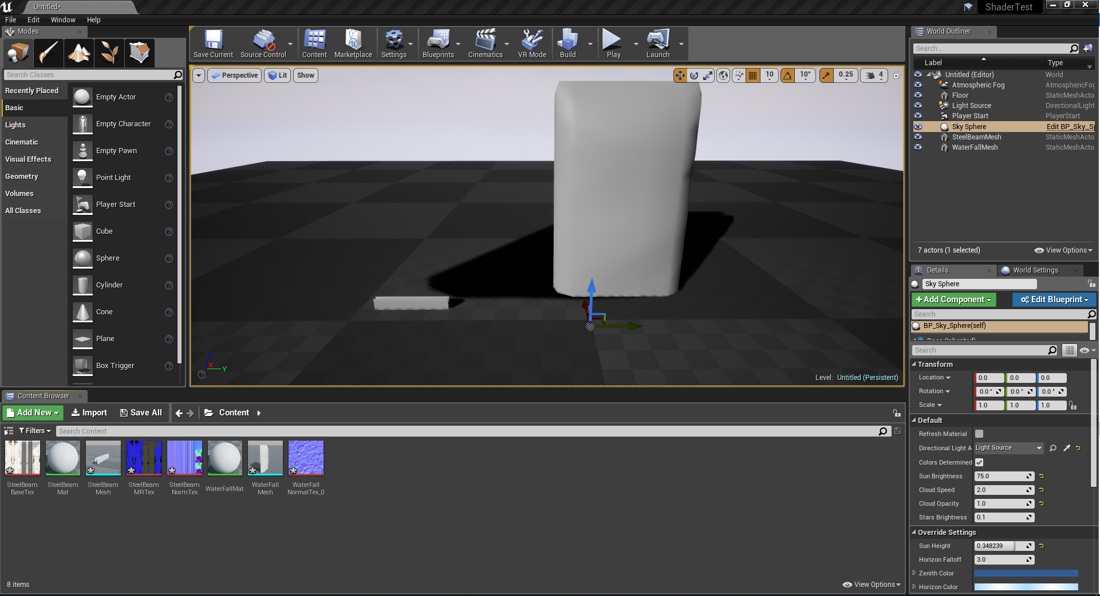

[Unity] User Interface presented to the test subject.
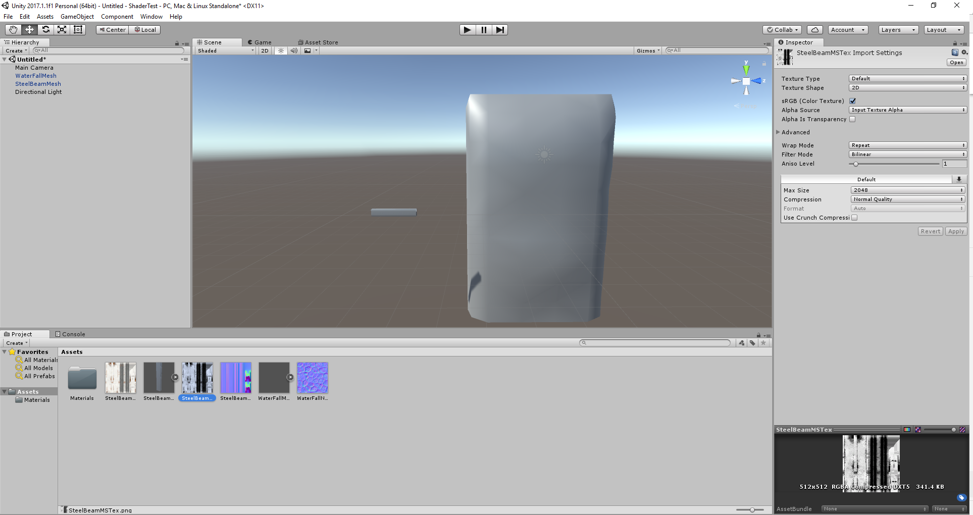

Pre-Test questionnaire results of primary subject:

Familiarity with Unreal Engine 4 Shaders:
None, Novice, Intermediate, Experienced
Familiarity with Unity Shaders:
None, Novice, Intermediate, Experienced
Time spent with Unreal Engine 4 Shaders (Total estimate):
Hours, Days, Weeks, Months
Time spent with Unity Shaders (Total estimate):
Hours, Days, Weeks, Months

Test results of subject:
 | Simple shader time: | Complex shader time:
Unreal Engine 4: | 00:00:55 | 00:00:33
Unity: | 00:04:22 | DNF- Test time expired.
Developer survey was not circulated as a part of this test.

[Unreal Engine 4] Post-test visual result.
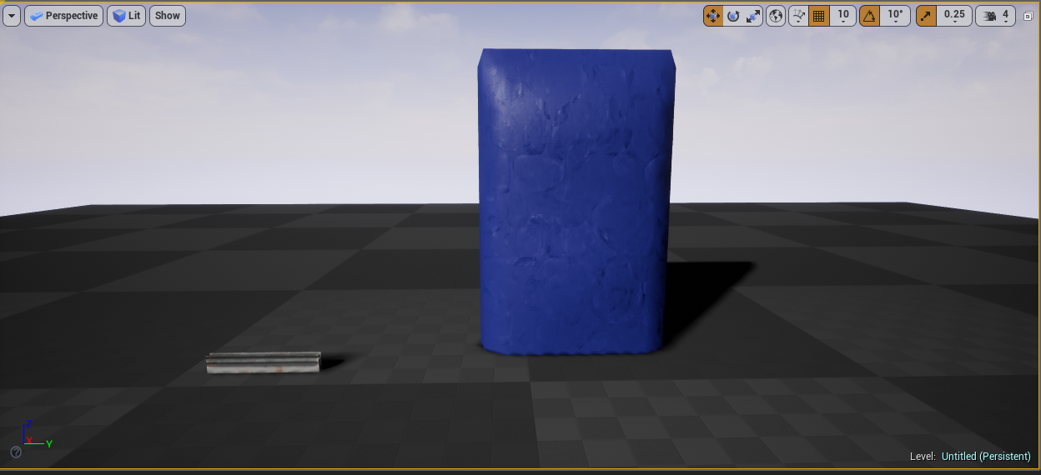
[Unity] Post-test visual result.
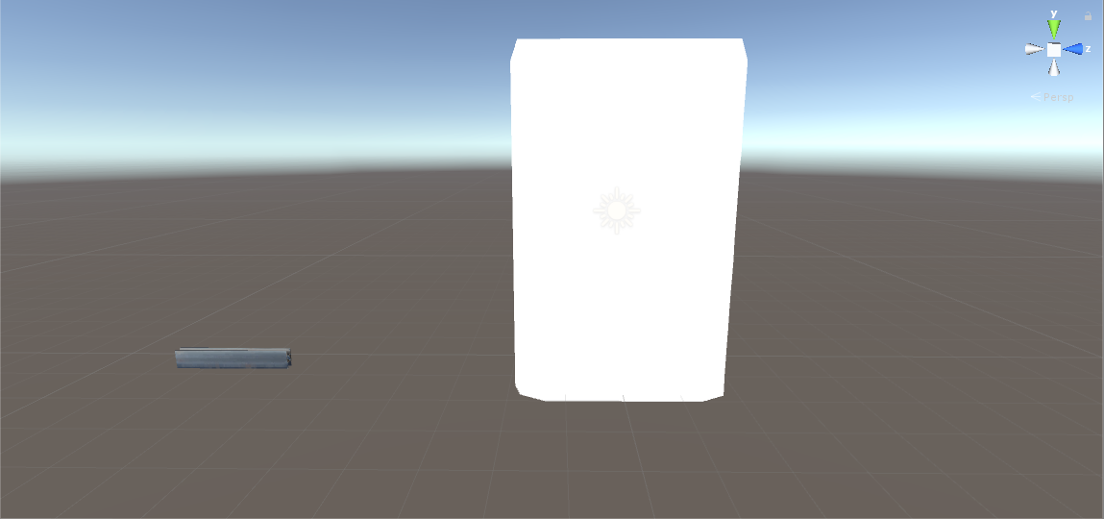

Post-Test questionnaire results of primary subject:

Simple Asset Unreal Engine 4: (0, 55)
Complex Asset Unreal Engine 4: (4, 22)
Simple Asset Unity: (33)
Complex Asset Unreal Engine 4: (-, -)
External Reasons of influence/delay: (Open Question) (Potential time effect)
-No external reasons for delay-
Internet usage:- Null
Unity Complex- Research into: Panning Textures, Adding Normal Textures into Shader, Purple Error colour/Syntax errors.
Unreal Engine 4 Shader Preferences: Node based shader system is fast to use and easy to set up, no need to worry with syntax errors.
Unity Engine Shader Preferences: Default shaders are very fast and easy to set up with almost no loading time.
Unreal Engine 4 Shader Dislikes: With complex tasks the node interface can become cluttered. Setting are often hidden on nodes that only show up when the node is clicked.
Unity Engine Shader Dislikes: Trying to complete complex tasks in a shader is made tougher because of the syntax needed to complete the tasks. Simple features in a new custom shaders like normal maps are absent.
Preferred Shader system: Unreal Engine 4
In the test, unnecessary components that may have distracted the user were removed. In Unreal Engine 4 this was the ‘Player Start’ actor, in Unity the ‘Camera’ actor was removed, this was to prevent any external influence on the test.
Analysis:
Interface
Both engines show a modular interface with smaller windows for specific engine functions, these windows can determine how accessible an engine initially is for new users.
Unreal Engine 4’s Level viewport and Unity’s #Scene Window are both referred in this text as the level window, both sharing the same function of showing with a live render what is in the users current game level/scene contains.
Assets within both of the level widows can be clicked and Unreal Engine 4’s Details and Unity’s Inspector panel will display the attributes of the asset including its currently selected Material/Material Instance/shader. As both of these level viewports are similar in regards to the shader systems accessibility, it can be determined that the level windows being so similar have no effect in regards to the accessibility when a user would transfer from Unreal Engine 4 to Unity. The user in the test would click an asset and identify the attributes window and apply the material, or simply click and drag the shader from the Asset window onto the asset in the level window to apply it, a function both engines share suggesting that this would have little impact on a user moving from Unreal Engine 4 to Unity.
Unreal Engine 4’s Content Browser and Unity’s project Window both show all assets in a folder sorting system that the user has control of. When one of these assets in the asset window is clicked, Unity only will display the details of the asset in its ‘Inspector’ tab. While Unreal Engine 4 has to open a new editor window taking a very short loading time, and time saving changes made to the asset, this also means that if the user is using one screen, their Level viewport is obscured or the windows shrunk becoming less efficient to use. Having the details of a shader instance displayed next to the material in the level allows the user to make fast changes and is preferable to the window management presented by Unreal Engine 4.
Unity’s Materials display their settings, such as texture channels, and what shader it class it is inheriting from. As the textures can be applied to the engine provided default ‘Standard’ shader from the ‘Inspector’ tab without loading a new window and their results can be seen instantly next to the ‘#Scene’ window. Being able to see immediately in the scene the result of the shader without having to create new content is a large contributor to the shorter time taken to apply the textures to the simple shader/asset as Unity’s default Material only requires the textures to be changed in the ‘Inspector’ tab to meet the criteria. This is why the time is far shorter even when the subjects stated familiarity with Unity was ‘Novice’, this would suggest that Unity’s shader system is more accessible to novices that have a generalised understanding of engine shaders.
Unreal Engine will only display a brief overview of the assets attributes such as ‘file path’, ‘size’ and ‘blend mode’. To open up and edit an asset such as a material it has to be double clicked and loaded into a new material editor window. While this can allow for multiple materials to be edited at the same time in different windows, the asset cannot be viewed in the scene without having multiple monitors, the asset can be viewed by clicking the asset in the ‘Content Browser’ then going back to the material editor window and clicking the teapot icon in the material window viewport. To apply the textures to an asset it has to be compiles taking considerable time, the default Material created for the Unreal Engine 4 is a Material Instance in Unity, so a Shader has to be made even for simple assets whereas one exits in Unity by default. Saving these ‘Materials’ can take a considerable amount of time depending on the complexity of the Shader. The subject had an ‘intermediate’ understanding of how Shaders worked in the Unreal Engine 4, but due to the engine defaults had to create a simple material shader and apply the nodes correctly to apply the textures to the asset, whereas Unity was set by default with only textures needing change. Loading and saving times, although they can be long only added 1.3 seconds to the subject’s time creating the Shader as this was a simple Shader, the reason the time took longer for the simple asset is due to Unreal Engine not having default Material Instances set up.
Usability/Fidelity
The interface was not the only contributor to the time spent with the simple Shaders. The core components of each engines shader system are vastly different in terms of usability. Unreal Engine 4 handles its shaders configuration in the ‘Material Editor’ a node based tool for creating simple and complex shaders using pre-scripted visually based nodes to let the user pseudo-script without concern for syntax. Every, ‘Material’ in Unreal Engine 4 is a shader, to create a ‘Material Instance’ equal to Unity’s ‘Material’ the parameters have to be set and an instance has to be created from the Unreal Engine 4 user made ‘Material’. In this instance, again opened in another window, the textures can be swapped quickly without the long saving times. This adds a considerable amount of time to create a ‘Material’ from scratch whereas Unity’s ‘Material’ has the correct shader by default ready for textures to be applied.
With the task of the complex asset to test the fidelity of each game engines shader system, Unity’s task remained unfinished. The user had to create a ‘Shader’ script in Unity, this presents the user with a text file (in a new window) in the coding language variant of HLSL called Cg. The subject had to create parameters in the text for the texture files and apply them correctly, the user failed to complete the task. The user struggled with the specific syntax of the programme, likely due to the unfamiliarity with Unity’s Shader system, while research was undertaken by the user online to complete features, many syntax errors stopped the completion of the task. Many of the syntax errors were fixed as Unity does provide an ‘Error Identifier’ in the ‘Inspector’ tab, greatly helping the user address errors encountered, but did not provide the user the method of fixing the error. Why the test subject did not manage to apply the textures after creating the parameters is likely due to the limited knowledge the test subject had with Cg preventing its completion.
The test subject had more of an understanding with regards to Unreal Engine 4’s ‘Material’ system, as stated before the test began. As the subject had more experience, the user knew shortcuts for specific tasks such as creating texture parameter (by pressing ‘T’ and clicking) greatly reducing time, that would have been used searching for the node. The subject also knew what scripting nodes were required for the task to be completed and searched them quickly by right clicking on the node interface and typing their names, this would have been similar to an understanding of the Cg coding in language in Unity as it’s a knowledge of existing syntax/nodes aiding the completion of the task. While Unreal Engine’s shaders leave little chance for syntax errors, it is still possible to have errors when the connecting nodes, this will result with an error message at the bottom of the ‘Material’ window informing the user of the error stopping the pseudo-script compiling. One of the bigger flaws with Unreal Engine’s system is arguably the time it takes to compile the code of its shaders, though only a few seconds, any edit to any parameter within the nodes will require a compiling.
In terms of the usability of Unreal, its node based user interface makes it more accessible to users that don’t have a coding background, its pseudo-script handling syntax. For a user who is used to Unreal Engine’s node based system the move to Unity can be difficult in some ways. The unique coding language of the shaders is a learning hurdle, yet the node based system of Unreal does have similarities. The fundamental coding maths and parameter system is shared allowing the users to similarly create the same result but with different methods. Unity allows for a faster application of simple shades to objects with its Materials being pre-set instances of precompiled script, this is brilliant for users new to game engines. Unity’s scripting language is specific and can be a drawback for more artistic users who want to create complex materials without learning scripting syntax, Unreal Engine 4 through its node based system teaches the user scripting techniques behind a friendly interface.
The complex shaders were supposed to test the fidelity of the engines shader systems, though the comparison of the times only reflects the subject’s knowledge of the pseudo-scripting-node system of Unreal Engine 4 against the Cg scripting language of Unity. The results could be shown to mean that Unreal Engine 4 users may struggle to use Unity’s shader scripting as it’s a syntax heavy text based system, but the test could not conclusively state anything about the either individual engine fidelity for the test subject. The problem is in the test method, a tools fidelity is tough to measure with only one test subject as the subject may simply be using it poorly (as seen being unable to complete the Unity Complex task). The test only discovered how fast the subject could do a more complex task, reflecting only how fast it was to do complex shaders in each engine, not how refined each tool was producing the result, or how refined the results were.
The test compared the default unedited versions of both Unreal Engine 4 and Unity, both game engines can be made more similar to one another through different means. Though not the same language as Unity’s Cg, Unreal Engine 4 does provide the option to drop its node based Blueprint system in favour of scripting language C++ if the user prefers. Both game engines support plugins, to add as the user wants, for Unity plugins exist such as Asset Forge (Holmér, 2014) that add a node based system to Unity visually similar to Unreal Engine 4’s for the purpose of ‘the artistic freedom of shader creation’. Similarly both engines have extensive online communities and official learning sites providing courses and tutorials so that over time users regardless of engine background can learn the either engine.

Conclusion:
The overall results of this are the results of one user and as such it would not be recommended to make generalisations for users of Unreal Engine 4 moving to Unity based on this.
Despite the test subject’s familiarity with Unreal Engine 4 and lack of familiarity with Unity, the simple shader was faster to create and apply for the user in Unity only taking 33 seconds, whilst Unreal Engine 4 took an additional 22 seconds to complete.
However the lack of familiarity for the test subject when it came to Unity’s Cg scripting language meant the complex asset remained unfinished, whilst the Unreal Engine 4 asset was completed normally in 4 minutes and 22 seconds.
The data is best used with many similar tests with more users to draw out similarities in problems and successes for Unreal Engine 4 users approaching Unity as there were too many variables/bias in the test, such as the subjects experience with each game engine that makes the data set very specific and invalid to apply to users on mass. The developer survey was intended to correlate data with the subject’s experience but remained unused, as the opinions of other developers would only be opinions and not academically analysed and approved information.
In regards to fidelity, the results from the test proved only the users skill with node based systems or scripting as the Unity complex shader remained unfinished. Though even with a result, the test would still only show how adept the user was with each game engine shader system. To properly test the fidelity of each engine, a different test structure and further work is needed.
Unity appears to be the more accessible engine for those new to game engines, its default materials making it a fast tool to apply simple shaders to assets as the timings in the results showed. In regards to its accessibility for an experienced Unreal Engine 4 user, though a visual node system isn’t used, the fundamental shader knowledge and terminology remain similar. This allows users from Unreal Engine 4 to create shaders, the only barrier being the Cg unique scripting language being a barrier for artistic types used to the node system. Unreal Engine doesn’t have default Material Instances set like Unity slowing the accessibility as default shaders must be created also requiring a knowledge of its node system for just creating simple assets. The results show a marginally lager time for the simple asset in Unreal because of this ever though the subject was more experienced with that engine, this experience allowed the user to complete the complex asset in this engine. The complex asset in Unity was not completed during the allotted time due to the transition from visual node based scripting to a scripting language new to the user.
The user interface of both engines is very similar, although the windows and tabs are named differently and located in different areas, the fundamental options remain the similar. Unity uses more tabs having options accessible from one viewport, allowing for faster visual feedback on Material changes, while Unreal Engine 4 opens more windows each time that require closing and opening to view changes in the scene. In this regard Unity is very accessible to an Unreal engine 4 user, more so with the available plugins that can offer a node based scripting system making any transition easy.

Further Work:
The accessibility of each engine is better tested using subjects that have a small knowledge on game shader systems but have no experience with either Unreal Engine 4 or Unity. The results would be a better comparison of both engines accessibility as bias in the knowledge of one engine shader system over the other is eliminated. As the user interface plays a large roll on accomplishing specific tasks with the shader systems, a follow up test on each engines UI may be insightful on how efficient it is to complete basic tasks with no knowledge of the game engines.
The fidelity of the game engines shader systems can be better tested by reproducing the aesthetic of something as closely as possible for a variety of things, then having the results offered for external viewing and having the closer looking shaders selected.
To better compare how user’s preforms using shader systems moving from Unreal Engine 4 to Unity it would be wise to preform many tests similar to this test to gather a greater pool of data to make more accurate conclusions. The data could be correlated to produce conclusions based on Unreal Engine 4 shader self-proclaimed skill level users transitioning differently into Unity, as the timed results would show.

References:
Test Raw Videos:
Gray, J. (2017). Test Raw Videos [Online} Available at: https://drive.google.com/drive/folders/1WKgphFOA5YzTPMImzxuUjYWH_wL_DWxL?usp=sharing [Acessed: 07/ 12/2017]
Content used in test:
Team Red Sofa (2015). Trackers Express SteelBeamMesh: Richards, C. SteelBeamTextures: Pinto, A.
Gray, J. (2017). Summer Fishing Game WaterfallMesh
Lantz, K. (2011). WaterFallNormalTex [Online] Available at: https://www.keithlantz.net/2011/10/tangent-space-normal-mapping-with-glsl/ [Accessed: 07/11/2017]
Other:
Holmér, J. (2014). Asset Store Shader Forge. [online] Assetstore.unity3d.com. Available at: https://www.assetstore.unity3d.com/en/#!/content/14147 [Accessed 21 Nov. 2017].

Bibliography:
Gamedesigning.org. (2017). The 3 Best Video Game Engines [online] Available at: https://www.gamedesigning.org/career/video-game-engines/ [Accessed 10 Oct. 2017].
Unknown. (2017). University Assignment: Unreal 4 vs Unity 5 - Beginners - Unreal Engine Forums. [online] Available at: https://forums.unrealengine.com/community/general-discussion/63166-university-assignment-unreal-4-vs-unity-5-beginners [Accessed 10 Oct. 2017].
Valuecoders. (2017). Unreal Engine vs Unity 3D Games Development: What to Choose? [online] Available at: https://www.valuecoders.com/blog/technology-and-apps/unreal-engine-vs-unity-3d-games-development/ [Accessed 10 Oct. 2017].
Sanders, A. (2016). An introduction to Unreal engine 4. Productivity Press.
Zucconi, A. (n.d.). Unity - A Gentle Introduction to Shaders. [online] Unity. Available at: https://unity3d.com/learn/tutorials/topics/graphics/gentle-introduction-shaders [Accessed 7 Dec. 2017].
Zucconi, A. and Lammers, K. (2016). Unity 5.x shaders and effects cookbook. Birmingham: Packt Pub.
Docs.unrealengine.com. (n.d.). Materials. [online] Available at: https://docs.unrealengine.com/latest/INT/Engine/Rendering/Materials/ [Accessed 7 Dec. 2017].
Unity Community. (n.d.). Unity Community. [online] Available at: https://forum.unity.com/ [Accessed 7 Dec. 2017].
Technologies, U. (n.d.). Unity - Manual: Shading Language used in Unity. [online] Docs.unity3d.com. Available at: https://docs.unity3d.com/Manual/SL-ShadingLanguage.html [Accessed 3 Oct. 2017].

Appendices:

Appendix 1: Test subject starting survey
Familiarity with Unreal Engine 4 Shaders:
None, Novice, Intermediate, Experienced
Familiarity with Unity Shaders:
None, Novice, Intermediate, Experienced
Time spent with Unreal Engine 4 Shaders (Total estimate):
Hours, Days, Weeks, Months
Time spent with Unity Shaders (Total estimate):
Hours, Days, Weeks, Months

Appendix 2: Test subject ending survey
Time to complete:
Simple Asset Unreal Engine 4: (Minutes, Seconds,)
Complex Asset Unreal Engine 4: (Minutes, Seconds,)
Simple Asset Unity: (Minutes, Seconds,)
Complex Asset Unreal Engine 4: (Minutes, Seconds,)
External Reasons of influence/delay: (Open Question) (Potential time effect)
Internet usage:
(Shader used in) (What)

Unreal Engine 4 Shader Preferences: (Open)
Unity Engine Shader Preferences: (Open)
Unreal Engine 4 Shader Dislikes: (Open)
Unity Engine Shader Dislikes: (Open)
Preferred Shader system: Unity/Unreal Engine 4

Appendix 3: Test Diary
Date: 03/10/2017
Test stage: Idea Generation
Summary: Lightly testing, thinking about and experimenting with different test ideas.
Raw notes:
-Comparing scripting or particle or lighting bake or shader or physics systems of Unity/Unreal 4-
-Comparing UV texture methods of Substance VS Photoshop-
-Comparing perceived quality of a game demo, with and without music. (As previous studies show music has no effect on gameplay skill)-
-Modelling pipeline comparison of Maya to 3DSMax-
-Procedural level generation in unreal engine vs traditional level creation.-
-Lighting bake of game engines using the same model, light power, location, to compare the visual results and differences present images to audience to see who thinks what one is better.-
-Comparing the information availability and access of the user forums for fixing specific bugs in different game engines.-
-Comparing the tutorial systems of unreal to unity, then giving a specific task to complete. See faster time/ occurring problems-

-Compare time of importing different asset type in different but comparable engines on same machine.- (loading up unreal to check if output log records import times)
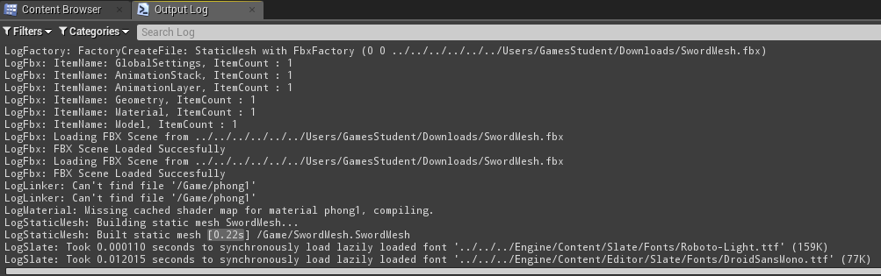
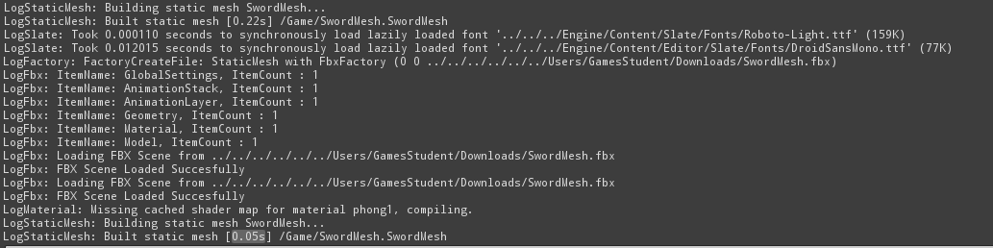
(Engine 4.16)
It does, but I may need to take an average, now to Google see if unity records the ‘static mesh build time’. No matches, will have to install Unity.
-Install unity, regardless comparing a Unreal vs Unity system.
Chosen Idea:
-Going with idea of comparison of how users find both Unity’s and Unreals shader systems. Send a survey asking time with engine, perceived skill level, what aspects a user enjoys/dislikes. What shader system they think is better. Can post survey link to existing dev groups, and dev students to get wide range of developer skills.
To do:
-Practise a bit with the Unity Shader system, research how it’s used using the online documents. Practise a bit and keep updated with Unreal’s system too.
-Formulate a base questionnaire for the developers. Verify the validity of the questions with someone experienced in each engine.

Date: 10/10/2017
Test stage: Idea Refining/ Research
Summary: Still thinking heavily on survey, researching engine differences.
Raw notes:
-Do an asset setup for different assets requiring different shaders, give own feedback for each in look and complexity of how to set up:
Static Mesh with Textures (Metallic, Roughness, ect)
Static Mesh with Textures (emissive ect)
Foliage Mesh with textures (Grass with masked texture)
Moving Water Shader (Normal with colour using planner)
Mesh deforming Shader (Making a shader that deforms and warps vertexs)
BackfaceCulling Two sided meshs
Unity 5 pipeline: Y up Z forward X side
Unreal Engine 4 pipeline: Z up X forward Y side

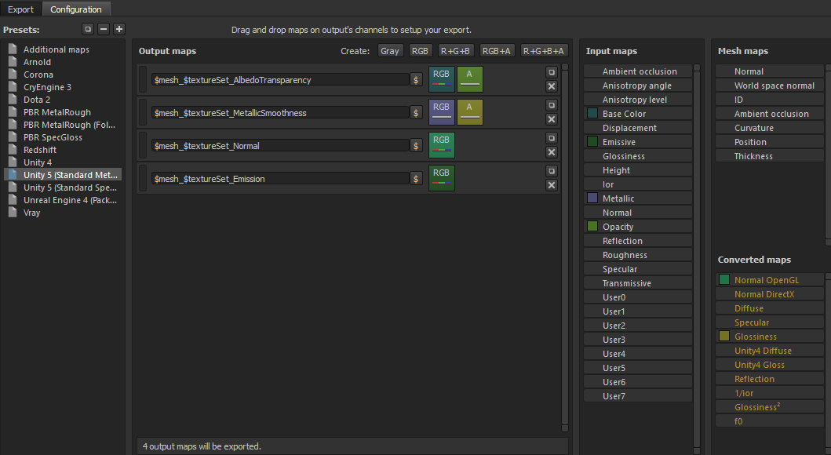
Notes:
-material is front end of a shader that tells the graphics card what to do
-Surface shader deals with scene lighting. Vert/Frag shaders used typically in places where you don’t care about lighting. Unlit shader closest to empty shader, image shader used for full screen image effect, like post process volume.
-In Unity, shader programs are written in a variant of HLSL language (also called Cg but for most practical uses the two are the same).
-Vert shaders manipulate the actual vertex’s of a shape for more physical distortion.
-frag shader runs once per pixel- content in shaders uses GP, so much faster.
-Look at Unity plugins.

Literature Review Explains all the background information the reader needs to know to understand your test.

Current Knowledge on the Subject
-Age of the engines is new, mostly forum posts
Unreal Engine = 19ys Unreal Engine 4= Less than yrs at earliest state
Unity = 12yrs Unity Unity 2017= This year, but is built off older versions.
Current Views on the topic
-Purely subjective, developers in forums
Relation to other subjects matters
Other study into asking for beginners
Survey Plan:

Ask skill level of many developers, and time spent with engine.
Make it an online survey as it’s easy to collect results from many large groups by simply sending a survey link.
Ask questions like:
-What game engine’s shader system do you prefer? Unity/Unreal Engine
-How easy was it to learn/understand Unity’s shaders?
-How easy was it to learn/understand Unreal’s shaders?
-Do you have experience with Unreal Engine, if you do, how skilled would you describe yourself?
-Do you have experience with Unity Engine, if you do, how skilled would you describe yourself?
-If yes to both, what engines shader system do you think can produce the best visual quality?
-What aspect do you look for in a game engine shader system?
-What is your preferred engine shader to use and why?
-Do you use Plugins with the shader systems for Unity/Unreal, if you do, what are they?
Then catagorise results based on peoples their time spent with engine and skills and collect results.

Date: 17/10/2017
Test stage: Adjusting test direction
Summary: Focusing less on Survey and pushing more for academic analysis.
Raw notes:
-Seems data will still be mostly opinion based, survey is fine but must be correlated against something of academic riggor.
-Will have to do timed comparative task in both engines as someone who knows both, or mention bias later. Need to test on others. Test simple shader and complex shader in both engines with test subjects. Get opinion on better and compare on times.
-take assets don’t spend time making
-need to redo literary review, be more specific on terms and not on literature surrounding the subject.
Date: 07/11/2017
Test stage: Conducting test
Summary: The methodology was applied and the test undertaken
Conducted test on self, gathered results.
Unreal was finished
Unity complex asset remained unfinished
Had to prepare assets differently for each engine due to how the engines work, not accounted into time.
Recording taken during test to accurately use the timings.
Time to start the creation of the academic document, though many further working already forseen. More test participants, fidelity was not tested due to incorrect methodology and perhaps testing more assets would make results more accurent. Will dive deeper in analysis.

