Independent Project


Research Proposal.
Student: Carlos Peromo Corella 2316576
Project Tutor: Fahad Ahmed
4/2/26

Introduction & Background
Working Tittle:
“A role-based Job posting Web Platform for Junior IT Professionals.”
The proposed project is a role-based web platform designed for publishing structured IT and technology-related tasks. It is specifically oriented towards students and junior IT professionals seeking entry-level opportunities. The platform will enable companies and freelance clients to post small, clearly defined technical tasks that can be completed by emerging professionals. Clients will be able to publish detailed job descriptions outlining requirements, skills needed, and relevant project information, while junior professionals can apply based on their competencies and field of study.
This approach creates mutual benefit: clients, including freelancers, project managers, and companies, gain access to affordable support for specific project needs, while students and junior professionals gain valuable real-world experience. This helps them develop practical skills, build confidence, and create professional portfolios that improve their employability.
In recent years, digital job platforms and freelance marketplaces have become increasingly important in connecting workers with employers. However, many existing platforms are highly competitive and often favour experienced professionals, making it difficult for entry-level candidates to access opportunities. Additionally, these platforms can be complex and not specifically designed to support early-career development.
This project addresses this gap by focusing on a simplified and structured platform specifically designed for junior IT professionals. It aims to provide an accessible environment where users can gain practical experience through small, manageable tasks, while clients benefit from cost-effective solutions.
Literature Review:
Digital labour platforms have significantly transformed the way clients and professionals interact within project-based work environments, particularly in the freelance and technology sectors. Existing platforms such as Fiverr have established themselves as dominant online marketplaces by enabling buyers to access a wide range of professional services. However, current literature and community-based evidence suggest that these platforms present several structural limitations that affect both buyers and sellers, particularly entry-level professionals.
From the seller perspective, previous research has identified that reputation-driven ranking systems and algorithm-based visibility mechanisms strongly influence opportunity access [2][3]. While these systems are designed to build trust, they can unintentionally disadvantage students and junior professionals who lack prior reviews or completed projects. This creates a high barrier to entry, where experienced sellers continue to dominate market visibility. Community reviews further support this issue, with users frequently reporting that platform success is increasingly determined by algorithmic exposure rather than actual skill or professional potential [1].
Similarly, buyer-side issues have also been identified in both literature and user feedback. Clients frequently report difficulties in verifying the actual quality, competence, and communication standards of professionals before engagement. The large volume of profiles and the inconsistent reliability of review systems often create uncertainty during the selection process. This problem is particularly significant in technical fields where task-specific competence is essential.
Academic studies on gig economy platforms further emphasise that platform trust, developmental opportunities, and transparent reputation systems are key factors influencing continued platform use [3]. Moreover, research on freelance marketplaces highlights that existing systems often prioritise commercial scalability over accessibility for emerging professionals [2].
These findings reveal a clear gap in the current market: existing platforms are not specifically designed to support the transition of students and junior IT professionals into real-world technical work environments. Therefore, the proposed project seeks to address this limitation by developing a simplified role-based platform focused on accessibility, trust, and early-career employability within the IT sector.
Aim of the Study:
The goal of this project is to design and develop a role-based web platform that connects clients—companies, organizations, workgroups, team leaders, or anyone with the responsibility and capacity to create and develop any technology project with students and junior IT professionals through a structured system. The platform will be published job postings for specific tasks, defined as part of a larger, more complex projects.
Objectives of the Study
- To design a relational database to manage users, profiles, job postings, and applications.
- To develop a role-based web platform using Django.
- To implement a structured workflow for posting and applying to tasks.
- To evaluate the usability and functionality of the platform through testing.

Project Design.
Minimum Viable Product (MVP):
- User Registration Login
- Profile Creation
- Job Posting (client)
- Job application (professional)
- Basic selection process
- Email notification
User Interaction Flow:
1. Login & registration: As we have already described, it is a role-based platform. Upon registration, the user will specify which role they will be registered with, depending on their needs: Client, Professional, or Admin. Depending on this choice, the main dashboard will offer options tailored to that role.
2. Client side: Once registered, the client (whether self-employed or representing a company) will need to:
- Create a profile with essential basic information.
- Create and post job offers using a form adapted to the professional field that requires service, where all the information about the specific task will be completed.
- See the professional, student profile candidate applications for each job offer post.
3. Professional side:
- Register account
- Create professional field profile (CV): Academic record, courses, tittles, any freelancer experience...
- Browse and check all the job posts related to his field.
- Apply to a job Show Status (Pending / Accepted / Declined)
- If Accepted, contacting with the employer (Client).
4. Extra features:
- Rating /reviewing systems: The clients will have the chance to rate the professional jobs by start.( We have evidence (based on user feedback research within the community) that on platforms like Fiverr, the review and ranking system carries significant weight, leading to an unbalanced algorithmic influence on user rankings. Therefore, given that our platform is geared towards students and junior professionals, we want the ranking and review system to be indicative, not definitive, so that the algorithm doesn't act drastically.)
5. Future Enhancements:
- Internal Messaging System.
- Payments system (PayPal).
- Advanced AI Matching system.

Resources & Planning:
Software resources will include Visual Studio Code as the main development environment, Python and Django for backend development, MySQL for database management, and HTML/CSS for frontend design and interface development.
Phyton: Core programming language, strong integration with Django which using these tools combined I will be able to cover the mains platform objectives:
- User authentication: Login register logic.
- Role-based access control: (Client / Professional)
- Form validation
- Database integration
- Email notification.
Phyton allows solid API’s Integration for features that the project needs:
- Calendar integration
- Payment system (Pay-pal)
- Messaging
Django (framework):
Django was selected as the web framework because it provides built-in features such as authentication, database integration, and security tools. This reduces development time and complexity compared to building these components from scratch. Django is well-suited for this project as it supports rapid development of structured, database-driven web applications.
HTML/CSS:Frontend : Layout interface and styles.
MySQL: Will be used as the database management system to store and organise the platform’s data, such as user accounts, profiles, job postings, and applications. It is suitable for this project because it is reliable, easy to use, and works well with Django through built-in integration tools. MySQL also supports structured data and relationships between tables, which is important for managing connections between users, jobs, and applications in the platform.
MySQL has been selected as the database management system due to its reliability, ease of use, and strong compatibility with Django. Compared to other database systems, MySQL is widely used, well-documented, and suitable for structured relational data.

Research and Support Resources:
In addition to the technical tools required for development, the project will rely on research and support resources to ensure an informed and well-structured approach. Access to academic journals, online databases, university library resources, and credible industry sources will be essential to support the literature review and justify the design decisions of the platform. Furthermore, community reviews and market analysis from existing freelance platforms will be used to identify current user issues and gaps in the market. Human support resources will include regular tutor feedback, academic supervision, and the use of official documentation and learning materials to assist with project planning, problem solving, and technical decision-making throughout the development process

Data collection:
Data collection for this project will focus on test data and system-generated records required to validate the platform’s core functionality. During the testing phase, real personal user data will not be necessary, as the aim is to evaluate system performance rather than analyse real user behaviour.
The only field that may require a valid real value is the email address, used to verify that the registration and authentication system performs correctly, including email validation and database response. All other profile fields, such as skills, education, certifications, and experience, may be completed using placeholder data.
Additional test data will include user registrations, job postings, applications, and status updates in order to validate the platform workflow and ensure that the Minimum Viable Product (MVP) functions effectively.
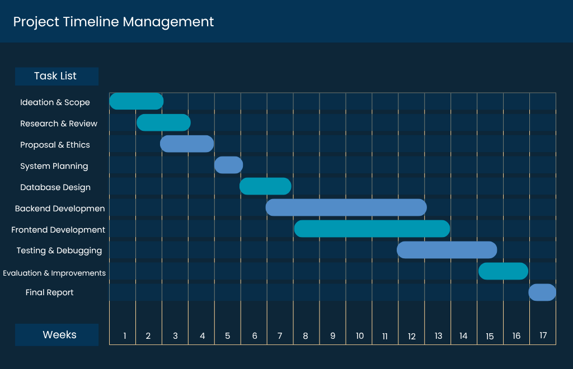

* Gannt Chart create by Canva.

References
[1]. Jahangir, F. (2025). The Fiverr Quality Crisis: An Honest Freelancer’s 2025 Review. Medium. https://medium.com/@faisaljahangir60/the-fiverr-quality-crisis-an-honest-freelancers-2025-review-d42d8ad5bdbb
[2]. Daryl D. Green, Jack McCann, Thao Vu, Nancy Lopez, Samuel Ouattara. (2018). Gig Economy and The Future of Work: A Fiverr.com Case Study. Management and Economy Research Journal. https://www.researchgate.net/publication/330207602_Gig_Economy_and_the_Future_of_Work_A_Fiverrcom_Case_Study
[3]. Hongpeng Wang, Rong Du, Wenqi Shen. (2021). Product Review: A Benefit, a Burden, or a Trifle? How Sellers reputation Affects the Role of Product Reviews. Sage Journals.https://www.researchgate.net/publication/352671604_PRODUCT_REVIEWS_A_BENEFIT_A_BURDEN_OR_A_TRIFLE_HOW_SELLER_REPUTATION_AFFECTS_THE_ROLE_OF_PRODU

