UNIVERSITY OF WALES
TRINITY SAINT DAVID

Topic: Coursework (Written Report) Part 2

Ivilina Atanasova Atanasova

Course: Business Management, 2028391
Data Handling and Business Intelligence
(LCBB5000)

Khaza Ahmed

15/11/22

Table of contents

Part 1, Section 1  1. Introduction MS Excel…………………………………………………………….. | 3
2. Covid-19 Dataset…………………………………………………………………… | 4
2.1. a Total number of cases of Covid-19……………………………………………. | 5
2.2. Days more than 20,000 cases…………………………………………………… | 5
2.3. Highest death count……………………………………………………………… | 6
2.4. Lowest death count……………………………………………………………….. | 6
2.5. Excel's "IF"………………………………………………………………………… | 7
2.6. In PivotTables……………………………………………………………………... | 7
2.7. Charts and graphs………………………………………………………………… | 8
Part 1, Section 2  Excel for pre-processing, analyzing, and visualizing the data………………... | 9
3. Worksheet functions and formulas………………………………………………… | 10
4. Creating Excel charts……………………………………………………………….. | 11
5. Conclusion…………………………………………………………………………… | 12
Part 2, Section 1  Sales_and_Ads_2021 Data Analysis……………………………………………… | 13
1. Introduction SPSS statistical software…………………………………………….. | 13
2. Analyses the Sales_and_Ads_2021……………………………………………… | 14
2.1. Mean Value for sales……………………………………………………………… | 14
2.2. Standard deviation for Advertising………………………………………………. | 15
2.3. Range……………………………………………………………………………… | 15
2.4. Larger variance…………………………………………………………………… | 16
2.5. Standard deviation……………………………………………………………… | 16
2.6. Scatterplot of Sales and Advertising…………………………………………… | 17
3. Conclusion…………………………………………………………………………… | 18
Part 2, Section 2  1. Explain the most common text mining methods that can be used in business with real-world examples……………………………………………….. | 19
2. Discuss the advantages and disadvantages of using SPSS and Excel using relevant practical examples………………………………………………… | 20
References List……………………………………………………………………….. | 21

Part 1, Section 1
1. Introduction
This is the report for The dataset provided in xls format: Covid-19 table, discussion, and analysis of Covid-19 cases in the United Kingdom for a specific period in 2020 (Part 1, Section 1); Using Excel to prepare data for analysis and visualization (Part 1, Section 2); Using the SPSS statistical software, discuss and analyze the Sales_and_Ads_2021 dataset; (Part 2, Section 1); text mining methods that can be used in business with real-world examples, the advantages and disadvantages of using SPSS and Excel using relevant practical examples ( Part 2, Section 2).
Data analysis investigates, summarises, and interprets data. Data findings drive research, management, and business.
The research analyst collects, assesses, and interprets data for business choices. An analyst must understand marketing, operations, and finance.
Data organization facilitates access. Organize your material logically and appropriately, like a file folder, so you and others can find it easily. Good data organization is crucial for managing your company's assets. This data could improve your company's business intelligence. Raw data is cleaned, modified, and analyzed for decision-making. Charts, graphics, tables, and graphs decrease decision-making risks.
Data analytics helps organizations find new opportunities and make strategic decisions. Companies digitize data analytics programs.
Differentiators In business, picking prices and polling customers to gauge satisfaction can help identify new customers, generate revenue, and focus efforts. (Michael (2013)).

2. Covid-19 Dataset
This section analyses Covid-19 cases from November 2020 to mid-December 2020 in the United Kingdom. The number of new infections, deaths, and cumulative COVID-19 infections per 100,000 people over 14 days is all displayed.
In Table 1, we can see the following:
- For each day separately 45 days from November 2020 to mid-December 2020 (Column 1); The date starts from November 2020 till the Middle of December 2020 (Column 2); The month of cases (Column 3); The year of the issues 2020 (Column 4); The number of infected patients for each day separately (Column 5); The number of death cases for each day apiece (Column 6); The country of the case United Kingdom (Column 7); The country territory Code GBR (Column 8); The Population Data 2019 (Column 9); The continent of cases Europe (Column 10); The Cumulative number of 14 days of COVID-19 cases per 100000 (Column 11).
On each row, we see the exact date, the number of infected cases, the dead, the country, the country code, population Data for 2019, and the continent and Cumulative number for 14 days of COVID-19 points per 100000.
Table 1. Covid 19 cases 2020
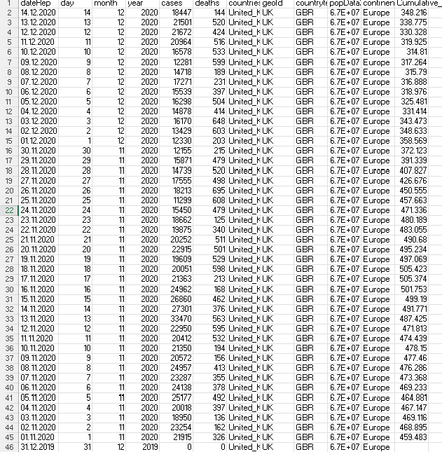
2.1. Total number of cases of Covid-19
The total number of cases is the sum of all topics. For the specified period, the instances are 859658 – Table 2.
The calculation is with the SUM function when column E2:46 is marked.
Table 2. Total number of cases of Covid-19
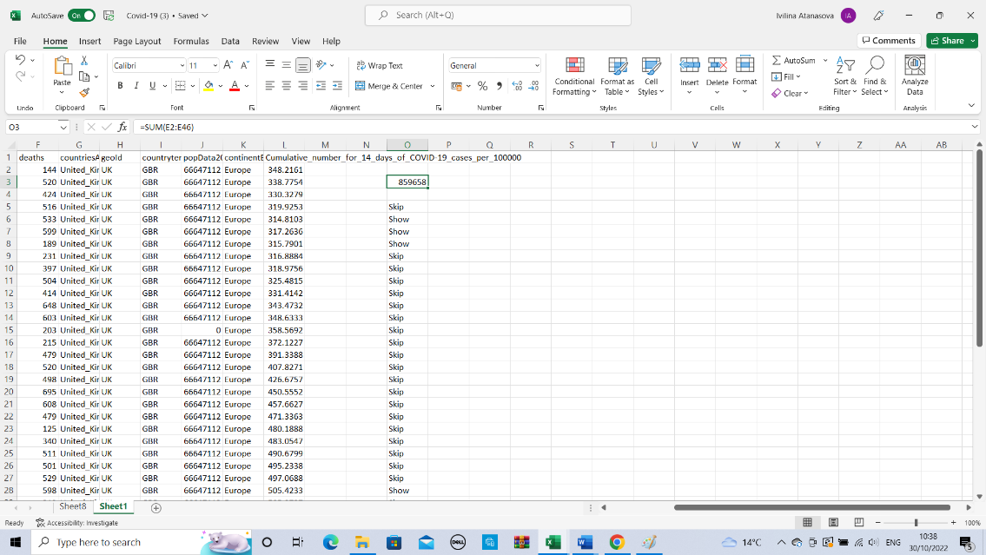
2.2. Days more than 20,000 cases
On the days with more than 20,000 cases in column N, we see "SHOW,” and on the rest (less than 20,000), “SKIP” – Table 3.
We calculate this with the function IF. The IF process requests the logical test to be executed, the action to be taken if the test is accurate, and the alternative step if the test is false.
The structure is: =IF (E2:E46>20000, "SHOW,” "SKIP")
Table 3. Days more than 20,000 cases
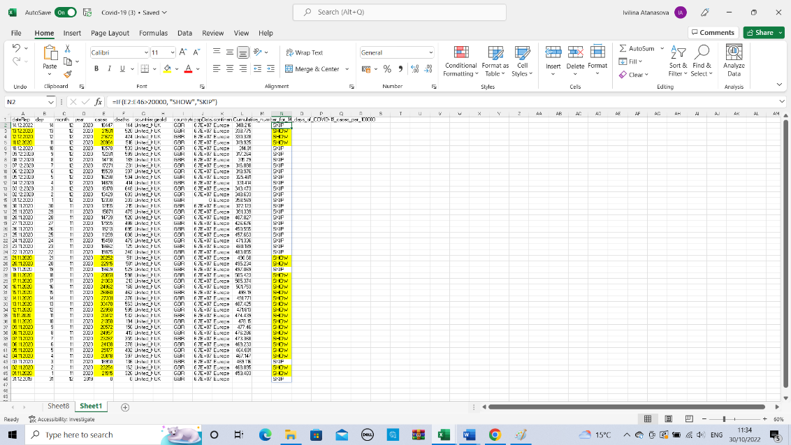
2.3. Highest death count
We find the number as follows the steps in Excel: Home Tab, Editing group, Arrow next to Auto sum, MAX – Table 4.
MAX returns the most outstanding value in a list of arguments. It will replace the highest value from a given set of numbers. MAX ignores empty cells, text, the logical values TRUE and FALSE, and text values while counting numbers.
In this case, it is 695 (F20) - These are the cases from 26/11/2020, with the number of patients less than 20000 (18213), and the Cumulative number of infected patients in 14 days per 100,000 is 450.555.
Table 4. Highest death count
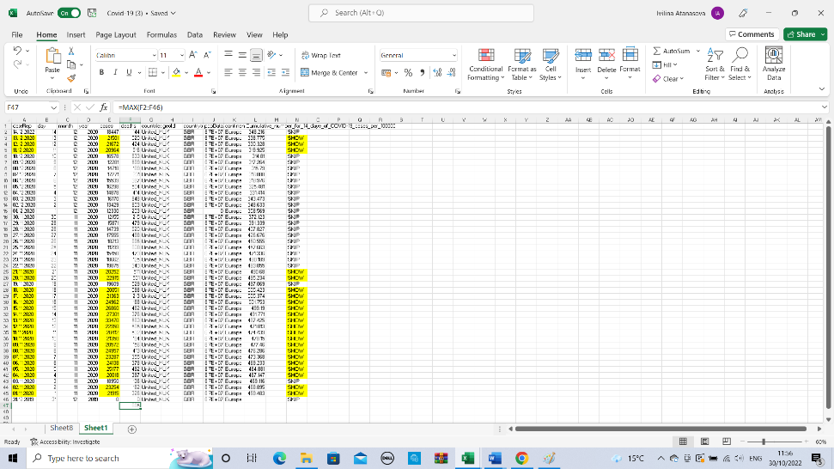
2.4. Lowest death count
We find the number as follows the steps in Excel: Home Tab, Editing group, Arrow next to Auto sum, MIN – Table 5.
In this case, it is 0 (F46) – No issues of dead people in 2019 because The covid started in 2020.
MIN returns the minimum value in a given argument list. It will replace the least number from a given set of numbers.
Table 5. Lowest death count
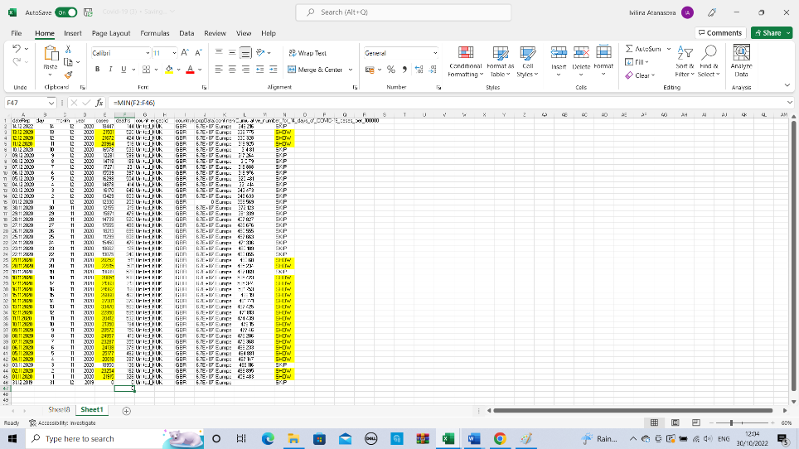
Excel functions such as IF, PIVOT TABLES, charts, and graphs are handy for data analysis, visualization, and decision-making.
2.5. Excel's "IF" feature lets users logically compare a value to their prediction.
Thus, IF statements yield two outcomes; if your comparison is valid, the first outcome will be True; if not, the second outcome will be False.
=IF(C2="Yes,” 1,2) represents the condition IF. Return 1 if C2 is Yes, two otherwise.
2.6. In PivotTables, we can utilize summary functions in value fields to merge source data values. We can construct formulas in calculated fields and items if summary functions and custom calculations do not produce the desired results. For instance, we may include a calculated item with the estimate for the sales commission, which could vary by area. The PivotTable would automatically incorporate the commission into the subtotals and grand totals.
Using Measures in Power Pivot, which you build using a Data Analysis Expressions (DAX) formula, is another calculation method. PivotTables allow for several forms of data calculation.
Select the cells from which you wish to create a Pivot Table.
2. Select Insert > PivotTable from the menu bar
This command creates a Pivot Table from an existing table or range.
4. Determine where the PivotTable report will be placed.
5. Select OK.
In this case, We can see the PivotTable (Table 6), with date Rep, day, and deaths -Total minimum(125) and Total maximum (695); maximum deaths November – 695; top deaths December – 648.
Table 6. PivotTable with date Rep, day, and deaths
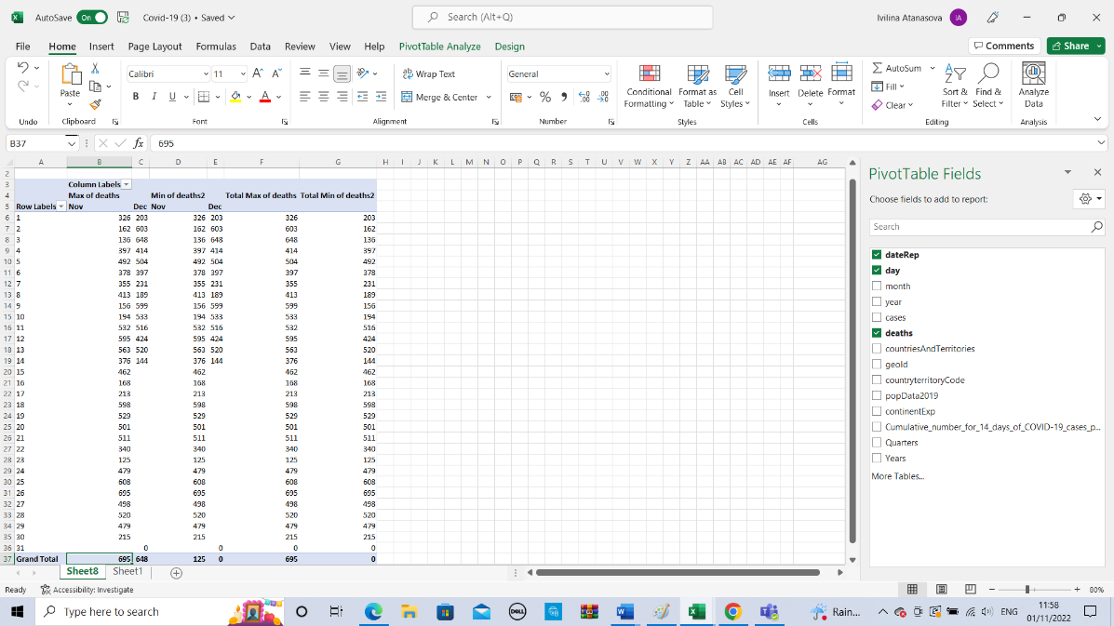

2.7. Charts and graphs
Charts enable us to visualize our data in a manner that can impact the audience we are addressing.
To make a chart, first, we need to choose the data to use.
Select INSERT > Suggested Charts.
Excel will suggest several different charts based on our data; on the Recommended Charts tab, you may peruse these suggestions and click on any chart to see how it displays our information.
We will use the mouse and the "OK" button to select the desired chart.
Table 7 shows the number of Covid-19 cases (axis Y) for the specified period (axis X) from November 2020 to mid-December 2020.
Table 7. Number of cases of Covid-19
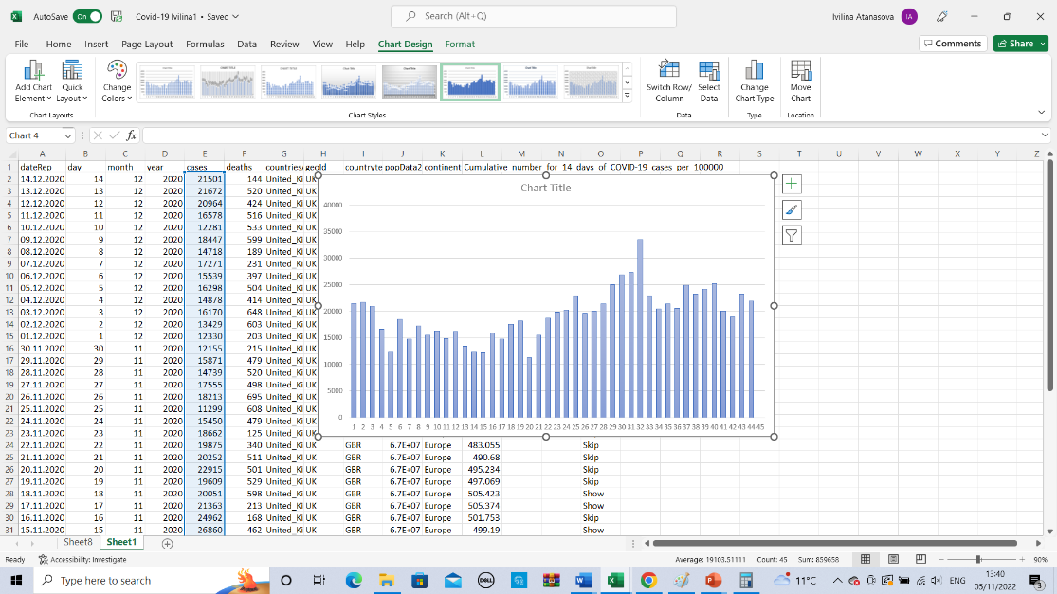
Table 8 shows the number of Covid-19 deaths (axis Y) for the specified period (axis X) from November 2020 to mid-December 2020.
Table 8. Number of Covid-19 deaths
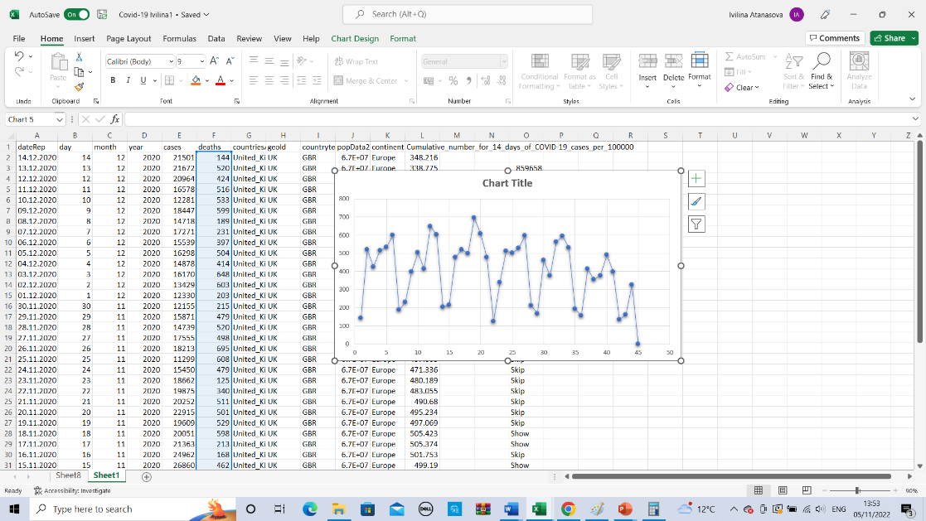
Part 1, Section 2
Excel for pre-processing, analyzing, and visualizing the data
Microsoft Excel is used to keep data records. Users manage numerical and other data with Microsoft Excel. Before using the software, you must grasp its concepts. 16384XFD Excel 2007 later allows 220 rows or 1048576 in a 26-base system. Excel can organize, store, and analyze data. Excel and other tools can be used to manage data, allowing analysts and other users to review it as it's added or amended. Excel has rows and columns of cells. (Price Michael (2013)).
The tabs on the document are called worksheets. Within a single workbook, there may be more than one worksheet, each containing its unique group of cells. The individual cells can have any combination of text, formulas, and data entered into them. In a spreadsheet, there is a drawing layer hidden from view; in this layer, you can save things like diagrams, charts, and images. Objects on the drawing layer are superimposed over the cells, as opposed to numbers or formulas, which are contained within the cells.
(Linoff Gordon S. (2015)).
Complex jobs automated: Excel's macro features allow you to accomplish a time-consuming activity with a mouse click.
Each cell has its unique address, composed of the letter of the column it is in and the number of the row it is in. The upper-left cell, for instance, has the address A1. (Carlberg (2014)).
In figure 1, we can see the Excel screen with many valuable elements we use often.

Figure 1. Excel screen with many valuable elements
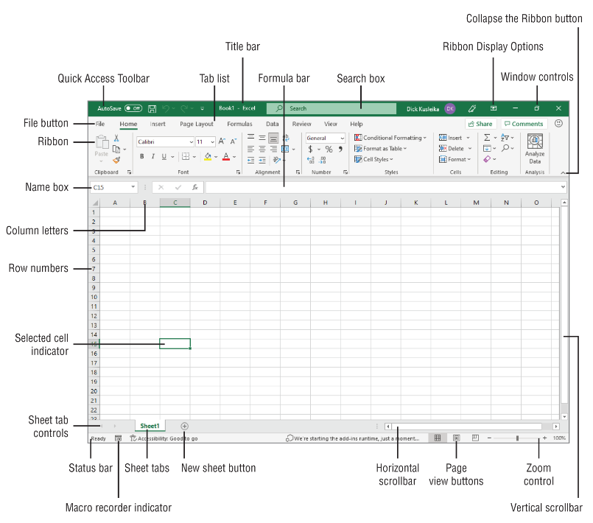

3. Worksheet functions and formulas are crucial for altering data in Excel and gaining insight from the spreadsheets we create.
A formula is a special kind of expression that can be used to determine the values of multiple cells at once.
In the case of the preceding sentence, the formula =A2+A2+A3+A4 would sum the contents of cells A2, A3, and A4.
Excel's built-in functions allow for quick and easy calculation of expected outcomes. The arguments or parameters of a process are used to determine the specific measures to be performed (Wayne Winston (2022)).
To add up a set of cells, for instance, we can use the SUM function instead of specifying each value to be added, as in the above formula: =SUM(A2:A4)
The Formulas tab houses the Function Library, where we can access all of Excel's built-in functions:
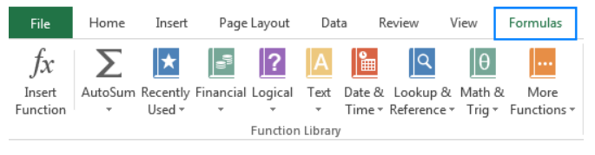.
Excel now has around 400 built-in functions, which are expected to expand with future updates. Below is a list of a few easy-ta o-learn yet handy Excel functions that should be known by anyone who aspires to go from an Excel newbie to an Excel pro.
An argument within Excel square brackets can be left out, but all other parameters are necessary. Suman H. (2019);
SUM: =SUM(B2:B6) - adds values in cells B2 through B6.
AVERAGE: The AVERAGE function in Excel calculates the standard, or arithmetic means, of a set of values. Comparable to SUM in syntax: =AVERAGE(B2:B6).
MAX & MIN: Excel's MAX and MIN functions find the highest and lowest numbers in a range. The formulas will be elementary for our example data set:
=MAX(B2:B6);
=MIN(B2:B6).
IF: It is Excel's most popular function based on blog comments. An IF formula tells Excel to test a condition and return one number or computation if it's met and another if it's not:
IF(logical_test, [value_if_true], [value_if_false]).
AND & OR
These logical functions examine numerous conditions. Their method differs:
AND returns TRUE if all conditions are met, FALSE otherwise;
OR returns TRUE if any condition is met, FALSE otherwise.
=IF(AND(B2>60, B2>60), "Pass", "Fail");
=IF(OR(B2>60, B2>60), "Pass", "Fail"); (Burns, & Bush, R. F. (2008)).
4. Creating Excel charts
A graph, or chart, depicts numeric data using symbols like bars, columns, lines, slices, etc. Excel graphs help see massive data sets and their relationships. Microsoft Excel lets you create many different graph types, such as Column charts, Bar charts, Line charts, Pie charts, Area charts, Bubble charts, Stock, Surface, Radar charts, and PivotChart.
Choose data to chart.
1. Click Insert > Recommended Charts.
2. On the Recommended Charts tab, scroll through Excel's suggestions for your data, and
3. click any chart to preview your data.
4. Select a chart and click OK.
In figure 2, we can see the pie chart and column chart:
Figure 2. Pie chart and column chart
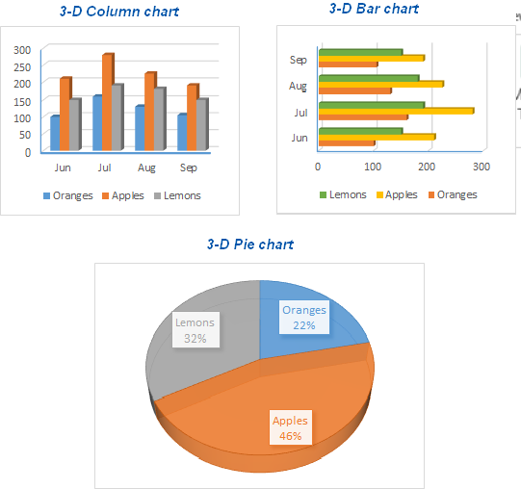
Data from external sources can be imported, and we can use the resulting spreadsheets, charts, and graphs to organize our work better and automate tedious administrative activities. (Jelen, & Alexander, M. (2013)).

5. Conclusion
Spreadsheet data can be organized and formatted in Microsoft Excel, and the program can also do calculations. When new data is added, or existing data is amended, it could be easier to understand the information if data analysts and other users use tools like Excel. Excel's fundamental data structure comprises many cells organized into rows and columns. Spreadsheet applications like Microsoft Excel allow users to manage, calculate, and format data in various ways. Data analysts and other users can make it easier to examine when new or modified data is added or changed data is added by gathering it in a tool like Excel. The various cells that make up Excel are organized into rows and columns.

Part 2, Section 1
Sales_and_Ads_2021 Data Analysis
1. Introduction SPSS statistical software
It's a set of programs designed to help analyze social science data. In SPSS, we can create simple or complicated models quickly and easily in a graphical interface. Surveys, data mining, market research, etc., benefit from the information acquired with the help of SPSS (J. P. Verma (2012)).
SPSS Inc. first released SPSS in 1968, and IBM eventually bought it out.
SPSS's popularity stems from its being both user-friendly and widely used. Many other organizations utilize it for this purpose, including government agencies, universities, survey firms, market researchers, marketing firms, health researchers, data miners, and more. (Julie Pallant (2010)).
This section analyses the Sales_and_Ads_2021 dataset using the value for sales, the standard deviation for advertising, the more comprehensive range, and the more considerable variance.

2. Analyses the Sales_and_Ads_2021
In Table 9, we can see the 36 Serial numbers of Sales (Column 1), 36 different Sales (Column 2), and 36 other advertising (Column 3), the number of groups 1 or 2 (Column 4) for the year 2021.
On each row, we see every single number of Sales, the Sale, the advertising, and the number of the group.

Table 9. Sales_and_Ads_2021
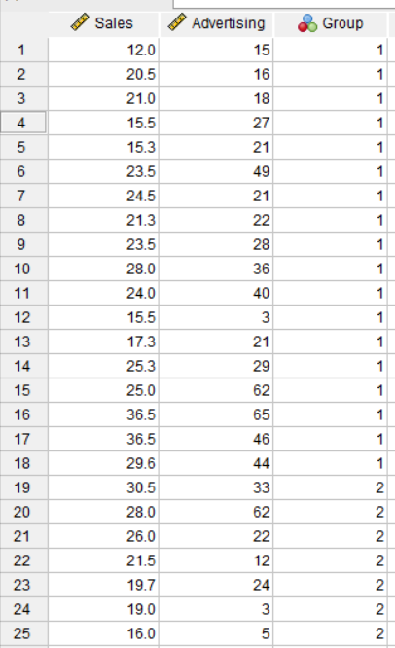
2.1. Mean Value for sales
SPSS provides the mean value:
Click Analyze, followed by Descriptive Statistics, followed by Descriptives.
Drag the sales variable from the left into the “ Variables “ box on the right.
Select Mean and Standard Deviation by clicking Options and selecting Mean and Standard Deviation.
Press Continue, followed by OK.
The outcome will be displayed in the SPSS output viewer – Table 10.
Table 10. Value for sales
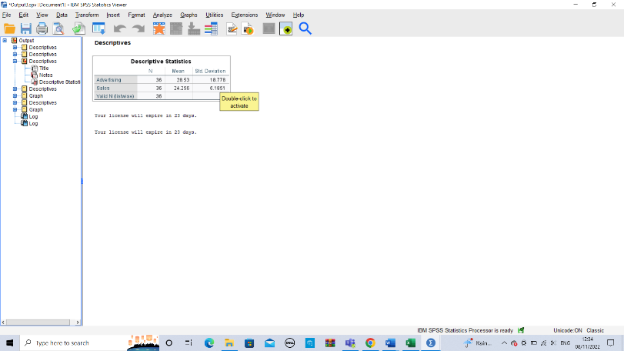
We see Sales of 36, a Mean of 24.256, and a Standard Deviation of 6.1851.
2.2. Standard deviation for Advertising
SPSS provides the mean Standard Deviation for Advertising:
1. Click Analyze, followed by Descriptive Statistics, followed by Descriptives.
2. Drape the Advertising section from the left into the box titled Variables on the right.
3. Select Mean and Standard Deviation by clicking Options and selecting Mean and Standard Deviation.
4. Press Continue, followed by OK.
The outcome will be displayed in the SPSS output viewer – Table 11.
Table 11. The standard deviation for Advertising
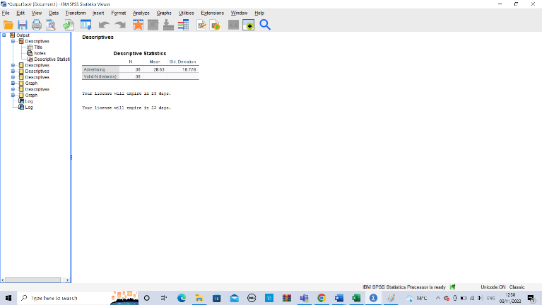
We see Advertising of 36, a Mean of Advertising of 28.53, and a Standard Deviation of 18.778.
2.3. Range
The distribution range is defined as the difference between the most extreme value and the least extreme value: Advertising (64) and Sales (24.5) – shown in Table 12.
Table 12 The range of Sales and Advertising
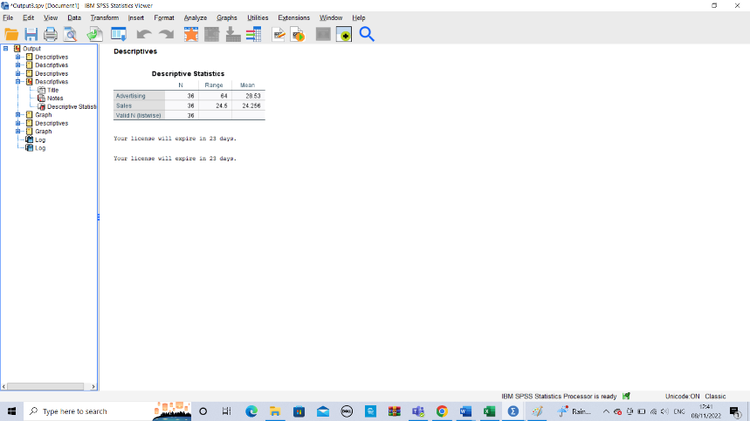
2.4. Larger variance
A high variance implies that the data points are very dispersed, both about one another and about the mean. The average squared distance between each end and the standard is what we mean when we talk about variance. Table 13 shows the values of Sales (38.256) and Advertising (352.256).
Table 13. The variance in Sales and Advertising
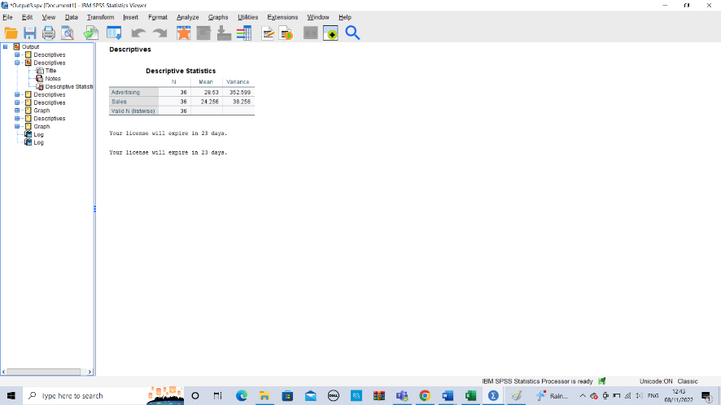
2.5. Standard deviation
A high variance shows that the data points are significantly dispersed from the mean and one another. The conflict is the mean of the squared distances between each end and the standard. Table 14 shows the values of Sales (18.778) and Advertising (6.1851).

Table 14. The standard deviation of Sales and Advertising
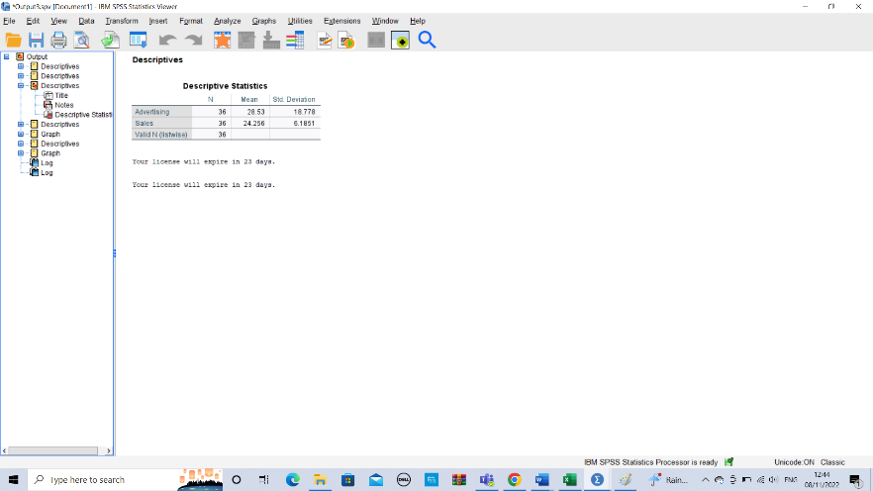
2.6. Scatterplot of Sales and Advertising
Visualizing the connection between two variables is possible by creating a scatterplot. It helps visualize the direction (positive or negative) of the relationship between the two variables and their intensity (weak, moderate, or vigorous). (David Robinson, Ph.D. (2016)).
Click graphs > scatter at the top of the data editor to construct the scatterplot. We will choose simple, then click "define." Selecting OK, we will select Advertising for the x-axis and Sales for the y-axis. The chart editor will open if we double-click anywhere on the graph, shown in Table 15.
Table 15. Scatterplot of Sales and Advertising
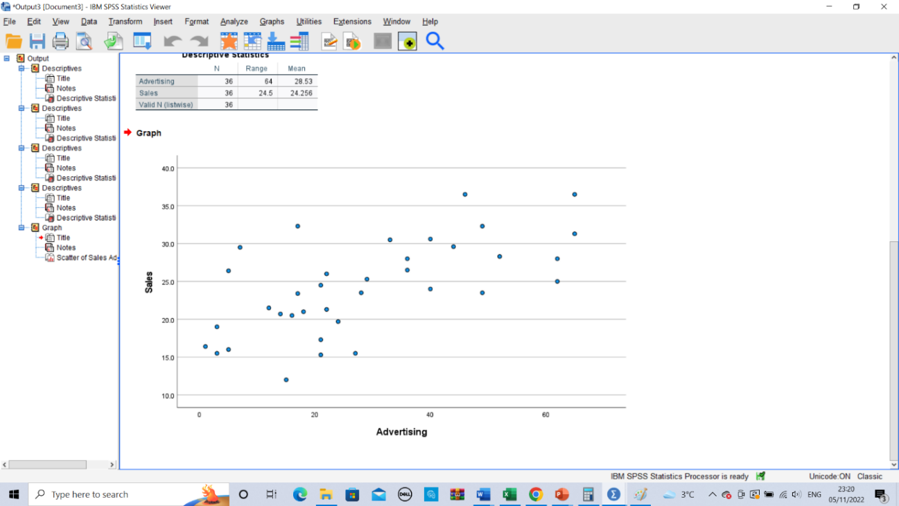

3. Conclusion
All sectors can benefit from SPSS Predictive Analytics because:
- Marketers can better target certain client groups with the aid of SPSS Predictive Analytics;
- Predictive analytics boosts a company's profitability and efficiency;
- SPSS analysis helps firms save a great deal of money;
Predicting operational failure or downtime is a significant benefit of SPSS software.
Through the analytics lifecycle—from planning to data collection to analysis to report production to deployment—SPSS supports scientists, researchers, business analysts, managers, and marketers. No matter our company goals, if we have a large amount of data that needs to be analyzed, SPSS is one of the most excellent statistical analysis tools.

Part 2, Section 2
1. Explain the most common text mining methods used in business with real-world examples.
Text mining uses classification, entity extraction, and sentiment analysis to find information. This helps companies uncover patterns in unstructured data. Its ability to ignore extraneous data and provide valuable answers has boosted enterprise usage.
The three text-mining examples below show how the real-world use of techniques for managing unstructured data can affect our organizational processes and our position in the market. (Goutam C., Satish G., Murali P. (2013)).
1.1. Enhanced Customer Service
Customer service teams benefit from text mining and NLP. They use surveys, trouble tickets, and customer call notes to improve problem resolution and customer experience. Chatbots use text analysis to gather customer data and respond quickly. Thus, organizations can drastically cut their call center operator use to resolve consumer issues.
1.2. Business Intelligence
Most enterprise decision-making uses business intelligence technologies. These technologies help you find patterns, trends, and opportunities faster by gathering, storing, and analyzing data. BI solutions can utilize text mining to exploit structured and unstructured data to provide business insight. This lets you build more muscular BI models with better business insight.
1.3. Social Media Data Analysis
Social media provides market and customer intelligence across the organization. Companies examine customer intent, brand impression, and product feedback with it. Text analytics helps firms contextualize vast amounts of social commentary to extract thoughts, emotions, and sentiments that reflect consumers' positive and negative brand and product interactions.

Conclusion
Companies are using text mining to make enormous amounts of unstructured data relevant as it grows exponentially. They gained a more robust business understanding and made better business decisions for several use cases.

2. Discuss the advantages and disadvantages of using SPSS and Excel using relevant practical examples.
 | Advantages | Disadvantages
SPSS | It answers quickly and is Dynamic with informative tables and graphs; many can use it because it supports many languages, manages data, Uses the software efficiently, and is Quantitative and qualitative. | SPSS cannot examine massive datasets. In medicine and nursing, researchers utilize SAS instead of SPSS to analyze enormous data sets.
Excel | Best data storage, Calculate, Analytical tools, Charts simplify data visualization, print reports effortlessly, Many free templates, Code automates, Clean data. | Excel's real-time unstructured and semi-structured data analysis is a drawback. However, several new data analytics tools can quickly discover and visualize this data. Excel struggles with JSON data.

SPSS: IBM-recommended data analysis and manipulation.
Excel: Microsoft-formulated data management and storage.
Only data and meta-data characterize SPSS data files (.SAV) (format, labels, value labels,s missing values, etc.). However, Excel spreadsheets can incorporate formulas.
Advantages of SPSS over Excel
SPSS provides advanced analytics like factor analysis, logistic regression, cluster analysis, etc. Excel does not treat columns and rows as variables like SPSS (in treating volume and rows, SPSS is more similar to Access than to Excel) (Nick L., Mike P. (2015)).

Conclusion
SPSS performs more statistical analysis than Excel. Unlike Excel, SPSS provides built-in data manipulation features, including recording and variable transformation.
SPSS provides advanced analytics like factor analysis, logistic regression, cluster analysis, etc.
Excel doesn't record your steps. When variables and observations become large, it becomes unmanageable.
SPSS and EXCEL in their fields. Thus, SPSS and EXCEL rule their domains.

References List

Burns, & Bush, R. F. (2008). Basic marketing research : using Microsoft Excel data analysis (2nd ed.). Pearson/Prentice Hall;
Carlberg (2014). Statistical analysis : Microsoft Excel 2013. Que.
David Robinson Ph.D. (2016) - SPSS for Students ;
Goutam Chakraborty, Satish Garla, Murali Pagolu (2013). Text Mining and Analysis: Practical Methods, Examples, and Case;
Harjit Suman (2019) Excel Formulas and Functions: The Complete Excel Guide For Beginners;
J. P. Verma (2012) Data Analysis in Management with SPSS Software;
Jelen, & Alexander, M. (2013). Excel 2013 pivot table data crunching. Que;
Julie Pallant (2010): Spss Survival Manual A step-by-step guide to data analysis using SPSS Spiral-bound;
Linoff Gordon S. (2015) Data Analysis Using SQL and Excel, 2nd Edition;
Nick Lee, Mike Peters (2015) Business Statistics Using EXCEL and SPSS;
Prince Michael (2013) Excel 2013 in easy steps. In Easy Steps;
Wayne Winston (2022) Microsoft Excel Data Analysis and Business Modeling (Office 2021 and Microsoft 365) (Business Skills).

