What they want you to want
We are coming into the big spending season, with Black Friday, Cyber Monday, the run-up to Christmas and then the winter sales. So will we all be rational maximisers and weigh up the utility we expect to receive from items against the price we pay (plus any other cost, such as time spent searching/shopping)? Or will we use a set of heuristics which make life easier and that we have found to be useful in helping us choose – heuristics such as buying things we’ve liked before, or going for things on special offer?
The answer is that we do probably use a set of heuristics, at least for many items. And don’t the retailers and the marketing firms they employ know this!
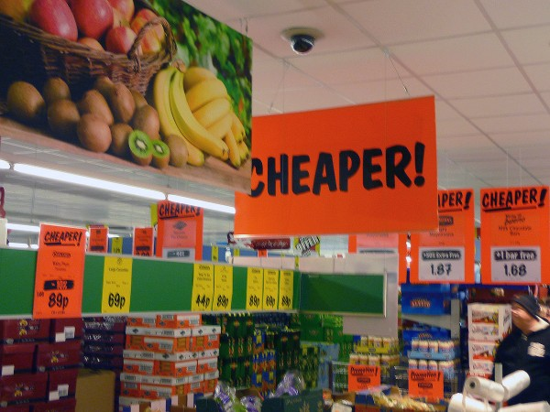
They will use all sorts of tricks of the trade to persuade us to part with our money. These tricks are designed to nudge us (or push us), without us feeling manipulated or conned – at least until we’ve bought their product.
And the tricks are getting more sophisticated. They include special offers which are not as good as they seem, time-limited offers which stimulate us to buy quickly without carefully thinking about what we’re doing, cunning positioning of products in shops to encourage us to buy things we had not planned to buy, adverts which play to our idealised perceptions or the ‘good life’ or what we would like to achieve, and packaging or display which make the product seem better than it is.
Also we are increasingly faced with targeted advertising where our smart devices capture information about our spending habits and tastes through our previous online spending or our search behaviour. This is then fed to advertisers to tailor adverts specifically to us on our mobiles, tablets, laptops and even, soon, on our smart TVs.
We may have a general desire to maximise utility from our spending, but market failures, such as consumers having imperfect information about products and a present bias (see also) in decision making, make us easy targets for the advertising and marketing industry. They understand the heuristics we use and try to take maximum advantage of them.
Happy shopping!
Articles
How shops use tricks to get you spending The Conversation, Cathrine Jansson-Boyd (16/11/17)
ColourPop looks to Qubit for next-gen personalization guidance Retail Dive, Dan O’Shea (13/6/17)
Channel 4 to offer 100% ad targeting across All 4 platform, seeking partners for linear equivalent The Drum, Jessica Goodfellow (14/11/17)
How Google aims to bring TV advertising into the 21st century The Drum, Ronan Shields (19/10/17)
How to Use Heuristics to Your Marketing Advantage MarketingProfs, Cam Secore (12/11/15)
Questions
- Does the use of heuristics contradict the assumption that consumers behave rationally?
- Give some examples of heuristics that you yourself use.
- Other than those identified above and in the first article, what ‘tricks’ might companies play on you to persuade you to buy their products?
- Is advertising personally targeted to individual consumers desirable for them?
- Give some examples of present bias in people’s behaviour.
- What factors should a retailer take into account when deciding whether to make pre-Christmas discounts?
- Explain what is meant by ‘affect heuristic’ and how the advertising industry uses the concept in setting the background to or scenario of an advertisement.
- Have you ever been persuaded into buying something you didn’t want? Why were you persuaded?

How shops use tricks to get you spending by Cathrine Jansson-Boyd
In the business of shops and selling, times are tough. Retail sales indicate that shops are are struggling to persuade customers to part with their cash. But there are some innovative methods which retailers are using to address the challenge of enticing and engaging consumers. And it’s not just about slashing prices and Black Fridays. Many well-known businesses make use of psychology to connect with customers and increase sales.
Here are some of the tricks they have up their shop sleeves.

Sniffing out a sale
A nice smell can make retail experiences more pleasurable. A scent can also have a strong association, some of which are shared, like the smell of a hospital or the seaside. It therefore makes sense to use smells that evoke positive emotions to improve sales.
This is the reason why branches of Starbucks are filled with the aroma of “Pumpkin Spice Lattes” during autumn, and gingerbread flavours over Christmas. The pumpkin fragrance is strong and can arouse positive seasonal memories related to “trick or treating” or Thanksgiving celebrations. But it is not just about memories. Using sweet smells can simply enhance the shopping experience in cosmetics stores such as Lush, or lingerie specialist Victoria’s Secret.

A hands on approach
A retailer that is precious about their products and prevents customers getting their hands on the goods, will miss out. Touch is vital for influencing consumer perception, and a lack of it can be frustrating.
Apple understand this better than anyone. Their stores are laid out specially to invite people to explore the products with their hands, in plenty of clean space. Tactile interaction not only increases the likelihood of purchase, it also increases perceived pleasure as touch is closely associated with emotions.

Getting emotional
Connecting emotionally with consumers is the holy grail of retail. Consumers subconsciously search their feelings when trying to work out what they think about a product.
Selling “self-assembly” products may seem like a simple cost cutting exercise, but for the company it also encourages engagement and increased emotional value. When consumers put “labour” into a product (such as putting together flat-pack Ikea furniture or getting to grips with Build-a-Bear) they end up valuing them more. These values are transferred onto the brand itself and can encourage repeat purchases.
Another way of getting consumers on board emotionally is by telling them they are valued. Again, Ikea has been good at this. One innovative solution involved identifying the most common internet searches for relationship problems, and suggesting a solution through their products. A set of champagne glasses was thus labelled: “When children leave home” and a spotlight lamp named “My brother gets all the attention”. The company has used humour to show that they identity with modern life.

Engaging the subconscious
Our brains have a need to make sense of the information we see. If the information is incomplete, we automatically attempt to fill in the gaps. Effectively, by leaving out information, businesses can make consumers engage in a mental process which means they recall the brand later on.
For example, when the Audi A3 was launched, the advertising campaign featured headlines with gaps in the word lettering. Consumers were forced to engage in an Audi-related thought process which meant the brand stuck in their minds. Are subtle cues praying on our subconscious the reason why Audi has its reputation? Perhaps not entirely, but the company has made clever use of perception techniques to ensure we think about it.
Successful selling involves attracting buyers by any means possible. Appealing to the senses, the subconscious and our emotions are clever business tools. It is unlikely that one method alone is the key to a successful brand – but if retailers want to have a chance in today’s competitive market, they need to be in the market for innovative ideas.

How Google aims to bring TV advertising into the 21st century
By Ronan Shields-19 October 2017
Google is introducing a host of new TV ad products to DoubleClick
TV has traditionally been top of the food chain in terms of ad spend, but all that changed in the US last year when it was surpassed by digital. As the leading online advertising provider, Google hopes to replicate its lead in the digital landscape on traditional living room screens, now it has shown its hand.
This was made clear in a host of announcements made at Google’s recent Partner Leadership Summit where it announced several new TV ad products in DoubleClick For Publishers (DFP). Among this the highlights were:
- TV Content Explorer: A new feature in DFP that places TV content is front and center in its platform
- TV-modeled forecasting and pacing tools: A planning tool enhanced to help media owners foresee seasonal TV effects
- Smarter TV ad breaks: A real-time optimization tool that helps TV owners to optimize during a commercial breaks by dynamically insert ad placements on inventory that is sold both direct and programmatically
- Outstream video placements: An in-feed plus in-article ad format, which means publishers can now run video ads outside video content on desktop or mobile app
Rany Ng, Google’s director of product management for video advertising, is leading this charm offensive, with the executive today (October 19) penning a blog post outlining the TV monetization tools. Here she also outlined her vision that while TV content has never been better, however, “the experience is not.”
“Over the years, we’ve rebuilt our video platform from the ground up — we knew that TV was a very different experience from the web and we knew that broadcasters had different challenges, infrastructure, distribution partners and content from web publishers,” reads the post.
“With TV coming to digital, we put our stake in the future of building for a better user experience — one that was connected, always on, and on-demand.”
Addressing attendees of the recent Google Partner Leadership Summit she said that the imminent changes to the TV ad experience isn’t about replacing TV with digital, nor is it about replicating TV in a digital world.
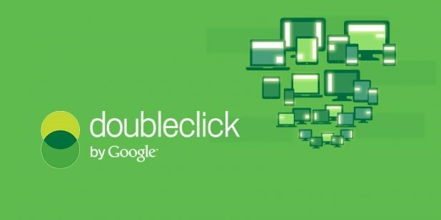
Google's DoubleClick ad server and ad exchange will now embrace TV ad inventory

It’s observations such as this that have motivated Google’s latest efforts culminating in the above product launches, with the outfit better help media owners monetize both live, plus on-demand content across screens, and even on set-top boxes, according to Ng.
“With DoubleClick Ad Insertion we’ve seen a four-time increase in ad impression from partaking partners, [which includes Time Inc, CBS and TF1] over the last couple of years,” explains Ng, also citing YouTube stats of 90% growth in watch time via connected TV.
Google also reports that the growth of connected TVs has seen it witness a 90% increase in YouTube content, a period which also saw it witness a two-time increase in ad impressions alongside its DFP partners. And with over 5m hours of news videos watched daily on YouTube – that’s 3.6-times the amount spent watching video news, according to Google data.
During her recent conference pitch, she gave further insight to the product roll outs, read below for more detail.
Google TV Content Explorer is coming to DFP later this year
TV Content Explorer will use machine learning and heuristics derived from a media owner’s content data feed, as well as other data sources to help them better monetize. This will include using the above data signals to automatically generate forecasts about which content categories will drive the most yield.
This will also include ‘insight cards’ (recently unveiled in its recent Insights Engine Project) that will contain statistics such as sell-through rates, revenues trends or opportunities, including the ability to benchmark against wider industry standards, as well as forecasting capabilities.
“With TV Content Explorer, we have really revamped the entire interface so you can better plan an sell against your content,” claims Ng.
TV modeled forecasting in DFP soon to begin
The seasonal viewership pattern of TV viewers is complex, with Ng adding that the complexities of scheduling, such as when televised sports games are played etc can lead to unpredictable spikes in traffic.
This makes the management of TV art time a difficult chore, and it is precisely for this reason that Google is soon to launch TV modeled forecasting and pacing in DFP as part of a beta trial later this year.
According to Ng, the tools will help publishers analyze historic data over an 18 month period, with Google on hand to help them analyze patterns in their audience behavior, such as organic growth, seasonal trends, as well as account for anomalies observed in their figures.
“We have leveraged a lot of Google’s scaled infrastructure, machine learning and advanced simulations to provide the most comprehensive forecasting system for video,” she states.
“We also allow you to import your offline TV data to inform our prediction models, and we can provide side-by-side views of your historic, versus future predictions, so you can get simultaneous view into availability and make adjustments where necessary,” according to Ng.
Armed with a host of statistics, Ng claims that on YouTube, Google has seen that campaigns that use intent-based targeting on mobile have 20% higher ad recall, and 50% higher brand awareness lift, compared to campaigns that only use demographic targeting.
‘Smarter TV ad breaks’ with dynamic ad insertion
Over the past year Google has observed over two-fold growth in the number of ad impressions from programmatic guaranteed deals from video in particular, according to Ng. She claims that while programmatic video presents great opportunity, it also introduces complexity into the traditional TV buying model.
This is especially the case as on-demand viewing patterns start disrupt the previously “fixed components” of every hour programing featuring certain amount of commercial time, with a fixed amount of media buyers, etc.
“However, the ability to dynamically show different users, different ads, and with real-time advertiser selection made possible through auction models and programmatic, we have to try and remember the user’s experience,” says Ng.
“This means not showing the users the same ad over-and-over again during the same show, and last year we announced the first phase of Smart Ad Breaks which unifies competitive exclusions to avoid sales channel conflicts across direct, and in-direct channels.”
Under the new updates media owners using DFP now have multiple options to monetize their air time in a way they think will maximize yield.
“We are now making it possible to make a portion, or indeed all, of your programmatic ad break available to programmatic demand partners in DFP. So you can sell your entire [ad] break, or a specific duration, at once through programmatic guaranteed deals, private, or open auction,” she adds.
New ‘mobile first’ video ad formats coming to DoubleClick
Google has conducted research with polling outfit Ipsos to better understand which types of ads audiences are more likely to pay attention to, with the study finding that users are three-time a likely to pay attention to online video ads, compared to those on conventional linear TV.
“So we want to see how we can help you deepen your engagement with mobile-first video ad formats… we believe this combination will drive higher value and revenue into publishers,” explains Ng.
These new formats include six-second “bumper ads” which can “adapt to the fact that we have limited attention spans on mobile.”
In addition, is a new “portrait video format” which has been designed to accommodate the fact that most people hold their phones in such as manner.
Also among the updates is an outstream video format, whereby ads can be placed in between the paragraphs of text-based content. This is so advertisers can serve users with ads in-article, and in-feed news in mobile web, mobile app, across desktop and across reserved programmatic deals, as well as on an open auction.
Some stats from the early tests
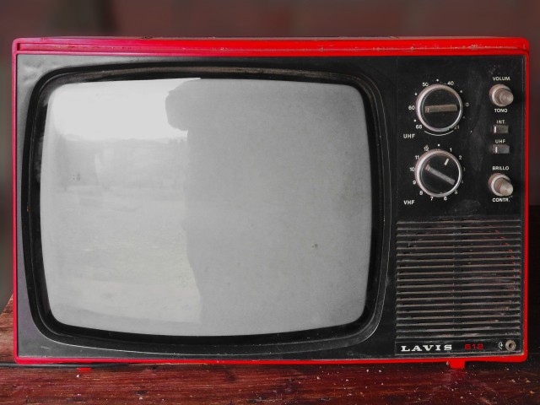The progress of TV advertising will be about evolution, not necessarily revolution, according to Ng / pixabay

Publishers to have used the formats in their early testing phase saw a three-time increase in out stream revenue, according to Ng. She also states that on YouTube, Google has seen that campaigns that use intent-based targeting on mobile have 20% higher ad recall, and 50% higher brand awareness lift, compared to campaigns that only use demographic targeting.
That’s why Google is currently running tests to let advertisers serve and against demographic data from through programmatic guaranteed using DoubleClick Big Manager (DBM).
After testing its bumper ad formats in the first half of 2017, early tests have demonstrated a “phenomenal” increase in demand and yield for publishers, according to Ng, who adds that that they helped generate a 20% CTR-lift.
Some more context
Speaking to journalists on the sidelines of the conference, Ng was also quick to point out that Google’s video ad serving platform and exchange was comparable to alternatives on the market, with the dual offering integrated into one platform.
“That allows us to do some unique things around just being able to understand directly sold campaigns, and direct relationships, along with programmatic relationships,” according to Ng.
This unified helps media owners to better manage some of the complexities of multi-channel monetization, such as understanding how best to monetize their ad inventory – “sales channel conflicts” being a common teething problem for publishers on the early steps of their programmatic strategies.
“One of the things that we’ve seen with some of the partners with we’ve worked with such as CBS is that they’re trying to work out how they embrace this new paradigm shift, and thinking about how new streaming services coexist traditional television,” she says.
She recounts how the broadcaster adopted a novel approach to the debut of its recent Star Trek reboot which entailed premiering the first episode on traditional linear TV channel, with subsequent installments only available on its streaming service.
“On that day they saw the highest number of [streaming service] sign ups,” she said. “As we think about the convergence of TV and digital, it’s not about TV replacing digital, it’s about bringing the best of both.”

