Creating a Network Virtual Machine

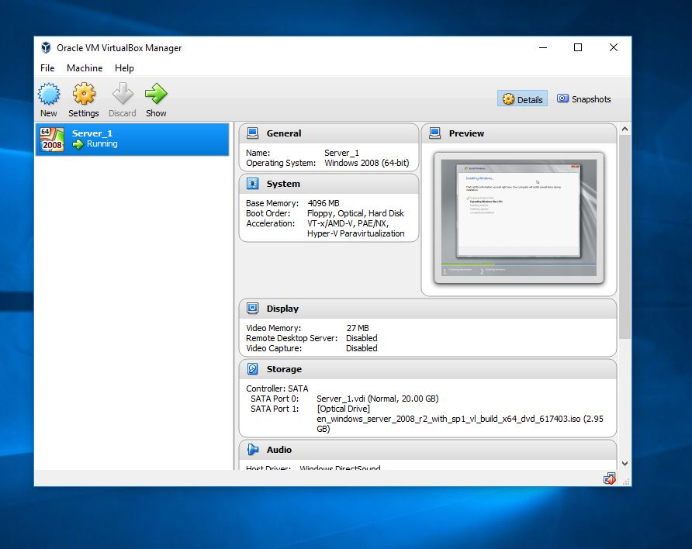
The above diagram shows, that server 1 has been created successfully
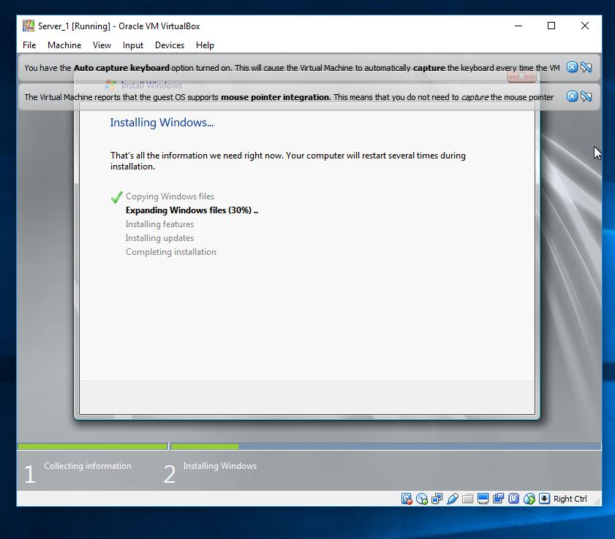
Following the guided steps.

Server 1 is currently running, and installing windows server software
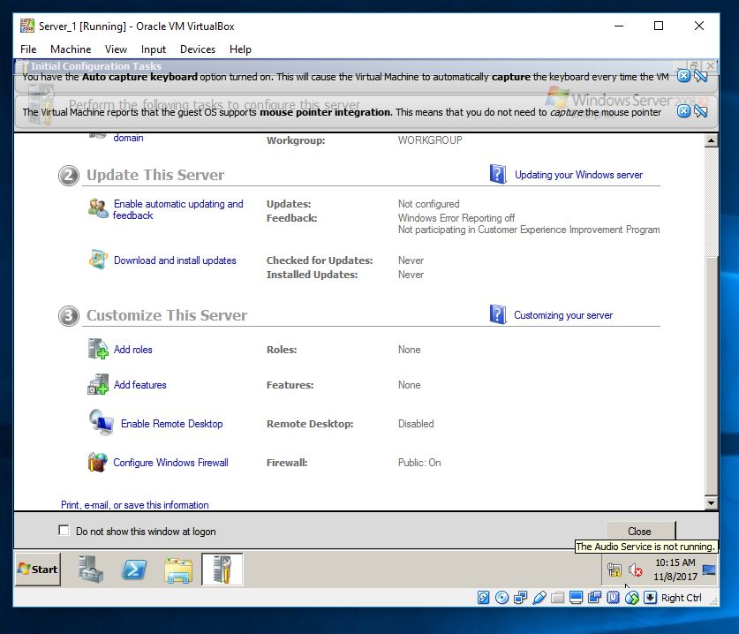
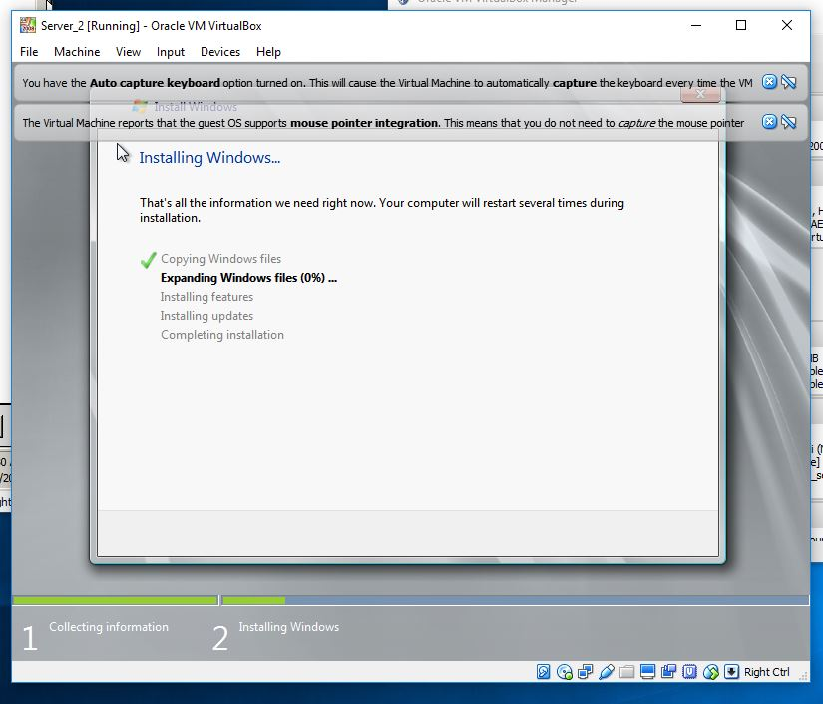
We had to turn off the windows firewall, so communication could commence.

Once server 2 was created successfully, I then went on to download windows server software.

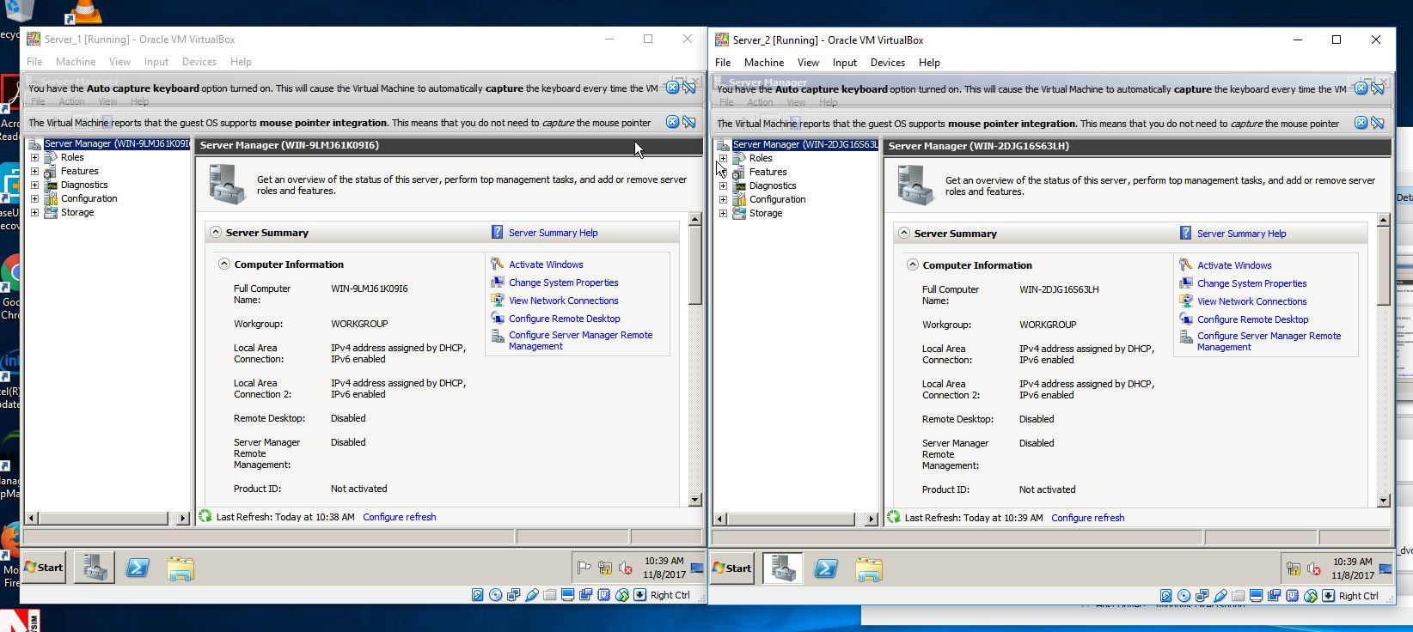
The above image shows, both servers running, side by side.
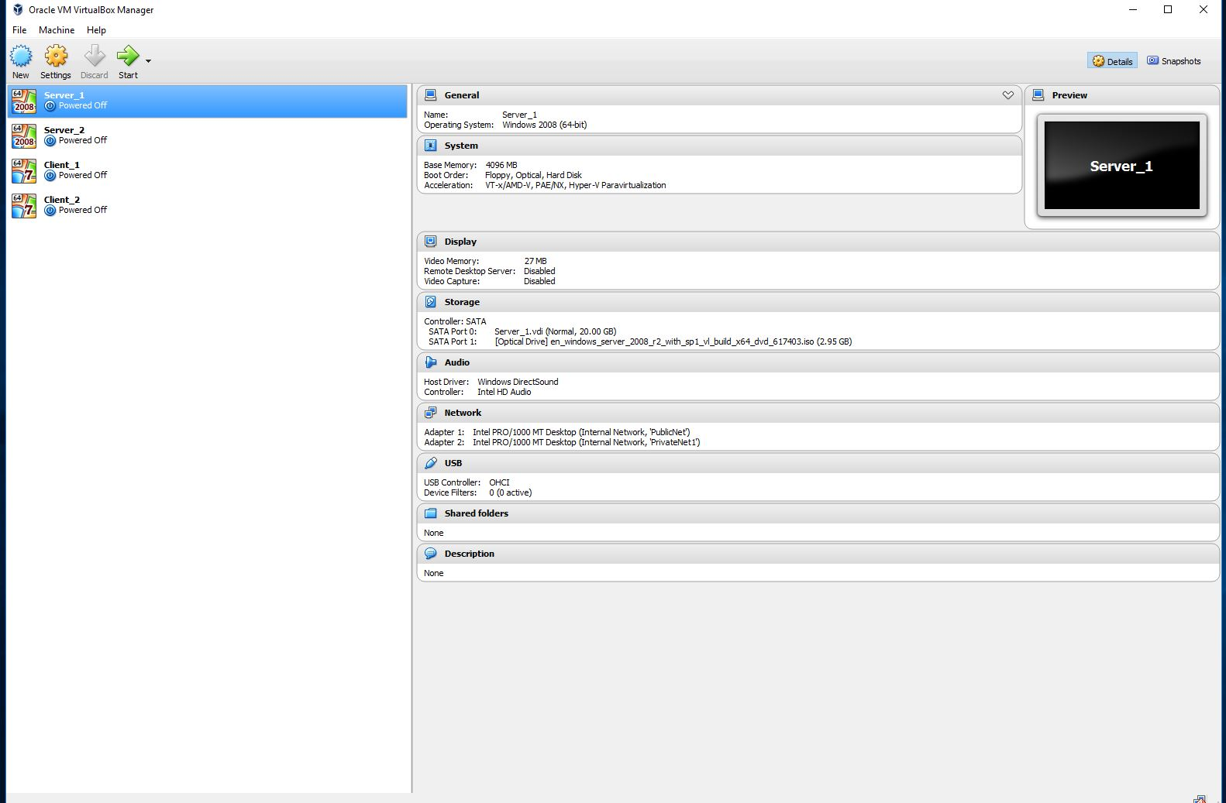

Following the guide, I created two clients which now need to talk to the servers, once the necessary software is installed on them.

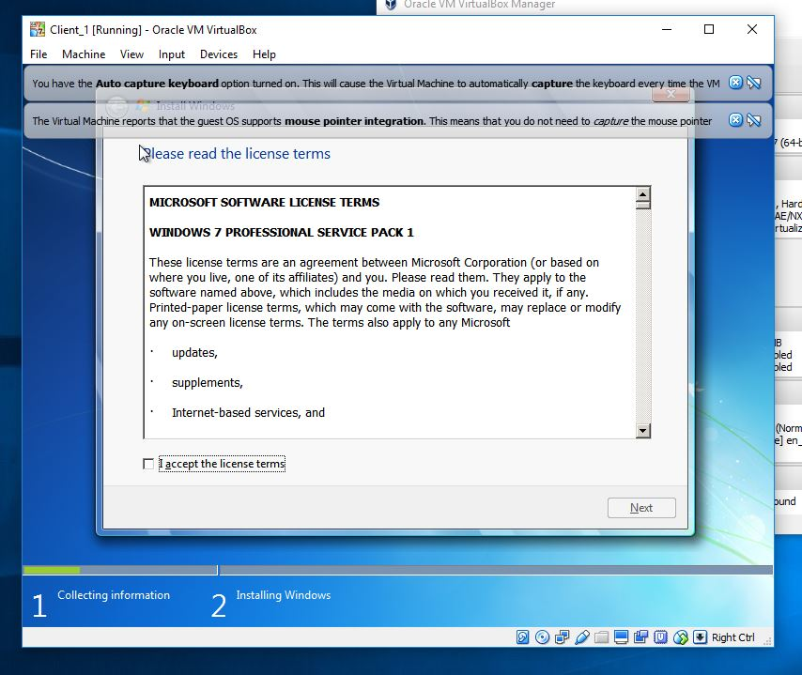
Windows version 7 downloading on to client 1.
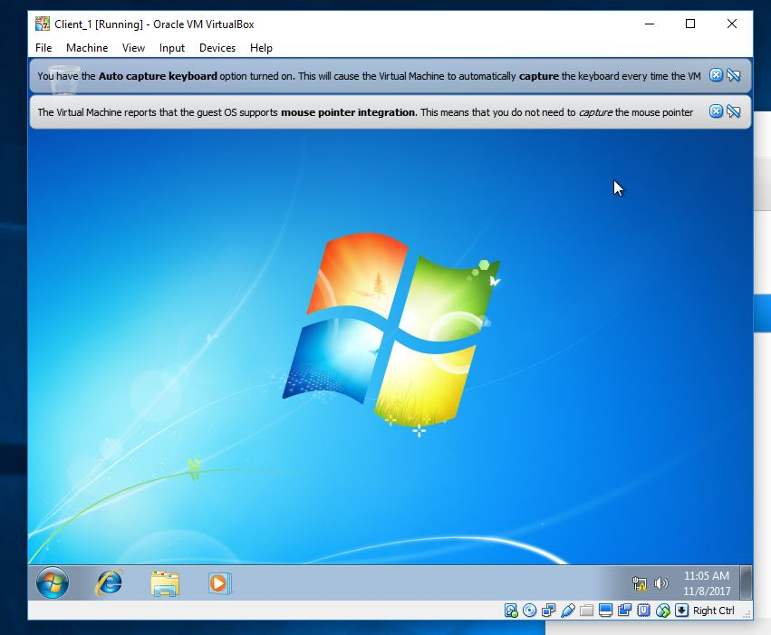

Windows 7, up and running on client 1
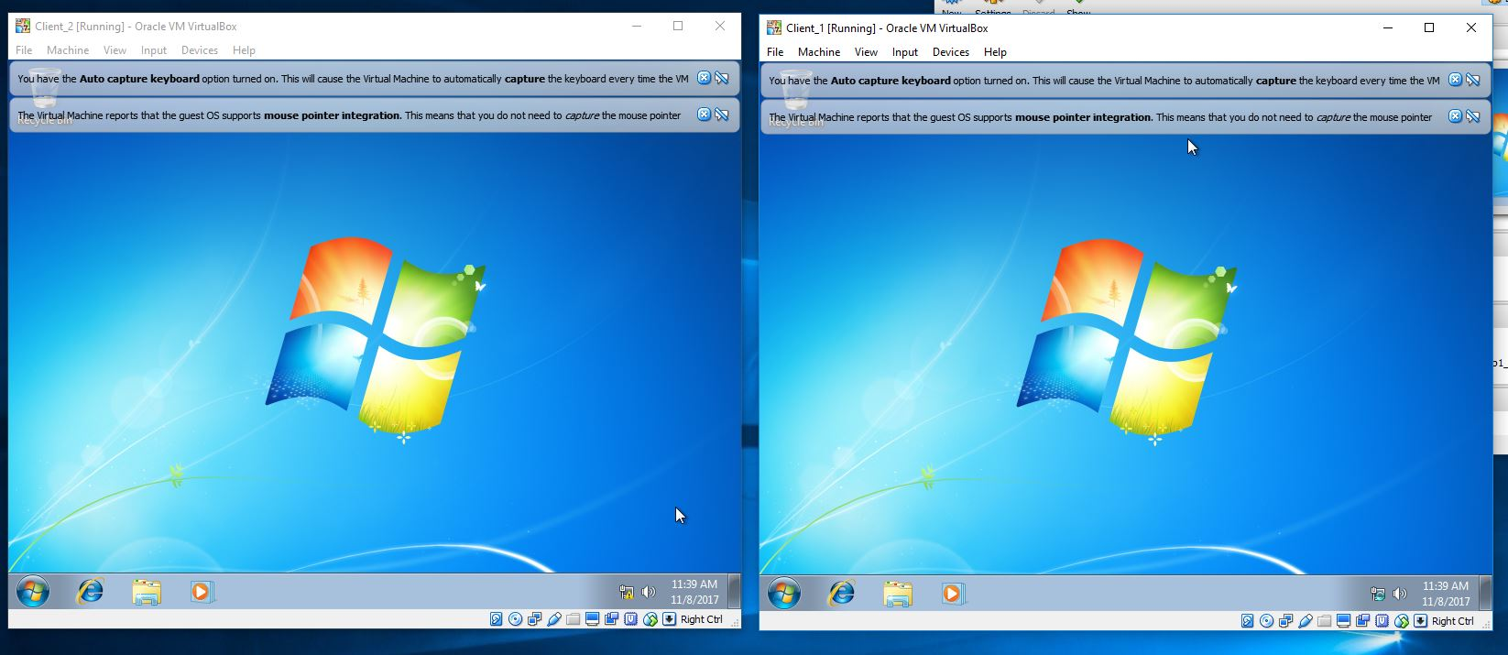
Image shows, both clients running windows 7.

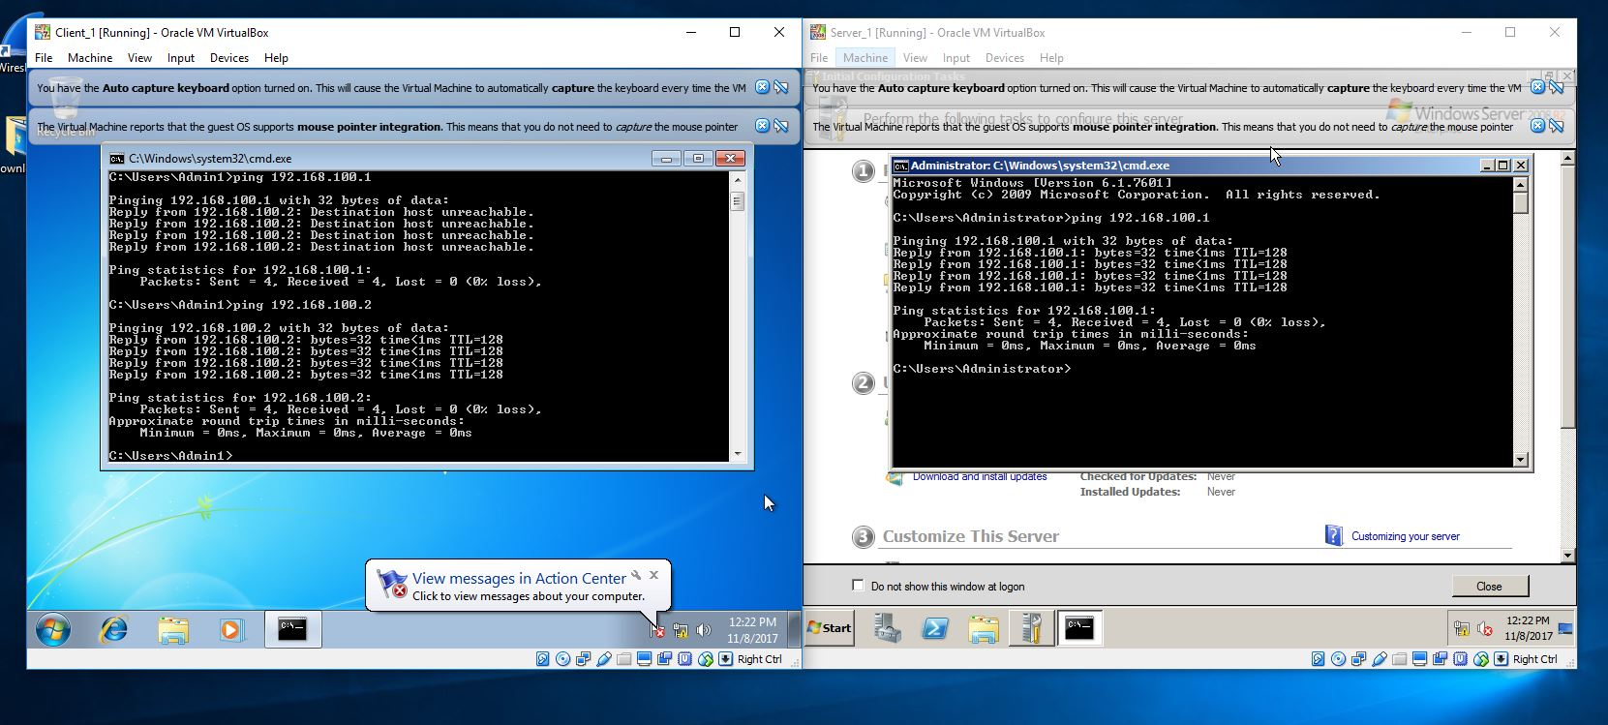

Image shows, client 1 is communicating with server 1, once I inserted the right information into client 1.

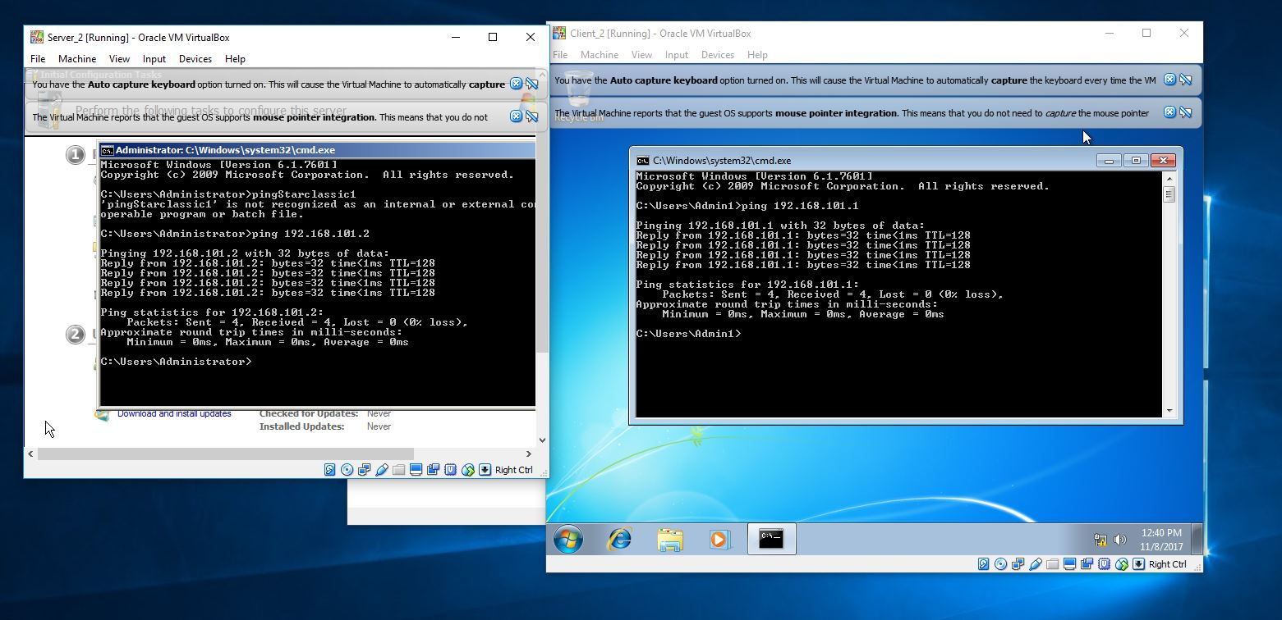

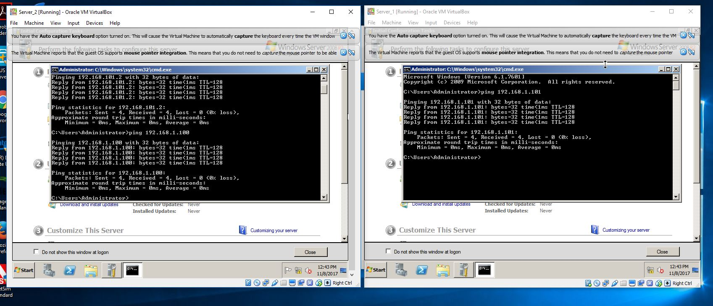
Server 2 and Client 2 both communicating through Ping.

Both servers are communicating.

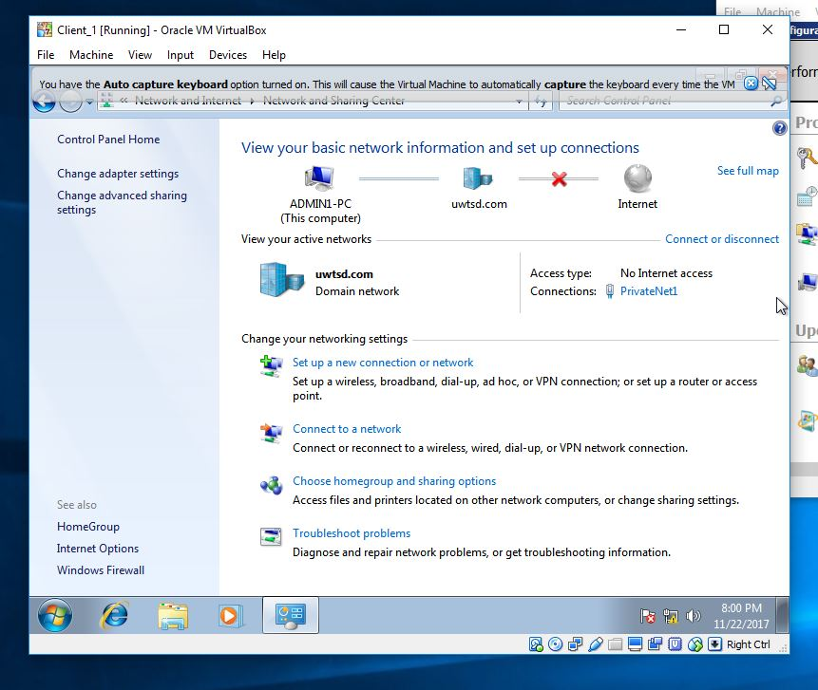

Client 1 shows that, a domain has been created, named ‘uwtsd.com’
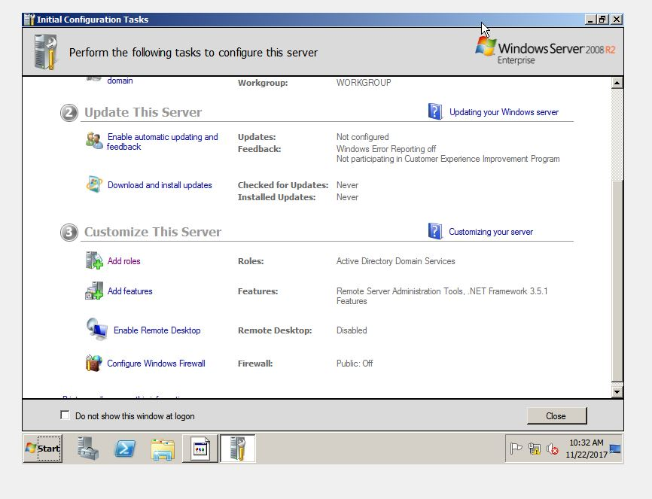

The above image shows that the server role is, Active Directory Domain Services.

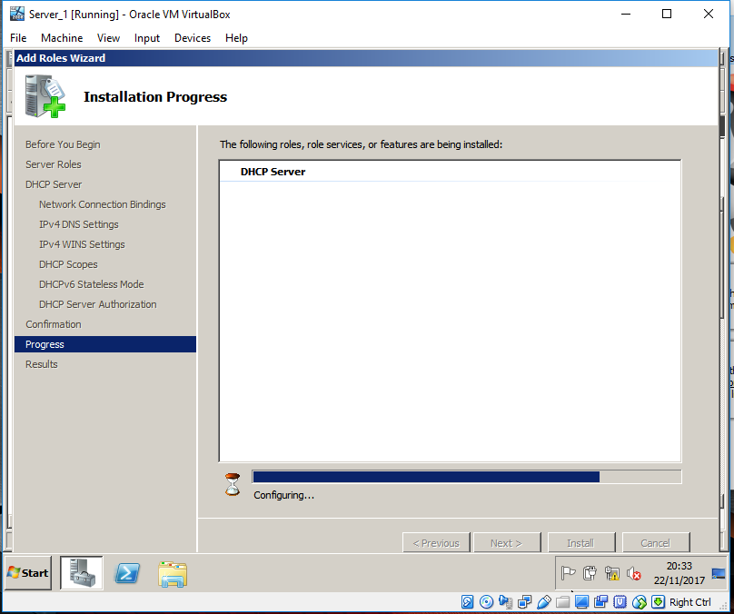
Installing the DHCP server.

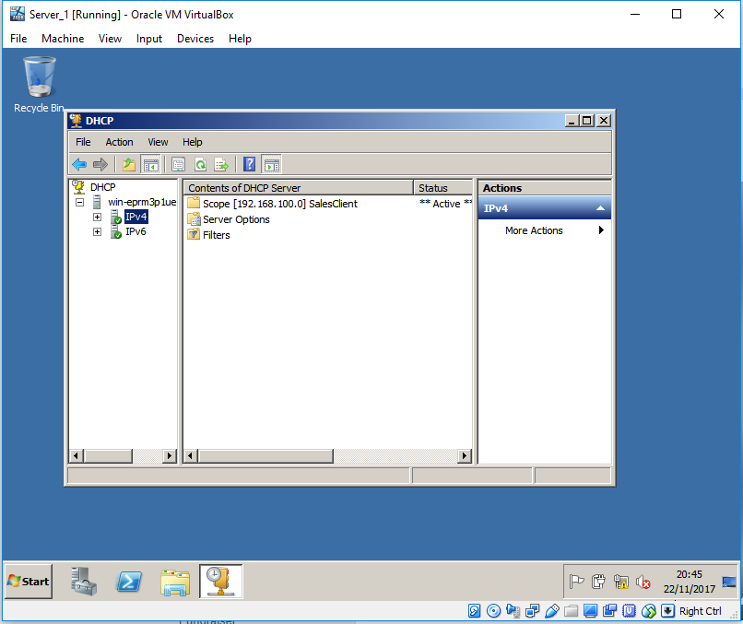
Installing and configuring the DHCP on server 1.
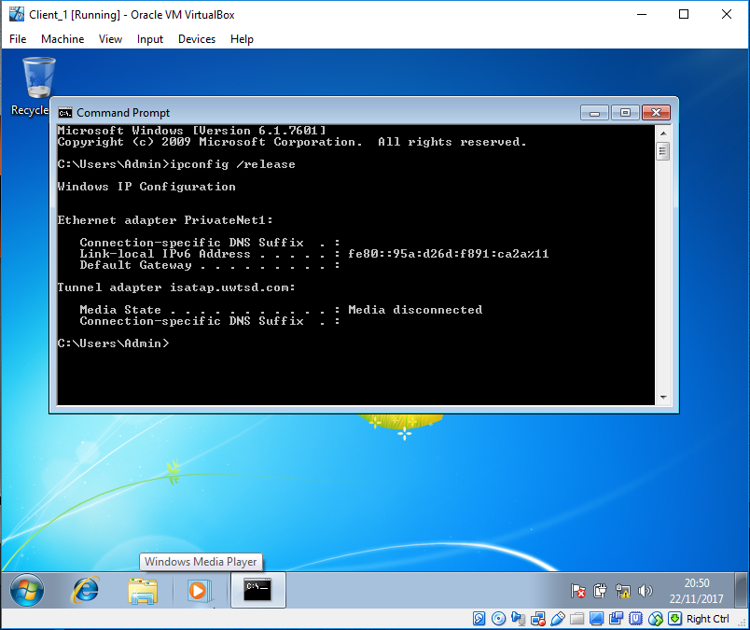
Using the IP Config Release command.

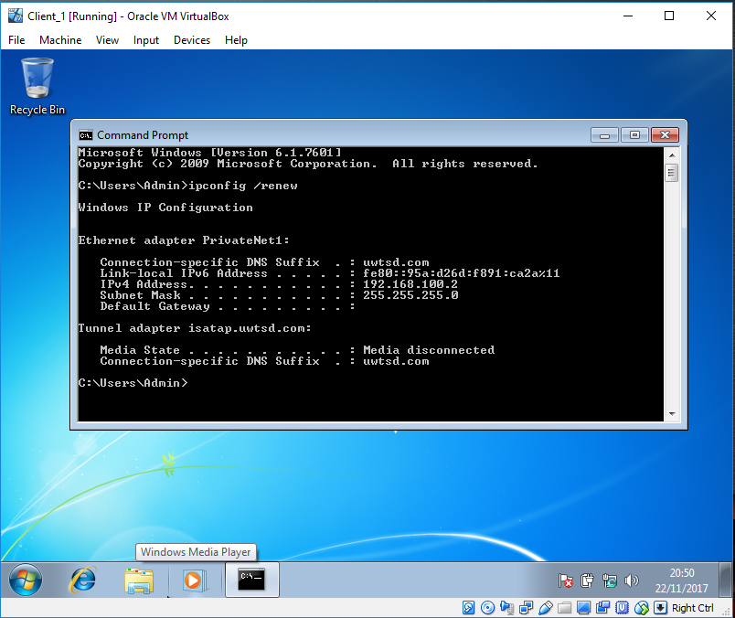
Using the IP Config Re-New command on client 1.
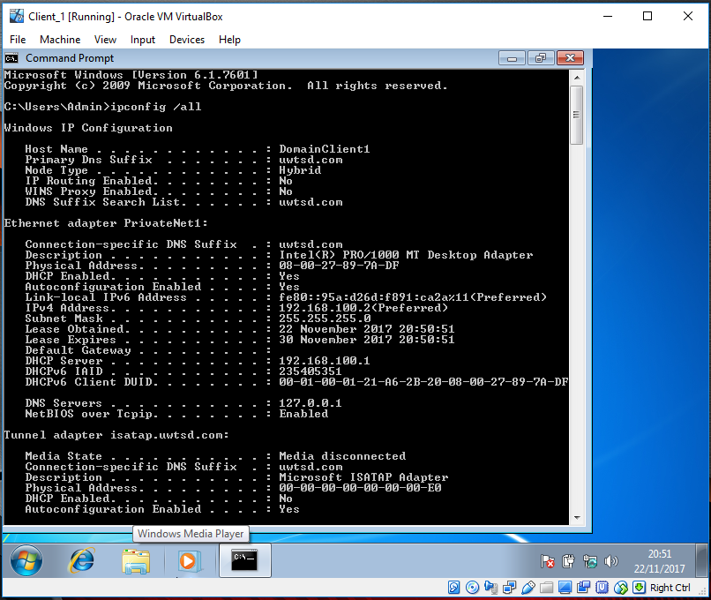
Using the IP Config ALL command on Client 1.

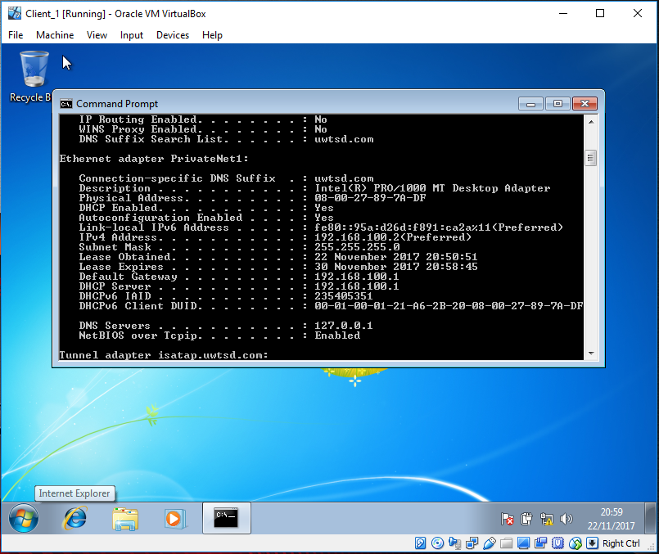
Image shows, the workings of the PrivateNet1.

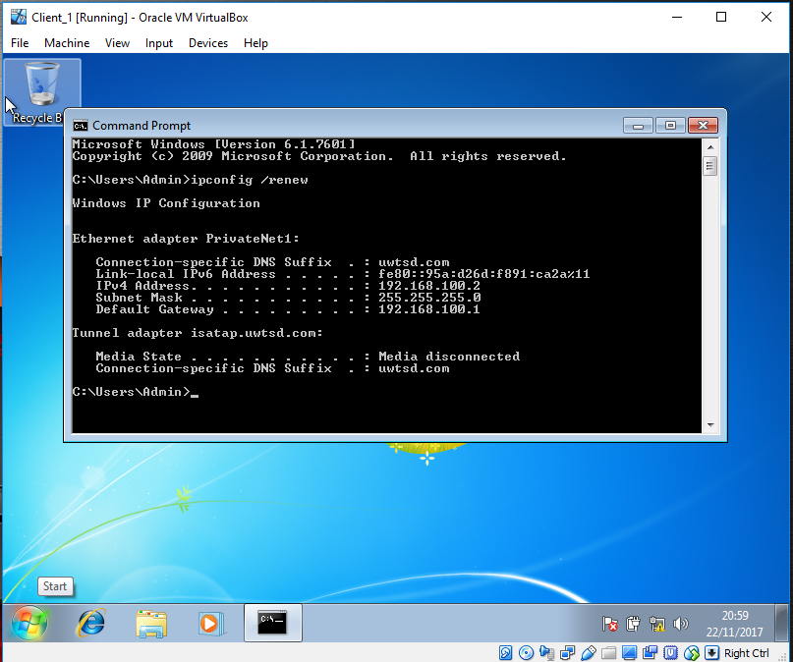
Image shows that client 1 is being assigned a default gateway.

Observational Tasks 1
a)
there are several benefits for using hypervisor software, while designing VM’s. The most prominent being, that hypervisors can support multiple Operation systems on a single hardware system. This is turn can lead to reduced costs, as less PC’s are required, and server hardware can also be decreased.
The Set- up of many virtual machines can be an advantage and make the creation easier and flexible, as cloning VM’s can be easy to produce, and if one just happens to be faulty, you can just remove and start all over again, without causing any damage to hardware or software.
I have come to realise that using VirtualBox has far more advantages than disadvantages, while creating my network. One of the major pro’s is that the software is fundamentally free, and can be used on different platforms, although different expansion packs can be added for a small fee.
I found the software very user friendly, so can be accessible from mid to hardened users, and overall found VirtualBox fast in operation, with the avoidance of dualbooting a big bonus.
There are only a few flaws in using VirtualBox, which I must admit, did not affect me at all in the process of making my network, but unexplained/none operation, was evident with other student’s networks, in which they had to start all over again. This software can also be slightly confusing if you were a novice, who has no technical knowledge of networking.
b)

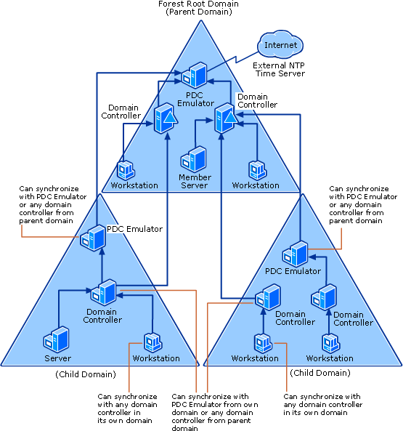
Fig 1 Directory Forest
The above image (Fig 1) [1] shows an active directory forest, which contains trees, parent and child domains.
Parent Domain – this domain holds the administrative rights, and sits at the top of the domain tree, giving two-way transitive trust, to the child domain. (e.g. if domain A trusts domain B, and domain C trusts domain D, the transitive trust means that all the domains can trust each other).
Child Domain – these sit directly under a parent domain and creates a domain tree. These types of domains can be allocated to different departments of a business and can give the capabilities of safeguarding from restructuring the domain hierarchy if reorganisation and reshuffle happens within the structure of the business. [2]
Directory Forests/Trees - The forest is a collection of one or more domain trees, and all trees exist within a forest, and the forest is the security boundary. Trees have the same DNS name from the top to the bottom, the forest can contain multiple trees, which can have different DNS names, but have the same administrative unit. [3]
c)
the domain controller is a physical machine that holds the active directory database, its responsible for authorising all users within the domain and applying group policies on the machines.
The main responsibilities of the active domain controller are to make sure that the right users are allowed to access the network, and that the computer system is a part of the domain network. Security settings are also applied and any other changes that need to be assigned, once the user has logged in. Once a user has become apart of the domain, the DC will determine whether they are a standard user, or apart of the system administration, and give the right licence to that user. [4]

d)
If a certain domain controller becomes unavailable, the user can still be allowed access, as the domain can still operate. This is managed by all domain controllers which are available in the domain, need to communicate and update with the other DC’s on a regular basis. But all this does depend on the infrastructure of the DC’s, being used by the individual or business. [5] [6]

References

[1] | t. article, "microsoft," [Online]. Available: https://social.technet.microsoft.com/wiki/contents/articles/18573.time-synchronization-in-active-directory-forests.aspx.
[2] | microsoft, [Online]. Available: https://technet.microsoft.com/en-us/library/cc759073(v=ws.10).aspx.
[3] | pcmag, [Online]. Available: https://www.pcmag.com/encyclopedia/term/43400/forests-and-trees.
[4] | microsoft, "technet microsoft," [Online]. Available: https://technet.microsoft.com/en-us/library/cc780036(WS.10).aspx#w2k3tr_ad_over_qbjd.
[5] | microsoft, "technet," [Online]. Available: https://social.technet.microsoft.com/Forums/windows/en-US/648e44c7-ee95-42ab-adc4-120fa7010fb7/what-if-what-if-domain-controller-is-unavailable-for-site-a-but-domain-controller-is-available-in?forum=.
[6] | "techopedia," [Online]. Available: https://www.techopedia.com/definition/4193/domain-controller-dc.

