Construction Materials- Semester 2
Royal national theatre, London

Concrete Frame Analysis

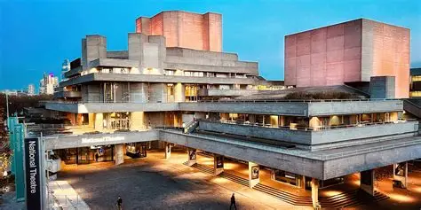

Fig 1. National Theatre London

By Charlie Mckenzie (2516471)

Table of contents
- Elements of the National Theatre, London
  - Brief
  - Original Design
  - Method of Construction
- Analysation of the framing material
2.1 Strength, durability and resistance to climatic conditions
2.1.1 Galvanised Reinforced Concrete vs Standard Reinforced Concrete
  - Time, Labour, Programme and cost when comparing to Steel Framing
2.3 Ease of Assembly and Adaptation Over the Buildings Life Cycle
2.4 End of life Demolition Challenges
  - The problems faced by the integration of services
3. The negatives to concrete process and production
- Sieve Analysis
- Reference List

- Elements to the National Theatre, London
  - Brief
Designed and constructed by Sir Denis Lasdun, the National Theatre London is one of the Uks largest examples of brutalist architecture. The building is “characterised by its use of raw concrete and its innovative approach to urban space” London Museum. (2024). The National theatre is located on the south bank of the river Thames, with Layered terraces implemented to the theatre to align with the surrounding environment such as the outskirts of the Thames. The choice of concrete by Lasdun was predominantly due to the expression for his design philosophy. The building was originally designed by Lasdun in the early 1960s but during the buildings later refurbishment from 2007-2015, it was then taken over by Haworth Tompkins. Tompkins undertook this £80m programme, being the most significant change to the building since opened in 1976.
  - Original Design
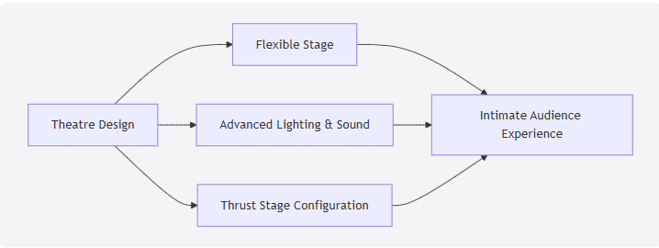
Fig 2. Olivier Theatres design
Designed and completed in 1976, Lasdun intended for the building to be set as layered concrete terraces which would then aesthetically place itself working around the slope of the bank. Lasdun started the design by working around three separate auditoriums, all of which constructed using reinforced concrete. These separate auditoriums were designed individually, “Each theatre complex was individually designed to suit its performance type” Architecture Lab. (2025). All three of the auditoriums were designed before the exterior shape and was Lasdun’s focus to perfect these concrete “boxes”. Due to the Olivier theatre being the largest out of the 3 auditoriums, it required a drum like design and structure which was concrete framed. Concrete framing allowed for a bowl structure and furthermore a stage tower which ultimately acted as an anchor.
Like the Olivier theatre, when designing the Lyttelton theatre it required a deep area, also inclusion of a straight-lined concrete enclosure for structural purposes. The installation of the three main theatres gave Lasdun the next step too the buildings design. Due to the initial design of these theatres, it meant Lasdun had to prioritise using reinforced concrete as there was no inclusion of internal support. The auditoriums height and position indicated the large massing; therefore, the inclusion of fly towers was necessary. “A fly tower in a concrete theatre is a crucial component that allows for the suspension and movement of various pieces of equipment, such as lighting, scenery, and props” Theatrecrafts.com (2025). Terraces as mentioned, acted as glue for Lasdun’s design.
The Three different Auditoriums
Auditorium | Structural Form | Design | Materials Purpose
Studio Theatre | Flexible concrete enclosure | Created for trial/experimental productions with internal seating | One purpose for the concrete on this auditorium is that it will ensure a rigid structure shell, and it will improve the frames isolation
Lyttelton Theatre | Concrete rectangular perimeter | Designed initially for frontal theatre and traditional production | The reinforced concrete used forms deep spanning beams, which again will reduce the need for internal columns that benefit structure
Olivier Theatre (the largest of the 3) | Drum- shaped with steep layered seating and an open stage | This auditorium is used for open staging and large productions | With the use of reinforced concrete, this allows the auditorium to become column free

Fig. 3 Different Auditoriums
  - Method of Construction
Looking from an external view, it’s clearly visible that the national theatre has been built and constructed by using reinforced concrete. The functional advantages that the method included, certainly played a crucial part to Lasdun’s design. Such as its “strength and durability, Versatility in design, Fire resistance, cost effectiveness and sustainability” (Southeast Farmwork,2025). The choice of method was significantly due to the creation of heavy and large structural forms that Lasdun had in place. The mouldability that reinforced concrete has, allows for large shapes to be curved for the structure of the auditorium’s to then be designed uniquely.
The introduction of two fly towers to the method meant that these towers had the responsibility to act as load-bearing points. Alongside that responsibility, the fly towers also are used for supporting the upper roof structure, stage machinery and lighting gantries.
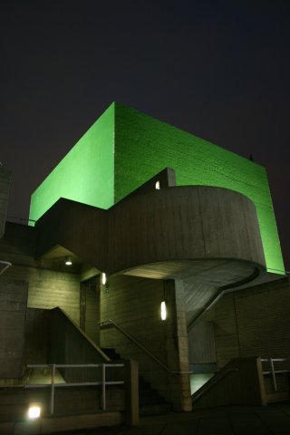
Fig. 4 National theatres Fly tower
The construction process for the theatre had to be exactly precise and to the point of perfection for Lasdun. The structural system was constructed using layered concrete pours, which then enabled the terraces to fix and connect the auditoriums. The decision for the theatre to be left raw gave it its brutalist character.

- Analysation of the framing material
The core of the national theatre as mentioned is made up of reinforced concrete. The choice of Reinforced concrete was predominantly for the materials strength and the durability it provides. As a location overview for the theatre, London’s climate is wet and cloudy. In this case it will have large effects exposed concrete.

  - Strength, durability and resistance to climatic conditions facing the structure
The Location of the national theatre includes a great exposure to the river Thames, which exposes the structure to most of the Thames moisture. The strength and durability of the reinforced concrete made Lasdun’s decision to create this “brutalist building”. Reinforced concrete can “withstand heavy loads and environmental tensile stresses without cracking, spalling, or breaking” (FMP Construction Marketing (2025).
The reinforced concrete was produced to a precise calibre, guaranteeing that the creation of the Beton brut (raw concrete) was correct. The attention to the cement mix will support any surface failure and avoid the likelihood of microcracking. “Constructed using 1000 t of galvanised reinforcement in external parapet walls to ensure that these most exposed parts of the building were free from spalling and staining”Galvanized Rebar. (2016). National Theatre, London - Galvanized Rebar”. The galvanized reinforcement also known as steel rebar within the concrete, was desired by Lasdun mainly to ensure that the durability of the theatres exposed reinforced frame was long-term. The environmental conditions conflicting from the Thames consist of Dirt, rainwater and airborne salts. With corrosive weathering and environments of such, this is the reason Lasdun needed the frame to be long-term and for little work to ever be done to the building in future times.

    - Galvanised Reinforced Concrete vs Standard Reinforced Concrete

 | Galvanised RC | Standard RC
Durability | The Zinc layer delays the corrosion and prevents spalling and staining. | Easily affected by chloride and carbonation, which can ultimately damage the steels protective layer and start the process of corrosion.
Strength | The structural strength is both the same but Galvanised RC will retain performance longer due to corrosion protection. | Standard RC’s has compressive strength and great tensile capacity, but corrosion weakens the bond and reduces long-term structural reliability.
Resistance to moisture and salts/ chlorides | The Zinc coating will protect steel during wet and prolonged exposure.  There will be a strong resistance due to the sacrificial zinc layer which comes across as ideal for the Thames side exposure. | Moisture reduces alkalinity and the corrosion rate to steel.  On the other hand, there is a high risk of chloride induced corrosion in the environment around the riverside.
Fig.5 Comparison of Concrete
Architectuul. (n.d.). Royal National Theatre
HIC | an archive of architectures and other things. (2025).
Visar Krelani, Ahmeti, M. and Driton Kryeziu (2025).

  - Time, Labour, Programme and cost when comparing to Steel Framing
The high demand for tonnes of galvanised rebar also required a large volume of in-situ concrete. With large amounts of wet trades work meant that the theatres had to be slowly poured through staged pours and took an increased number of hours. Focusing on a steel frame, prefabricated universal columns, beams and a rigidity system like a X-bracing or K-bracing allow quicker construction and a straightforward programme. However, with Lasdun’s terrace design, using a steel form would have to include a fire protection driving the costs higher and generalised risks. “The strength of steel reduces at elevated temperatures” Steelconstruction.info (2014). Fire and steel construction. Therefore, when a large fire is to breakthrough the building would have no chance of support from the steel structure. Reinforced concrete became the best option for the design desired by Lasdun. Now considering the programme risk, Reinforced concrete instead of steel was considered a lower risk. Due to the building having irregular shapes, the steel frame would demand many temporary supports and advanced installation steps that would cause negative implications within the process.
  - Ease of Assembly and Adaptation Over the Buildings Life Cycle
The frame of the National theatre was not straight forward to construct, with key parts such as large projecting platforms and large seating areas positioned precisely internally. These key elements to the building require careful load sequencing and certainly multi-staged framework. Also, the later adaptations in 2015 to the building was a difficulty due to the usage of reinforced concrete. The difficulties occurred when cutting openings into the concrete and possibly hitting any surrounding rebar affecting its structural strength. An example for when openings had to be cut was during the refurbishment and by adding glazed openings required stage removal. Steel on the other hand, is a much easier solution when trying to refurbish or adapt from the Theatres point of view. Overall Reinforced concrete is known for being a slow process and needs specialist strengthening.
  - End of life Demolition Challenges
Demolition challenges at the end of life for Reinforced concrete will be challenging and a complex process for the National Theatre. The main challenge for the building being the environmental deconstruction process. “The NT is always ‘questioning our impact on the environment’ and ensures productions to follow the theatre green book, a set of guidelines to minimise environmental impact” (Hines, D. (2023).) The national Theatre is placed in an area where the environment is monitored, and its reduction to lower carbon output shall be achieved when demolition occurs. Due to the characteristics and the nature of the reinforced concrete, comes large amounts of noise pollution and dust which again would be against the Theatre green books regulations.
‌

  - The problems faced by the integration of services
The original design for the national theatre simply did not have any intention to consider later services. With Lasdun’s brutalist frame, further meant that any smaller changes to the building would require high levels of care due to the concrete’s structural forces. A change being the inclusion of ducts, drainage or electrical works. All these services needing a specialist to carefully drill to ensure rebar isn’t struck and structural integrity remains the same. As of any future upgrades and creations, this will only bring complications to Lasdun’s reinforced framing and large amounts of pressure to the maintenance team at the theatre, who will need to collectively find new routes for the new services.

- The negatives to concrete process and production
Concretes broad production has numerous negative impacts, where both the environment and community will be affected. The cement element of production is known for releasing high levels of Co2. This Co2 will contribute highly to climate and the carbon footprint when large jobs include concrete in their construction. “In fact, cement accounts for around 8% of all CO₂ emissions worldwide” Gregory, J. (2021). Concrete. Taking end of life into consideration again, increased amounts of waste are generated which then rely on an intensive source of energy to dispose of in a correct manor. Linking this to Lasdun’s building, is a key example to large projects having such a high concrete demand and leaving a significant carbon footprint. The theatre also clearly demonstrates long term consequences from carbon heavy production which is demanding for a more efficient and sustainable solution to its construction.

- Sieve Analysis
As shown in the table below we can see that the fine material is 56.56%, the coarse material 40.4 % in this material and 4.4% silt. This indicating to us that this is a well-rounded mix. With both Coarse and fine material having such a large presence means that this mix is going to improve its packing density. However, in this mix 4.4% of silt can have negative implications to the strength of the bond with cement paste and ultimately weaken the mix. The recommendation for a strong threshold in a mix is for the silt levels to be approximately below 3-4%. Even though the distribution of the particle size is within a positive scope, this sample would not be affected as for direct usage.

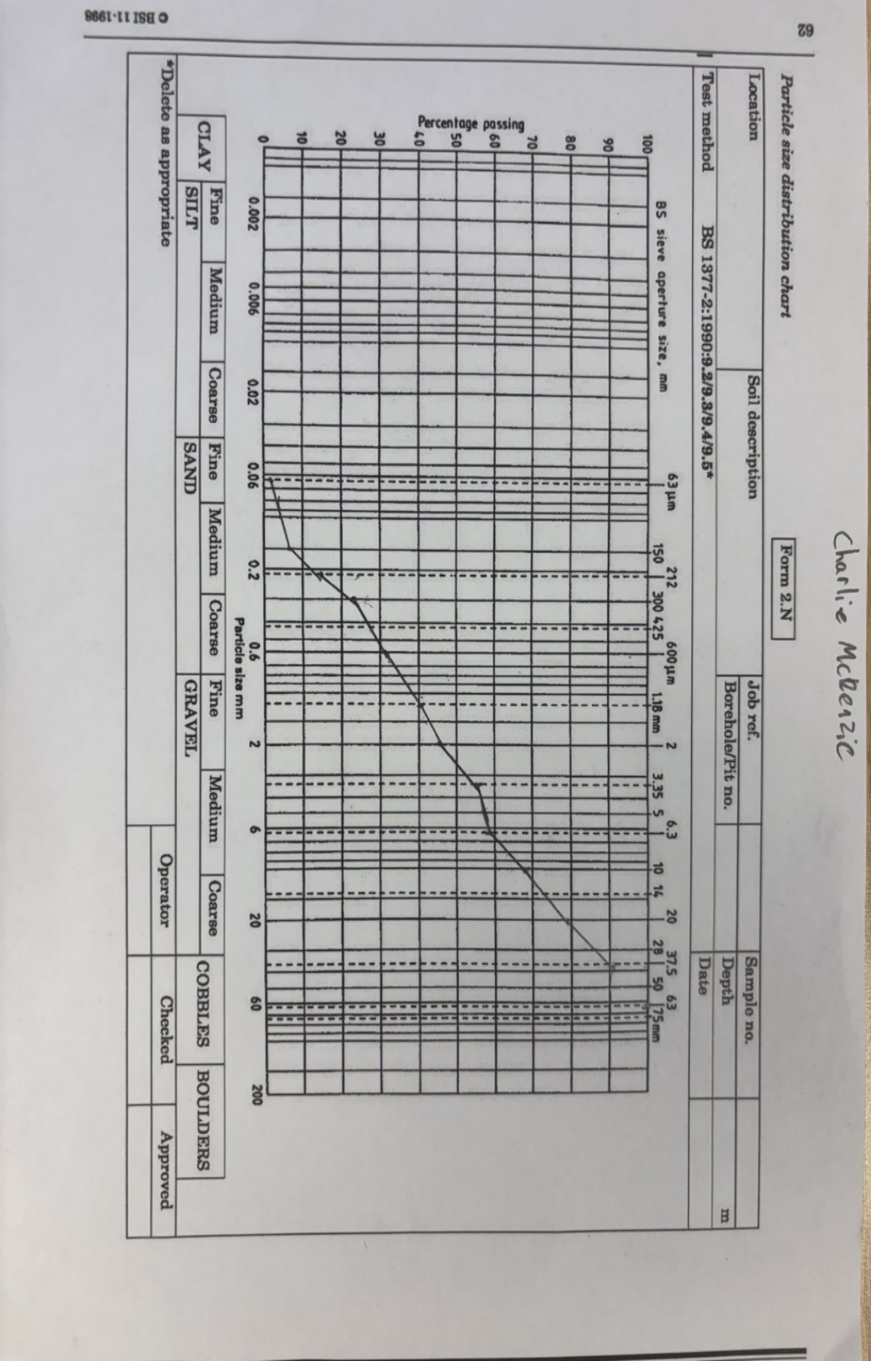

- Reference list
London Museum. (2024). London’s Brutalist buildings. [online] Available at: https://www.londonmuseum.org.uk/collections/london-stories/londons-brutalist-buildings/.
Architecture Lab. (2025). Royal National Theatre / Denys Lasdun | Classics On Architecture Lab. [online] Available at: https://www.architecturelab.net/royal-national-theatre-denys-lasdun/.
admin13 (2025). South East Formwork. [online] South East Formwork. Available at: https://southeastformwork.co.uk/top-5-advantages-of-using-reinforced-concrete-in-structural-projects/.

‌FMP Construction Marketing (2025). Reinforced Concrete and its Value for Building Materials - FMP Construction. [online] FMP Construction. Available at: https://fmpconstruction.com/reinforced-concrete/.
Galvanized Rebar. (2016). National Theatre, London - Galvanized Rebar. [online] Available at: https://www.galvanizedrebar.com/project/national-theatre-london/ [Accessed 11 Mar. 2026].
Steelconstruction.info (2014). Fire and steel construction. [online] www.steelconstruction.info. Available at: https://www.steelconstruction.info/Fire_and_steel_construction.
Hines, D. (2023). National Theatre joins London venues to create first sustainable production centre. [online] Evening Standard. Available at: https://www.standard.co.uk/culture/theatre/national-theatre-london-rufus-norris-sustainable-production-centre-b1088429.html.
Gregory, J. (2021). Concrete. [online] MIT Climate Portal. Available at: https://climate.mit.edu/explainers/concrete.

Fig 1: Swain, M. (2022). Your complete guide to the National Theatre in London. [online] London Theatre. Available at: https://www.londontheatre.co.uk/theatre-news/news/your-complete-guide-to-the-national-theatre-in-london.

Fig. 2 : Lee, S. (2025). Discovering Olivier Theatre at National Theatre. [online] Numberanalytics.com. Available at: https://www.numberanalytics.com/blog/olivier-theatre-national-theatre-guide [Accessed 2 Mar. 2026].
Fig. 3 Different Auditoriums
Fig. 4 National theatres Fly tower: Ackroydandharvey.com. (2025). FlyTower | Ackroyd & Harvey. [online] Available at: https://www.ackroydandharvey.com/flytower/

Fig 5.
HIC | an archive of architectures and other things. (2025). Denys Lasdun > The National Theatre | HIC. [online] Available at: https://hicarquitectura.com/2025/06/denys-lasdun-the-national-museum-1967/. [Accessed 17 Mar. 26]
Architectuul. (n.d.). Royal National Theatre. [online] Available at: https://architectuul.com/architecture/royal-national-theatre. [Accessed 17 Mar. 26]
Visar Krelani, Ahmeti, M. and Driton Kryeziu (2025). Increased Durability of Concrete Structures Under Severe Conditions Using Crystalline Admixtures. Buildings, 15(3), pp.352–352. doi:https://doi.org/10.3390/buildings15030352
‌

