Source Type & Why It Is Appropriate | URL/DOI | What search engine did you use? Google/Online Library/Library AI Assistant | Keywords/Boolean Operators Used
Talk about the employability skills of business graduates | https://librarysearch.uwtsd.ac.uk/permalink/44WHELF_UWTSD/lrq2gq/cdi_crossref_primary_10_1108_ET_10_2015_0094 | Library AI Assistant | What employability skills do business graduates need to succeed in the modern workplace
Talks Communication skills | https://www.bing.com/search?q=+the+employability+skills+of+business+graduates+journal+article&qs=GS&pq=+the+employability+skills+of+business+graduates+jou&sc=10-51&cvid=2650D80735B54BB28C65B54990B27F0F&FORM=QBRE&sp=1&ghc=1&lq=0 | Google | Graduate Employability of Business Students (Administrative Sciences, 2022)
Task 1: Locating Sources
Identify and locate three different sources (a report, a journal article, and a website) related to the question
“What employability skills do business graduates need to succeed in the modern workplace?”
Show how you used keywords, search terms, and Boolean operators to find them, and explain how you know which type of source each one is and why it is appropriate for the research question.

Task 2: Evaluating Information (CRAAP Test)
Your colleague has forwarded you a source from a peer reviewed journal, and they are not sure whether it is appropriate to use and has asked for your help. Your task is to evaluate the source by using the CRAAP Test to assess its appropriateness.
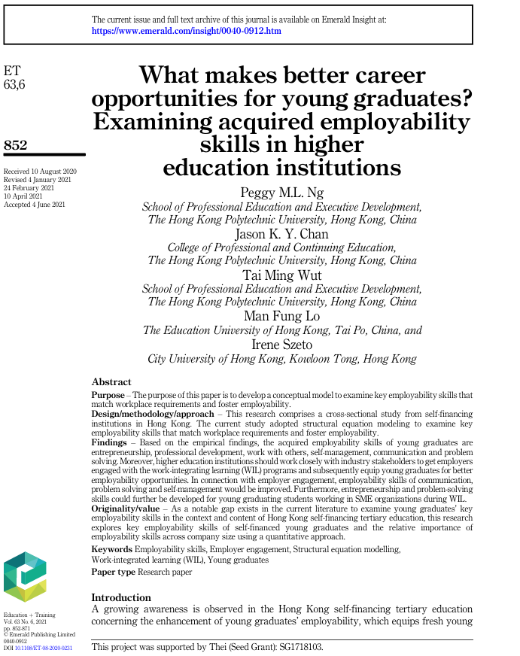

CRAAP Test
Currency | Received 6 years ago on 10 august 2020 and also accepted on 4 June 2021.
Relevance | They gave us an information about opportunities for young graduates are entrepreneurship professional development and work with others .
Authority | Peggy M.L. Ng  Jason K.Y. Chan  Tai Ming Wut  Man Fug Lo  Iren Szebo
Accuracy | Key employability skills across company size using a quantitative approach
Purpose | Talk about better career opportunities for young graduates .

Task 3: Source Analysis
Your manager has provided you with a short extract from a source and has asked you to analyse the source by Identifying one strength, one weakness, and providing a brief explanation of the strength and weakness identified.
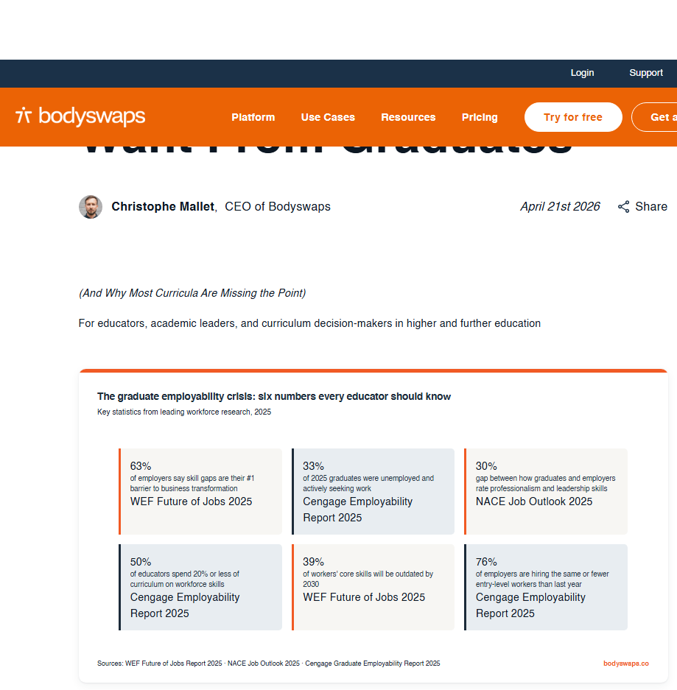
.

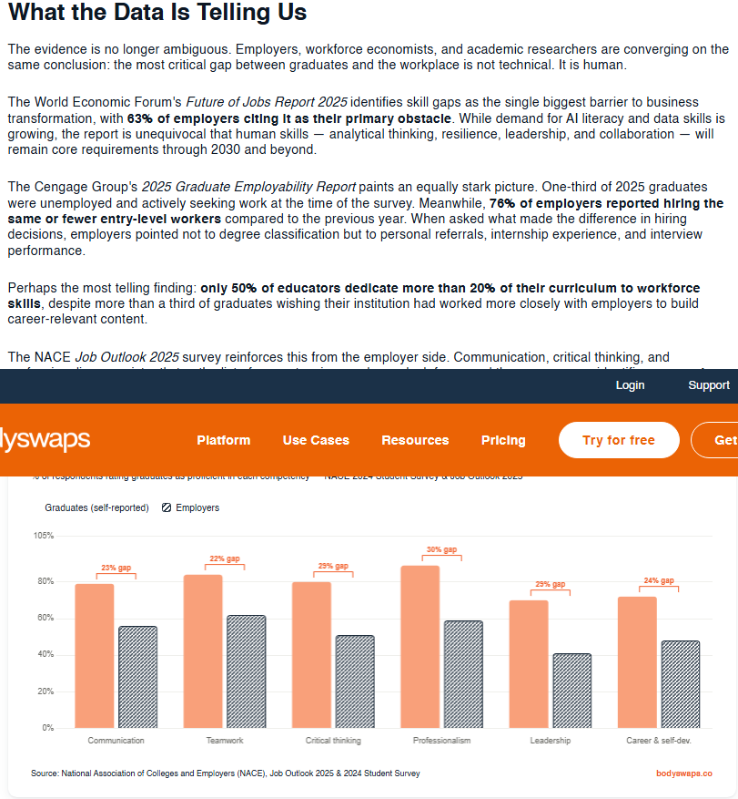

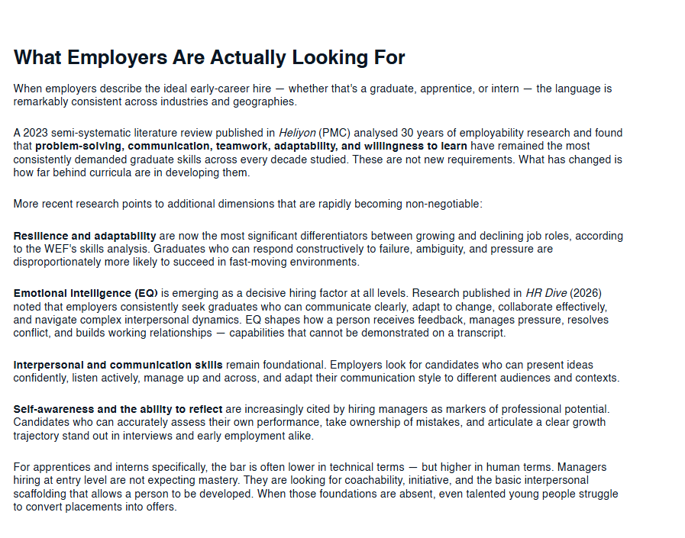

Please click the link, if you wish to read the article online.
What Employers Actually Want From Graduates

Strength of the Source:

In my opinion one of the strength of the source is employers describe the ideal early career hire , the language is remarkably consistent .

Weakness of the Source:

In my opinion the weakness of this source is emotional intelligence is emerging as a decisive hiring factor at all levels .

