
Master of Business Administration

Module Name: Marketing Management
Module Code: LCMB7024

Assessment component 2: Marketing Strategies Portfolio
Lecturer’s Name: Laila Maazouz

Student Name: Anjaliben Harishbhai Chavda
Student ID: 2532966



Marketing Management
LCMB7024

Assessment component 2: Marketing Strategies Portfolio
Portfolio: Brand development

TOPIC: Aquafine company and smart water bottle


1.0 Element 2: STDP Analysis: Aquafine Smart Water Bottle

1.1 Segmentation Analysis
Aquafine is a UK-based company that offers water solutions across the UK. Strategically in terms of marketing, the Aquafine Smart Water Bottle should be segmented based on convergence of digital health, sustainability and high lifestyle consumption. The market of smart bottles is growing at a rate of 15%+ CAGR globally, and the wearable and fitness-tech market is growing in double-digits in the UK, which shows high potential to adopt tech-enabled hydration solutions. In this context, segmentation cannot be just descriptive but has to find high-value, behaviourally aligned consumers.
Geographic Segmentation
The Geographical opportunity of the brand lies on urban smart cities such as big cities globally like London, Barningham, Edinburgh and others, as here the consumers value digital transformation and have disposable income and awareness for wellbeing in long-term. As of the study of Roy et al. (2022), these metropolises contribute to a high proportion of the total consumption premium and the use of smart devices in the UK and thus can serve as focal points for entry.
Demographic Segmentation
The demographic of the segment comprises of young professionals aged 22-40 years, middle to upper-middle income and tertiary education (Eslami et al., 2024). Demographic profiling by itself is however not enough.
Psychographic Segmentation
Psychographic segment is typified with self-optimisation behaviour, in which the individuals are keen on acquisition of tools that will help them to improve productivity, health and lifestyle efficiency. As stated by Abhirama, Wardani and Amriel (2023), consumers are highly sustainability oriented, and this fits the reports that indicate that more than 70% of the consumers in the urban areas globally are highly oriented towards eco-friendly products.
Behavioural Segmentation
The target group is highly engaged in terms of behaviour in fitness ecosystems, such as wearable devices, mobile health apps, subscription-based wellness services (Nawi et al., 2022). Not only are they ready to pay a premium, but integrated, data-driven experiences are expected, a sign of a product ownership to solution-based consumption.
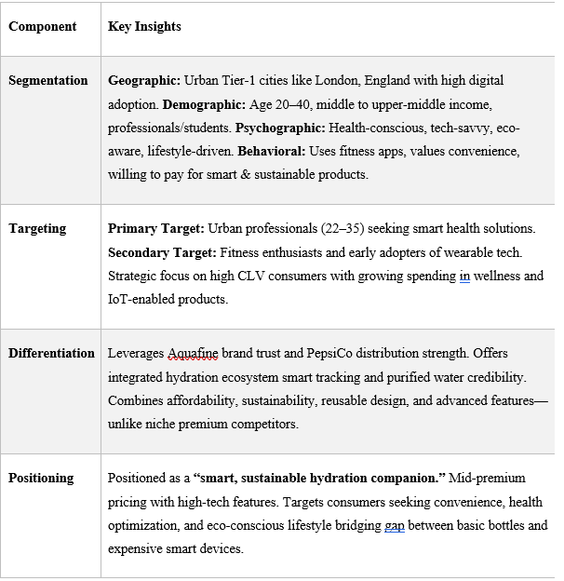
Figure 1: STDP Table
(Source: Self-Develop)

1.2 Targeting Strategy
Based on the segmentation information, Aquafine ought to consider a focused differentiation targeting strategy, focusing on urban, tech-savvy professionals of age 22 to 35 as the target audience. As of opinion of Umamaheswari et al. (2022, November), group is a high growth and high-margin segment and has high lifetime value potential. Their spending habits reveal that they are spending more on health technology products, and the market size of fitness and health wellness in the UK is expected to reach over $30billion in 2027. More importantly, this segment is underserved by the conventional bottled water brands, such as Aquafine, which are already in the commoditised position of low-involvement products (Syahrir et al., 2024). By positioning itself to this group, Aquafine will be able to shift its positioning to a lifestyle solution brand and thus gain a higher value.
Another target would be the fitness enthusiasts and early adopters of the IoT-enabled products, who are the opinion leaders and brand amplifiers in digital communities. This stratified targeting is twice more effective in penetrating the market and promoting the brand, which are critical in growing a new category.

1.3 Differentiation Strategy
The competition features HidrateSpark and Thermos, which work in the smart and reusable bottle segments. These competitors do not, however, have a strong brand equity in hydration, or compete on functionality and design.
Differentiation of Aquafine should then be multi-dimensional and be defensively strategic. As stated by Rasyd et al. (2025, August), to start with, the brand enjoys its existing fame in the UK can be used to transfer trust instantly hence perceived risk that comes with adoption of new technology is minimised. Second, Aquafine will be able to develop a holistic ecosystem of hydration, integrating both the smart bottle and its fundamental purified water product, thus providing more of a holistic value proposition, as opposed to a single device.
Thirdly, sustainability offers a point of survival. Given the growing regulatory and consumer demands to decrease plastic waste, positioning the smart bottle as an alternative sustainable, reusable bottle is in line with both ESG agenda and the changing consumer demands (Ramizares et al., 2024). Lastly, implementing an affordable premium pricing approach will enable Aquafine to strike a balance between the expensive niche products and the cheap generic products to create a higher level of access without reducing the perceived quality.

1.4 Positioning Strategy
The Aquafine Smart Water Bottle positioning will have to indicate a strategic change from commoditisation to value-added innovation. The suggested positioning will be: A smart and sustainable hydration companion to the health-conscious and modern lifestyles.
This positioning is specifically created to fit in the mid-premium, high-technology segment to stand out against low-cost reusable bottles, as well as high-end niche smart devices (Rasyd, Furqon and Yuliawati, 2025, August). Aquafine incorporates the elements of trust by brand equity, intelligence, adopting technology and responsibility, implementing sustainability into the same product, unlike their competitors who focus on one of these elements.
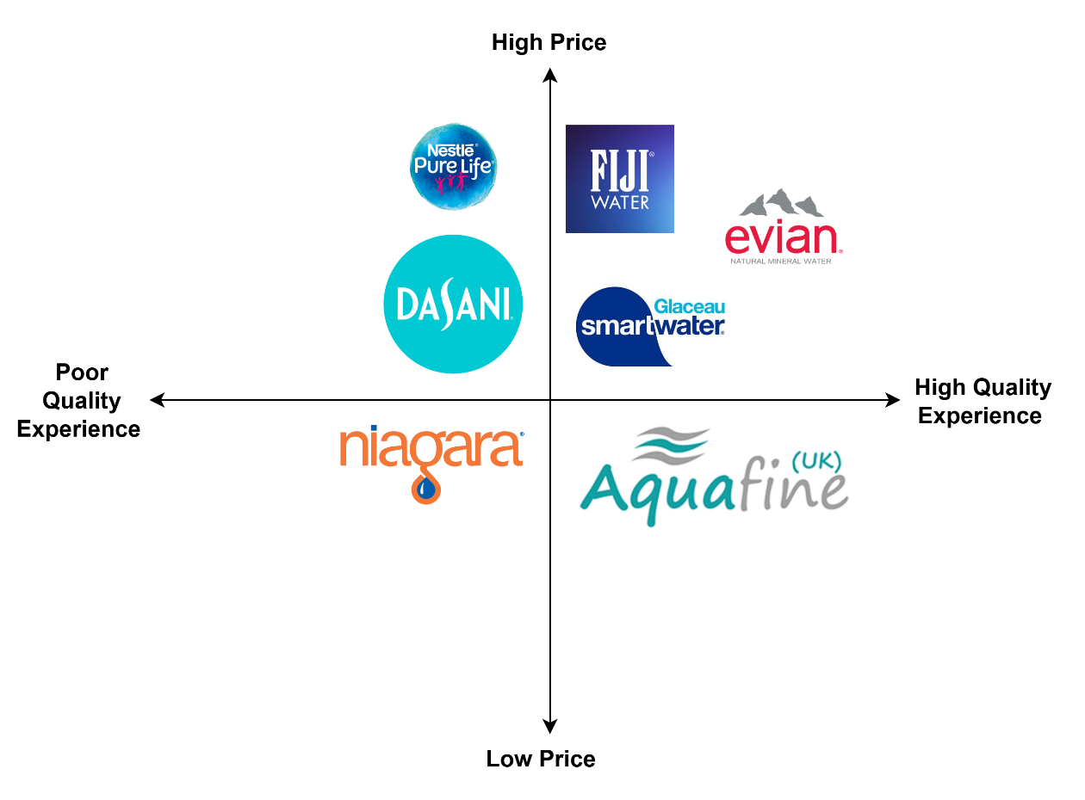
Figure 2: Positioning Matrix of Aquafine
(Source: Self-Develop)
Perceptually, the brand is climbing the ladder in terms of the intensity of technology as well as perceived value, allowing it to expand the margin and increase brand loyalty. Notably, the repositioning aids Aquafine in its long-term strategic goal of transforming itself into more than a bottled water brand, to the provider of smart hydration solutions.
The STDP framework indicates that Aquafine is in a position of taking advantage of overlapping macro trends of digital health adoption, sustainability, and premiumisation. With a focus on urban high-value consumer and using its brand equity, the company can gain a category differentiation, greater customer engagement, and sustainable competitive advantage, which will provide long-term growth in accordance with board-level strategic priorities.

2.0 Element 3: Marketing Mix: 7Ps
Product
The Aquafine Smart Water Bottle is a hybrid product-service system that is a physical design but has digital functionality. Its key aspects are a hydration tracking system, an app synchronisation system, LED notifications, and recyclable materials that are environmentally friendly (Jain, Jain and Jain, 2022). According to Kotler product levels, the health optimisation core value is the main advantage, the smart bottle is the real product, and the enhanced layer is the app-based insights and customised hydration targets.
Most importantly, this puts Aquafine on a higher level than a low-involvement FMCG category, but the high-engagement and data-driven solution, which boosts the frequency of customer interaction. Aquafine will be in a position to combine its credence in purified water, unlike standalone smart bottles like HidrateSpark, and form a differentiated ecosystem instead of a single device. This is in line with the sustainability strategy, which involves the value being co-created during continuous use and not a one-time purchase.
Price
It is suggested to implement value-based pricing strategy and place the product in the mid-premium category that will convey the technological value but be affordable. Other rivals tend to use premium pricing like £ 40 and restrict mass adoption. Aquafine can set its strategic prices at £ 25 to £ 30 in terms of economies of scale.
In theoretical terms, this can be discussed as the perceived value pricing, when the consumers will calculate the benefits (health tracking, sustainability) and compare them with the price. As of discussion of Praesri et al. (2022), the penetration pricing might be used to hasten adoption, but it will also jeopardise the quality image. Thus, the skimming-lite strategy would be more suitable, as it would help to find early adopters and grow at a slower pace. Customer lifetime value (CLV) can also be further increased by having subscription-based add-ons (e.g., premium features of an app).
Place (Distribution)
Distribution needs to be representative of an omnichannel approach, including both online and physical touchpoints. Mainstream distribution channels would be e-commerce (Amazon, Flipkart), direct-to-consumer, and upscale retail stores in major cities like Mumbai and Bengaluru.
Importantly, by using the huge distribution network of Aquafine, the brand will be able to gain benefits, although the selective distribution is necessary to retain the premium image (Kaur, Gangwar and Dash, 2022). The smart bottle, in contrast to the traditional bottled water mass distribution, will have to be retailed through experience, such as in in-store demonstrations and technology displays. This is in line with channel differentiation theory, whereby distribution strategy enhances brand positioning.
Also, collaborations with gyms, corporate offices, and wellness centres can help to integrate the product into everyday activities, making it more frequently used and recognised.
Promotion
The promotion must be done on the basis of an integrated marketing communications (IMC), digital interaction and experiential marketing. The main strategies are: Influencer marketing to fitness and tech communities, app-based engagement and push notifications, social media campaigns with emphasis on hydration tracking and sustainability and experience events with fitness expos, marathons.
Theoretically, this corresponds to the AIDA model (Attention–Interest–Desire–Action), with digital content creating awareness and the integration of the apps maintaining the interest. The messages should change to smart hydration and lifestyle improvement as compared to the traditional Aquafine campaigns that are based on purity (Khemani, Ali and Kashif, 2025). This repositioning is essential in order not to create cognitive dissonance in the consumers. It has been shown that more than 65% of Gen Z and millennials are actively consuming health-related digital content, and it is crucially important to promote it via digital channels.
People
People not only work in a service-dominant logic but also include customer interaction ecosystems. The customer service department, retail staff, and digital support staff to operate the app interface are key stakeholders. As per the discussion of Minghui and Chelliah (2022), the staff should be trained to be able to convey both technical and health benefits, making it seem simpler than complex, which is one of the frequent obstacles in adopting smart products. Moreover, user communities’ fitness influencers, early adopters, are co-creators of value, which strengthens brand credibility, using social proof. This is in line with the relationship marketing theory whereby long-term interaction takes the place of transactional interactions (Ridoan, Rochman and Maftuchach, 2025). Aquafine can increase brand loyalty and advocacy by creating a community that embraces hydration and wellness.
Process
The process aspect is concerned with providing an integrated and smooth user experience. This consists of: Simple onboarding through mobile app, real-time hydration tracking and reminders, effective after-sales service and support and Data synchronisation with fitness apps. More importantly, process efficiency eliminates friction in the process of technology adoption, which is a significant factor in customer satisfaction (Kumar et al., 2025). Implementing service blueprinting, Aquafine will need to be consistent with all the touchpoints, such as purchase to everyday use.
Aquafine can use the focus on user-friendly processes as a distinguishing factor, as compared to competitors, which can often focus on product features. Never-ending changes and data-driven insights also provide value addition, which is in line with customer experience management (CEM).
Physical Evidence
The use of physical evidence is a significant aspect in supporting the intangible value. The design, packaging and digital interface of the product should convey high quality and sustainability. The bottle itself must be sleek, hardy and have noticeable branding that resonates with the name of Aquafine.
It should be packaged in an environmentally friendly manner, which will back the sustainability argument and increase credibility. The mobile app interface is also digital physical evidence, in which the intuitive design and the visualisation of the data contribute to the trust in the functionality of the product (Sadri and Aprianingsih, 2025). Theoretically, this is in line with servicescape theory, in which tangible cues affect customer perception and customer satisfaction. Aquafine has an excellent design and branding, which forms a sharp visual distinction compared to generic reusable bottles.
The 7Ps model illustrates how Aquafine can implement its brand extension strategy through the incorporation of technology, sustainability and brand equity. As of discussion on Praesri et al. (2022), Product innovation initiates value, pricing makes it accessible, distribution makes it reach more people, promotion makes more people aware, people, process, and physical evidence make it a consistent experience. This marketing mix transforms Aquafine into a commoditised water brand to high value experience-based smart hydration provider, allowing to compete and grow in the long term.

3.0 Element 4: Reflection with Gibbs’ Reflective Cycle
Gibb's reflective cycles highlight 6 components to address the learning experience; they are discussed below.
Description
This project allowed me to create a brand extension of Aquafine and present a smart water bottle and build a complete marketing plan, including STDP and the 7Ps. Another activity I did was to design and present a poster to convey the idea in a short period of time in a persuasive way. This involved a combination of both theoretical and practical knowledge.
Feelings
In the beginning, I perceived that the task would be difficult, especially in the conversion of a conventional bottled water brand to a technology-based solution. I was confused in the synergies between innovation and brand identity. As of discussion of Turangan, Erlangga and Wiadi (2026), I developed confidence, particularly when I determined that the consumer trends health-tech and sustainability had definite connections with the proposed product. I experienced some level of anxiety and was also encouraged to make a strong pitch during the presentation.
Evaluation
One of my strengths was the facility to implement strategic marketing models like STDP and Marketing 7Ps in a logical and business-wise sense. I successfully supported decisions with the trends that are in the market, like the development of smart devices and green consumption. Nevertheless, I understand that my poster presentation might have been more graphically effective and succinct. Sometimes I was more concerned with content richness as opposed to audience responsiveness, which is vital in marketing communication in real world.
Analysis
The learning process has improved my knowledge on brand extension strategy, especially the need to carry out innovation in line with the already existing brand equity. I got to know that effective extensions are creative and need to be strategically reasoned and market-led. Moreover, I gained competencies in critical analysis, data analysis, and decision-making because I needed to assess competitive positioning and defend pricing and differentiation strategies (Turangan, Erlangga and Wiadi, 2026). Professionally, I enhanced my communicational and presentation skills as I realised the need to simplify complex concepts to various stakeholders including the seniors.
Conclusion
This marketing project development support me to improve my critical thinking as an professional managers in the global market. This support to enforce my strategical thinking that support to improve operational efficiency in profession.
Action Plan
To better capture the audience, in future projects I will concentrate on better visual communications and storytelling especially in presentations. I will further enhance my application of real-time market data and analytics tools to enhance strategic recommendations. I join online class for further skill development. Moreover, I want to become more confident in speaking in front of the audience both in practice and with feedback to be more effective in a professional context.

Reference List
Abhirama, A., Wardani, N. I. K., and Amriel, E. E. Y. (2023). Green marketing, lifestyle, and the purchase intention of bottled water among generation Z. East Asian Journal of Multidisciplinary Research, 2(8), 3209-3220. https://pdfs.semanticscholar.org/9f05/b094a4c6dff7fc0bbd65ebc67903d9fd29de.pdf
Eslami, E., Razi, N., Lonbani, M., and Rezazadeh, J. (2024). Unveiling IoT customer behaviour: segmentation and insights for enhanced IoT-CRM strategies: a real case study. Sensors, 24(4), 1050. https://www.mdpi.com/1424-8220/24/4/1050
Jain, R., Jain, S., and Jain, S. (2022). Analysing and exploring the effectiveness of each element of 7Ps of marketing mix. International Journal of All Research Education and Scientific Methods (IJARESM), 10(1), 2455-6211. https://www.researchgate.net/profile/Riddhisha-Jain/publication/357657009_Analyzing_and_Exploring_the_Effectiveness_of_Each_Element_of_7Ps_of_Marketing_Mix/links/61d84cdfb6b5667157d148c7/Analyzing-and-Exploring-the-Effectiveness-of-Each-Element-of-7Ps-of-Marketing-Mix.pdf
Kaur, B., Gangwar, V. P., and Dash, G. (2022). Green marketing strategies, environmental attitude, and green buying intention: A multi-group analysis in an emerging economy context. Sustainability, 14(10), 6107. https://www.mdpi.com/2071-1050/14/10/6107
Khemani, S. V., Ali, M., and Kashif, S. (2025). Green Marketing for People and Planet: 7Ps and Green Knowledge Impact on Nestlé Single-Use Plastic Water Bottle Repurchase Intentions in Pakistan. Journal of Asian Development Studies, 14(2), 1893-1905. https://poverty.com.pk/index.php/Journal/article/view/1411
Kumar, S., Sharma, C., Mishra, M. K., Sharma, S., and Bhardwaj, V. (2025). Smart, sustainable, and green: the digital transformation of green-marketing. Discover Sustainability, 6(1), 388. https://link.springer.com/article/10.1007/s43621-025-01242-5
Minghui, B., and Chelliah, S. (2022). Marketing Strategies and Export Performance among Bottled Water Manufacturing in China. Global Business & Management Research, 14. https://www.gbmrjournal.com/pdf/v14n3s/V14N3s-94.pdf
Nawi, R. D., Cabel, W. F., Muin, N. A., Rody, N. S., and Saien, S. Smart bip bottle. In International Exhibition & Symposium On Productivity, Innovation, Knowledge & Education (pp. 478-483). Universiti Teknologi MARA, Kedah. https://ir.uitm.edu.my/id/eprint/127921/
Praesri, S., Meekun, K., Lee, T. J., and Hyun, S. S. (2022). Marketing mix factors and a business development model for street food tourism. Journal of Hospitality and Tourism Management, 52, 123-127. https://www.sciencedirect.com/science/article/pii/S1447677022001115
Ramizares, J. M. Z., David, L. A. D., Acuesta, P. C. A., Mejia, M. B., Ong, A. K. S., Diaz, J. F. T., and Dangaran, P. C. (2024). The role of brand equity and decoy effect on actual purchase of insulated water flasks. Cogent Business & Management, 11(1), 2422560. https://www.tandfonline.com/doi/abs/10.1080/23311975.2024.2422560
Rasyd, M. R. A., Furqon, C., and Yuliawati, A. K. (2025, August). The Role of Brand Communication in Building Loyalty in Indonesia’s Bottled Water Market. In Proceeding of International Conference on Digital, Social, and Science (Vol. 2, No. 01, pp. 742-759). https://journal.ebizmark.id/index.php/ICoDSS/article/view/256
Ridoan, A., Rochman, A., and Maftuchach, V. (2025). The impact of brand awareness, green marketing, and consumer behaviour on purchasing decisions: Empirical evidence from Bottled Water consumers in South Jakarta. Journal of Economics and Business Letters, 5(1), 29-44. http://journal.privietlab.org/index.php/JEBL/article/view/580
Roy, A., Dutta, H., Griffith, H., and Biswas, S. (2022). An On-Device Learning System for Estimating Liquid Consumption from Consumer-Grade Water Bottles and Its Evaluation. Sensors, 22(7), 2514. https://www.mdpi.com/1424-8220/22/7/2514
Sadri, I., and Aprianingsih, A. (2025). Strategic Marketing Approaches Leveraging the 7P Marketing Mix Framework to Overcome Sales Challenges and Enhance Purchase Intention for IELTS Programs at Athena English Course. Journal of Research in Social Science and Humanities, 5(1), 120-125. https://digilib.itb.ac.id/assets/files/2025/MjAyNV9UU19QUF9pbG1hbiBTYWRyaS0yOTEyMzA4MV9GdWxsIFRleHQucGRm1.pdf
Syahrir, A. A., Shahruzzaman, M. E., Nor Hazly, D. F. H., Mohammad Shamsul Kamil, I. H., Zaiful Azhar, A. F., and Samsuri, S. (2024). Air up flavoured water bottle. https://ir.uitm.edu.my/id/eprint/107235/
Turangan, M. M., Erlangga, D., and Wiadi, I. (2026). An STP-Based and Marketing Mix Strategy for Increasing Sales and Competitive Advantage: A Case Study of Mobagu Coffee Shop. Multidiscience: Journal of Multidisciplinary Science, 3(1), 65-75. https://journals.stratapersada.com/index.php/multidiscience/article/view/468
Umamaheswari, E., Devi, V. K., Karmel, A., Gururaj, A. D. M., and Bacanin, N. (2022, November). IoT-WBH-Internet of things based water bottle for better health. In AIP Conference Proceedings (Vol. 2516, No. 1, p. 090002). AIP Publishing LLC. https://pubs.aip.org/aip/acp/article-abstract/2516/1/090002/2827725

Appendix

Element 1: Poster

