University of Wales Trinity Saint David
School of Engineering


L6 Plant and Asset Engineering
Evaluating the Effectiveness of Coke Oven Guide Machine Maintenance Strategies at TATA Steel
ACMA6007

Matthew Frey
1302960
19/04/2026

Table of Contents
1 Introduction 4
2 Background 5
3 Critical Review of Current Maintenance Practices 6
4 Evaluation of Improvements to Maintenance Strategy 10
5 Costs and Resources Required 12
5.1 Current Maintenance Cost Baseline 12
5.2 Hidden and Indirect Costs 13
5.3 Critical Evaluation of Cost Efficiency 13
5.4 Cost Implications of Proposed Improvements 14
5.5 Strategic Trade-Offs and Limitations 15
5.6 Recommended Cost Strategy 16
6 Conclusions and Recommendations 17
7 References 18
8 Appendices 19
8.1 Machine Maintenance Outage Plan (2020) 19

Figure 1:Guide Machine Operation in Coke Oven Battery During Coke Discharge Process (Coke Fuel Equipment, no date) 4
Figure 2: Example of SAP maintenance work orders for the No.3 guide machine, illustrating recorded defects and maintenance activities (Jenkins, 2021, based on SAP data) 6
Figure 3: Monthly delay hours for No.3 guide machine comparing FY19–20 and FY20–21, illustrating variability in equipment performance (Jenkins, 2021) 8
Figure 4: P–F curve illustrating asset degradation and maintenance intervention (adapted from Aladon, n.d.; Moubray, 1997). 11
Figure 5: Breakdown of 8-weekly and 16-weekly planned maintenance spare costs for the guide machine (Chambers, 2023) 12
Figure 6: Coke Oven Machine Maintenance Outage Plan for No.3 Guide Machine (Scott, 2020) 19

Table 1: Comparison of time-based and condition-based maintenance strategies, highlighting key advantages and limitations in terms of reliability, cost, and implementation complexity 12

Introduction
Maintenance strategy selection is critical to ensuring the reliability, safety, and efficiency of industrial assets. In heavy industries such as coke production, equipment failure can lead to significant operational, financial, and safety consequences. Maintenance is therefore a strategic function that directly influences asset performance and lifecycle outcomes (Moubray, 1997; ISO, 2014).
This report evaluates the effectiveness of the maintenance strategy used for the coke oven guide machine at Tata Steel UK’s Morfa Coke Ovens. The guide machine, pictured in Figure 1, is a production-critical asset responsible for positioning, guiding coke discharge, and handling oven doors. Its reliability directly impacts plant performance.
The report reviews the current maintenance approach, identifies strengths and limitations, and evaluates improvements using condition-based maintenance (CBM) and reliability-centred maintenance (RCM). It also considers the cost and resource implications of these improvements and provides recommendations for future strategy development.
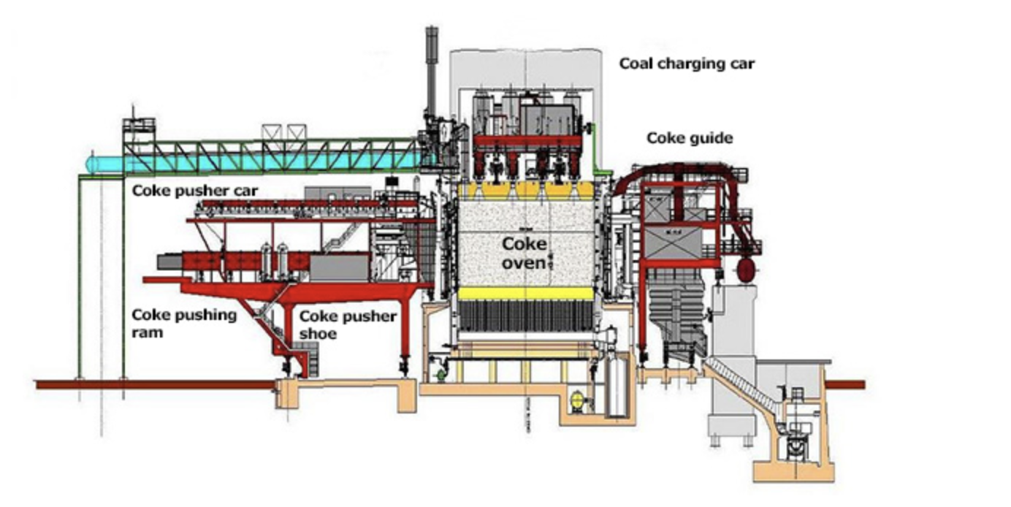
Figure 1:Guide Machine Operation in Coke Oven Battery During Coke Discharge Process (Coke Fuel Equipment, no date)

Background
Morfa Coke Ovens operated as part of a high-temperature process in which coal is heated in the absence of oxygen to produce coke for steelmaking. The process is continuous, meaning failure of critical equipment can disrupt production. This places strong emphasis on reliability and asset management (Campbell and Jardine, 2001).
The guide machine operates alongside the coke oven battery, aligns with the oven chambers, assists with door removal, and guides coke during discharge. These tasks require precision under harsh conditions, including high temperatures, dust, and mechanical stress.
The machine consists of multiple subsystems, including structural elements, bogies, rollers, drive systems, braking systems, and hydraulics. This complexity increases both failure risk and maintenance requirements.
As a result, the guide machine is a high-criticality asset. Its failure can lead to production loss and safety risks, requiring maintenance strategies that prioritise reliability and risk reduction (ISO, 2014).

Critical Review of Current Maintenance Practices
The current maintenance strategy for the guide machine is based primarily on planned preventive maintenance. Tasks are scheduled at fixed intervals and include inspection, lubrication, and functional checks. The structured nature of the maintenance strategy is further supported by detailed outage planning schedules (see Appendix 8.1), which demonstrate a high level of planning and coordination. However, such schedules also reinforce the reliance on fixed maintenance intervals, which may not fully account for variable component degradation.
Maintenance is managed through a computerised system (SAP) and is further illustrated by SAP-generated work orders, as shown in Figure 2. These records demonstrate a consistent and formalised approach to maintenance planning, with tasks covering a wide range of mechanical and structural issues. This supports the argument that the current strategy is well-organised and capable of managing routine maintenance activities effectively.
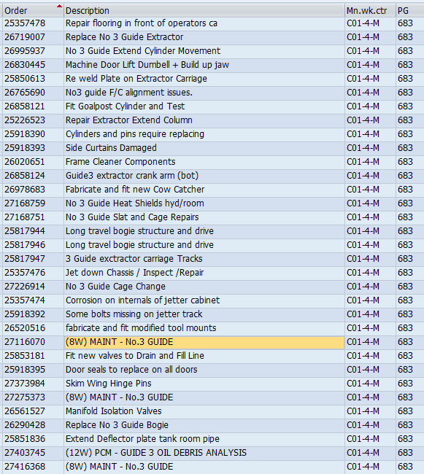
Figure 2: Example of SAP maintenance work orders for the No.3 guide machine, illustrating recorded defects and maintenance activities (Jenkins, 2021, based on SAP data)

However, the nature of the recorded tasks also highlights a limitation of the current strategy. Many of the work orders relate to reactive or corrective actions, such as repairs and component replacements, suggesting that maintenance is often driven by observed defects rather than early-stage condition monitoring. This reinforces the view that, despite its structured approach, the system remains partially reactive and could benefit from integrating condition-based techniques to detect degradation before failure.
A key strength of this approach is its structured nature. In a demanding industrial environment, time-based maintenance offers predictability, enabling work to be planned around shutdowns and resource availability. This reduces the likelihood that severe degradation will go unnoticed and supports consistent maintenance delivery (Kelly, 2006; Wireman, 2010).
The system also demonstrates a degree of maintenance maturity. The use of defined schedules and formal defect reporting indicates a move beyond purely reactive maintenance. As noted by Campbell and Jardine (2001), effective maintenance systems require structured processes to manage asset condition over time, and this approach contributes to that objective.
Another strength is the recognition of the machine’s multi-system nature. Maintenance activities address a range of subsystems, including mechanical, hydraulic, and structural components. This is important because failures in industrial systems are often interconnected rather than isolated.
However, despite these strengths, the strategy has clear limitations. The most significant issue is the reliance on fixed maintenance intervals. Traditional preventive maintenance assumes that failure is primarily age-related, yet many industrial failures occur due to variable operating conditions rather than time alone (Moubray, 1997). In a harsh and unpredictable environment, components may degrade at different rates, making fixed intervals inefficient.

Figure 3: Monthly delay hours for No.3 guide machine comparing FY19–20 and FY20–21, illustrating variability in equipment performance (Jenkins, 2021)

The limitations of the current maintenance strategy are further supported by operational performance data. As shown in Figure 3, monthly delay data for the No. 3 guide machine indicate consistently higher downtime in FY19–20 than in FY20–21, with several months showing significant peaks in delay hours. While some improvement is observed in FY20–21, recurring delays suggest that the existing time-based maintenance strategy does not fully prevent performance losses. This supports the argument that preventive maintenance alone is insufficient to manage failure behaviour effectively, particularly in a variable operating environment.
This creates two key risks. Maintenance may be carried out too early, resulting in unnecessary cost and reduced component life, or too late, increasing the likelihood of failure. In addition, frequent interventions introduce the risk of maintenance-induced faults, such as misalignment or contamination. As RCM principles highlight, excessive maintenance can reduce reliability if not properly justified (Moubray, 1997).
Another limitation is the reliance on qualitative inspection methods. Visual checks are essential but depend heavily on human judgement and may not detect early-stage faults. Many failures develop gradually and can be identified through measurable changes in vibration, temperature, or lubrication condition before becoming visible (Mobley, 2002). Without these techniques, the system remains partly reactive.
A further issue is the lack of prioritisation based on failure consequence. RCM emphasises that maintenance should focus on the impact of failure rather than treating all components equally (Smith and Hawkins, 2004). The current approach does not clearly differentiate between high- and low-risk components, potentially leading to inefficient use of resources.
Finally, although SAP is used to record maintenance data, there is limited evidence of systematic analysis. Data is collected but not fully used to identify trends or improve decision-making. Effective maintenance requires converting data into actionable insights, which is currently underutilised (Jardine, Lin and Banjevic, 2006).
Overall, the existing strategy provides a structured and reliable foundation but lacks flexibility, prioritisation, and data-driven optimisation.

Evaluation of Improvements to Maintenance Strategy
Improving the maintenance strategy does not require replacing the current system but refining it into a more targeted and adaptive approach. High-performing maintenance systems typically combine multiple strategies to balance reliability and cost (Campbell and Jardine, 2001; ISO, 2014).
A key improvement is the introduction of component-specific maintenance strategies supported by condition monitoring.
Condition-based maintenance (CBM) should be applied selectively to critical components such as drive systems, braking systems, and hydraulics. Techniques such as vibration analysis, thermography, and oil analysis can detect early-stage faults and enable maintenance only when necessary (Jardine, Lin and Banjevic, 2006; Mobley, 2002).
The P–F curve (Figure 4) illustrates the interval between initial fault detection and functional failure. This interval represents the optimal window for maintenance intervention, allowing faults to be addressed before failure occurs (Moubray, 1997). Applying CBM within this window improves reliability while reducing unnecessary maintenance.
However, CBM has limitations. Not all failures are detectable, and some may occur suddenly without warning. This means CBM cannot fully replace preventive maintenance and must be applied selectively.
Reliability-centred maintenance (RCM) provides a structured method for prioritising maintenance based on failure consequence. High-risk components require more intensive maintenance, while lower-risk components may be maintained less frequently. This ensures resources are used efficiently (Smith and Hawkins, 2004).
Data-driven maintenance is another key improvement. By leveraging SAP data, maintenance teams can identify trends, predict failures, and optimise maintenance intervals. However, this requires accurate data and appropriate training.
The most effective solution is a hybrid strategy combining preventive maintenance, CBM, and RCM. This approach provides a balance between reliability, cost efficiency, and practicality.

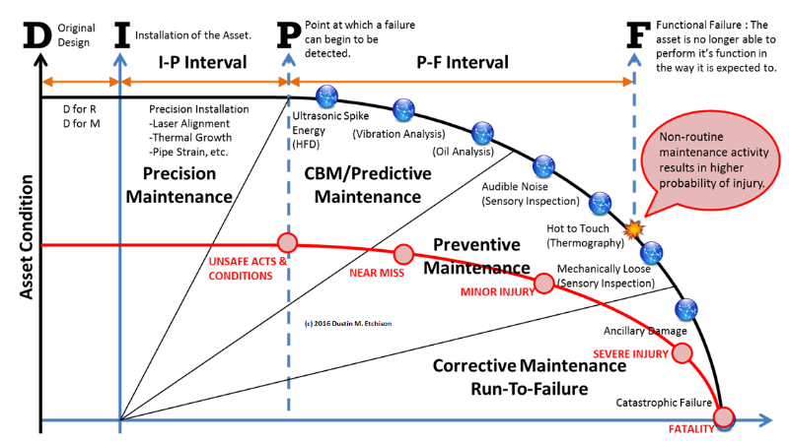
Figure 4: P–F curve illustrating asset degradation and maintenance intervention (adapted from Aladon, n.d.; Moubray, 1997).

Costs and Resources Required
Any proposed improvement to the maintenance strategy must be justified not only on technical grounds but also on cost, resource availability, and operational impact. While advanced maintenance strategies such as condition-based maintenance (CBM) and reliability-centred maintenance (RCM) are often associated with improved reliability, their implementation introduces both direct and indirect costs, as well as organisational challenges. Therefore, a critical evaluation must consider whether these improvements deliver genuine value when compared to the existing maintenance approach.

Current Maintenance Cost Baseline
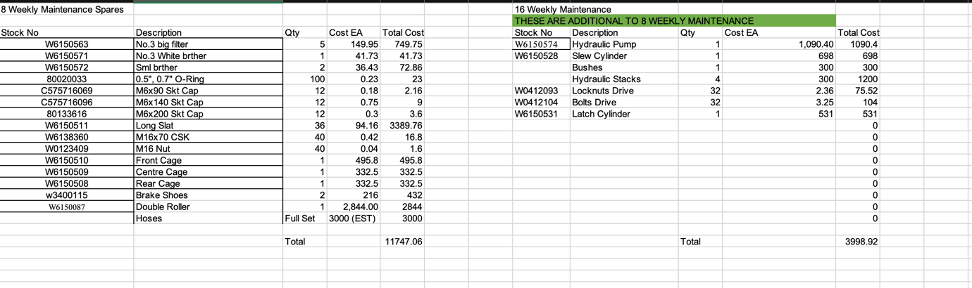
The existing maintenance strategy already involves substantial planned expenditure, particularly due to the scheduled replacement of key components.
Figure 5: Breakdown of 8-weekly and 16-weekly planned maintenance spare costs for the guide machine (Chambers, 2023)
Analysis of maintenance data indicates that the 8-weekly maintenance cycle incurs an estimated cost of £11,747.06, driven largely by high-value components such as:
- Double roller (£2,844)
- Hydraulic hose set (~£3,000 estimated)
- Long slat components (£3,389.76)
- Brake shoes and structural cage elements
- In addition, the 16-weekly maintenance introduces a further £3,998.92, including:
- Hydraulic pump (£1,090.40)
- Hydraulic stacks (£1,200)
- Slew cylinder (£698)
- Latch cylinder (£531)
This results in a combined maintenance cost of approximately £15,746 per 16-week cycle, excluding labour, downtime, and indirect costs.
When annualised, assuming three full 16-week cycles per year, this equates to a baseline annual planned maintenance cost of over £47,000, before labour and production impacts are considered.
As shown in Figure 5, the maintenance cost profile is heavily influenced by a small number of high-value components, particularly hydraulic systems and rollers. This concentration of costs suggests that targeted condition-based maintenance for these components could yield disproportionate economic benefits by reducing unnecessary replacements.

Hidden and Indirect Costs
While direct component costs are significant, they represent only part of the true maintenance cost. Several indirect costs must also be considered:
- Planned downtime during maintenance windows
- Labour costs (including skilled technicians)
- Production losses during intervention
- Risk of maintenance-induced failures
- Inventory holding costs for spare parts
In heavy industrial environments, downtime can be particularly costly due to the sequential nature of operations. A delay in the availability of the guide machine may disrupt coke-pushing schedules, leading to knock-on effects across the process.
This highlights a key limitation of traditional cost analysis: focusing only on spare parts can underestimate the true economic impact of maintenance decisions (Campbell and Jardine, 2001).

Critical Evaluation of Cost Efficiency
From a critical perspective, the current maintenance regime appears to prioritise reliability through frequent scheduled replacement, but this may come at the expense of efficiency.
A central issue is the potential for premature component replacement. Components such as hoses, rollers, and structural elements may be replaced based on time intervals rather than actual wear or degradation. This leads to:
- underutilisation of component life
- unnecessary expenditure
- increased waste
Premature component replacement reduces asset utilisation and can introduce unnecessary cost, a recognised limitation of time-based maintenance where failure behaviour is not strictly age-related (Moubray, 1997).
However, it would be overly simplistic to conclude that this approach is inefficient. A valid counterargument is that the guide machine operates in a severe environment, where component degradation may be difficult to predict and failure consequences are high. In such cases, conservative maintenance intervals may be justified as a risk mitigation strategy.
This creates a classic engineering trade-off:

Table 1: Comparison of time-based and condition-based maintenance strategies, highlighting key advantages and limitations in terms of reliability, cost, and implementation complexity
Strategy | Advantage | Disadvantage
Time-based maintenance | Predictability, low failure risk | High cost, inefficiency
Condition-based maintenance | Cost efficiency, optimisation | Complexity, implementation risk

The limitation of the current strategy is not that it is incorrect, but that it lacks optimisation. It does not distinguish sufficiently between components that genuinely require frequent replacement and those that could operate safely for longer periods.

Cost Implications of Proposed Improvements
The introduction of CBM and RCM would require initial investment, including:
- Monitoring equipment (vibration, thermography)
- Staff training and upskilling
- Data management improvements
- Time required for implementation and analysis
However, compared with the existing annual maintenance cost (~£ 47,000), these investments are relatively modest and have the potential to generate significant long-term savings.
The key economic benefit lies in reducing unnecessary maintenance interventions. For example:
- Extending component life by even 10–20% could result in measurable cost savings
- Avoiding premature replacement of high-value items (e.g. rollers, pumps) has a disproportionate financial impact
- Reducing downtime improves production efficiency and throughput
Condition-based maintenance improves cost efficiency by enabling maintenance to be performed based on actual equipment condition rather than fixed intervals, reducing unnecessary interventions and extending component life (Jardine, Lin and Banjevic, 2006).
Reactive maintenance is significantly more expensive than planned maintenance due to production losses, emergency repairs, and inefficiencies in labour and resource allocation (Wireman, 2010; Mobley, 2002).
Importantly, CBM does not eliminate maintenance; it improves decision quality, ensuring that interventions are carried out when needed rather than when scheduled.

Strategic Trade-Offs and Limitations
Despite the potential benefits, several limitations must be considered.
Firstly, CBM assumes that failures are detectable before they occur. Some failures are random or rapid, meaning that monitoring may not always provide sufficient warning. This limits the effectiveness of predictive approaches.
Secondly, the success of CBM depends heavily on data quality and interpretation. Poor data or incorrect analysis can lead to false confidence or missed faults. This introduces a new type of risk: decision error based on incorrect data.
Thirdly, implementing advanced maintenance strategies requires organisational change. Resistance from maintenance personnel, lack of training, or insufficient management support may limit effectiveness. As Smith and Hawkins (2004) note, maintenance improvements often fail due to organisational rather than technical factors.
A further limitation is the potential for over-investment in technology. Installing extensive monitoring systems across all components may not be economically justified. Not all parts of the guide machine require advanced monitoring, and excessive data collection can create inefficiencies.
Finally, there is inherent uncertainty in cost-benefit predictions. Savings from avoided failures are difficult to quantify precisely, as they depend on hypothetical scenarios. This means that financial justification must be treated with caution and supported by realistic assumptions.

Recommended Cost Strategy
Given these considerations, the most appropriate approach is a targeted and phased implementation strategy.
Short-term:
- Improve inspection accuracy and decision-making
- Reduce unnecessary component replacement
- Enhance use of existing maintenance data
Medium-term:
- Introduce CBM for high-cost, high-risk components (e.g. rollers, hydraulics, drive systems)
- Begin collecting condition data to support future decisions
Long-term:
- Use accumulated data to optimise maintenance intervals
- Transition towards predictive maintenance, where justified
This approach balances cost, risk, and practicality. It avoids the extremes of both over-maintenance and over-investment, instead focusing on incremental improvement and evidence-based decision-making.

Conclusions and Recommendations
The evaluation of the maintenance strategy for the coke oven guide machine shows that the current approach is structured and generally reliable, which is essential in a harsh, production-critical environment. Planned preventive maintenance, supported by SAP systems and routine inspections, helps maintain consistency and reduces the risk of major failures. However, it is not fully optimised. Its reliance on fixed intervals and visual inspections limits its ability to respond to variable component degradation (Moubray, 1997).
Performance and maintenance data indicate that, while the system functions effectively, it does not prevent all failures or delays. Maintenance remains partly reactive, with many interventions driven by visible defects rather than early-stage condition monitoring. This results in both premature component replacement and missed degradation, meaning the strategy delivers reliability but not efficiency.
Condition-based maintenance (CBM) and reliability-centred maintenance (RCM) offer clear improvements. CBM enables earlier fault detection through measurable indicators, while RCM ensures maintenance effort is focused on high-risk components. However, these approaches have practical limitations. Not all failures are predictable, and implementing monitoring across all systems would be costly and complex. A fully predictive strategy is therefore unrealistic.
A more effective solution is to refine rather than replace the current system. A hybrid approach—combining time-based maintenance with targeted condition monitoring and risk-based prioritisation—provides the best balance between reliability and cost. From a cost perspective, maintenance expenditure is heavily concentrated in a small number of high-value components, creating clear opportunities for optimisation.
Overall, the current strategy is effective but inefficient. A phased approach, improving data use in the short term, introducing targeted CBM in the medium term, and optimising maintenance intervals over time, offers a practical and achievable path forward, aligned with the operational constraints of the guide machine and the wider coke oven process (ISO, 2014).

References
Aladon (n.d.) Why the original model of the P-F curve is the correct model. Available at: https://www.aladon.com/why-the-original-model-of-the-p-f-curve-is-the-correct-model/ (Accessed: 18 April 2026).
Campbell, J.D. and Jardine, A.K.S. (2001) Maintenance excellence: Optimizing equipment life-cycle decisions. New York: Marcel Dekker.
Coke Fuel Equipment (n.d.) Coke oven equipment. Available at: https://www.cokefuelequipment.com/products/coke-oven-equipment/ (Accessed: 11 April 2026).
ISO (2014) ISO 55000: Asset management – Overview, principles and terminology. Geneva: International Organization for Standardization.
Jardine, A.K.S., Lin, D. and Banjevic, D. (2006) ‘A review on machinery diagnostics and prognostics implementing condition-based maintenance’, Mechanical Systems and Signal Processing, 20(7), pp. 1483–1510.
Jenkins, C. (2021a) No.3 guide machine monthly delay data. Unpublished internal data, Tata Steel UK.
Jenkins, C. (2021b) SAP maintenance work order data for No.3 guide machine. Unpublished internal data, Tata Steel UK.
Mobley, R.K. (2002) An introduction to predictive maintenance. 2nd edn. Oxford: Butterworth-Heinemann.
Moubray, J. (1997) Reliability-centred maintenance. 2nd edn. Oxford: Butterworth-Heinemann.
Randall, R.B. (2011) Vibration-based condition monitoring. Chichester: Wiley.
Scott, J. (2020) Machine maintenance outage plan for No.3 guide machine. Unpublished internal data, Tata Steel UK.
Smith, A.M. and Hawkins, B. (2004) Lean maintenance. Oxford: Elsevier.
Wireman, T. (2010) Total productive maintenance. 2nd edn. New York: Industrial Press.

Appendices

Machine Maintenance Outage Plan (2020)
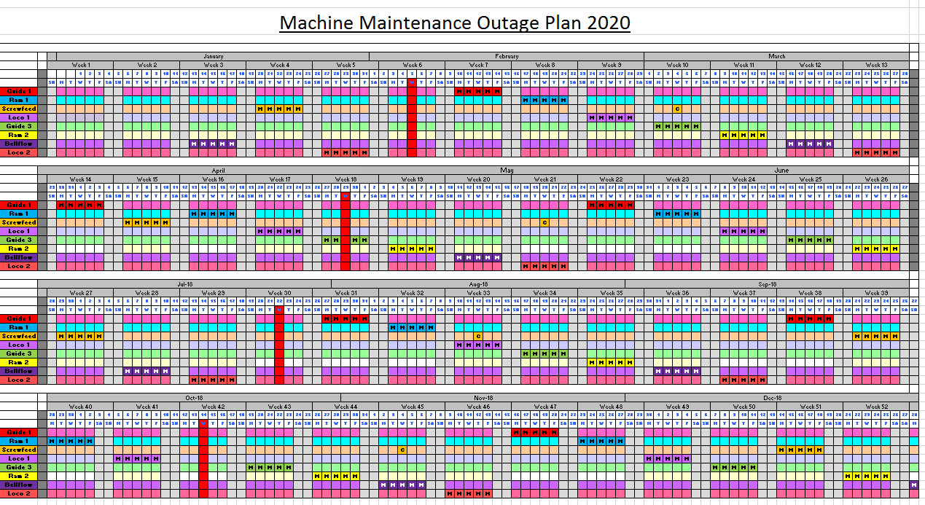
Figure 6: Coke Oven Machine Maintenance Outage Plan for No.3 Guide Machine (Scott, 2020)

