Student: Calin Matei
Student ID: 1916953
Module: Project Management (LCBB6006)
Assignment: Component 2: Coursework: Essay
Lecturer: Dr Zainab Atta

Component 2: Essay – Contracting Methods in Project Management

Table of Contents
Introduction 3
Contracting In Project Management Overview 3
Turnkey Contract 4
Multicontract 5
DIY (DO-IT-YOURSELF) 6
Hybrid 6
Comparative Analysis 8
Critical Discussion 9
Conclusion 10
References 11

List of Figures
Figure 1: Contracting Decision Tree 4
Figure 2: Risk Distribution 10

List of Tables
Table 1: Suitability Mapping 7
Table 2: Contract Comparison 8

Introduction
Project management is a discipline that is organised and aimed at employing knowledge and skills in this industry, as well as tools and techniques, in order to enable project delivery that results in pre-determined objectives. It provides a controlled project lifecycle management within time, cost, scope, and quality restrictions, defining the project as stipulated by PMI and PRINCE2 principles (Tinnirello, 2021). Contracting in project management is a process that involves a formal agreement between an organisation and a supplier with a third party to provide services, goods or project parts wherein responsibilities, risks and performance expectations are agreed upon. Organisational contracting provides organisations access to expert knowledge, enables the organisation to cut costs, enhance efficiency and allocates/shares project risk, especially in complex environments that may have limited internal capacity. Choosing a suitable contract approach can be key to project delivery success, particularly in massive digital engagements where there is complexity in the system, integration requirements, and stakeholder demands, and the models allow outsourcing to different extents and internal control.

Contracting In Project Management Overview
The concept of outsourcing has been a ubiquitous feature in contemporary project settings, whereby it has been utilised to gain expert knowledge in specific fields, enhance effectiveness, and control the expenses involved in any given project. It is particularly prevalent in digital change efforts within the areas of public service, such as universities, healthcare systems and government platforms/solutions, where the technological solution is complex (Wijesooriya and Basnayake, 2024). Nevertheless, there exist important trade-offs involved in outsourcing, such as control and cost efficiency, speed and flexibility, and risk transfer and reliance on an external supplier. Good contracting decisions are, thus, necessary to strike a balance between performance, governance and long-run sustainability of project performance.
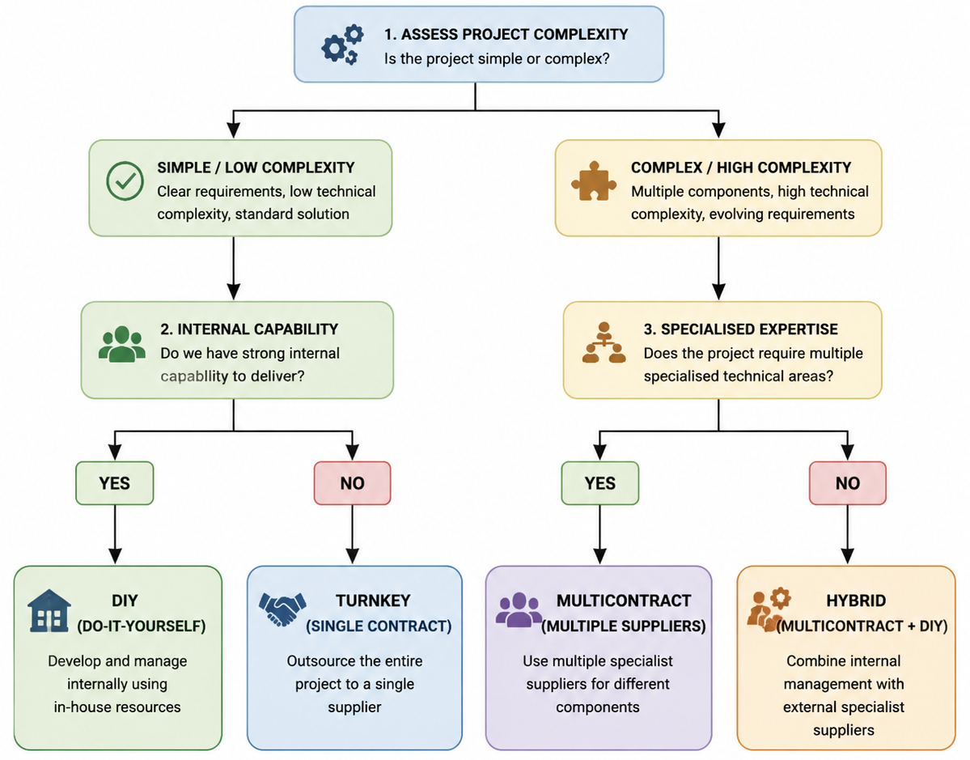
Figure 1: Contracting Decision Tree

Turnkey Contract
A turnkey contract is a procurement approach where one contractor produces a project completely; both through initial design to final implementation. The result is a completed, fully-functional system to be passed on to the client with only a slight further input being needed. Under this structure, the contractor has end-to-end project responsibility in the form of planning, executing, testing and providing and hence he/she is held fully responsible towards project completion.
Single-point responsibility is one of the key benefits of turnkey contracting that makes administration easy and eliminates problems with coordination on behalf of the client organisation (Smith et al., 2025). It can also demand little participation by the clients, thus internal teams are able to concentrate on actual operations instead of the day-to-day running of the projects. It may also lead to expedited delivery faster especially in instances where the contractor has developed quality and resources.
There are, however, also significant demerits of the turnkey contracts. In many cases, there is immense dependency on the supplier, the end route to any challenges in case of poor performance or the failure to meet expectations.
This strategy best applies to organisations with limited technical capacity and want to fully outsource their digital systems, which have a compaints limited internal technical capacity, in which a fully developed, ready-to-use solution is needed that has limited maintenance over time.

Multicontract
Multicontract is a procurement strategy whereby a project is broken down into distinct parts, and each part is granted to a specific, specialised supplier. The client organisation engages more than one contractor at a time, where one supplier is given the responsibility of providing a particular component of the entire system, as opposed to relying on one contractor. This can consist of independent software development vendors, cybersecurity providers, cloud providers and user interface design vendors.
Among the major benefits of this approach is professional experience, as organisations can find the best in-class providers of each technical area. It also facilitates competitive procurement, and this may result in better pricing and innovation. It is also flexible in terms of vendor selection as organisations can use capability, cost and performance as factors to select suppliers.
Multicontracting, however, has a number of difficulties as well. The greatest weakness is the complexity of coordination, whereby the diversity of suppliers needs to be well governed and communicated (Zou, 2022). The chances of integration failure are also increased, in which various components of the system might fail to positively interrelate, causing performance problems or slowing down.
The model is a good fit for the use of complex digital systems that entail multiple specialisations in technical areas. An example is that the creation of large digital platforms may require certain expertise in fields of software development, cybersecurity, cloud services and UI/UI design. Multicontracting in these situations allows organisations to take advantage of external expertise and still have control of individual components of a project, as long as excellent project governance and integration management exist.

DIY (DO-IT-YOURSELF)
A Do-It-Yourself (DIY) contracting method is a type of project delivery process in which a company generates and maintains the whole project in-house with its own resources. Under this model, every phase of the project life cycle, such as the planning, designing, development, implementation and maintenance of the project, will be performed by the in-house teams with no outsourcing to other suppliers.
The benefit of the DIY strategy is one of the core ones because, in this way, an organisation can have complete organisational control, quality, timescales and decisions can be made within the organisation. It also provides enhanced congruence to internal policies, systems and operational requirements since development is completely customised according to organisational needs (Ecim, Maroun and Ferreira, 2025). Moreover, it favours the growth of long-term capability in the development of expertise in internal teams, so that in the long term, the internal teams can enhance technical capacity.
Nevertheless, the DIY model can be thought of as having considerable drawbacks as well. It involves high skills of in-house expertise that is not necessarily available in the organisation. It is also resource-consuming, and a lot of money is required in terms of staffing, training and infrastructure. Moreover, it can lead to slower project delivery, especially with less experienced internal teams to work with complicated or large-scale systems.
The method is best applied to organisations which have established high internal IT capacity and would still want to have full command of the project development. It is especially useful when internally driven and owning the system over time is a key strategic consideration, and in situations where confidentiality, security and internal control are paramount.

Hybrid
A hybrid model of contracting is where the internal management of projects (DIY) is incorporated in addition to multiple external suppliers (multicontract). In this type of model, the organisation retains the overall control and strategic management of the project and outsources some of the parts to the vendor of expertise. This forms an integrated framework where internal teams are synchronising the project, and external providers can perform certain technical or specialised functions.
Amidst the control versus external expertise, one of the primary benefits of the hybrid model is the strike between maintenance of control and the outside expertise that enables organisations to gain governance but at the same time use the specialised capabilities (Johanson and Vakkuri, 2024). It also involves risk sharing in that the tasks are assigned to internal teams and external contractors, allowing increased tasks to be handled by one party. It also provides an ideally customizable delivery model, and it can be changed depending on the complexity and availability of the resources used in the project, as well as the changing needs.
The challenge with the hybrid approach is, however, not in vain. It may cause problems in coordination, especially in dealing with various stakeholders and external system integration, which has been developed by other systems. It also needs effective governance systems and communication strategies to bring all parties into line. In case of ineffective management, it may lead to problems of communication gaps, delays and inconsistency of deliverables.
This is most applicable to complicated digital service systems, which demand both rigorous inner management and external technical understanding. It is also very suitable for the large-scale project in which the security needs, user needs, and complexity of the technical solutions require a collaborative delivery model that incorporates both internal knowledge and external innovation.
Table 1: Suitability Mapping
Project Type | Suitable Contract
Simple system | Turnkey
Complex system | Multicontract
Internal system | DIY
Digital transformation | Hybrid

Comparative Analysis
The four contracting strategies, namely, Turnkey, Multicontract, DIY and Hybrid, vary greatly in cost, risk distribution and allocation, control, speed of delivery, scalability, and quality results.
Turnkey contracts tend to be expensive in terms of cost, whereas full outsourcing implies high costs, whereas DIY may be cheaper in the external but costly in the internal environments because of the investment of resources (Chen, Zhang and Karamemis, 2025). The multicontract is in the middle-to-high bracket due to numerous vendors, but the hybrid model minimises costs by providing a balanced supply of both internal and external resources.
Insofar as risk allocation is concerned, turnkey transfers a significant risk to the contractor, whereas DIY leaves all the risks to the organisation. Multicontract disperses the risk, but raises the coordination risk. The hybrid model spreads the risk more efficiently by sharing accountabilities.
In control, DIY will have the utmost control, then hybrid. Turnkey offers low levels of control, whereas multicontract offers moderate levels of control, but high coordination effort.
Single ownership tends to make turnkey faster in terms of delivery speed, but multicontract could have delays because it is related to issues with integration. Generally, DIY is slower, whereas the hybrid is moderate and flexible.
Multicontract and hybrid models outperform in terms of scalability and quality results because they have special input and flexibility (Anh, 2024). On the whole, high-risk digital public service systems are best covered by the hybrid model, since it is a balanced model that has to balance between governance, flexibility, and expertise. It is also the most effective method for complex digital environments due to its ability to offer the best combination of innovation and control.
Table 2: Contract Comparison
Contract Type | Cost | Risk | Control | Flexibility
Turnkey | High | Low client risk | Low | Low
Multicontract | Medium | Shared | Medium | High
DIY | Low external cost | High internal risk | High | Low
Hybrid | Balanced | Shared | High | High

Critical Discussion
The significance of hybrid contracting models is increasing in the contemporary project setting because digital transformation initiatives are becoming more intricate. As opposed to using the traditional single method approaches, hybrid models integrate internal project control as well as external supplier knowledge, which allows organisations to be responsive in response to the dynamic technological and stakeholder demands.
Projects of digital transformation are a complex phenomenon by their very nature that might comprise various systems, stakeholders, and changing user needs (Uchihira and Eimura, 2022). Consequently, no contracting methodology can be considered to be comprehensive enough to accommodate all the operational, technical and governance needs. Hybrid approaches offer the malleability required to bring in expert external functionality without losing internal control, and have proven especially applicable to scaled-up digital systems.
Stakeholders have to rule and control such environments. The hybrid models enable organisations to have strategic decision-making power and assign technical implementation to formidable outsourced professionals. This would make sure that they correlate to the goals of organisations, regulations or even anticipation of users. This balance, however, ought to be carefully managed so that it is not split in the responsibility.
Sensitive Systems do not implement full outsourcing due to a lack of visibility, dependency on third parties and inability to adapt to changes (Redu, 2026). They are particularly important in cases when data confidentiality, user confidentiality, and regulatory compliance are vital.
There is also a risk of integration failure in multi-vendor environments where any discrepancies between components developed autonomously can lead to inefficiencies of the system or system failure. Thus, even as hybrid models stand out as having undoubted benefits, effective governance structures, good communication and integration management practices are critical determinants of success.
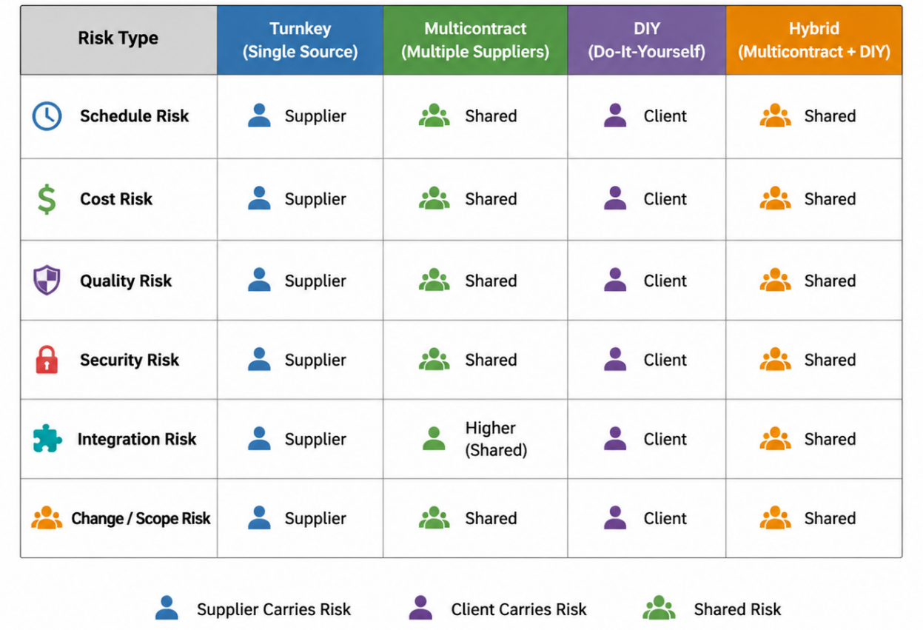
Figure 2: Risk Distribution

Conclusion
To sum up, the four existing contracting techniques, including Turnkey, Multicontract, DIY and Hybrid, present unique benefits and constraints to projects, based on the needs. There is no such universal approach to contracting that fits all the projects because it depends on the complexity, resources and organisational ability. The hybrid model offers, however, the most moderate approach towards the intricate digital systems, i.e. by offering internal and external experience. Thus, the right contracting strategy is vital in the attainment of the success of the project, good governance and best delivery results among contemporary project set-ups.

References
Anh, N.H. (2024). Hybrid Cloud Migration Strategies: Balancing Flexibility, Security, and Cost in a Multi-Cloud Environment. Transactions on Machine Learning, Artificial Intelligence, and Advanced Intelligent Systems, 14(10), pp.14–26.
Chen, Y., Zhang, J. and Karamemis, G. (2025). Outsourcing Fundamentals: The Supply Chain Analysis of Manufacturing Outsourcing Relationship. International series in management science/operations research/International series in operations research & management science, pp.31–69. doi:https://doi.org/10.1007/978-3-031-91845-2_2.
Ecim, D., Maroun, W. and Ferreira, C. (2025). Aligning Key Performance Indicators With Integrated Thinking Principles: Insights From Academic Literature and South African Organisations’ Extra‐Financial Reports. Corporate Social Responsibility and Environmental Management. doi:https://doi.org/10.1002/csr.3176.
Johanson, J.-E. and Vakkuri, J. (2024). Governance of hybrid networks in organisations and society. Edward Elgar Publishing eBooks, pp.11–31. doi:https://doi.org/10.4337/9781800888456.00010.
Redu, P. (2026). Third-Party Model Risk: Advanced Due Diligence and Contractual Oversight for Embedded AI/ML Solutions in SaaS Core Banking and Risk-as-a-Service Platforms -- A Model Governance and Regulatory Risk Framework for Financial Institutions. International Journal of Artificial Intelligence, Data Science, and Machine Learning, 7(1), pp.56–70. doi:https://doi.org/10.63282/3050-9262.ijaidsml-v7i1p113.
Smith, M., Finn, M., Broome, J. and Maddox, C. (2025). Early Contractor Involvement. Emerald Group Publishing.
Tinnirello, P. (2021). Project management. 1st ed. Boca Raton: Auerbach.
Uchihira, N. and Eimura, T. (2022). The Nature of Digital Transformation Project Failures: Impeding Factors to Stakeholder Collaborations. Journal of Intelligent Informatics and Smart Technology, pp.16–16. doi:https://doi.org/10.14456/jiist.2022.8.
Wijesooriya, C. and Basnayake, R. (2024). Digital Transformation in Redefining the Role of the Finance and Audit Professional of the Future. Springer eBooks, pp.61–104. doi:https://doi.org/10.1007/978-3-031-46209-2_3.
Zou, W. (2022). Managing the complexity of service contracting in buyer-supplier collaboration. Aalto.fi. Aalto University.

