
Student Name: Ioana-Theodora Popescu
Student ID: 1922523

Management Economics

Topic - Using the appropriate economic theories, discuss and evaluate the possible market structures (Perfect competition, Monopoly, Duopoly, Oligopoly) and their effect on managerial decisions using the appropriate examples

University of Wales Trinity Saint David
Module Number: LCBB5003
Module Name:Management Economics
Module Tutor: Vasilios Tavlaridis

Table of Contents

Introduction 3
Economic theories 3
Different economic theories 4
Supply and demand 4
Classical economics 4
Keynesian economics 4
Malthusian economics 4
Market socialism 5
Market structures 5
Perfect Competition 5
Imperfect Competition……………………………………………………………………………..6
Monopolistic Competition 6
Oligopoly 6
Monopoly 7
Effects on managerial decisions 7
Conclusion 8
References 9

Introduction

It is the job of econometricians to analyse the distribution of resources and the effects of social policy choices. Forecasting economic trends, consumer behaviour, financial market movements, and labour market anxieties may all be done by experts in this area of study. Diverse economic theories are based on a set of ideas and principles that define how various economies operate in a variety of situations (or conditions of variation). Depending on their socioeconomic standing, an economist may use a wide range of concepts to achieve several goals. The theory of supply and demand allows for the calculation of price in microeconomics. Price equilibrium is attained when the quantity provided by consumers equals the quantity demanded by consumers, or whichever comes first when the quantity supplied by clients equals the quantities by consumers (Todaro, 2012).
In accordance with Ledina (2020), ‘’A pricing equilibrium is a kind of equilibrium in which prices are equal. Various market systems will be better understood by the reader because of the several economic ideas that will be explored in this article. An examination of the impact of market structures on managerial decisions is also being prepared.’’
Pursuant to Tiwari (2022), ‘’The market in economics is defined as a way of exchange between services and goods that takes place as a result of direct contact between the supplier and the consumer, or indirectly through institutions or sales agents and it is classified as:
- Local Market: both sellers and buyers are limited to the region or local area of ​​the business. Perishable goods are usually sold because the transportation of these goods can be expensive.
- Regional Market: This type of market covers a larger area than the local market, such as a district and a smaller group of states.
- National Market: The demand for goods is limited to a certain country, or the government does not allow trade in such goods outside national borders.
- International Market: When the demand for the product takes place outside the borders of the country, the goods are traded internationally in industrial quantities.’’

Economic theories

A bachelor's degree in economics is a social science subject that studies the production, distribution, and consumption of different products and services in society. The dynamics of decision-making and investment decisions are the focus of this study area, which includes. It is assumed that human beings operate rationally and seek the largest amount of benefit or utility feasible. This is the basis of economic theory. Human behaviour is investigated through economic theory. It is at the core of economics' foundations to examine the study of labour and commerce. Researchers in economics are tasked with determining which approaches provide the greatest outcomes, given the vast range of possible applications for human labour and the extensive range of resource acquisition techniques accessible in the actual world (Etro, 2013).
High-level theoretical thinking and mathematical concerns, which are backed by empirical study into economic issues in Economic Theory, may be advantageous to all fields of economic science, including microeconomics. For example, in the study of the consequences of separate human activities, arithmetic reasoning is regularly applied, as is the "means-ends" paradigm, which is widely used to investigate the effects of particular human activities. Rather than attempting to meet all of their demands and obtain all of their objectives on their own, it is more efficient for individuals and businesses to focus entirely on a single form of labour, such as a specific level of production, rather than attempting to meet all of their needs and actually accomplish all of their goals at the same time. It has been shown that when commerce is organised around the usage of money, it is the most successful. Although this approach of identifying economic standards results in an increase in the number of new rivals joining a market, the exact number of new associated with entering a market is currently unknown (Schweitzer, 2016).

Different economic theories

Economic activity evaluation professionals have access to a diverse variety of concepts when it comes to evaluating economic activities. A selection of economic theories is presented in the next section:

Supply and demand
The microeconomic theory of supply and demand determines the market's pricing levels. As long as demand and supply are equal, the price of the product or service will fluctuate until that balance is achieved. When the supply of a product or service is decreasing, and the demand for it is increasing, the price of that product or service is likely to rise (Sandri, 2010).

Classical economics
Classical economics refers to the economic ideas produced by early economists and political intellectuals such as: Adam Smith, John Stuart Mill and others. Classical economics holds that capitalist economies are, by definition, self-regulating systems governed by the fundamentals of production and supply. It was Smith's foundation that drove him to develop a metaphorical notion and explanation for free markets, arguing that people acting in their own personality bring society advantages and the greater good (Russett, 2009).

Keynesian economics

Pursuant to Jung (2010), ‘’Keynesian economics is comprised of a number of macroeconomic theories and models that provide explanations for how aggregate demand—the sum total of an economy's spending—influences phenomena such as economic output and inflation. Keynesian economics is a branch of economics that originated in the United Kingdom. One of the core ideas of Keynesian economics is that aggregate demand does not intrinsically correspond to an economy's productive potential but rather that it is determined by a range of variables, both public and private. Consequently, Keynesian economic approaches are in favour of an economy where fluctuating levels of aggregate demand are capable of causing shifts in employment and production but not in prices.’’

Malthusian economics
Food production and other resource output, according to Malthusian economic theory, is linear even while population growth is exponential. According to this idea, if a civilisation's population continues to grow at a pace that surpasses its ability to generate resources, the quality of life in that society would deteriorate dramatically. In order to keep population growth under control, Malthusian economics encourages the use of population control measures. Although Malthusianism has been generally debunked as a theory of agricultural productivity, the argument about environmental deterioration, resource depletion, and scarcity remains (Rdseth, 2010).

Market socialism
In consonance with Ramsay (2010), ‘’Liberal socialism is a term that is often used to describe it. In political economics, market socialism is a concept that supports the formation of a political economy that has elements of both socialist planning and private entrepreneurship. While capital is owned in common in a market socialist economy, the production and trading of goods and services are dictated by market forces rather than government control. Compensation for employees, public investment, and a social dividend are all examples of how the wealth generated by publicly held firms is divided in accordance with various market socialism models.’’

Market structures

In economics, market structure is the categorization and differentiation of separate sectors depending on the amount and kind of rivalry in each industry. A company's behaviour and results in a given market are influenced by the characteristics of other enterprises in that market (Russett, 2009).

Perfect Competition
As reported by Morrow (2014), ‘’ It is impossible to have ideal competition when a big number of small enterprises compete against one another. As a consequence, they have the flexibility to enter and exit the market whenever they seem appropriate since they provide comparable products (homogeneous). They are well aware of the responsibilities that come with working in this sector. Prices and product names are not kept a secret from the public. In the real world, market arrangements like these are rare to find in their purest form, and this is especially true for the financial markets. It is, nonetheless, a useful tool for comparing organisations that have similar features to each other. In this market, there are a lot of major problems, some of which are listed below.
In the real world, organisations that have a dominant market share are more likely to invest in innovation in order to stay up with the competition and maintain the status quo than those that do not. Despite the fact that the profit margin is fixed in a completely competitive market, sellers are unable to increase prices without risking losing customers.’’
In economic theory, there is a concept known as perfect competition. If all businesses sell the same things, market share has no influence on pricing, companies may join and leave at any time, customers have full or perfect information, and corporations are unable to establish their own prices, as is the case in the United Kingdom. Essentially, this is what it means to have "perfect competition." To put it simply, this is a market that is entirely moulded by the forces of supply and demand. It is more accurate to describe the existing market structure using irregular competition than it is to describe ideal competitive conditions. Consider the following scenario: farmers' market where every vendor is selling the exact same brand of jam. As a result, there is no differentiation between their products since they all utilise the same formula and charge the same price. A limited number of sellers are also permitted to access the market without being subjected to any limitations. Purchasers would be able to easily find out the formula for the product as well as any other essential information in this situation (Lonkila, 2011).
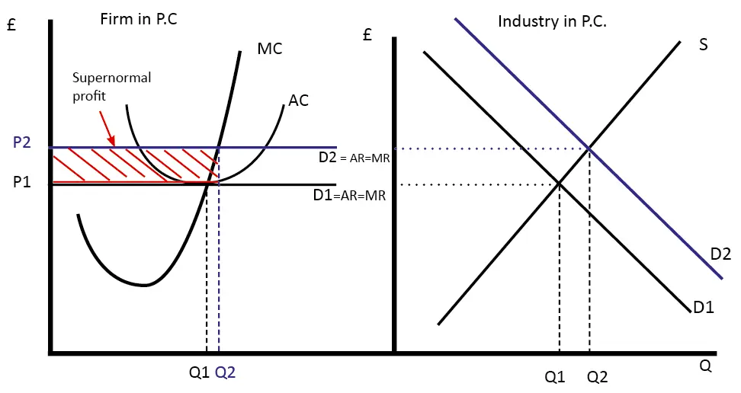

Imperfect Competition
Imperfect competition is a market structure in which buyers or sellers have absolute power over prices, which brings the market to be imperfect competition. However, they have absolute power over the market, market participants abuse power and raise prices to manipulate the market to ensure the highest possible revenues and profits. Some examples that I will talk about below for the imperfect market are: Monopoly and Oligopoly. In both cases, the producers of the goods can influence the prices, act and perform services as a producer of the price, setting the price above the marginal cost and increasing their profit (Daniel, 2021).
The characteristics of the imperfect market vary from monopoly to monopoly competition, so sellers have power and control over prices. Their sources of power come from the ability of an organization to differentiate between supply and demand. This market time has a small and uniform size of production in relation to the perfect market (Kelly, 2021).
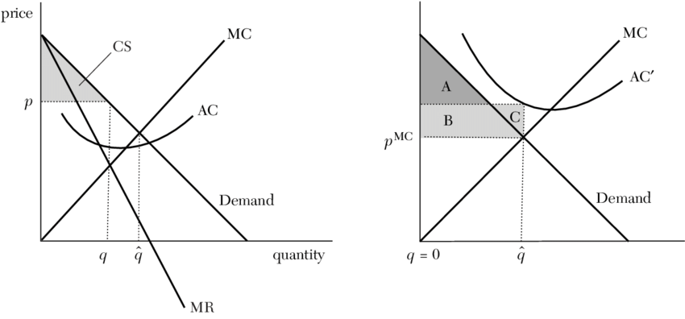
Imperfect Competition

Monopolistic Competition
A market that is both monopolistic and competitive, but not entirely competitive, is described as having monopolistic competition in economics. Selling on Amazon is competitive, thus sellers may try to set themselves apart from one another by emphasising differentiating factors such as quality and branding. In this kind of competition, sellers take into consideration their rivals' prices while ignoring the impact of their own pricing on those rivals. When comparing the short-term and long-term monopolistic competition, there are two distinct features that may be seen. In the short run, a monopolistic company makes the most money and reaps the benefits that come with it (Levina, 2020).
Many companies in monopolistic competitive industries make products that are similar but not the same. The goal of most businesses' advertising budgets is to set themselves out from the competitors. With so much competition and so few barriers to entry, an individual need to work extra hard and think outside the box if an individual wants to succeed in a market (Etro, 2013).
There are several well-known businesses, such as restaurants and hair salons as well as clothing and consumer electronics, that suffer from monopolistic competition to varying degrees. Examples of firms that accomplish this successfully include Burger King and McDonald's. Restaurants like McDonald's and Taco Bell are both quick food chains that serve the same demographic. Both organisations and a slew of others are battling it out for the attention and loyalty of customers, and they are doing all in their power to stand apart (Jung, 2010).
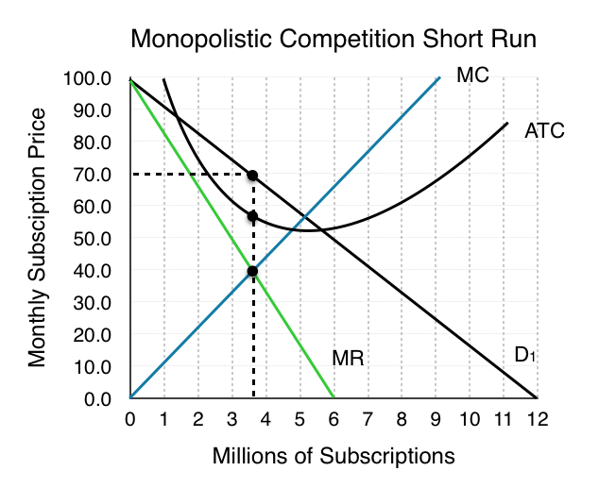Figure 8.4b

Oligopoly
In line with Cyert (2010), ‘’In an oligopoly market, there are only a few significant firms that offer products that are similar or identical to one another. Because there are only a few competitors in the market, their competing strategies are dependent on one another. Here are a few illustrations: The cost-cutting efforts of one actor will very certainly encourage similar efforts by others. Competition may be deterred from taking any action in expectation of people preferring their products if the price of the item is raised, on the other side. Therefore, players of this calibre are required to participate in strategic planning.’’
A situation in which two or more enterprises are in direct competition with one another may lead to an agreement to restrict production to maximise profits. In the case of the prisoner's dilemma, a Nash equilibrium state occurs if no side violates it and both sides honour it. They are able to function as monopolies as a result of this structure (Etro, 2013).
When examining the scale of firms in relation to the size of the industry, it is possible to assess whether an oligopoly exists. There are a variety of locations where high concentration ratios may be found, including the environment and the media. Time Warner, Viacom CBS, and News Corporation continue to have considerable power in the United States television industry, even though streaming services such as Netflix and Amazon Prime are beginning to encroach on the market. Even though both Google Android and Apple iOS are owned by large corporations, they continue to dominate the smartphone operating system sector (Rdseth, 2010).
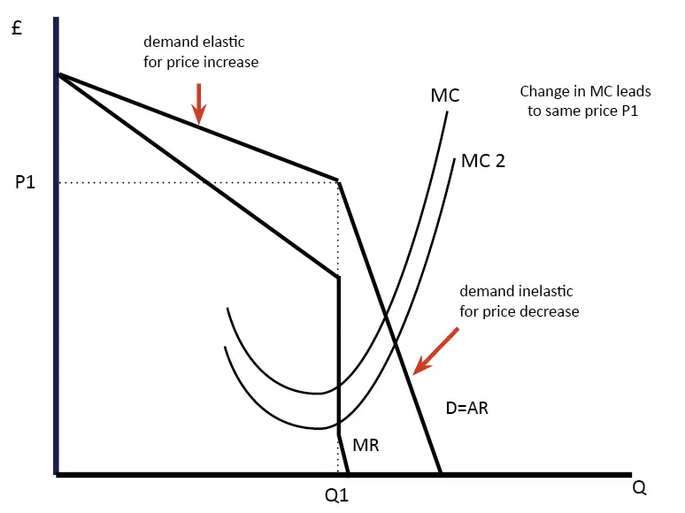
Oligopoly Graphic

Monopoly
A whole market sector is under the exclusive control of only one firm in a market that is monopolistic in nature It's the only firm in the market that sells anything at all, therefore it has no real competition. Patents, copyright, and government-issued licences are all elements of this market type, as are the high initial costs and exclusive claim to resources. All the characteristics associated with a monopoly in the preceding paragraphs hinder new players from entering the market. To maintain its dominance of the market and control the price of its goods, the company has remained a single vendor (Sayfieva, 2018).
In contrast to a market with perfect competition, where companies have no market power and simply respond to market prices, a monopoly market is one in which enterprises have complete market domination and no competitors at all. The whole output of a market is in the hands of a single company when there is a monopoly. Monopolies are created by the inclusion of components such as government licencing, control of resources, trademark, and intellectual property rights, as well as a high starting cost. It is difficult for new vendors to join the market because of these factors. A monopoly may also get the knowledge that is not accessible to other providers, which gives them an advantage (Dudin, Sayfieva and Lyasnikov 2018).
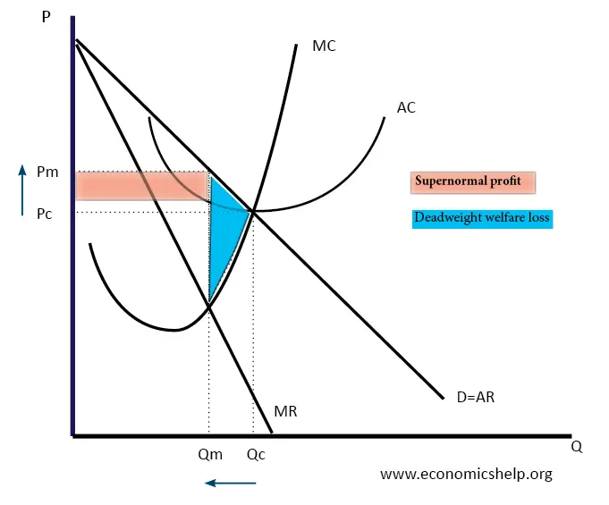

Effects on managerial decisions

Executives' decisions determine whether a company's management is successful or not. As the complexity of the corporate world grows, the responsibilities of business managers become more difficult to accomplish. Constraints imposed from outside the economy of the organisation's headquarters, both in terms of the production of commodities and the marketability of those items, are increasingly influencing business choices Another key contributor to the complexity of the business environment is fast technical development. This is in addition to the influence of technology on product and process innovation, as well as on marketing and sales tactics. Prices of inputs and outputs are also becoming more volatile as the market grows more globalised. In the face of shifting economic and commercial trends, it is becoming more difficult to predict the effects of a company's choice. Fast-paced environments need the use of sound economic research more than ever before. It is the goal of managerial economics to educate corporate leaders so that they may make educated and well-reasoned choices in their organisations (Doellgast, 2014).
According to Cohen (2010), ‘’Administration and company decision-making are two areas in which economic theory, methodology, and strategy are all used. This is known as the field of managerial economics. The first stage in deciding is to gather all relevant economic data and organise it in such a manner that it can be used as a foundation for management decisions. Next, it is critical to define the company's explicit objectives. Management objectives are established and executed in accordance with the specified aims and objectives.’’

Conclusion

The mechanisms of readjustment in the situation of balance-of-payments imbalances need an understanding of macroeconomics in an open economy. Individual nations are treated as distinct entities in the microeconomic aspects of international economics. Trade openness and policy are notable examples of microeconomic parts of international economics since they deal with the relative price of commodities and individual nations. To put it another way, a country's balance of payments is taken to indicate the macroeconomic importance of international economic growth because it deals with the country's total revenues, as well as its expenditures and other economic policies that have a direct impact on national income and overall prices.

References

Araujo, A., Chateauneuf, A. and Faro, J., 2018. Financial market structures revealed by pricing rules: Efficient complete markets are prevalent. Journal of Economic Theory, 173, pp.257-288.

Cohen, K. and Cyert, R., 2010. Theory of the firm. Englewood Cliffs, N.J.: Prentice-Hall.

Daniel, L., 2021. Imperfect Competition Definition. [online] Investopedia. Available at: <https://www.investopedia.com/terms/i/imperfect_competition.asp> [Accessed 24 February 2022].

Doellgast, V., 2014. Disintegrating democracy at work.

Dudin, M., Lyasnikov, N. and Sayfieva, S., 2018. Safety of the financial system of Russia in the conditions of the development of the global market of crypto-currencies. Market Economy Problems, (4), pp.28-37.

Etro, F., 2013. THE THEORY OF ENDOGENOUS MARKET STRUCTURES. Journal of Economic Surveys, 28(5), pp.804-830.

Hutchinson, D. and Hutchinson, U., 2022. 8.4 Monopolistic Competition. [online] Ecampusontario.pressbooks.pub. Available at: <https://ecampusontario.pressbooks.pub/uvicmicroeconomics/chapter/8-3-monopolistic-competition/> [Accessed 24 February 2022].

Jung, Y., 2010. Asset Market Structures and Monetary Policy in a Small Open Economy. SSRN Electronic Journal.

Kelly, R., 2022. Imperfect Competition: Characteristics, Types. [online] Penpoin. Available at: <https://penpoin.com/imperfect-competition/> [Accessed 24 February 2022].

Levina, E., 2020. Development of corporate resources of business structures in the context of the formation of the digital economy. Market economy problems, (4), pp.120-136.

Lonkila, M., 2011. Networks in the Russian market economy. Basingstoke: Palgrave Macmillan.

Morrow, G., 2014. The ethical and economic theories of Adam Smith. Clifton, N.J.: Kelley.

Ostroy, J., 2022. Imperfect Competition. [online] ResearchGate. Available at: <https://www.researchgate.net/figure/Imperfect-Competition-Leads-to-Inappropriable-Benefits-Hence-to-Inefficient-Price-Making_fig4_4732392> [Accessed 24 February 2022].

Pettinger, T., 2022. Diagram of Perfect Competition - Economics Help. [online] Economics Help. Available at: <https://www.economicshelp.org/blog/198/economics/diagrams-of-perfect-competition/> [Accessed 24 February 2022].

Pettinger, T., 2022. Oligopoly Diagram - Economics Help. [online] Economics Help. Available at: <https://www.economicshelp.org/microessays/markets/oligopoly-diagram/> [Accessed 24 February 2022].

Pettinger, T., 2022. Diagram of Monopoly - Economics Help. [online] Economics Help. Available at: <https://www.economicshelp.org/microessays/markets/monopoly-diagram/> [Accessed 24 February 2022].

Ramsay, M., 2010. Community, culture, and economic development.

Rdseth, A., 2010. Open economy macroeconomics. New York: Cambridge University Press.

Russett, B., 2009. Economic theories of international politics. Chicago: Markham Publishing Co.

Sandri, S., 2010. Reflexivity in economics. Heidelberg: Physica.

Schweitzer, F., 2016. Modelling complexity in economic and social systems. New Jersey: World Scientific.

Tiwari, G., 2022. Market- Meaning and Classification. [online] Toppr. Available at: <https://www.toppr.com/guides/business-economics/meaning-and-types-of-markets/market-meaning-and-classification/> [Accessed 24 February 2022].

Todaro, M., 2012. Economic development. New York u.a.: Longman.

