
Student Name: Kavya Nareshbhai Kankotiya
Student ID: 2537035
Module Name: Human Capital Management
Module Code: LCMB7023

Lecturer’s Name: Dr. Gladius Kulothungan

Word Count: 2652 Words
Table of Contents
TASK A: Socialisation, Identity & Business Activism 3
1.1 From transactional onboarding to strategic socialisation 3
1.2 A structured socialisation framework for Helios 5
1.3 Mechanisms for identity, ethics and activism 6
TASK B: Job Design 9
2.1 A motivational, skills-based job architecture 9
2.2 Stimulating intrinsic motivation and innovation 12
TASK C: Reflective Report 14
Reference List 16

TASK A: Socialisation, Identity & Business Activism

1.1 From transactional onboarding to strategic socialisation
Tactical framework by Van Maanen and Schein (1979)
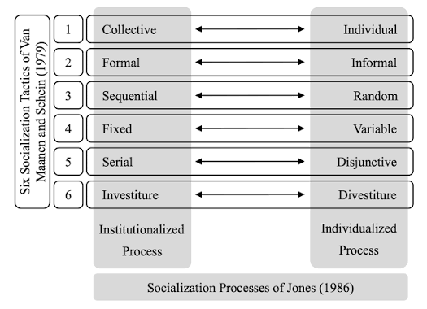
Figure 1: Tactical framework by Van Maanen and Schein (1979)
(Source: Bumann and Pettersson 2025)
The eight-month ramp-up period of Helios Urban Mobility is not an issue of training, but a problem of socialisation. Conventional onboarding views entry as an administrative activity - contracts, compliance and systems access- loaded up-front in a first week and thought to have concluded thereafter. Strategic organisational socialisation, in its turn, is a longitudinal process whereby newcomers develop the knowledge, behaviours and meaning needed to act as committed insiders. The difference is explained in the tactical framework by Van Maanen and Schein (1979). They distinguish between institutionalised strategies (collective, formal, sequential, fixed, serial and investiture) and the individualised strategies (individual, informal, random, variable, disjunctive and divestiture) in six dimensions. Institutionalised strategies minimise role ambiguity and expedite insider status and individualised strategies the de facto sink-or-swim reality of Helios during rapid scaling leave newcomers to create knowledge by themselves, increasing ramp-up time and loss of commitment (Hall and Paul, 2020). The tactics involved are then a strategic rather than an administrative decision and so far Helios has failed on the more expensive individualised pattern.
Psychological contract theory
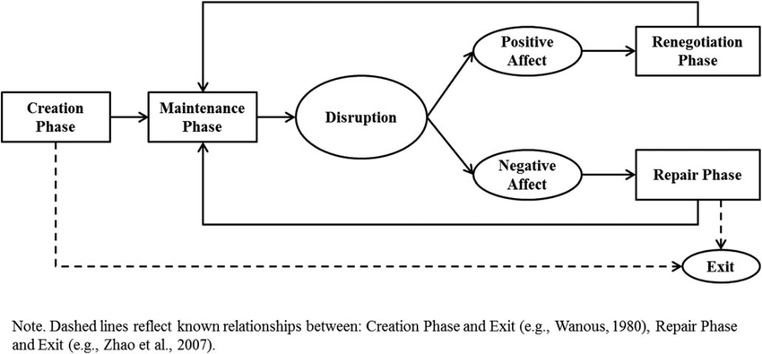
Figure 2: Psychological contract theory
(Source: Rousseau et al. 2018)
The forging of psychological contracts is achieved during this period of time. According to Rousseau (2004), it is unwritten expectations between the employer and employee, which are most changeable at entry point. In onboarding, as a transactional relationship, a transactional contract results: effort in exchange of pay, little affective and high hitchiness with hikes in exit intentions - a reasonable motivation as to why Helios has lost high-potential graduate employees. The alternative approach is strategically socialisation that fosters a relational contract based on mutual investment and a sense of purpose. Most importantly, socialisation is an identity work as well (Zhou, Gomes and Ferran Vendrell‐Herrero, 2023). New entrants indulge in sensemaking in a provisional test of organisational cues with their provisional selves; unless identity construction is intentional, the construction drifts or stagnates to at least 54% of the engagement that Helios currently records.

1.2 A structured socialisation framework for Helios
The suggested design has three stages which would be mainly institutionalised and the design is based on the evidence that it is the most suitable tactic to apply when innovative roles are applied in combination with investiture and not divestiture (Bauer et al., 2024).
Pre-boarding.
Between acceptance of offer and day one, Helios implements digital induction portal, realistic job preview, and assignment of a peer navigator and structured, predetermined, manager welcome call. This lowers the expectations not met yet, begins establishing a sense of early belonging and sets organisational identity prior to the arrival, reducing the unproductive front end of the eight-month curve and cues that relationship has already start-up (Gcolotela, 2025).
The first ninety days.
A fixed and serial programme has proper milestones which are experienced, role models and predictable progress. Affirmation tactics (not denial) that seeks to preserve or not to deny the current identity of the recruit, is indispensable to employees who are graduates having a weak technical confidence (Lwamba et al., 2022). Facilitated by mastery and revealed by identifying psychological-contract gaps during structured thirty, sixty and ninety-day reviews, the ambiguity is transformed into clarity and previous gaps are exposed before disappointment sets in to exit intention.
Year one.
Socialisation is no longer implying absorption but giving back. The cross-site rotations in London, Berlin and Singapore, communities of practice, and a project of first stretch, an indication of the importance of the tasks. This unites insider identity, proving that the contribution of the recruit is indeed important, and makes the new member a part of the relational structure on which the retention of a firm ultimately relies (Kaliannan et al., 2023).

1.3 Mechanisms for identity, ethics and activism
Organisational identification.
Using social identity theory by Ashforth and Mael, (1989), membership must be psychologically gratifying, and can be achieved by defining the purpose, which is to decarbonise urban mobility, as a unique and prestigious cause, and making the individual effort directly connected to it. Storytelling, visible managerial mission measurements, leader role-modelling and inclusive symbols turn a basic job to a sense of self, once employees identify themselves with the organisation in part, identification becomes the best predictor of resort to discretionary effort and intention to stay.
Ethical professionalism.
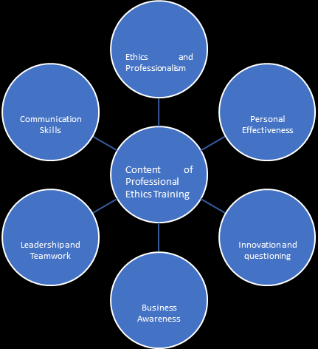
Figure 3: Ethical professionalism
(Source: Yang and Hu 2021)
Since Helios uses the information about the city-government and citizens, ethics cannot become a compliance consideration. By creating a structure of professional standards, ethical decision-making structures and reflective supervision during the year-one journey, juridical judgement is developed as opposed to rule-following and therefore ethics is created as a hallmark of an effective member of an organisation (Jerab, 2023). Ethical professionalism is not only the moral duty of a firm, but also a form of confidence that will secure long-term legitimacy in terms of the city governments with which Helios conducts its business.
The business-activist mindset.
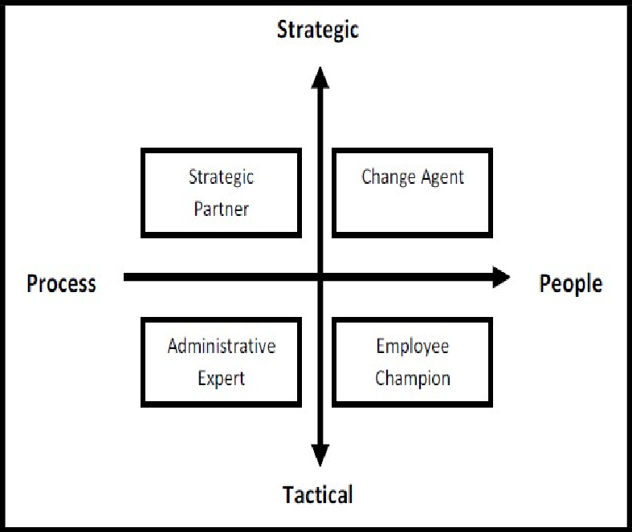
Figure 4: HR role by Ulrich
(Source: Ahmad et al. 2019)
The development of the HR role by Ulrich as an administrative specialist to strategic partner, and currently activist of organisational and societal agendas is an excellent design climax. In line with stakeholder capitalism, the perception that companies exist to serve employees, communities and the planet and not just shareholders, Helios is advised to invite new entrants to view themselves as actors who challenge, impact and make a difference (Cayrat and Boxall, 2023). Mechanisms that are practical could encompass reverse-mentoring on sustainability, challenge forums to which graduates make pitches to the top leadership, secondments to civic partners, and recognition based on impact to stakeholders as opposed to pure output. This makes the passive recruits become dedicated members of the organisation by becoming organisational citizens that bring in a new dimension of recruits (Saka-Helmhout et al., 2024).
A combination of these three phases and the three mechanisms is an integrated architecture. The broken front end of the ramp up curve is repaired through pre- boarding and the initial ninety days, the competence is transformed to commitment through year-one contribution and identification mechanisms, and the commitment is refocused to renewal instead of compliance, through the activist mindset. The design views socialisation as an activity, as opposed to induction, and it is an organisation that is constructed as an organisational citizen and directly challenges Helios interwoven issues of slow ramp-up, poor engagement and graduate flight (Kappel, 2026).

TASK B: Job Design

2.1 A motivational, skills-based job architecture
It is partly structural in nature that Helios has engagement and attrition issues. Situations like jobs designed with rapid delivery at scale-up are often narrow, fragmented and low in autonomy and no longer appeal to ambitious graduates who are most desirable to Helios. I believe that a solution to job design involves having a conceptual framework that combines the Job Characteristics Model, job-crafting theory and an abilities-oriented talent marketplace into one logical framework.
The Job Characteristics Model.
Hackman and Oldham (1980) discuss five fundamental dimensions as skill variety, task identity, task significance, autonomy and feedback that produce three essential psychological experiences that are experienced meaningfulness, experienced responsibility for consequences and knowledge of consequences. These states in turn act as the driving force of intrinsic motivation, performance quality and satisfaction. Their Motivating Potential Score formula is instructive since autonomy and feedback go in multiplicatively: a role that is unsuccessful in either of them effectively becomes a perfectly daunting motivating potential, regardless of its other dimensions. In the case of Helios, I would contemplate the redesigning of analyst and engineering positions in such a manner that each one has a complete identifiable city client deliverable to ensure identification of tasks and importance of tasks.
As per Atanassova et al. (2024) Effective discretion in approach and timing of each post-holder would be genuine, they would have autonomy and would have a client and data feedback in person, not as it is fed down the various levels of management. This assaults directly the lack of engagement that the most recent 54% survey report has indicated with its reestablishment of purpose, ownership and visible outcomes into the day-to-day work. This would increase the level of skill variety in having both the technical delivery with client-facing and analytical duties, where the competent graduates would be challenged and not limited to only one tedious role (Morandini et al., 2023).
Job crafting
The job-crafting theory by Wrzesniewski and Dutton (2001), is bottom-up, where the core idea is that employees can reshape their jobs themselves–task crafting, which can alter the nature of activities performed, relational crafting, which can alter workplace relationships, and cognitive crafting, which can redefine the meaning of the work performed. Vehicles of deliberate crafting should be sanctioned by Helios, via quarterly conversation of roles, enclosed time of innovation, and manager training that empowers, as opposed to restraints, change. Retkowsky et al. (2023) further stated that the development, in particular crafting, is particularly effective in keeping high-potential graduates, who would otherwise quit jobs when they become stalled and want to grow; being able to grow the job and make it personal to them means that they can grow without leaving the company, and their impatience is to their advantage. Significantly, continuous person-job fit is facilitated by crafting, as roles are constantly modified as employees change their capabilities and interests instead of being redesigned.
Skills-based architecture or an internal talent marketplace
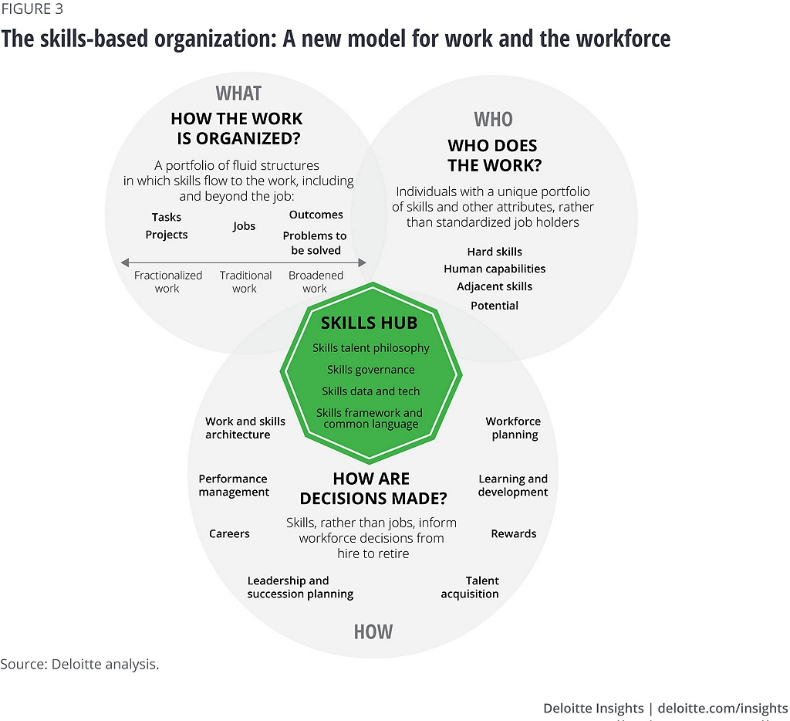
Figure 5: Skill Based Architecture
(Source: Cantrell et al. 2022)
Instead of repairing employees within inflexible job instructions, Helios ought to elaborate work as packaged abilities and discrete projects, which can be offered by a digital internal expertise market, which pairs individuals to temporary projects, gigs, mentoring and stretch jobs in the three locations (Nestor, 2025). This breaks silos, reveals ability that job titles cover, and provides the lateral and personal growth which new graduates now seek through quitting. It also future proofs the workforce, as AI changes the kind of skill that is valuable, a skills based system can redeploy and re-skill talent much more quickly than a job based structure is able to. These three components combine to provide Helios with managerial design and employee agency under a single architecture, a mix between the organisational consistency and individual customisation that drives knowledge workers (Abdelrahman et al., 2025).

2.2 Stimulating intrinsic motivation and innovation
Motivation
The design has been made coherent with self-determination theory (Deci and Ryan, 2000) where only three fundamental psychological needs are met and intrinsic motivation will thrive. The discretion that is embedded via the Job Characteristics Model, freedom to design, and the freedom to select assignments in the marketplace satisfy autonomy (Bruyne, 2026). Whole tasks containing a lot of feedback, as well as stretch projects in which mastery is gradually acquired, cannot be satisfied by competence. The relatedness is met with the cross-site cooperation, mentoring and communities of practice across London, Berlin and Singapore which overcomes the isolation that can come with remote and multi-site working. Employees are motivated when they have all three needs fulfilled and not because they are forced to work, but because work itself is a satisfying experience and this is the only case of long-term discretionary effort and reduced turnover by the high potential staff Helios is losing (Thomson Reuters, 2025).
Innovation
The same architecture results in innovation, as opposed to having to have a different initiative. Psychological safety arises through autonomy and afforded time to experiment, to fail in an intelligent way and task significance relates daily effort to a meaningful decarbonisation mission which inspires perseverance in face of hardship and failure (Mhlanga, 2022). The talent marketplace reshapes a combination of different talents in the three destinations, creating the knowledge collisions and cross-pollination in whose presence new mobility and analytics innovations are usual. Cognitive crafting helps to get employees to problem-frame as an opportunity, and a skills-based system rewards the ability to keep growing capacity rather than time within the company, which is a promotion of the endlessly learning that the truly innovative organisations always need (Priyanka, 2020).
These mechanisms, together, transform the jobs of Helios, as mere containers of delivery, to engines of motivation and renewal. The identical built-in design also has the effect of hastening ramp-up, as more identifiable tasks and more feedback increase competence faster. This also elevates engagement as meaning, autonomy and feedback are reinstatement; and enhances retention as growth becomes accessible within the organization and not only via resignation (Jolley, 2026). Most importantly, the strategy is both theoretically based and not superficial. Tian and Tóth (2024) states that all the elements are based on the long-developed motivational paradigm, and the elements interrelate with each other and do not oppose each other, so the architecture will resolve the three presenting problems of Helios with a single, disciplined, evidence-based human-capital intervention instead of a patchwork of individual, unsustainable ideologies.

TASK C: Reflective Report
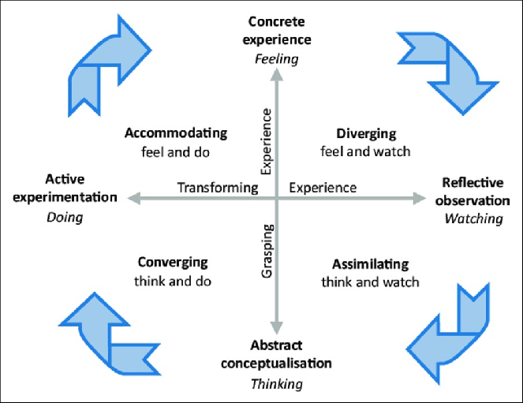
Figure 6: Kolbe’s Reflection Cycle
(Source: Ahmed and Opoku 2021)
Concrete Experience
By working through the module material related to artificial intelligence (AI) in strategic human resource management, I learned to have a better insight into what opportunities and threats artificial intelligence-supported decision-making carries. The presentations and examples of cases revealed the way AI is able to process workforce data, predict risks of attrition, summarize employee engagement pattern, and produce predictive forecasts. Meanwhile, they also mentioned ethical issues regarding the algorithmic bias, transparency, responsibility, and overreliance on automated recommendations.
Reflective Observation
Considering this learning experience, I noticed that I previously viewed AI as the means of making things more efficient. Nevertheless, I have now realised that when people have excessive trust in algorithmic recommendations, managerial judgement is undermined by automation bias, in which people will trust AI results complacently because those results seem objective (Pavithran and Vadivel, 2026). I also realised that contextual factors, culture of organisations, the dignity of a worker, and fairness cannot be sufficiently reflected with quantitative models. As a result, these human judgements are still vital in making decisions concerning recruitment, promotion, and talent management. Moreover, I realised that AI-based solutions that are already trained on past data about organisations could perpetuate the existing inequalities when their results are embraced without question (Tarafdar, Rets and Hu, 2023).
Abstract Conceptualisation
This experience has redefined what AI can bring to the strategic HR. Instead of perceiving AI as a decision-maker, now I view AI as a decision-support mechanism that can provide hypotheses and evidence to help in managerial decisions. The ethical judgment, organisational understanding and legal aspects require humans to be responsible in assessing AI suggestions. By holding on to high human-in-the-loop approach, organisations can enjoy the benefits of analytical functions without exposing themselves to risks of bias and overtrust to algorithms. Critical judgement thus implies unremitting inquirement as to what AI outputs encompass now as as well as to what they do not and whether the suggestions are congruent with ethical and organisational values.
Active Experimentation
To enhance my ability to be a strategic human resource professional in the future, I have outlined four areas of priorities in developing my skills. To begin with, I will enhance my data literacy by increasing my ability to gain competency in people analytics and statistical rationale to ensure that I do not take the analytical products at face value (Chuang, Chiang and Lin, 2025). Second, I will gain useful experience with AI-powered HR technologies and gain an understanding of the ethics governance systems that can assist in ethical AI adoption. Third, I will enhance my influencing capabilities in strategy by enhancing the management of stakeholders, persuasive communication, and evidence-based decision-making, which is the competencies of strategic HR business partner outlined by Dufrane et al. (2021). Lastly, I will increase my concern of global awareness, by doing cross cultural learning and by knowing more about global employment practices in Europe and Asia.

Reference List
Abdelrahman, M., Papamichail, K.N., Hammady, R., Kurt, Y., Abdallah, W., Shixiong Liu, L. and Kapser, S. (2025). Organisational Culture and Knowledge Management Systems Adoption: Examining Employee Usage in Multinational Corporations. Global Journal of Flexible Systems Management. doi:https://doi.org/10.1007/s40171-025-00448-w.
Ahmed, V. and Opoku, A. (2021). Technology supported learning and pedagogy in times of crisis: The case of COVID-19 pandemic. Education and Information Technologies, 27(1). Available from: https://doi.org/10.1007/s10639-021-10706-w.
Ashforth, B.E. and Mael, F. (1989). Social Identity Theory and the Organization. Academy of Management Review, [online] 14(1), pp.20–39. doi:https://doi.org/10.5465/amr.1989.4278999.
Atanassova, I., Bednar, P., Khan, H. and Khan, Z. (2024). Managing the VUCA environment: The dynamic role of organizational learning and strategic agility in B2B versus B2C firms. Industrial Marketing Management, 125, pp.12–28. doi:https://doi.org/10.1016/j.indmarman.2024.12.008.
Bauer, T.N., Erdogan, B., Ellis, A.M., Truxillo, D.M., Brady, G.M. and Bodner, T. (2024). New Horizons for Newcomer Organizational Socialization: A Review, Meta-Analysis, and Future Research Directions. Journal of Management, 51(1). doi:https://doi.org/10.1177/01492063241277168.
Bruyne, T. de (2026). Self-Determination Theory explained: autonomy, competence and relatedness. [online] SUE Behavioural Design. Available at: https://www.suebehaviouraldesign.com/en/blog/self-determination-theory-explained/.
Cayrat, C. and Boxall, P. (2023). The Roles of the HR function: a Systematic Review of tensions, Continuity and Change. Human Resource Management Review, 33(4). https://doi.org/10.1016/j.hrmr.2023.100984
Chuang, Y.-T., Chiang, H.-L. and Lin, A.-P. (2025). Insights from the Job Demands–Resources Model: AI’s Dual Impact on Employees’ Work and Life well-being. International Journal of Information Management, [online] 83(102887), p.102887. doi:https://doi.org/10.1016/j.ijinfomgt.2025.102887.
Dufrane, A., Morales, J., Ulrich, D., Schiemann, W. and Sartain, L. (2021). The Rise of HR foreword wisdom from 73 ThoughT Leaders ediTors. [online] Available at: https://www.hrci.org/docs/default-source/default-document-library/the-rise-of-hr-wisdom-from-73-thought-leaders.pdf?sfvrsn=d4ecf1e3_1.
Gcolotela, T. (2025). THE IMPACT OF THE ONBOARDING PROGRAMME ON EMPLOYEE ENGAGEMENT AND PRODUCTIVITY AS PERCEIVED BY NEW HIRES IN THE FAST-MOVING CONSUMER GOODS INDUSTRY. [online] Available at: https://uwcscholar.uwc.ac.za:8443/server/api/core/bitstreams/3ff73050-4384-4f36-aa04-c84cc8d78077/content.
Hackman, J.R. (1980). Work redesign and motivation. Professional Psychology, 11(3), pp.445–455. doi:https://doi.org/10.1037/0735-7028.11.3.445.
Hall, M. and Paul, M. (2020). Organizational Socialization | Quality Improvement Center for Workforce Development. [online] Qic-wd.org. Available at: https://www.qic-wd.org/umbrella/organizational-socialization.
Jerab, D.A. (2023). How to Be an Effective Leader in Decision Making in an Unstable Environment. [online] Social Science Research Network. doi:https://doi.org/10.2139/ssrn.4525803.
Jolley, S. (2026). Motivosity Blog | 10 Best Employee Engagement Programs for 2026 | Motivosity. [online] Motivosity.com. Available at: https://www.motivosity.com/blog/employee-engagement-programs
Kaliannan, M., Darmalinggam, D., Dorasamy, M. and Abraham, M. (2023). Inclusive talent development as a key talent management approach: A systematic literature review. Human Resource Management Review, 33(1), pp.1–23. https://doi.org/10.1016/j.hrmr.2022.100926
Kappel, R. (2026). The 7 Essential Elements of a Compliance Framework You Need to Know - Centraleyes. [online] Centraleyes. Available at: https://www.centraleyes.com/the-7-essential-elements-of-a-compliance-framework-you-need-to-know/.
Lwamba, E., Shisler, S., Ridlehoover, W., Kupfer, M., Tshabalala, N., Nduku, P., Langer, L., Grant, S., Sonnenfeld, A., Anda, D., Eyers, J. and Snilstveit, B. (2022). Strengthening women’s Empowerment and Gender Equality in Fragile Contexts Towards Peaceful and Inclusive societies: a Systematic Review and Meta‐analysis. Campbell Systematic Reviews, [online] 18(1), pp.1–264. doi:https://doi.org/10.1002/cl2.1214.
Mhlanga, D. (2022). Human-Centered Artificial Intelligence: The Superlative Approach to Achieve Sustainable Development Goals in the Fourth Industrial Revolution. Sustainability, 14(13), p.7804. doi:https://doi.org/10.3390/su14137804.
Morandini, S., Fraboni, F., De Angelis, M., Puzzo, G., Giusino, D. and Pietrantoni, L. (2023). The Impact of Artificial Intelligence on Workers’ skills: Upskilling and Reskilling in Organisations. Informing Science: the International Journal of an Emerging Transdiscipline, 26(1), pp.39–68. doi:https://doi.org/10.28945/5078.
Nestor. (2025). Reskilling: What It Is, Why It Matters, and How to Do It Right - Nestor. [online] Available at: https://nestorup.com/blog/reskilling-what-it-is-why-it-matters-and-how-to-do-it-right/.
Pavithran, M.S. and Vadivel, S.M. (2026). Explainable attrition risk scoring for managerial retention decisions in human resource analytics. Frontiers in Big Data, 8. doi:https://doi.org/10.3389/fdata.2025.1699561.
Priyanka (2020). Study on skill based Compensation structure with reference to Randstad. AIMT Journal of Management, [online] 9(I and II), pp.81–94. doi:https://doi.org/10.65301/aimt.2020.9.I.II.732.
Retkowsky, J., Sanne Nijs, Jos Akkermans, Khapova, S.N. and Jansen, P. (2023). Seeking stability in unstable employment: An explorative study of temporary agency workers’ career self-management. Journal of Vocational Behavior, 143, pp.103877–103877. doi:https://doi.org/10.1016/j.jvb.2023.103877.
Rousseau, D.M. (2004). Psychological Contracts in the Workplace: Understanding the Ties That Motivate. Academy of Management Perspectives, [online] 18(1), pp.120–127. doi:https://doi.org/10.5465/ame.2004.12689213.
Saka-Helmhout, A., Álamos-Concha, P., López, M.M., Hagan, J., Murray, G., Edwards, T., Kern, P., Martin, I. and Ling Eleanor Zhang (2024). Stakeholder engagement strategies for impactful corporate social innovation initiatives by multinational enterprises. Journal of international management, 30(4), pp.101159–101159. doi:https://doi.org/10.1016/j.intman.2024.101159.
Tarafdar, M., Rets, I. and Hu, Y. (2023). Can ICT enhance workplace inclusion? ICT-enabled workplace inclusion practices and a new agenda for inclusion research in information systems. The Journal of Strategic Information Systems, 32(2), pp.101773–101773. doi:https://doi.org/10.1016/j.jsis.2023.101773.
Thomson Reuters (2025). 20 ways employees are motivated by their work. [online] @thomsonreuters. Available at: https://www.thomsonreuters.com/en/careers/careers-blog/20-ways-employees-are-motivated-by-work.
Tian, X. and Tóth, A. (2024). New human capital theory from the perspective of time allocation: Evolution and prospects. Prosperitas, [online] 11(2), pp.1–13. doi:https://doi.org/10.31570/prosp_2023_0087.
Van Maanen, J. and Schein, E.H. (1977). Toward a Theory of Organized Socialization. Research in Organizational Behavior, [online] 1(960-77.). Available at: https://www.researchgate.net/publication/5175507_Toward_a_Theory_of_Organized_Socialization.
Wrzesniewski, A. and Dutton, J.E. (2001). Crafting a Job: Revisioning Employees as Active Crafters of Their Work. The Academy of Management Review, 26(2), pp.179–201. doi:https://doi.org/10.2307/259118.
Zhou, Y., Gomes, E. and Ferran Vendrell‐Herrero (2023). Learning ‘from’ vs. learning ‘about’ partners in pre-acquisition strategic alliances: The role of familiarity. Long Range Planning, 56(6), pp.102386–102386. doi:https://doi.org/10.1016/j.lrp.2023.102386.
Ahmad, Z., Haque, I., Khan, M.S. and khan. (2019). Changing HR Roles, HR Effectiveness and its impact on Organizational Effectiveness; A Study of Indian Healthcare Firms. International Journal of Scientific &amp; Technology Research [online], 8(11), pp.2351–2358. Available from: https://www.researchgate.net/publication/352573622_Changing_HR_Roles_HR_Effectiveness_and_its_impact_on_Organizational_Effectiveness_A_Study_of_Indian_Healthcare_Firms
Bumann, A. and Pettersson, J. (2025). Success in Motion: How Employees Navigate Internal Mobility A Case Study on Employee Socialization During Internal Role Transitions. , 2025. Available from: https://lup.lub.lu.se/luur/download?func=downloadFile&recordOId=9192762&fileOId=9192837.
Cantrell, S., Griffiths, M., Jones, R. and Hiipakka, J. (2022). The skills-based organization: A new operating model for work and the workforce [online]. Deloitte Insights [online]. Available from: https://www.deloitte.com/us/en/insights/topics/talent/organizational-skill-based-hiring.html
Rousseau, D.M., Hansen, S.D. and Tomprou, M. (2018). A dynamic phase model of psychological contract processes. Journal of Organizational Behavior [online], 39(9), pp.1081–1098. Available from: https://onlinelibrary.wiley.com/doi/abs/10.1002/job.2284
Yang, J. and Hu, Z. (2021). Contents and Methods: The Reference and Enlightenment of ACCA Professional Ethics Education to China. Advances in Social Science, Education and Humanities Research [online], 2021. Available from: https://doi.org/10.2991/assehr.k.211215.06

