Programme: BA (Hons) Leadership and Management Skills for the Workplace
Module Title: Developing and Managing Individuals and Teams
Module code: LCLM5002
Component 2- Individual Report
Student name:Ionela Olivia Lupsa
student number:2416880
Lecturer’s name: Toyin Adisa
Assignment Title: An analysis of business transformation in BP, London using digital technological trends and flexible working arrangements
Word Count: 2021

Table of Contents
Introduction 3
Explanation of Key Factors within BP 3
Contemporary HR practices 4
Critical Evaluation of Managerial Implementation 5
Conclusion 6
Recommendation 6
References 7

Introduction
This report has been prepared for the Human Resources (HR) team of BP plc. BP plc is one of the top multinational oil and gas organisations that refines oil and gas into fuel and eventually sells it at petrol stations (BP, 2025). A serious rise in employee grievances at the company was noticed during the phase of organisational change. Thus, it is important for the HR team of the company to explore the key factors such as digital technology trends, business transformation and working shifts along with their impacts on employees and teams. This report will present proper HR practices based on performance and employee well-being.
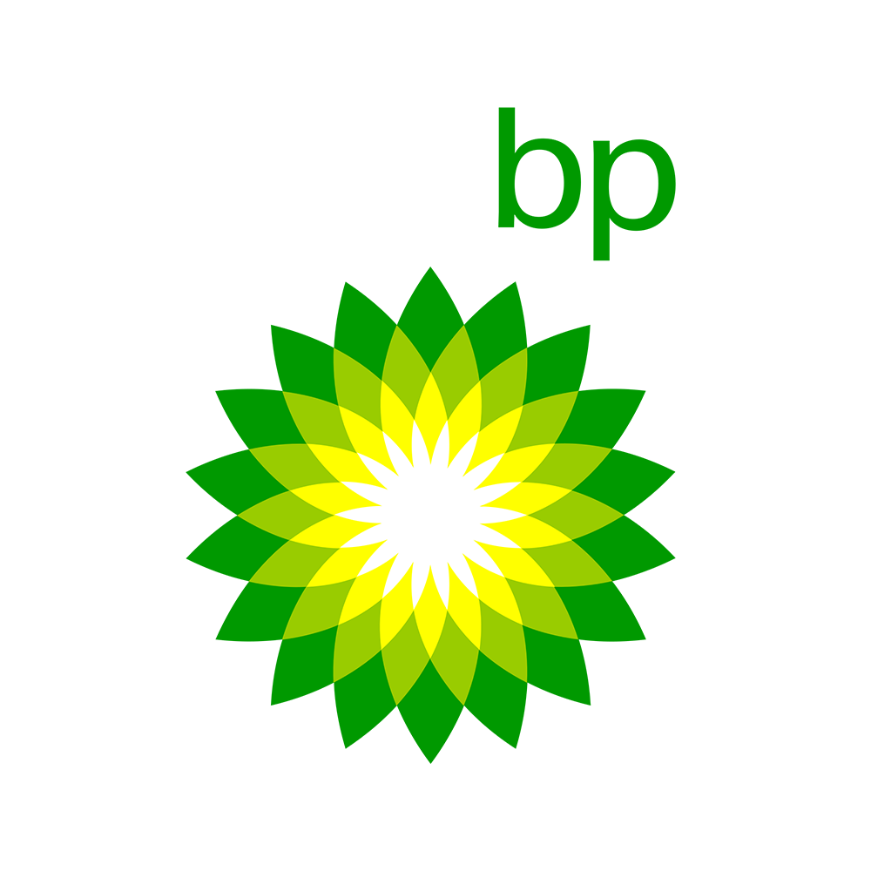
Figure 1: BP plc
(Source: BP, 2025a)

Explanation of Key Factors within BP
There are several key factors that are important to analyse in order to gain a proper knowledge of the business operation. At BP, three major factors have been chosen- business transformation, digital technology and working arrangements for employees. These three factors are to be vastly explored in this section.
Business Transformation
BP is considered to be transforming its business operations widely. As far as its functions were concerned, the company was earlier majorly based on oil and gas regardless of the intervention of sustainability practices. However, the company has now intended to focus on the development of sustainable operations so that it can become an integrated energy company. According to Schiemann et al. (2022), organisational sustainable transformation was made mainly for the global pressure of reducing carbon emissions from large firms and those firms were forced to invest in cleaner energy. Therefore, the authority of BP had to focus on making sustainable schemes. As far as the strategy of BP based on “Reimagining Energy” was concerned in this regard, the company intended to reduce the production of oil and gas by a margin of 40% by the end of 2030, whereas it will increase the investment for the purpose of developing electric vehicle charging stations, renewable energy and hydrogen technologies (Trencher, 2023). There were different ways the employees of the company were affected by this transformation. Traditional ways of refining oil and gas were decreased while teams of the company were expected to learn new skills. They had to embrace sustainable practices which led them to a stage of job loss and uncertainty which eventually contributed to increasing grievances.
Digital Technology Trends
BP is understood in terms of investing heavily for the purpose of digital development. In order to improve the decision-making process and work efficiency, the company has accommodated digital technologies in its infrastructure. As per the views of Annapareddy (2022), there are different digital trends such as artificial intelligence (AI), cloud computing, machine learning and more which are highly effective in order to monitor organisational operations, optimise the use of energy and predict the failures of equipment. Understanding all these benefits of implementing digital technologies in the system, the company decided to implement these in its business practices. A partnership between BP and Microsoft Azure was made so that real-time data could be analylsed across the global sites of the company (Microsoft, 2023). There was no doubt that the implication of these technologies enhanced work efficiency; however, there was a challenge from the perspectives of employees. Particularly those employees who worked at the company for a long period of time and work generally in the conventional way found it difficult in the era of digital implications. Employees do not have a huge digital expertise and thus, they may feel overwhelmed by the brand-new systems. They can even have a fear of being replaced by automation. Therefore, there is a need for digital training and practical support for the development of digital employability skills.
Flexible Working Arrangements
According to Krajčík, Schmidt and Baráth (2023), due to the outbreak of the COVID-19 pandemic, global companies started to arrange flexible working shifts for their employees, focusing on remote work, flexible hours and hybrid models. BP started flexible working schedules in order to improve work-life balance for its employees and moreover, a huge amount of operational costs was also saved. On the other hand, flexible working also led to a lack of communication, which made employees isolated from real office environments (Vaidya and Bedi, 2024). These issues became problematic for employees of BP plc.

Contemporary HR practices
There should be proper practices from the HR perspective in order to address the issues that were mentioned in the earlier section, based on all three departments- transformation, digital implication and working schedules. This action will show how those challenges can be met in sustainable ways.
Addressing Business Transformation
In order to support the shift of BP towards sustainability, HR of the company must need to arrange practices based on which employees may feel they should adapt to the new setup. Change management training can be an effective approach to deal with this situation as it involves the implication of coaching sessions which will show the beneficial aspects of making sustainable changes within the organisation to employees and how they can contribute to this transformation (Brandes and Lai, 2022). After understanding the bigger picture and long-term goal, employees are highly likely to support this transformation. Another useful technique can be career development planning. Employees should be given proper support in order to excel in new skills so that they can remove the fear of failure (Webster, 2019). Those employees who worked in the oil exploration at BP can be trained properly and engage in the role of data analytics or renewable energy. Employees will need full support from the HR team of the company so that they can eliminate their issues fast and acquire new, sustainable skills. Transparent communication between HR and employees can also play a vital role. Healthy feedback is expected from the HR team so that employees can keep excelling and developing their learning methods.
Supporting Digital Technology Trends
To go with the innovative digital trends, the HR team of BP must need to emphasise the arrangement of a digital training skills program. Under this digital skills development training, employees will be offered online courses and properly mentored by the HR team so that they can easily learn the implications of AI and cloud tools (Rustam, Astuti and Safitri, 2024). This approach will surely be beneficial for employees in order to reduce their stress, which is related to handling innovative technologies. Therefore, employees of BP should be given proper digital training so that they can acquire innovative skills on how to operate digital tools. Job redesign can also be a fruitful strategy for employees as it will help them understand the future needs of the business. Digital well-being policies should also be introduced with the inclusion of screen time, breaks and more (Uslu, 2025). These polices will help employees stay mentally fresh throughout the day in the office. It is important to stay fresh in order to deliver efficient work efforts in the system and these efforts will allow the company to obtain productive outcomes. Therefore, digital wellbeing polices along with skills training programs can be a sustainable approach from the HR perspective of BP in order to have employees of the company excel in handling digital tools.
Managing Flexible Working Arrangements
BP can make its flexible working successful by making proper policies. Clear remote working rules will clearly show the expectations from employees regarding availability, performance, data security and communication (Vander Peterson, 2025). Employees must obey these rules. There is also a requirement for inclusive activities within teams. Hybrid meetings can be arranged so that all employees remain connected even if they operate sometimes remotely. Meetings can play a vital role in terms of keeping employees fresh and they will act as a medium of collaboration for employees. HR should use performance management tools in order to update regular check-ins and check-outs. They can also provide feedback on these tools from a remote location.

Critical Evaluation of Managerial Implementation
Departmental managers play a critical role in terms of applying the rules and guidelines in day-to-day official practices. HR and the higher authority of the organisation are mostly considered to be developing rules and practices for the betterment of the organisation. However, managers should take those practices with urgency and establish them in the workforce so that teams are supported properly and grievances are reduced. From the managerial perspective, one of the highly demanded approaches is active leadership. Managers should always be around their employees so that they can be supported in their jobs. Managers can easily explain the concerns of employees with proper leadership. This is evident that employees feel less anxious when their leaders are easily approachable and present. Healthy communication from leaders can build trust and reduce confusion among employees (Meyer, Le Fevre and Robinson, 2017). Thus, managers at BP should communicate with their employees on a regular basis. Before the division of regular tasks, managers should properly explain the need for those tasks and the expectations from employees, along with their roles. HR is mainly considered to be designing a message; however, it is the job of managers to convey that message to employees in the best possible way so that every employee becomes eager to perform the task for the betterment of the organisation and the environment. Managers should lead their teams by example. They must have to be proficient in handling digital tools such as AI dashboards, cloud-based tools and more so that employees get motivation from their leaders in accessing those tools. Managers need to find the skills gap in specific employees so that they can be sent to the training program again in order to develop digital skills. Therefore, it is quite evident that managers will have to play an active role in terms of eliminating organisational employability issues and establishing HR practices for organisational change and digitalisation.
Managers should build an inclusive environment within BP. All the workers should be equally treated so that they find equal opportunities and promotions. Remote workers should be professionally invited to team meetings along with office workers. In the decision-making process, employees should be encouraged to give their opinions. This is how managers will be able to have employees take ownership of their jobs and conflicts can easily be avoided within the workforce. Digital performance management tools should be implemented by managers so that the work efficiency of employees can be managed properly (Burnett and Lisk, 2021). These tools should include clear goals in terms of tracking the progress of employees. Moreover, employees should be given timely feedback so that they can address their mistakes on their own. This will enhance the learning process of employees. Overall, managers need to act like grievance gatekeepers so that they can understand the issues of employees way before these get escalated. Early signs regarding employee conflict, stress and more should be observed thoroughly by managers and they should report to the HR team immediately so that new strategies can be drawn instantly.

Conclusion
After a thorough analysis of workplace practices and skills, it is concluded that BP is going through a transformational phase where the company intends to incorporate sustainable practices into the system, focusing on digital tool implication. However, the employees of the company need to be proficient in order to handle those innovative digital tools. It is evident that these sustainable approaches are surely beneficial in terms of stabilising the operations of BP within its workforce. Managers will have to establish HR rules in the workforce by giving proper support to employees.

Recommendation
BP should make several changes to address current issues. The company can launch a support program for its employees with clear communication so that they can acquire digital proficiency in handling digital tools (Kulkarni et al. 2022). There should be an investment for the purpose of arranging employee training programs. The company needs to publish organisational policies based on the expectation of employees emphasising inclusive practices. For the prevention of grievances, managers should be alert and active in their jobs. They can use performance management tools to monitor the tasks of employees. After monitoring, it is important to provide feedback to employees based on their performance.

References
Annapareddy, V. N. (2022) Integrating AI, Machine Learning, and Cloud Computing to Drive Innovation in Renewable Energy Systems and Education Technology Solutions. Available at SSRN 5240116. http://dx.doi.org/10.2139/ssrn.5240116
BP (2025) Our History. Available at: https://www.bp.com/en/global/corporate/who-we-are/our-history.html (Accessed: 23 October 2025)
BP (2025a) BP. Available at: https://www.bp.com/ (Accessed: 23 October 2025)
Brandes, B., and Lai, Y. L. (2022) ‘Addressing resistance to change through a micro interpersonal lens: an investigation into the coaching process’, Journal of Organizational Change Management, 35(3), pp. 666-681. https://doi.org/10.1108/JOCM-07-2021-0214
Burnett, J. R., and Lisk, T. C. (2021) ‘The future of employee engagement: Real-time monitoring and digital tools for engaging a workforce’, In International perspectives on employee engagement (pp. 117-128). London: Routledge.
Krajčík, M., Schmidt, D. A., and Baráth, M. (2023) ‘Hybrid work model: An approach to work–life flexibility in a changing environment’, Administrative Sciences, 13(6), p. 150. https://doi.org/10.3390/admsci13060150
Kulkarni, P. M., Appasaba, L. V., Gokhale, P., and Tigadi, B. (2022) ‘Role of digital simulation in employee training’, Global Transitions Proceedings, 3(1), pp. 149-156. https://doi.org/10.1016/j.gltp.2022.04.014
Meyer, F., Le Fevre, D. M., and Robinson, V. M. (2017) ‘How leaders communicate their vulnerability: Implications for trust building’, International Journal of Educational Management, 31(2), pp. 221-235. https://doi.org/10.1108/IJEM-11-2015-0150
Microsoft (2023) Bp powers greater innovations with a modular data mesh design on Azure. Available at: https://www.microsoft.com/en/customers/story/1596942341326478042-bp-energy-microsoft-intelligent-data-platform#:~:text=To%20speed%20innovations%20in%20support%20of%20this%20initiative%2C,for%20a%20new%20multicloud%20modular%20data%20mesh%20architecture.?msockid=153a42cccf676bdb286354face5f6a2e (Accessed: 24 October 2025)
Rustam, A., Astuti, I. Y., and Safitri, U. R. (2024) ‘Strategies for improving employee competencies in the digitalization era through training and human resource development’, The Journal of Academic Science, 1(7), pp. 849-857. http://thejoas.com/index.php/thejoas/article/view/130
Schiemann, M., Böhm, B., Chirone, R., Senneca, O., Ströhle, J., Umeki, K., and Vujanovic, M. (2022) ‘Technical solutions to foster the global energy transition: Special issue on clean fuel conversion technologies for carbon dioxide and pollutant reduction’, Renewable and Sustainable Energy Reviews, 154, p. 111770. https://doi.org/10.1016/j.rser.2021.111770
Trencher, G. (2023) ‘Keeping Your Fossil-Fuel Cake While Eating It? Comparing the Decarbonization Approach of BP, Chevron, ExxonMobil and Shell’, In Governance for a Sustainable Future: The State of the Art in Japan (pp. 251-278). Singapore: Springer Nature Singapore. https://doi.org/10.1007/978-981-99-4771-3_13
Uslu, O. (2025) ‘Understanding digital wellbeing: impacts, strategies, and the path to healthier technology practices’, Discover Social Science and Health, 5(1), p. 145. https://doi.org/10.1007/s44155-025-00259-5
Vaidya, S., and Bedi, H. S. (2024) ‘Explore The Effects Of Remote Working, Hybrid Models, And Flexible Hours On Employee Productivity And Mental Health’, Library of Progress-Library Science, Information Technology & Computer, 44(3). https://search.ebscohost.com/login.aspx?direct=true&profile=ehost&scope=site&authtype=crawler&jrnl=09701052&AN=180918102&h=kacTRzGZKYM5J5%2BpQBUtkqL3jcKgaa95zm0fi8%2BYcnbatv0vIrouRjzowL4oyS8ney9SS3KLIcCkf%2BNNv8DL8Q%3D%3D&crl=c
Vander Peterson, C. (2025) ‘Information Assurance in the Context of Mobile and Remote Work: Addressing New Challenges in Access, Storage, and Communication’, International Review of Artificial Intelligence, Machine Learning, and Automated Decision Systems, 15(6). https://thescicentral.com/index.php/IRAIMLADS/article/view/peterson2025
Webster, K. J. (2019) Befriending the Boogeyman: Using Improvisation Methods to Motivate Employees and Mitigate Fear of Failure. OCAD University. https://openresearch.ocadu.ca/id/eprint/2433/

