

University of Wales Trinity Saint David

Module: Strategic Management
Module code: LCMB7003
Assessment Title: Assessment component - Individual report
Student Name: Sherife Aleksieva
Student ID: 2211682
Lecturer name: Dr Ejike Udeogu
Word count: 5,257
Submission date: 17 July 2026

Strategic Management Analysis of Jaguar Land Rover’s Electric-First Modern Luxury Strategy in the UK Automotive Market

Table of Contents

Executive Summary 3
1. Introduction 3
Section 1: Strategic Consultant Report 5
2. Organisational Context and Overview 5
2.1 Historical Background, Mission, Vision and Business Model 5
2.2 UK Automotive Industry Context, Competitors and Market Position 5
3. External and Internal Analysis 6
3.1 External Environment: PESTEL and Porter’s Five Forces 6
3.2 Internal Environment: VRIO, Value Chain and Core Competencies 9
3.3 SWOT Analysis and Strategic Implications 11
4. Comprehensive and Holistic View of the Organisation 13
4.1 Corporate Social Responsibility Strategy and Business Alignment 13
4.2 Balanced Scorecard Analysis 14
5. Strategic Choices and Implementation 16
5.1 Strategic Options and Evaluation 16
5.2 Recommended Strategy and Implementation Plan 18
5.3 Implementation Challenges and Mitigation Strategies 18
6. Recommendation and Conclusion 20
Section 2: Reflective Account 21
7. Reflection Using Gibbs’ Reflective Cycle 21
Conclusion. 23
References 23

Executive Summary
This report evaluates the current strategic position of Jaguar Land Rover (JLR) in the UK automotive market and proposes recommendations to strengthen its competitive advantage. JLR is a premium automotive manufacturer whose current transformation is shaped by its Reimagine strategy, focused on modern luxury, electrification, sustainability and long-term value creation. The UK automotive market is an appropriate focus because it is being reshaped by electric vehicle regulation, changing customer expectations, technological innovation, supply chain pressure and intense premium competition.
The analysis applies strategic management frameworks including PESTEL, Porter’s Five Forces, VRIO, SWOT and the Balanced Scorecard. The findings suggest that JLR benefits from strong intangible resources, including British luxury heritage, Range Rover and Defender brand equity, design capability and support from Tata Motors. However, these strengths are challenged by rapid EV competition, software capability gaps, high operating costs and the need to improve quality and sustainability execution.
The report argues that JLR should not compete primarily through cost leadership. Its most suitable strategic route is focused differentiation through electric-first modern luxury, supported by stronger EV and software capabilities, strategic alliances, sustainability, quality improvement and premium customer experience. This means JLR’s heritage remains strategically valuable, but future advantage depends on converting that heritage into a credible, sustainable and technologically advanced modern luxury position.

1. Introduction
The UK automotive industry is undergoing significant strategic change as electrification, sustainability regulation, digital technology and changing customer expectations reshape the basis of competition. This report evaluates Jaguar Land Rover’s current strategic position in the UK automotive market and proposes recommendations to enhance its long-term competitive advantage. The analysis is written from the perspective of a strategic management consultant preparing a report for the Board of Directors.


Jaguar Land Rover is an appropriate organisation for this report because it operates in a highly competitive, technology-driven and regulation-intensive industry. Its Reimagine strategy aims to transform the business through modern luxury, electrification, strategic collaboration and a carbon net zero ambition by 2039 (JLR, 2026). The UK market is selected because it is JLR’s home market and reflects many of the pressures currently affecting global automotive manufacturers, including EV adoption, premium competition and supply chain transformation. In 2025, UK new car registrations reached 2.02 million, while almost half a million new battery electric vehicles were registered, showing both growth in EV demand and the continuing gap between market demand and policy ambition (SMMT, 2026).
The report applies PESTEL, Porter’s Five Forces, VRIO, SWOT and the Balanced Scorecard to evaluate JLR’s external environment, internal capabilities and strategic choices. The central argument is that JLR’s strongest route is not pure cost leadership, but focused differentiation through electric-first modern luxury. Therefore, the purpose of the analysis is to show how JLR can convert its heritage, brand equity and engineering capability into a credible future competitive advantage.

Section 1: Strategic Consultant Report

2. Organisational Context and Overview

2.1 Historical Background, Mission, Vision and Business Model
Jaguar Land Rover (JLR) is a UK-based premium automotive manufacturer and a wholly owned subsidiary of Tata Motors, which acquired the Jaguar and Land Rover businesses from Ford in 2008 (JLR, 2008). The company operates through distinct British brands associated with luxury, performance, capability and premium customer experience. Its product portfolio includes Range Rover, Defender, Discovery and Jaguar, positioning JLR strongly in the premium SUV and luxury vehicle segments.
JLR’s strategic direction is shaped by its Reimagine strategy, which aims to create a future of modern luxury through electrification, sustainability and distinctive brand identities. The company states that Reimagine is focused on the electrification of Range Rover, Defender and Discovery, alongside the renaissance of Jaguar as an all-electric brand (JLR, 2026a). This vision is supported by JLR’s wider sustainability ambition to achieve carbon net zero across its supply chain, products and operations by 2039 (JLR, 2026b). Therefore, JLR’s business model is not based on high-volume low-cost production, but on premium pricing, brand desirability, design, engineering capability and differentiated customer value.

2.2 UK Automotive Industry Context, Competitors and Market Position
The UK automotive market provides both opportunity and pressure for JLR. New car registrations reached 2.02 million in 2025, while almost half a million new battery electric vehicles entered the market, showing that electrification is becoming central to industry competition (SMMT, 2026). However, EV demand remains uneven and policy-driven, creating uncertainty for manufacturers that must invest heavily before demand is fully mature. JLR also faces intense competition from BMW, Mercedes-Benz, Audi, Porsche, Lexus, Volvo/Polestar, Tesla and emerging Chinese EV brands, all of which challenge its premium position through technology, pricing, software and customer experience.
Financially, JLR’s position shows both recovery and vulnerability. In FY25, it reported strong full-year performance, including profit before tax and exceptional items of £2.5 billion, but FY26 results fell sharply to £14 million due to a challenging year and strategic transition pressures (JLR, 2025; JLR, 2026c). This indicates that JLR has valuable brand assets, but its future competitiveness depends on converting its heritage and premium reputation into a credible electric-first modern luxury advantage.

3. External and Internal Analysis

3.1 External Environment: PESTEL and Porter’s Five Forces
The external environment includes the macro and industry forces that influence an organisation’s strategy, performance and competitive advantage. For JLR, external analysis is important because the UK automotive market is being reshaped by electrification, government regulation, sustainability expectations, digital technology and intense premium competition. The UK zero emission vehicle mandate requires the market to move progressively towards zero-emission vehicles, with 80% of new cars expected to be zero emission by 2030 and 100% by 2035 (Department for Transport, 2024). This creates a clear opportunity for JLR’s electric-first modern luxury strategy, but it also increases pressure to deliver EV products quickly and credibly.
Figure 1: PESTEL Analysis Framework.
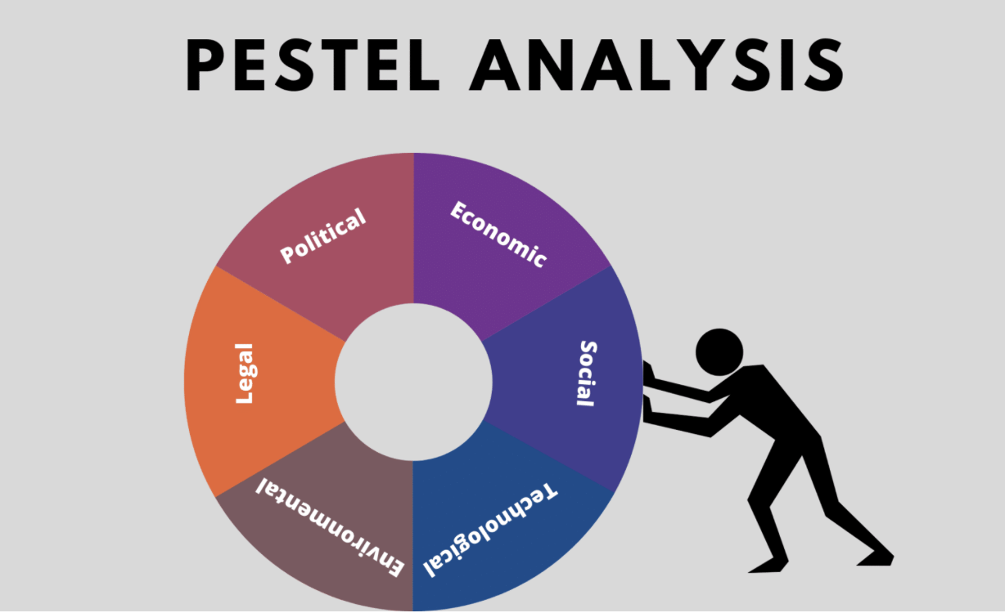
Source: Adapted from strategic management framework.

Table 1: PESTEL Analysis of JLR in the UK Automotive Market
Factor | Key issue | Strategic implication for JLR
Political | UK policy supports zero-emission vehicle transition. | JLR must align product development with EV regulation.
Economic | Inflation and high interest rates can weaken premium car demand. | JLR needs cost discipline without damaging luxury positioning.
Social | Customers expect sustainability, digital convenience and premium experience. | Modern luxury must include sustainability and technology.
Technological | EVs, batteries, AI and software-defined vehicles reshape competition. | JLR must strengthen EV, software and digital capabilities.
Environmental | Net zero targets increase pressure on products and supply chains. | JLR’s 2039 net zero ambition must be supported by delivery.
Legal | Emissions, safety, data and automated vehicle rules increase compliance pressure. | Innovation must remain compliant, safe and trusted.

The PESTEL analysis shows that JLR faces a demanding macro-environment. UK new car registrations reached 2.02 million in 2025, with almost half a million new battery electric vehicles registered, showing that EV demand is growing but still below policy ambition (SMMT, 2026). This supports JLR’s Reimagine strategy, which aims to create modern luxury through electrification and sustainability, including a carbon net zero ambition across its supply chain, products and operations by 2039 (JLR, 2021). However, the key issue is execution. JLR must turn its EV and sustainability commitments into products and customer value, not only strategic statements.
Table 2: Porter’s Five Forces Analysis of JLR in the UK Automotive Market
Force | Strength | Strategic implication for JLR
Competitive rivalry | High | BMW, Mercedes-Benz, Audi, Porsche, Tesla and Chinese EV brands intensify competition.
Buyer power | Moderate to high | Premium customers expect quality, technology, sustainability and strong after-sales service.
Supplier power | High | Batteries, semiconductors and software suppliers are strategically important.
Threat of substitutes | Moderate | Mobility services and alternative EV brands may reduce loyalty.
Threat of new entrants | Moderate | EV-focused entrants can compete through technology, speed and price.
Figure 2: Porter’s Five Forces Framework
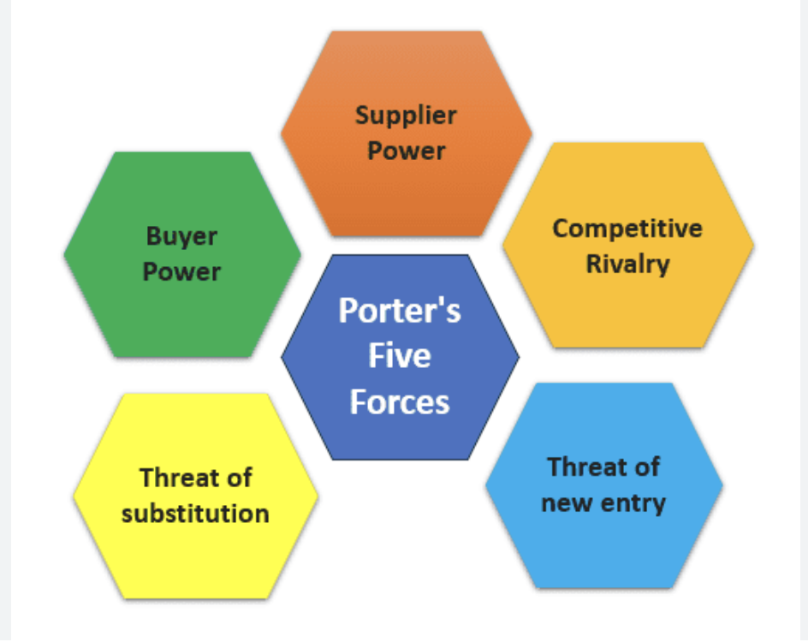
Source: Adapted from Porter (1980).

Porter’s Five Forces indicates that JLR faces strong competitive pressure. Rivalry is high because premium competitors compete not only through design and brand, but also through battery performance, software, charging convenience, digital services and customer experience. Supplier power is also significant because electrification depends on batteries, semiconductors and specialist technology partners. Therefore, JLR’s strongest response is not pure cost leadership, but focused differentiation. The strategic implication is that JLR’s heritage remains valuable only if it is combined with faster EV execution, stronger software capability, credible sustainability and a premium customer experience that competitors cannot easily copy.

3.2 Internal Environment: VRIO, Value Chain and Core Competencies
The internal environment refers to the resources, capabilities and competencies inside an organisation that influence its ability to create value and compete effectively. For JLR, internal analysis is important because the company’s future performance depends not only on external EV demand, but also on whether it has the right capabilities to deliver electric-first modern luxury. The VRIO framework is useful because it assesses whether resources are valuable, rare, difficult to imitate and organised to capture value (Barney, 1991).
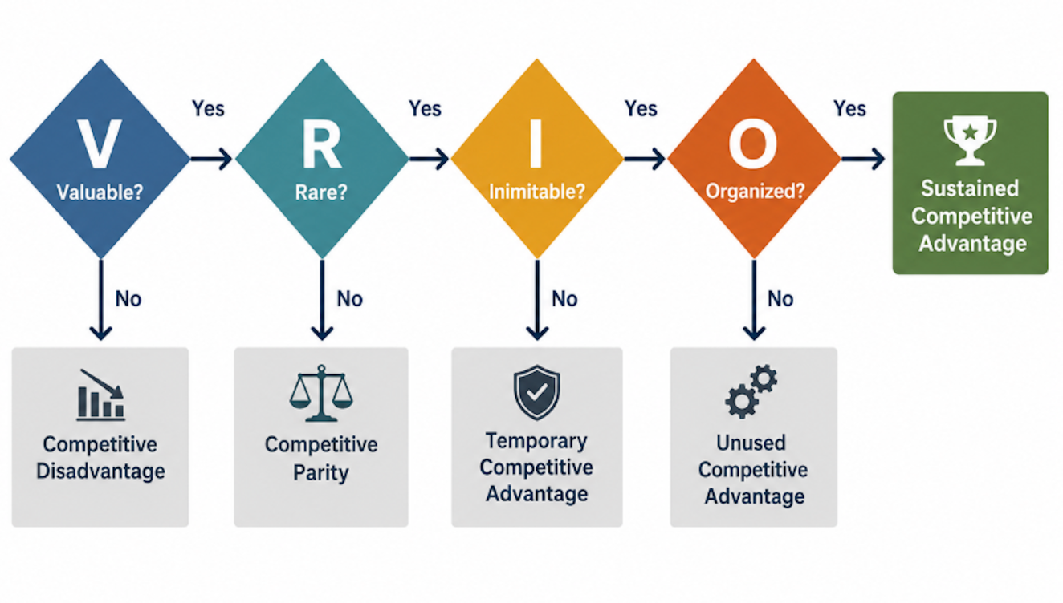
Source: Adapted from Barney (1991).
Figure 3: VRIO Framework Process for Evaluating Strategic Resources

Table 3: VRIO Analysis of JLR Resources and Capabilities
Resource / Capability | Valuable | Rare | Inimitable | Organised | Strategic outcome
British luxury heritage | Yes | Yes | Yes | Yes | Sustained advantage
Range Rover and Defender brand equity | Yes | Yes | Yes | Yes | Sustained advantage
Design and engineering capability | Yes | Yes | Partly | Yes | Temporary advantage
Tata Motors backing | Yes | Yes | Partly | Yes | Strategic support
EV and battery capability | Yes | No | No | Developing | Competitive parity / gap
Software and digital capability | Yes | No | No | Developing | Weakness
Premium customer experience | Yes | Yes | Partly | Yes | Differentiation potential

The VRIO analysis shows that JLR’s strongest resources are intangible. Its British luxury heritage, Range Rover and Defender brand equity, and premium design reputation are valuable because they support customer loyalty and premium pricing. They are also relatively rare and difficult to imitate because they are built through history, reputation and emotional brand meaning.
This supports JLR’s focused differentiation strategy. However, JLR’s EV, battery and software capabilities are not yet clear sources of sustained advantage because competitors such as Tesla, BMW, Mercedes-Benz and Chinese EV manufacturers have already developed strong technology positions.
Value Chain and Core Competencies
JLR’s value chain also shows how the company creates customer value. Its primary activities include design, engineering, manufacturing, marketing, sales and after-sales service. Support activities include technology development, procurement, human resource development and strategic partnerships. In luxury automotive markets, value is not created only through physical production. It is also created through brand identity, customer experience, quality, digital services and emotional appeal. This means JLR’s core competencies are linked to luxury design, engineering heritage, premium SUV capability and customer desirability.
However, core competencies must evolve. Prahalad and Hamel (1990) argue that core competencies should help firms access markets and create customer value, but they must also remain relevant as competition changes. For JLR, this means heritage and design are not enough on their own. The internal strategic challenge is to protect its luxury strengths while building stronger EV, software, battery, quality and digital service capabilities. Therefore, JLR’s internal environment supports focused differentiation, but only if the company upgrades the capabilities needed to make electric-first modern luxury credible in practice.

3.3 SWOT Analysis and Strategic Implications
SWOT analysis brings together the main findings from the external and internal analysis by identifying JLR’s strengths, weaknesses, opportunities and threats. This is useful because it connects the company’s internal capabilities with the external pressures shaping the UK automotive market.

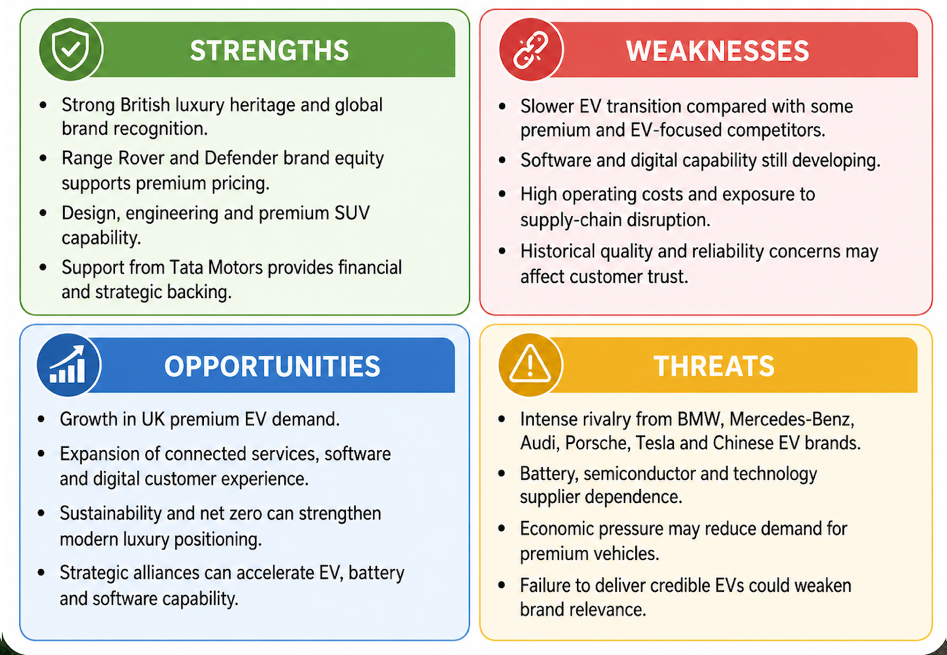
Source: Author’s own analysis.
Figure 4: SWOT Analysis of JLR in the UK Automotive Market

The SWOT analysis shows that JLR’s strongest strategic assets are intangible: heritage, brand equity, design capability and premium customer loyalty. These strengths support differentiation and make it difficult for JLR to compete through low prices. However, the weaknesses show that JLR’s traditional strengths must be renewed. In particular, slower EV progress, developing software capabilities and reliability concerns could weaken its ability to compete with faster-moving EV rivals.
The opportunities available to JLR are closely linked to electrification, sustainability and digital value creation. The UK market’s movement towards battery electric vehicles creates an opportunity for premium EV growth, while connected services and digital customer relationships may support new forms of customer value. At the same time, threats from Tesla, German premium brands and Chinese EV manufacturers show that JLR’s market position cannot be protected by heritage alone.
The strategic implication is that JLR should use its brand heritage as a platform, not as a shield. Its future competitive advantage depends on combining luxury differentiation with stronger EV delivery, software capability, sustainability credibility, quality improvement and carefully selected partnerships. This prepares the logic for the recommended strategy: focused differentiation through electric-first modern luxury.
The relationship between JLR’s external and internal environments is central to the strategic recommendation. Externally, regulation, EV adoption, sustainability pressure and premium rivalry are pushing the UK automotive market towards electrified and digitally enabled mobility. Internally, JLR has strong luxury resources, brand heritage and design capabilities, but weaker or still-developing capabilities in software, batteries and EV execution. This creates the main strategic tension in the report: JLR’s existing strengths support differentiation, but the market now requires a new form of differentiation based on electric technology, sustainability credibility and digital customer value. Therefore, JLR should not abandon its heritage; it should renew it by aligning its internal resources with the external demands of the EV transition.

4. Comprehensive and Holistic View of the Organisation

4.1 Corporate Social Responsibility Strategy and Business Alignment
Corporate social responsibility (CSR) refers to the way an organisation manages its responsibilities towards stakeholders, including customers, employees, suppliers, communities, shareholders and the natural environment. Carroll (1999) explains CSR as a broad responsibility that includes economic, legal, ethical and philanthropic dimensions, while Elkington’s (1997) triple bottom line links business responsibility to people, planet and profit. For JLR, CSR is strategically important because modern luxury customers increasingly expect premium brands to demonstrate sustainability, ethical behaviour and social responsibility.
JLR’s CSR direction is closely connected to its Reimagine strategy. The company aims to become carbon net zero by 2039 across its manufacturing and operations, supply chain and vehicle emissions (JLR, 2026). It has also linked sustainability to decarbonisation, resource use, nature and biodiversity through its Planet Regenerate approach (JLR, 2026). This aligns with the company’s modern luxury positioning because premium value is no longer based only on design, performance and heritage. It also depends on whether customers believe the brand is responsible, sustainable and future-focused.
CSR can also support competitive advantage when it is connected to strategy rather than treated as a separate public relations activity. Porter and Kramer (2006) argue that CSR is most valuable when it links social responsibility with business competitiveness. This is relevant to JLR because credible sustainability can strengthen its differentiation in the premium EV market. However, CSR also creates risk. If JLR’s delivery is slow or unclear, the company may face criticism that its sustainability claims are more promotional than operational. This is especially important because EV production still depends on batteries, raw materials and complex global supply chains.
The strategic implication is that CSR should be treated as part of JLR’s value proposition, not as a separate corporate message. For JLR, modern luxury will be credible only if sustainability is visible in the vehicle, the supply chain, the production process and the customer experience.

4.2 Balanced Scorecard Analysis
The Balanced Scorecard is a strategic performance management framework that combines financial and non-financial measures. Kaplan and Norton (1992) argue that organisations should not evaluate performance through financial indicators alone, because long-term competitiveness also depends on customers, internal processes, learning and growth. This is relevant to JLR because its electric-first modern luxury strategy requires both financial discipline and long-term capability development.
Table 4: Balanced Scorecard for JLR
Perspective | Objective | KPI | Target | Initiative
Financial | Improve profitability while funding EV transformation. | Operating margin, cash flow, EV investment returns. | Maintain profitable growth and reduce cost pressure. | Premium pricing, cost control and disciplined capital allocation.
Customer | Strengthen premium customer loyalty and EV satisfaction. | Customer satisfaction, repeat purchase, brand perception. | Improve trust in JLR’s EV and luxury experience. | Premium EV ownership experience and improved after-sales service.
Internal Business Processes | Improve EV delivery, quality and supply-chain resilience. | EV launch timing, defect rates, supplier performance. | Reduce delays, quality issues and supply disruption. | Supplier partnerships, quality improvement and operational efficiency.
Learning and Growth | Build EV, software and digital capabilities. | Training hours, software talent, innovation projects. | Increase internal capability for electric-first luxury. | Workforce reskilling, technology partnerships and innovation culture.

The Balanced Scorecard shows that JLR should not measure success only through short-term financial recovery. Financial outcomes are important, especially after the sharp fall in FY26 profit before tax and exceptional items, but the strategy also requires customer trust, reliable internal processes and new organisational capabilities (JLR, 2026). The customer perspective is particularly important because premium buyers expect more than vehicle ownership; they expect quality, digital convenience, sustainability and strong after-sales support. Internal process measures are also necessary because delays, software problems or quality issues could damage the credibility of JLR’s electric-first strategy.
The learning and growth perspective is central to JLR’s future because the company must develop skills in EV production, batteries, software, AI, data and digital customer services. This links directly to strategic leadership because employees should be treated as human capital requiring investment, not simply as a cost to reduce (Hitt, Ireland and Hoskisson, 2019). The strategic implication is that JLR’s transformation must be controlled through a balanced mix of financial, customer, operational and learning measures. This will help ensure that short-term profitability does not weaken the long-term capabilities needed for sustainable modern luxury.

5. Strategic Choices and Implementation

5.1 Strategic Options and Evaluation
Strategic choice refers to the selection of the most suitable strategy after analysing the organisation’s external environment, internal capabilities and competitive position. Porter (1980) identifies three generic strategies: cost leadership, differentiation and focus. For JLR, pure cost leadership is not appropriate because the company does not compete mainly through low prices or mass-market volume. Its brand identity, customer base and product portfolio are built around premium value, design, performance, luxury and customer experience.
A differentiation strategy is more suitable because JLR can compete by offering distinctive products that customers perceive as valuable and difficult to substitute. However, broad differentiation alone is not enough because the automotive market is highly competitive, and EV technology is changing quickly. Therefore, the most appropriate strategic option is focused differentiation, targeting premium and luxury customers who value electric mobility, sustainability, digital services, design and brand heritage.
Ansoff’s Matrix also supports this direction. JLR’s strongest growth route is product development within existing premium markets, through electric Range Rover, Defender and Jaguar models, supported by connected services and improved customer experience (Ansoff, 1957). Market development may also be relevant in global luxury EV segments, but the UK market remains important because it is JLR’s home market and a strong test of its modern luxury credibility.

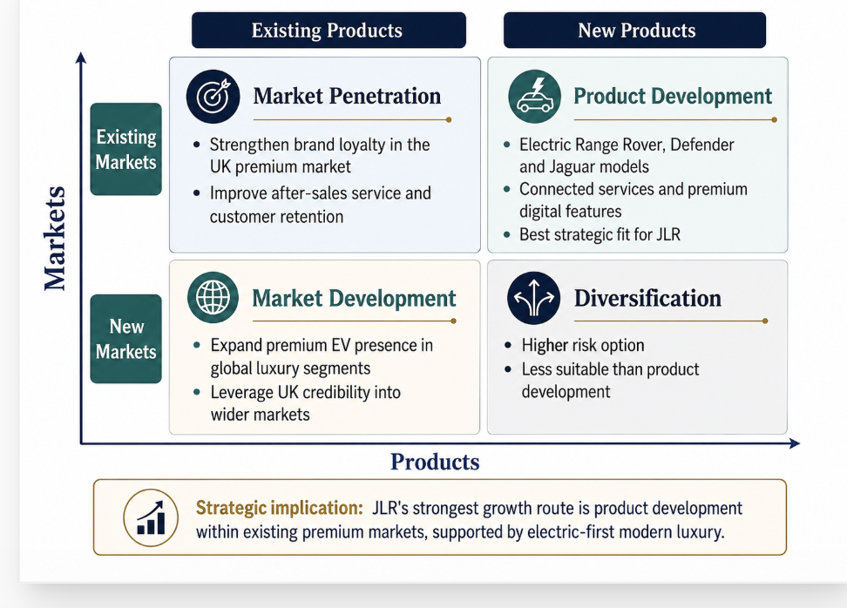
Figure 5: Ansoff Matrix for JLR’s Strategic Growth Options
Source: Author’s own analysis, adapted from Ansoff (1957).

Using the SAFe framework, focused differentiation is suitable because it fits the external EV transition and JLR’s internal brand strengths. It is acceptable because premium customers and shareholders are likely to support a strategy that protects brand value and long-term profitability. It is feasible if JLR strengthens EV platforms, software capability, supply-chain resilience and workforce skills. This means the strategy is attractive, but only if implementation is disciplined.
Figure 6: SAFe Evaluation of JLR’s Recommended Strategy
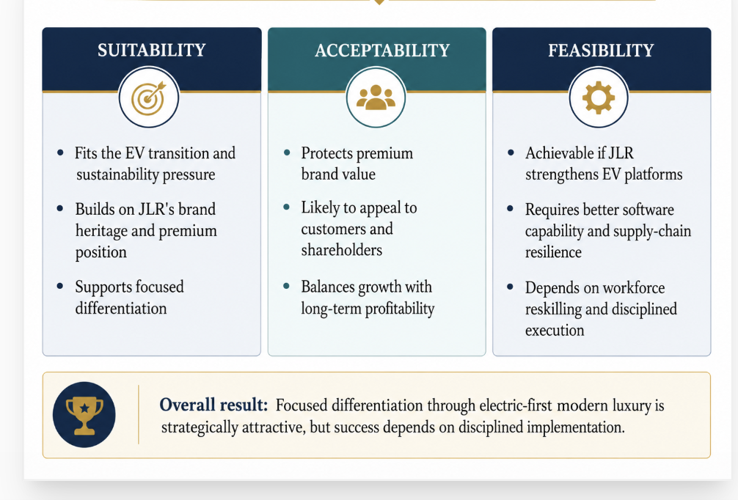
Source: Author’s own analysis based on Johnson et al. (2020).

5.2 Recommended Strategy and Implementation Plan
The recommended strategy is for JLR to pursue focused differentiation through electric-first modern luxury. This means JLR should not attempt to compete directly with low-cost EV manufacturers. Instead, it should use its strongest resources — British luxury heritage, Range Rover and Defender brand equity, design capability and premium customer relationships — while building stronger capabilities in EV technology, software, batteries, sustainability and digital customer experience.
Implementation should focus on five priorities. First, JLR should accelerate EV product development while protecting quality and reliability. This includes ensuring that electric Range Rover, Defender and Jaguar models deliver the luxury, performance and trust expected by premium customers. Second, JLR should strengthen software and digital capability because modern vehicle competition increasingly depends on connected services, over-the-air updates, customer data and digital ownership experience. Third, JLR should use strategic alliances with battery, semiconductor, software and charging partners to reduce risk and improve speed. Cooperative strategy is appropriate where firms need access to resources they cannot efficiently develop alone (Hitt, Ireland and Hoskisson, 2019).
Fourth, JLR should continue embedding sustainability into product design, supply chains and operations. This supports both CSR and competitive differentiation because modern luxury customers increasingly expect responsible consumption. Fifth, the company should invest in human capital through reskilling and training in EV production, software, AI, quality management and digital services. Strategic leadership is important here because employees must understand and support the transformation, not only follow operational instructions.

5.3 Implementation Challenges and Mitigation Strategies
The main implementation challenge is execution risk. JLR’s strategy is ambitious, but if EV launches are delayed, software quality is weak or customer experience does not match premium expectations, the strategy may lose credibility. A second challenge is cost pressure. EV investment, battery sourcing, technology development and supply-chain change require significant capital. A third challenge is competition. Tesla, German premium brands and Chinese EV manufacturers may move faster in software, battery efficiency and pricing.
Table 5: Implementation Challenges and Mitigation Strategies
Challenge | Strategic risk | Mitigation
EV launch delays | Weakens credibility of electric-first strategy. | Strong project controls, phased launches and supplier coordination.
Software capability gaps | Reduces customer experience and competitiveness. | Invest in software talent, partnerships and digital platforms.
High EV investment costs | Pressures profitability and cash flow. | Disciplined capital allocation and focused model priorities.
Supply-chain disruption | Delays production and increases costs. | Battery and semiconductor partnerships, supplier diversification.
Quality and reliability concerns | Damages premium trust. | Total quality management, testing and stronger after-sales support.
Cultural resistance | Slows transformation. | Strategic leadership, employee communication and reskilling.

To mitigate these risks, JLR should use balanced organisational controls. Financial controls are needed to monitor profitability, cash flow and investment discipline, but strategic controls are equally important to track EV delivery, software reliability, customer satisfaction, quality and sustainability performance. Kaplan and Norton’s (1992) Balanced Scorecard is useful because it prevents the company from focusing only on short-term financial results while neglecting future capabilities.
The strategic implication is that JLR’s recommended strategy is not simply “make more EVs”. It is to make premium electric vehicles that are consistent with JLR’s luxury identity, supported by technology, sustainability, quality and customer experience. Focused differentiation can protect JLR’s competitive advantage, but only if the company turns its strategy into measurable execution.

6. Recommendation and Conclusion
This report has evaluated JLR’s current strategic position in the UK automotive market by examining its external environment, internal resources, CSR alignment, balanced performance needs and strategic choices. The analysis shows that JLR has strong foundations for competitive advantage, particularly through its British luxury heritage, Range Rover and Defender brand equity, design capability, engineering experience and support from Tata Motors. However, these strengths are being tested by the rapid shift towards electrification, software-defined vehicles, sustainability expectations, supply-chain pressure and strong rivalry from premium and EV-focused competitors.
The main recommendation is that JLR should pursue focused differentiation through electric-first modern luxury. Cost leadership is not suitable because JLR’s competitive identity is built on premium value rather than low-cost volume. Instead, the company should use its luxury heritage as a platform for future advantage while strengthening EV delivery, software capability, digital services, quality, sustainability and customer experience. This strategy is supported by Porter’s generic strategies, Ansoff’s product development logic and the SAFe evaluation, which show that focused differentiation is strategically suitable, acceptable and feasible if implementation is disciplined (Porter, 1980; Ansoff, 1957).
To deliver this strategy, JLR should prioritise EV platform execution, strategic alliances, workforce reskilling, supplier resilience, quality improvement and balanced organisational controls. The Balanced Scorecard should be used to monitor not only financial results, but also customer satisfaction, internal process performance and learning capabilities (Kaplan and Norton, 1992). Overall, JLR’s heritage remains valuable, but future competitiveness depends on converting that heritage into a credible, sustainable and technologically advanced electric-first luxury position.

Section 2: Reflective Account

7. Reflection Using Gibbs’ Reflective Cycle
This reflective account uses Gibbs’ Reflective Cycle (see Figure 7) to evaluate the process followed when researching, analysing and preparing the strategic management report on Jaguar Land Rover (JLR). The purpose of the reflection is to consider what was learned from applying strategic management theories to a real organisation and how this developed academic and analytical skills.
Figure 7: Gibbs’ Reflective Cycle
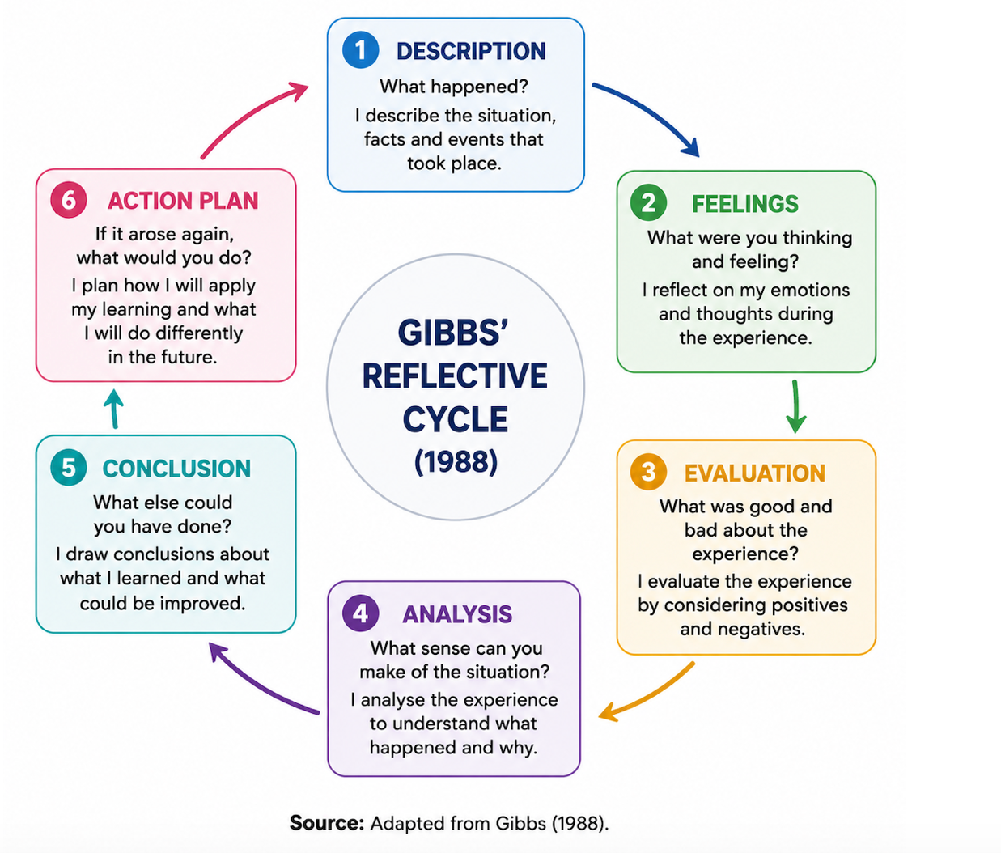
Description.
The report required me to act as a strategic management consultant and evaluate JLR’s current strategic position in the UK automotive market. I selected JLR because it is a well-established premium automotive manufacturer operating in a highly competitive and changing industry. My research focused on JLR’s electric-first modern luxury strategy, including its response to electrification, sustainability regulation, digital innovation and premium competition. I used academic models such as PESTEL, Porter’s Five Forces, VRIO, SWOT, the Balanced Scorecard, Ansoff’s Matrix and SAFe to structure the analysis.
Feelings.
At the beginning of the task, I felt uncertain because there were many frameworks available, and it was difficult to decide which ones were most relevant. I was also concerned about the word count because the report required detailed analysis but had to remain concise. However, as I worked through the external and internal analysis, the strategic direction became clearer. I realised that JLR’s main issue was not simply whether it should become electric, but how it could convert its luxury heritage into a credible electric-first competitive advantage.
Evaluation.
The most useful part of the process was applying the frameworks in combination rather than using them separately. PESTEL helped me understand the wider macro-environment, while Porter’s Five Forces showed the strength of competitive pressure in the premium EV market. VRIO was useful for identifying JLR’s strongest internal resources, especially brand heritage and Range Rover/Defender brand equity. SWOT then helped bring together the key internal and external issues. The Balanced Scorecard was also valuable because it showed that JLR’s success should not be measured only through financial outcomes, but also through customer experience, internal processes and learning capabilities.
Analysis.
The main learning point was that strategic management is not about listing frameworks, but about using them to build a clear argument. For example, PESTEL showed that the external environment supports electrification, but VRIO showed that JLR’s strongest advantages are still linked to heritage, design and premium brand reputation. This created the central argument of the report: JLR should not pursue pure cost leadership, but focused differentiation through electric-first modern luxury. I also learned that a company’s historical strengths can become insufficient if they are not renewed. JLR’s heritage is valuable, but it must be supported by EV technology, software capability, sustainability, quality and customer experience.
Another important learning point was the connection between CSR and strategy. Before completing the analysis, I viewed CSR mainly as a separate ethical or environmental responsibility. However, the report showed that for a premium brand such as JLR, sustainability can become part of the value proposition. If customers expect modern luxury to be responsible and low carbon, then CSR becomes strategically important rather than decorative.
Conclusion.
Overall, the process improved my ability to connect theory with practice. I learned how to move from description to evaluation by asking what each framework actually means for the organisation’s strategy. I also learned the importance of building a consistent argument throughout the report. Each section contributed to the final recommendation that JLR should pursue focused differentiation through electric-first modern luxury. The main weakness in my process was that I initially tried to include too many ideas, which risked making the report too descriptive. I improved this by focusing on the most relevant frameworks and linking each section back to JLR’s strategic challenge.
Action Plan.
In future strategic analysis, I will begin by identifying the central strategic question before selecting frameworks. This will help me avoid unnecessary description and keep the analysis focused. I will also plan the word count more carefully from the beginning, especially in reports with several required sections. Finally, I will continue to develop my ability to use evidence critically by comparing academic theory, company information and industry data. This will help me produce stronger, more balanced and more professional strategic recommendations in future assignments.

References
Ansoff, H.I. (1957) ‘Strategies for diversification’, Harvard Business Review, 35(5), pp. 113–124.
Barney, J. (1991) ‘Firm resources and sustained competitive advantage’, Journal of Management, 17(1), pp. 99–120.
Carroll, A.B. (1999) ‘Corporate social responsibility: Evolution of a definitional construct’, Business & Society, 38(3), pp. 268–295.
Department for Transport (2024) Pathway for zero emission vehicle transition by 2035 becomes law. Available at: https://www.gov.uk/government/news/pathway-for-zero-emission-vehicle-transition-by-2035-becomes-law (Accessed: 12 July 2026).
Elkington, J. (1997) Cannibals with Forks: The Triple Bottom Line of 21st Century Business. Oxford: Capstone.
Gibbs, G. (1988) Learning by Doing: A Guide to Teaching and Learning Methods. Oxford: Oxford Polytechnic.
Hitt, M.A., Ireland, R.D. and Hoskisson, R.E. (2019) Strategic Management: Competitiveness and Globalization: Concepts and Cases. 13th edn. Boston: Cengage Learning.
JLR (2008) Tata Motors completes acquisition of Jaguar Land Rover. Available at: https://www.jlr.com (Accessed: 12 July 2026).
JLR (2021) Jaguar Land Rover reimagines the future of modern luxury by design. Available at: https://www.jlr.com/news/2021/02/jaguar-land-rover-reimagines-future-modern-luxury-design (Accessed: 12 July 2026).
JLR (2025) JLR delivers strong full year performance. Available at: https://media.jaguarlandrover.com/news/2025/05/jlr-delivers-strong-full-year-performance (Accessed: 12 July 2026).
JLR (2026a) Reimagine. Available at: https://www.jlr.com/reimagine (Accessed: 12 July 2026).
JLR (2026b) Sustainability. Available at: https://www.jlr.com/sustainability (Accessed: 12 July 2026).
JLR (2026c) JLR delivers significantly improved Q4 performance in challenging year. Available at: https://media.jaguarlandrover.com/news/2026/05/jlr-delivers-significantly-improved-q4-performance-challenging-year (Accessed: 12 July 2026).
Kaplan, R.S. and Norton, D.P. (1992) ‘The balanced scorecard: Measures that drive performance’, Harvard Business Review, 70(1), pp. 71–79.
Porter, M.E. (1980) Competitive Strategy: Techniques for Analyzing Industries and Competitors. New York: Free Press.
Porter, M.E. (1985) Competitive Advantage: Creating and Sustaining Superior Performance. New York: Free Press.
Porter, M.E. and Kramer, M.R. (2006) ‘Strategy and society: The link between competitive advantage and corporate social responsibility’, Harvard Business Review, 84(12), pp. 78–92.
Prahalad, C.K. and Hamel, G. (1990) ‘The core competence of the corporation’, Harvard Business Review, 68(3), pp. 79–91.
SMMT (2026) UK new car market breaches two million as almost one in four buyers go electric. Available at: https://www.smmt.co.uk/uk-new-car-market-breaches-two-million-as-almost-one-in-four-buyers-go-electric/ (Accessed: 12 July 2026).
Tata Motors (2025) Annual Report 2024–25. Available at: https://www.tatamotors.com/investors/annual-reports/ (Accessed: 12 July 2026).

