
Digital skilll And research method BMSK4003 (LON)
Pauline Burrell 1809580

May 2, 2019

Introduction:

This report is based on modern technology survey in the NHS, specifically in a hospital clinic. Five open ended questions in the system of Likert 5 opinion scale based on quantitative research will be used. I will perform a primary research on Doctors and patients within in the clinic.
The results will be shown using Bar-Graphs and Pie-Charts. I will examine the graphs, discuss the findings and the relationship between patient’s satisfaction of their personal data being used collectively amongst other health care professionals involved in their care.
I will be also evaluating the benefits and difficulties of continuous development which medical technology supports practice aimed at doctors to work proficient and efficiently with experts in the chosen fields.
Patients participating in clinical research allows them to play a significant part in having authority knowing how their data is being used. It supports new lessons and how improvements can be made in medical practice on a larger scale making it resourcefully cost and time effective. (Fleurence, 2014)

Literature Review:
Patient empowerment is an increasing theory regarded in proposal to cover circumstances where people are stimulated to actively take part in managing their own health needs. (PE) helps to transform the outdated way doctors- patients’ relationship are formed while providing people with physical team work and emphasis which regulates issues beneficial for their health and wellbeing.
It is usually debated that an educated patient would be able to make more knowledgeable choices, improve compliance, reduce anxiety levels and participate actively in the treatment of his/her diseases. This fact is more relevant in prolonged situations where the patient must change his/her life being able to life changing illnesses. Gibson, in a review about PE in health, redefined empowerment as process of helping people to assert control over the factors which affect their health” (Calvillo, et al., 2015)
Research Methodology:
Qualitative Research Method: “The two most shared types of research are Qualitative and Quantitative. Quantitative studies use theory testing. Qualitative studies involve researching the answers to determined reviews. Qualitative research relies on visual and verbal cues” (Masue, Swai, & Anasel, 2013 Quantitative Research Method: (Orest, et al., 2019)
“Quantitative studies involve mainly data analysis through various sources, data driven observation, scientific research, and close-ended questions. (Carroll, 2010) I will use both; qualitative and quantitative research methods as I will be conducting a survey which previous studies have shown “Qualitative and Quantitative research approaches can be contradictory to each other. Both research methods are valid when used properly” (Hoe & Hoare, 2012). Qualitative research includes; obtaining information data on form the Nation Health Services.

Population:
To better understand the thoughts of patients regarding modern technology and their health care needs. Quantitative research consists of; graphs and pie chart to recognise the statistical data of the people according to the qualitative research that I have done through my survey. “A research population is a large collection of patients that is the focus of a public judgement survey is used for the benefit of patients that researches are done regular however, due to the large sizes of the growing population, researchers often cannot test every individual because it is too expensive and time-consuming. This is the reason why researchers rely on sampling techniques” (Hasan, 2018). “This study involved the selection of a predefined population, which is the strength of a purposive sampling method” (Maxwell, 2013). Sample and Sample Size: “Sample size is a procedural term used. To carry out this research I chose the hospital.

Data collection process:
“Researchers usually measure turnover objective by adding a few enquiries on to the end of a tool as part of a research study using a Likert 5-point scale” (Chovwen, Balogun, & Olowokere, 2014; Hofaidhllaoui & Chhinzer, 2014). I planned five questions based on patient’s satisfaction within the NHS. I will collect information on Likert 5-point scale, which are: Strongly Agree, Agree, do not know, Disagree and Strongly Disagree (Hofaidhllaoui & Chhinzer, 2014). This will allow the patient to respond faster and permits easy data collection. Therefore, the statistics I will collect will allow me to find the quantity and opinions of the patients within that specific clinic.
I will distribute the surveys out to fifty patients in different sector in the clinic, to get a clear understanding of how they feel about their health and social care needs being shared amongst other health care professionals using modern technology.

Ethics in data collection:
“When humans are part of study, it is common place for the researcher to obtain approval from an ethical approval committee prior to data collection” (Gelling, 2016). Therefore, I have asked for consent/permission of the organisation before I conducted my survey. It is significant to do that as I will be consuming data created on the patients of the NHS. They have the right to confidentiality. The name of the organisation will remain unspecified. It has been stated plainly that the information I will be using is only for study purpose for the University of Wales Trinity Saint David.

Sample and Sample Size:
“Sample size is a term used in market research for outlining the number of questions contained within a sample. By sample, we recognize a group of topics designated from the overall population and is well thought-out a representative of true inhabitants for that specific study. The sample must be illustrative of the population from which it is selected, and it must have a good size to permit statistical analysis” (Hasan, 2018). This survey will be carried out within an NHS hospital where altogether 150 patients and outpatients. Therefore, I will be choosing only 50 who will be my sample that I will conduct my survey on; Patients Satisfaction survey. (Hasan, 2018)

Findings, Analysis and Discussions:

Appendix 1: Modern Technology within Healthcare
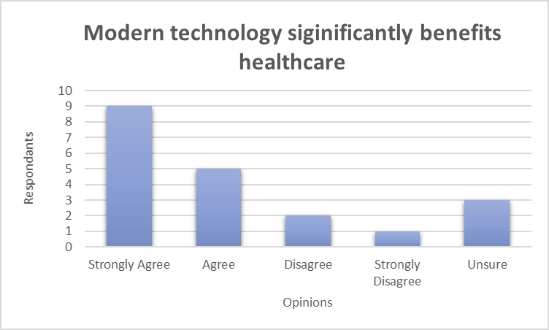
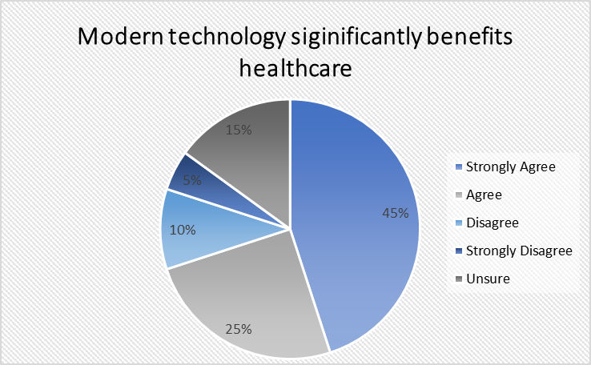

It is evident that majority of patients agree modern technology is effective within healthcare. Patients felt they could remotely check their wellbeing, plan and track visits to their doctor or outpatient’s clinic with easier access to results and health information. Technology within healthcare is also cost effective saving the NHS a proportion amount of money whilst being eco-friendly.
Some of 15% of the population disagreed; potentially highlighting the drawbacks of technology or preference for paper documents. Whilst the remaining 14% were unsure. Overall, patients felt using modern technology is faster and reliable to achieving instant information and results.

Appendix 2: Modern Technology & It’s Benefits to Patient Treatments
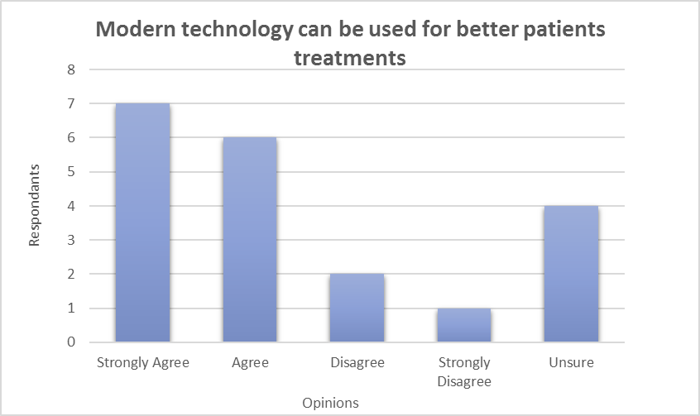
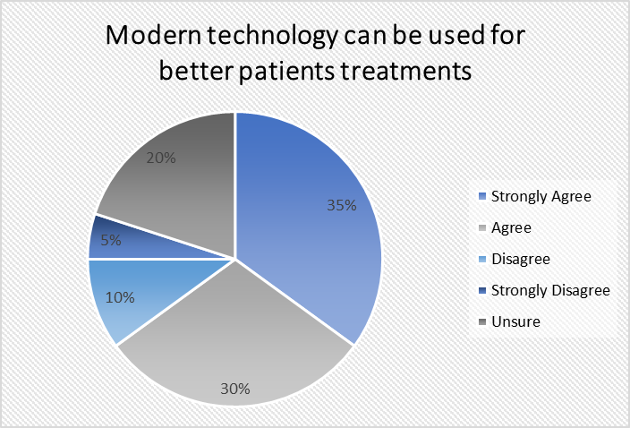

65% of patients agree or strongly agree with the idea of modern technology making patient treatments better. Thanks to modern technology, patients are able to get quicker and more accurate results therefore, allowing prescriptions specialised for the individual’s needs. Doctors are now able to send prescriptions electronically to the pharmacy, allowing the pharmacy to dispense the drugs almost instantly.

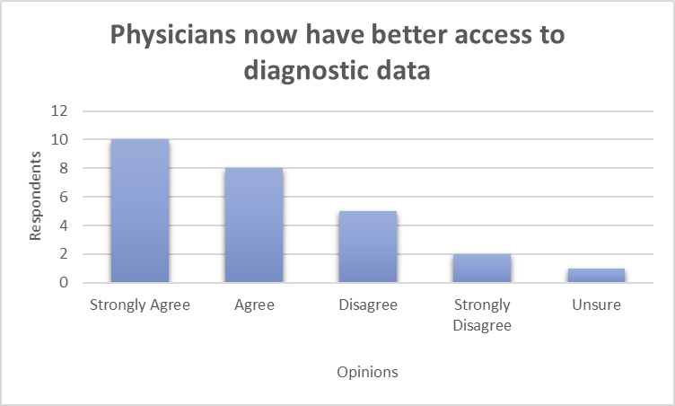
Appendix 3: Physicians now have better access to diagnostic data

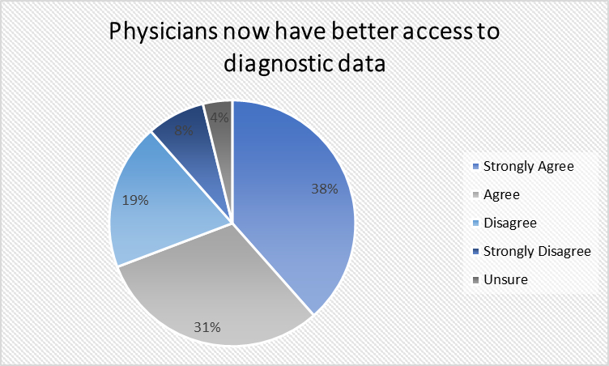

69% of patients strongly agreed that Doctors and specialist have easier access to diagnostic data. The diagnostic team members will determine their decision based on the diagnostic that they are accurate and timely clarification of the patient’s diagnosis findings which they will explain in more specific details. (National Academy Press, 2015).
For the more complicated health concerns such as cancer or diseases, patients will have a better understanding of their diagnosis with an accessible record to read or educate themselves on the issue. For deciding next courses of actions, technology has allowed physicians / doctors to keep a cohesive record of all patient check-ups with good detail. This prevents poor information or incorrect medicine being passed onto the patient. Whilst 12% disagreed or strongly disagreed, it is evident technology has more benefits for patients overall.

Appendix 4: Healthcare workers are in a better position to share information

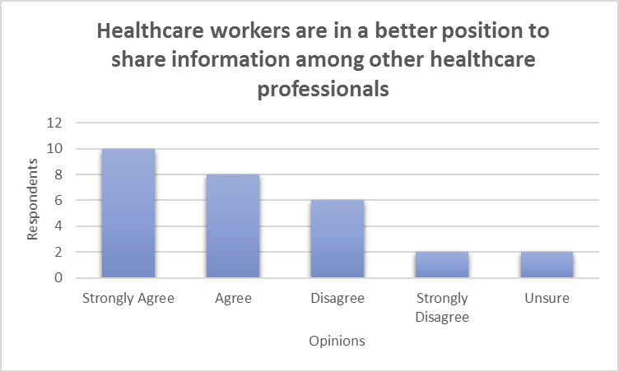

65% of patients agreed that efficient sharing of information among healthcare professionals will allow specific and efficient decision-making. Focusing on life-threatening sicknesses, where there are important decisions to be made at key points in the disease process technology could save an individual’s life.
There are some reservations to accessing shared information and its impacts on decision making such as diverse/ conflicting results and uncertainty. However, it is evident the overall benefits are outweighed by this allowing a smoother decision-making model for both doctors and patients. (Sulaiman Al-Shammari, 1977, pp. 681-692).

Appendix 5: New information technology significantly benefits health care services

With a more balances finding, 58% of patients agree future information technology will significantly increase the health care services. With the increased use of electronic medical records (EMR), telehealth services, and mobile machineries like tablets and smart phones, doctors and patients can efficiently help patients with patients easily understanding and coming to results for their concerns. With extra hospitals and observes using medical technology such as mobile devices to support with work. Medical doctors can now quickly have admittance to any type of statistics they need from medication evidence, research and studies, patient past or present records. (Cocchi, 2019)
Whilst 35% of patients disagreed that technology will further improve healthcare, this highlights the vast improvements the healthcare sector is yet to make. It is evident many gaps still occur or could be improved on.

Summary of the findings:
From study and evidence gathered, I can say most patients feel satisfied with sharing their personal information using modern technology. Therefore, by doing surveys on patient’s satisfaction has helped me understand the importance of valuing patient’s opinion, viewpoints and feedbacks. It is necessary for the Management of all organisations to take into consideration what patients are saying. Everyone’s views should be perceived and considered as this will help companies prosper and succeed. Limited time constraint on this task, to conduct a survey on the public regarding Patients Satisfaction, restricted the number of surveys I was able to carry out, limiting the data and statistical information I was able to present. Therefore, from the statistics I was able to gather, gives a principle of how patients are feeling. However for upcoming study, I would recommend that by expanding the sample frame of the population would give a restored numerical understanding and by asking more questions to get clear perspectives of the employees and patients More so, target the same type of organisations by sending surveys online.

Conclusion:
Patients are the NHS asset. They have their own individual needs which requirements which must be managed if they are to contribute to organisational progress and growth. Patients bring their own viewpoints, values and characteristics to administrative life, and when accomplished effectively can bring substantial benefits to the organisation moving forward. If patients are unsatisfied will produce unacceptable results. Therefore, it is vital for top management to take care of its employees to ensure that they are satisfied in their jobs; when satisfied; they strive for the company’s goals and aim. By understanding patient’s needs, managers can understand what rewards to use to motivate them. The goal of the NHS is to benefit from positive patient conduct by promoting research to progress change collectively for both the company staff and patients”.

References

American Institute of Medical Sciences, 2015. The Benefits of Technology in Healthcare: Patient Care & Economic Boom. [Online]
Available at: https://www.aimseducation.edu/blog/benefits-of-technology-in-healthcare
[Accessed 2 April 2019].
Anon., 2015. National Academy of Sciences.. s.l.:s.n.
Anon., 2016. http://www.healthcarebusinesstech.com/medical-technology/. [Online]
Available at: http://www.healthcarebusinesstech.com/medical-technology/Tuesday
[Accessed Tuesday April 2019].
Anon., n.d. New Pespectives Marketing Research Con. [Online]
Available at: https://www.new-perspectives.net/quantitative-research-improves-healthcare-facilities/
Anon., n.d. New perspectives Marketing E. [Online]
Available at: https://www.new-perspectives.net/quantitative-research-improves-healthcare-facilities/
[Accessed Saturday April 2019].
Balogh, P. M. B. T. M. a. B. J. R. (., 2015. Improving Diagnosis in Health Care. Washington (DC): National Academies Press.
Calvillo, J., Román, I. & Roa, L. M., 2015. Health Expectation. How technology is empowering patients? A literature review, 18(5), p. 643–652..
Carroll, L. &. R. J. P., 2010. Levels of Reconstruction as Complementarity in Mixed Methods Research: A Social Theory-Based Conceptual Framework for Integrating Qualitative and Quantitative Research. International Journal of Environmental Research and Public Health , 7(9), pp. 3478-88.
Cocchi, R., 2019. [Online]
Available at: http://www.healthcarebusinesstech.com/medical-technology
[Accessed 2 May 2019].
COCCHI, R., 2019. Health Care Business And Technlogy. [Online]
Available at: http://www.healthcarebusinesstech.com/medical-technology
[Accessed 2 May 2019].
Demarco, E. e. a., 2016. Medical Technology. [Online]
Available at: http://www.healthcarebusinesstech.com/medical-technology/
[Accessed 2 May 2019].
Fleurence, R. L. e. a., 2014. Patient-Powered Research Networks Aim To Improve Patient Care And Health Research. Health Affairs, 33(7), pp. 1212 - 1219.
Hasan, M. A., 2018. Research populatin. [Online]
Available at: https://www.academia.edu/5563491/Research_Population
[Accessed 7 May 2019].
Hofaidhllaoui & Chhinzer, 2014. Academcia. [Online]
Available at: https://www.academia.edu/5563491/Research_Population
[Accessed 7 May 2019].
Masue, O. A. S. I. L., 2013. The Qualitative-Quantitative 'Disparities' in Social Science Research: What Does Qualitative Comparative Analysis (QCA) Brings in to Bridge the Gap. Asian Social Science, 9(10).
National Accademy Press, 2015. Improving Diagnosis in Health Care. [Online]
Available at: https://www.nap.edu/catalog/21794/improving-diagnosis-in-health-care
[Accessed 3 May 2019].
Orest, S. M., Idda, L. S. & Mackfallen, G. A., 2019. The Qualitative-Quantitative 'Disparities' in Social Science Research: What Does Qualitative Comparative Analysis (QCA) Brings in to Bridge the Gap. Asian Social Science, 9(10), pp. 211-221.
Sulaiman Al-Shammari, J. S., 1977. Long-term care experience in Saudi Arabia. Socail science and medicine, 44(4), pp. 681-692.
Thimbleby, H., 2013. Technology and the Future of Healthcare. https://www.ncbi.nlm.nih.gov/corehtml/pmc/pmcgifs/logo-jphr.gif, pp. 1,2,3.

