Name: Andrew Breading
Student Number: 2203234
Module Title: Coexistent Perspectives
Module Number: ADCD7001
Theme: Time and Memory
Essay Title: What can Richard Misrach’s and Guillermo Galindo’s Border Cantos project tell us about memory and its relation to place?
Word Count: 4367

QUESTION
What can Richard Misrach’s and Guillermo Galindo’s Border Cantos project tell us about memory and its relation to place?
Introduction
Memories are a fundamental human reaction to everyday lived experiences. They are, by their nature, personal and unique. Some of these memories we share with others, whether that be by conversation or by showing photographs and film. As will be discussed in this essay there are some memories that are shared by the fact that they happen very publicly. Just as with our personal memories, these can be happy ones, like when your football team wins an important match, or sad ones, such as when a natural disaster happens.
In “Regarding the Pain of Others”, Susan Sontag observes that “[it] is felt that there is something morally wrong with the abstract of reality offered by photography: that one has no right to experience the suffering of others at a distance…” (Sontag, 2003, p. 103). She later makes the argument that there is nothing wrong with it and that it can sometimes be appropriate as it does make the viewer sit back and think.
One of her major contentions throughout the essay is that all around us we can see images of war and hurt, from the newspapers to the internet where this information is freely and readily available. The human psyche is such that one is drawn to looking at others in distress, something that we can see when passing any incident. For example, if someone is passed out on a pavement opposite it is our nature to stare, but rarely to intervene. The same can be said with the photographing of conflict zones or, in the case of The Border, where one is likely to find others in distress. Some photographs are all too graphic in showing suffering, for example Nick Ut’s Pulitzer Prize winning “Napalm Girl (The Terror of War)” (Fig. 1) or Richard Drew’s “The Falling Man”. (Fig. 2) Both of these pictures can make the viewer want to look at the pictures and memorialise them in their mind.

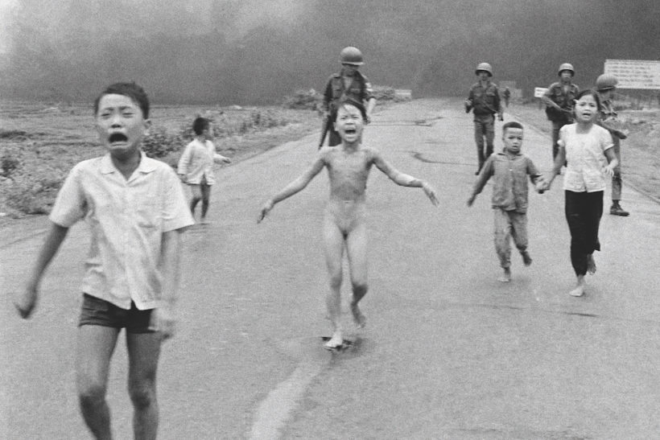
Figure 1: “Napalm Girl (The Terror of War)” (Ut, 1972)
“Napalm Girl” is an horrific photograph. The look of pain and terror on the children’s faces shocks, no matter how many times the picture is viewed. It has become the subject of many articles and documentaries looking into the subsequent life of the little girl, Kim Phúc.

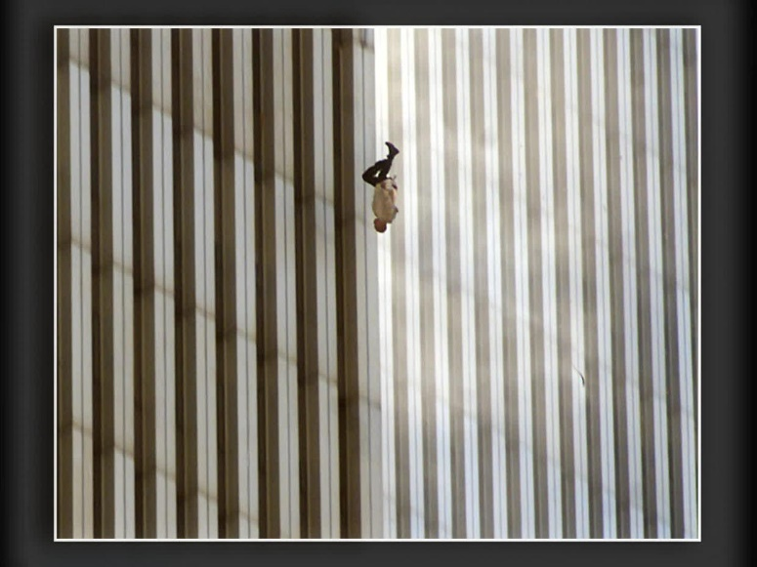
Figure 2: “The Falling Man” (Drew/PA, 2001)
“The Falling Man” is very different. Without knowing the context of the photograph, it does not have the obviousness of “Napalm Girl”. But once it is understood that it is a man who jumped out of the World Trade Centre following the terrorist attack it has a whole new meaning. Sontag writes that, at the time, the scene was referred to as feeling “like a movie” (Sontag, 2003, p.17.), but it is photographs, like “The Falling Man” that are used to illustrate what occurred. These are memories that enter the collective consciousness.
Sontag says that she believes that “Photographs objectify…” (Sontag, 2003, p.70). This needs some consideration as to how to interpret her thoughts. In “Regarding the Pain of Others” she discusses how a photograph becomes a memento, a precious record to be kept and something that makes a memory better than it may have been. However, there is also the uglification of a picture, show a scene where it doesn’t look its best, demanding an immediate reaction. She is right, however, that scenes that are not captured on film don’t remain in the public consciousness in the same way.
Both Napalm Girl and The Falling Man are examples of “Flashbulb Memory” (Sutton, 2009), an idea posited by Roger Brown and James Kulik which argued that a event, so unusual, can help someone to describe it in the greatest detail. As Sutton says, it is the ultimate “where were you when x happened?” situation. He gives the example of John F Kennedy’s assassination, but good example for today would be “where were you when the Queen died?”.
There are, though, events that happen that do not enter the public consciousness and it is left to people and organisations to bring those events to the public arena.
The Mexico – United States Border
The US-Mexico border (The Border) has been established in its current form since 1849 when the Mexican-United States Border Commission agreed on its position. (Hewitt, 2022). Since then, it has been the subject of intense scrutiny and, since the terrorist attacks on New York in 2001 a major political spotlight for both the Republican and Democrat parties in the United States. The Border Wall has been built to specifically keep migrants from crossing from Central America and Mexico into the United States, hoping, in part, to curtail the passage of drugs.
Migrants, whether legal or so-called illegal are the cause of are some of the loudest outrages in the media. They are a divisive group of people as their plight is so often misunderstood. From Europe to the United States the flow of these migrants is a hot political topic. The Border Wall on the southern US border has been expensive to construct; in the 10 years between 2005 and 2015 over $23 billion has been paid to companies constructing various sections of the wall (Kun, 2016). The Border was also one of the major campaign issues in the 2016 Presidential campaign with Donald Trump mentioning his promise to “build the wall” over 200 times (Jankowicz, 2020).
President Trump has tried to make the border wall become a “sacred place” in the way that Tuan describes various statues and monuments in the United States. Trump was very keen in many of his speeches to describe the wall as “beautiful”:
I am a builder. I build great buildings. Building a border — you know they talk about, ‘Oh, I don’t know, how can we possibly build a fence that nobody can climb over?’ I would build a border like you’ve never seen before. Nobody’s climbing over. (Nixon and Qiu, 2018)
To his followers the promise of the wall was vote winner, but others fundamentally disagree with him. Photographer Richard Misrach is one of those. In his lecture to the Crystal Bridges Museum of American Art he says that the wall has become an “… anti-monument. It basically says, ‘Keep Out’”, a very different message to the Statue of Liberty (Crystal Bridges, 2017)
The Border Cantos Project
In the early 1970s, Misrach worked on a series of portrait photographs in Berkeley, California. This series became “Telegraph 3AM”, a reference to the street where most of them were taken. Although this was a successful project – the book was published and Misrach was invited to show his work at The International Center for Photography in New York. However, he felt that he had let down the young people in the pictures, doubting himself over whether he could ethically record their stories whilst remaining true to them. He found himself asking questions to himself that Sontag was addressing years later that as to whether it was ethical to want situations to be bad so that they made great pictures. (Misrach, 2022)
Misrach took a decision to take up landscape photography. Living in California the desert was nearby, and he started by taking pictures of cacti in the desert at night, a technique taken from “Telegraph 3AM” but applied to the majestic plants, often resembling humans in their stature.
Misrach’s desert photographs started to take more interest in the social and environmental with one of his seminal works “Bravo 20” being taken around a bomb test site near a nuclear site. This is where he began taking expansive pictures of the desert and the damage that had been caused by the bomb tests. From craters in the ground to buses that had been used as targets Misrach has documenting it all. One picture of dead fish lying on the desert floor, seemingly nowhere near water, leads one to question what was happening. The fact that these fish are so out of place suggests that something has happened, but it is unknown what.
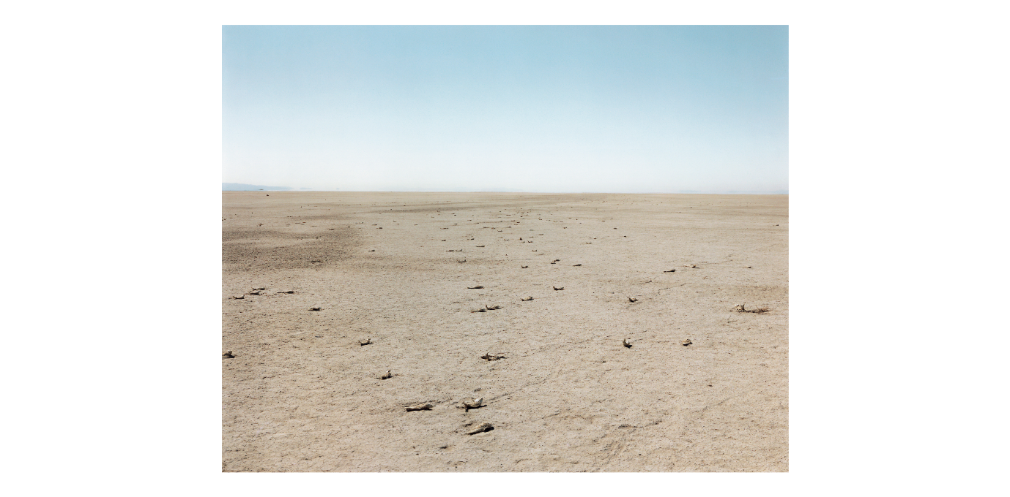
Figure 3: Dead Fish, Bravo 20 Bombing Range (Misrach, 1986)
In poetry there is a method of dividing poems into Cantos, as seen in works such as “The Faerie Queene” by Edmund Spenser, originally published in 1590 (British Library, 2022). These cantos can be seen as chapters as they are used to break up the poems. Misrach has used this syntax within his photographic works, each piece of work being called a Cantos. For instance, the picture above of dead fish is from Desert Cantos V: The War, commonly subtitled as Bravo 20.
He uses this canto structure throughout his work. Anne Wilkes Tucker explains that Misrach has a deep interest in both Dante’s Divine Comedy and Ezra Pound’s Cantos (Wilkes Tucker, 1996, p.21). Misrach uses this method to allow him the freedom to add to photographs to the cantos as he comes across them, rather than having to concentrate on a particular subject matter in one go. This gives him the artistic freedom that he needs to get his projects done. This rhizomatic approach to his photography and the cataloguing of the photographs allowed Misrach a greater to freedom and he discovered that the names of the cantos would present themselves, rather than him having to look for them. An example of this can be seen in Desert Cantos, Canto IV, “The Fires” where over time he made various pictures and was able to group them together for publication.
In 2004, Misrach took a photograph of a blue water bottle in the Low Desert of California. This became the start of his Border Cantos project.
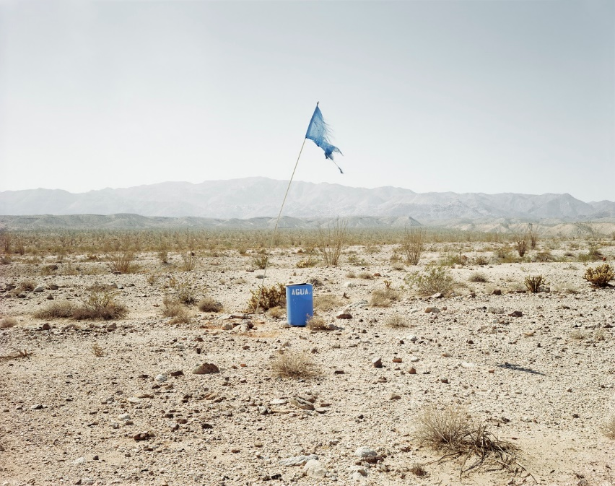
Figure 4: Agua #1 (Misrach, 2004)

In 2009 he accelerated his work as he could see that the border was getting more heavily guarded as work to stop the migrants accelerated.
Border Cantos (Misrach and Galindo, 2016) stands to one side of the rest of the Cantos Misrach has produced. Border Cantos is made up of eight cantos as well as a performance experience produced by Galindo. The use of Cantos also works well on this project as cantos is Spanish for songs.

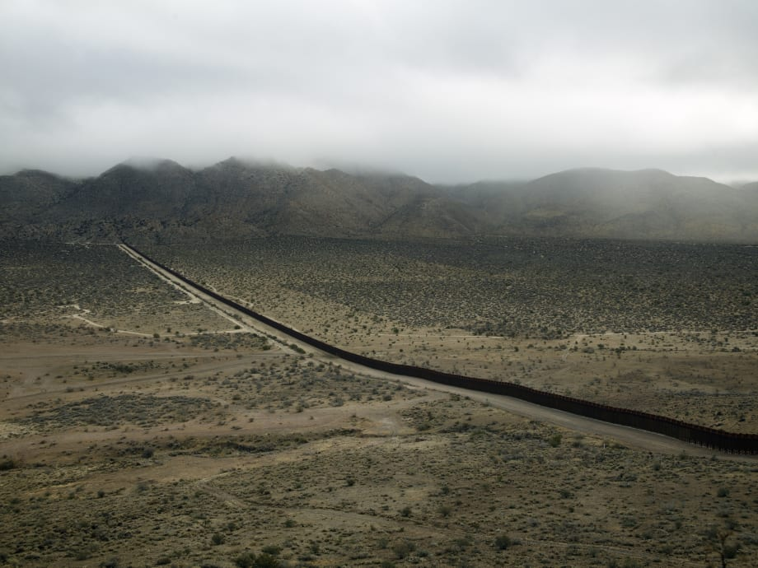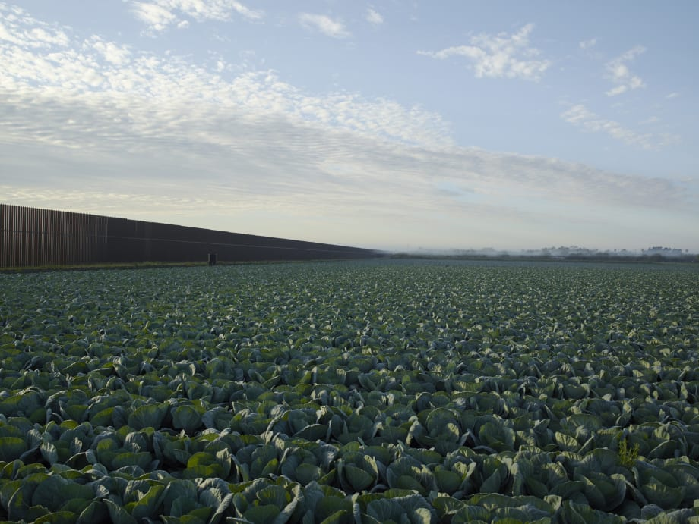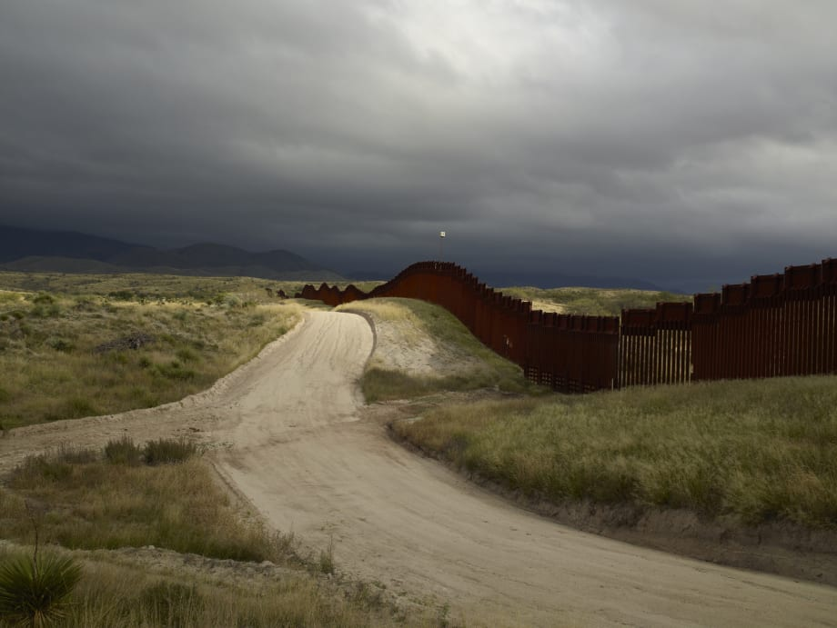
Figure 5: Border Cantos (Three Views) (Misrach, 2009)
Along with the sound artist Guillermo Galindo, he produced “Border Cantos” covering the Border Wall and the objects that are left behind. This work was both an exhibition and book, along with an accompanying website displaying a selection of photographs and musical instruments that Galindo created for the exhibition from the discarded objects.
The Border is a unique place that crosses between town, desert, and river. When the border wall was first constructed its main purpose was to keep diseased animals from crossing (Kun, 2016, p.9), but that has evolved to become a means for stopping human crossings from Central America into the United States.
In the photographs, Misrach looks at The Border and how its presence and the attempted “illegal” migrant crossings affect the land. His work concentrates on the American side of the border.
Objects are powerful memory triggers. They are generally more personal, but some objects invoke powerful memories, such as the statue of Edward Colston in Bristol which was torn down because of the connections to the slave trade (Siddique and Skopeliti, 2020) – something that no one alive today has lived through, but a deep collective memory keeps the horror of the time alive in the collective memory.
Misrach makes use of discarded objects found around the wall in his photographs. These items, ranging from tyres, nail files and an old copy of Doctor Zhivago evoke memories and thoughts of the people to whom they belong. However, there is no-one to vocalise these memories, so using Galindo’s musical knowledge and inventiveness these same inanimate objects are given a voice, allowing them to share new and communal memories and, as part of Misrach and Galindo’s mission, give migrants crossing the border a presence that they may not have had. What is striking about him choosing a subject that so deeply affects people is the lack of people in the work. Where they do appear in the photographs, they are rarely the subject of the picture, instead they are just merely another item that appears. It is the items he photographs that will what triggers memories for the viewer.
Signs are all around the border of human existence. The objects collected and repurposed by Misrach and Galindo ensure that they are available for the world to see, keeping alive the memories of the migrants for all to see. Border guards use drag techniques to smooth lines into the sand that are disrupted by the migrants crossing. This fleeting movement from the migrants leaves an equally fleeting memory of their passing the area. Comparing these lines to the Inuit, Ingold suggests that such lines are shadowy memories.
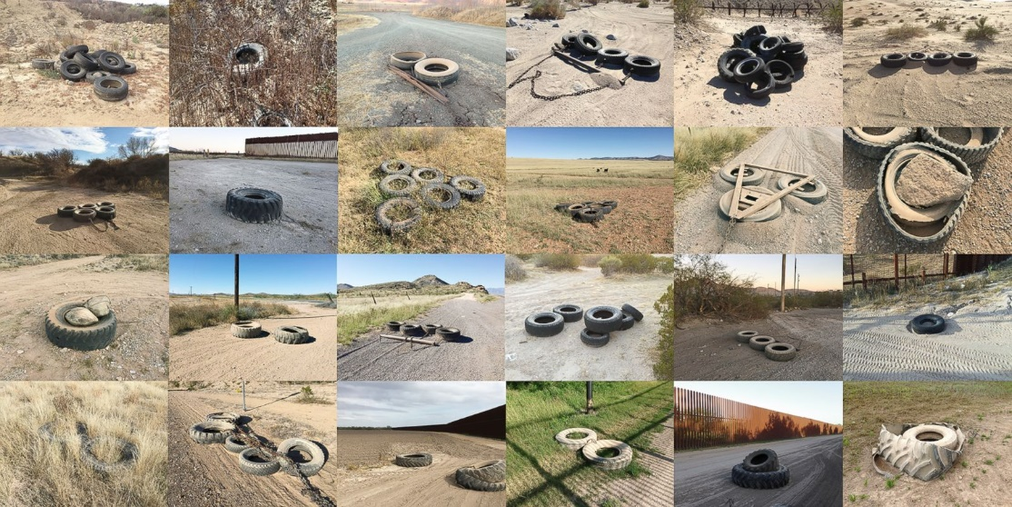
Figure 6: Tire drags used along the border from the Pacific Ocean to the Gulf of Mexico (Misrach, 2016)
The migrant would, in Ingold’s language, walk “hither and dither”. There is no set path that they take. It is a trail of survival, the easiest route that they can take over hostile and dangerous territory. The infographic below from the Humane Borders Organization, based in Tucson, Arizona, shows the sites of nearly 4000 migrant deaths between 2000-2021 (red and yellow dots). As well as showing the danger in migration, it clearly shows that the migrants do not have one path, but they are taking whichever path they deem the best. By recording these deaths, Humane Borders are ensuring that their memory is kept alive.
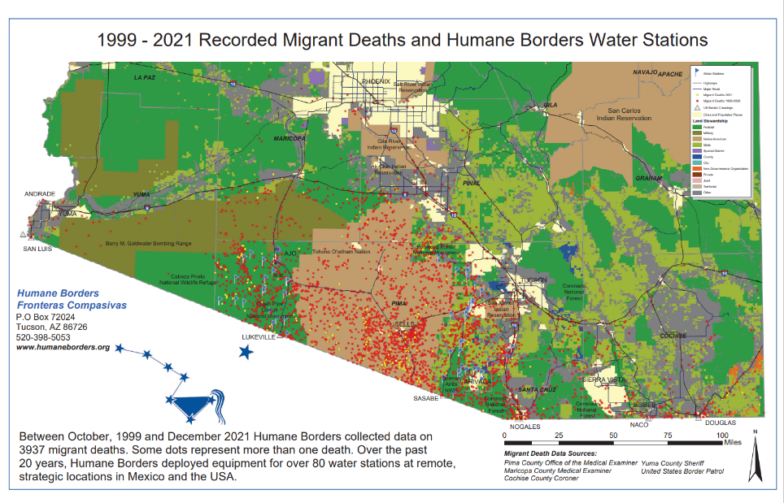
Figure 7: Border Deaths (Humane Borders, 2022)
What does Border Cantos tell us?
In his classic book, Camera Lucida (2000), Roland Barthes theorises how photographs can be read. The “studium”, he suggests, is the interest one takes in a picture. It is the make up of the picture, how it is composed, the thing that makes you want to look at the picture. However, if there is some kind of emotional effect on the viewer, that is the “punctum”. The punctum is the emotional pull of the picture that connects emotionally. It is easy to see the punctum in the photographs above – in Ng’s picture it is the face of the little girl and in Drew’s picture the man who is falling. Not all pictures will have this effect on the emotions. The picture below of the pier at Weston-super-Mare is perfectly nice, but there is no punctum, nothing in the picture to stir an emotion and nothing in the picture that will create a lasting memory.
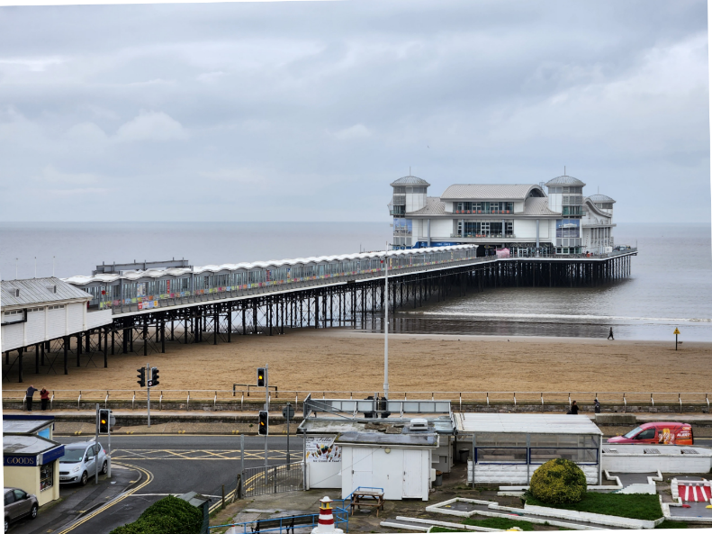
Figure 8: Grand Pier (Breading, 2022)

Misrach’s pictures certainly make you stop in your tracks to look at them. Barthes classification of “liking, not of loving” certainly applies if you see the pictures without wider context. (Barthes, 1980, p.27) They are well composed, interesting, enough to make anyone stop and look at them in greater detail. However, once the context is known, that this is a place where people die, where the discarded items are from people that may not have survived a journey or their only means of water has been deliberately sabotaged, then the punctum does appear.
Marc Augé discusses the concept of supermodernity (Augé, 1995, p.29) and an “excess” that he sees in modern life. Soap operas, Hallmark movies and sitcoms all give a great impression of what life is like in the United States and this is often what foreigners will see (not only about the US, but most other countries). Even murder mysteries are set in enticing locations and will convince people to try and migrate to another country.
Augé specifically refers to an airport (an official border crossing) as a non-place discussing in detail the process of air travel. How, though, does an “illegal” traveller move across a border. It must be across the line where they won’t be noticed, when they can slip under the radar and disappear into the night. As well as being in a non-place, one that doesn’t exist for the purpose it is being used, do they also become a non-person with no one to hold them in their memory? As Augé says, “The Space of non-place creates neither singular identity nor relations; only solitude, and similitude” (Augé, 1995, p.103).
The Border is just one long, single place, albeit nearly 2000 miles long, but it is the ultimate non-place. Made up of an infinite number of smaller places, the migratory routes pass through several other places, each which also has another use, whether that is a township, farmland, or the border. Augé talks about routes as used by markets, sanctioned by the state, but in the case of “illegal” migrants this isn’t so. They will use whatever means they can to cross the border and safely make it into their destination country. In fact, they will do all they can to avoid these official acknowledged routes and this what keeps them out of the public eye.
If someone gets caught crossing a border illegally, they are treated as a criminal. Arrested, detained, and then processed by the system. They will either be imprisoned or deported back to where they came. If they are successful in crossing, they will, by the very nature of the process they are involved in, disappear amongst the population, not wanting to be discovered, so they are unlikely to publicise their endeavours and a collective memory isn’t made.
Misrach has used his skill as a photographer to show, not only the Border Wall itself, but the objects left behind by the migrants. Looking at these small, seemingly insignificant objects, we can imagine the people that have crossed the border. One such item is a Pocahontas Towel (Misrach, 2016, p.152). Finding this in a city centre it would be looked at as a just a towel dropped by a child. But in the context of looking at the Border, so many other questions are asked. Who dropped it? Was it a child? Probably. What happened to them for the towel to be dropped? Are they still alive? Very different emotions are drawn stirred as you look at that picture. Kun suggests in his essay that the towel may have been used as protection against barbed wire, a countermeasure against the obstacles put up in the way of the migrants. There are no “flashbulb moments” for crossing the Border. No one is there to record it and it happens several times a day. Misrach is using his photography to create the moments. He is using the Border Wall, its surroundings and the found objects to create a connection between a distant event and the viewer so that when one sees, for example, the towel, the first thing thought of is the towel found on the border crossing. This is the punctum of that picture. What could be mundane, now becomes an emotional picture. The answers to the questions will never been know, it is up to us to make the judgement and our own story. This same thought process can be made of any one of the 48 items on just one gatefold in the book.
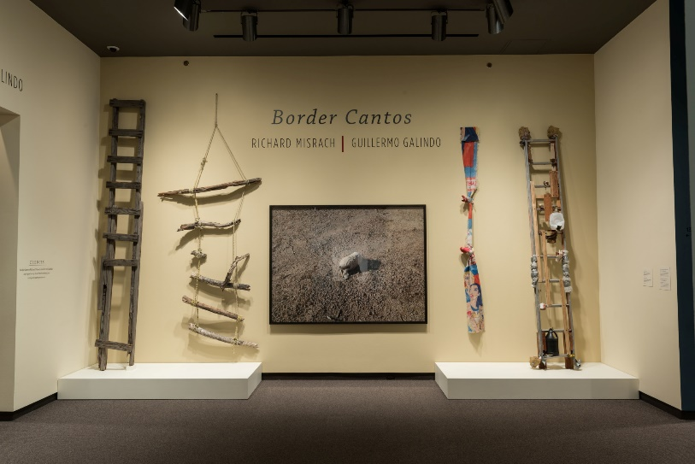
Figure 9: Installation View of Border Cantos (showing Pocahontas Towel) (Carter Museum, 2016)
The Border as a Place
In Nomadology – The War Machine (Deleuze and Guattari, 1987) it is implied that space not actively used by the state is smooth space, this is a concept that accurately describes the area around the border wall. Most of the wall photographed by Misrach has a road running next to it where the border patrols can patrol on the look out for migrants who have tried to cross the wall. In his book Misrach recounts the story of some youths who were able to climb the wall in 18 seconds showing the futility of the wall. It is where he found several of the objects in the book.
They further talk about the unique properties of smooth space that can applied to desert space. Due to the very nature of a desert, distance and direction are hard to determine without the aid of some kind of compass or electronic device. A new space is faced each time a step is taken, with what happens next a total unknown. Misrach’s pictures show some of the experiences that the migrants would have faced and, as the viewer of the pictures we can only surmise how disorientating it must be for the migrants. One picture shows a broken wheel from a bicycle that was run over by the border guards. There is a direct link between the space that the migrants inhabit and the memories of the items they drop.
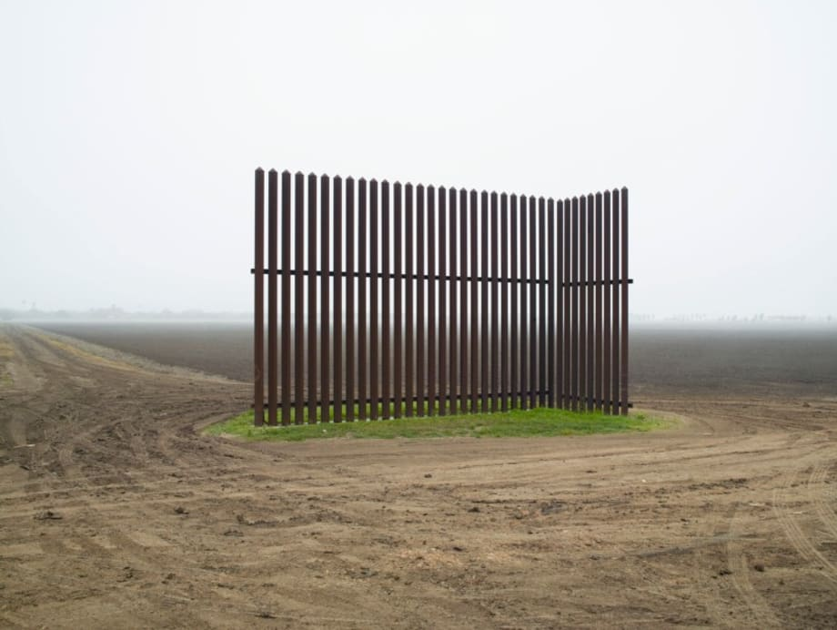
Figure 10: Wall, Near Los Indios, Texas (Misrach, 2015)
As the migrants continue to use the desert what was smooth, uninhabited space, becomes striated, lived in space. The opposite is also true though. Misrach has pictures of areas that were inhabited but, due to the way the wall has been built, they have become abandoned spaces, given back to the desert. Striated spaces back to smooth spaces. These changes occur all the time around the border. The movement of the migrants over the border also turns the areas into a striated space. There are two elements – the border wall and the crossing points. One remains steadfastly in place, unable and unwilling to be moved, whilst the other is determined to cross the line. Other lines are there to be crossed too. The border has electronic and aerial surveillance, all determined to spot the line of the migrants. Old-fashioned tracking techniques are also used, literal lines in the sand are made by the guard dragging tyres or chains behind a vehicle to smooth the sand so they can see where a migrant has attempted to cross into the United States. It is events such as this that Deleuze and Guattari talk about in The Smooth and The Striated (Deleuze & Guattari, 1987). The movement that the migrants can have in the desert is much freer and easier than they would have in the city and over an official border crossing.
Migrants are willing to give up their homes in the pursuit of a better life in a new home, regardless of the danger that they face in their journey. They are, by their nature transient, but as Tuan suggests, the permanence of a place is important as it is where the memories are. (Tuan, 1977, p. 136). There is a big similarity to ancient Greece, as Tuan notices, that the use of the sand by the border to mark out paths is very similar to the way the Greeks used soil to mark the borders of their settlements (Tuan, 1977, p. 153).
Migrants must have an attachment to the items they drop in the desert, as found by Misrach so for him and Galindo to repurpose them in the way that he does is to honour their original owners.
The instruments made by Galindo each has its own distinct sound and, at the original exhibitions, were showcased being played alone. Videos of these performances are available on the website, a further example of the items being immortalised (as far as the Internet is able to do this). This artistic upcycling very much has its roots in the Dada principle of “Ready-mades”, with one of Galindo’s instruments, the Listo, being compared by Kun to Marcel Duchamp’s Bicycle Wheel. Whilst the similarities between them are obvious, the big difference is that Listo makes music whilst Bicycle Wheel is just an object with no purpose other than art.
Misrach describes the wall as being a sculpture, a monument to the border, a memory to those who’s lives have been affected by it. Tuan saying that structures in the public domain lose their stature after a time. Time alone will tell how history treats this monument.
Misrach’s photographs along with the instruments and music made by Galindo have made a permanent record of not just The Border, but also of the people that have crossed the border. By avoiding using portraiture in his pictures, he takes us into the bleak vastness of the deserts and border areas that migrants are willing to put their lives at risk.
Conclusion
The ideas of place and memory are forever intertwined. It’s possible to mention a place that you have never been to and still have deep held memories about. If you mention Tiananmen Square to someone it is likely to be that their memory of it will be of a tank approaching a protester in 1989. Likewise, if you talk about Chernobyl the most likely memory is of the nuclear accident in 1986. What will future generations remember about the wall? Will it be the hazardous crossings made by migrants or will the memory be more likely a politician talking about it at a rally?
Migrant crossings are like a war. The migrants are avoiding the border guards, crossing battle lines drawn by the guards in the sand and one side being more powerful than the other. Despite this, crossings are successful. The journeys are fraught with danger and sadness – at leaving their home and the risk to life and limb they face. There is no memorial to these people, so it is up to photographers and documentary makers to create memorials on their behalf.
The theories of both Susan Sontag and Roland Barthes have particular resonance with Misrach and Galindo’s work. The pictures are multi-layered in their appeal to the viewer. They work as good pieces of art that would happily adorn any gallery, but they have a deeper meaning that can only be appreciated once the background of the photographs are know. This is when we get to understand the horrors that the migrants have been through in their attempts to get to the United States through some of the most inhospitable landscapes on the continent. Barthes idea of a punctum may not be immediately present in the photographs, but looking at the pictures and listening to the music made of the discarded items can only bring a emotional thought or memory, even if one hasn’t lived through the journey taken.

Bibliography
Augé, M. (1995) Non-Places. London: Verso.
Barthes, R. (1980) Camera Lucida London: Vintage.
Bergson, H. (1991) Matter and Memory. New York: Zone Books.
Border Cantos (2016) [Exhibition]. San Jose Museum of Art, San Jose 26 February 2016 – 31 July 2016.
Breading, A. (2022) Grand Pier [Photograph] Available at: https://www.instagram.com/mrandrewbreading/ (Accessed: 30 November 2022).
British Library (2022) The Faerie Queene by Edmund Spenser 1590. Available at: https://www.bl.uk/collection-items/the-faerie-queene-by-edmund-spenser-1590 (Accessed: 10 December 2022).
Cooke, K. and Hesson, T. (2020) ‘What are 'sanctuary' cities and why is Trump targeting them?’, Reuters, 25 February. Available at: https://www.reuters.com/article/us-usa-immigration-crime-idUSKBN20J25R (Accessed: 30 November 2022).
Crystal Bridges (2017). Opening Exhibition Lecture » Richard Misrach on Border Cantos. Available at: https://www.youtube.com/watch?v=DMmNqzoBHNU (Accessed: 12 December 2022).
Deleuze, G. and Guattari, F. (1987) A Thousand Plateaus: Capiltalism and Schizophrenia. Minneapolis: University of Minnesota Press.
Drew, R. (2001) Falling Man [Photograph]. Available at: https://www.cbsnews.com/news/richard-drew-on-photographing-the-falling-man-on-911/ (Accessed: 30 November 2022).
Hewitt, H. (2022) Mexican-United States Boundary Commission. Available at: https://www.tshaonline.org/handbook/entries/mexican-united-states-boundary-commission (Accessed: 29 November 2022).
Humane Borders (2022) Migrants Deaths, Rescue Beacons, Water Stations 2000-2021. Available at: https://humaneborders.org/printable-maps-and-posters/ (Accessed: 1 December 2022).
Ingold, T. (2007) Lines: A brief history. Abingdon: Routledge.
Jankowicz, M. (2020) A timeline of unfulfilled promises Trump made about his border wall, a cornerstone of his 2016 campaign which has faded from view in 2020. Available at: https://www.businessinsider.com/timeline-of-president-trumps-unfulfilled-border-wall-promises-2020-9?r=US&IR=T (Accessed: 28 November 2022).
Misrach, R. (1986) Dead Fish, Bravo 20 Bombing Range. [Photograph] Available at: https://www.sfmoma.org/artwork/2007.108/ (Accessed: 1 December 2022).
Misrach, R. (1987) Desert Cantos. Albuquerque: University of New Mexico Press.
Misrach, R. (2004) Agua #1 [Photograph]. Available at: http://bordercantos.com/ (Accessed: 30 November 2022).
Misrach R. (2009) Border Cantos (Three Views). Available at: https://www.artbasel.com/catalog/artwork/91664/Richard-Misrach-Border-Cantos-Three-Views (Accessed: 13 December 2022).
Misrach, R. (2015) Wall, Near Los Indios, Texas. Available at: https://www.artbasel.com/catalog/artwork/37729/Richard-Misrach-Wall-Near-Los-Indios-Texas (Accessed: 13 December 2022).
Misrach, R. (2016) Tire drags used along the border from the Pacific Ocean to the Gulf of Mexico. [Photograph]. Available at: https://abcnews.go.com/US/photos/richard-misrachs-border-cantos-36386289/image-richard-misrach-tire-drags-border-pacific-ocean-gulf-36386555 (Accessed: 13 December 2022).
Misrach, R. (2022) Richard Misrach on Telegraph 3 A.M. Available at: https://www.moma.org/magazine/articles/683 (Accessed: 30 November 2022).
Misrach, R. and Galindo, G. and Kun, J. (2016) Border Cantos New York: Aperture.
Misrach, R. and Weisang Misrach, M. (1990) Bravo 20 Baltimore: The John Hopkins University Press.
Nixon, R. and Qiu, L. (2018) “Trump’s Evolving Words on the Wall”, The New York Times, 18 January. Available at: https://www.nytimes.com/2018/01/18/us/politics/trump-border-wall-immigration.html (Accessed: 30 November 2022).
Perec, G. (1997) Species of Spaces and Other Pieces. London: Penguin Books Ltd.
Siddique, H. and Skopeliti, C. (2020). “BLM protesters topple statue of Bristol slave trader Edward Colston”, The Guardian, 7 June. Available at: https://www.theguardian.com/uk-news/2020/jun/07/blm-protesters-topple-statue-of-bristol-slave-trader-edward-colston (Accessed: 30 November 2022).
Sontag, S. (2003) Regarding the Pain of Others. London: Penguin Random House.
Sutton, D. (2009) Photography, Cinema, Memory: The Crystal Image of Time. Minneapolis:: University of Minnesota Press.
Tuan, Y. (1977) Space and Place: The Perspective of Experience.
Ut, N. (1972) Napalm Girl (The Terror of War) [Photograph] Available at: https://www.amateurphotographer.co.uk/latest/photo-news/nick-ut-50-years-on-the-story-of-the-napalm-girl-photo-167564 (Accessed: 30 November 2022).
Wilkes Tucker, A. (1996) Crimes and Splendours: the desert cantos of Richard Misrach Houston: Bullfinch Press

