UNIVERSITY OF WALES TRINITY SAINT DAVID
Birmingham
Master of Business Administration
Marketing Management | Module Code: LCMB7024
Assessment component 1: Marketing Environment Analysis
Comprehensive report on Codelco
Student Name: | Kajal Pratap Goraniya
Student ID Number: | 2610332
Programme: | Master of Business Administration
Module: | Marketing Management
Module Code | LCMB7024
Lecturer: | Taonga Kaonga Sobere-Snithers (Birmingham)
Word Count: | 2641
Submission Date: | 22 Oct 2026

Contents
Introduction 4
Task 1: Marketing Environmental Analysis 4
Critical analysis of three external marketing environment factors influencing transition of Codelco towards lower carbon products 4
Economic actors 5
Technological actors 6
Environmental actors 7
Task 2: Strategic growth as well as competitive positioning 8
Strategic growth approaches for Codelco, using Ansoff Matrix 8
Market penetration 9
Market development 9
Product development 10
Diversification 10
Recommendation on strategic growth approaches for Codelco: Product Development strategy 10
Achieving Competitive Advantage through a Lower-Carbon Business Model 11
Task 3: Managerial and Professional Reflection 12
Reflection on decisions devised throughout the report 12
Selection of Codelco 12
External environmental actors 12
Growth strategy 13
Managerial judgement 13
Reflection on limitations of the analysis 13
Data limitations 13
Customer uncertainty 13
Financial uncertainty 13
Competitive gaps 14
Consultant recommendation 14
Conclusion 14
References 15
Appendices 19
1. Economic actors 19
1.1 Inflation 19

Introduction
Purpose of the present report is to analyse the marketing environment of Codelco for determining key market opportunities as well as challenges. Codelco is mining company, with headquarters located in Santiago, Chile, with core business of exploring, developing along with exploiting mineral resources, process them for producing refined copper as well as by products, further market them to target clients across the globe (Codelco, the company of all Chileans, 2026). For extraction and processing of ore, Codelco works responsibly in northern along with central Chile (Our Operations, 2022).
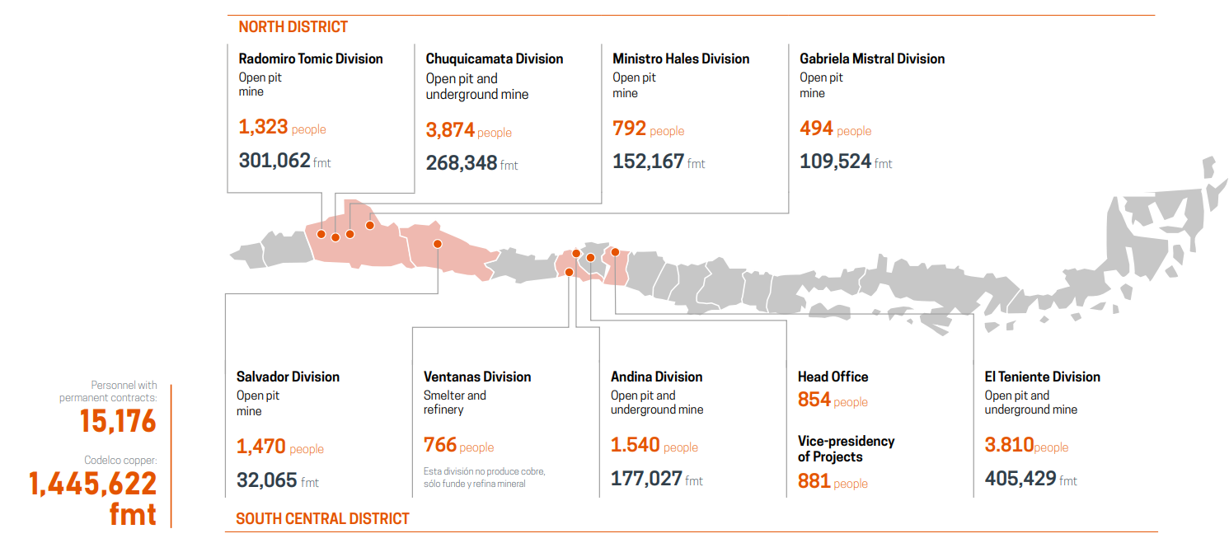
Figure 1: Operations of Codelco
(Source: Our Operations, 2022)
The report covers marketing environment analysis, strategic growth, competitive positioning, managerial and professional reflection.

Task 1: Marketing Environmental Analysis

Critical analysis of three external marketing environment factors influencing transition of Codelco towards lower carbon products
Marketing environment is termed as an environment wherein marketing and other activities of the company take place (Paurova and Gregova, 2020). It comprises external actors in addition to forces which influence the capacity of a company to generate value and sustain relationships with suppliers, customers, employees, investors and other stakeholders. In context to Codelco, Chile’s state owned copper producer, transition towards lower carbon commodities is shaped specifically by economic, technological and environmental actors. It is evaluated that such forces must not be taken separately, as environmental actors create imperative for decarbonisation, economic conditions determine whether the transformation can generate sustainable value and technology actors determine feasibility of minimising emissions. This is specifically important as copper is no longer only an industrial input, rather emerged as a foundational material underpinning infrastructure of low carbon and electrified economy (De Donno, 2026). Accordingly, Codelco confronts a fundamental strategic paradox, as it should produce more of the mineral needed for international decarbonisation while minimising environmental implications related to producing it.
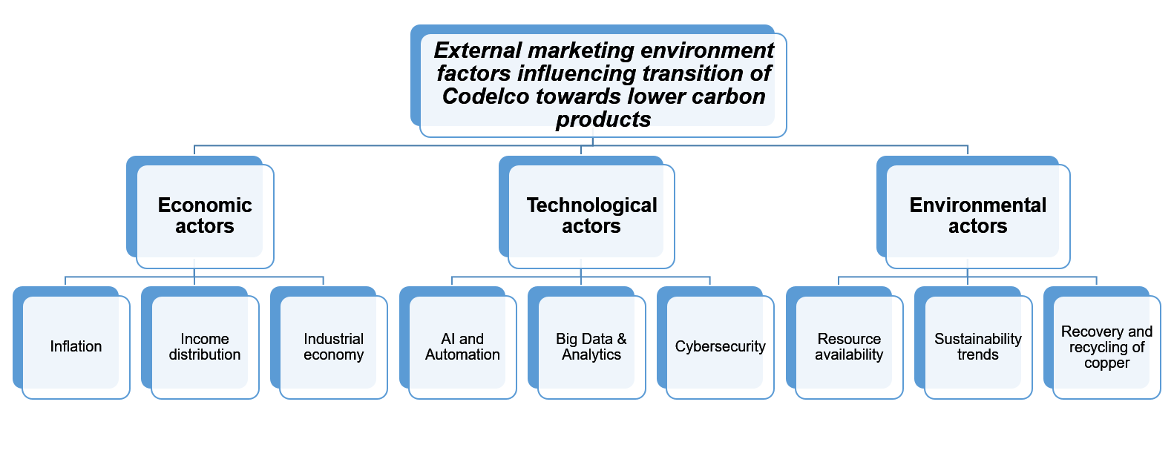
Figure 2: External marketing environment factors influencing transition of Codelco towards lower carbon products
(Source: Self developed)

Economic actors
Mentioned economic actors significantly influence the capacity of Codelco to finance as well as commercialise lower carbon copper.
- Inflation: In 2025, average inflation rate in Chile stood at 4.21 percent (Referring Appendix 1.1). This enhances the cost of Codelco’s renewable energy infrastructure, operational inputs and electrification tools, potentially constraining investment in production of lower carbon. Also, inflation rate is forecasted to decline between 2025 and 2031 by 1.21 percentage points, fluctuating as it trends downward (Statista Research Department, 2026). This can improve financing planning and affordability. In critical aspects, Codelco needs to accelerate capital intensive decarbonisation investments as inflationary pressure eases, which can improve its long term cost effectiveness.
- Income distribution: Chile is a high income country, under World Bank country classification with per capita income around USD 17093 in the year 2023 (Zapata-Román and Barrientos, 2026). High income level of Chile supports government revenues as well as investment ability for decarbonisation practices of Codelco. Nonetheless, income inequality limits domestic demand for lower carbon technologies. Since Codelco primarily serves industrial markets, income distribution influences commercialisation indirectly in the form of demand for renewable energy infrastructure and electrification.
- Industrial economy: Chile’s industrial economy strengthens the ability of Codelco to commercialise lower carbon copper as renewable energy, manufacturing along with electrification need substantial copper inputs. At same time, strong industrial demand improves prospects of revenue and supports reinvestment in decarbonisation. On the other side, it is analysed that capital intensive industrialisation intensifies pressure for reliable and cost efficient copper supply.

Technological actors
Following technological actors are enhancing the transforming ability of Codelco to decarbonise production and maintain productivity:
- AI and Automation: AI enabled tools assist improving operational efficiency throughout the supply chain, assuming maintenance, minimising waste addition to lower transportation costs (Corrigan and Ikonnikova, 2024). This minimises fuel consumption, operational inefficiencies and energy waste by optimising mine planning, usage of energy and material movement. In Chile, digital transformation of Codelco has the ability to minimise emission intensity as well as improve productivity. On the other hand, automation needs substantial capital investment in addition to new technical abilities, stating that technological adoption initially enhances cost despite immediately building financial return.
- Big Data & Analytics: In the mining sector, big data and analytics assist pipeline owners along with operators to undertake proactive actions promptly, preventing failures as well as ensuring efficient and safe operations of the system (Hussain, Zhang and Seema, 2023). This enables Codelco to optimise emissions, equipment, water and energy performance while forecast failures. Independently and correct verifiable data substantiate lower carbon claims, strengthening differentiation and customer trust. It is evaluated that poor quality of data improves reporting without delivering genuine environmental improvements.
- Cybersecurity: As per David et al. (2025), ensuring robust cybersecurity in the mining sector is crucial to maintain trust, regulatory compliance and operational continuity. Cybersecurity supports lower carbon transition of Codelco through protecting connected mining systems, emissions monitoring techniques and operational data from cyberattacks. Nonetheless, enhancing digitalisation expands vulnerability as well as needs costly security investment. Accordingly, robust cybersecurity is important for maintaining operational continuity, stakeholder confidence and data credibility.

Environmental actors
Underneath are some environmental actors which are influential as production of Codelco relies directly on finite natural resources while generating major environmental implications.
- Resource availability: Energy consumption of the mining industry enhances because of decreasing resource availability, such as ore grade, generating increment in extraction costs. Reduction in copper in mineral deposits requires companies to process more resources for obtaining the same copper (Leiva González and Onederra, 2022). Declining ore grades as well as scarcity of water enhance extraction costs together with operational risks, which encourages managers of Codelco to make investment in resource efficient technologies, cleaner production and recycling of water. On other hand, it is analysed that efficiency improvement lacks eliminating underlying reliance on finite mineral resources, making long term resource security important.
- Sustainability trends: Principal aim of developing sustainability includes finding equilibrium among social, economic and environmental aspects for maintaining stability of the system (Leiva González and Onederra, 2022). This reshapes expectations of customers as well as other stakeholders. Within Chile, industrial customers increasingly seek lower carbon minerals and a responsible supply chain, which causes opportunities for Codelco to distinguish its copper through credible environmental performance. However, it is evaluated that sustainability claims can become reputational liability, when unsupported by independently verifiable evidence. Accordingly, Codelco needs to demonstrate measurable environmental improvements despite depending only on promotional sustainability activities.
- Recover and recycle: Recovery and recycling of copper assists satisfying demand as well as developing a sustainable future (Seck et al., 2020). This support transition of Codelco through minimising reliance on energy intensive primary extraction, conserving finite resources and lowering related emissions. As an outcome, it strengthens efficiency of resources and aligns with growing circular economy expectations. Nonetheless, recycling lacks completely replacing primary copper production as demand continues to expand. It is evaluated that Codelco needs to integrate recycling and cleaner mining despite treating it as a standalone decarbonisation solution.
- Overall, lower carbon transition of Codelco is shaped by interconnected economic, technological as well as environmental actors. While resource scarcity, capital intensity and inflation constrain investment, there are elements, such as industrial demand, recycling and digital innovation which create opportunities for decarbonisation. In critical terms, sustainable competitive benefits for Codelco rely on integrating such factors to minimise costs and emissions, while maintaining reliable copper supply alongside credible environmental performance.

Task 2: Strategic growth as well as competitive positioning

Strategic growth approaches for Codelco, using Ansoff Matrix
Ansoff Matrix provides typology of growth approaches on the basis of dimensions related to markets and products (Johansson and Izev, 2026). For Codelco, application of Ansoff Matrix became a cornerstone of strategic planning, as it offers managers a structured technique to evaluate growth choices and their related risk profiles. Enduring appeal of the matrix lies in its intuitive logic as well as practical applicability across organisational and industrial contexts. It enables systematic evaluation of growth options for Codelco, while considering economic, technological and environmental risks.

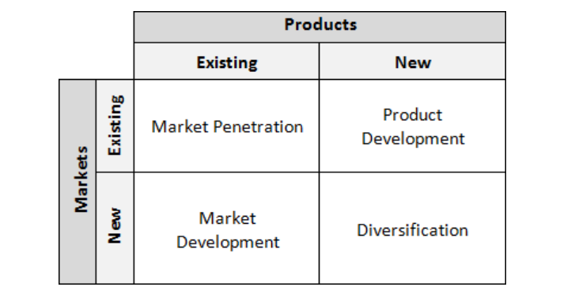
Figure 3: Ansoff Matrix
(Source: Sibiya and Barnard, 2020)

Market penetration
This aims to get a wider market or huge individuals for using a product (Haris, Samosir and Lubis, 2023). In context to Codelco, market penetration can entail strengthening its position in established copper markets through enhancing retention of customers, securing longer term contracts along with improving reliability of supply. Nonetheless, capacity of Codelco to support lower carbon transition is restricted if its offerings remain fundamentally unchanged. Enhancing conventional copper sales can result in making extra revenue for decarbonisation, however it would not essentially differentiate the company environmentally. Accordingly, this approach is more suitable for Codelco as a supporting strategy despite its principal growth mechanism.

Market development
This means offering commodities of the company to new demographic or geographical regions, with recognition of customer’s preferences, enter markets where it was not earlier (Zanjani et al., 2023). Codelco can target copper intensive sectors, for instance, renewable energy, electricity grids along with electric vehicles, benefiting from rising structural demands in addition to potential supply constraints. Nonetheless, expansion might enhance regulatory and logistical complexity without minimising emissions. Accordingly, Codelco must selectively target customers prioritising responsible, lower carbon, which align expansion of market with decarbonisation goals.

Product development
This is about launching improved or new offerings of the company to current markets (Rifki and Kirana, 2024). It represents the strongest strategic fit for Codelco as it permits the venture to retain its core copper business while changing environmental features of its offerings. Codelco can build a verified lower carbon copper proposition which could be supported by electrified equipment, recycling, digital emissions tracking, renewable electricity and resource efficiency. Accordingly, Codelco needs to combine minimised emissions with quality, cost efficiency, traceability and reliability.

Diversification
It entails redistribution of resources which exist at a given company to other areas of functioning which are meaningfully different from previous ones (Afanasyeva, Belous and Antonova, 2022). It is the highest risk strategy of Ansoff Matrix. In context to Codelco, use of diversification strategy can entail diversifying into renewable energy, recycling services and battery materials, which can minimise dependence of primary mining. Nonetheless, declining ore grades, decarbonisation costs and capital intensity can make wider diversification risky. Also, selective copper recycling diversification might result in circular economy advantages, nonetheless must remain secondary to major strategic priorities of Codelco.

Recommendation on strategic growth approaches for Codelco: Product Development strategy
As per environmental analysis, Codelco must prioritise product development, supported by market penetration. Product development strategy retains current mission along with developing commodities which have new together with varied features, including will improve performance of mission (Ferreira and de Sá, 2024). This can enable Codelco to differentiate through verified lower carbon copper, strengthen loyalty of customers and access the growing clean energy market. On the other hand, this needs substantial capital investment, operating restructuring and technological abilities. Risks comprises technological obsolescence, uncertain green premiums, execution failures alongside rivals fastly matching its environmental performance.

Achieving Competitive Advantage through a Lower-Carbon Business Model
Mentioned are proposed ways for Codelco to achieve competitive benefits through Lower Carbon business model:
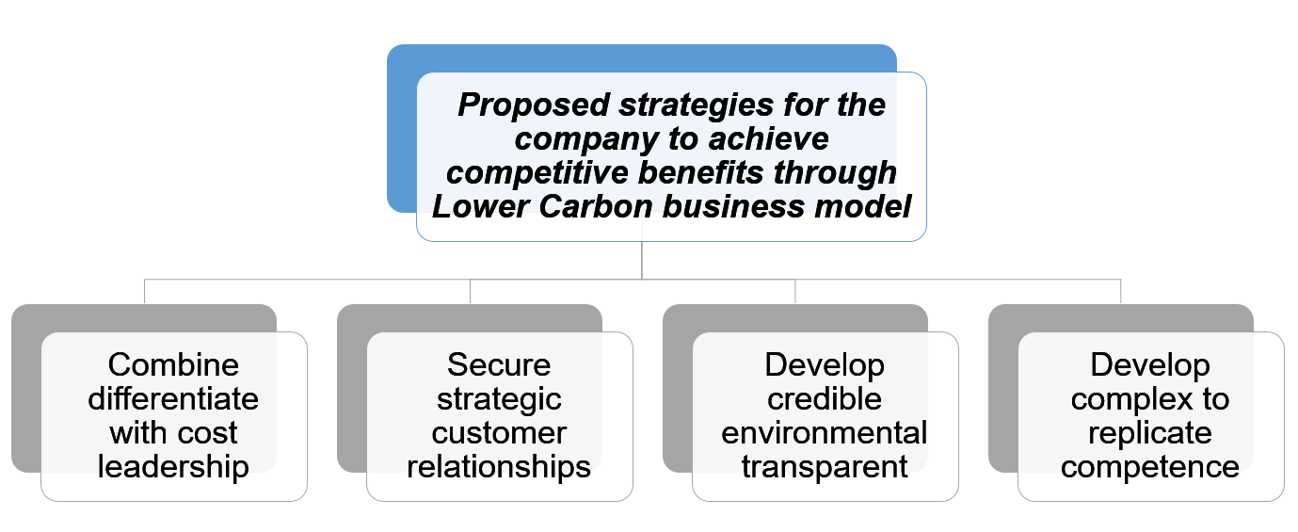
Figure 4: Proposed strategies for Codelco to achieve competitive benefits through Lower Carbon business model
(Source: Self developed)
- Combine differentiate with cost leadership: Decarbonisation needs adoption of multiple pathways, such as widespread deployment of renewables, energy efficiency improvements, electrification of end use industries and integrating emerging technologies, such as hydrogen and energy storage (Apata, 2025). Codelco must ensure that decarbonisation simultaneously improves efficiency of operations. Automation, predictive maintenance and artificial intelligence can minimise equipment downtime, material waste and energy consumption. As an outcome, it can build a stronger competitive position as Codelco competes not only through green credentials, rather through lower carbon copper at commercially competitive costs.
- Secure strategic customer relationships: Powerful customer relationship management results in fast business growth and expands the customer base as well as brand image of a company (Miller, 2022). Codelco must build long term supply agreements with sustainability oriented industrial customers, providing predictable demand as well as supporting investment in cleaner technologies. It is proposed to Codelco that it should not assume customers will consistently pay a substantial green premium.
- Develop credible environmental transparency: Companies need to be sensitive to the environment, so that they can build environmental transparency along with accountability (Wong et al., 2021). Independent verification along with digital traceability of emissions can minimise greenwashing based concerns as well as strengthen trust of stakeholders. It is specifically significant as unsupported sustainability claims damage the reputation of Codelco despite creating benefits.
- Develop complex to replicate competence: Sustainable advantage for Codelco must arise from integration of technology, resource efficiency, established customer relationships, low carbon production and traceability. It is more defensible than other individual green technology as well as supports long term transition of Codelco without undermining supply reliability.

Task 3: Managerial and Professional Reflection

Reflection on decisions devised throughout the report

Selection of Codelco
Throughout the report, Codelco was selected as its position as a major state owned copper producer builds major strategic paradox, including, copper is important for international electrification, however, its extraction generates major environmental pressures. It makes the company specifically suitable for assessing ways sustainability imperatives can be translated into commercially viable growth, despite being treated individually as a compliance issue.

External environmental actors
Evaluation in the report prioritised external marketing environmental actors, as declining ore grades, sustainability expectations, resource scarcity and water constraints directly shape transition of Codelco. Technological and economic actors were incorporated as environmental ambition alone lacked delivering competitive benefit, financial feasibility determined capacity of investment, while technology determined feasibility of operations. In critical terms, such forces are interconnected despite being independent.

Growth strategy
For Codelco, product development was chosen as the primary Ansoff Strategy as it permits the company to leverage current copper abilities while developing a differentiated lower carbon proposition. Also, market penetration can provide Codelco with complementary stability in the form of stronger retention of customers and contracts in the long term. Diversification was rejected deliberately as a principal approach because it has higher risk which can dilute attention of management along with foster capital exposure.

Managerial judgement
For Codelco’s management, key decisions include pursuing lower carbon differentiation combined with efficiency of cost, despite the assumption that sustainability automatically devises a premium. It shows a wider commercially defensible approach wherein environmental performance becomes a source of competitive benefit only when supported by traceability, operational efficiency and reliability.

Reflection on limitations of the analysis

Data limitations
The analysis depends majorly on external sources, restricting insights into actual decarbonisation performance of Codelco. Real consultants need site level emissions, carbon abatement, water consumption and energy intensity data for validating proposed approaches.

Customer uncertainty
Throughout the report, the analysis assumes growing demand for lower carbon copper, however, evidence of willingness of customers to make payment remain restricted. Direct customer research can determine whether sustainability develops genuine premium or becomes only a minimum expectation of the market.

Financial uncertainty
In this report, capital intensity was recognised as a constraint, the analysis lacks quantifying investment requirements or financial returns. In Codelco, managers might require OPEX, NPV, CAPEX and ROI estimates, tested under varied copper price, carbon price and energy cost situations.

Competitive gaps
Strategies of rivals need deeper benchmarking in the mining industry. Comparison of Codelco with giant producers can determine whether its proposed differentiation is genuinely complex to replicate.

Consultant recommendation
Stakeholder interviews, sensitivity analysis and scenario planning must precede final approval. This can ensure that strategy remains commercially viable under regulatory, market and technological uncertainty.

Conclusion
In conclusion, lower carbon transition of Codelco is shaped by interconnected economic, technological and environmental challenges which results in strategic opportunities along with threats to the company. From Ansoff Matrix, product development strategy, supported by market penetration, offers strongest balance among competitive differentiation, manageable strategic risk, operational efficiency and decarbonisation. Nonetheless, Codelco must validate the strategy in the form of robust financial analysis, competitor benchmarking, scenario planning and customer evidence for ensuring commercially defensible and sustainable competitive benefit.

References
Afanasyeva, O.K., Belous, K.V. and Antonova, N.V. (2022). Diversification strategy as a way to increase the competitiveness of a freight forwarding company. Економічні інновації. Зб. наук. праць. https://rp.onmu.org.ua/bitstream/handle/123456789/2953/%D0%91%D0%95%D0%9B%D0%9E%D0%A3%D0%A1_5_Diversification%20strategy%20as%20a%20way%20to%20increase%20the%20competitiveness%20of%20a%20freight%20forwarding%20company.pdf?sequence=1&isAllowed=y
Apata, O. (2025). Decarbonization pathways through multi-energy system planning. Energy Reports, 13, pp.4477-4490. https://www.sciencedirect.com/science/article/pii/S2352484725002410
Codelco, the company of all Chileans. (2026). About Us. | Codelco. [Online]. Available through: https://www.codelco.com/codelco-the-company-of-all-chileans [Accessed on: October 06, 2026]
Corrigan, C.C. and Ikonnikova, S.A. (2024). A review of the use of AI in the mining industry: Insights and ethical considerations for multi-objective optimization. The Extractive Industries and Society, 17, p.101440. https://www.sciencedirect.com/science/article/pii/S2214790X24000388
David, O., Vallabhaneni, R., Lallie, H. and Caporale, G.M. (2025). Cloud Computing and Cybersecurity: Emerging Threats and Defense Mechanisms. https://www.researchgate.net/profile/David-Oluremi/publication/393434987_Cloud_Computing_and_Cybersecurity_Emerging_Threats_and_Defense_Mechanisms/links/6869387039c35835120733d7/Cloud-Computing-and-Cybersecurity-Emerging-Threats-and-Defense-Mechanisms.pdf
De Donno, M.G. (2026, June). Copper as a Critical Enabler of Electrification: Supply Chain Bottlenecks, Investment Needs, and the Role of Circularity. In SPE Europec featured at EAGE Conference and Exhibition (p. D021S017R001). SPE. https://onepetro.org/SPEEURO/proceedings-abstract/26EURO/26EURO/800288
Ferreira, A.P.P.F.S. and de Sá, M.M.B.P. (2024). The importance of the Ansoff matrix for the study of the information services market. The Canadian Journal of Information and Library Science, 47(2), pp.78-84. https://www.erudit.org/en/journals/cjils/2024-v47-n2-cjils09826/1115996ar/abstract/
Haris, A., Samosir, H.E. and Lubis, S.H. (2023). Marketing communications as strategy expanding market share in era 4.0. International Journal of Social Science and Business, 7(1), pp.188-198. https://ejournal.undiksha.ac.id/index.php/IJSSB/article/view/53535
Hussain, M., Zhang, T. and Seema, M. (2023). Adoption of big data analytics for energy pipeline condition assessment-A systematic review. International Journal of Pressure Vessels and Piping, 206, p.105061. https://www.sciencedirect.com/science/article/pii/S0308016123001783
Johansson, G. and Izev, M. (2026). The Interplay Between Ansoff's Product-Market Growth Strategies and Resource-Based View (RBV) in Achieving Competitive Advantage. ScienceOpen Preprints. https://www.scienceopen.com/document_file/4d161505-9942-49f2-b47f-b991b78295ee/ScienceOpenPreprint/The%20Interplay%20Between%20Ansoff%27s%20Product-Market%20Growth%20Strategies%20and%20Resource-Based%20View%20%28RBV%29%20in%20Achieving%20Competitive%20Advantage.pdf
Leiva González, J. and Onederra, I. (2022). Environmental management strategies in the copper mining industry in Chile to address water and energy challenges. Mining, 2(2), pp.197-232. https://www.mdpi.com/2673-6489/2/2/12
Miller, O. (2022). Successful Customer Relationship Management Strategies. | Medium. [Online]. Available through: https://medium.com/@olivvmiller/successful-customer-relationship-management-strategies-7def3835ec97 [Accessed on: October 08, 2026]
Our Operations. (2022)c. Codelco Comprehensive Report 2022. | Codelco. [Online]. Available through: https://www.codelco.com/sites/site/docs/20230607/20230607094540/m22_eng__1_.pdf [Accessed on: October 10, 2026]
Pantskhava, E. and Jishkariani, M. (2025, March). Decarbonization and its aspects in the energy sector. In Proceedings of III International Scientific and Practical Conference Madrid, Spain (pp. 117-123). https://www.researchgate.net/publication/389706499_Decarbonization_and_Its_Aspects_in_the_Energy_Sector
Paurova, V. and Gregova, E. (2020, December). Importance and Process of Marketing Environment Analysis as Strategic Analysis Tool of Business. In Fifth International Conference on Economic and Business Management (FEBM 2020) (pp. 720-723). Atlantis Press. https://www.atlantis-press.com/proceedings/febm-20/125948486
Rifki, M.B. and Kirana, D.H. (2024). Market Expansion Strategy for Sweet Potato Export Products Using the Ansoff Matrix (Case Study of CV SNR Bumi Indonesia). International Journal of Management and Business Economics, 2(3), pp.59-63. https://putrapublisher.org/index.php/jamis/article/view/586
Seck, G.S., Hache, E., Bonnet, C., Simoën, M. and Carcanague, S. (2020). Copper at the crossroads: Assessment of the interactions between low-carbon energy transition and supply limitations. Resources, Conservation and Recycling, 163, p.105072. https://pmc.ncbi.nlm.nih.gov/articles/PMC7391239/
Sibiya, D.Z. and Barnard, B. (2020). Institutionalizing entrepreneurship: The case of B-BBEE Based Enterprise and supplier development in South Africa. IUP Journal of Business Strategy, 17(1), pp.7-45. https://www.researchgate.net/profile/Brian-Barnard/publication/337943474_Institutionalizing_entrepreneurship_The_case_of_B-BBEE_Based_Enterprise_and_Supplier_Development_In_South_Africa/links/5df6890e4585159aa4807da3/Institutionalizing-entrepreneurship-The-case-of-B-BBEE-Based-Enterprise-and-Supplier-Development-In-South-Africa.pdf
Statista Research Department. (2026). Average inflation rate in Chile 1980-2031. | Statista. [Online]. Available through: https://www.statista.com/statistics/370367/inflation-rate-in-chile/?srsltid=AU7gw4XBsbxP__cGZTv0uYaQO5FFt-oBxLI50VTVpI8hAvtOWFygSyGB [Accessed on: October 05, 2026]
Wong, C.W., Wong, C.Y., Boon-Itt, S. and Tang, A.K. (2021). Strategies for building environmental transparency and accountability. Sustainability, 13(16), p.9116. https://www.mdpi.com/2071-1050/13/16/9116
Zanjani, S., Iranzadeh, S., Khadivi, A. and Feghhi Farahmand, N. (2023). Designing a model for selecting a company growth strategy based on market and product success forecasts by comparing FIS and ANFIS methods. International Journal of Nonlinear Analysis and Applications, 14(5), pp.219-234. https://ijnaa.semnan.ac.ir/article_6893_5b40a71b06dbb61df0777a010275ed2c.pdf
Zapata-Román, G. and Barrientos, A. (2026). Social protection in Chile: Between growth and redistribution (No. 23/26). WIDER Working Paper. https://www.econstor.eu/bitstream/10419/339292/1/1966709196.pdf

Appendices

1. Economic actors

1.1 Inflation
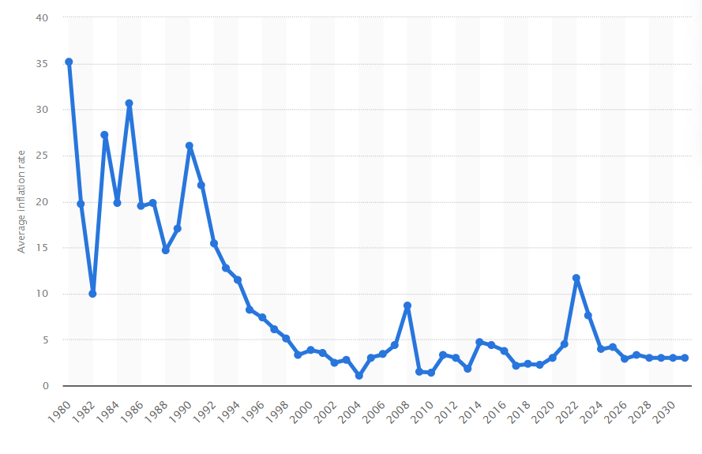
Figure 5: Average inflation rate in Chile 1980-2031
(Source: Statista Research Department, 2026)

