Assessment Tasks 1-5
ACCMA 4031
Task 1:
A.
The rise of e-commerce has resulted in a variety of website builders catering to online businesses. Some of the popular options available in the market include Volusion, PrestaShop, Wix, Weebly, and 3dcart. Each of these platforms offers unique features and benefits to suit different needs and budgets.
- Volusion is an all-in-one e-commerce platform that provides a range of tools, including website design, hosting, payment processing, and inventory management. It is ideal for small to medium-sized businesses that require a user-friendly platform.
- PrestaShop is an open-source platform that offers a range of features and customization options. It is suitable for businesses of all sizes and allows users to create a fully functional online store, manage products, and process payments.
- Wix is a website builder that offers various templates and features to create an online store. It is a simple platform that allows users to customize the website design, manage products, and accept payments.
- Weebly is another website builder that is user-friendly and provides a range of templates and features to build an online store. It also offers tools to manage products, inventory, and payments.
- 3dcart is an e-commerce platform that offers various features, including website building, hosting, payment processing, and inventory management. It is a scalable solution suitable for businesses of all sizes, from small businesses to enterprise-level organizations.
Businesses should research and evaluate the features and benefits of each e-commerce website builder before making a decision. The choice depends on various factors, including business size, budget, and specific requirements.
B.
Portfolio link:
https://sites.google.com/d/1_VigIjaBkxqyLQWyjR3lx9bgpjeyEO8N/p/1uDkZ-MroJ8VYqilfU1KS8RZTa7ROg1o3/edit
Task 2:
Some points for a mind map on contemporary software applications used in business operations are following below:
- Virtual meeting software
- Cloud storage and file-sharing software
- Employee monitoring software
- Learning management systems
- Website builders
- Document management software
These software applications serve a wide range of functions in businesses and organizations, from protecting sensitive information to facilitating remote work and training, to managing online content and documents. They are constantly evolving to meet the changing needs and demands of the modern workplace.

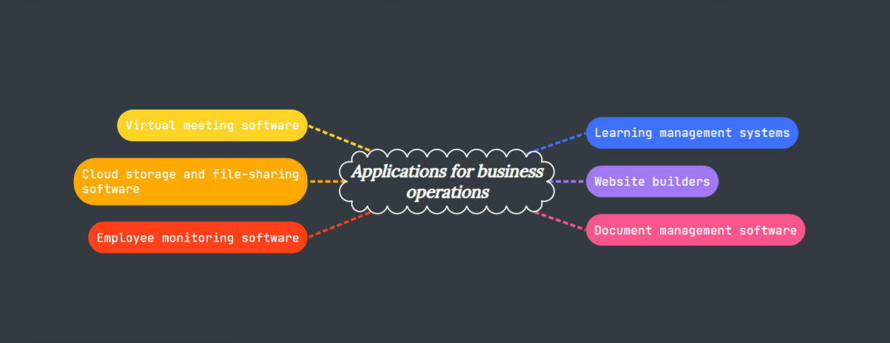
Task 3:
A.
There are several contemporary Office applications available for creating, storing, analyzing, and presenting information and data. Here are some key features of four of the most commonly used applications:
- Word-processing: Microsoft Word and Google Docs are two popular options for word-processing. Both applications offer features such as formatting tools, spell-check, and the ability to collaborate with others in real-time. Microsoft Word offers more advanced features such as mail merge, and the ability to create forms and templates. Google Docs offers seamless integration with other Google apps and cloud-based storage.
- Spreadsheets: Microsoft Excel and Google Sheets are two widely used applications for creating and analyzing spreadsheets. Both applications offer features such as formulas and functions, charting tools, and the ability to collaborate with others. Microsoft Excel offers more advanced features such as pivot tables and data analysis tools. Google Sheets offers easy sharing and collaboration features, as well as cloud-based storage.
- Databases: Microsoft Access and Google Cloud SQL are two options for creating and managing databases. Microsoft Access offers a user-friendly interface and the ability to easily create forms and reports. Google Cloud SQL is a cloud-based solution that offers scalability and high availability.
- Presentations: Microsoft PowerPoint and Google Slides are two commonly used applications for creating and delivering presentations. Both applications offer features such as slide templates, animation and transition tools, and the ability to collaborate with others. Microsoft PowerPoint offers more advanced features such as the ability to record and embed audio and video, and to create interactive presentations. Google Slides offers seamless integration with other Google apps and cloud-based storage.
B.
For this task, I tested some business-related features of Google Sheets, which is a freely available Office Application. I created a simple sales report spreadsheet with data on sales for a small business, and tested the following features:
- Conditional Formatting: This feature allows you to format cells based on specific conditions, such as values being above or below a certain threshold. In my sales report, I used conditional formatting to highlight cells with sales below a certain amount in red, and cells with sales above a certain amount in green.
- Charts: Google Sheets offers several types of charts, including line charts, bar charts, and pie charts. I used a column chart to visualize the sales data in my report.
- Data Validation: This feature allows you to set rules for data entry, such as requiring a certain format or restricting data to a certain range of values. In my sales report, I used data validation to ensure that sales figures entered were positive numbers only.
Here is the screenshot of my sales report in Google Sheets, showing these features in action:
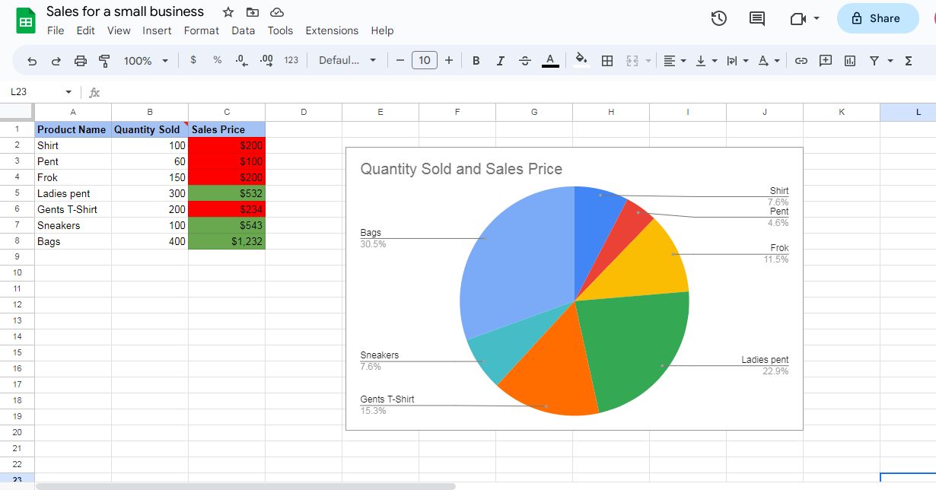

Task 4:
Digital Dashboard/Data Analytics software solutions are designed to provide quick and easy access to relevant information for users. These software solutions come with several key features that enable businesses to track and analyze data effectively. Some of the common key features of contemporary digital dashboard and data analytics software solutions are:
- Data visualization: The ability to visualize data through graphs, charts, and other visual representations.
- Customization: The ability to customize the dashboard according to the needs of the user.
- Real-time data: The ability to provide real-time data that is updated automatically.
- Integration: The ability to integrate with other software solutions, such as CRM and ERP systems.
- Analytics: The ability to perform analytics on the data, such as trend analysis and forecasting.
- Mobile access: The ability to access the dashboard and data analytics from mobile devices.
For the poster, I use a fictitious project for a restaurant and showcase how a digital dashboard and data analytics software solution could benefit their operations. The poster is taken from “postermywall”.


Task 5:
A.
There are many communication, collaboration, and project management applications available in the market. Some of the most popular ones are:
- Slack: Slack is a cloud-based collaboration tool that allows team members to communicate with one another via direct messaging, voice calls, and video conferencing. It also offers file sharing and integration with other productivity tools like Google Drive and Trello.
- Asana: Asana is a project management tool that helps teams keep track of their tasks, deadlines, and progress. It allows for task assignment, collaboration, and file sharing. It also has a calendar view and the ability to integrate with other apps like Slack and Google Drive.
- Trello: Trello is a visual collaboration tool that uses boards, lists, and cards to organize and prioritize tasks. It allows teams to create workflows, assign tasks, and track progress. It also integrates with other tools like Slack and Google Drive.
B.
I chose to test the communication and collaboration features of Microsoft Teams, a free collaboration tool. I tested the following features:
- Chat: Microsoft Teams offers direct messaging between team members, similar to Slack. Users can send text messages, voice notes, and files.
- Video Conferencing: Teams allows users to host video conferences with up to 250 participants. It also offers screen sharing and recording features.
- Collaboration: Teams allows for file sharing and collaboration in real-time. Users can work together on Word documents, Excel spreadsheets, and PowerPoint presentations.
Microsoft Teams is a powerful tool for communication and collaboration within a team. It offers a range of features that make it easy to work together and stay connected, no matter where team members are located.
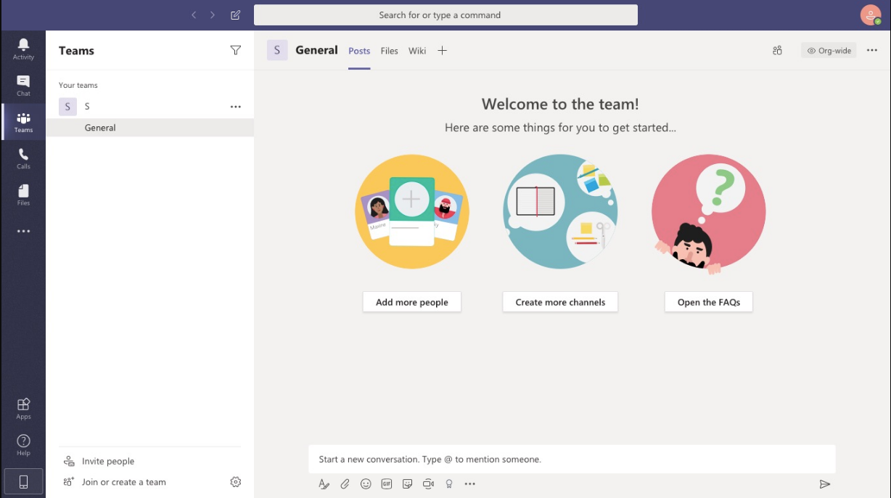
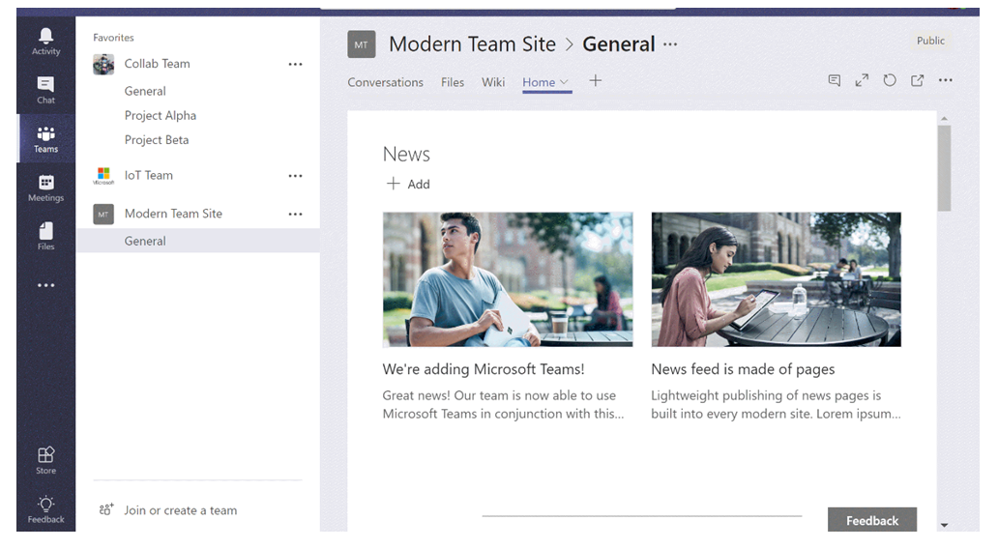

Reference:
Peltier, T. R., & Naidu, G. M. (2015). E-commerce 2015 (11th ed.). Pearson.
Choudhary, V., & Bhatia, A. (2017). Comparative study of e-commerce website development platforms. International Journal of Computer Science and Mobile Computing, 6(10), 152-160.
Zhong, R. Y., Huang, G. Q., Lan, S., & Dai, Q. Y. (2019). A study on the key success factors of e-commerce in China. Journal of Industrial and Production Engineering, 36(6), 388-401.
Bughin, J., Catlin, T., Herring, J., & Kostovetsky, L. (2016). The case for digital reinvention. McKinsey Quarterly, 2, 1-10. https://www.mckinsey.com/business-functions/digital-mckinsey/our-insights/the-case-for-digital-reinvention
Bligh, M. C., Kohles, J. C., & Meindl, J. R. (2004). Charisma under crisis: Presidential leadership, rhetoric, and media responses before and after the September 11th terrorist attacks. The Leadership Quarterly, 15(2), 211-239. https://doi.org/10.1016/j.leaqua.2004.02.004

