

Module Name: Academic Skills in the Digital Era
Module Code: BMSW4013
Assignment Name: Time-Management: An Essential Skill for Student Success in Higher Education
Student Name: Devi Raju
Student Number: 2435195
Lecturer: Ffion Cumberpatch
Deadline: Friday 6th June 2025
Wordcount: 769

AI Acknowledgement and Contents:
AI Acknowledgement:
I confirm that I have not presented any AI generated materials as my own work.
Also, I confirm that I have copies of my drafts, notes, and other resources I used, which I may be asked to provide in evidence.

TABLE OF CONTENTS:

Introduction
The important of Mastering time management
Applying the Eisenhower Matrix to student time management
Students struggle with time management
Evidence based solutions of time management
using Pomodoro technique
Conclusion
Reference List

Introduction:
Time Management is a fundamental skill that underpins academic success in higher education. University life introduces a variety of unique challenges, such as increased academic workloads, greater personal freedom, and the need to balance academic, social and personal responsibilities. Without effective time management, students are at risk of heightened stress levels, missed deadlines, and reduced academic performance. Conversely, effective time management enables students to manage task efficiently, meet academic deadlines, and achieve their goals while maintaining a balance lifestyle. Furthermore, it reduces stress by helping last minute work and supports the effective allocation of study time.
Time constitutes one of the most valuable resources available to us. For students, who frequently balance academic obligations, social engagements, and part-time employment, the ability to manage time effectively can distinguish between flourishing and merely coping (Mccullough, 2024).
This report explores the importance of time management for students, outlines key principles such as Eisenhower Matrix, Students struggles with time management and present an evidence-based strategy -the Pomodoro technique—as a practical solution, Pomodoro Technique.

The important of Mastering time management:
Mastering time management is vital as it enables individuals to prioritize tasks and allocate their resources effectively. When time is managed well, students can identify key priorities and dedicate adequate effort towards them, ensuring deadlines are met and academic objectives are fulfilled, in contrast, poor time management may leave individuals feeling overwhelmed, leading to missed opportunities and substandard outcomes.
Effective time management is a crucial factor in achieving a rewarding and successful university experience, and it also plays a vital role in maintaining personal well-being. (McMillan and Weyers, 2021).
Efficient time management supports better scheduling of study sessions, which enhances preparation of assessments and improvs academic performance. On the other hand, inadequate time management often leads to last minute cramming and increased anxiety, ultimately grades negatively.
According to Mac and Fabian, (2023) That time management among students, is often caused by underlying factors such as academic stress, rather than a lack of organisation alone.

Applying the Eisenhower Matrix to student time management:
One of the effective time management tools is the Eisenhower Matrix, which offers a structured method for prioritizing tasks. This model helps students determine which tasks require immediate attention and which ones are more important for long-term academic goals.
This popular method sorts into 4 quadrants. Urgent &Important,
important & Not Urgent, Urgent & not important, Not Urgent & not important.
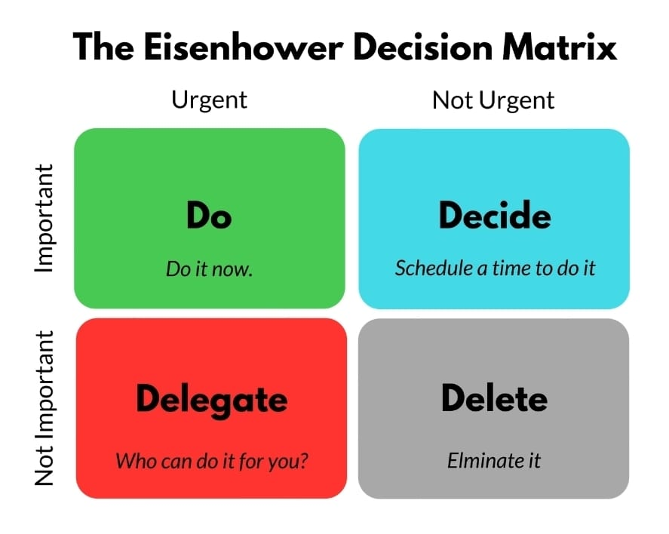

For students, using this method encourages a shift from reactive behaviour to product planning. By identifying and prioritizing important but not urgent tasks.
Eisenhower Matrix as a framework that brings the greatest relief, particularly in high pressure environments where task overload is common, for students, this model offers clarify by enabling them to focus on academic task that contribute meaningfully to their success. (Darryl,2024)

Students struggle with time management:
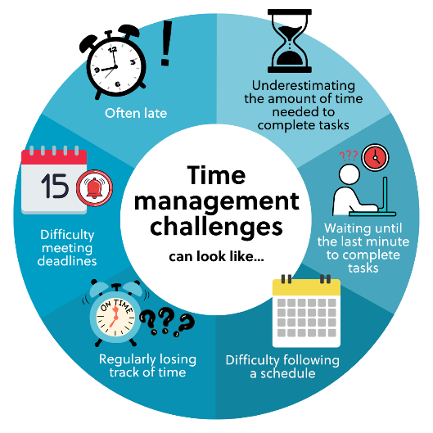
Students often find it challenging to manage their time effectively while at university, this difficulty can lead to procrastination and a sense of being overwhelmed, resulting in delays, rushed assignments, and reduced study time. Many students struggle to stay motivated, fail to adopt suitable time management tools or techniques, and face constant digital distractions, all which make it harder to focus and use time efficiently. Ineffective time management can have serious academic consequences, such as lower grades, missed deadlines and late submission of assignments

Observe that students who possess inadequate study skills and time management strategies often find it challenging to adjust to the increased academic demands of postgraduate education (Casey and Audra, 2022)

Evidence based solutions of time management using Pomodoro technique:
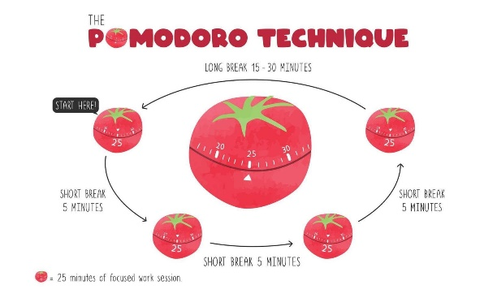
Effective time management is critical for academic success and personal wellbeing. One evident based strategy that has gained popularity among students is the pomodoro technique, developed by Francesco Cirillo in the late 1980s. this method use intervals of focused work followed by short breaks to enhance concentration and reduce fatigue.
A wide range of educators, academics, productivity experts, study skills experts and researchers support the Pomodoro Technique,

Although students frequently use digital devices limited research has been conducted to explore effective methods for supporting students in managing their time, this thesis examines the effectiveness of the widely used pomodoro technique as potential time management solution (Salman Ahmed, U., 2020)

Conclusion:
Time management is an essential skill for success in higher education. With effective strategies, such as the Eisenhower matrix and the Pomodoro technique, Students can control of their time, reduce stress and improve academic outcomes. Though challenges exist, especially regarding digital distractions, prioritization, practical techniques and structural approaches offer possible solutions. Students who adopt these methods are more likely to success academically and maintained balanced university experience.

Reference List:
Darryl, B., (2024). Building Capacity by Applying the Eisenhower Matrix. Journal of Environmental Health, 86(8), pp.42–43.
https://www.proquest.com/scholarly-journals/building-capacity-applying-eisenhower-matrix/docview/3000390458/se-2?accountid=130472

Casey, B. and Audra, S. (2022) ‘Determining the time management techniques and study strategies of master’s students enrolled in a graduate gross anatomy course: a pilot study’, The Federation of American Societies for Experimental Biology, 36 (5), United States.
Availableat https://librarysearch.uwtsd.ac.uk/permalink/44WHELF_UWTSD/igoone/cdi_pubmed_primary_35556836

McCullough, C. (2024) Why time management matters: how students can benefit from scheduling skills. London: Rotageek.
Available at https://blogs.reading.ac.uk/careers/why-time-management-matters-how-students-can-benefit-from-scheduling-skills/

McMillan, K. and Weyers, J. (2021) The Study Skills Book. 4th edn. Harlow: Pearson Education Ltd.
Available at https://ebookcentral.proquest.com/lib/trinity/reader.action?docID=6665529&ppg=37&c=UERG

Mac, M., Fabian, M., (2023), More carrot or less stick: Organically improving student time management with practice tasks and gamified assignments. In: Proceedings of the 2023 Conference on Innovation and Technology in Computer Science Education V. 1, New York, NY, USA: ACM, pp.278–284.
Available at
https://librarysearch.uwtsd.ac.uk/permalink/44WHELF_UWTSD/igoone/cdi_acm_books_10_1145_3587102_3588825

Salman Ahmed, U., (2020). Investigating the Effectiveness of Pomodoro Technique for Time Management among students. ProQuest Dissertations & Theses
Available at
https://librarysearch.uwtsd.ac.uk/permalink/44WHELF_UWTSD/igoone/cdi_proquest_journ
als_2566294713

