

The Role of AI in Hospitality: Transforming Customer Service and Operational Efficiency
Student name: Alexandra Adriana Popa
Student ID: 2133013
Lecturer: Dr Ernest Balutie Wavei
AI acknowledgment statement
I confirm that I have not used any AI tools in the research and creation of this assignment. I confirm that I have not presented any AI-generated materials as my own work. I confirm I have copies of my drafts, notes, and other resources I used. I may be asked to provide them as evidence.
Table of Contents
Slide 1: Introduction 4
Slide 2: Background – The Hospitality Industry. 4
Slide 3: Contemporary Theme – AI in Hospitality 4
Slide 4: Literature Review- AI in Hospitality 5
Slide 5: Theoretical Framework 5
Slide 6: Research Methodology 6
Slide 7: PESTEL Analysis (Political and Economic Factors) 7
Slide 8: PESTEL Analysis (Social and Technological Factors) 7
Slide 9: PESTEL Analysis (Environmental and Legal Factors) 8
Slide 10: Case Study - AI integration of Hilton 8
Slide11: Industry Responses &Challenges 9
Slide 12: Strengths & Weaknesses of AI in Hospitality 9
Slide 13: Future Recommendations 10
Slide 14: Conclusion 10
References 12

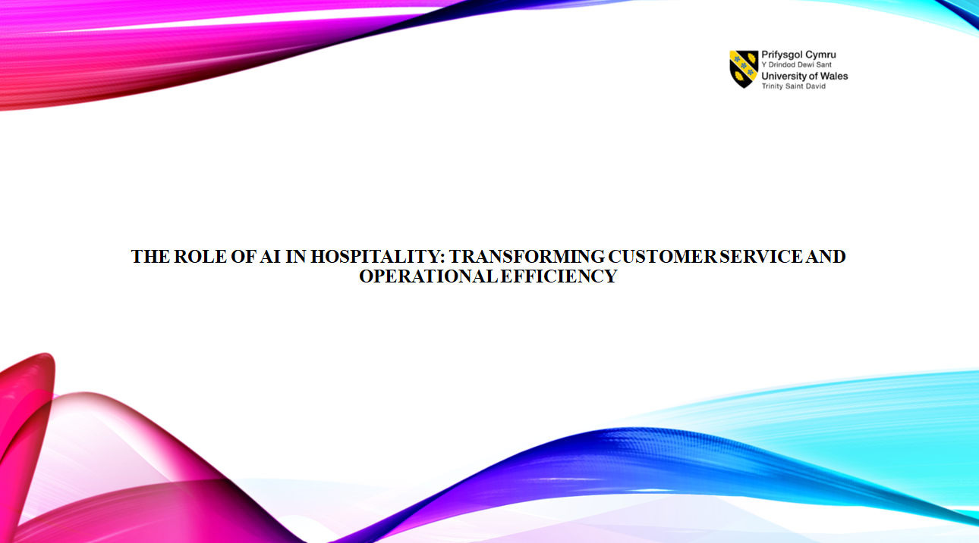
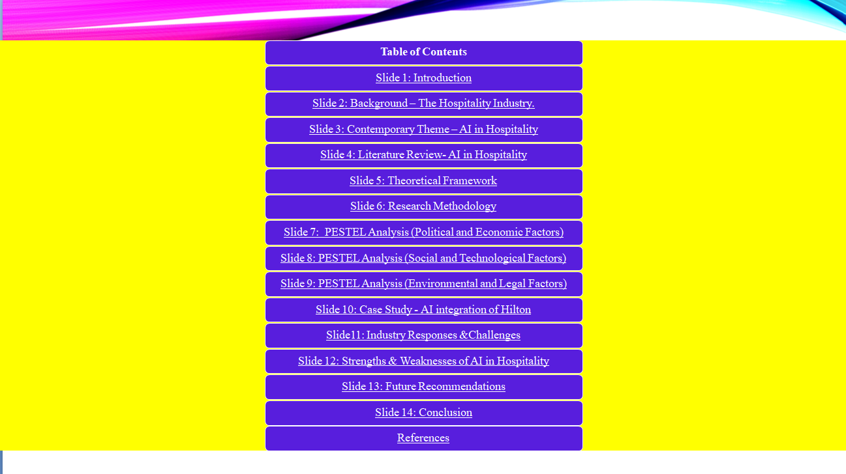

Slide 1: Introduction
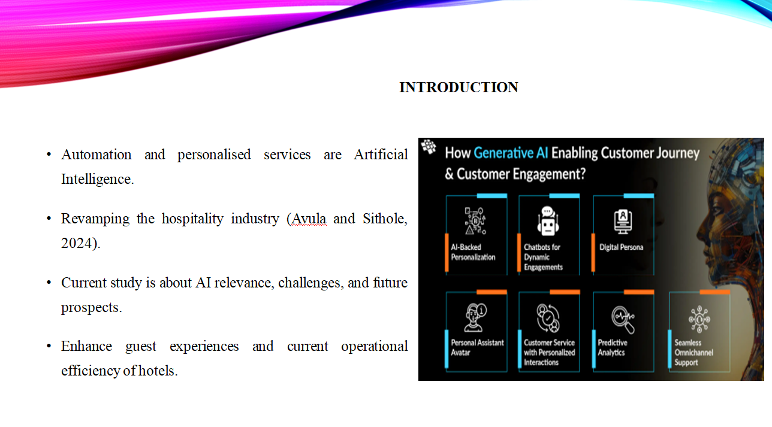Speaker Notes:
Artificial intelligence has proved to become a new horizon in revolutionisation within the fields of hospitality-optimisation. Hotel employments are deploying facilities to carry out tasks with artificial intelligence for speedy operations and even offers personal touch provision of services for improved guest satisfaction (Kannan, 2024).

Slide 2: Background – The Hospitality Industry.
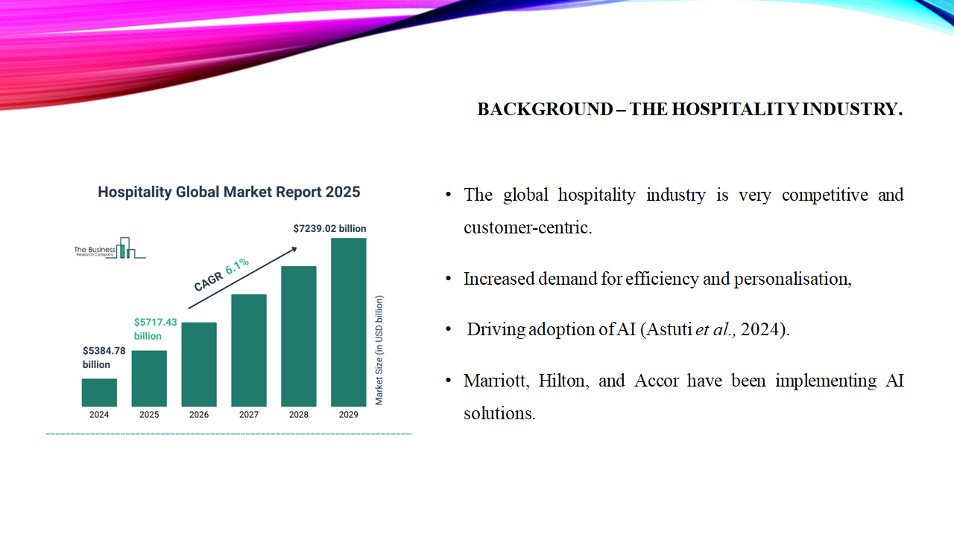Speaker Notes:
The hospitality industry adapts with technology to guest expectations, process optimisation, and competition. Hotels become more efficient, personalise guest experiences and better manage and react to changing consumer demands with the help of artificial intelligence (Milton, 2024). Henceforth, the presentation discusses the growing influence of AI in the industry, challenges confronting it, and future trends, availing insightful projections into the impact and strategic implementation of this technology in the hospitality sector.

Slide 3: Contemporary Theme – AI in Hospitality
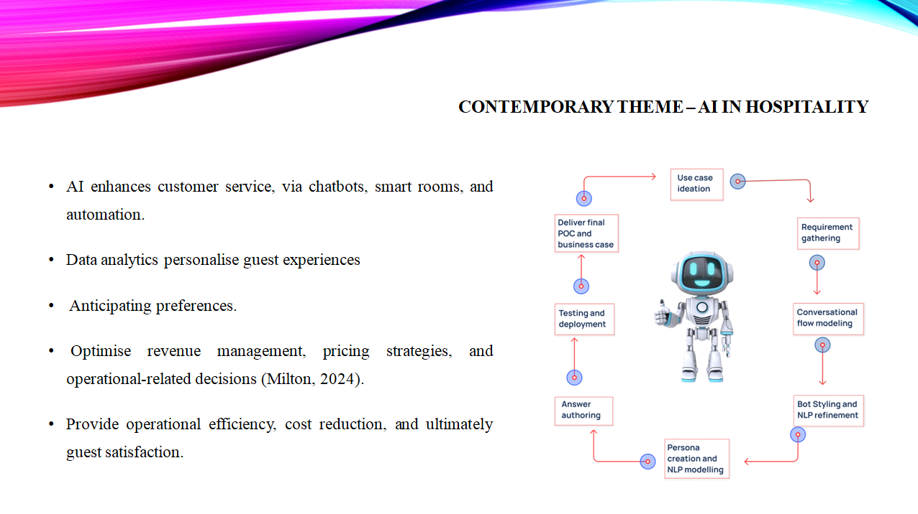Speaker Notes:
AI-driven innovations continue to transform the hospitality sector with improved efficiency and higher response rates (Jogarao,2024). Chatbots help with instant support, managing bookings and inquiries. Smart hotel rooms maximise convenience, allowing guests to control lighting, temperature, and entertainment through voice commands or mobile application. Predictive analytics apply guest data for personalising service, increasing customer loyalty, and foreseeing needs.

Slide 4: Literature Review- AI in Hospitality
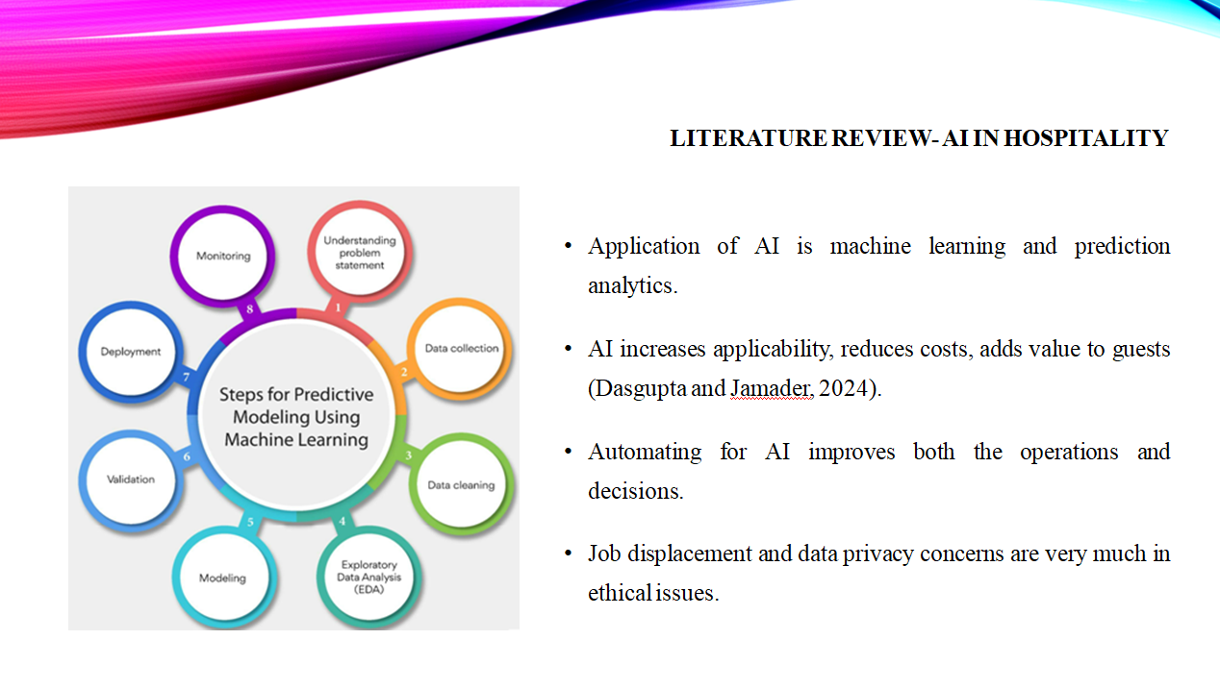Speaker Notes:
Research says that in the academic world, artificial intelligence can transform the hospitality industry by making operations more efficient and cost-reducing practices that end in improved guest satisfaction (Mariani and Borghi, 2024). The hotel can use machine learning and predictive analysis to customise experiences, optimise prices, and streamline operations. AI-powered automation results in improved decision-making, from customer service to inventory management. Data privacy issues arise when guest data is used for personalised experiences.

Slide 5: Theoretical Framework
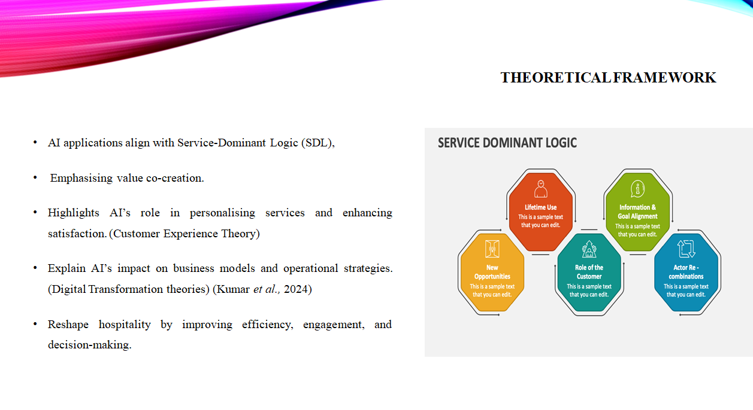Speaker Notes:
AI’s impact on hospitality can be understood through several theoretical frameworks. Service-Dominant Logic (SDL) emphasises value co-creation, where AI enhances guest interactions and operational efficiency (Reis, 2024). Customer Experience Theory supports AI’s role in personalising services. Predictive analytics and AI-driven recommendations improve guest satisfaction by anticipating needs. Digital Transformation theories highlight AI’s role in reshaping business models, optimising decision-making, and streamlining operations.

Slide 6: Research Methodology
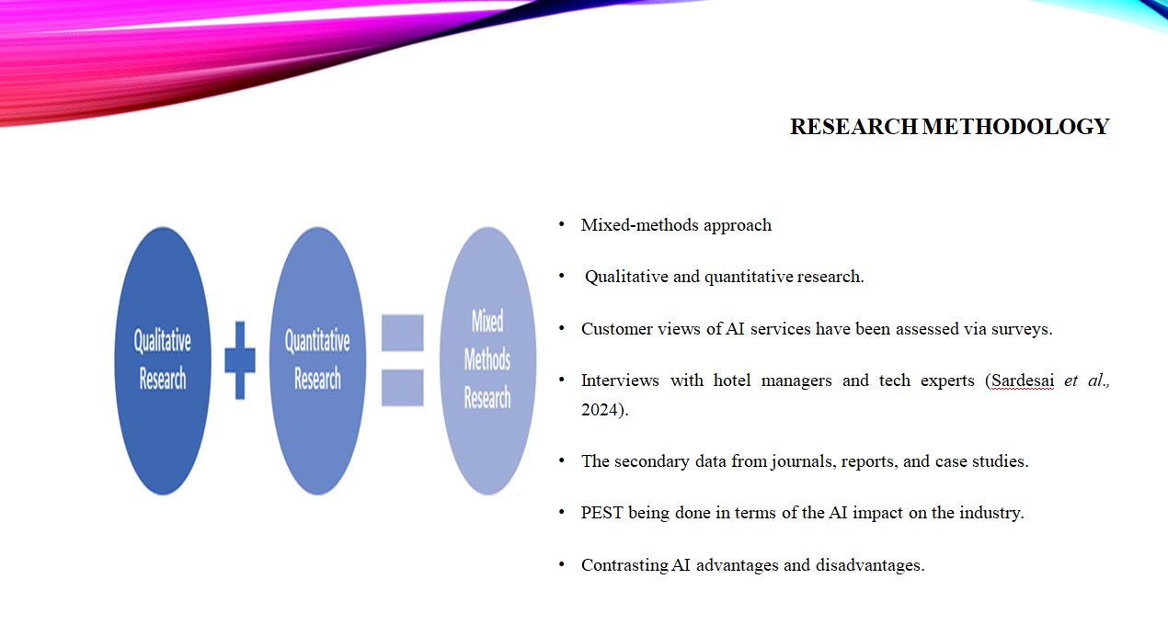Speaker Notes:
This study uses a mixed-methods approach, incorporating both qualitative and quantitative research. Surveys evaluate customer feedback toward AI services such as chatbots and self-service kiosks, while interviews with hotel managers and specialists offer industry perspectives. Secondary data from journals and case studies prompt further analysis (Giannoukou, 2024). A PEST analysis framework assesses AI's political, economic, social, and technological impact on hospitality.

Slide 7: PESTEL Analysis (Political and Economic Factors)
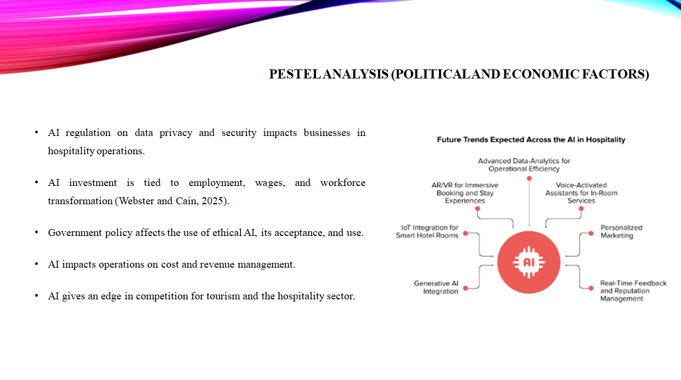Speaker Notes:
There are government regulations on the use of AI, data privacy, and security, to which a hotel has to comply as policies evolve. Automation by AI brings fears of getting displaced from labour, and therefore, it affects employment structure and wages (Joshi, 2024). AI implies a high initial entry cost but has significantly lower marginal costs per year in future use by making operations more efficient. Making the most suitable workforce optimally prepared with skills needed but not overdoing spends is equally important to make a long-term reality of AI in hospitality.

Slide 8: PESTEL Analysis (Social and Technological Factors)
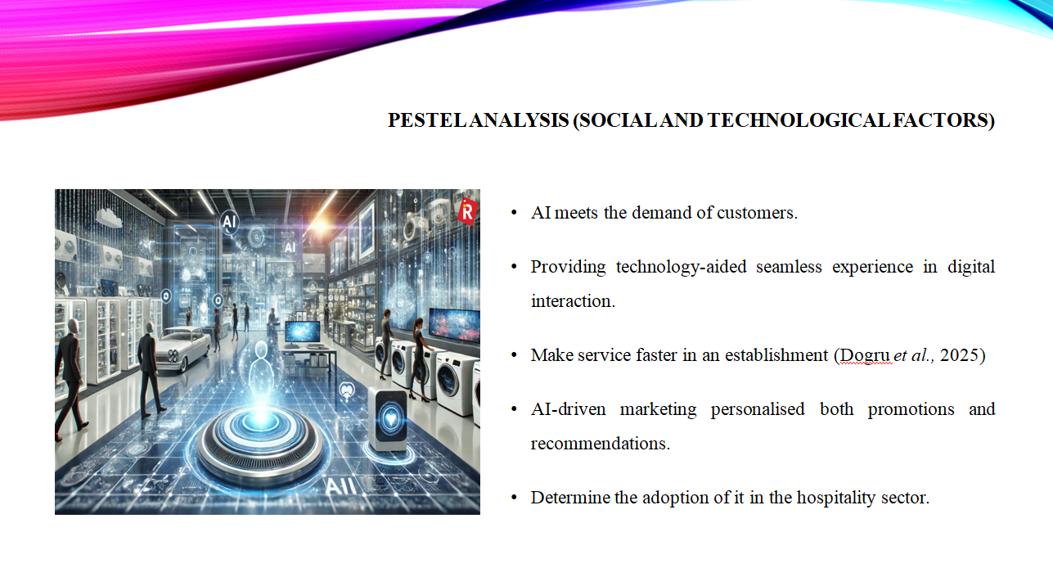Speaker notes:
Modern travellers expect them to have seamless digital experiences, so it has become inevitable to integrate AI in systems and processes in the hospitality sector. Guest query-resolution bots and voice command-enabled devices are some examples of rapid responses. However, there are areas entirely supported by robotics-from automatic check-in to smart room service-that are revolutionising hotel operations (Dogru et al., 2025).

Slide 9: PESTEL Analysis (Environmental and Legal Factors)
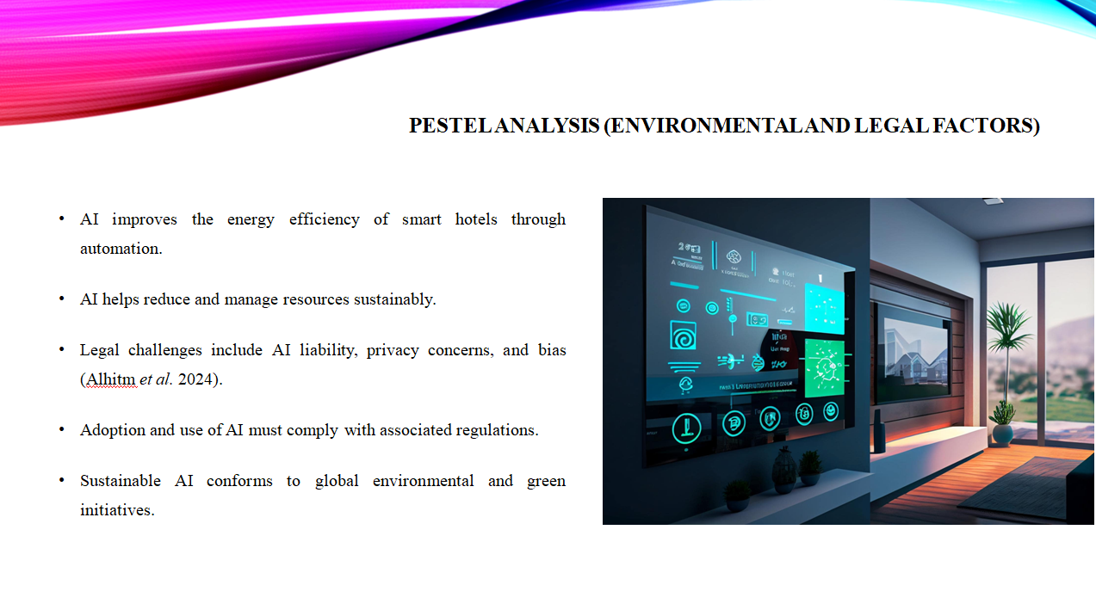Speaker Notes:
AI plays a pivotal role in fostering sustainability in the hospitality sector. For instance, energy consumption in smart hotels is being optimised through the automation of lighting and climate control, among other things, resulting in reduced waste, and so on, which collectively lead toward environmental goals (Alhitm et al. 2024). However, challenges emerge mainly due to such things as AI's liability in decision-making and algorithmic bias. Privacy laws also impinge on the use of AI.

Slide 10: Case Study - AI integration of Hilton
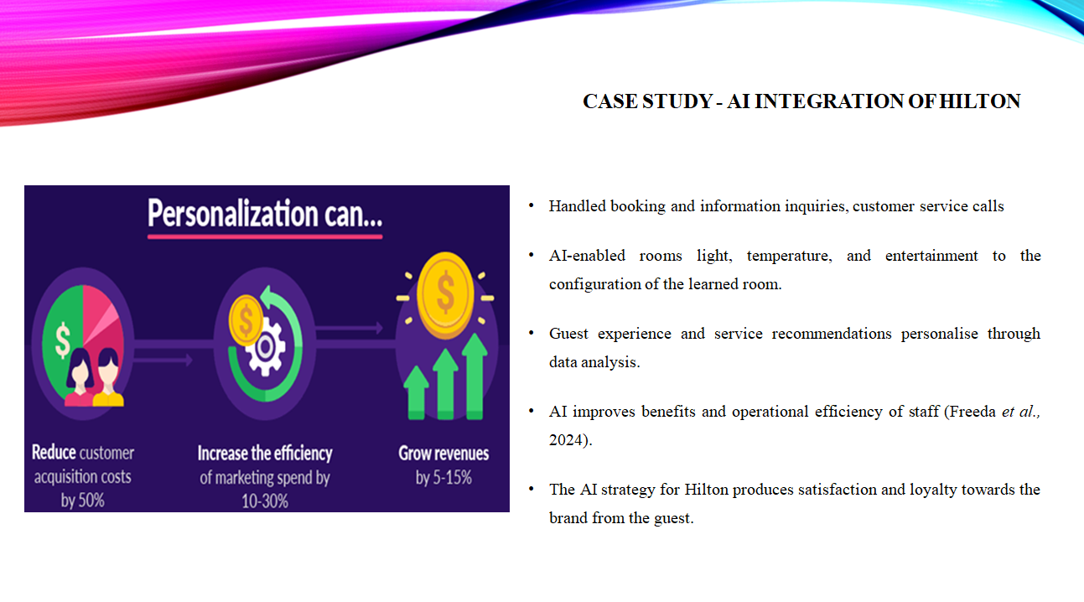Speaker Notes:
Hilton integrates artificial intelligence into all aspects of guest experiences and operational activities. AI-enabled chatbots allow customers to book their hotel rooms, check into those rooms, and even make inquiries in real-time. Smart rooms can control automated lighting, temperature, and entertainment based on learning individual guest preferences, ensuring personalised comfort, unlike anything experienced in a previous hotel stay (Freeda et al., 2024).

Slide11: Industry Responses &Challenges
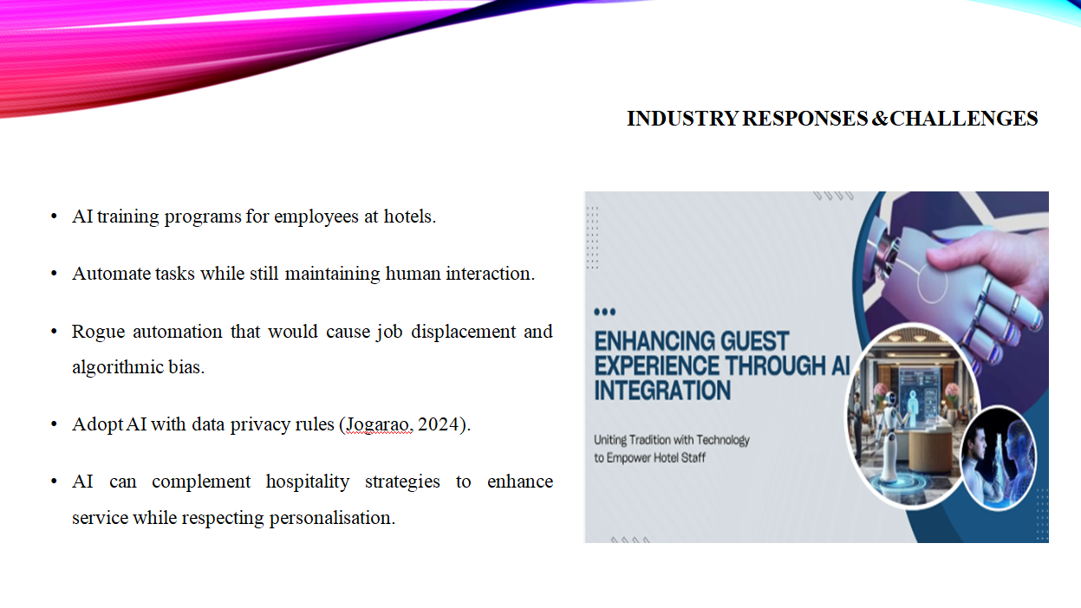Speaker Notes:
The acceptance of AI into the hospitality business has led to several pressing matters that need to be resolved. Hotels are therefore going to train staff members in the field of AI and thereby upskill employees who can work alongside AI-powered systems instead of being displaced by them (Jogarao, 2024). Likewise essential is preserving the human touch when delivering customer service, as guests value their personalised interactions. Ethically, there are concerns such as job displacement through automation and the possible bias involved in making decisions using AI.

Slide 12: Strengths & Weaknesses of AI in Hospitality
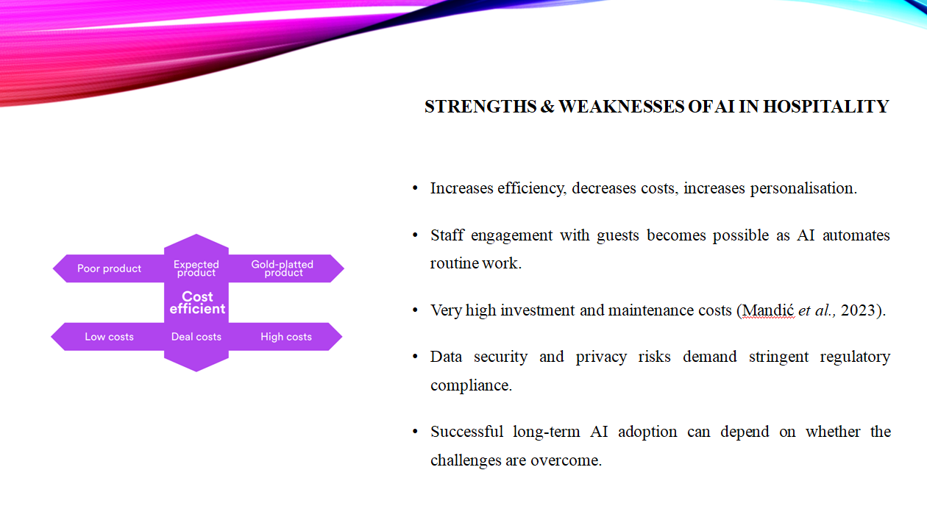Speaker Notes:
AI increases operational efficiency in hospitality, lessening costs and personalising guest experiences, thus improving operations. Hence, AI in hotels helps with streamlining services with a fair amount of customer satisfaction (Mandić et al., 2023). On the contrary, implementing AI solutions face challenges. Higher initial investment and maintenance costs act as inhibitors to smaller businesses. On the other hand, data security and privacy issues compel regulations to enforce compliance.

Slide 13: Future Recommendations
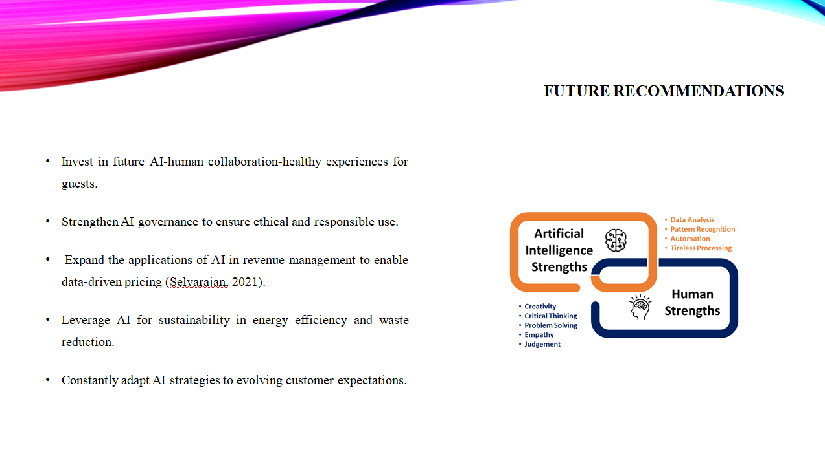Speaker Notes:
Future AI implementations in hospitality would weigh heavy on the adoption of automation vis-a-vis human intervention. An investment in AI-human collaboration can ensure that efficiency does not overpower personal experiences (Selvarajan, 2021). It is also a necessity for strengthening governance of AI to respond to ethics about data privacy, AI biases, and job displacements; expanding AI for revenue management can be optimised pricing.

Slide 14: Conclusion
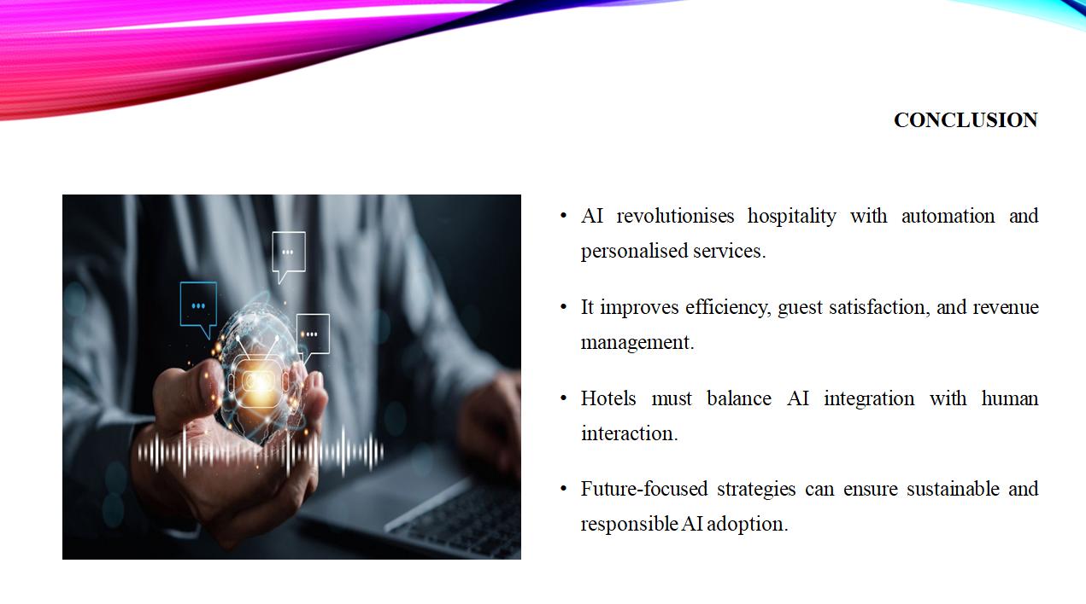Speaker Notes:
AI is changing the hospitality industry, increasing efficiency, guest satisfaction, and operational decision-making. Service delivery enhanced through automation and personalisation makes AI a good ally for hotels. However, there are challenges such as high costs, data security risks, and moral implications. Hotels must continue to balance AI integration with human interaction to maintain quality service.

References
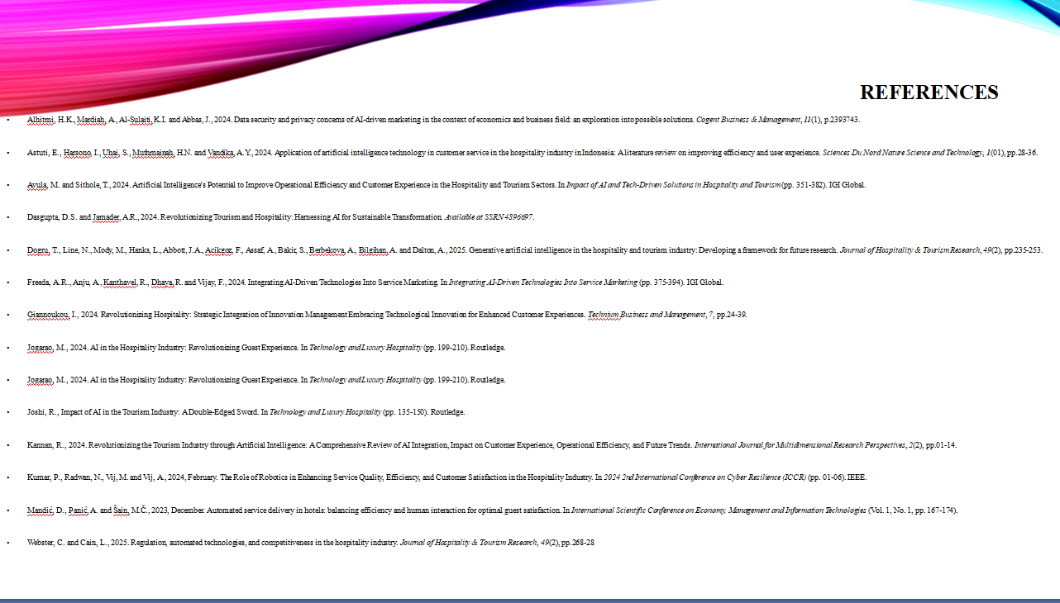
Alhitmi, H.K., Mardiah, A., Al-Sulaiti, K.I. and Abbas, J., 2024. Data security and privacy concerns of AI-driven marketing in the context of economics and business field: an exploration into possible solutions. Cogent Business & Management, 11(1), p.2393743.
Astuti, E., Harsono, I., Uhai, S., Muthmainah, H.N. and Vandika, A.Y., 2024. Application of artificial intelligence technology in customer service in the hospitality industry in Indonesia: A literature review on improving efficiency and user experience. Sciences Du Nord Nature Science and Technology, 1(01), pp.28-36.
Avula, M. and Sithole, T., 2024. Artificial Intelligence's Potential to Improve Operational Efficiency and Customer Experience in the Hospitality and Tourism Sectors. In Impact of AI and Tech-Driven Solutions in Hospitality and Tourism (pp. 351-382). IGI Global.
Dasgupta, D.S. and Jamader, A.R., 2024. Revolutionizing Tourism and Hospitality: Harnessing AI for Sustainable Transformation. Available at SSRN 4896697.
Dogru, T., Line, N., Mody, M., Hanks, L., Abbott, J.A., Acikgoz, F., Assaf, A., Bakir, S., Berbekova, A., Bilgihan, A. and Dalton, A., 2025. Generative artificial intelligence in the hospitality and tourism industry: Developing a framework for future research. Journal of Hospitality & Tourism Research, 49(2), pp.235-253.
Freeda, A.R., Anju, A., Kanthavel, R., Dhaya, R. and Vijay, F., 2024. Integrating AI-Driven Technologies Into Service Marketing. In Integrating AI-Driven Technologies Into Service Marketing (pp. 375-394). IGI Global.
Giannoukou, I., 2024. Revolutionizing Hospitality: Strategic Integration of Innovation Management Embracing Technological Innovation for Enhanced Customer Experiences. Technium Business and Management, 7, pp.24-39.
Jogarao, M., 2024. AI in the Hospitality Industry: Revolutionizing Guest Experience. In Technology and Luxury Hospitality (pp. 199-210). Routledge.
Jogarao, M., 2024. AI in the Hospitality Industry: Revolutionizing Guest Experience. In Technology and Luxury Hospitality (pp. 199-210). Routledge.
Joshi, R., Impact of AI in the Tourism Industry: A Double-Edged Sword. In Technology and Luxury Hospitality (pp. 135-150). Routledge.
Kannan, R., 2024. Revolutionizing the Tourism Industry through Artificial Intelligence: A Comprehensive Review of AI Integration, Impact on Customer Experience, Operational Efficiency, and Future Trends. International Journal for Multidimensional Research Perspectives, 2(2), pp.01-14.
Kumar, P., Radwan, N., Vij, M. and Vij, A., 2024, February. The Role of Robotics in Enhancing Service Quality, Efficiency, and Customer Satisfaction in the Hospitality Industry. In 2024 2nd International Conference on Cyber Resilience (ICCR) (pp. 01-06). IEEE.
Mandić, D., Panić, A. and Šain, M.Č., 2023, December. Automated service delivery in hotels: balancing efficiency and human interaction for optimal guest satisfaction. In International Scientific Conference on Economy, Management and Information Technologies (Vol. 1, No. 1, pp. 167-174).
Mariani, M.M. and Borghi, M., 2024. Artificial intelligence in service industries: customers’ assessment of service production and resilient service operations. International Journal of Production Research, 62(15), pp.5400-5416.
Milton, T., 2024. Artificial Intelligence Transforming Hotel Gastronomy: An In-depth Review of AI-driven Innovations in Menu Design, Food Preparation, and Customer Interaction, with a Focus on Sustainability and Future Trends in the Hospitality Industry. International Journal for Multidimensional Research Perspectives, 2(3), pp.47-61.
Milton, T., 2024. Exploring the Synergy of Artificial Intelligence and Financial Management in the Hotel Industry: A Critical Review of Innovations, Challenges, and Strategic Implications for Enhancing Operational Efficiency and Competitive Advantage. International Journal for Multidimensional Research Perspectives, 2(2), pp.79-95.
Reis, J., 2024. Customer service through AI-Powered human-robot relationships: Where are we now? The case of Henn na cafe, Japan. Technology in Society, 77, p.102570.
Sardesai, S., D'Souza, E. and Govekar, S., 2024. Analysing the impacts of artificial intelligence service quality and human service quality on customer satisfaction and customer loyalty in the hospitality sector. Turizam, 28(1), pp.37-48.
Selvarajan, G., 2021. Leveraging AI-Enhanced Analytics for Industry-Specific Optimization: A Strategic Approach to Transforming Data-Driven Decision-Making. International Journal of Enhanced Research In Science Technology & Engineering, 10, pp.78-84.
Webster, C. and Cain, L., 2025. Regulation, automated technologies, and competitiveness in the hospitality industry. Journal of Hospitality & Tourism Research, 49(2), pp.268-281.


