
Professional career development
Akhteruzzaman Quraishi - 1709589


mARCH 29, 2018
UNIVRSITY OF WALES TRINITY SAINT DAVID

Table of Contents
Terms of Reference 3
Introduction 4
Part 1 5
Part 2 10
Conclusion 12
Appendix 13
Bibliography 16

Terms of Reference
This report has been compiled by the request of Shehla Khan and Melanie Squire. The report was requested on Tuesday 13th March 2018 to display the skills required to work effectively and be work ready and how the writer has developed those skills and to also show the writers understanding of the recruitment process. This report was compiled by Akhteruzzaman Quraishi to be submitted by 3pm on Thursday 29th March 2018.

Introduction
Professional career development is important as it allows people to improve the quality of their lives through potentially higher income and helps shape the type of person that they are. Through constant development the individual can gather new skills to keep their employment but also put themselves forward for progression. Developing professional careers is also important as it increases the chances of future successes and this can be in the form of promotions and other workplaces achievements such as awards (Watts, No Date).
The first section of the report will underline skills and the knowledge required to work effectively in the workplace and how these things can make an individual work ready. The report will also show how the writer has developed some of these skills and how these can benefit them in future work endeavours. It will also identify development needs by using models such as SWOT analysis and GO MAD and will also include a personal development plan (PDP).
The second section of the report will focus on recruitment and selection for a job as an employer. This will identify the various stages of recruitment and support it using existing academic research. The section will include a devised job and person description along with an application form and CV.
The recruitment process spans from an initial job description which is advertised (internally/externally or both). For applications to be received it is important that a job description is put in place and person specification. An application form must capture the main pieces of information and paired with this the CV and covering letter from the applicant helps the employer grasp an understanding of the type of person that is applying. The next stage following this is the selection stage which is followed by interviews and official offers which will be discussed further in this report.

Part 1

The development of an individual begins from self-awareness. In order to know how to develop yourself you must first have a starting point and therefore self-awareness is key to evaluate this first. Inglis (1994 cited by Megginson and Whitaker, 2007). This requires asking yourself questions about the current situation, and also shares that this process is ongoing throughout life (Niles, 2011). Using myself as an example it is important that I know what my strengths are and what my weaknesses are. This will then help me choose the correct way in order to develop myself and cater to my strengths and try and build on my weaknesses in the process. This stage is also important as it not only allows you to understand yourself, but it also helps you understand how other people see you and whether your outward personality is also a strength or a weakness.
There are various tools available to help evaluate yourself however self-evaluation also relies on understanding what actually motivates you. Maslow (1943) shared that there is a certain hierarchy of needs that a person has to achieve and then they can look beyond that to accomplish the next stage. The most basic of those needs are the physical requirements for human survival such as having a roof over your head, getting the right amount of sleep and having access to food and water. Maslow’s theory see’s these requirements as the basic needs for motivation. On a personal level this is no longer what motivates me as I feel that I am comfortably at the stage where I know that all of these needs have been met.
The second need then expands onto safety and security.
“The common preference for a job with tenure and protection, the desire for a savings account” (Maslow, 1943).
This description shows that once the physical requirements have been met then a person’s motivations move onto their wellbeing and progression into getting a job. These things can then be built on to increase health and provide a platform for a family. This need has also been met as I feel that I am stable and have the relevant security in life and also in my current job as well as in my family.
This brings us onto the next step on the ladder which is love needs. This is described as having a sense of belonging and having a friendship circle and family however large or small. The reason that that is third on the list of motivations is that the other two are to be met first in order to provide a stable platform to have a secure friendship and to have a family. This need differs from person to person however I personally believe that this need has also been met as I am lucky enough to have a great friendship circle and a large extended family. I have the connection with all of my friends and family and this level will always motivate me in order to ensure that this need is never broken. Once this sense of love and belonging is reached the next stage of motivation moves onto self-esteem.
This is the level of gaining respect from others and having the confidence and recognition of being successful. Maslow continues in his theory that all people in society have a desire to uphold a high level of esteem, however it depends on the individual in terms of how far they want to take it as some people may be happy and motivated enough with the sense of love and belonging. I personally am the type of person that wants to constantly improve and learn new things and therefore I am confident of my abilities and have achieved a lot in my life. I always see this level as something that motivates me as there are always things to learn and this is especially why I have undertaken this University course. This is my current level of motivation.
The final motivator is self-actualization. This refers to the individual realising what their potential is and then using this as a motivator within itself to become the best they can possibly be.
“What a man can be, he must be”.
Maslow and Inglis’s theories help us understand ourselves and help us reflect, and this is important for working effectively and being work ready. It helps an individual understand themselves before going on to understanding new things to develop further. SWOT analysis is a way in which a person is able to identify their development needs and as previously mentioned is a format in which a person is able to gauge their strengths and weaknesses.
SWOT stands for strengths, weaknesses, opportunities and threats. These four categories are split into internal and external origin (see Appendix A).
One of my main strengths is my strong verbal communication skills. Communication is key as it enables me to understand others better as communication is a two-way process, but it also helps me get across my point of view well in a verbal scenario. Olenski (2016) shared that communication skills are vitally important and helps when trying to be effective and this has been the case when carrying out University presentations recently. My willingness is also a trait I would consider to be a strength as I am always ready to give 100% to whatever I am doing, and this has helped me in the past and continues to help me during my current studies and full-time job. This strength rubs onto others who I might be working with as part of a team and helps massively in a team scenario but also helps me when working individually. This makes me flexible to work with but also means that I am up to the task if I need to carry it out alone. A third strength would be my ability to understand. This can be taken a few different ways, but I will begin with my understanding of people. Having dealt with a multitude of different people over my life, whether that is as a peer or a manager, I have built an understand of how people react to certain scenarios and also what makes people work better as well. My academic abilities also help my understanding as I now think about things in a more constructed way and look at more than one side of an argument. This not only helps me on an academic level but also helps me in the world of work.
Regardless of my strengths there will always be weaknesses and one of them is my shortage of IT skills. Growing up I was not exposed to computers and IT until I came to the UK. This has particularly been a strong weakness of mine. This has hampered my prospects in the workplace and has troubled me during my current university studies. A second weakness I would attribute to myself is my shortage of knowledge in history. This again has to do with my childhood days as I learnt about the history of my country Bangladesh but did not have the opportunity to learn much about general history and the history of the UK. I class this as a weakness as people are able to fall back on their general history knowledge and due to this have a greater awareness of certain problems as they learnt about them in the past. This is something that I do not possess as much of and I have seen this to be a weakness within myself. A third weakness that I would class myself as having would be my presentation skills. Although I have previously stated that I good at communication verbally, I have not had many opportunities to present in front of a large group of people about a certain subject, especially in English. I feel this is a weakness as presentations are common in University and can also be common in the workplace dependant on what type of role you have. This ties in with my IT skills as unlike others I am not able to make professional looking PowerPoint presentations without assistance. This also ties in with the fact that English is my second language. This can also be seen as a weakness as although I now consider my English to be a lot better, it is still not my first language and I do sometimes struggle with grammar. I think the last point about my English ties in with my communication skills, IT skills and presenting skills and therefore I would say that although my English is now what I consider to be good, it is still one of my weaknesses when it comes to academic and presentation work.
In regard to opportunities I am in a fortunate position where I have a lot of things at my disposal. Beginning with addressing some of the weaknesses above, I think that my IT skills can still be improved and having the opportunity of going to university has already helped with this as it is mandatory for me to research online, write reports and attempt to make presentations also. University has been my biggest opportunity as it has allowed me to work on all of my weaknesses in one place and this also addresses my written communication. As mentioned my verbal communication is something I value and see as a strength however my written communication is something to be desired. By attending University, I have already written some reports and it has forced me to research the correct ways to write them and has also helped me to improve my grammar and be more careful when choosing how I want to word things. Other opportunities are also my connections now that I have met new people at university but also my existing circle of friends and family. I am confident that if I need something and I may not possess all of the necessary qualities or have the relevant contacts, then I can rely on these groups of people to help me and advise me. An example of this would be if I wanted to get a job in management and required an interview for this. I would be able to speak to one of my close friends who already works in management and I would be able to get some tips and insight into what the interviewer would be looking for and therefore would benefit from this type of advice. Further related to University, the potential outcome is to have a qualification which can be recognised by an employer and therefore would put me in a better place than my current situation with no relevant qualifications. This opportunity will have me better placed in the eyes of an employer and will equip me will with skills I can transfer into the workplace.
Threats are things that I necessarily don’t have full control over. It is defined as something unpleasant that may happen, especially if an action or order is not carried out (Cambridge Dictionary, 2018). One of which would be the sheer amount of competition as many people are better qualified than me or may have more work experience than me. When applying for a job role this would be seen as a threat, however I would be able to use the various opportunities that I have mentioned above to help minimise threats as much as possible. Another threat would be technology as it is constantly changing. I am relatively up to date when it comes to phones, tablets and computers however as things change drastically in this market it can sometimes be hard to keep up with these things. This can slow down my progress if I am required to make use of these technologies but again the opportunities that I have mentioned above would again help me reduce this. An example would be that if I needed to use some new software but I was not familiar with it, I would be able to transfer my newly attained research skills and learn how to use them, but also make use of my family connections as someone in my family or friends group may already have experience using it and I could rely on them to help me understand it and how to use it.
Appendix B shows the Go Mad Framework which is also another tool like SWOT analysis. It helps visualise a future goal but can also help in understanding previous goals and help evaluate which bubbles were stronger than others to make future goals more reachable. My defined goal for this GoMad is to pass my university degree. The reason why I want to do this is to challenge myself and to achieve a lifetime goal of graduating with a qualification from university. To do this I need to prioritise my time so that I can attend lectures to take important notes and to also ensure that I leave enough time to finish my assignments and group work. By working towards this goal, I believe that it will increase my confidence and learning about these topics makes me self-aware about the work that I am doing but also about my future and how I conduct myself, especially with my learning. This goal also relies on me taking responsibility for my work and research, and when working in a group ensuring that everyone takes responsibility for sharing the work. This links in with involving others and communicating well with them, which includes building friendly relationships. This is especially important during team exercises such as our recent presentation. The final bubble is to take action and measure the results. In reference to my goal, completing reports, assignments and further group work is taking action and in order to measure my results I will use the feedback given to me by the lecturers and also use my results that are given for each of these to measure how I am doing. My final classification will be the final measure to determine how I have done.
To further develop ourselves in class we also completed questionnaires which measured different things about ourselves. One of which was a Myers Briggs personality test. This theory was developed by a mother and daughter partnership of Katharine Briggs and Isabel Briggs Myers. The test itself looks at 16 different personality types and by judging the options chosen helps understands the user’s unique personality (Teamtechnology, 2018). The four main preferences of this theory are:
- “People and things or ideas and information
- Facts and reality or possibilities and potential
- Logic and truth or values and relationships
- A lifestyle that is well-structured or one that goes with the flow”
The test itself involves 20 questions to which you answer A or B and finally you add up your scores which then provides you with some insight into your personality based on the questions. Using Appendix C which are the results of my test it shows that I am an extrovert which means that I prefer to deal directly with situations and people. This is very clear as none of the answers suggested any aspect of being an introvert. The test also shows that both sensing and intuition are personality traits however intuition is slightly ahead with 3 points instead of 2. This shows that I prefer to deal with ideas more as opposed to facts. My preference for feeling shows more than my preference for thinking. This shows that I prefer to make decisions on what I think is more important instead of a more detached approach. Finally, the test also shows that I prefer to deal with things as and when they come instead of having every single detail pre-planned. The score shows 3 points towards perceptive and 2 points towards judging.
The test is beneficial as it helps build a personality profile about me and shows that I am relatively balanced as a whole however clearly shows that I am an extrovert. On top of learning about my personality, it is also important to know how I learn. The VARK questionnaire helps you understand how you learn and this is also something that has helped develop myself in class. VARK was developed by Neil Fleming in 1987 for the purpose of helping people understand one another and to help them learn as effectively as possible (VARK-Learn, 2018). The results are split into four categories:
- V – by visual Study Strategies
- A – by Aural Study Strategies
- R – by Read/Write Study Strategies
- K – by Kinesthetics Study Strategies
As Appendix D shows there is a large difference between my results. Read/Write study strategies is clearly a strong learning style of mine and shows that I learn best by doing that as opposed to learning aurally and via kinesthetic study. This questionnaire therefore helps me understand that if I
want to learn something I am likely suited to reading and writing about it. I feel the study is accurate as I have always learnt best this way and that is why I enjoy the challenge of University as it is heavily Read/Write orientated.
Now I will look at a personal development plan (PDP) for myself to look at achieving one learning objective which will be time management. The PDP will allow me to refer back to it to see if I am on track and make sure I am using all of the available resources that will be stated on it.
Learning objective to be achieved? | What do I have to do? | What support and resources will I need? | How will I show I have improved and when is my target to review?
Better time management | Ensure that I allocate enough time for my studies around my full-time job. Ensure that lectures are not missed and that all assignments are handed in on time and completed with room to read through it again. | I will need to keep in touch with my lecturers, employer and family to ensure that I plan my time according to each person. I need to understand everybody and prioritise each one accordingly. I will need to write down important dates such as key family days, work shifts and also important university dates such as lectures and assignment hand in dates. | My standard of work will improve as I am able to double check what I am submitting. I will also be continuing to keep a high level of work in my job and also giving enough time to my family. I will be able to see that I have improved mainly with feedback from lecturers and my assignment grades. I aim for this to be improved by the time I have received feedback for the first 3 assignments.

The PDP is important for monitoring my development and new objectives can be added where necessary. This can be taken from feedback from an assignment. If I am found to be lacking in one area, then I can set it as an objective to improve on and similarly to above I can set myself a date or time frame that I want to improve by. This is a good way to keep track of my development.

Part 2
This section will focus on the recruitment and selection process for a job. The chosen job that this section will focus on is the role of a Marketing Executive. This role can also be known as marketing coordinators or marketing officers and involves creating campaigns for the organisation they work for to promote things such as new products or upcoming events. The role can also include things such as advertising and public relations work (GradIreland, 2018).
To recruit for a job as an employer it is important that firstly it has been clearly identified that there is a staffing need and in what role particularly. The following stage is to then write up a job description. Edinborough (2005) defines a job description as pointing out the responsibilities of the role, however doesn’t necessarily label what personability/behavioural traits are required from the individual. The job description may also underline who the candidate would need to report to if they were successful and would also underline what qualifications/experience the candidate would be expected to have however this may fall under the person specification also. The job description would also show if the role was full time or part time and if it was a permanent or temporary role. The job description is important for all parties involved as it is the key factor which will attract interest and is the first impression that the candidates get of the employer.
Person specification is also important as unlike the job description it also shows what qualities and skills would be expected of a potential applicant (Wilkinson and V. Zwanenberg, 1994). This specification is important for both parties as the applicant would have the best opportunity to understand if they are correctly suitable for the role and equally the employer would be able to compare this with the curriculum vitae (CV) to ensure that they have someone who meets the criteria to take forward into the recruitment process.
The next step is the application form which can usually be accessed online or with a paper format dependant on the company’s procedure. This application form is important for gathering the main pieces of information that the business may need and ensures that the applicant is legally able to be employed. This is checked by asking if the applicant has the relevant paperwork to work. An example of this is a passport valid for that country or a valid working visa (Gov.uk, 2015). The application form usually gets a lot of the information that would already be on a CV. There is usually a section as part of the application form to upload the CV for the employer to view.
As mentioned a CV is a critical part of the recruitment process and plays a large role from the beginning of the recruitment process right up until a formal job offer. Rolfe (2018) defines a CV as a written format of an individual’s skills and education. It also includes any relevant work experience and employment. Its main purpose is served to send to potential employed. As an employer regarding the Marketing Executive role, the employer would be looking for relevant experience in Marketing and potentially any previous employment also in Marketing. Due to the executive role it may be required that the applicant has the right amount of qualifications for the role such as a degree in Marketing and an employer may also require a minimum of years served the industry.
Paired with a CV there is usually the requirement of a cover letter. This is usually at the front of the CV and differs from it as it is specifically catered for the applied role, in this case the marketing role (Cheary, 2018). As an employer for this role it would be expected that the applicant would highlight how their attributes, qualifications and experience make them the most suitable candidate for the marketing role. It would be expected that they would emphasise marketing related attributes as opposed to others that may not be considered as closely linked with marketing.
The concluding stages then focus on the interview’s once the applications have been sorted and candidates selected. An interview is a chance for the employer to see the candidate face to face but also the other way around. It allows the employer to ask questions and get and understanding of how the candidate reacts in a face to face scenario. Edenborough (2005) discussed two types of interview assessment methods which were the Rodger seven-point plan which is made up of:
- Physical make-up
- Attainments
- General Intelligence
- Special aptitude
- Interests
- Disposition
- Circumstances
The five-fold grading system is made up of:
- Impact on others
- Acquired Qualifications
- Innate abilities
- Motivation
- Adjustment
These 2 methods would be used dependant on the employer’s procedure. From the aspect of the employer it would be important to ask questions to gauge if the interviewee has the passion for marketing and has had successes in the past or has the potential to do so.

Conclusion
In conclusion, as part of this report it has been learnt that personal reflection and awareness is key to understand yourself as base and then it is also important to understand the best ways in which you learn, and this can be found out by carrying out the questionnaires mentioned in this report. This then helps to move forward efficiently in life and in study. The recruitment process is tough and due to lots of competition it is made even more difficult however if the steps can be perfected by the candidate then they will stand a good chance especially if they have good interview techniques. This can help boost an individuals career and give them the best possible chance of bettering themselves and helping them accomplish their goals for motivation.

Appendix
A.
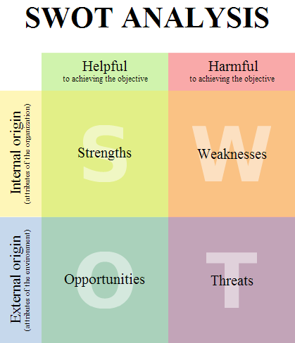
B.
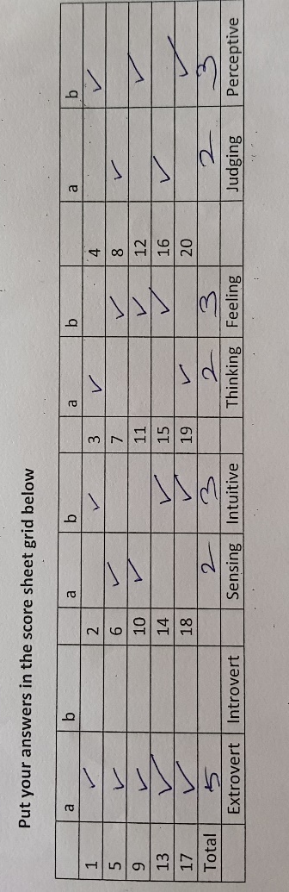
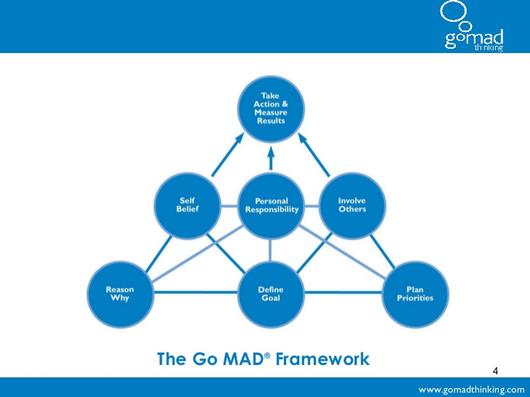

C.

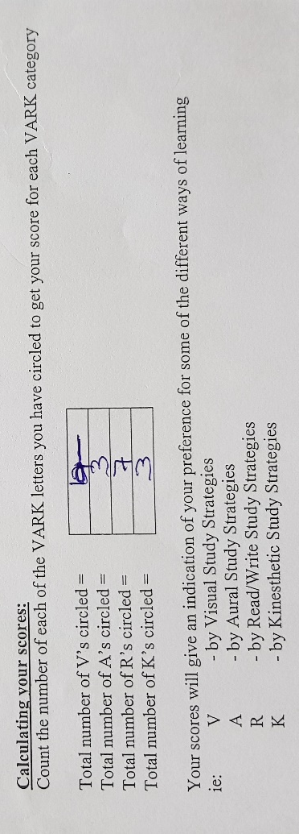
D.

Bibliography

Cambridge Dictionary - Threat. (2018). In: Cambridge Dictionary. [online] Available at: https://dictionary.cambridge.org/dictionary/english/threat, Accessed 25th March 2018
Cheary, M. (2018). What is a cover letter? [online] Available at: https://www.reed.co.uk/career-advice/what-is-a-cover-letter/, Accessed on 28th March 2018
Edenborough, R. (2005). Assessment methods in recruitment, selection & performance. 1st ed. London: Kogan Page
GoMad Framework Image. (2011). [image] Available at: https://www.google.co.uk/search?q=go+mad+framework&rlz=1C1CHBF_enGB753GB753&source=lnms&tbm=isch&sa=X&ved=0ahUKEwizycDZ74zaAhWRDOwKHUbVAC4Q_AUICigB&biw=1745&bih=920#imgrc=baWMZo--YWUOGM:, Accessed 26th March 2018
Gov.uk. (2015) An employers guide to acceptable right to work documents. [online] Available at: https://www.gov.uk/government/uploads/system/uploads/attachment_data/file/441957/employers_guide_to_acceptable_right_to_work_documents_v5.pdf, Accessed 27th March 2018
GradIreland. (2018). [online] Available at: https://gradireland.com/careers-advice/job-descriptions/marketing-executive, Accessed 26th March 2018
Maslow, A (1943). A theory of human motivation. 1st ed. Indianapolis: Bobbs-Merrill, pp.371-396.
Megginson, D and Whitaker, V. (2007). Continuing Professional Development. 2nd ed. London: Chartered Institute of Personnel and Development, pp.29.
Niles, G. (2011). Career Flow: A hope-centred model of career development. [online] Available at: http://librarycatalogue.uwtsd.ac.uk/44WHELF_UWTSD_VU1:CSCOP_EVERYTHING:TN_proquest912809121, Accessed 24th March 2018
Olenksi, S. (2016). Five communication skills that make good leaders great, [online] Available at: https://www.forbes.com/sites/steveolenski/2016/03/29/five-communication-skills-that-make-good-leaders-great/#70622b57ae9b, Accessed 25th March 2018
Rolfe, A. (2018). What is a CV? [online] Available at: https://www.reed.co.uk/career-advice/what-is-a-cv/, Accessed on 28th March 2018
Scott, W. and Gough, S. (2004). Key Issues in sustainable development and learning. 1st ed. London: RoutledgeFalmer
SWOT Analysis Image. (2018). [image] Available at: https://www.google.co.uk/search?q=swot+analysis+wiki&rlz=1C1CHBF_enGB753GB753&source=lnms&tbm=isch&sa=X&ved=0ahUKEwjO2uLDsozaAhUJZ1AKHcirD_sQ_AUICigB&biw=1745&bih=920#imgrc=PkO54IvtlAGZTM:, Accessed 25th March 2018
TeamTechnology. (2018). Myers Briggs Personality Types. [online] Available at: http://www.teamtechnology.co.uk/tt/t-articl/mb-simpl.htm, Accessed 26th March 2018
VARK-learn. (2018). Introduction to VARK – Do you know how you learn?. [online] Available at: http://vark-learn.com/introduction-to-vark/, Accessed 26th March 2018
Watts, T. (No Date). Why Career Development Matters, [online] Available at: http://www.careersengland.org.uk/documents/public/why-career-development-matters.pdf, Accessed 24th March 2018
Wilkinson, L. and V. Zwanenberg, N. (1994). Development of a person specification system for managerial. [online] Available at: http://librarycatalogue.uwtsd.ac.uk/44WHELF_UWTSD_VU1:CSCOP_EVERYTHING:TN_proquest214832177, Accessed 27th March 2018

