#

Certificate of Higher Education in Skills for the Workplace

Task 2
Professional career development report

Student name: Lilia Lisseth Mera Vera
Student ID: 2113990

Module name: Professional Career Development
Module code: (BMSW4005_LON)
Lecturer name: Bianca Sanfilippo
Word count: 2381 words
Submission date: 5 September

Table of Content

- Introduction 3.
- Recruitment and selection 3.
- Skills and Knowledge which contributes to work effectively 5.
- Knowledge to work effectively as Software Engineer 5.
- My personal strengths and areas for further development 6.
- Swot Analysis 6.
- My employment goals and personal career Action plan / Development plan 6.
- Conclusion 9.
- Reference 10.
- Appendix A 11.
- Appendix B 12.

Introduction
Choosing a future career is one of the most important decisions we can make in our life. In this report I will cover the idea of my dream career, the skills and knowledge I need to inquire to accomplish this goal. Also, I will use the ‘’Gibbs Reflective Cycle ‘’ as referencing style.
Gibbs' Reflective Cycle was developed by Graham Gibbs in 1988 to give structure to learning from experiences. It offers a framework for examining experiences, and given its cyclic nature lends itself particularly well to repeated experiences, allowing you to learn and plan from things that either went well or didn’t go well. (University of Edinburgh, 2020)

Recruitment and Selection:
Personal reflection on the role play applying Gibbs’ Reflective Cycle

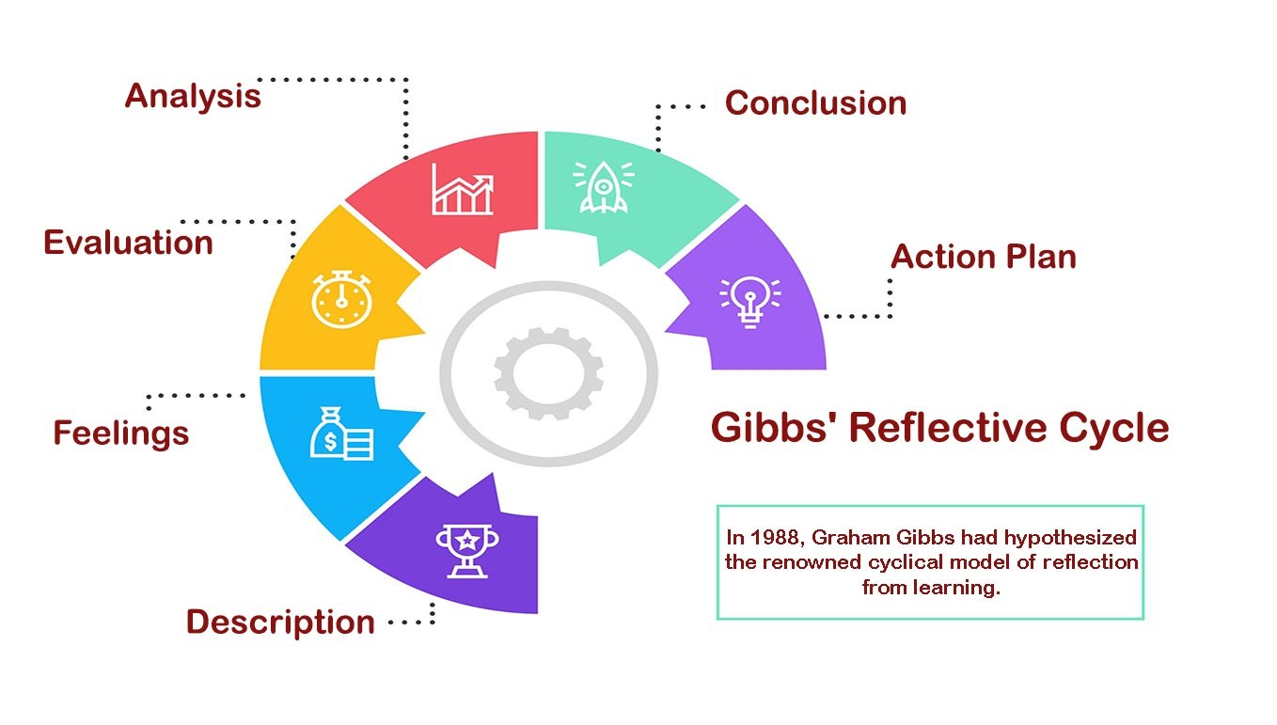

Description:
In the previous week of finish our classes, at this last term we had to present a roleplay where we did interview for a job of our interest. One of my colleagues did the part of the interview and I presented my application form and answer his questions about the job I was applying for.
Feelings:
I was intrigued for this interview because I had a few interviews before for other jobs but never for one that I really want it. I was inquisitive and nervous before the session began, and after that I was more nervous thinking about the outcome of the roleplay, and I was worried if I did it good for obtain a good mark for this term.
Evaluation and Analysis:
As a positive point was important to us do this kind of practice, I believe I have a strong understanding of this topic but putting into practise at that moment makes me realise I have more work to do and is no that easy as I thought.
At other hand I was happy that this team of terms of do a presentation with public I did much better comparing of the first term of this year. I couldn’t speak properly at that time. But now I feel more confident and prepared to this roleplay.
Conclusion:
Finally, I realise that have knowledge of how to do an interview is vital for us as aspirants to have a career because is the first step we should affront in the future for find our desired job. I believe I should study and do my best effort to improve other points of the way I act for an interview.
Action plan:
Because is my first time doing this kind of roleplay, I will be more prepared for the next time. If I continue to practise my speaking and body language and of course making my CV look more attractive I think I will be able to achieve the goal, I have in mind.
Skills and knowledge which contribute toward working effectively
First, we should know the importance of the legislation such as Equality Act 2010, that means ´´ It covers everyone in Britain and protects people from discrimination, harassment and victimisation. ´´`
Equality And Human Rights commission (2020)
This legislation constitutes that you can’t be discriminated regarding your:
-Age
-Disability
-Gender Reassignment
-Marriage and civil Partnership
-Pregnancy and Maternity
-Race
-Religion or believe
-Sex
-Sexual orientation
Under the Equality Act you are protected when you are at workplace, or when you use healthcare or education… etc.

Skills required to work effectively as Software engineer
Using a career Guide ‘’ (Indeed. 2020)’’
This are the skills required to work as Software engineer:
-Communication:
-Many software developments require multiple work together
-Teamwork:
-Involves discussion problems that arise with co-workers
-Coding and Technical Literacy
- Basis of software engineering
- Problem Solving:
-Finding the source of the problem and able to find a solution
-Multi Tasking:
-Able to work in multiple projects under a tight deadline
-Attention to detail:
- Must be thorough when creating and proofreading project materials like code and documents.
The knowledge required to work effectively as Software Engineer:

- Coding and Computer programming
- Software testing
- Object-oriented design (ODD)
- Software development
  - Java
  - Python
  - C and C++
  - Scala
  - Java Script

Brainstation (n.d)

My personal strengths and areas for further development

I’m a goal setting person, who have cleared her goals.
I’m good at listening and I’m able to be organised with my projects.
But I know I as well need a further development for my weakness as being adaptable and being more productive.

SWOT Analysis

SWOT ANALYSIS

STRENGHTS  Passionate about my career  Goal setting person  Good Listening | WEAKNESSES  Not being very adaptable  Productive but the essential  Not having experience with problem solving
OPPORTUNITIES  Studying for reach my career  Lecturers Support  More works for Software Engineers | THREATS  Better engineers more prepared for this role  More engineers in my area

My employment goals and personal career action plan/development plan

My professional career pathway is:
Software Engineer

What are my current strengths?
I’m really interested in computer world and I’m starting to learn more about it.
I’m exited to start this career pathway and finish with a degree.

What are my achievements and areas of success since the beginning of the module/programme?
Computer literacy
Writing

In what areas do I need to develop?
Listening
Communication
Accepting feedback

Why is it important to improve in these areas?
Because I will need it for my future career and for my desire job

Who will help me? What resources will I need?
Through the Lectures and studies, I will achieve these areas that I need to develop and make it better to suit my needs.

What are the constraints/ barriers to achieving these key areas and how I will manage these– e.g. time, resources.
My English is not good enough and is not covering all the subject that I would like to talk about.
But I think in one year more I will improve more and using my studies I gonna be able to achieve my goals

What further action do I need to take now?
Actions to be taken – things to do, people to see.
Talk with the University support for more help with my classes

Time scale – by when
Around 1 year more or less

My short - medium – long term targets for the development of my own professional career plan (using SMART targets)

Short-term plan (3 - 6 months)
Specific | Continue with my studies, level 5 at UWTSD.
Measurable | Attendance above 70% and submit first assignment and achieve a pass
Agreed | Lecturers, line manager, family and work/
Realistic | Yes, as I am completing level 4
Time-Bound | 02/10/2023
Medium-term plan (1-2 years)
Specific | Graduation
Measurable | Submit and achieve a pass in all assignments including dissertation.
Agreed | Lecturers, line manager, family and work
Realistic | Yes
Time-Bound | 01/10/2024
Long-term plan (2-5 years)
Specific | Postgraduate qualification/ start employment
Measurable | submit first assignment and achieve a pass  Contract and pass probation period
Agreed | Family and work
Realistic | Yes
Time-Bound | 10/10/2025

Conclusion
This report has been a helpful because I had the time to analyse my role play, and the career I would like to do in the future, also my strengths and weaknesses. This research in my opinion is beneficial for all the students who are not sure about the career they want to choose, and this assignment help you to see what can suits you and help you about being realistic about your goals. I would like to do more course with my Lecturer in the future since she has been nice with us, and I appreciate it.

References
- The University of Edinburgh (2020). ‘’Gibbs’ Reflective Cycle’’(online)
Available at: https://www.ed.ac.uk/reflection/reflectors-toolkit/reflecting-on-experience/gibbs-reflective-cycle

- www.assignmentclassmates.com. (n.d.). Gibbs Reflective Cycle References with Example. [online]
Available at: https://www.assignmentclassmates.com/blog/gibbs-reflective-cycle.
‌
- Equality And Human Rights commission (2020). Your Rights under the Equality Act 2010. [online] Equality and Human Rights Commission. Available at: https://www.equalityhumanrights.com/en/advice-and-guidance/your-rights-under-equality-act-2010.
‌- BrainStation. (n.d.). What Skills Do You Need to Be a Software Engineer? | BrainStation®. [online]
Available at: https://brainstation.io/career-guides/what-skills-do-you-need-to-be-a-software-engineer.
‌

Appendix A: The questions asked as interviewer in the role play (A1)

- Tell me about you.
- What do you know about the Organisation?
- What can you bring to the company?
- What are your Weaknesses?
- What are your strengths?

Role play:
Partner for the role play – Raul Torres

Advertisement about my chosen career \ a Admin Assistant for a Video Game company

The Role:
- Providing an excellent beginning-to-end service, ensuring all visitors and or queries are attended to in an appropriate manner
- Supporting meeting room bookings using the booking system
- Meeting and greeting all incoming guests into offices, including preparing meeting rooms and providing tea/coffee service for guests
- Ensuring audio and video conference facilities are in place and working when required
- Answering and directing calls as well as message taking
- Managing email and collecting mail deliveries
- Managing the “Info inbox”– directing queries through to the relevant team and following up accordingly within SLA timeframes
- Organising and maintaining the reception area, meeting rooms, and communal areas
- Working with ground floor reception and internal staff to ensure smooth meet and greet for visitors
- Ensuring Health & Safety policies are complied with in relation to visitors

Application form to my partner and
5 Questions:

Introduction – My name is Raul and I going to do the interview today …

Tell me about. Yourself
Hello, I’m lily and about myself, actually I’m working for a big company as administrative assistant improving the efficiency of my department.
I started as assistant and in a short time I improve my skills and started to take my responsibility in the company. I’m looking for the next step in my career and I believe that your company can offer me that possibility.

What do you know about the organisation?

/this company works in an industry that it’s interesting for me such a video game company, the goals also are important because reflect how the company thinks and the pathway the want to follow.

What can you bring to the company?

I’m a hard worker and I’m not afraid of try new challenges also I have a real passion for this industry. Since I was little, I feel curios about how this industry works and I had a dream of work for it. As well I can bring new prospective and fresh thinks to the company.

What are your weaknesses?
I think I focus too much on the details because I like to have everything on the right place.
I feel stressed when projects run beyond the deadline but at the end I accomplish the deadline on time.
Sometimes I have trouble asking for help.

What are your strengths?

I’m a enthusiastic person, trustworthy, creative and patience, I’m respectful and I have determination with my work. As well I like to take the initiative and I’m not afraid of be versatile when I should.

Raul – Thank you Lily , we going to be in touch with you shortly.

Appendix B: Application Form completed as applicant for the role play (A1).

Job application form

Application for [job title] - Administrative Assistant

Your details

Name: Lilia Mera

Education and training
Please give details:

-University of Wales Trinity Saint David, London Campus

- Instituto Jaime 1 Valencia, Spain

-Institute of Language Valencia, Spain

-Hospital Calceta, Republic of Ecuador

Qualifications
Please give details:

-Certificate of Higher Education Skills for the Workplace
-General Certificate of Secondary Education
-Level A French
-Vocational Education and Training (VET) Nursery

Employment history

Your current or most recent employer

Name of employer: Book S.A

Job title: Administrative Assistant

Length of time with employer: 2 years

Reason for leaving: Change Career

Duties:

Using Ms Office including word and Excel on regular basis
Strong customer services
Problem solving
Ensure a quality customer service
Deliver excellent products for costumers
Punctual with the timeline of products

Previous employers
Please tell us about other jobs you have done and about the skills you used or learned in those jobs.

Receptionist at Spanish Restaurant
Practice of costumer services
Learning planning skills and organisation / Management of a business

Supporting statement
Please tell us why you applied for this job and why you think you are the best person for the job.

I’m writing to apply for the position Admin Assistant at London as advertised
in Student Job UK on 8 August 2022.
I’m currently completing a Certificate of Higher Education at the University of
Wales Trinity Saint David London Campus.
I’m interested in a career in Administration because since I was child, I really
like to have order and take care of my duties and the work I had to do.
I didn’t have the experience before but I’m wiling to learn and I’m very
passionate about this career.
I develop important IT skills as using Microsoft Word, Excel or Power point also
the ability to communicate effectively in writing and to work in partnership
with other organisations. I’m very experience using email and I’m confident
with any duties as costumer services. I have a few years working face to face
and learning from mistakes, this made my ability to communicate verbally with
costumers and colleagues.

Right to work in the UK
Do you need a work permit to work in the UK? Yes

References
Please give the names and contact details of 2 people who we can ask to give you a reference. We may ask them before an employment offer is made. We will not ask your current employer until we get your permission.

Declaration
I confirm that to the best of my knowledge the information I have provided on this form is correct and I accept that providing deliberately false information could result in my dismissal.

Name: Lilia Mera

Signature: Lilia M.

Date: 08/08/2022

