ACCA4024 Component 1 Coursework
Author: Cristian Stefan Stancu
L4 - Network and Cybersecurity Essentials (ACCA4024)
School of Applied Computing
Wales Institute of Science and Art
Date and Time of submission: 8th January 2021

Table of Contents
Abstract 3
1. Introduction 4
2. Related work 4
2.1. Networks and types 4
2.2. Threats and attacks 5
2.3. Mitigation 5
2.3.1. Phishing 5
2.3.2. Sniffing 5
2.3.3. Webserver 7
3. Design and Implementation 7
3.1. Weak points/Vulnerabilities 7
3.1.1. General policy 7
3.1.2. Internal network security 7
3.2. Tools used for testing the security 8
3.3. Implementation and PENETRATION TEST 8
3.3.1. Nmap port scanning 8
3.3.2. Sniffing unencrypted packages 9
3.3.3. Webserver weakness 11
3.4. The outcome of the running tests 13
4. Mitigation strategy and recommendation 13
4.1. Security policies training 13
4.2. Data encryption 14
4.3. Weak point identified 14
Bibliography 14

Abstract
“A computer network is a group of computers that use a set of common communication protocols over digital interconnections for the purpose of sharing resources located on or provided by the network nodes. The interconnections between nodes are formed from a broad spectrum of telecommunication network technologies, based on physically wired, optical, and wireless radio-frequency methods that may be arranged in a variety of network topologies.” [1]

Introduction
Computer networking as we know it today has started in the late 1960s and early 1970s. The Advanced Research Projects Agency Network (ARPANET) started development of the first packet-switching network at that time and was one of the first networks to implement the TCP/IP protocol suite, the technology that is the foundation of the Internet.
Historically speaking, the voice and data communication is based on electric circuit switching since the traditional telephone network was invented. Even though the binary numeric system has been invented in the 16th Century, it was the perfect solution make two machines to communicate to each other by electric circuit open or close. Each group of eight binary numbers is known as byte.
The communication between two machines goes through more layers from the Physical Layer which it might be a cable or a wireless transmission up to what we exactly see on our web browser (no matter is on a laptop, mobile phone or even watch) or email client or any other end-user Application. The 7 layers are being categorised by what is known as the Open-Source Interconnection Model (OSI model).
By the expansion of the networks worldwide, the security threatens came up. In todays, the CyberSecurity is must as many of the sensitive data is being sent through the network: from financial information, credit cards, important correspondence.

Related work

Networks and types
The Che-Si network is based on the headquarters’ network which is the foundation of their company. It’s comprised of all the servers necessary to handle the entire company workflow.
- Web server
- FTP/Storage server
- DNS server
- Mail server

A sample topology how the headquarter is looking like can be found below:

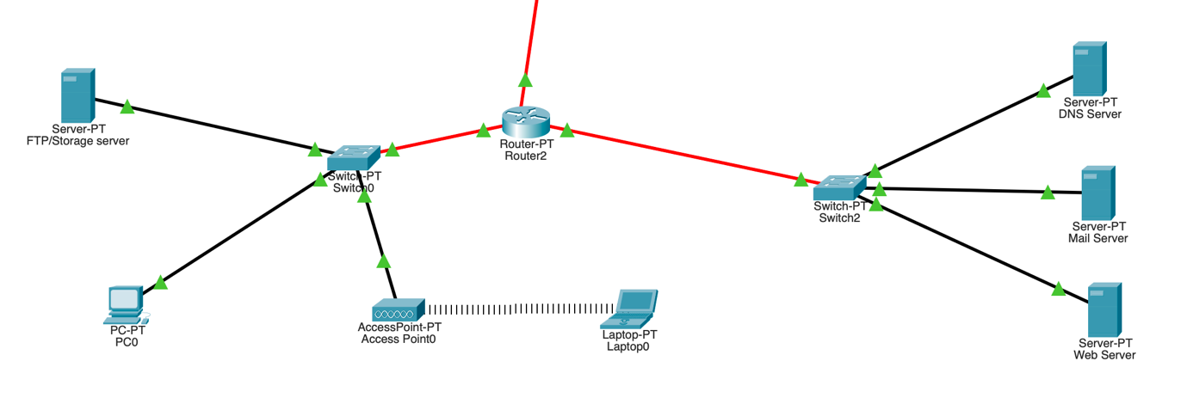

Figure 1 Local Network
Of course the number of working stations is bigger, but the whole structure is similar to this one.

Threats and attacks

In todays, most of the persons are using Wireless connections to connect on a network via their mobile devices like Smartphones, Tablets. The wireless networks are the most vulnerable part of that chain. The security policy of the company must include that all the wireless networks on sites must be password protected as an open network is an open door for a person with bad intentions.
Secondly, the using of the headquarter resources such as ftp/storage server, has to be limited to local area network use. In that way, the clients and sites have to be forced to use the VPN secure connection to get into the local network. Instead of making it public, the storage server which contains valuable information such as projects, inventory etc. it will be available to a limited number of persons.
Using FTP is not recommended these days as FTP is using unencrypted connection, hence is exposed.
The emails are also a vulnerable part of such a system. Emails that are unencrypted can be a valuable resource for a bad intention person. The people are exchanging a lot of sensible information over email inside a company.

Mitigation
There’re several tools and ways to mitigate an attack over company or company’s personnel.

Phishing
The easiest way to a hacker is to fake emails in order to grab valuable data from someone. These are being called Phishing emails that are being sent to victims in order to get a specify type of data. Most of the time, they’re faking a true email content with a different redirect link to their own fake webserver.

Sniffing
Sniffing is a technique of listening for unencrypted data that pass through a network.
Many hackers are using tools as WireShark for capturing packets on a network and use them as in the Figure 2. Unencrypted traffic is exposed such as mail, ftp. Many of the hackers are scanning for open ports through a network using tools like NMAP. How it helps that to a hacker? Well, it helps to identify the weakness. For instance, port 21 is the port for FTP, an unencrypted communication between the client and the server. The same happens for other ports like 80 (HTTP), 25(SMTP), 110(POP3).
Such a captured packet can be seen on Figure 3.
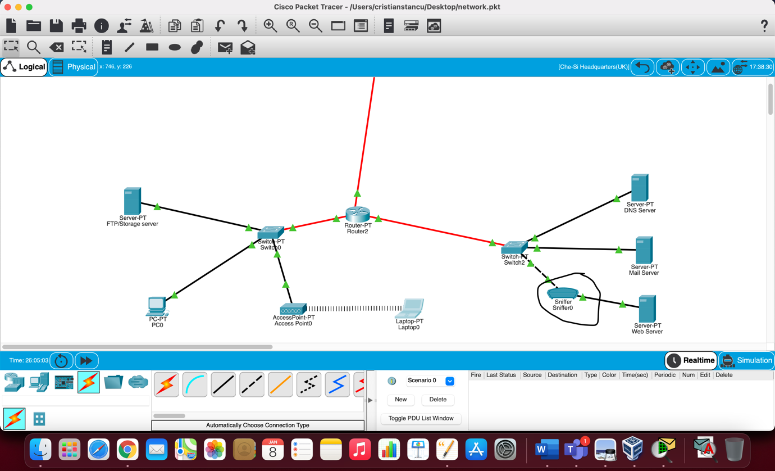
Figure 2 Sniffer tool on Local network
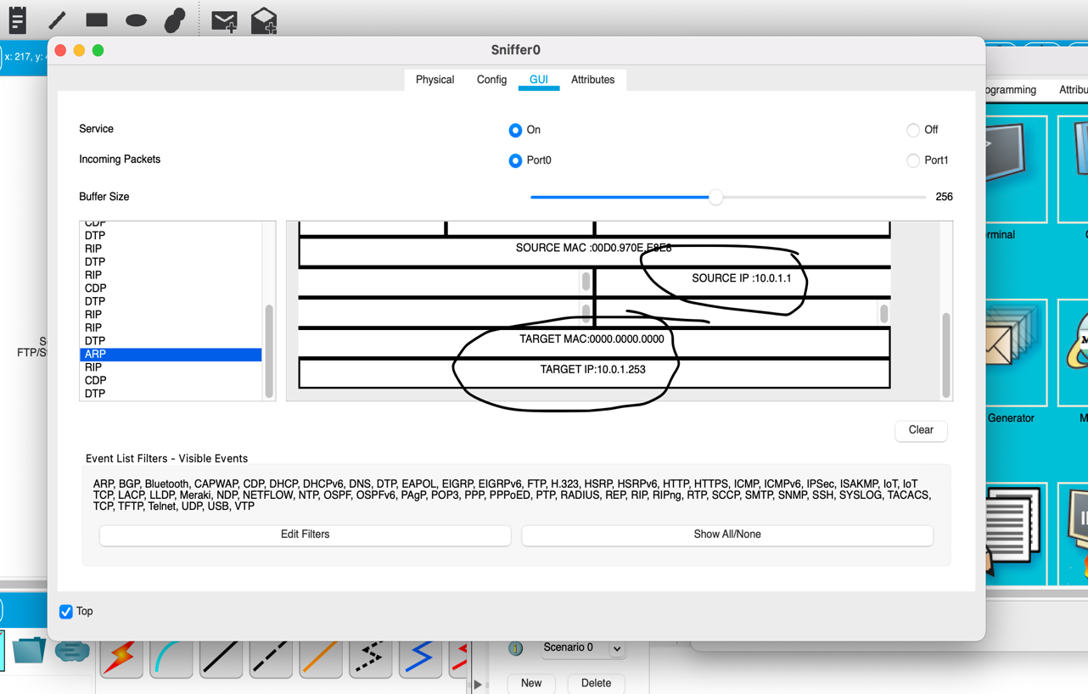
Figure 3 Sniffer result

Webserver
The Web Server itself is one of the most exposed to many kind of attacks from SQL Injection, unprotected REST API’s, bruteforcing. For REST API’s functionality and security, I’m using a tool called POSTMAN. No one wants their data grabbed and served in a webpage or an alteration of data inside the Database to be altered by anyone except the webserver’s calls.

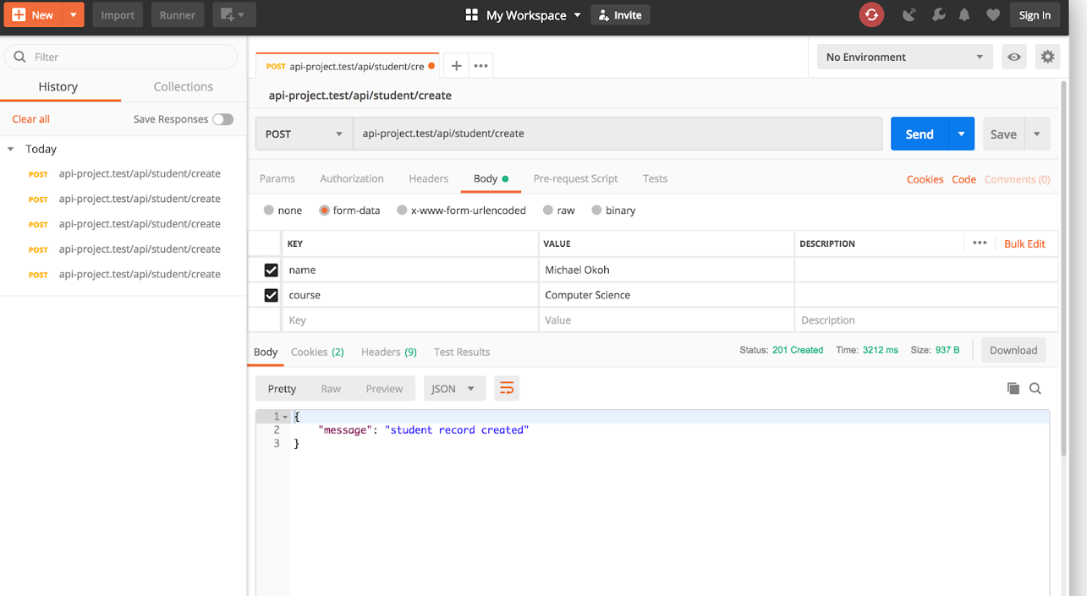
Figure 4 Postman API call

Design and Implementation

Weak points/Vulnerabilities

General policy
General policy refer to all the users that in any way connects to the Che-Si network.
- Passwords used for their accounts needs to be composed by a strong combination of Uppercase and Lowercase Alphanumeric Characters;
- Avoid as much as possible the use of Open Wireless Networks - that’s one of the most vulnerable way when someone can “sniff” important data if it’s unencrypted;
- Regularly change the account(s) passwords;

Internal network security
Internal network security is the most important. No matter we are speaking about the spaces accessible only from the local network with or without the VPN tunnelling or the public spaces such as the Mail Server or the Web Server or even the DNS server all of these must be secured meaning that the access with unencrypted applications must be avoided as much as possible. For instance, instead of using the classic 25 port for SMTP, can be used the 587 port on which the communication between email client and the server is encrypted with TLS encryption. The functionality won’t be affected at all as all the email clients are able to use it, but the security will be increased. The same thing must be done for the FTP server. Instead can be used either the FTP over TLS/SSL which is exactly the same FTP protocol the only difference is that is using the TLS/SSL channel or the SFTP which is SSH File Transport Protocol and is using a different port, 22.

Tools used for testing the security

The environment used is based on Linux. I’m using MacOS system which is based on Linux platform and Ubuntu Virtual Image. The reason is that both systems offers me more flexibility and more built-in network tools such as “Nmap” to discover the open ports on a network class. Also, for demonstration of how a sniffer it’s working, I’m using Packet Tracer along with its built-in basic sniffer. The webserver API’s are being run through a tool called Postman. This is a tool for API’s coders to test functionality and accessibility in different scenarios.

Implementation and PENETRATION TEST

Nmap port scanning
Nmap is a very useful tool which can scan a whole network class for the available hosts and also for the open ports on the alive IP’s. Below is a sample of results that came out once I’ve scanned my home network for the alive IP’s with the port 80 (HTTP) open
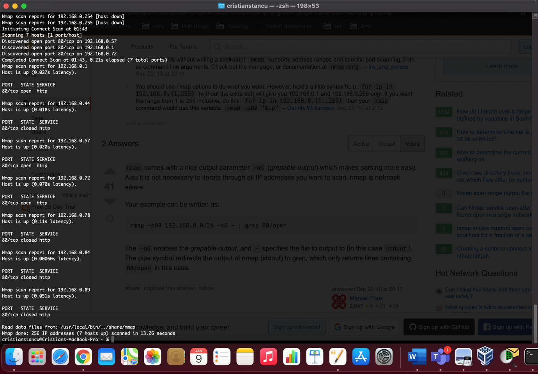
Figure 5 Nmap network scan

Sniffing unencrypted packages
For the demonstration purposes of the weakness on classic unencrypted connection with a webserver I’m going to use the Packet Tracer on our example. The configuration is illustrated in the image below on Figure 4

Figure 6 Sniffer tool
The scenario is very simple: the hacker is gaining access to the local network (in our case to a switch). He’s running a sniffing tool to capture and interpret or read in clear the packets. The Packet Tracer sniffer is a very basic one, but it works in the same way as any other much advanced sniffer such as Wireshark. When we start capturing TCP, HTTP and FTP packets, the outcome is the following:

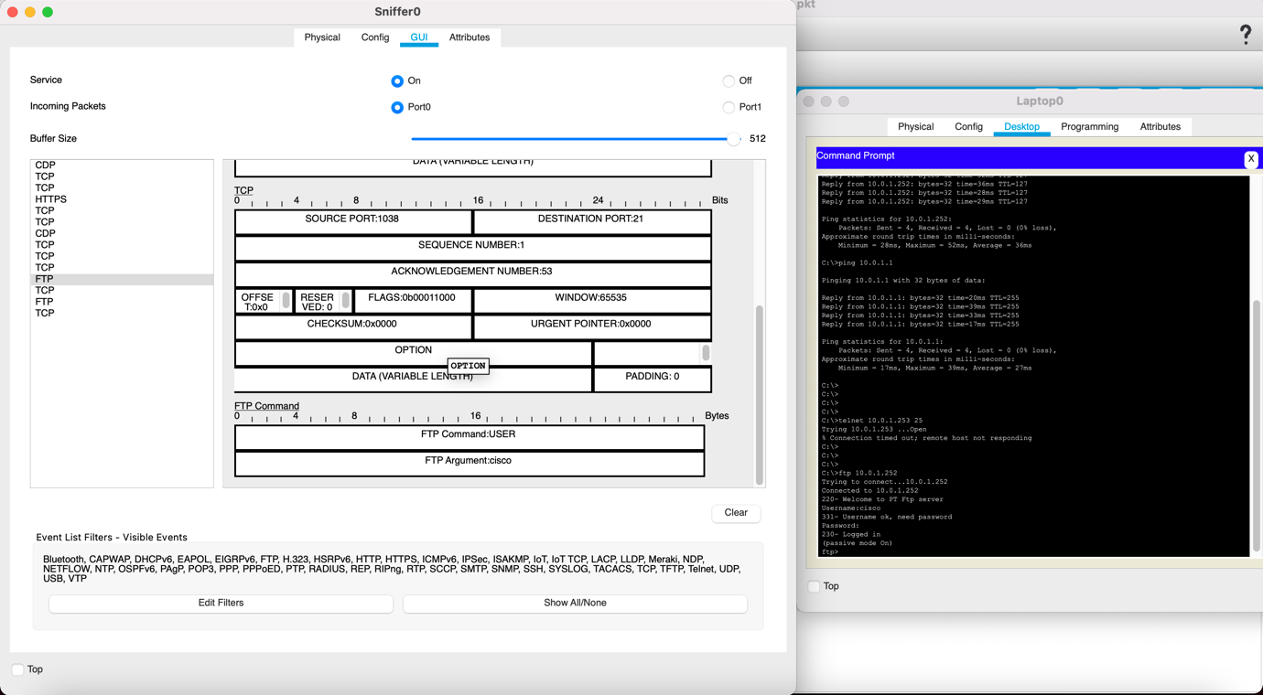
Figure 7 Sniffing results on FTP Port 21

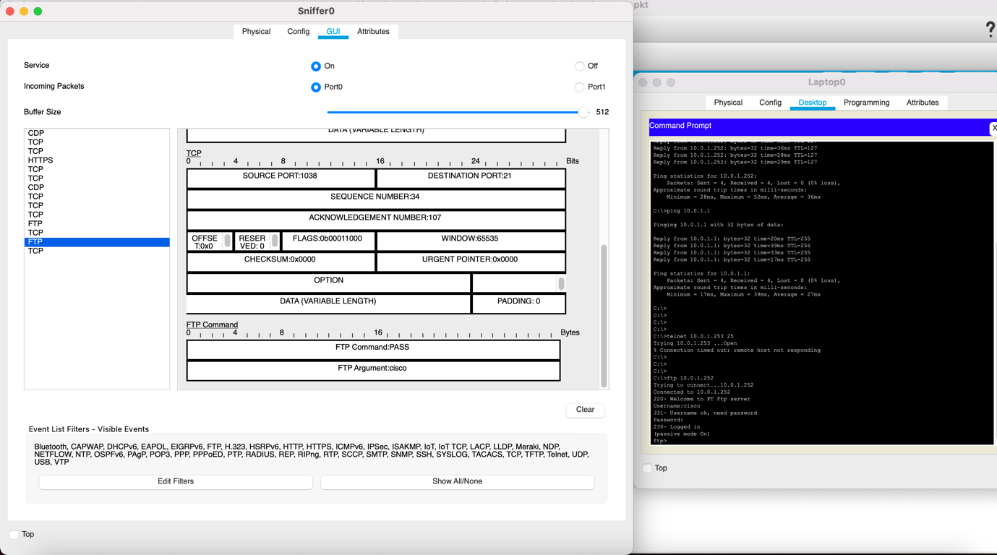
Figure 8 Sniffing results on FTP Port 21
As can easily be seen, the username and passwords are in clear text and can be read by anyone. About the HTTP packages, the ones captured by the basic sniffer available on packet tracer contains the header of the request and the data as well.

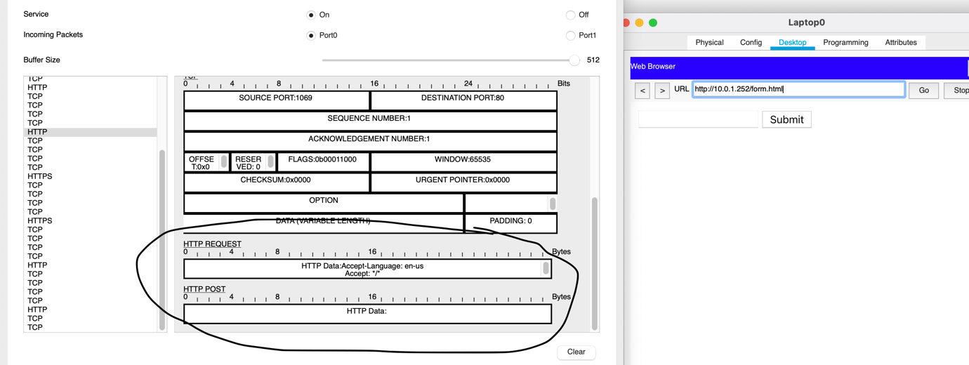
Figure 9 Sniffing results on HTTP Port 80
In the same way, the packages that are being sent and received through the any unencrypted ports, can be sniffed and used by a hacker.

Webserver weakness

MySQL Injection
SQL is one of the widest used database servers all over the world. Over the time, many vulnerabilities have been discovered and hackers took advantage of them. One of the well-known vulnerabilities is the one who’s being called the “SQL injection”. What it refers to? It means that the query made through a web-interface(form, URL request) is not escaped of special characters such as simple quote or double quote, special characters that are used in the backend of the website to query the database.
Let’s say after completing a form, we’re getting redirected to an URL like this: http://www.testwebsite.co.uk/userid=33
In the backend, we’re having a code which looks like this:

UserId = getRequestId(“userid”);
Query = “SELECT * FROM Users WHERE UserId = “ + UserId;

What happens if the backend code is not protected if the hacker fills instead of the regular ID of the user, 33, with something like: “33 OR 1 = 1”. Our unprotected query will become “SELECT * FROM Users WHERE UserId = 33 OR 1 = 1”. It transforms a conditional query into an always true one and returning the whole content of the table “USERS” exposing it to the hacker. [2]

Unprotected REST-API’s

The API’s are already for long time a part of almost every website. No matter we are speaking about the external API’s to fill a certain content into it such as Google Maps API, or a payment gateway API as PayPal is offering or the local API’s created for grabbing dynamically content without loading other page using AJAX calls, API’s are a part of almost every website in todays. While most external API’s are being dedicated to a domain, the local API’s development are being created by the company’s web developer. I’m using to test the API’s security and functionality in the same time, a tool called Postman.

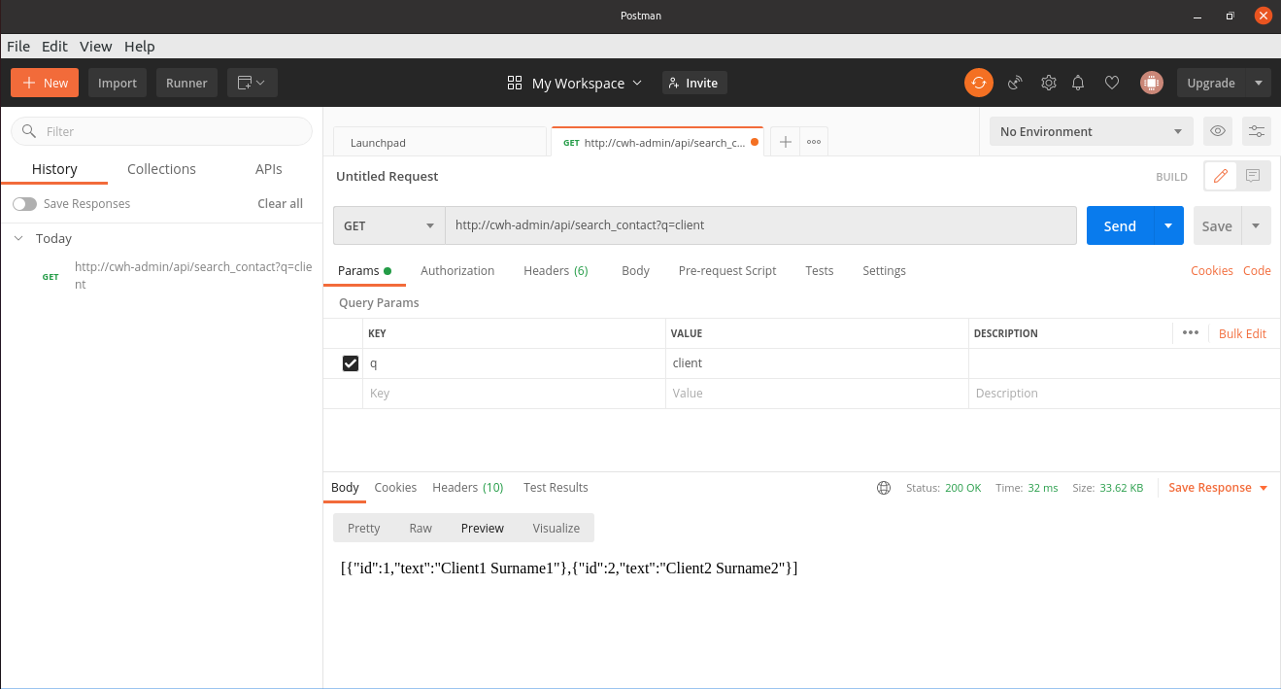
Figure 10 Postman call on unsecured API
Figure 8 shows a unsecured API which is returning the results without being needed to be logged in into the website (no token or any kind of authentication), so the results are being public and can be accessible from anywhere.

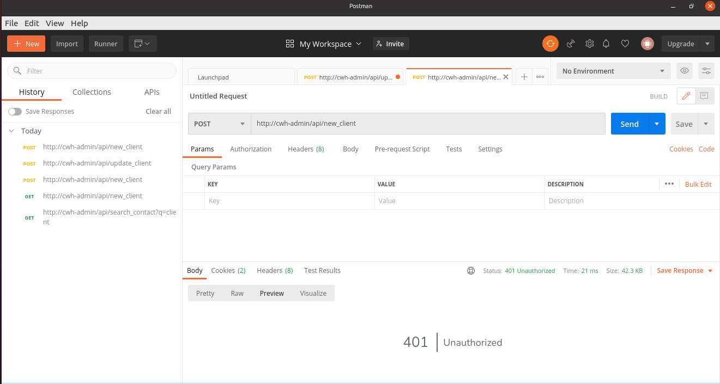
Figure 11 Postman call on AJAX call protected API
On this screenshot, the API is checking if the request is being made through an AJAX call. The AJAX call request is generating a header containing the Server variable called ‘HTTP_X_Requested_With’ and in case this one is not being set, then it’s a call made from straight from a browser or other web client.

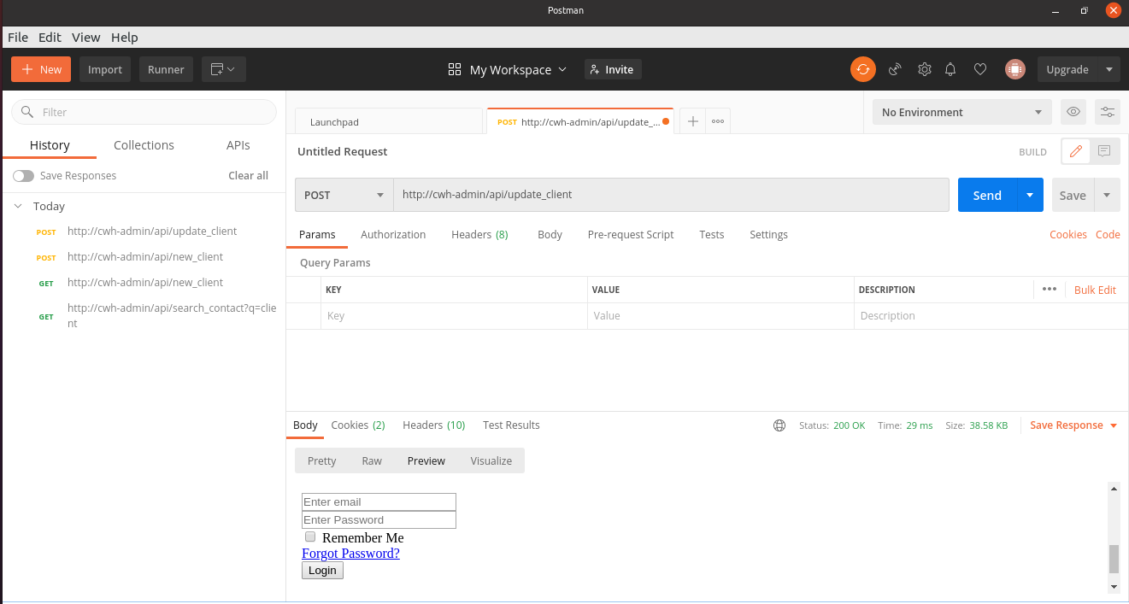
Figure 12 Postman call on secured API
The Figure 10 shows the outcome of the call made to an API which requires the user to be logged in to the website. Otherwise, it will show the login page.

These are couple of ways to secure the API’s and of course the database in case them are grabbing or updating the database.

The outcome of the running tests

Using the tools mentioned above, Nmap, Wireshark(for more advanced sniffing) and Postman, we can identify many of the issues in the Che-Si network. The outcome of Nmap helps us to see the hosts with vulnerable ports or unencrypted, which can be easily captured by someone who’s getting into the local network. The sniffer application can be used to run a complete penetration test over the IT services offered no matter they are private (local network use) or to the entire public such as the webserver or the mail server which must be accessible from anywhere in the world. Also, by going even deep inside the website, we can detect potential issues with help of tools as Postman which can harm the database of the company.

Mitigation strategy and recommendation

Security policies training
The security policies as password strength, session ending once leaving the computer should be trained to the staff which is using the company’s systems.

Data encryption
All the equipment’s should use only encrypted protocols on their communications. This includes routers and switches which some of them are still having by default unencrypted connections left open by factory.
The old protocols as HTTP will be gone soon and as all modern browsers can use the encrypted protocol instead it is advisable to migrate the webserver(s) to HTTPS.
The encryption of data is not limited to the connection itself, but also sensitive content sent through emails can be encrypted or password protected.

Weak point identified
The existence of unencrypted connections on services as HTTP (port 80), Mail Server (port 25 and 110), FTP (port 21) is one of the biggest security issues discovered. The Webserver is most of the time the interface between the end-user and the database of the company. The code must be updated to comply with the present security measures, to avoid intrusions as SQL Injection or unsecured API’s.

Figure 1 Local Network 5
Figure 2 Sniffer tool on Local network 6
Figure 3 Sniffer result 6
Figure 4 Postman API call 7
Figure 5 Nmap network scan 8
Figure 6 Sniffer tool 9
Figure 7 Sniffing results on FTP Port 21 10
Figure 8 Sniffing results on FTP Port 21 10
Figure 9 Sniffing results on HTTP Port 80 11
Figure 10 Postman call on unsecured API 12
Figure 11 Postman call on AJAX call protected API 12
Figure 12 Postman call on secured API 13

Bibliography

[1] | Wikipedia, Computer network.
[2] | W3Schools, SQL Injection.

