Research method
Optimization Research of Three-dimension character Modeling

Abstract：with the rapid develop of the related software, three-dimensional model is large-scale used in human daily life such as game entertainment, landscape design and film production. The majority of 3D animation will have animation character. Characters are an important element of animation. The design and modeling of the role model determine the first image of 3D animation. However, there are big differences between the animated characters designed by different designers in number of modeling polygon faces, character skeleton system, character topology structure and many aspects. A good animation modeling is easy to adjust and rendering with few polygonal faces. An inflexible are difficult to adjust, animate and render. Therefore, this article is based on the research of software Maya and plugin polygons, improve and summarize some methods for making character modeling to allow animation modeling characters can achieve better running and rendering effects with as few polygonal faces as possible.

Keyword: animation: character modeling, polygonal faces, skeleton system, topology

- Introduction

  - Research background
The computer hardware facilities have a rocket develop since the popularity of personal computers in 1980s. This led to a great improvement in the precision of the 3D role models directly. Character can make all kinds of personification movements in animation and games at present. However, many too sophisticated 3D models can greatly slow down the computer’s speed and consume the computer’s hardware life in animation animate step and rendering steps for most of computers. Meanwhile, a complex character model is more difficult to be moved and previewed in the process of animated. In light of this, it is necessary to use some techniques and methods to optimize the three-dimension character model.

1.2Research objective
Optimization, also called mathematical programming, refers to the study of decision problems in which one seeks to minimize (min) or maximize (max) a function by systematically choosing the values of variables within their allowed sets (GuanQuan Zhang 2015 p26). This paper will research character model optimization. The research objective of this paper is to solve the contradiction between the demonstrate quality of character model and the preview rendering speed of role model.

This paper will research the three-dimension character model optimize for three aspect

1.2.1Optimized character modeling.
Find a balance between the fineness of the role model and the speed of rendering. Ensure the operation of the character model by minimizing the number of polygonal faces.

1.2.2improved role joints and controller
Find a way to optimize the design skeleton and controller of the character based on the real human or animation skeleton system.

1.2.3ameliorate modeling topology
Check the topology structure of the role model to ensure that the model does not appear too abrupt. Make the edges of the character models more reasonable so as not to affect the textures and overall impressions of the models.

2. Methodology
2.1Overview
A three-dimensional model is a geometry constructed by a great deal of polygons. “It demands a large number of vertices and polygons to demonstrate a 3D model if this 3D object has a complex structure or surface”. (Liang Bo 2015). Detail character model requires take up more data and threads. On this account, it is necessary to optimized animation vertex, polygons and skeleton. This will help for animation preview and animation render in the process of the animation production and animation rendering. In this chapter, the author will elaborate on the research methods, research design and research process of the paper.

2.2Research Method
Artistic research is closely related to humanities research, in particular to that in art studies and cultural studies. These disciplines may provide interpretive frameworks that can also figure in research in and through artistic practice, such as hermeneutics, semiotics, critical theory, or cultural analysis. (Henk Borgdorff 2014). Author will not only refer to the data on 3D models, but also read the data from anatomy, geography and computer graphics to help this paper research.

Quantitative research is a structured way of collecting and analyzing data obtained from different sources. Quantitative research involves the use of computational, statistical, and mathematical tools to derive results. (SIS International Research 2018) The main methods for quantitative research are investigation, correlation and experimentation. The research in this paper demand to test 3d character model to get objective data for comparison from surface number, joint action, topological structure and many aspects. Therefore, quantitative research was adopting in this thesis as its methodology.

2.3Research Process
As the show in figure2.3-1. Author will study the optimization of three-dimensional character model from three aspects: geometric properties of three-dimensional role model, skeletal structure of three-dimensional model and topological structure of three-dimensional model by consulting relevant books, papers and videos.

In terms of geometric elements of 3D character models, this paper will focus on the optimization of vertices, number of polygonal faces and edges of three-dimensional models. Author will research and optimize each part of the research object, get the data, compare, analyze by previous researcher’s paper and book.

On the skeletal system research, author will read data about the real human skeleton, the skeletal system of three-dimensional role model. It is very important to optimize the skeleton of animation according the structure of the real skeleton because most of the role models are based on the real human beings or animals. In general, the joint of the buttocks is the initial joint. Therefore, this paper will optimize the skeletal joints and collect data according to the structure of real human skeleton and the request from the research objective model.

Character topology affects the role of map and the overall impression directly. Optimizing the topology structure of animation model is essentially to check the whole topology structure of the model, delete or modify the unreasonable wiring to make the model match the animation better. In this paper, author will analysis the rationality of the topological structure of the research objective model and checks the model’s topological structure based on relevant literature. Then, the relevant parameters and data are obtained.

After the data are obtained from these three aspects, the author will analyze the parameters obtained by the previous research in the result chapter with the relevant literature. Then, elaborates the limitations and achievements of this paper in the summary chapter.
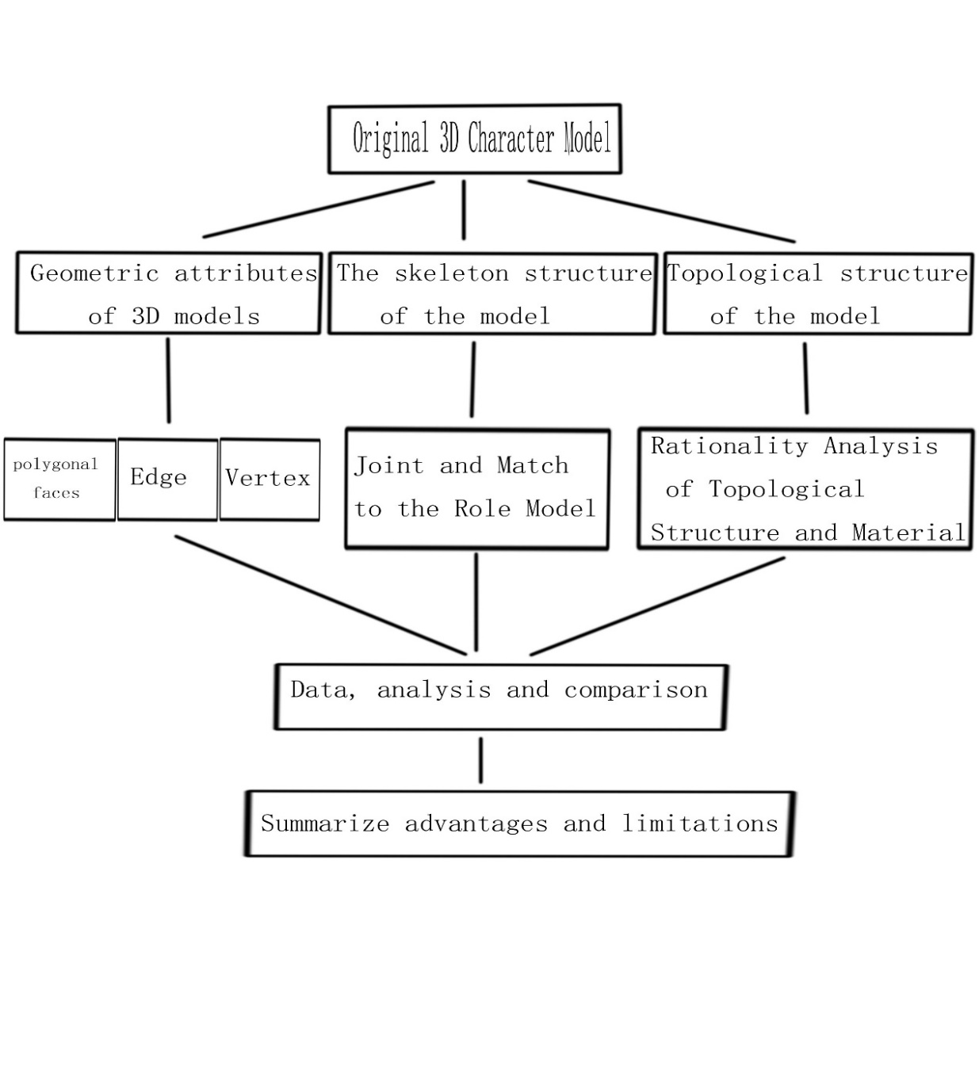
2.3-1Research Process

3. Critical and contextual review
3.1 preface
Three-dimensional software was widely used in the various walks of life in 1990s. However, the research of optimization of three-dimensional models began in the 1970s with the computer graphics develop in some countries. Limited to the hardware facilities at that time, it took about 25 minutes to render 512*512-pixel image of a model. In 1976, James H. Clark defined the model as several “working set” by layering the model in computer. Then, the visible part and the optimized part of the model are adjusted according to the angle of the camera. (James H. Clark 1976) Flexible adjustment or hiding of work set according to camera angle or user's requirement. This is the origin research of the most 3D model optimization studies.

3.2 previous studies and critical review about model optimized

In 1982, Rubin proposed a new algorithm about hierarchical representation of complex model which combined ray tracing algorithm. (Rubin S M 1982) It greatly declines the time of computer rendering complex 3D models.

In 1991, Dehaemer proposed a method to represent objects based on regular quadrilateral meshes. (Michael J Dehaemer 1991) This method simplifies polygonal mesh model by using adaptive recursive method.

Greg Turk proposed a method to automatically generate multi-level surface models from the original polygon description of a given object in 1992. According to his theory, the new model is created by removing each original vertex and locally re-triangulating the surface in a way that matches the local connectedness of the initial surface. (Greg Turk 1992) This is the predecessor and theoretical basis of model sampling method.

In the same years, William J Schroeder proposed an algorithm that can obvious decline a great deal of triangles request for physical model. This algorithm makes multiple passes over an existing triangle mesh, using local geometry and topology to remove vertices that pas a distance or angle criterion. (William J Schroeder 1992) Author gives an example in his paper to verify that this algorithm can be applied to volume and terrain modeling. This is a mesh simplification algorithm based on fixed point removal.

In 1993, Hugues Hoppe proposes a function-based global model grid optimization method for mesh matching and mesh simplification processes. His approach is to minimize an energy function that explicitly models the competing desire of conciseness of representation and fidelity to the data. (Hugues Hoppe 1993) This method is suitable for surface fitting and skin optimization of the model.

After that, due to the large-scale development and application of three-dimensional software, there are numerous researches of methods and plug-ins about model optimization. According to the previous research by the author and others who have contributed to the field of model optimization, there are mainly the following methods for model optimization.

3.2.1Model element deletion method
Model deletion is the most common method in the field of model optimization. The purpose of this method is to simplify the model by optimizing the deletion of geometric elements which have less influence on the model features. The deletion method can be divided into vertex Removal, edge collapse and triangle collapse according to the different deletion model elements. Vertex deletion method is easy to understand. This method means deleting vertices in the model that will not lead to significant changes in the topology of the model. Edge collapse algorithm is based on Hoppe's theory. According to this algorithm selected an edge 1 and its two related vertices B and C. Folding B-point to c-point, modifying the relevant topological relationship to complete the optimization of the model. As shown in Figure 3.2.1-1. Triangle collapse is a method that re-triangulation of the parts of the model that need to be optimized, as shown in Figure 3.2.1-1.
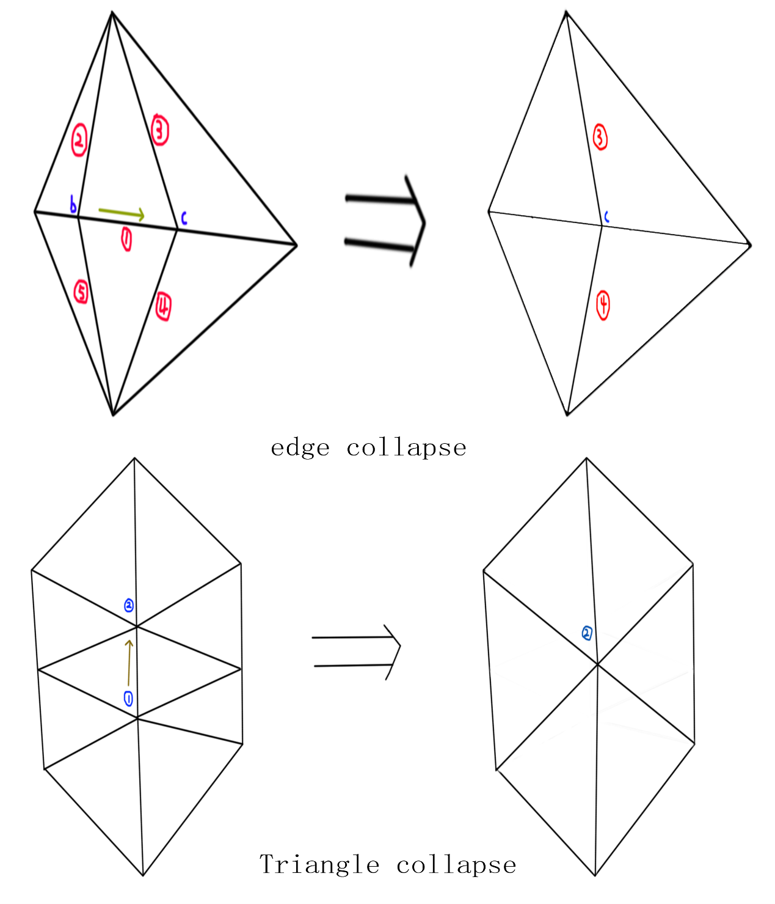
3.2.1-1The explain picture about edge collapse and triangle collapse

3.2.2sampling method
The sampling method is based on the theory from Greg Turk. It is referring to adding vertices or voxels to the surface of the model or three meshes of the model, then adjusting the distribution of vertices or voxels according to the physical or geometric error measures, and finally generating simplified models matching these vertices or voxels as far as possible under certain constraints. Sampling method is suitable for the optimization of smooth surfaces without folding edges, sharp corners and discontinuous regions. However, it is not effective for the simplification of non-smooth surface models.

3.2.3Adaptive subdivision method
The adaptive subdivision is method that add more detail in the base model. It will construct the simplest basic mesh model, then subdivides the triangular patches of the basic mesh model repeatedly according to algorithm, and obtains the mesh model with higher details in turn until new model generated.

The adaptive subdivision algorithm is simple and easy to implement. An advantage of this approach is that the refinement is essentially local reducing the computational requirements which permits the processing of large databases. Furthermore, the method is simple in concept, yet realizes efficient data compression. (Francis J. M. Schmitt 1986) However, it is only suitable for some applications such as terrain mesh model simplification, which is easy to find out the basic mesh model. When the deviation between the mesh model and the original model reaches a threshold value, this method is not suitable for model optimized. Moreover, the simplified model has poor retention effect for features such as sharp corners and folding edges.

3.2.4Vertex clustering method
The vertex clustering method is to merge two or more vertices in the original mesh model into one vertex, and delete the degenerate triangle after merging vertices, so as to simplify the mesh patches and achieve the purpose of simplifying the mesh model. Edge folding method can also be regarded as the merging of two vertices in vertex clustering method. Vertex clustering method can deal with any type of grid model with simple algorithm and fast speed. Major advantages of the vertex-clustering technique are its low computational cost and high data reduction rate, and thus suitable for use in interactive applications. (KoK-Lim Low 1997) However, due to the difficulty of error control in simplification, it is easy to lose the details of smaller structures, so the quality of simplified models is usually not high.

3.2.5Polygon merging
Polygon merging method can reduce the number of vertices and facets by merging nearly coplanar triangular meshes into a plane. The plane ﬁltered points are converted to a set of convex polygons. (Joy deep Biswas 2011) Then re-triangulating the formed plane. Also known as Surface Cluster and Super Surfaces. However, this method may change the void structure in the process of merging and triangulation, so the topological structure of the simplified model cannot be guaranteed.

3.3 contexture review
optimization is essential whether in 3D animation and game or any other place that need three-dimensional model to be used. As the shown in finger 3.3-1. The original three-dimensional model of Boeing 777 airplane has more than 5 million polygonal faces. The quantity of geometries in this model is a nightmare for most computers, whether previewed or rendered. At that time, The Research of Boeing using compressed geometry, to make high-performance graphics much more accessible for low-cost graphics hardware implementations. (Mike M. Chow 1997) The principle of this method is to compress the data of invisible polygons face into compressed geometric figures and cache them. In this way, the optimized Boeing 777 airplane model has less than 1 million polygons face. Moreover, the rendering speed of the optimized model has been increased by 10 times, and the quality of the image has no loss
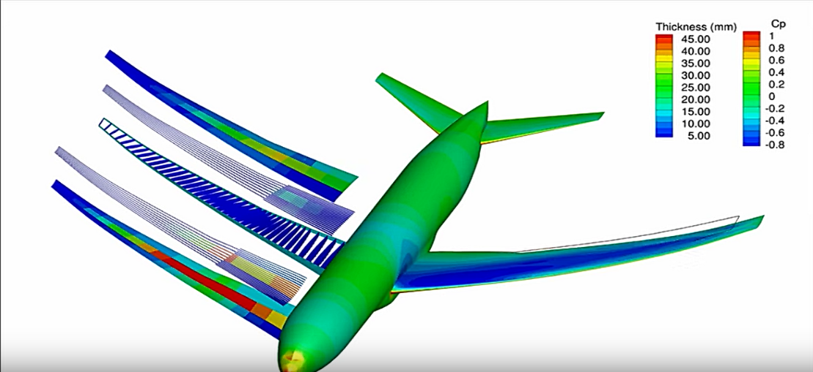
3.3-1 The model of the Boeing 777
In 3D character animation, the precision of three-dimensional characters is related to the lens language. Optimized models exist widely in panoramic lens and Long shots. For instance, in the animation film Final Fantasy: The Spirits Within, parliament hall is an indoor scene and it has so many characters in this scene. As the shown in picture 3.3-2, A panoramic lens is necessary to reflect Dr. Sid and General Hein's fierce debate about ghosts. The requirement of character’s action and expression is not very meticulous in this panoramic lens. But in the picture 3.3-3, When Dr. Sid presented his reasons to oppose General Hein in Parliament. The protagonist's facial expressions and movements are abundant in this close-up shot. Elaborate character models were requiring in this shot. Comparing the two pictures, Dr. Sid in close-up shot is different from Dr. Sid in panoramic shot.
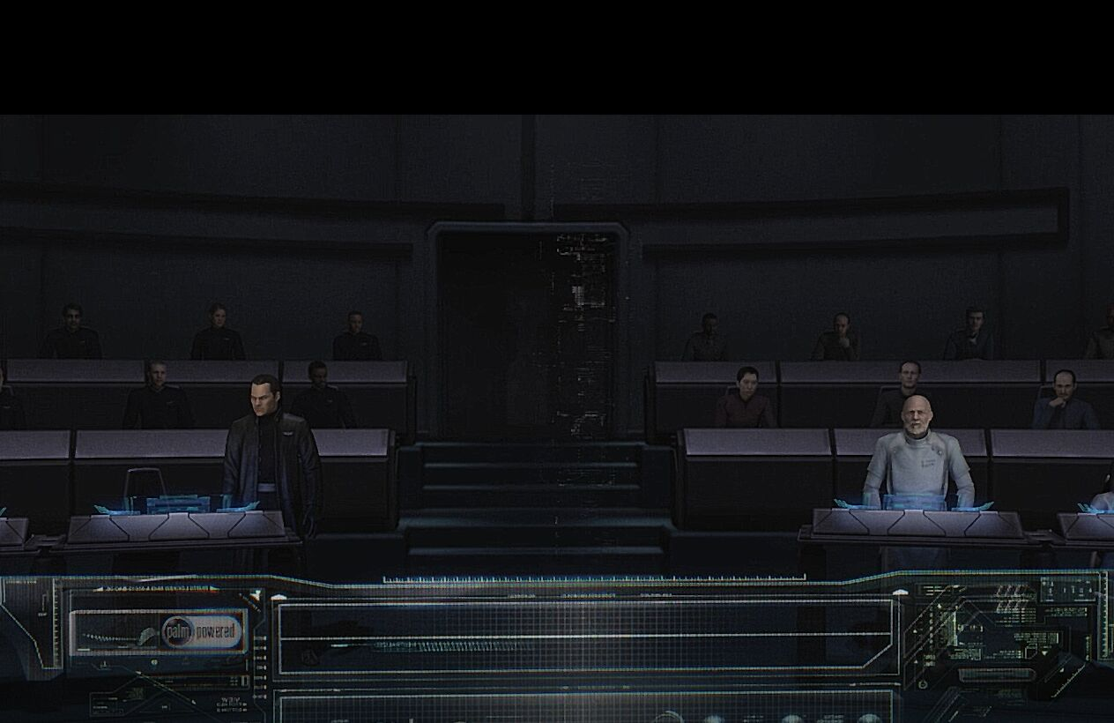
3.3-2 panoramic lens in Final Fantasy: The Spirits Within
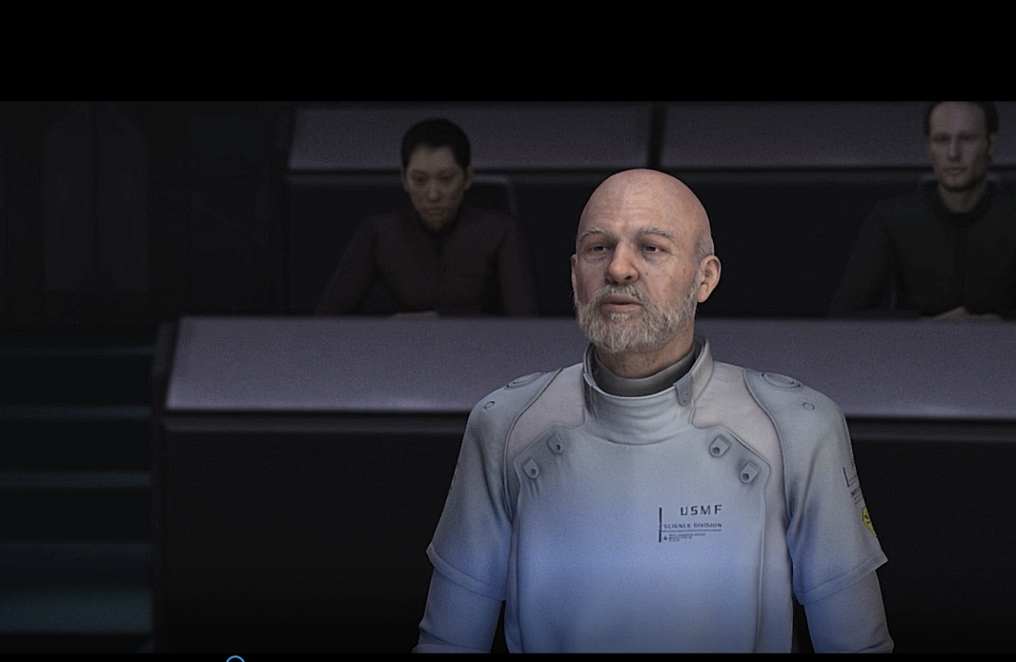
3.3-3 close-up shot in Final Fantasy: The Spirits Within

The same illustration can also be found in Stand by me Daemon. As the shown in picture 3.3-4, Daemon have rich expressions and body language such as blinking, blushing in this shot. So, the role model is very elaborate in this close-up shot. But in other picture 3.3-5, it is a prospect shot and character has only dialogue and simple action in this shot.

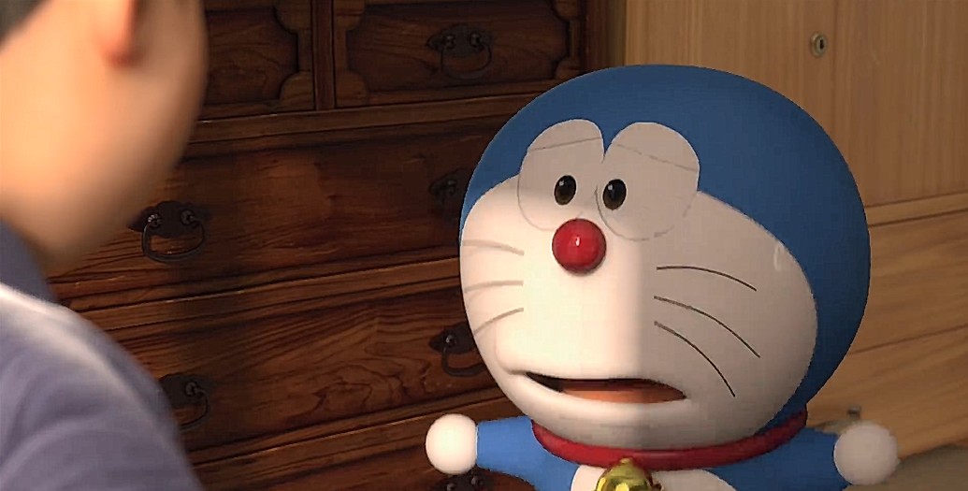
3.3-4close-up shot in Stand by me Doraemon
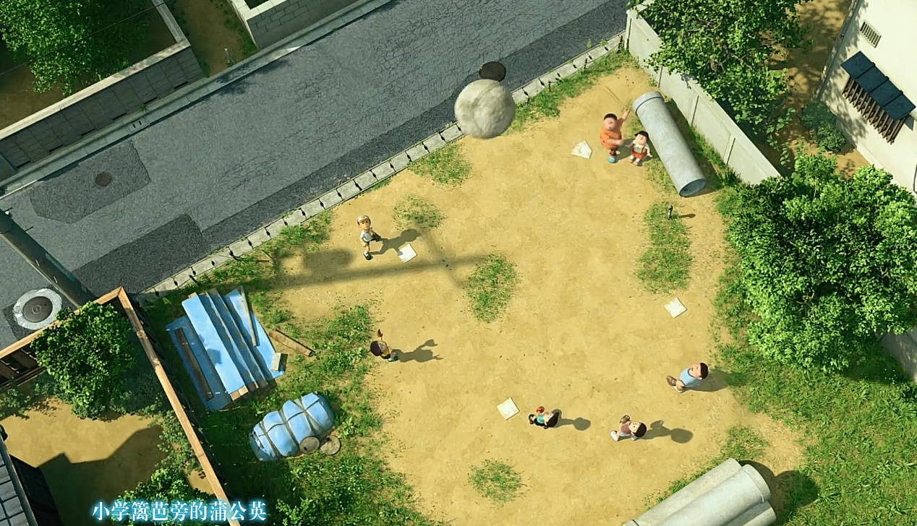
3.3-5 prospect shot

4 Project-specific research
4.1 Mesh optimize
In the software Maya, it has a great deal of way to product a model. But when the module was built. The figure of polygonal faces in this module was becomes an important parameter. A skilled designer can roughly control the number of polygons and vertex in the modeling of rough model. Then, they will adjust the detail in the fine modeling according their demand.

As the shown in figure 4-1-1 and figure 4-1-2, This is a personate mouse model. There are more than 150000 polygonal faces in this detail model. This bring a great trouble to subsequent step and rendering. Too many unnecessary polygonal faces lead slow program operation even software crashes
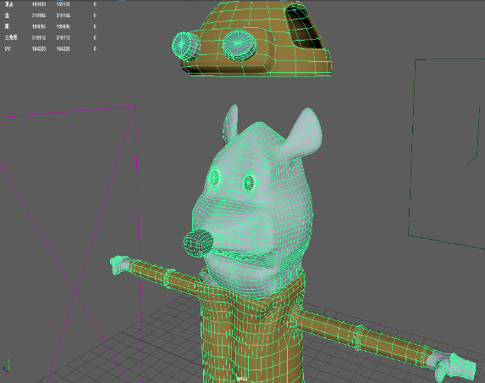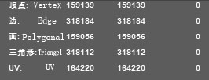
4-1-1research object model 4-1-2 the parameter of the research object
To the mesh optimization, designer can optimize some part of the model according animation demand. it is necessary to maintain enough vertices and polygonal faces to ensure the character can perform their action reliably for some parts need to do complex action such as fingers, wrists feet, knees. But for body, arm and any other part of role model that not affect overall impression. It can further optimization. This can optimize the modeling without affecting the normal operation of the character model.

4.2 Skeleton system optimize
Animation character is the core of an animation. Skeleton is a core of role modeling. The role of bones is to drive three-dimension character to do action that simulation and anthropomorphic. Skeleton is the most important step of the role modeling. It affects the performance of animation directly.

Making a skeleton to match character model is not an easy task. “Designers not only demand understanding the process of skeletal binding, but also has an adequate planning of the character in their design” (Huang Meijuan 2016). This means that the designer has a general design for the joint, range of motion, weight and corresponding controller of the character model. The designer should understand what character will do in the animation to let skeletal matching of the character’s actions throughout the animation.

As the shown in figure 4.2-1. This picture demonstrates the structure of the real human skeleton. Most of the animated role’s action are based on human or animals. Therefore, research the bones of the human body is a positive thing for designer to design animation skeleton.

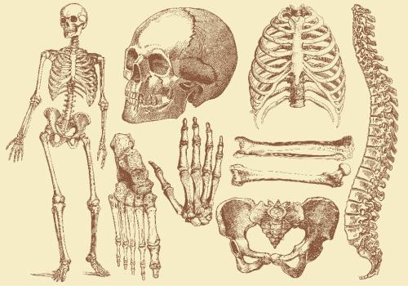
4.2-1 the real human skeleton

Human anatomy is of great significance for designers to understand the animation skeleton system. In 2004, Robert elaborated on his research on the skeletal system of three-dimensional models in his book. He decomposed the skeleton into spine, rib cage, pelvic girdle, skull and shoulders. According to this, He propose that skeletal system should be consist by Plane Joints, Pivots Joints, Hinge Joints, Ball-and _socket Joints, Saddle joints and condyloid Joints. (Robot. S 2004 PP48-52)

As the show in picture 2.2-2, this is a skeleton made by a designer base on Maya. The matching object of this skeleton is a humanoid animal. We can see that there are a large number of unnecessary joints and controllers in the arms, body, and thighs of the character skeleton. Because of the weight occupied by the joints, these redundant joints will greatly affect the action of the key joints after binding the animation character model. It will lead the action of the role become very stiff. Meanwhile, a great deal of joints and controllers will consumedly delay the speed of software operation.
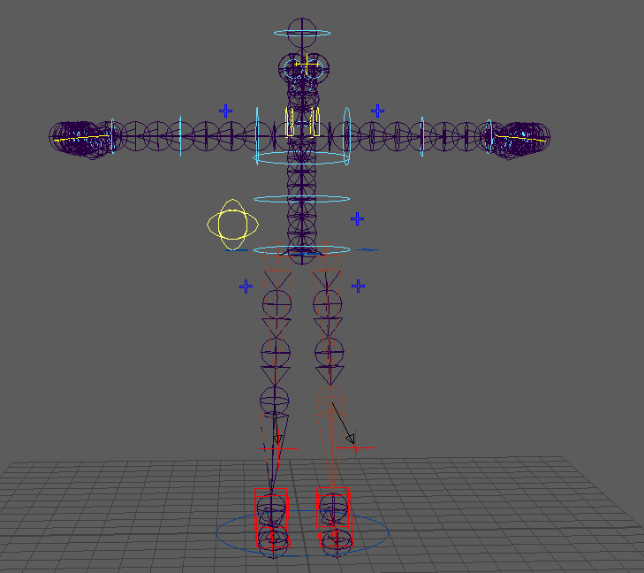
    - the research object about skeleton system

4.3Topology optimize
The word topology is a geometric concept originally. the definition of topology in three-dimensional modeling refers to the layout, structure and connection of points, lines and surfaces of polygonal mesh model. The meaning of topology is to express the same or similar effect with the fine model with fewer vertex and edge. If a model has a perfect topological structure, the model will not only be more regular in the overall impressions, but also can enable designers to better and more accurately adjust the details of model.

Character topology affects the role of map and the overall impression directly. Optimizing the topology of animation model is essentially to check the whole topology structure of the model, delete or modify the unreasonable edges and vertex to make the model match the animation better. Designer demand to pay attention to the following point when their check and optimizing wiring. First, the edges of role model should be arranged uniform relatively to ensure the material can mapping in the model smoothly. Second, “for ensure the flexible about role, the edges in the joints of character should be not spare. “(Sun Yuan 2014) Third, it should be not existing five sides or even six sides in the role model. The overall impression and texturing effect of the animation character will be improved when the model topology optimize was finished.

As shown in figure 4.3-1, the wiring of this role model on the head is very unreasonable. First, the edges around the eyes are too sparse. The eye is an important medium for character countenance in animation. Therefore, there are more reasonable edges around the orbit to content the requirement of animation. This character has an exaggerated nose. However, the topology structure has issue that lead the turning angle of the face area from eye to nose is too abrupt.
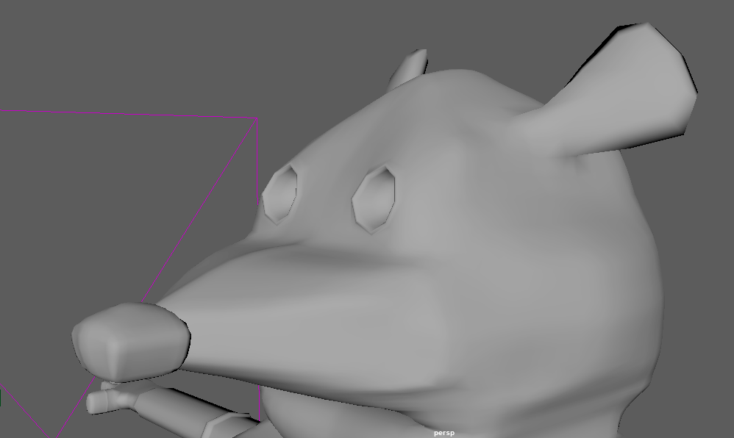
4.3-1The head of the research object model

5. Result
The significance of optimizing the skeleton of 3D character model is to decline the unnecessary joints and controllers of the animated character according to the action of the character in the animation. On the one hand, it reduces the workload of designers in drawing the weight of skeletal skin. On the other hand, it avoid many problem caused by too many joints in skeleton system, such as workload increased and action stiff

As shown in the figure5-1, the skeleton relationship in the outline view is very complex. Every joint links two or more joints except the start joint and the end joint. In this case, adjusting the skeletal joints requires care and caution to avoid destroying the entire skeletal structure. As shown in the figure5-2 and figure5-3, the hip joint needs to be optimized, so it needs to be skeleton removed temporarily. Then the related joints under the hip joint are moved back to the skeletal system to complete the optimal deletion of this joint.
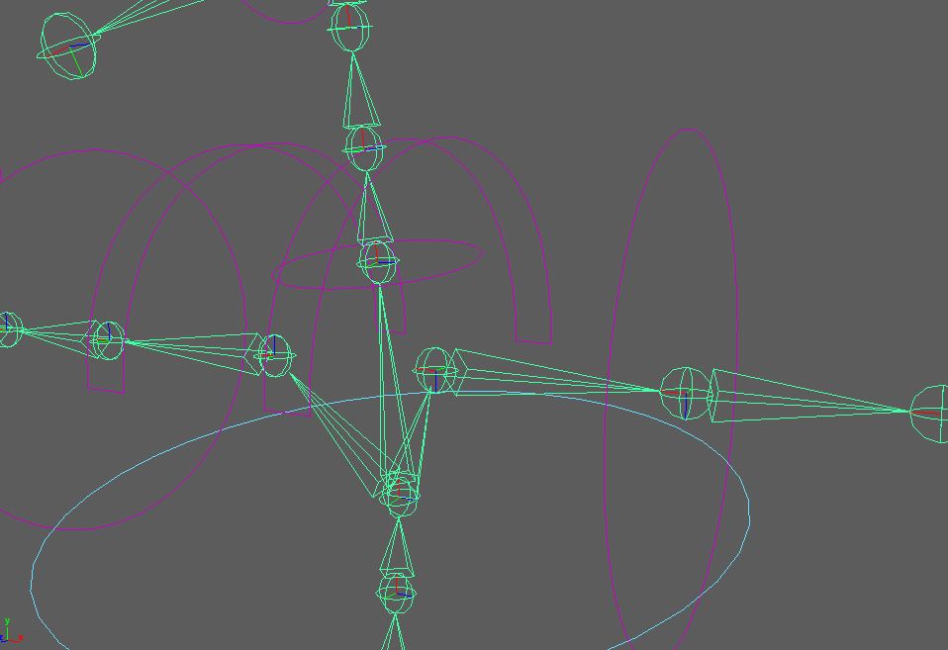
5-1 skeleton’ joints relationship
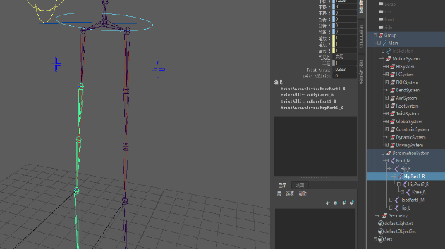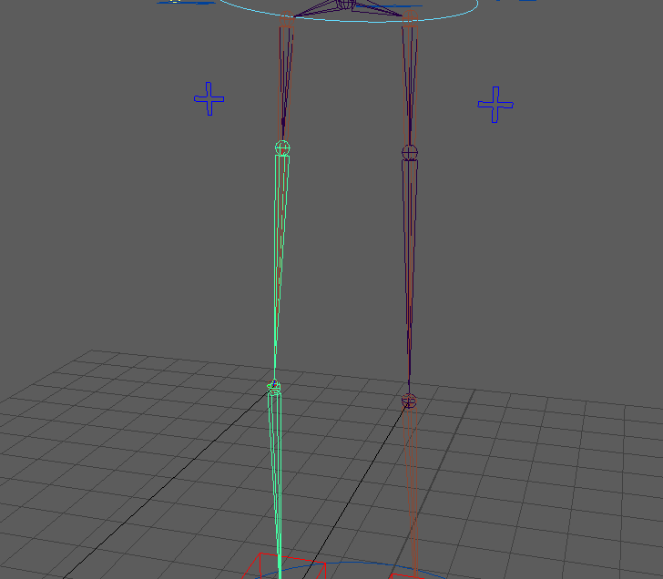
5-2 Optimize joints Before 5-3Optimize joints After

However, some joints are not easy to optimize as expected because joint-based skeleton systems are already bound to Ik and Fk. As the shown in this figure5-4 It will cause skeleton system errors if optimize those joints. Even if the relationship between IK, FK and joins is removed before this step, the old IK and Fk cannot match the optimized skeleton system. Therefore, this cause IK, FK and controller should be deleted and Re-establish to match the optimized skeleton system.
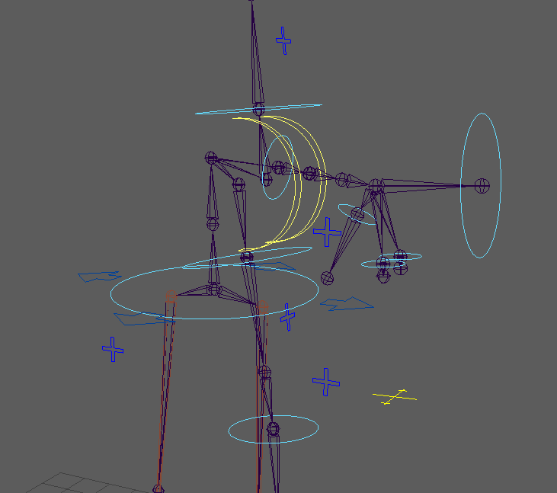
5.4 Collapsed skeletal system

According to the request of the research object and the research of real human skeleton. After optimizing and improving the redundant joints, the skeletal system has been streamlined to become more intuitive and simplified, rather than as complex and stiff. As the shown in picture 5-5
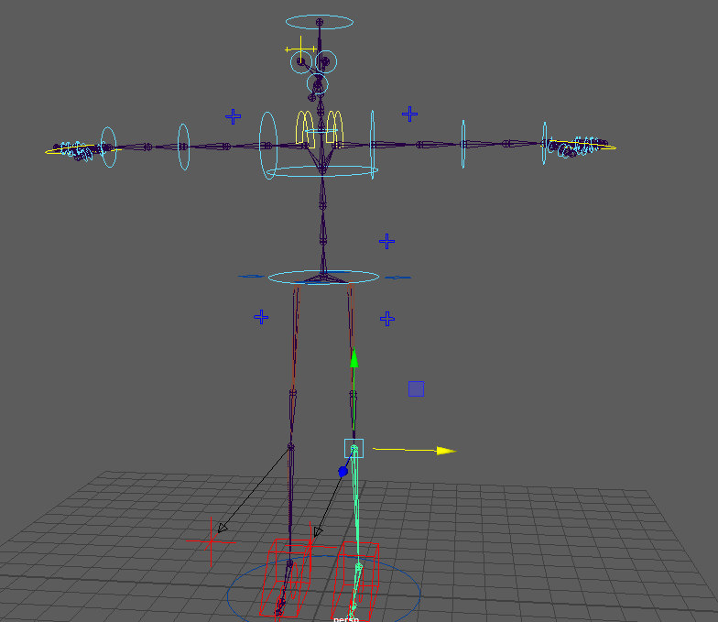
5-5 Finished Skeleton system optimize

The optimization of 3D role topology structure means to check the rationality of three-dimensional model edges, so that the map can be better applied to the model. As the shown in picture 5-6, the head of the research objective model is the focus point of the whole topology optimization. Based on the design chart of the model, soft selection and polygon customization tools are used to edit the unreasonable parts of the mesh to change the model according to the Edge collapse algorithm. Moreover, it is important to optimize model’s texture. Normal mapping is not suitable for this model because topology optimization will slight changes model’s topology structure. Therefore, this paper adopts ordinary UV map. Export UV in the UV menu and optimize it in photoshop.
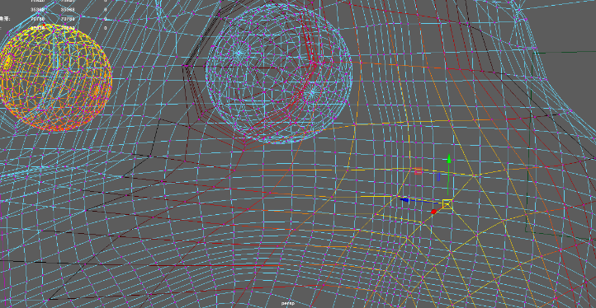
5-6 adjust topology structure

The optimized topological structure and map are more suitable for animation. As the shown in picture 5-8 and 5-9.

The deletion of 3D model polygonal faces is the most common form 3D model optimization. The principle of this is to reduce invisible parts and some parts which have less influence on model feature.

By choosing the polygonal faces model of the 3D character model, executing the command modeling model- grid- clean. Then, setting up the polygonal faces and other parameter that should be clean up or optimized especially the pentagonal and non- manifold geometry based on the surface fitting method. After executing this command, the next step is reducing the proportion of polygonal faces according to the command grid reduction according to the Polygon merging method. In the parameter bar, the ratio of the number of modified polygonal faces can be adjusted. It should be noticed that optimizing models requires reducing the number of polygon faces but designer cannot over decline the finger of polygonal faces so that the model cannot be smooth or affect the character of the action.

As we shown in this picture5-7, the character model has a big change and mistake when the command reduces polygonal faces covered to the whole module. The eyes of model are disappeared and the mouth deforms. The head of module was over optimization. This is contravention the original of role module optimization because the over-simplified model has affected the normal function of the 3D character model. Therefore, A pertinent research of this model needs to be carried out to analyze which parts can be optimized and which parts cannot be simplified due to its too importance.
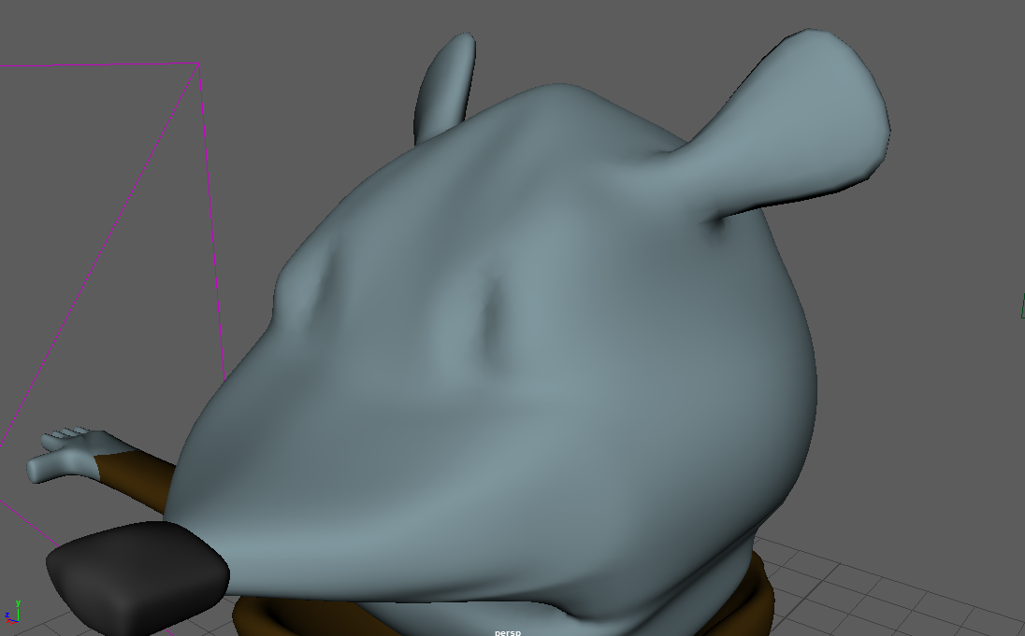
5-7over optimize

The effects of parameters before executing merge command and after executing merge command are shown in figure5-8,5-9,5-10,5-11 and form 5-12. This 3D character model has been considerably optimized and the actual appearance of this model has not changed visibly.
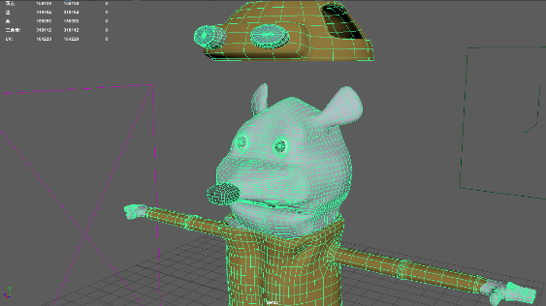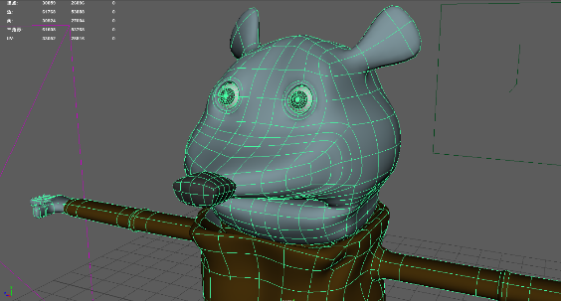
5-8 model Optimize before 5-9Model Optimize After
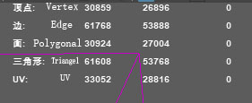
5-10Parameter Before Optimize 5-11Parameter After Optimize

Model Parameter | Before Optimize | After Optimize
Vertex | 159139 | 30859
Edge | 318184 | 61768
Polygonal | 159056 | 30924
Triangle | 318112 | 61608
UV | 164220 | 33052
5-12Form about Model optimize Parameter

6. Evaluation and Conclusion
This paper researches the optimization technology of three-dimensional role model from three aspects and summarizes the previous papers and data so that the optimized three-dimensional model can run better based on software. In the mesh optimization, author uses model sampling method, surface fitting method and model deletion method to reset and optimize the mesh structure of the model, and achieves good results. This is a good example that summarize the optimization method about model’s mesh.

In terms of joints and controllers of skeleton system, author proposes a method of optimizing joints and controllers based on human real skeleton according to data about human anatomy and 3D role models. However, this method has limitations in practical application. It requests to remove and re-establish skeleton system’s IK and FK. This requires designers to have better skills about skeletal systems construct to use this approach.

In the term of topology optimize, author checks and optimizes the topology structure based on Maya with reference to the design drawings, so that the topology of the 3D role model can be more match with the animation. However, due to this method need to slightly adjust the topological structure of the model, the normal mapping cannot use in the optimized model. So, the limitation is that this optimization method cannot use normal mapping.

According to the foregoing chapters research, optimizing the three-dimensional character model according to the requirements of the scene can not only reduce unnecessary data operations, but also improves the overall impression of the character. Therefore, it is important and meaningful to optimize 3D role models according to requirements.

Reference

1.GuanQuan Zhang, Jie Lu, Yao Gao, Multi-Level Decision Making: Models, Methods and Applications[M] London, Springer publishing 2015.p26
2. Liang Bo A Research of Optimizing Techniques for the 3D Scene Model Based on Creator[D] Wuhan Central China Normal University 2009.p18
3. Henk Borgdorff the conflict of the faculties: perspectives on artistic research and academia[M] Amsterdam, Leiden University Press 2012.p123
4. SIS International Research [ACB]. What-is-quantitative-research,2018 [Report on the internet] New York: ACB; 2018 Available from:https://www.sisinternational.com/what-is-quantitative-research
5. Clark J H. Hierarchical geometric models for visible surface algorithms[c], Communications. Of the Acm,1976,19: 547-55
6. Rubin S M The representation and display of scenes with a wide range of detail[J] The Graphics and Image Processing,1982,19: 291-299
7. Michael J Dehaemer, Jr and Michael J. Zyda. Simplification of Objects Rendered by Polygonal Approximations[J]. Computer & Graphic. 1991,15(2): 175-184
8. Greg Turk. Re-Tiling Polygonal Surface[J]. Computer & Graphics. 1992, 26(2): 55-64
9. William J Schroeder, Jonathan A. Zarge, William E. Lorensen. Decimation of Triangle Meshes[J]. Computer Graphics. 1992,26(2): 65-70
10. Hugues Hoppe, tony DeRose, Tom Duchamp,et.al.Mesh Optimization[J]. Computer Graphics ,1997,27: 19-26
11. Francis J. M. Schmitt An Adaptive Subdivision Method for Surface-Fitting from Sampled Data[p]1986 Proceedings of the 13th annual conference on Computer graphics and interactive techniques Pages 179-188
12. KoK-Lim Low Model Simplification Using Vertex-Clustering 1997[P] 1997 Proceedings of the 1997 symposium on Interactive 3D graphics Pages 75-ff.
13. J Biswas, M Veloso, Fast Sampling Plane Filtering, Polygon Construction and Merging from Depth Images[D], Pittsburgh Robotics Institute Carnegie Mellon University Pittsburgh 2011
14. Mike M. Chow, Optimized Geometry Compression for Real-time Rendering [P] 1997 VIS '97 Proceedings of the 8th conference on Visualization '97 Pages 347-ff.
15. Huang Meijuan Maya based simulation of two leg role binding skills[J] Journal of Chongqing University of Science and Technology 2016. (5): p94
16. Robot. S. Character Animation in 3D: Use traditional drawing techniques to produce stunning CGI animation[M], Waltham, Focal Press.2004 PP48-52
17. Sun Yuan Analysis of 3D game character modeling wiring technology[J] XueYuan 2014. (19): p93 Image Reference 3.3.1 MDO Lab， Wing Design Optimization of a Boeing 777-sized Aircraft ，[Video Online] available at:< https://www.youtube.com/watch?v=HRc5vuuIyOg> [Accessed 15 November 2018] 3.3.2 Final Fantasy: The Spirits Within，2001[Film] Directed by Sakaguchi Hironobu USA SQUARE ENIX 3.3.3 Final Fantasy: The Spirits Within，2001[Film] Directed by Sakaguchi Hironobu USA SQUARE ENIX 3.3.4 Stand by me Doraemon, 2014[film] Directed by Ryuichi Yagi Japan Toho Company Limited 3.3.5 Stand by me Doraemon, 2014[film] Directed by Ryuichi Yagi Japan Toho Company Limited 4.3.1[Human’s real Skeleton system] n.d.[image online] available at: <https://www.vecteezy.com/vector-art/109645-old-style-drawing-human-bones>[Accessed 15 October 2018] Except for the above pictures, all the other pictures and from are from author.

