Student name:Maura Sousa Pontes
Student Id:1809187
Lecturer: Anupam Mazumdar
Module name/code:Digital Skills and Research methods(BMSW4003)

Impact of Implementing a Virtual Learning environment (VLE) In high education

Contents
Introduction
Rationale of the research
Literature review
Research methods and methodology
Qualitative
Quantitative
Sample and sample size
Data collection methods (consent form)
Ethical considerations
Analysis and discussions
Recommendations for future research
Conclusions

Introduction
A virtual learning Environment is a web-based framework for providing learning materials to students.Such systems provide assessment, student monitoring, collaboration , and networking resources.They can be accessed on and off campus, allowing students to learn outside the classroom,24 hours a day, seven days a week.This help universities not only to educate conventional full-time students, but also as well as someone unable to access the campus on daily basis due to geographical or availability limitations, such as those on distance learning courses, evening classes, or workers studying part-time.
There are various types of VLE, both of which operate some what differently but essentially serve the same purpose and can provide the same learning materials.
A Higher Education establishment is likely to have a VLE licence that falls into either of the following three categories:off -the-shelf, such as Blackboard. Open source(often free to use and modify but support is charged),such as Moodle.
Bespoke (established by universities towards their own particular needs) VLEs are also considered as course management systems (LMS).
VLEs are aligned with certain government standards that help to make content and tests binary compatible ( I,e. they could be used in various forms of VLE). This report sets out the findings from a research study related to the virtual learning environment also based on a survey questionnaire from UWTSD students to identify the impacts whether positive and negative.

Key words
VLEs:Virtual learning environments
UWTSD:University of Wales Trinity Saint David
VLE:Virtual learning Environment

Literature review:Most of theiroctical concepts that support this case study are based on author such as Robert Ubell (2017) and Martin weller (2007),in regards to the implementation of VLEs and their role in education.

Using common VLE tools
A VLE may be seen as a powerful set of e-learning tools in a bundle allowing for a shared interface and data sharing among users.Although the particulars of each VLE vary , they provide similar functionality on the whole.We can think of a VLE as having three dimensions to its functionality, reflecting a different interface and audience (figure 1).The three dimensions consists of:
.Institutional – the VLE must be incorporated into others university systems, including students records, library systems, content management, etc. The IT specialists who will deploy and assist a VLE are mainly concerned with being able to do so in an effective manner.
.Academic – while students are considered to be end-users of the VLE, it is the academic staff who will eventually decide the effectiveness of the VLE.
The methods for designing classes, setting up software and helping students would also be the main determinants in a VLE is popularity.Helping a variety of subject areas and pedagogies would be essential for these users as well as ease of use.
.Learner-you can see the end user of the VLE as learner, when their experience is not positive, for example, the system is difficult to use or not stable ,otherwise the input and use of the system will be weak, which will hinder its adoption.The programme must be simple to use and consistent with its layout for this category, but most importantly it must add value to the learning experience.
That is particularly the case when a VLE is implemented on campus.When the programme does not add any value, then it will be ignored by most learners as a strategic team.Adding value could be in terms of additional content, more flexible research habits, improved support and a more suitable environment for certain users.Viewing a VLE as having these three dimensions underlined that it is a device that needs to relate to different audiences, each of which may have different goals and needs.A “Herran (2000)” indicates that there are four viewpoints from which a VLE is examined.
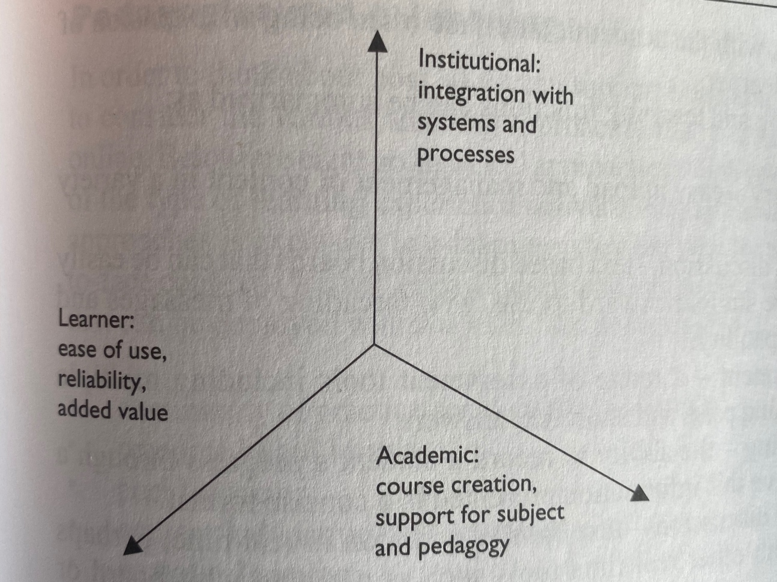
Figure1:The dimensions of a VLE interface

. Administrators – scalability, value for many, and compatibility with current systems for those users are essential.
.Technicians- reliability, user base, technical assistance and maintainability will be essential.
.Course developers or teachers- paramount will be the customizability,versatility and incorporation of legacy content.
.Learners- the main issues would be accuracy ,usability and quality of design.(M Weller, 2007,p.17)
If we define the methods that compose a VLE, then the institutional aspect is the one that stands out from the others. This will include populating programs with the correct students, assigning the right positions to teachers, academics and administrators, recording any assessment and accessing resources.
The exact approaches to conducting these tasks will differ depending on each VLE.
It should be noted that these can also be an important factor in deciding the choice of VLE, particularly if the choice is made by a central IT department. An influential factor would be the ability of any given VLE to integrate with their chosen database technology and operate on their current configuration.
The importance of these factors in the successful implementation of a VLE should not be underestimated.If two VLEs are identical in terms of their end-user features, then the ease with which they can be deployed and assisted by IT staff and their established knowledge base is a fair determinant. But these are also highly technical and complex specifications, so let us assume for our reason that the VLE will effectively integrate with the current university system and turn our attention to the other two key dimensions, academic and learner. Obviously, both have a high degree overlap, with the academic framework being mostly an extension of what is presented to the learner.
The main functions of learning and teaching can be defined as:
.Content delivery-simple uploading and handle content through a range of formats.
.Asynchronous discussion-text based discussion boards that are simple to create simple to use, with message threading and attachment capabilities.
.Online assessment-a variety of assessment methods, including multiple selections, matching pairs and short text responses.
.Student tracking-a student is ability to report is accomplishment through the course and this information is provided in a succinct manner.
.Synchronous discussion- real-time text-based discussion, maybe combined with other real-time resources such as a virtual whiteboard or webcasting.
. Student tools- normally these include a calendar, personal resource upload are, note-taking tools, and email.
Methodology
The research was carried out in form of an questionnaire (survey monkey) allowing analysis with excel.The questions were based on UWTSD students using VLE to identify the perspectives either positive and negative. Most procedures and characteristics of the present study are found in M Weller (2007) .The purpose of this research was mean to be more quantitative data in order to identify the impacts of implementing a VLE in education program students experience ,unfortunately I did not have a large number of respondents ,as quantitative data is about quantities, and therefore numbers , also qualitative data requires a variety of methods to develop deep understanding of how people perceive their social realities and in consequence,how they act with social world ,so the research methods could be considered either quantitative and quantitative.

Sample and sample size
About 8 students from UWTSD participated in this study case regarding the implementation of VLE in High education. I had created a virtual questionnaire (survey) and invited some students to take, my sample size from my point of view is considered randomly because I did not get to many respondents .

Ethical considerations
I had created the virtual questionnaire (survey monkey) before complete my research,unfortunately some students were unwilling to participate. Despite this current situation about covid-19 ,the main purpose of this case study was collected more information as much I can from the students to identify how students reacted to use of technology and restrictions surrounding the implementation of VLE in their courses.
Analysis
Q1:Do you agree or disagree with using virtual learning in Higher education?

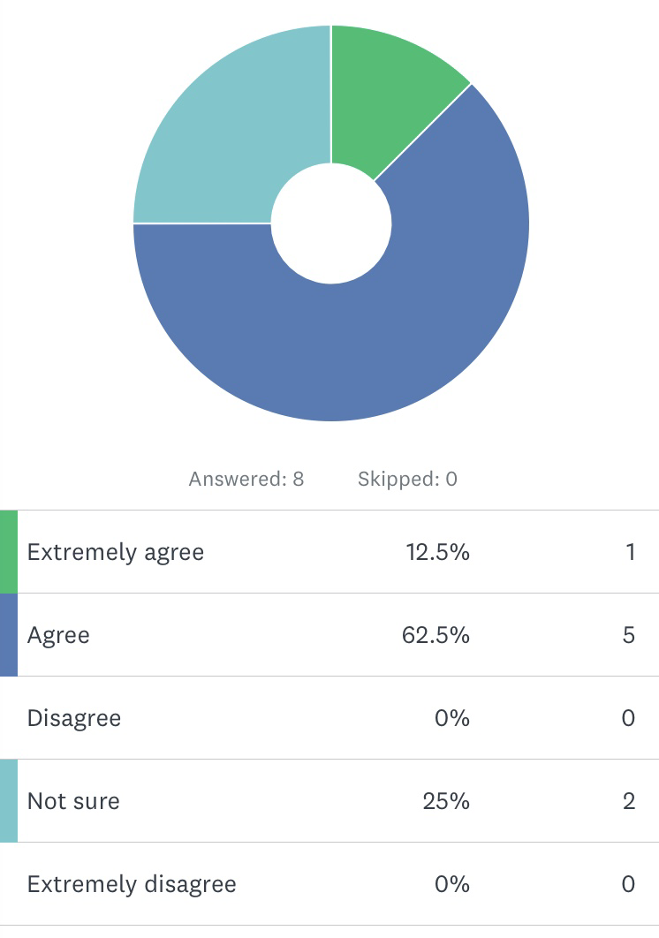
Q2:Can virtual learning system affects the conventional library system?

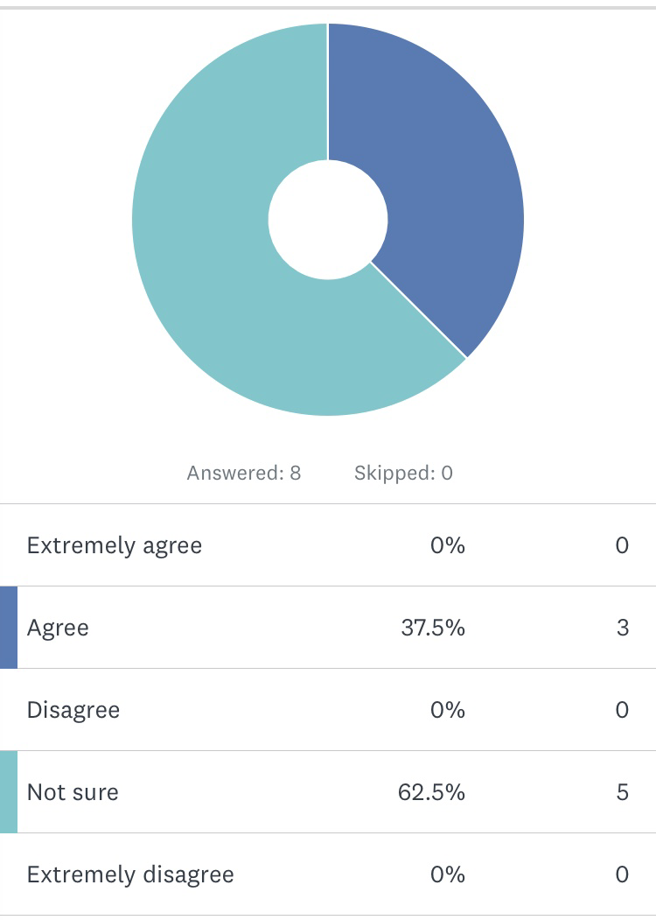

Q3:The Virtual learning would be an issue for those never have used the system before?

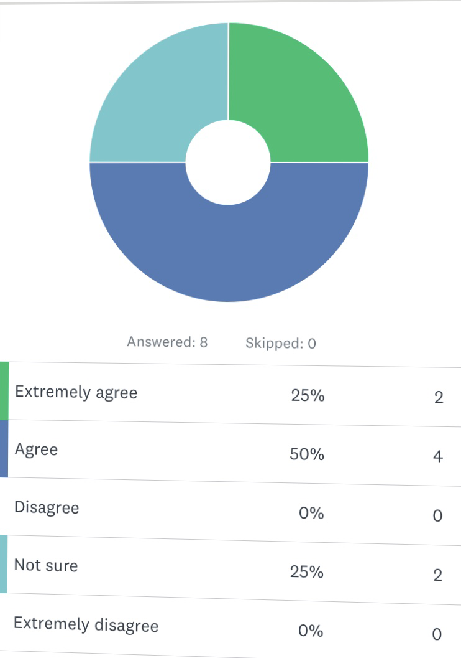

Q4: Is the online module from the university only related to the subjects that you are studying for?
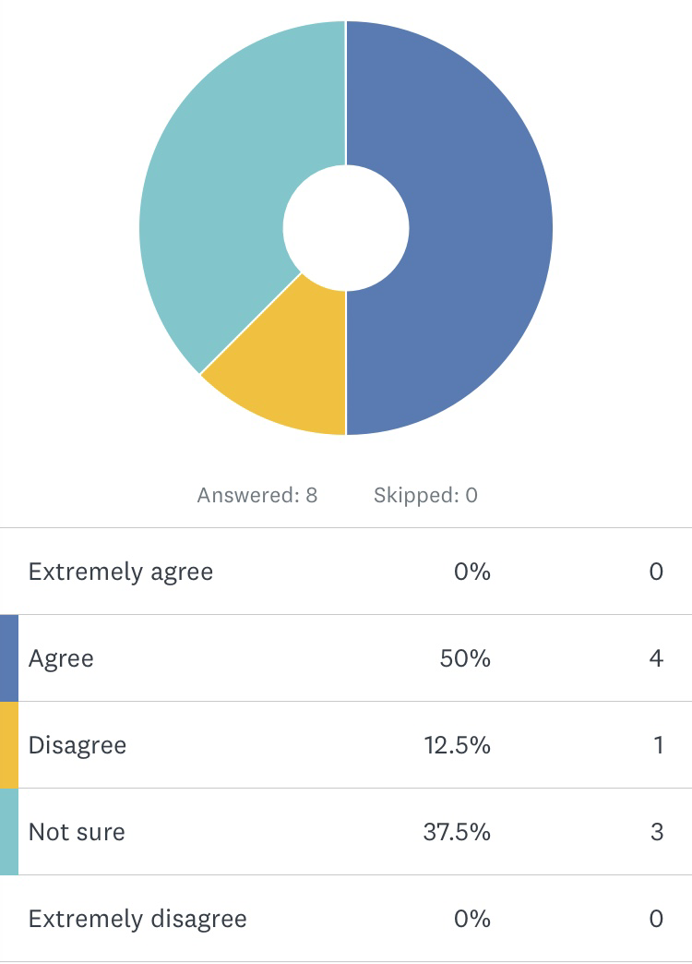

Q5: Can you consider online module a intentional way to encourage students to gain more knowledge in terms of technology skills?
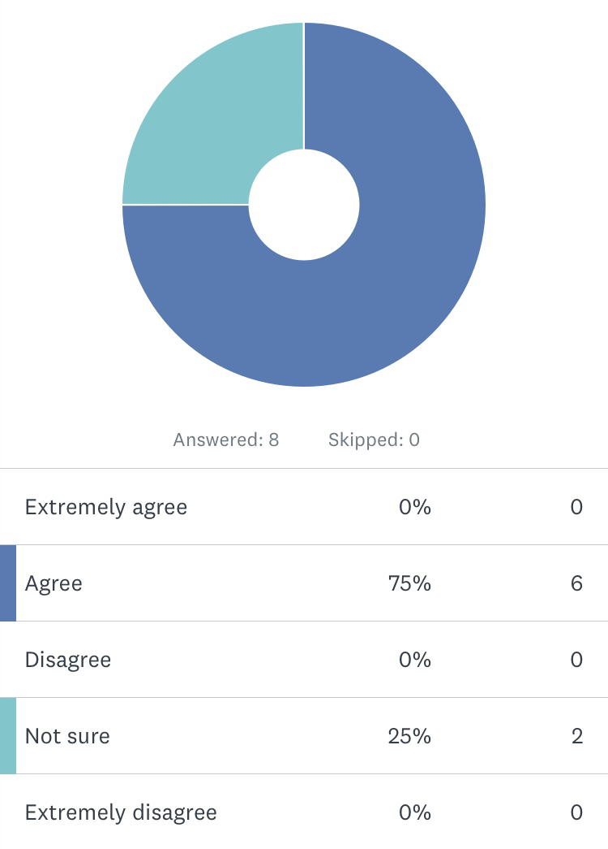

Q6: UWTSD online library is the best method to find the resources you need.
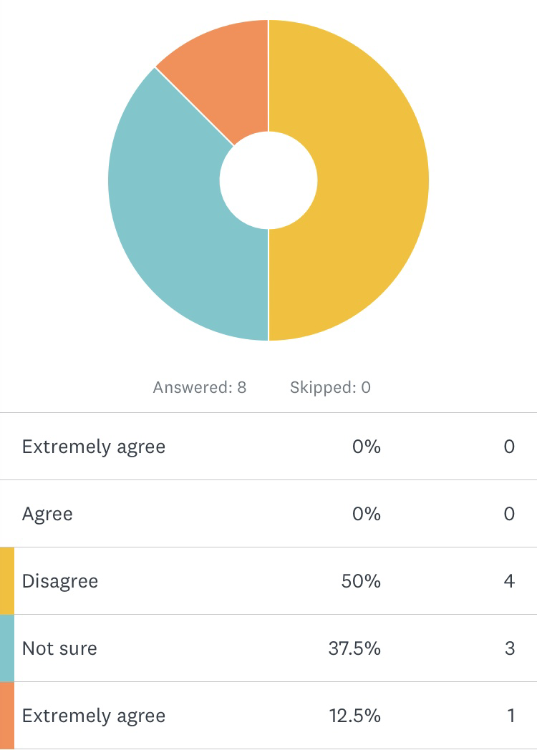

Q7:Do you consider virtual learning environment better for self study ?

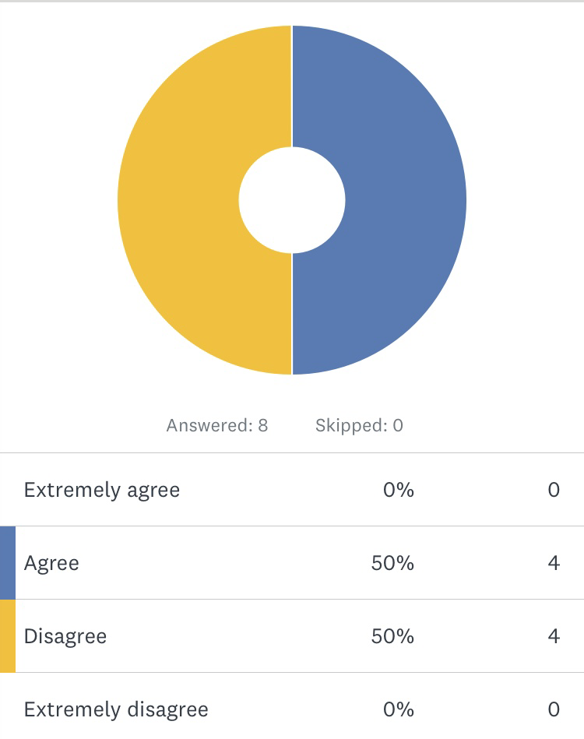

Q8:Nowadays virtual learning is considered more effective than the traditional methods.
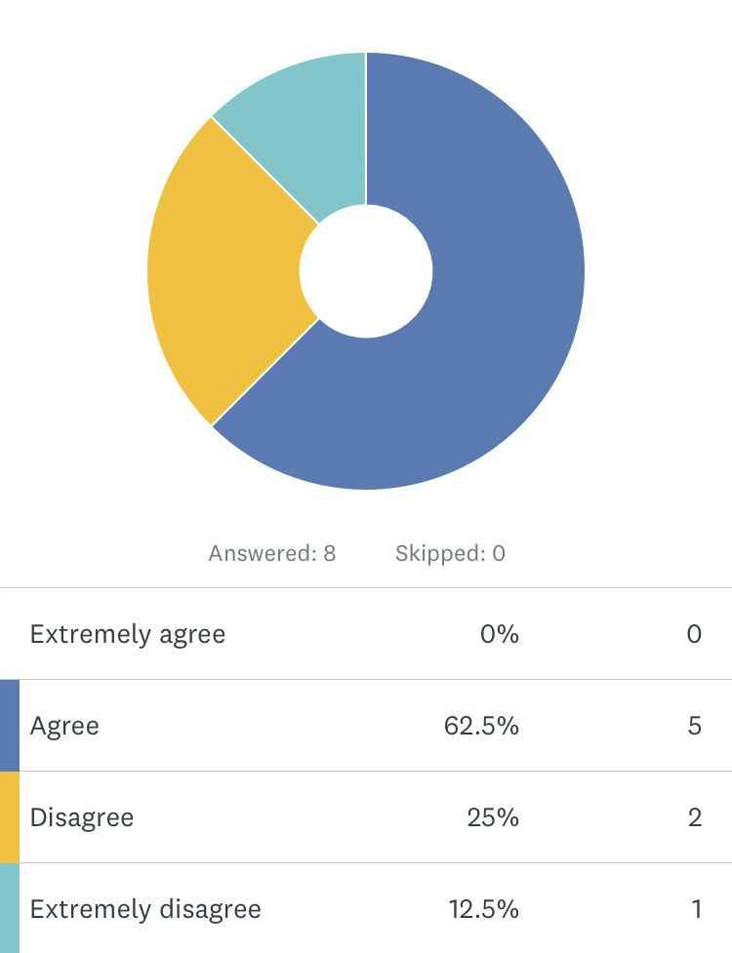

Recommendations
This case study aimed to investigate whether VLE or students engagement and performance.Most of the institutions currently are using VLE as a part of their program study and was not difficult to find the resources as the things related to the technology are easily found online or even in books. Regarding the students perspectives I am completely unsatisfied because I could not reach the main goal of my research and gain more credibility ,derives this current situation some students just refused to participate.

Conclusion
From conclusion by most college and university programs, students are asked to complete paper-based surveys assessing their experience in the classroom, reflecting on their understanding of how well the teachers performed and whether students achieved what they set out to accomplish, among other assessments of the importance of each course.(Robert Ubell,2017,p.80) To gauge the quality of online education , similar tests must be carried out by students at a distance.Most students indicated in the SUNY Learning Network is largest continuing analysis of student impressions of their online courses that their online experience was equivalent to, or better than, that of traditional classrooms.
In order to obtain those results, the most productive schools have implemented online student services that provide almost all the elements that the campus community is expected to have.
For example at Nyu Tandon school of Engineering, virtual students can do almost anything online that their peers do on campus applications and registration regularly, get academic advice, but books ,pay tuitions obtain access the digital library of the school, and carry out course assessments.
A study by Eduventures states that virtual education will deliver a broad range of features to remote students to meet their needs-engaging and interactive presentations ,discussion channels, student support around the clock seamless transactions.
According to OLC ,”students excel in studying online and are usually happy with their experience. “Overall, the literature supports that claim students are satisfied when there is vigorous online communication with their teachers and class mates when their online learning experience meets their expectations, when university service consulting, registration and access to materials is at least as good like those offered on campus. Institutions that provide effective interactive tutorial sessions for new and whose educational results provide smooth paths to productive employment and educational achievement emerge as pioneers in online education.
Quality in online learning is crucially dependent on careful planning and sound analysis. It needs, above all, wide-ranging academic and administrative involvement. Before the first course is delivered online, universities must come to terms in how it will impact all facts of university life.
Students, lecturers , scholarships.It ,library , administrators, and libraries. Very careful of course , will lead to academic paralysis.
Schools choosing a leader who commands respect between staff and students will help negotiate competing desires to find consensus and help advance staff.
Maybe the most important indicator of performance is institutional commitment,financial,technological,and legal-in a high-level environment that promotes and facilitates online education.
The End
References
Fredericksen,E.,Pickett,A.,Shea,P. and Pelz, W.(2000)
Student Satisfaction and Perceived learning with online courses: Principles and examples from SUNY learning network.JALN,4(2).

Gallagher,S.(2002 September). Distance Learning at the tipping point.Eduventures Report.

Hezel,R.T.(2002 October).How to plan for your institution is distance Learning efforts.
Educational Pathways

Ubell, R. (2017)Going online: Perspectives on digital learning. New York

Weller, M.(2007) Virtual Learning Environment
Great Britain:TJ International Ltd, Padstow, Cornwall

Effective Practices Sorted by Pillar-
Student Satisfaction at http://olc .onlinelearning Consortium.org/ep_by_pillar_ss?page=3.

https://global.oup.com/uk/orc/learnvle /

