

Student name: Emilia Milewska
Student ID:2245525
Module name: (LCHS7003_LON)
Module code: Community Care and Management of Longer-term Conditions
Lecturer name: Muhammad Khan

Table of Contents
Dementia 4
What is dementia? 4
Critical Evaluation 4
Burden and Prevalence of Dementia 5
Worldwide Prevalence 5
United Kingdom Prevalence 5
Critical Evaluation 6
Risk Factors and Aetiology of Dementia 6
Non-Modifiable Risk Factors 6
Age 6
Genetics 6
Family History 7
Modifiable Risk Factors 7
Cardiovascular Disease 7
Smoking 7
Physical Inactivity 7
Social Isolation 7
Alcohol Misuse 7
Educational Attainment 7
Critical Evaluation 8
Impact of Dementia on Individuals and Families 8
Physical Implications 8
Critical Evaluation 8
Psychological Implications 8
Critical Evaluation 9
Social Implications 9
Critical Evaluation 9
Impact on Families and Caregivers 9
Critical Evaluation 10
Evidence-Based Treatments and Management of Dementia 10
Pharmacological Treatments 10
Acetylcholinesterase Inhibitors 10
Memantine 10
Critical Evaluation 10
Non-Pharmacological Treatments 10
Cognitive Stimulation Therapy (CST) 10
Reminiscence Therapy 11
Physical Activity 11
Occupational Therapy 11
Critical Evaluation 11
Multidisciplinary Care 11
Critical Evaluation 11
Theoretical Perspectives and Models of Care 11
UK Model: Kitwood's Person-Centred Care Model 12
Evaluation 12
International Model: WHO Integrated Care for Older People (ICOPE) 12
Evaluation 12
Comparative Evaluation of Both Models 12
Critical Evaluation 13
Political Health and Social Care Agendas 13
The National Dementia Strategy 13
NHS Long Term Plan 13
Dementia Well Pathway 13
Critical Evaluation 14
Recommendations for Improving Person-Centred Care, Self-Management and End-of-Life Care 14
Promote Self-Management and Early Intervention 14
Strengthen Support for Family Caregivers 14
Enhance Multidisciplinary and Integrated Care 15
Reduce Dementia Risk Through Prevention 15
Improve End-of-Life Care 15
Critical Evaluation 15
Conclusion 16
References 16

Dementia
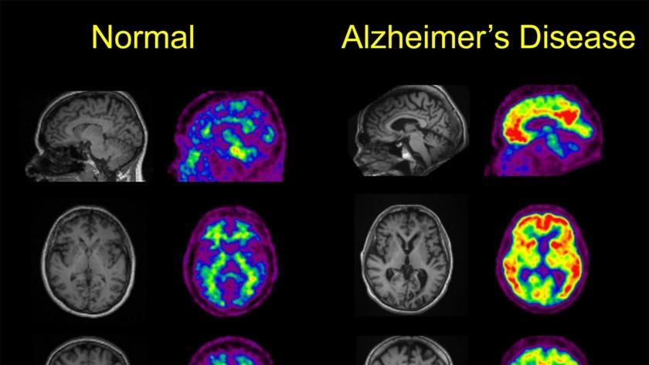
Figure 1: Comparison between a healthy brain and a brain affected by Alzheimer's disease, showing cerebral atrophy and tissue loss (WHO, 2025).

What is dementia?
Dementia is an umbrella term describing a group of progressive neurological disorders affecting memory, thinking, behaviour, communication and the ability to perform everyday activities independently (WHO, 2025). It results from damage to brain cells, disrupting signal transmission and causing a gradual decline in cognitive function (Mathys et al., 2023). Dementia is not a normal part of ageing, although increasing age is the greatest risk factor (Fonseca et al., 2025). Alzheimer's disease is the most common form, accounting for approximately 60-70% of cases worldwide (WHO, 2025). Other major types include vascular dementia, dementia with Lewy bodies, frontotemporal dementia and mixed dementia. Although each has distinct pathological features, all are characterised by progressive cognitive decline that eventually impairs independent functioning.
Common symptoms include memory loss, confusion, impaired judgement, difficulties with language and communication, changes in mood and personality, and reduced ability to perform activities of daily living (NICE, 2018).

Critical Evaluation
Dementia is one of the most significant global public health challenges of the 21st century. Unlike many acute illnesses, it is progressive, irreversible and associated with increasing dependency. Its impact extends beyond the individual to families, caregivers, healthcare systems and society. The complexity of dementia requires long-term multidisciplinary management that addresses cognitive decline and its physical, psychological and social consequences (Prince et al., 2016).

Burden and Prevalence of Dementia

Worldwide Prevalence
The World Health Organisation (2025) reports that dementia affects more than 55 million individuals globally, with approximately 10 million new diagnoses recorded each year. Owing to population ageing and longer life expectancy, the number of people living with dementia is expected to increase to 78 million by 2030 and reach 139 million by 2050.
Dementia is the seventh leading cause of death globally and a major cause of disability and dependency among older adults. It also places substantial demands on healthcare and social care services and contributes to economic losses linked to informal caregiving (WHO, 2025).

Figure 2: Projected increase in global dementia prevalence between 2021 and 2050 (WHO, 2025).

United Kingdom Prevalence
Alzheimer’s Society (2024) predicts a substantial rise in dementia cases in the UK, from nearly one million people currently affected to around 1.4 million by 2040. Current statistics indicate that:
- Dementia affects approximately one in every eleven individuals aged 65 years and over (Alzheimer's Society, 2024).
- In England and Wales, dementia remains the most common cause of death (Alzheimer's Society, 2024).
- The annual economic cost of dementia exceeds £42 billion (Alzheimer's Society, 2024).
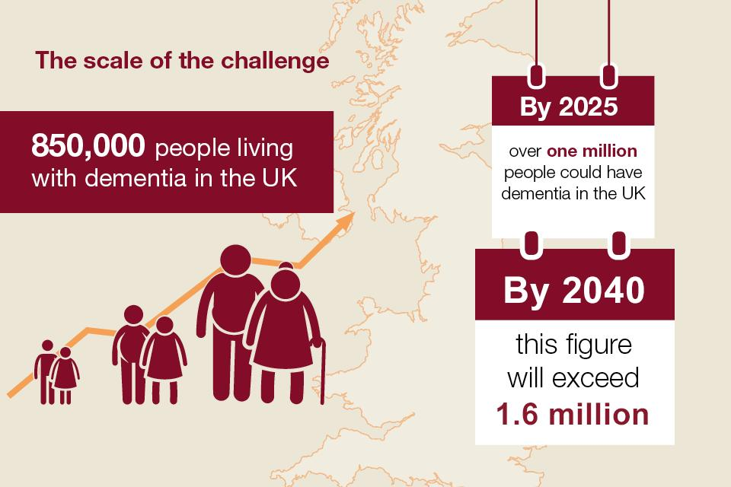
Figure 3: (Gov.uk, 2022)

Critical Evaluation
The increasing prevalence of dementia presents significant challenges for health and social care systems nationally and internationally. Population ageing is expected to drive a substantial rise in dementia cases, increasing demand for diagnostic services, long-term care and support for unpaid carers. Consequently, dementia has become a major public health priority requiring coordinated policies, sustainable funding and integrated care models to meet future demand (NHS England, 2023).
Although advances in healthcare have improved life expectancy, there is still no cure for most forms of dementia. This emphasises the importance of prevention, early diagnosis and effective long-term management to improve quality of life and reduce disease burden.

Risk Factors and Aetiology of Dementia
Dementia arises from the combined influence of genetic, biological, environmental, and lifestyle-related factors (Livingston et al., 2024). Although certain risk factors cannot be altered, others may be mitigated through lifestyle modifications and targeted public health strategies (WHO, 2025).
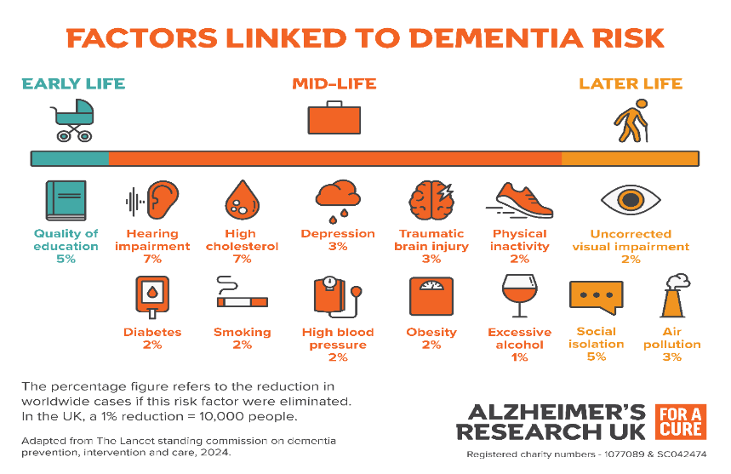
Figure 4: Livingston et al., 2024

Non-Modifiable Risk Factors

Age
The risk of developing dementia increases significantly after the age of 65 and approximately doubles every five years thereafter (Livingston et al., 2020). As life expectancy continues to increase globally, the number of people affected by dementia is expected to rise substantially (see Figure 2).

Genetics
Genetic factors contribute to the development of some dementias, particularly Alzheimer's disease (Alzheimer's Society, 2024). The APOE-ε4 gene variant increases Alzheimer's disease risk, although carrying the gene does not guarantee disease development (Scheltens et al., 2021).

Family History
Individuals with a family history of dementia may have an increased risk due to inherited genetic factors and shared environmental influences (Livingston et al., 2024).

Modifiable Risk Factors

Cardiovascular Disease
Conditions such as hypertension, diabetes, obesity and high cholesterol are associated with an increased risk of dementia. These conditions can damage blood vessels supplying the brain, contributing to both vascular dementia and Alzheimer's disease (Livingston et al., 2020).

Smoking
Smoking contributes to oxidative stress, inflammation and vascular damage, increasing the risk of cognitive decline (Livingston et al., 2024). Smoking cessation is therefore an important strategy for reducing dementia risk (Office for Health Improvement and Disparities, 2023).

Physical Inactivity
Regular physical activity is associated with improved cardiovascular health and may help maintain cognitive function. Conversely, sedentary lifestyles have been linked to an increased risk of dementia (Alzheimer’s Society, 2024).

Social Isolation
Evidence indicates that both loneliness and social isolation contribute to an increased risk of cognitive decline and dementia. Maintaining social connections may enhance cognitive reserve and promote long-term brain health (Livingston et al., 2020).

Alcohol Misuse
Excessive alcohol consumption can cause direct damage to brain tissue and increase the likelihood of developing dementia later in life (Dementia UK, 2024).

Educational Attainment
Lower educational attainment is associated with a higher risk of dementia due to reduced cognitive reserve, whereas higher education may help compensate for age-related brain changes (Livingston et al., 2024).

Critical Evaluation
The identification of modifiable risk factors has important implications for dementia prevention and public health policy. The Lancet Commission estimates that up to 45% of dementia cases may be preventable through interventions targeting risk factors across the life course, including smoking cessation, physical activity, cardiovascular health and social engagement (Livingston et al., 2020).
However, many risk factors are shaped by wider social determinants of health, including poverty, education, healthcare access and environmental conditions. Therefore, reducing dementia risk requires both individual behaviour change and population-level interventions that address health inequalities and support healthy ageing (WHO, 2025). A comprehensive public health approach is essential to reducing the future burden of dementia.

Impact of Dementia on Individuals and Families
Dementia has significant physical, psychological and social impacts on individuals, families and caregivers (Prince et al., 2016). As the condition progresses, increasing support is often required, creating substantial personal, social and economic challenges (NICE, 2018).

Physical Implications
Dementia is commonly associated with progressive physical decline. In the early stages, individuals may remain largely independent; however, as the condition advances, physical functioning often deteriorates significantly. Common physical consequences include mobility difficulties, weight loss, swallowing difficulties, incontinence and increased susceptibility to infections (NICE, 2018).

Critical Evaluation
Dementia is associated with increased healthcare use, hospital admissions and long-term care needs (NICE, 2018). Early intervention, rehabilitation and multidisciplinary support can help maintain function and quality of life. However, despite these interventions, disease progression often results in increasing dependency (Prince et al., 2016).

Psychological Implications
Dementia can have profound psychological effects, including anxiety, depression, frustration, confusion and social withdrawal as cognitive decline progresses (Prince et al., 2016). Memory loss and communication difficulties may further reduce emotional well-being.
A major consequence is the gradual loss of independence. As cognition deteriorates, individuals may struggle to manage finances, drive, prepare meals, recognise familiar people or make informed decisions, negatively affecting self-esteem and quality of life (Nowrangi et al., 2025).
Behavioural and Psychological Symptoms of Dementia (BPSD), including agitation, aggression, wandering, sleep disturbances, apathy and hallucinations, are common throughout disease progression and can be distressing for both individuals and caregivers (Harris et al., 2021).

Critical Evaluation
Psychological distress can significantly reduce quality of life and increase dependency and social isolation (Prince et al., 2016). Therefore, effective dementia care should include psychological support, therapeutic interventions and person-centred approaches that promote dignity, identity and emotional well-being (NICE, 2018).

Social Implications
Dementia can significantly affect social relationships and participation, leading to social isolation, stigma, loss of employment, reduced independence and difficulties maintaining relationships (Prince et al., 2016). Memory and communication difficulties can make social interactions increasingly challenging.
People with dementia are also more vulnerable to abuse, neglect and financial exploitation due to impaired judgement and increased dependency, making safeguarding a key aspect of care (NICE, 2018).

Critical Evaluation
Social exclusion can negatively affect mental health, self-confidence and overall wellbeing (Prince et al., 2016). Dementia-friendly communities and inclusive services can reduce stigma, encourage social participation and improve quality of life for people living with dementia (NICE, 2018).

Impact on Families and Caregivers
Family members provide most dementia care in the UK. Although caregiving can be rewarding, it is often associated with emotional, physical, social and financial challenges (Brodaty and Donkin, 2009).
Caregivers commonly experience stress, anxiety, depression, fatigue and anticipatory grief. Many reduce working hours or leave employment to provide care, resulting in financial pressures and limited career opportunities.
Caregiving may also contribute to poor health, sleep disturbances and burnout.

Critical Evaluation
Caregiver burden is strongly associated with stress, poorer health outcomes and reduced quality of life (Brodaty and Donkin, 2009). Therefore, education, respite services, financial support and psychological interventions should be considered essential components of dementia care rather than optional additions.

Evidence-Based Treatments and Management of Dementia
There is no cure for most forms of dementia; therefore, management focuses on slowing progression, controlling symptoms, maintaining independence and improving quality of life. Effective care requires a multidisciplinary approach involving healthcare professionals, social care services, caregivers and community support (NICE, 2018).

Pharmacological Treatments

Acetylcholinesterase Inhibitors
Acetylcholinesterase inhibitors are prescribed for mild to moderate Alzheimer's disease and increase acetylcholine levels involved in memory and learning. Examples include donepezil, rivastigmine and galantamine. These medications may improve cognition, memory and daily functioning in some individuals (NICE, 2018).

Memantine
Memantine is recommended for moderate to severe Alzheimer's disease and works by regulating glutamate activity in the brain, helping to manage cognitive symptoms (NICE, 2018).

Critical Evaluation
Although pharmacological treatments may improve symptoms, they neither cure dementia nor prevent disease progression. Benefits vary between individuals, and some experience limited improvement or adverse effects. Consequently, medication should be considered one element of a broader person-centred management approach (NICE, 2018).

Non-Pharmacological Treatments
Non-pharmacological interventions are an important component of dementia care (NICE, 2018).

Cognitive Stimulation Therapy (CST)
Cognitive Stimulation Therapy uses structured group activities to improve cognition, communication and social interaction. Evidence suggests it can enhance cognition and quality of life (Woods et al., 2012).

Reminiscence Therapy
Reminiscence therapy encourages discussion of past experiences using photographs, music and personal memories, which may improve mood, communication and psychological wellbeing (NICE, 2018).

Physical Activity
Regular physical activity can maintain mobility, support cardiovascular health, reduce fall risk and improve wellbeing (Livingston et al., 2024).

Occupational Therapy
Occupational therapists help individuals maintain independence through environmental adaptations, assistive technology and personalised interventions (NICE, 2018).

Critical Evaluation
Non-pharmacological interventions are increasingly recognised as key components of dementia care because they promote independence, wellbeing and quality of life. Compared with medication, they typically have fewer adverse effects and align with person-centred care principles (NICE, 2018). However, access may be limited by geographical location, funding and workforce capacity (NICE, 2018).

Multidisciplinary Care
Effective dementia management requires collaboration between healthcare and social care professionals, including GPs, dementia specialist nurses, psychiatrists, occupational therapists, physiotherapists, social workers and speech and language therapists (NICE, 2018). Multidisciplinary working helps ensure coordinated, responsive care that meets changing needs.

Critical Evaluation
A multidisciplinary approach supports holistic care by addressing physical, psychological and social needs simultaneously (NICE, 2018). Integrated care models can improve outcomes, reduce hospital admissions and enhance continuity of care (Prince et al., 2016). However, communication barriers between services and limited resources may hinder effective implementation.

Theoretical Perspectives and Models of Care
Dementia management increasingly uses holistic approaches that address physical, psychological and social needs. Two influential models are Kitwood's Person-Centred Care Model and the WHO Integrated Care for Older People (ICOPE) framework.

UK Model: Kitwood's Person-Centred Care Model
Kitwood's Person-Centred Care Model challenged traditional biomedical approaches by emphasising the individual rather than the disease (Kitwood, 1997). Central to the model is personhood, recognising and valuing individuals despite cognitive decline.
Key principles include:
- Respect and dignity
- Individualised care
- Meaningful relationships
- Inclusion and participation
- Choice and autonomy
Person-centred care aims to preserve identity, independence and wellbeing while reducing distress and behavioural symptoms.

Evaluation
Person-centred approaches can improve quality of life, reduce agitation and enhance satisfaction with care (Fazio et al., 2018). However, effective implementation requires adequate staffing, specialist training and organisational support, which may be limited by workforce and resource pressures.

International Model: WHO Integrated Care for Older People (ICOPE)
The WHO's Integrated Care for Older People (ICOPE) framework promotes coordinated, community-based care that supports functional ability and healthy ageing (WHO, 2022).
Key principles include:
- Early identification of decline
- Integrated health and social care
- Multidisciplinary collaboration
- Community-based support
- Prevention and self-management
The framework recognises that health outcomes are influenced by physical, psychological and social factors, requiring coordinated responses across services.

Evaluation
ICOPE supports prevention, early intervention and integrated care, which may improve outcomes and reduce hospital admissions (WHO, 2022). However, implementation can be affected by variations in healthcare systems, funding and workforce capacity.

Comparative Evaluation of Both Models
Kitwood's model focuses on dignity, individuality and personhood, whereas ICOPE takes a systems-based approach to coordinated care. Both promote holistic care, but Kitwood emphasises relationships and autonomy, while ICOPE prioritises service integration and functional ability. Together, they demonstrate the need for both personalised care and coordinated multidisciplinary support.

Critical Evaluation
Neither model addresses all dementia care challenges. Person-centred care requires sufficient resources, while integrated models may be limited by fragmented services and workforce shortages. Nevertheless, both provide valuable frameworks for delivering comprehensive dementia care.

Political Health and Social Care Agendas

The National Dementia Strategy
The National Dementia Strategy aimed to improve awareness, diagnosis and quality of care by increasing public and professional awareness, improving access to early diagnosis and enhancing service quality (Department of Health, 2009).
Evaluation: The strategy increased awareness and diagnosis rates; however, service availability and access to specialist support remain variable across regions (Department of Health, 2009).

NHS Long Term Plan
The NHS Long Term Plan identifies dementia as a major public health challenge, prioritising earlier diagnosis, personalised care, community-based support, integrated services and greater support for unpaid carers (NHS England, 2019).
Evaluation: The plan promotes holistic, integrated care but relies on sufficient funding, workforce capacity and effective inter-agency collaboration (NHS England, 2019).

Dementia Well Pathway
The Dementia Well Pathway supports individuals throughout the dementia journey, focusing on prevention, timely diagnosis, living well with dementia, carer support and high-quality end-of-life care (NHS England, 2023).
Evaluation: This person-centred framework promotes continuity of care and wellbeing, although inconsistent service provision may limit its effectiveness (NHS England, 2023).

Critical Evaluation
National policies have improved dementia awareness, diagnosis and care planning. However, regional inequalities, increasing demand, funding pressures and workforce shortages continue to challenge service delivery (Hampel et al., 2022). Delivering integrated, person-centred care will require sustained investment, workforce development and stronger cross-sector collaboration.

Recommendations for Improving Person-Centred Care, Self-Management and End-of-Life Care
As the prevalence of dementia continues to increase, there is a growing need to develop services that support individuals throughout the disease trajectory. Future improvements should focus on prevention, self-management, integrated care and high-quality end-of-life support.

Promote Self-Management and Early Intervention
Although dementia is a progressive condition, individuals in the early stages can be supported to maintain independence and participate actively in decisions about their care. Self-management strategies may include:
- Education programmes for patients and families.
- Memory aids and assistive technologies.
- Digital health applications.
- Advance care planning.
- Community support groups.
Supporting self-management can improve confidence, promote autonomy and delay dependence on formal care services (NICE, 2018; NHS England, 2023).

Strengthen Support for Family Caregivers
Family caregivers play a vital role in dementia care and should be recognised as key partners in the care process. Greater investment is needed in:
- Respite care services.
- Psychological support programmes.
- Carer education and training.
- Financial assistance and benefits advice.
- Peer support networks.
Improving support for caregivers can reduce caregiver burden, improve well-being, and enhance the quality of care provided to individuals living with dementia (Brodaty and Donkin, 2009; NICE, 2018).

Enhance Multidisciplinary and Integrated Care
Dementia management requires effective collaboration between healthcare professionals, social care providers and community organisations. Services should continue to develop integrated care pathways involving:
- General Practitioners.
- Dementia specialist nurses.
- Occupational therapists.
- Physiotherapists.
- Social workers.
- Mental health professionals.
Integrated care can improve continuity, reduce service duplication and support holistic care delivery (WHO, 2022; NHS England, 2023).

Reduce Dementia Risk Through Prevention
Public health initiatives should focus on addressing modifiable risk factors associated with dementia. Key priorities include:
- Smoking cessation.
- Increasing physical activity.
- Managing hypertension and diabetes.
- Reducing obesity.
- Tackling social isolation.
- Promoting lifelong learning and cognitive stimulation.
The Lancet Commission estimates that approximately 45% of dementia cases may be preventable through interventions targeting risk factors across the life course (Livingston et al., 2020). This highlights the importance of prevention as a public health priority.

Improve End-of-Life Care
Advance care planning should be introduced early in the disease process to ensure that individuals can express their preferences regarding future care. End-of-life care should include:
- Discussion of treatment preferences.
- Preferred place of care and death.
- Family involvement in decision-making.
- Effective symptom management.
- Emotional and spiritual support.
Person-centred palliative care can help maintain dignity, comfort and quality of life during the final stages of dementia (NICE, 2018; NHS England, 2023).

Critical Evaluation
Improving dementia care requires a shift from reactive service provision towards proactive, preventative and person-centred approaches. Whilst current policies provide a strong foundation, rising dementia prevalence will require greater investment in prevention, workforce development, caregiver support and integrated care systems (NHS England, 2023). Sustainable improvements depend on effective collaboration between healthcare services, social care organisations, policymakers and communities (WHO, 2022).

Conclusion
Dementia has significant physical, psychological and social impacts on individuals, families and society, and its increasing prevalence presents major challenges for health and social care systems worldwide (WHO, 2025). Effective management extends beyond medical treatment to include psychological support, social inclusion and person-centred care, with multidisciplinary and integrated approaches helping to improve quality of life throughout disease progression (NICE, 2018; WHO, 2022).
Policies such as the National Dementia Strategy, NHS Long Term Plan and Dementia Well Pathway have improved awareness, diagnosis and care provision (Department of Health, 2009; NHS England, 2019; NHS England, 2023). However, future efforts should prioritise prevention, early diagnosis, self-management, caregiver support and high-quality end-of-life care through continued investment in evidence-based, person-centred services (Livingston et al., 2020; NICE, 2018).

References
Adelman, R.D., Tmanova, L.L., Delgado, D., Dion, S. and Lachs, M.S. (2014) 'Caregiver burden: A clinical review, JAMA, 311(10), pp.1052-1060.

Alzheimer's Society (2024) Dementia UK: Update. London: Alzheimer's Society.
Bowling, A., Rowe, G. and Lambert, N. (2019) 'The measurement of quality of life in dementia', Age and Ageing, 48(5), pp. 634-641.

Brodaty, H. and Donkin, M. (2009) ‘Family caregivers of people with dementia’, Dialogues in Clinical Neuroscience, 11(2), pp. 217–228.
Brooker, D. (2007) Person-Centred Dementia Care: Making Services Better. London: Jessica Kingsley Publishers.

Buckner, S., Mattocks, C., Rimmer, M. and Lafortune, L. (2019) Dementia Friendly Communities in England. Cambridge: University of Cambridge.

Dementia UK (2024). Dementia UK. [online] Dementia UK. Available at: https://www.dementiauk.org/information-and-support/types-of-dementia/alcohol-related-brain-damage/ [Accessed 20 June 2026].

Department of Health (2009) Living Well with Dementia: A National Dementia Strategy. London: Department of Health.
Fazio, S., Pace, D., Flinner, J. and Kallmyer, B. (2018) ‘The Fundamentals of Person-Centered Care for Individuals with Dementia’, The Gerontologist, 58(S1), pp. S10–S19.
Fonseca, M., Pires, A., Mouta, S., Figueiredo, D., Pires, M. and Soares, I. (2025) ‘Let’s Talk About Potentially Modifiable Risk Factors for Dementia’, European Psychiatry, 68, pp. S853 - S853. doi: 10.1192/j.eurpsy.2025.1729.
Gov.uk (2022). Dementia: Applying All Our Health. [online] GOV.UK. Available at: https://www.gov.uk/government/publications/dementia-applying-all-our-health/dementia-applying-all-our-health [Accessed 20 July 2026].
Alzheimer’s society (2024). Physical activity and the risk of dementia | alzheimer’s society - connected content. [online] www.alzheimers.org.uk. Available at: https://www.alzheimers.org.uk/about-dementia/managing-the-risk-of-dementia/reduce-your-risk-of-dementia/physical-activity [Accessed 20 June 2026].
Hampel, H., Vergallo, A., Iwatsubo, T., Cho, M., Kurokawa, K., Wang, H., Kurzman, H. R. and Chen, C. L. H. (2022) ‘Evaluation of major national dementia policies and health‐care system preparedness for early medical action and implementation’, Alzheimer's & Dementia, 18, pp. 1993 - 2002. doi: 10.1002/alz.12655.
Harris, S.A. et al. (2021) ‘The Impact of Dementia on the Self: Do We Consider Ourselves the Same as Others?’, Neuroethics, 14(Suppl 3), pp. 281–294.
Kitwood, T. (1997) Dementia Reconsidered: The Person Comes First. Buckingham: Open University Press.
Livingston, G. et al. (2020) ‘Dementia prevention, intervention and care: 2020 report of the Lancet Commission’, The Lancet, 396(10248), pp. 413–446.
Livingston G, Huntley J, Liu K et al. Dementia prevention, intervention, and care: 2024 report of the Lancet standing Commission The Lancet, 2024; 404, 572-628
Mathys, H. et al. (2023) ‘Single-cell atlas reveals correlates of high cognitive function, dementia, and resilience to Alzheimer’s disease pathology’, Cell, 186, pp. 4365 - 4385.e27. doi: 10.1016/j.cell.2023.08.039.
National Institute for Health and Care Excellence (NICE) (2018) Dementia: Assessment, Management and Support for People Living with Dementia and Their Carers. NICE Guideline NG97.
NHS England (2019) The NHS Long Term Plan. London: NHS England.
NHS England (2023) Dementia Well Pathway. London: NHS England.
National Institute for Health and Care Excellence (NICE) (2018) Dementia: assessment, management and support for people living with dementia and their carers (NG97). London: NICE.
Nichols, E. et al. (2022)’ Estimation of the global prevalence of dementia in 2019 and forecasted prevalence in 2050, The Lancet Public Health, 7(2), pp. e105-e125

Nowrangi, M.A. et al. (2025) ‘Influence of cognitive, neuropsychiatric, and diagnostic factors on financial capacity: A longitudinal analysis of the ADNI cohort’, Alzheimer's & Dementia: Diagnosis, Assessment & Disease Monitoring, 17(1), e12583.
Office for Health Improvement and Disparities (OHID) (2023) Dementia prevention, risk factors and health promotion. London: Department of Health and Social Care.
Prince, M. et al. (2016) World Alzheimer Report 2016: Improving Healthcare for People Living with Dementia. London: Alzheimer's Disease International.
Public Health England (2021) Health Matters: Midlife Approaches to Reduce Dementia Risk. London: Public Health England.
S., Drury, M., Dennison, A. and Bray, J. (2020) 'Effective dementia education and training for the health and social care workforce: A systematic review', Aging and Mental Health, 24(8), pp. 1137-1150.

Scheltens, P. et al. (2021) ‘Alzheimer’s disease’, The Lancet, 397(10284), pp. 1577–1590.
Surr, C.A., Gates. C., Irving, D., Oyebode, J., Smith, S.J., Parveen, Woods, B. et al. (2012) ‘Cognitive stimulation to improve cognitive functioning in people with dementia’, Cochrane Database of Systematic Reviews, Issue 2.

World Health Organisation (WHO) (2022) Integrated Care for Older People (ICOPE): Guidance for Person-Centred Assessment and Pathways in Primary Care. Geneva: WHO.
World Health Organisation (WHO) (2025) Dementia. Geneva: WHO.

