MATTHEW FORD (1903400)

STRESS ANALYSIS AND DYNAMICS ASSIGNMENT

DESIGNING AN OVERHEAD GANTRY CRANE

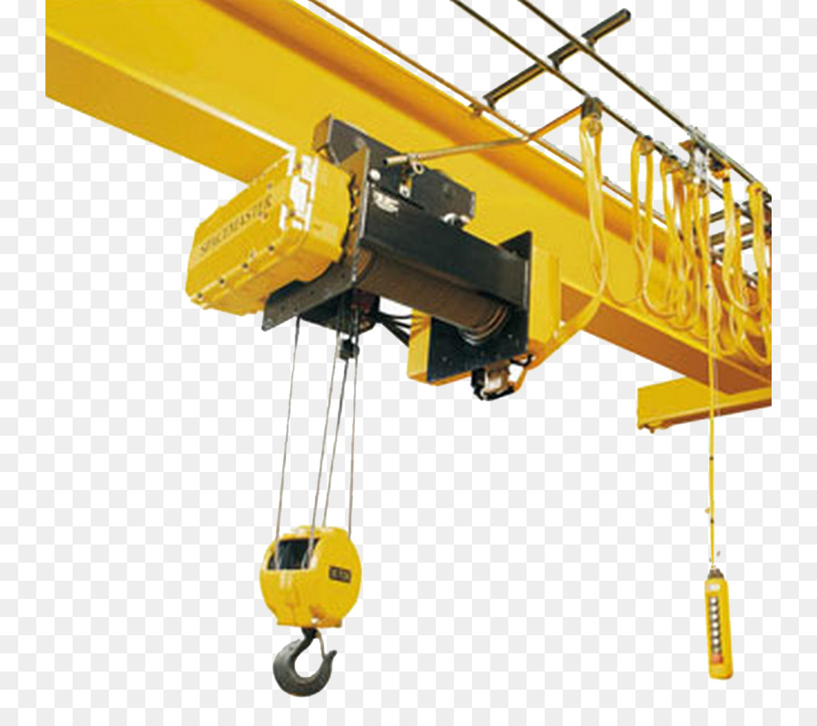

LECTURER: K LAKE
CONTENTS

Page no.

Cover page 1

Contents 2

Introduction 3

Task 1 4

Task 2 9

Task 3 11

Task 4 15

Bibliography 17
INTRODUCTION

The following assignment aims to investigate how gantry cranes are designed with respect to the framework’s mechanical properties, specifically the bending moment of the girder. It will go on to investigate what different types of strain gauges are available, and how these might be used within the gantry crane system.

Task 1

It has been proposed that the assembly shown below be designed in such a way that the main bridge girder deflection is limited to 10mm in order to ensure that the whole assembly is still able to operate properly.
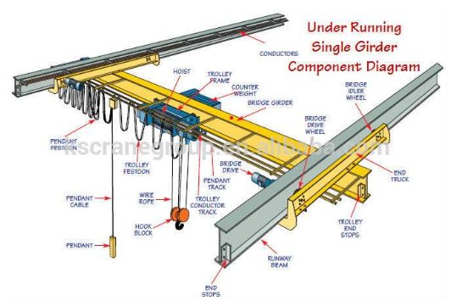
In order to calculate the correct bridge girder size to stay within these design parameters, several assumptions must be made.

ASSUMPTIONS
- Beam length is 12 meters
- Maximum deflection will be at the centre of the beam.
- Trolley weight is 1000kg.
- Trolley will be considered a point load
- Points where bridge girder meet support beam will be considered fixed and rigid for purposes of the calculations.
- Any safety factor is already being taken into account within the specified 10mm deflection.
- Bridge girder will be sourced from a reputable, quality assured supplier.
- Trolley frame is symmetrically designed
- Any additional loads attached to the bridge girder not considered due to negligible mass
- The structure will not be subjected to impact loads.

CALCULATIONS
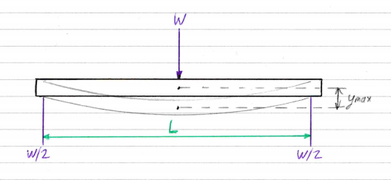
The diagram above is a representation of the scenario in question. From the information provided, we can use the known engineering equation: -
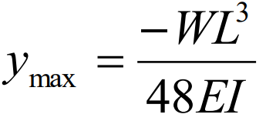
Where: - Y_{max} = maximum deflection = 10mm = 0.01m
W = Load on beam = 5000kg+1000kg = 58860N
L = Span of the beam = 12m
E = Modulus of Elasticity = 210GPa = 2.1x10¹¹ N/m²
I = Moment of inertia = ??? m⁴

So: -
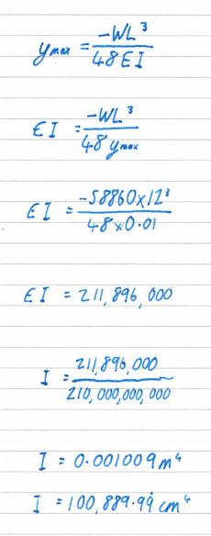

Having calculated the second moment of area required for the girder in question, this can be used to calculate the dimensions of the beam. The following equations can be used to calculate such dimensions; -
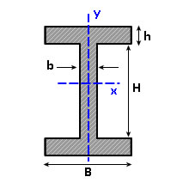
I_{xx} = H³b/12 + 2[h³B/12 + hB(H+h)²/4]
I_{yy} = b³H/12 + 2(B³h/12) (Amesweb, n.d.)

However, structural steels are manufactured and supplied in standardised sizes. Therefore charts/tables are readily available for referring to. One such chart is shown overleaf.

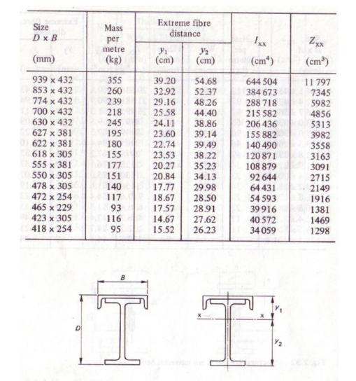
(Lecture notes, 2021)

From the table above, it can be seen that the appropriate beam size ensuring a higher second moment area value would be 618mm x 305mm. Referring to BS4-1:2005 for appropriate measurements, the standard flange dimension (upper and lower plate thickness) would be 31.4mm and the standard web thickness (vertical steel between flanges) being 18.4 mm (Rainham Steel, 2021).

Task 2

Below are the assumptions made for task 1, and their justifications/reasoning.

- Beam length is 12 meters.
The beam length of 12m was selected as this is the typical width of a medium sized workshop, typical of dealing with a maximum subject load of 5000kg.

- Maximum deflection will be at the centre of the beam.
It is assumed that there are no other off-centre forces such as additional hoists of support structures, and that the structure is symmetrical about the beam centre, therefore the maximum deflection will occur at the beam centre.

- Trolley weight is 1000kg.
Trolley weight has been estimated to be 1000kg. This accounts for the hook and cable, drum, motor, and counterbalance weight.

- Trolley will be considered a point load.
The trolley has been considered a point load as the trolley wheelbase can vary. Using a point load errs on the side of caution as any distribution of the load away from the trolley centre will decrease the beam deflection, only small deviations are being considered here, but the greater the wheelbase, the lower the deflection.

- Points where bridge girder meet support beam will be considered fixed and rigid for purposes of the calculations.
These assumptions have been made in order to make the calculations possible in theory. In practicality, there will be clearances and permissible movements between these two points in order to accommodate the travel of the bridge along the runway beams.

- Any safety factor is already being taken into account within the specified 10mm deflection.
It is assumed that any safety margin (nominally 120% for lifting equipment) has already been considered within the 10mm maximum deflection.

- Bridge girder will be sourced from a reputable, quality assured supplier.
This ensures the girder will be to standard, and thus no need for additional safety factors such as those mentioned in point 6.

- Trolley frame is symmetrically designed.
This assumption ensures the trolley as a complete unit is balanced, negating any need to calculate torsion in the beam and ensuring the hook and thus load, act directly through the centre of the trolley.

- Any additional loads attached to the bridge girder not considered due to negligible mass.
Items such as cable bracketing and support, buzz bar, trolley rails are deemed not to influence the calculations.

- The structure will not be subjected to impact loads.
Any impact loading on the structure will dramatically decrease the girder’s ability to resist deflection. There are very few lifting devices designed specifically to withstand impact outside of highly specialised equipment. It is assumed that this structure will be operated by competent personnel and that this will not occur.

Task 3

Some types of strain gauges are listed and described below: -

- Brittle lacquer
- Electronic resistance
- Mechanical gauges or extensometers
- Pneumatic gauges
- Semiconductor/ piezo-resistive gauges
- Inductive gauges
- Capacitance gauges
- Digital image correlation and tracking (DIC)
- Mercury in rubber
- Nanoparticle based, the future of gauges?

Brittle lacquer gauge
This type of gauge was first available commercially between 1937 and 1941, when Ellis, De Forrest and Stern created a numerous lacquers they called “Stresscoat”, however the fundamentals of the technique can be dated back as far as 1850, when Clarke was investigating tubular bridges (Hearn, 1997).
This technique is a relatively simple one, that involves a lacquer being applied to a surface that is to be monitored. The lacquer material is formulated in such a way that its yield value is a known quantity. After application to the surface of the plain that is to be monitored, the lacquer will exhibit cracks when the formulated yield value is reached. This form of strain gauge is only 10-20% accurate, therefore it is used more often as a way of identifying where stresses occur, rather than their value.

Electronic resistance gauge
An electrical resistance strain gauge is an instrument used to measure the amount of force an object/surface has acting upon it. It is a device that makes use of the relationship between a wire conductor’s resistance and the strain exerted upon it. This relationship was first documented in 1856 by Lord Kelvin, it was developed further in the early 1930s when Charles Kearns used the theory to measure dynamic strains on propeller blades. Although Kearns logic was sound, his measurement systems were not accurate and were unable to measure slow changing or static strains.
Toward the end of the 1930s Arthur Rouge and Edward Simmons both independently found that small diameter wire could be mounted directly to a structure . This idea meant that static strains could be measured. This concept was soon used in the aeronautical industry to develop aircraft (Sensorland.com, n.d.).

In 1952 Saunders-Roe Company UK moved away from bonded wire gauges and used the technique of printing circuit boards to etch the gauge pattern from thin foil. This development made strain gauges far smaller and cheaper to produce, opening the concept up to a far wider market.

The resistance strain gauge can be found in many different forms, all use the same fundamental principle of electrical resistance, but they have their wires routed in different formations to suit different applications.

Some of the most widely used geometries are: -

Linear, have a single grid for measurement in one direction, example below.


Membrane rosette, the grid is laid across a membrane so that the resistance changes as the membrane flexes. This tequnique is widely used as a means of measuring pressure within a system by transducing force acting on the diaphragm.


Double linear, have two parallel measuring grids, typically used to measure bending beams, example below
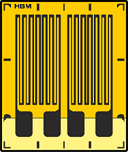

Full bridge, these comprise of four grids, all set at 90º to each other, shown below


Column, consist of a series of small grids set equidistant apart. These are useful when measuring strain gradients, see below


0º /45º/ 90º rosette or 0⁰ /60⁰ /120º rosette, used to measure biaxial stresses.
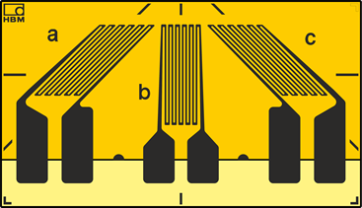

Mechanical gauges or extensometers
These devices measure the change in length of an object by means of two knife edge contacts. This value is then divided by the objects original length providing a value of strain that is being exerted on the object. They were invented by Charles Huston in 1879.

Pneumatic gauges
These gauges as the name suggests, use changes in pneumatic pressure to calculate stresses exerted on an object surface.

Semiconductor/ piezo-resistive gauges
These gauges make use of the piezoresistive effect present in semiconductive materials such as silicon. They can be used to obtain higher sensitivity and more level output, but these types of gauges are highly susceptible to temperature changes and its very difficult to compensate this (Science direct, n.d.).

Digital image correlation and tracking (DIC)
This form of strain measuring device is a non-contact method of collecting data. It can be described simply as a before and after technique. A camera or cameras are set up and used to monitor an object during load application. Although the principle is basic, the data analysis is extremely complicated in the way in which the images provided are compared to each other. This technique can and has been used on organic structures, successfully and highly accurately determining loads on animal limbs such as mice (Mark T.Begoniaa, 2015). There are also other non-contact strain gauges available, such as laser-speckle gauges.

Mercury in rubber
A somewhat dated, but interesting type of strain gauge used to measure blood flow from and to the heart. This was achieved by using a silastic (rubber) tube filled with distilled mercury, wrapped around a limb. Each end of the tube was plugged with a conductive material, and connected to one leg of a Wheatstone bridge. The strain produced on the mercury could then be measured and extrapolated out to calculate the flow of blood (J. GAMBLE, 1993).

Nanoparticle based strain gauges
These devices operate on almost identical principles to the electrical resistance strain gauge, except that instead of using metallic conductors or semiconductors, they use nanotechnology, specifically carbon nanotubes within a polymer matrix. The aim of this design is to provide higher sensitivity, and to drive down costs (J. L. Tannera, 2011).

Task 4

Before selecting which type of strain gauges to be used its important to decide how many are required, and where the strain gauges should be positioned on the structure. I would suggest that seven gauge setups would be optimal for both reliability and safety. These would be positioned as follows: -
- One on each of the end trucks, equidistant from the drive wheel and idle wheel to ensure neither end of the bridge was being excessively strained or failing prematurely.
- Three equally spaced along the bridge girder length, for the same reasons as above.
- One on the trolley frame, directly between the trolley wheelbase, to ensure the trolley itself is not being over strained.
- One on the hoist drum to measure the load on the block to offer both an overweight lift cut off, and a digital display of load weight to the user.

It should be noted at this point that the above arrangement for the gauges is an ideal set up, in a situation where safety has been considered paramount. In practicality, a gantry crane would usually only have a gauge on the bridge girder and on the hoist drum. Failure of the other girders within the system would be identified prior to catastrophic failure by means of regular inspection by competent personnel.

In order to select the appropriate strain gauges there are four main things to consider. These are: -
- Accuracy and repeatability of results
- Ease of installation
- Costing
- Suitability to the operating conditions and environment
(Efunder engineering fundamentals, n.d.)

Further to these points, the gauge length, gauge pattern, gauge resistance and gauge materials should all be considered.

Taking all these points into the equation, the type of strain gauge most suitable for this application would undoubtably be an electrical resistance type device. This would be suitable for all seven locations, although the gauge pattern would vary.

A linear resistance gauge would be suitable for all six of the beam/ girder measurements and could be mounted directly to the steelwork (See below for mounting technique), whereas the hoist drum, would actually require four linear strain gauges, each incorporated into load cells located at each of the four corners of the drum support frame (Michigan Scientific Corporation, 2018).

Linear resistance gauges have been selected for use on the beams as they are most suitable, they measure in one direction only which is all that is required, they are cheap to source, and they provide a reliable output signal. This signal can be fed back to the crane CPU which can transduce it into a form so as to provide a warning and/ or cut off if any of the strain parameters are exceeded. These gauges will be bonded to the steel girders after the beams have been manufactured, but prior to girder installation (to minimize working at height).

Load cells incorporating strain gauges are to be used on the hoist drum, the signals given from these four units are to be fed back to the CPU where they can be treated in the same way as the linear gauge signals above, and also transduced to provide an output to a digital display that could be mounted on the gantry itself, providing the user with real time load on hook information. The load cells will be bolted into place, allowing for easy replacement if any one of the units were to fail.

Bibliography
Amesweb, n.d. Second Moment of Inertia. [Online]
Available at: https://amesweb.info/section/second-moment-of-area-calculator.aspx
[Accessed April 2021].
Efunder engineering fundamentals, n.d. Principles of selecting strain gauges. [Online]
Available at: https://www.efunda.com/designstandards/sensors/strain_gages/strain_gage_selection.cfm
[Accessed April 2021].
Hearn, E., 1997. Mechanics of Materials Volume 1. 3rd ed. Oxford: Butterworth-Heinemann.
J. GAMBLE, I. B. G. A. F. C., 1993. A REASSESSMENT OF MERCURY IN SILASTIC STRAIN GAUGE. Journal of Physiology, pp. 407-422.
J. L. Tannera, D. M. C. S. R. T., 2011. Nanoparticle strain sensor. Procedia Engineering 25, pp. 635-638.
Lecture notes, 2021. Bending of beams revision. Swansea: UWTSD.
Mark T.Begoniaa, M. L., 2015. Non-contact strain measurement in the mouse forearm loading model using digital image correlation (DIC). Bone, Volume 81, pp. 593-601.
Michigan Scientific Corporation, 2018. How load cells are used in crane measuring systems. [Online]
Available at: https://www.michsci.com/load-cells-and-the-way-they-are-used-in-crane-measuring-systems/
[Accessed April 2021].
Rainham Steel, 2021. Universal Beams. [Online]
Available at: https://www.rainhamsteel.co.uk/products/universal-beams
[Accessed April 2021].
Science direct, n.d. Semiconductor strain gauge. [Online]
Available at: https://www.sciencedirect.com/topics/engineering/semiconductor-strain-gauge
[Accessed April 2021].
Sensorland.com, n.d. History of Sensors. [Online]
Available at: www.sensorland.com/histpage003.html
[Accessed April 2021].

